**FPT ACADEMY INTERNATIONAL**

**FPT – APTECH COMPUTER EDUCATION**

# Centre Name: ACE-HCMC-2-FPT.

**Address: 590 Cach Mang Thang 8, District 3, Ho Chi Minh City, Viet Nam.**

ASKME

User Guide

|  |  |  |
| --- | --- | --- |
| **Supervisor:** | Le Mong Thuy | |
| **Semester:** | 1 | |
| **Batch No:** | T1.2302.E1 | |
| **Group No:** | 5 | |
| **Order:** | **Full name** | **Roll No.** |
| 1. | NGUYEN QUOC DUONG | Student1457507 |
| 2. | HUYNH YEN PHUNG | Student1457502 |
| 3. | NGHIEM KHA AN | Student1457501 |

# System Requirement

|  |  |  |
| --- | --- | --- |
| **No.** | **Software** | **Description** |
| 1 | Operating System | Windows 7 or higher  Mac OS 10.13 or higher |
| 2 | Hardware | Intel core i3 or higher  4GB RAM or higher |
| 3 | Software | Visual Studio Code |
| 4 | Web browser | Internet Explorer 11, Google Chrome 72, Firefox  65, Safari 11 |

1. **Website Installation**
   * This document is created to guide user setup and use ASKME website effectively. It is advisable that users should read this document before starting to use reality on the website.
   * To run ASKME website, user need to do the following steps:
2. Download the https://github.com/Hannah1112/g5_akme
3. Open index.html file to start the website.

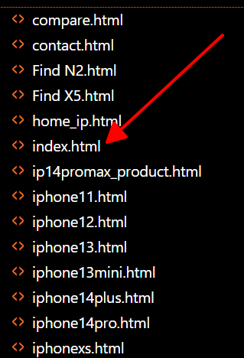

1. The homepage like figure in bellow:

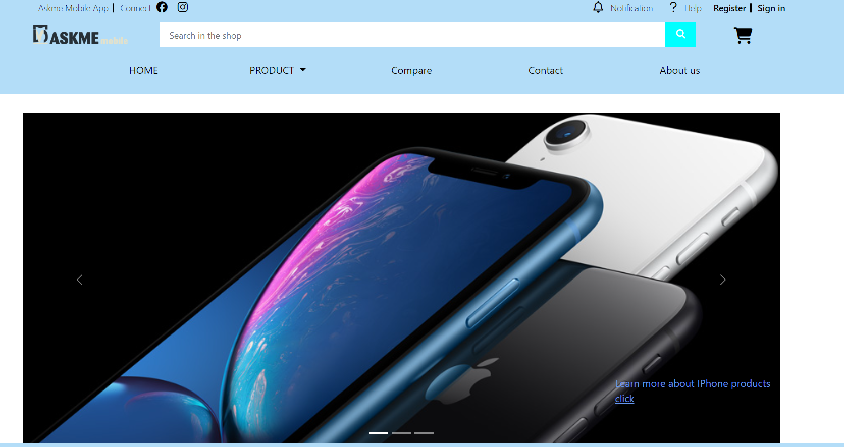

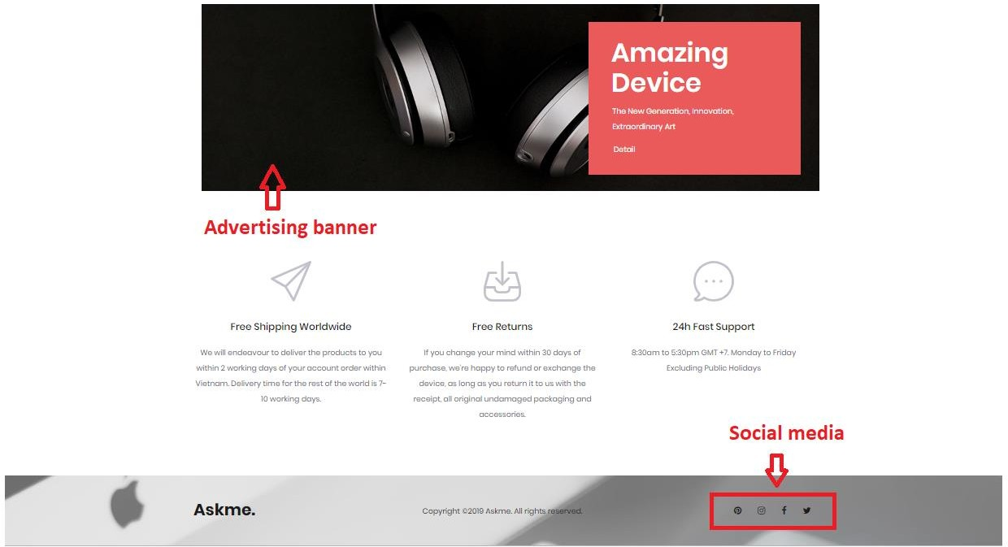



# Product, Sale and New

* 1. **Product page**

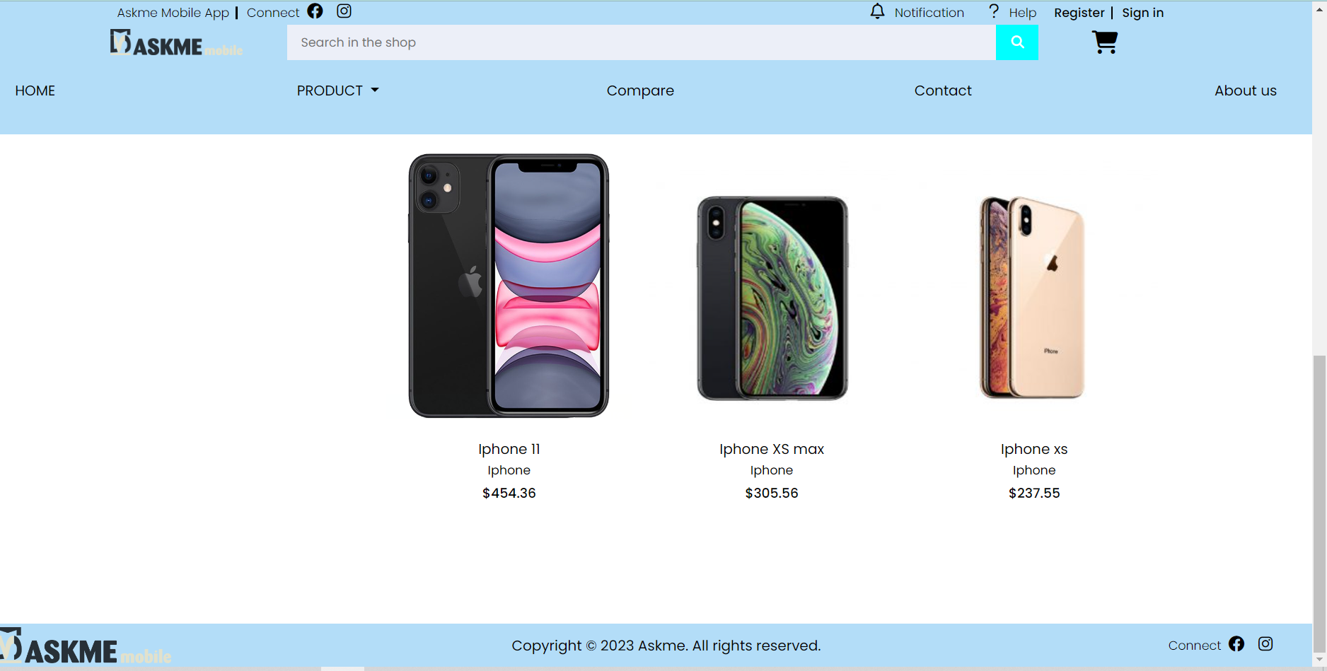

1. **Brand and Detail**
   1. **Apple page**

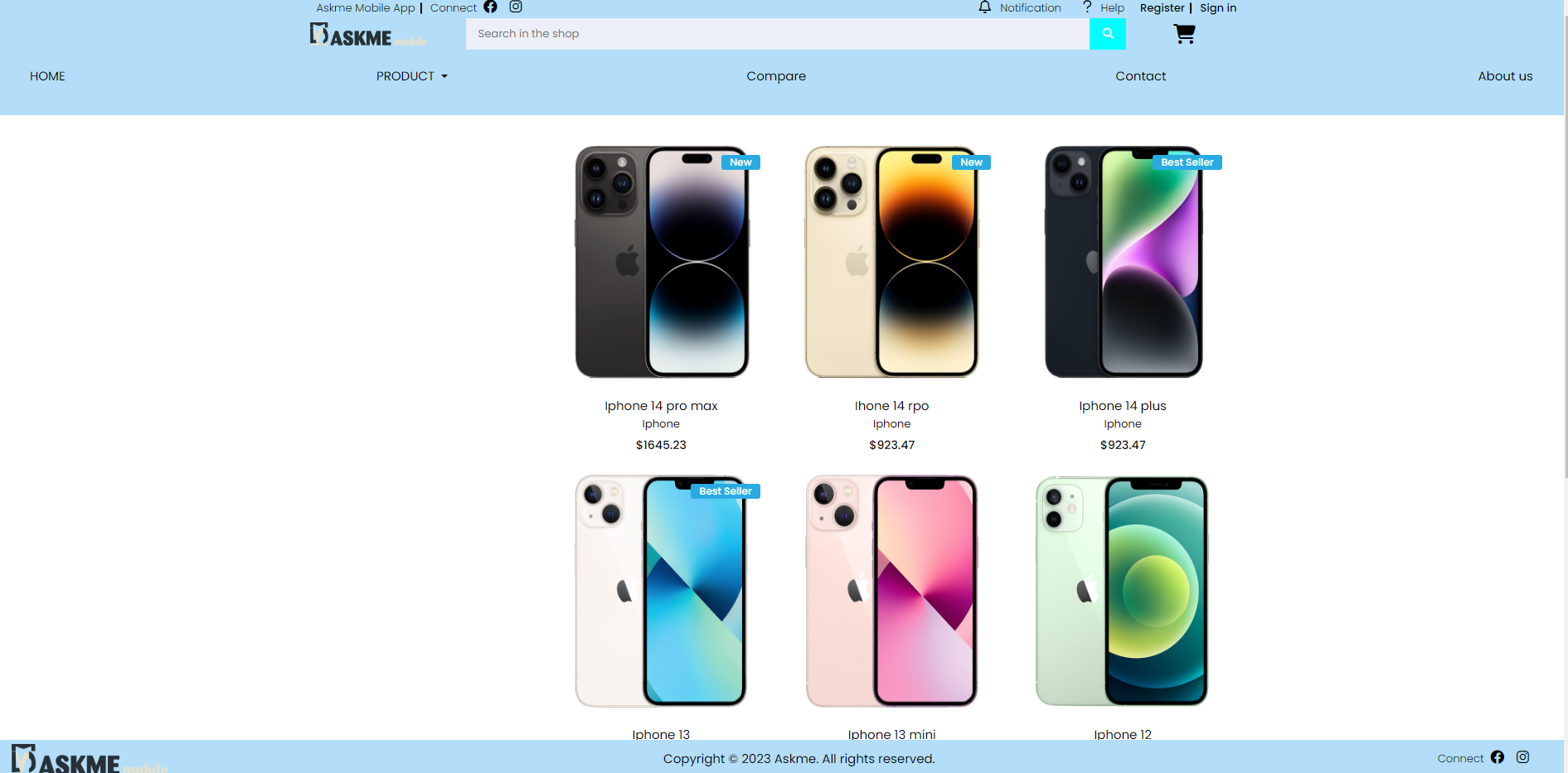

* 1. **Oppo Page**

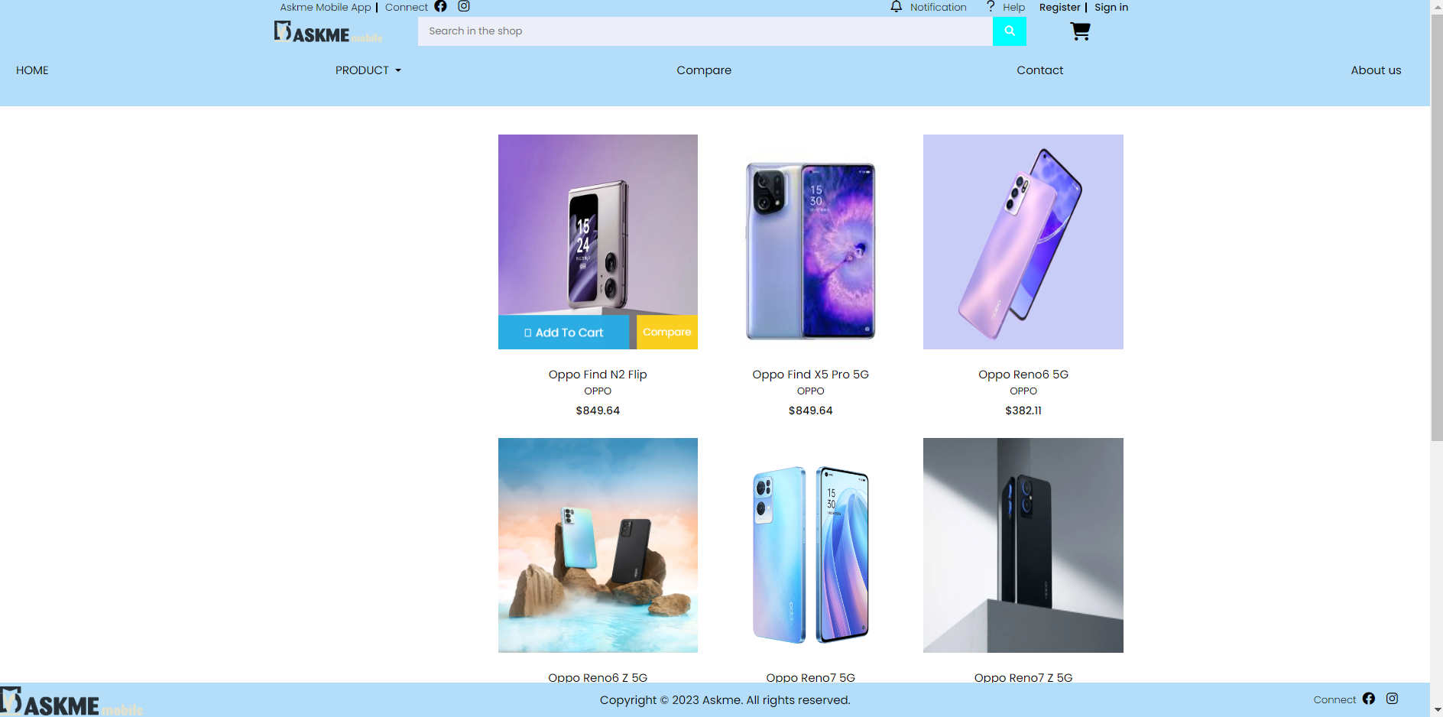

* 1. **Samsung page**

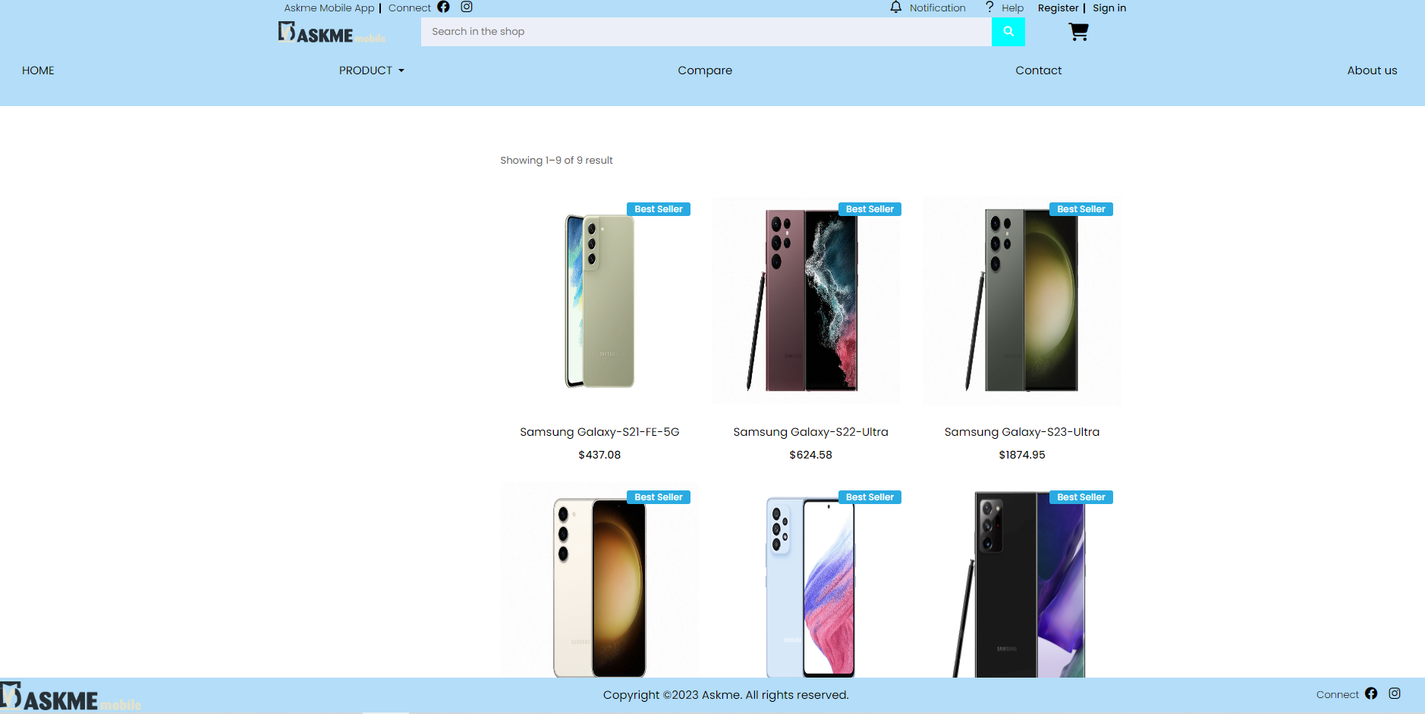

* 1. **Detail page**

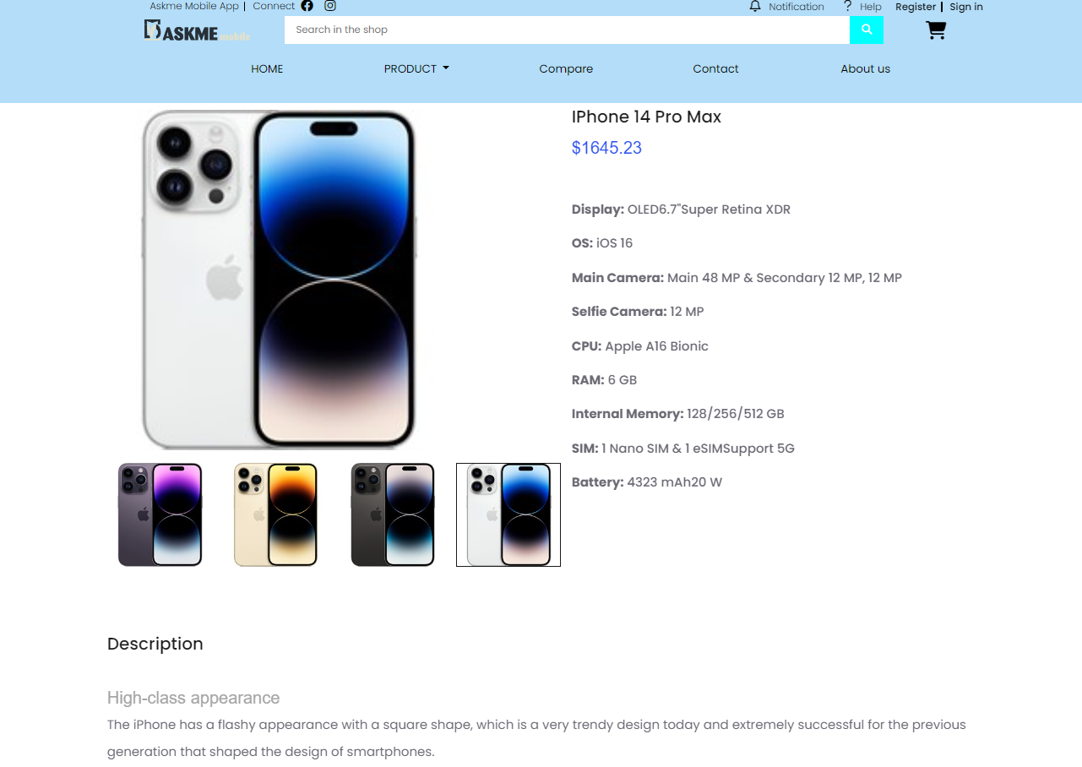

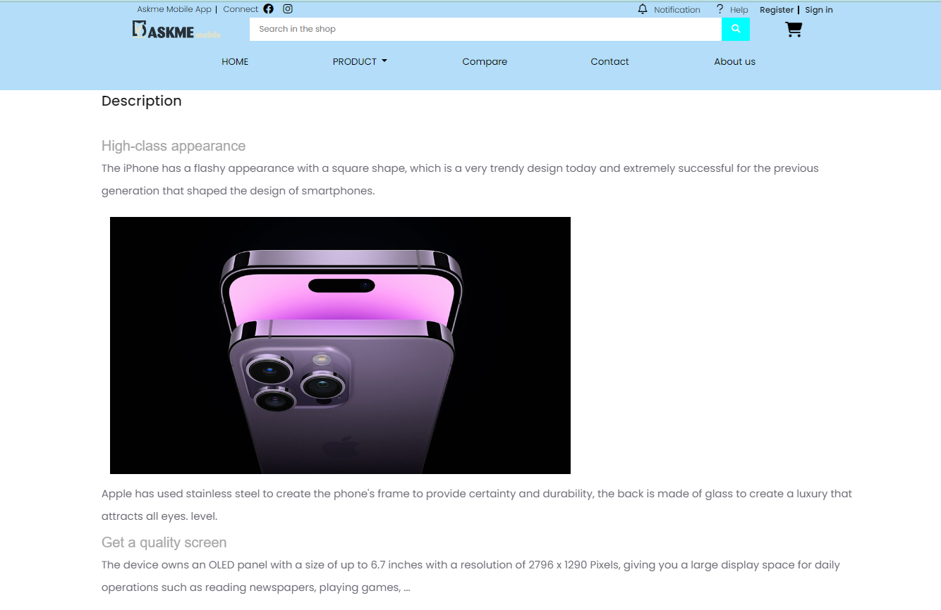

1. **Compare page**

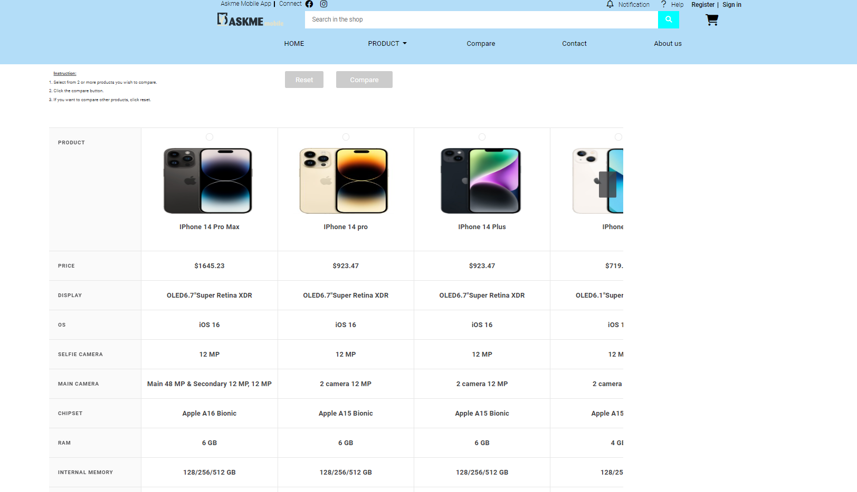

1. **Contact Us page**

