PhysMove: Movement Patterns
Hannah Calich, Jorge Rodríguez, Víctor Eguíluz & Ana Sequeira
Last updated: 2024-09-03

# Calculate RMS values with default parameters
rms.result <- rms(tracks)
# Summarise RMS results
summary(rms.result[["rmsResults"]])
# Summarise linear model results and identify the Hurst exponent
RMSlinearModel <- rms.result[["lm"]]
print(RMSlinearModel)
# Determine the Hurst exponent
RMSlinearModel$estimate[2]
# Calculate displacements with default parameters
disp.all <- calcDisp(tracks)
#> [1] "15598 displacements in 24 +/- 6 hour(s)"
#> [1] "15573 displacements in 48 +/- 6 hour(s)"
#> [1] "15548 displacements in 72 +/- 6 hour(s)"
#> [1] "15523 displacements in 96 +/- 6 hour(s)"
#> [1] "15498 displacements in 120 +/- 6 hour(s)"
#> [1] "15473 displacements in 144 +/- 6 hour(s)"
#> [1] "15448 displacements in 168 +/- 6 hour(s)"
#> [1] "15423 displacements in 192 +/- 6 hour(s)"
#> [1] "15398 displacements in 216 +/- 6 hour(s)"
#> [1] "15373 displacements in 240 +/- 6 hour(s)"
# Summarise displacements calculated over 24 ± 6 hours
summary(unlist(disp.all[[1]]))
#> Min. 1st Qu. Median Mean 3rd Qu. Max.
#> 0.2605 2.7049 5.5149 8.2299 11.1227 76.8543
# Create a pdf plot of normalized displacements
plot.data <- plotDispPDF(disp.all)
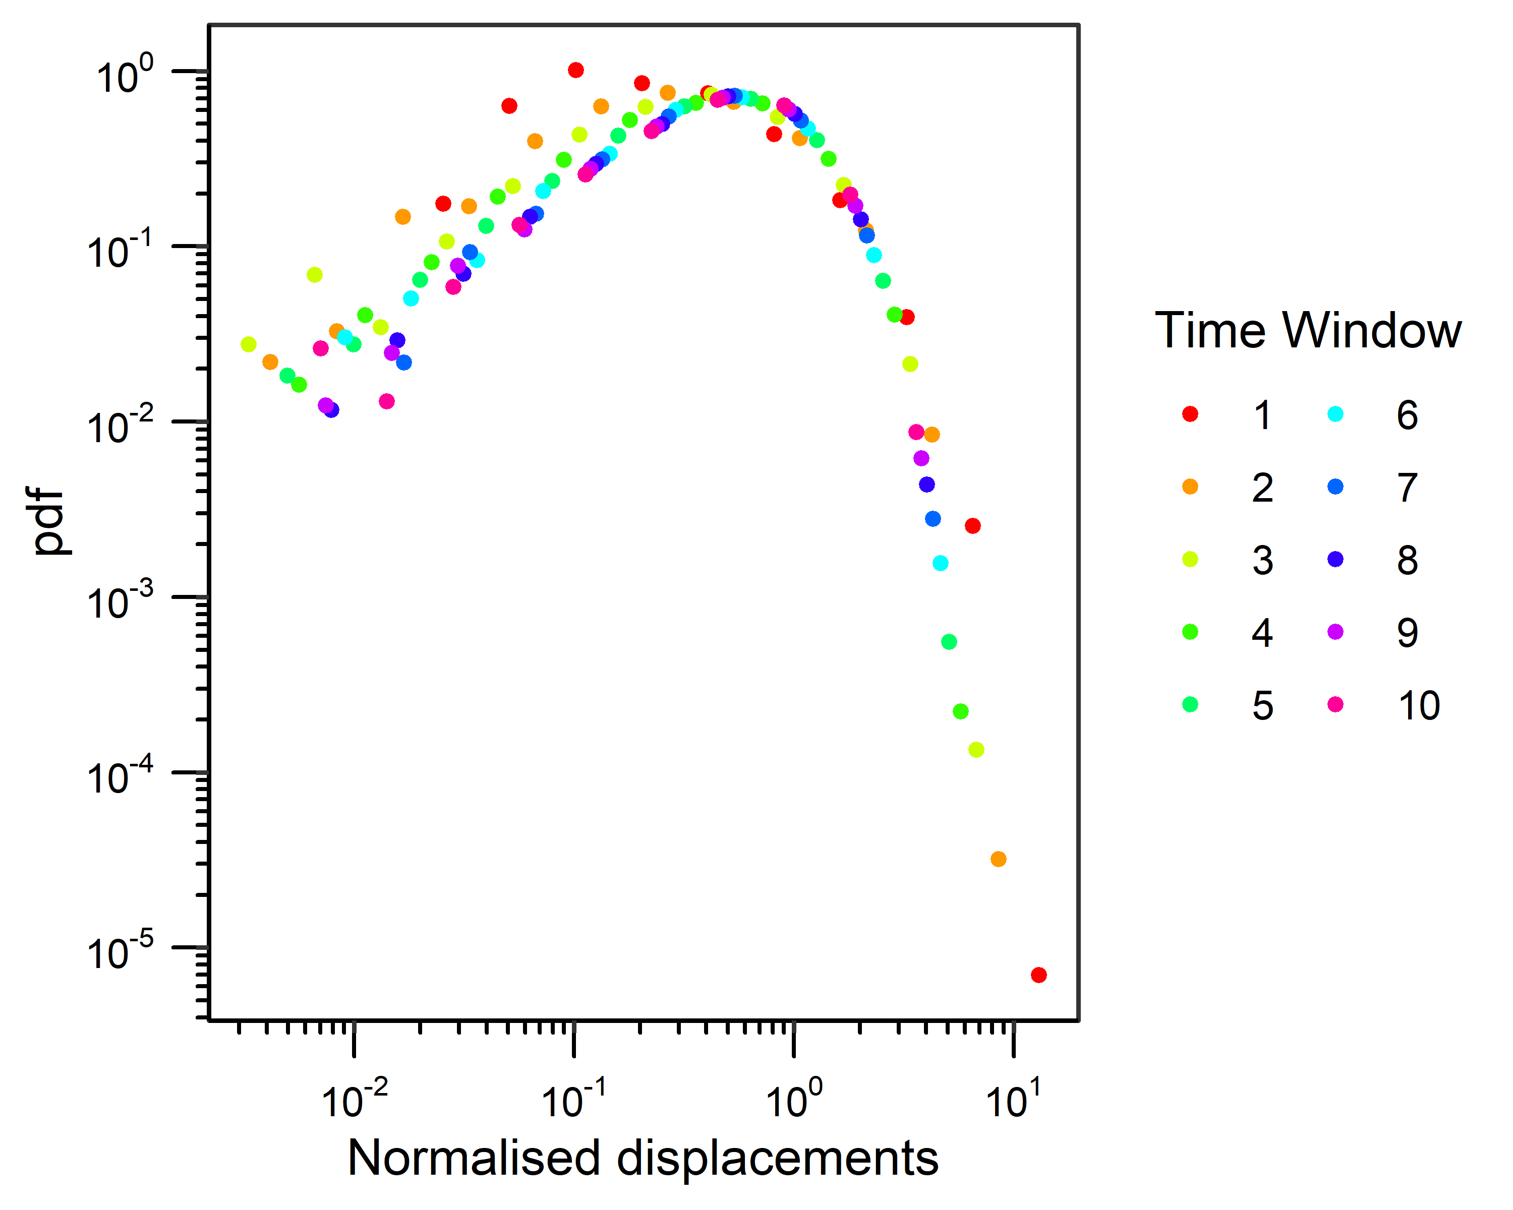
# Create a pdf plot of raw (i.e., not normalized) displacements
plot.data.norm <- plotDispPDF(disp.all, normalised=FALSE)
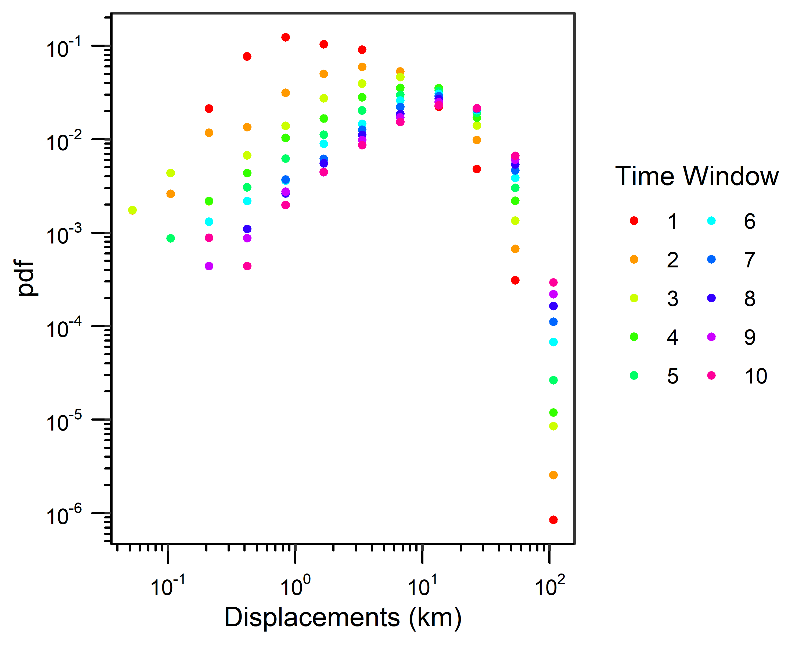
# Calculate displacements over 24 ± 6 hours
disp <- calcDisp(tracks, max_hr=24)
#> [1] "15598 displacements in 24 +/- 6 hour(s)"
# Summarise displacements
summary(unlist(disp))
#> Min. 1st Qu. Median Mean 3rd Qu. Max.
#> 0.2605 2.7049 5.5149 8.2299 11.1227 76.8543
# Plot displacements (as displacements were only calculated over one time window they do not need to be normalised)
plot.data.pdf <- plotDispPDF(disp, normalised=FALSE)
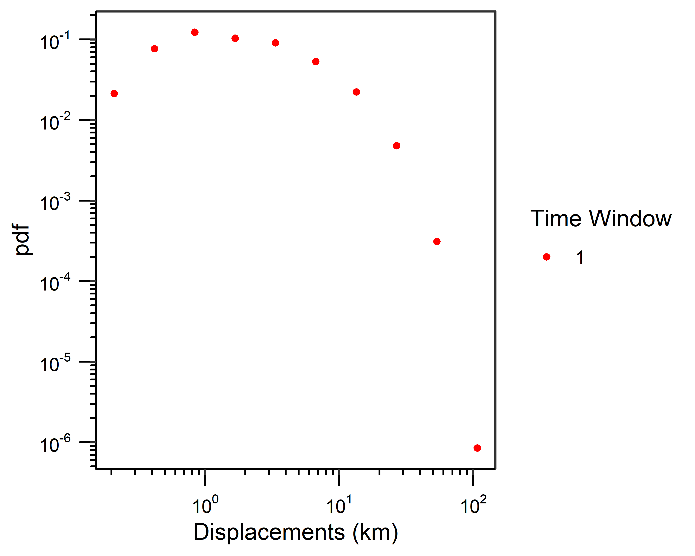
# Fit all distributions to the full range of displacement data
distResults <- fitDist(disp, full=TRUE, normalise=FALSE)
#> Fitting a power law distribution
#> Fitting an exponential distribution
#> Fitting a lognormal distribution
distResults[["distResults"]]
#> distribution xmin parameter1 parameter2 nTail
#> 1 pl 0.2605242 1.3341746 NA 15598
#> 2 exp 0.2605242 0.1254717 NA 15598
#> 3 lnorm 0.2605242 1.6405463 1.044668 15598
# Create a ccdf plot of displacements with fit lines illustrating distributions fit to the full range of displacements
plot.data.all.pdf <- plotDist(disp, distResults)
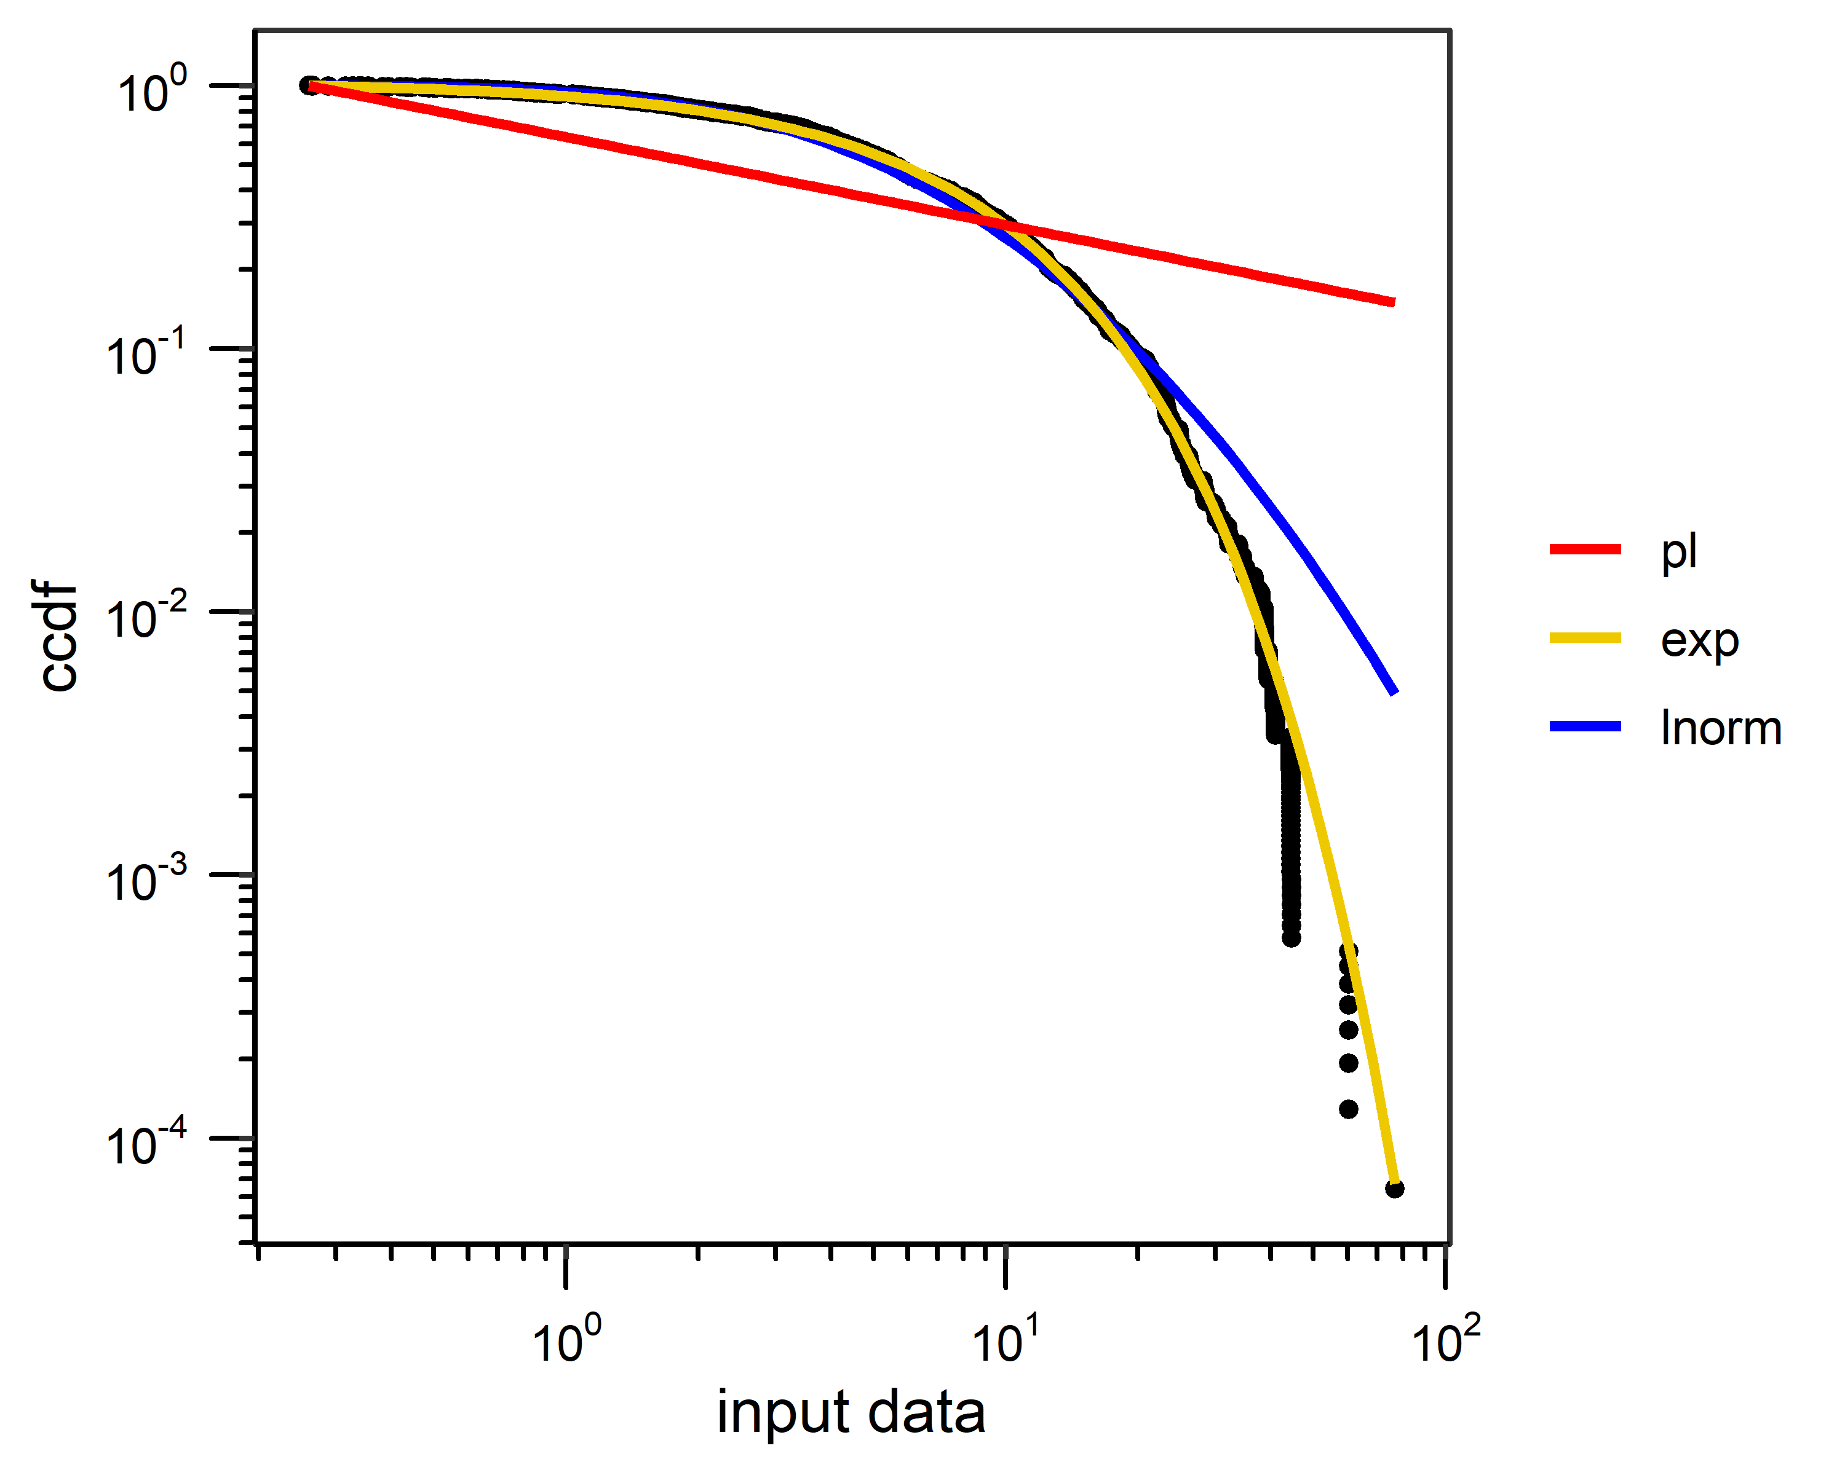
# Identify the best-fit distribution for the full range of displacement data
compResults <- compDist(disp, distResults)
compResults
#> distribution xmin parameter1 parameter2 nTail AIC wAIC
#> 1 pl 0.2605242 1.3341746 NA 15598 116783.60 0.000000e+00
#> 2 exp 0.2605242 0.1254717 NA 15598 95948.77 1.000000e+00
#> 3 lnorm 0.2605242 1.6405463 1.044668 15598 96664.80 3.274453e-156
# Fit all distributions and identify the best-fit xmin for each distribution
distResults.trunc <- fitDist(disp, full=FALSE, normalise=FALSE)
print(distResults.trunc[["distResults"]])
#> distribution xmin parameter1 parameter2 nTail
#> 1 pl 20.874018 4.887586 NA 1387
#> 2 exp 5.771445 0.120774 NA 7484
#> 3 lnorm 1.968525 1.901707 0.829428 12657
# Create a ccdf plot of displacements with fit lines illustrating distributions
# fit to the best-fit xmin for each distribution
plot.data.all.trunc <- plotDist(disp, distResults.trunc)
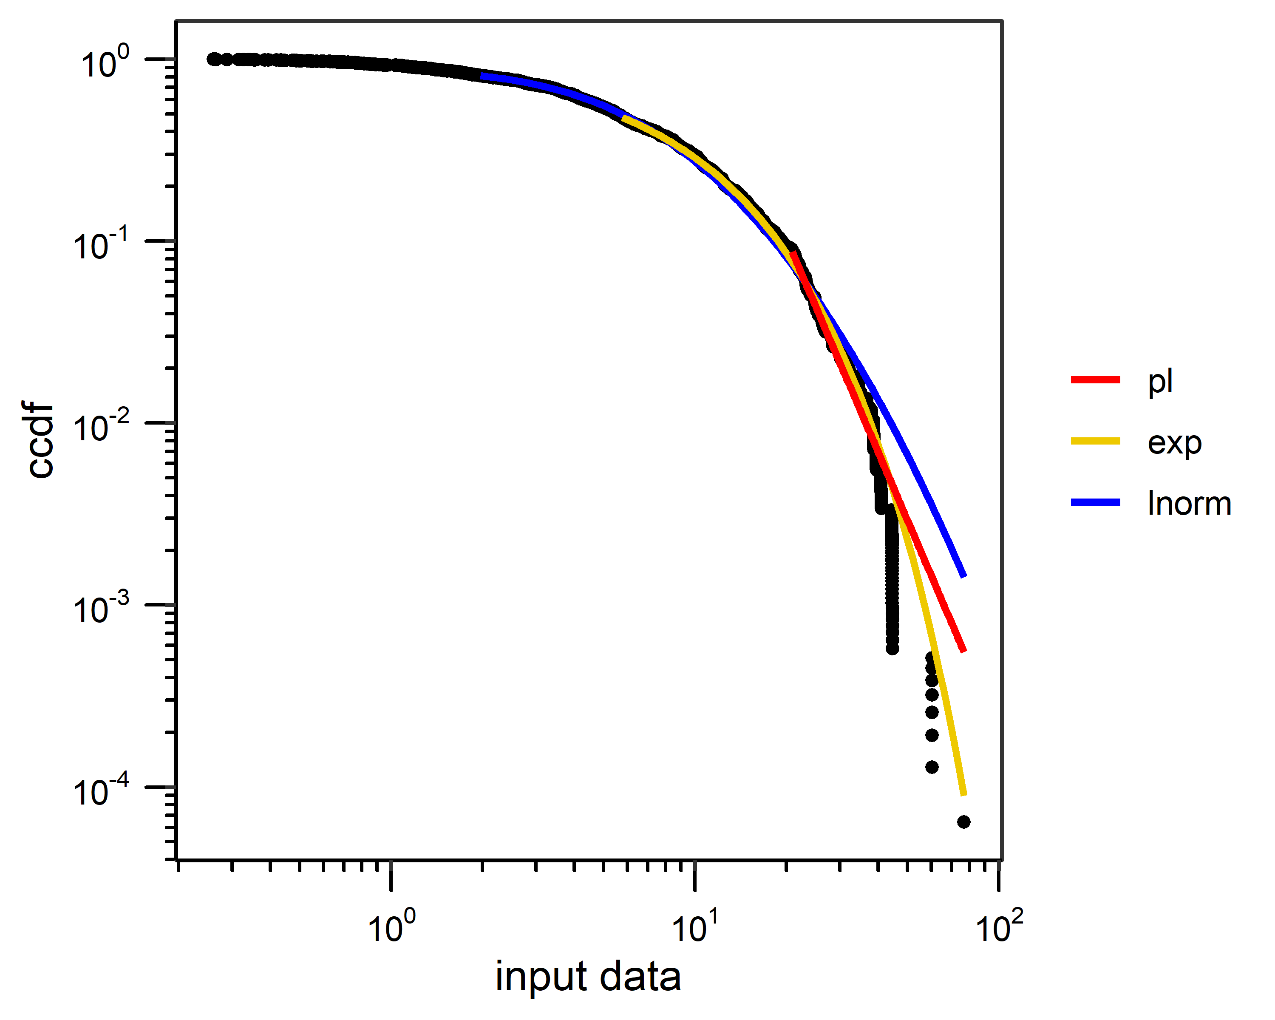
# Fit all distributions using the xmin value for the power-law distribution
xmin <- distResults.trunc[["distResults"]][1,2]
distResultsPl <- fitDist(disp, set_xmin=xmin, normalise=FALSE)
# Fit all distributions using the xmin value for the exponential distribution
xmin <- distResults.trunc[["distResults"]][2,2]
distResultsExp <- fitDist(disp, set_xmin=xmin, normalise=FALSE)
# Fit all distributions using the xmin value for the lognormal distribution
xmin <- distResults.trunc[["distResults"]][3,2]
distResultsLnorm <- fitDist(disp, set_xmin=xmin, normalise=FALSE)
# Compare distribution fits based on the best-fit xmin value for the power-law distribution
compResultsPl <- compDist(disp, distResultsPl)
compResultsPl
#> distribution xmin parameter1 parameter2 nTail AIC wAIC
#> 1 pl 20.87402 4.887586 NA 1387 8016.717 1.164476e-08
#> 2 exp 20.87402 0.145721 NA 1387 7980.295 9.440845e-01
#> 3 lnorm 20.87402 2.400092 0.5294741 1387 7985.948 5.591545e-02
# Compare distribution fits based on the best-fit xmin value for the exponential distribution
compResultsExp <- compDist(disp, distResultsExp)
compResultsExp
#> distribution xmin parameter1 parameter2 nTail AIC wAIC
#> 1 pl 5.771445 2.316868 NA 7484 48305.18 0.000000e+00
#> 2 exp 5.771445 0.120774 NA 7484 46464.64 1.000000e+00
#> 3 lnorm 5.771445 2.264535 0.6574655 7484 46545.40 2.906446e-18
# Compare distribution fits based on the best-fit xmin value for the lognormal distribution
compResultsLnorm <- compDist(disp, distResultsLnorm)
compResultsLnorm
#> distribution xmin parameter1 parameter2 nTail AIC wAIC
#> 1 pl 1.968525 1.7440589 NA 12657 83839.95 0.000000e+00
#> 2 exp 1.968525 0.1263358 NA 12657 77567.29 1.000000e+00
#> 3 lnorm 1.968525 1.9017083 0.8294269 12657 77708.50 2.172348e-31
# Randomise() involves random number selection, so setting a seed enables the replication of results
set.seed(1)
# Randomise tracks from the tracks dataset with default parameters
randomise.result <- randomise(tracks)
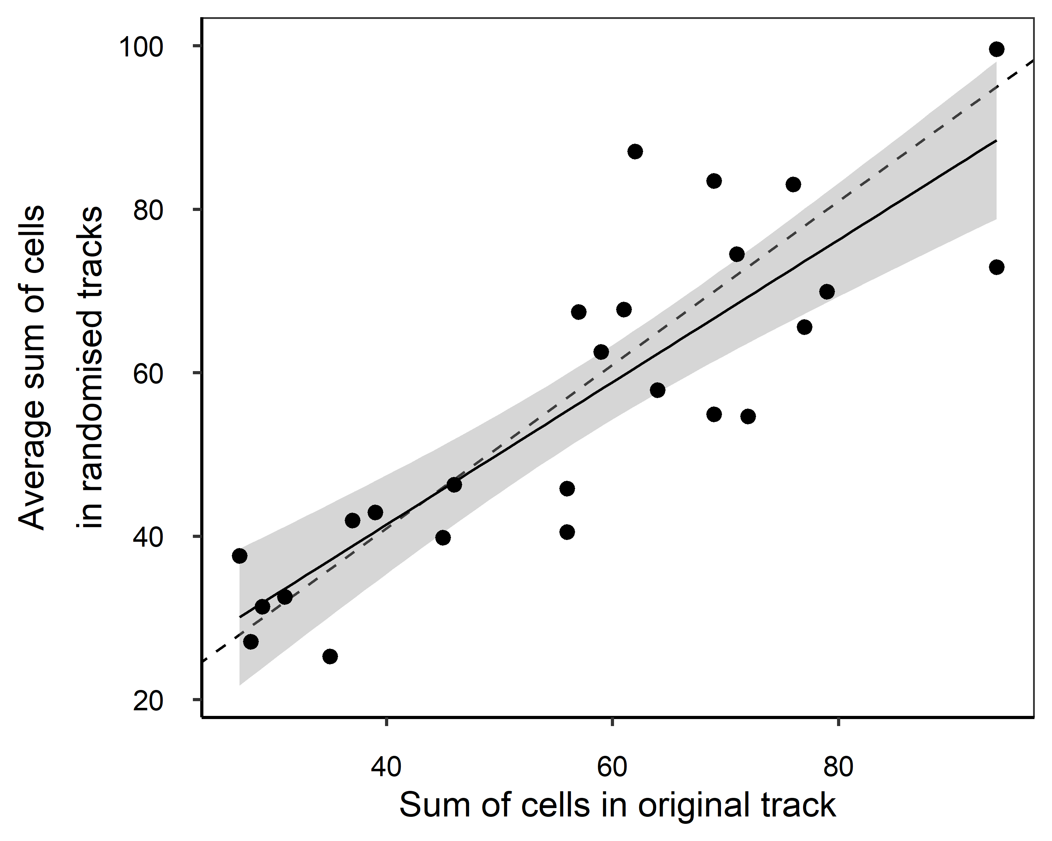
# Summarise RMS results
summary(randomise.result[["resultsDF"]])
#> ref CellsInOriginalTracks AvgCellsInRandomisedTracks
#> Min. : 1 Min. :27.00 Min. :25.29
#> 1st Qu.: 7 1st Qu.:39.00 1st Qu.:40.50
#> Median :13 Median :59.00 Median :54.93
#> Mean :13 Mean :57.32 Mean :56.50
#> 3rd Qu.:19 3rd Qu.:71.00 3rd Qu.:69.90
#> Max. :25 Max. :94.00 Max. :99.58
# Determine the slope of the linear model
RandomiselinearModel <- randomise.result[["lm"]]
print(RandomiselinearModel)
#> term estimate std.error statistic p.value
#> 1 (Intercept) 6.5763920 6.7960283 0.9676817 3.432696e-01
#> 2 plot.df$CellsInOriginalTracks 0.8709073 0.1122742 7.7569703 7.251785e-08
# Determine the slope without displaying the full linear model summary
RandomiselinearModel$estimate[2]
#> [1] 0.8709073
# Plot random tracks for tracks dataset reference id 1
plot.data.random.tracks <- plotRandomTracks(tracks, ref=1, randomise.result)
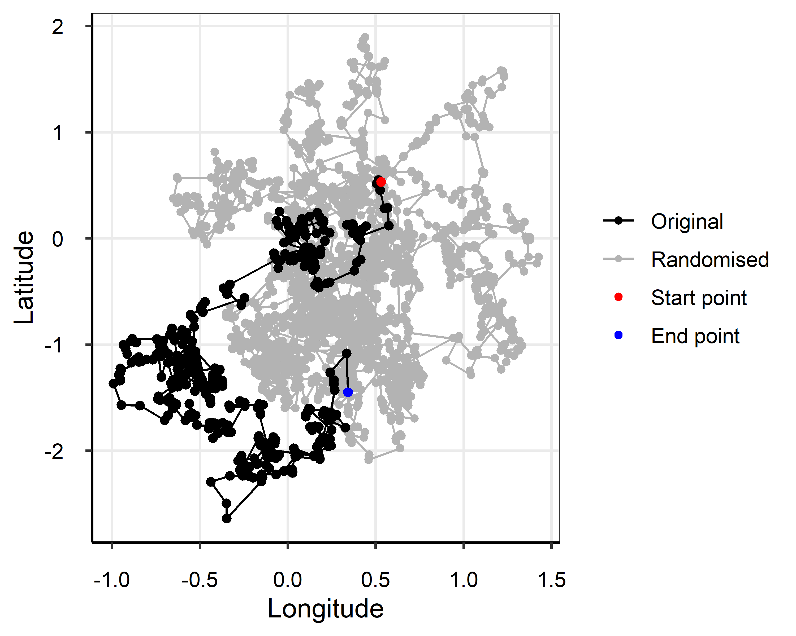
# Calculate turning angles in the tracks dataset using default parameters
angle.results <- turningAngles(tracks)
#> [1] "15573 angles in 24 +/- 6 hour(s)"
#> [1] "15523 angles in 48 +/- 6 hour(s)"
#> [1] "15473 angles in 72 +/- 6 hour(s)"
#> [1] "15423 angles in 96 +/- 6 hour(s)"
#> [1] "15373 angles in 120 +/- 6 hour(s)"
#> [1] "15323 angles in 144 +/- 6 hour(s)"
#> [1] "15273 angles in 168 +/- 6 hour(s)"
#> [1] "15223 angles in 192 +/- 6 hour(s)"
#> [1] "15173 angles in 216 +/- 6 hour(s)"
#> [1] "15123 angles in 240 +/- 6 hour(s)"
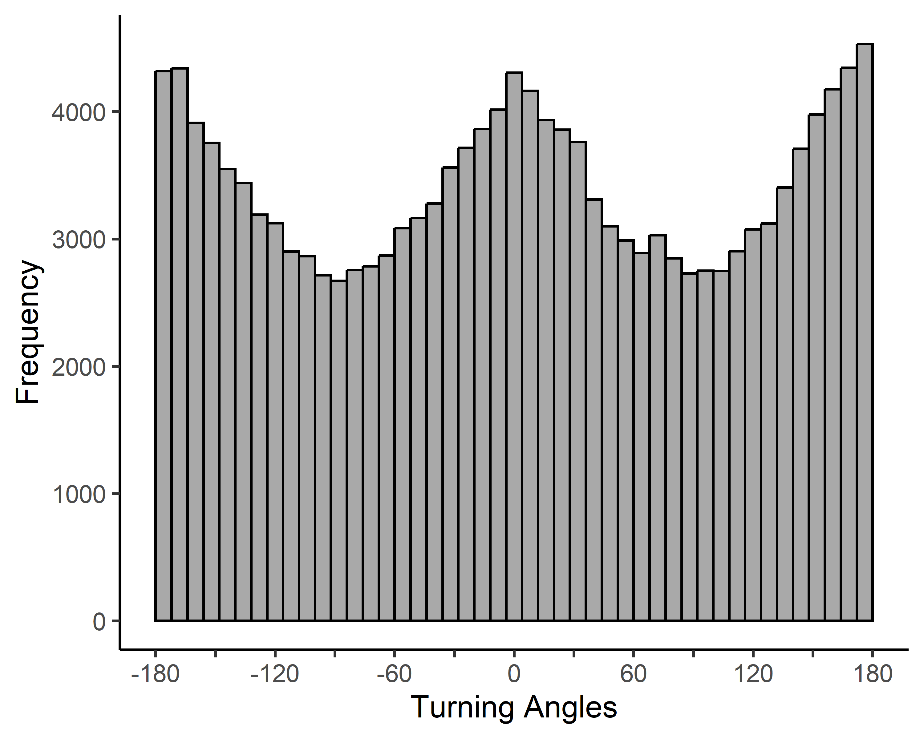
# Summarise turning angles calculated over the first time window
summary(angle.results[[1]])
#> Min. 1st Qu. Median Mean 3rd Qu. Max.
#> -179.97980 -93.41046 0.79527 -0.01537 92.75782 179.99861
# Plot angles with a circle plot
plot.data.angles <- plotAngles(angle.results)
