PhysMove: Intraspecific Movements
Hannah Calich, Jorge Rodríguez, Víctor Eguíluz & Ana Sequeira

Last updated: 2023-06-14

Index
- Introduction and preparing the data
- Movement patterns
- Space-use patterns
- Intraspecific movements

Intraspecific movements
PhysMove includes three metrics for quantifying intraspecific movement patterns that are based on four functions, including:
- Track dispersion: GyrationRad() and PlotPDF()
- Track entropy: Entropy() and PlotPDF()
- Track predictability: Predictability() and PlotPDF()

Track dispersion
The GyrationRad() function calculates the dispersion (i.e., the gyration radius) of each track in a dataset (Figure V16).
GyrationRad() requires a data frame with telemetry data (as described above) and includes two optional parameters:
- map: create a map (map=TRUE, by default), and
- mapCol: change the colour of the points, which indicate average track location, and circles, which indicate how far each animal dispersed (mapCol=c(“Black”, “Red”), by default). create
GyrationRad() outputs a data frame of the results, which were used to create each map, including:
- ref: the reference id for each track,
- avg long and avg lat: the average longitude and latitude coordinates in degrees for each track, and
- rG (km): the gyration radius in kilometres for each track.
# Calculate the dispersion of each track in the tracks dataset
GR <- GyrationRad(tracks)
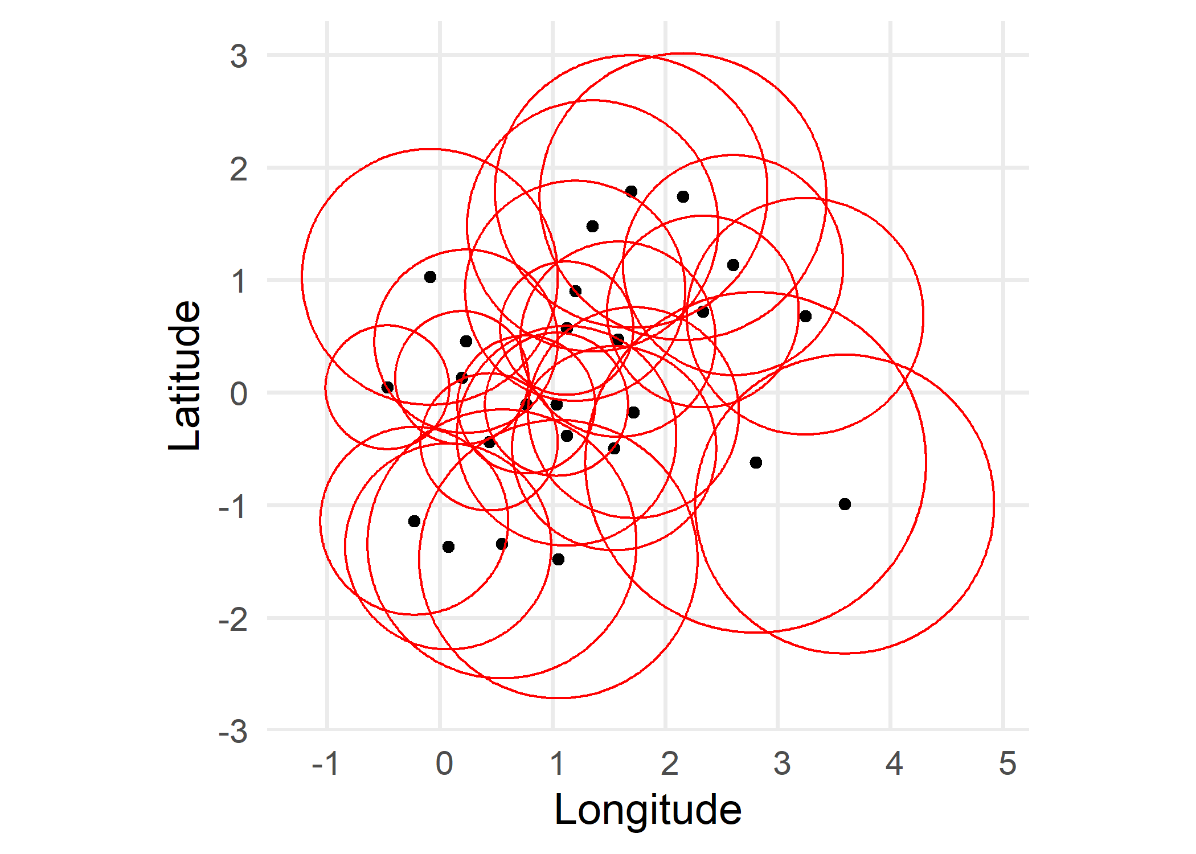
Figure V16 Map illustrating dispersion patterns for tracks dataset using GyrationRad() default parameters. Black points represent the mean location of each track and red circles represent how far each track dispersed (i.e., their gyration radius).
# Preview the first 6 rows of the gyration radius dataset
head(GR)
#> ref avg long avg lat rG (km)
#> 1 1 -0.2276723 -1.1400612 92.80884
#> 413 2 0.5514736 -1.3451059 132.77994
#> 910 3 1.1250293 -0.3847730 108.45032
#> 1568 4 1.7190069 -0.1784736 104.12900
#> 2494 5 0.7674021 -0.1059346 68.01475
#> 2855 6 2.3357980 0.7186781 94.56956

Probability density function of gyration radius results
A pdf of the results from GyrationRad() can be plotted with the PlotPDF() function when the desc parameter is set to “GyrationRad” (Figure V17).
# Create a pdf plot of gyration radius values
pdf.gr <- PlotPDF((GR$`rG (km)`), desc="GyrationRad")
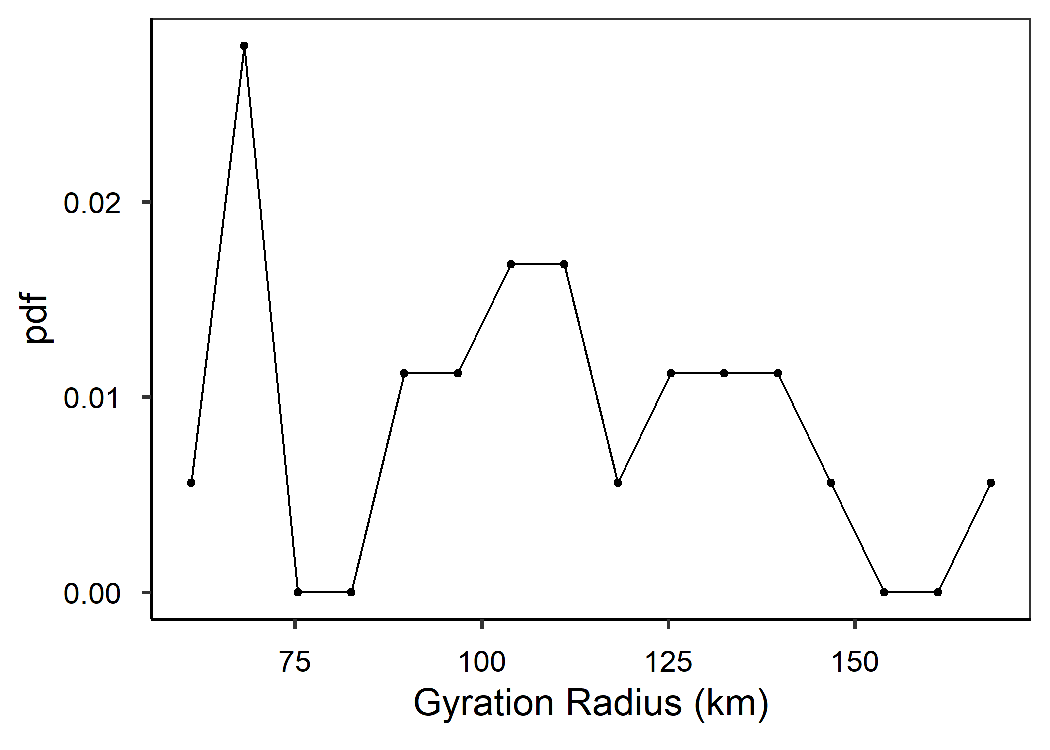
Figure V17 Probability density function (pdf) plot of gyration radius values for tracks dataset determined with GyrationRad() default parameters. Plot created using PlotPDF() with desc=“GyrationRad”.

Back to top

Track entropy
The Entropy() function calculates track randomness based on the fraction of data points from each track within each grid cell (Figure V18). The resulting entropy scores are then normalised so results can be compared between individuals.
Entropy() requires a data frame with telemetry data (as described above) and includes two optional parameters:
- gridCell: change grid cell size in degrees (gridCell=0.25, by default), and
- histPlot: output a histogram (histPlot=TRUE, by default).
Entropy() outputs results a data frame with in four columns, including: * ref: the reference id for each track, * normalisedEntropy: normalised entropy scores, * indivEntropy: individual entropy scores before they were normalised, and * cellsVisited: the number of cells visited by each track.
# Calculate track entropy using default parameters
Ent <- Entropy(tracks)
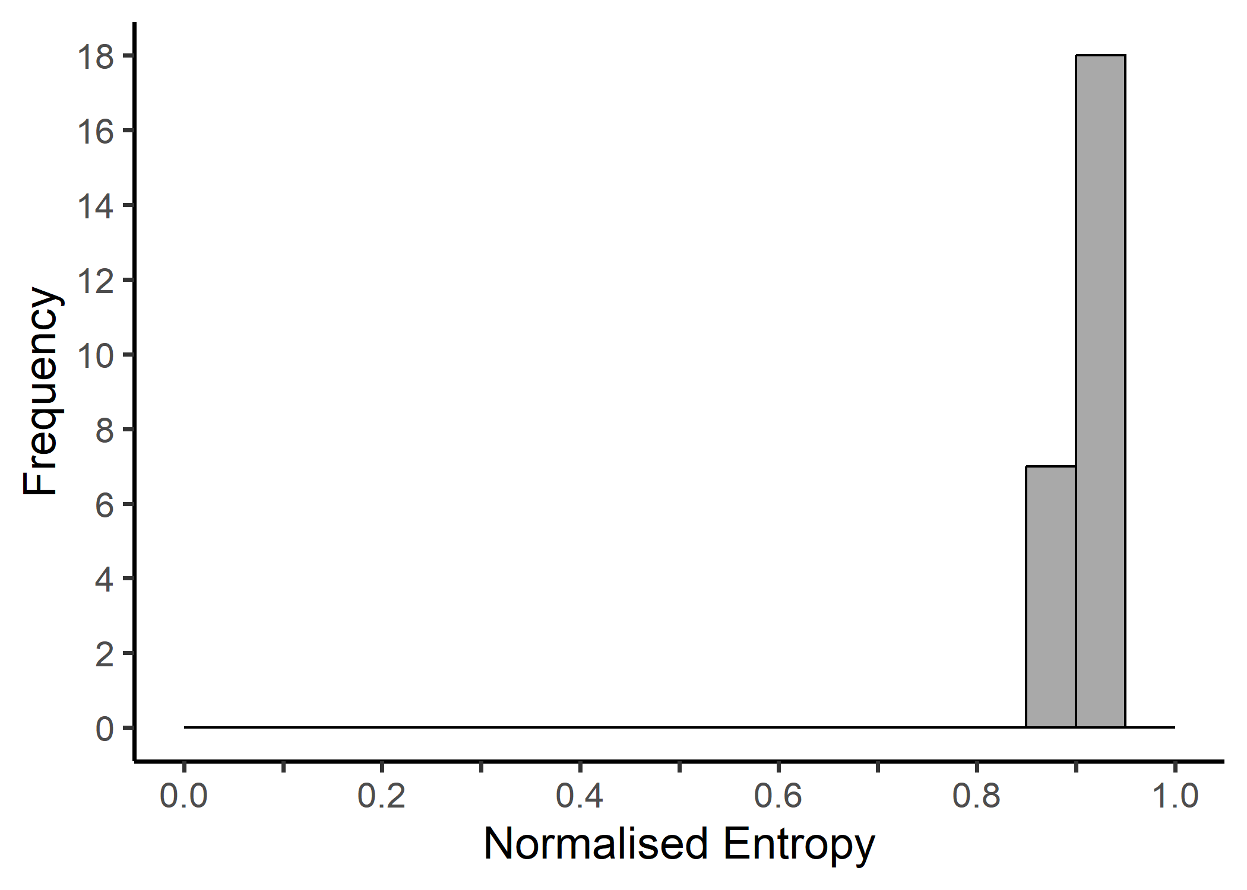
Figure S18 Histogram of normalised entropy scores for tracks dataset created using Entropy() default parameters.
# Preview the first 6 rows of the entropy results
head(Ent)
#> ref normalisedEntropy indivEntropy cellsVisited
#> 1 1 0.8744141 3.328600 45
#> 2 2 0.9255766 3.543701 46
#> 3 3 0.9033790 3.683562 59
#> 4 4 0.9050806 3.832208 69
#> 5 5 0.9144473 3.079215 29
#> 6 6 0.9121058 3.888015 71

Probability density function of Entropy results
A pdf of the results from Entropy() can be plotted with the PlotPDF() function when the desc parameter is set to “Entropy” (Figure V19).
# Create a pdf plot of the entropy scores
pdf.ent <- PlotPDF(Ent$normalisedEntropy, "Entropy")
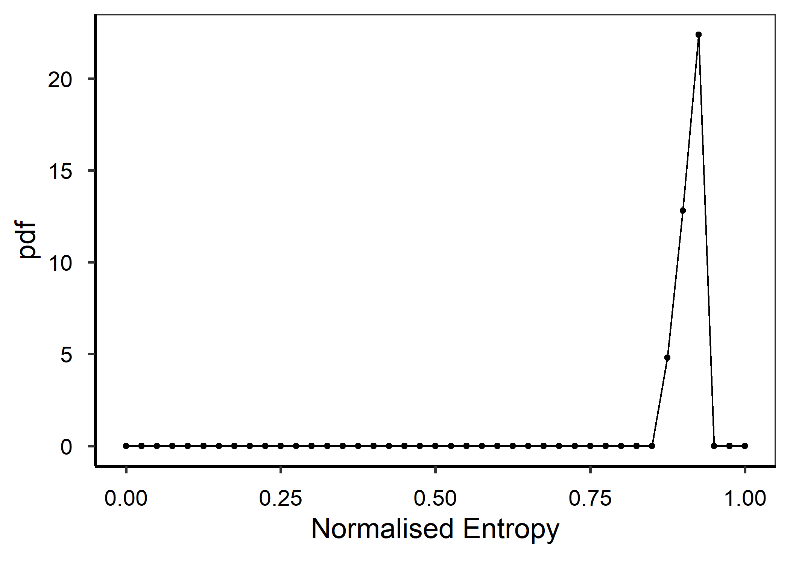
Figure V19 Probability density function (pdf) plot of normalised entropy scores for tracks dataset determined with Entropy() default parameters. Plot created using PlotPDF() with desc=“Entropy”.

Back to top

Track predictability
The Predictability() function calculates the limit of predictability for each track based on their individual entropy scores (Figure V20; Figure 1).
Predictability() requires a data frame with telemetry data (as described above) and a data frame of results output from Entropy(), and includes two optional parameters:
- startVal: the starting value used to find a root value for the limit of predictability equation (startVal=0.99, by default), and
- histPlot: output a histogram (histPlot=TRUE, by default).
Predictability() outputs a data frame of results with two columns, including: * ref: the reference id for each track, and * Predictability: the predictability scores for each track.
# Track predictability using Predictability() default parameters and the output from Entropy()
Pred <- Predictability(tracks, Ent)
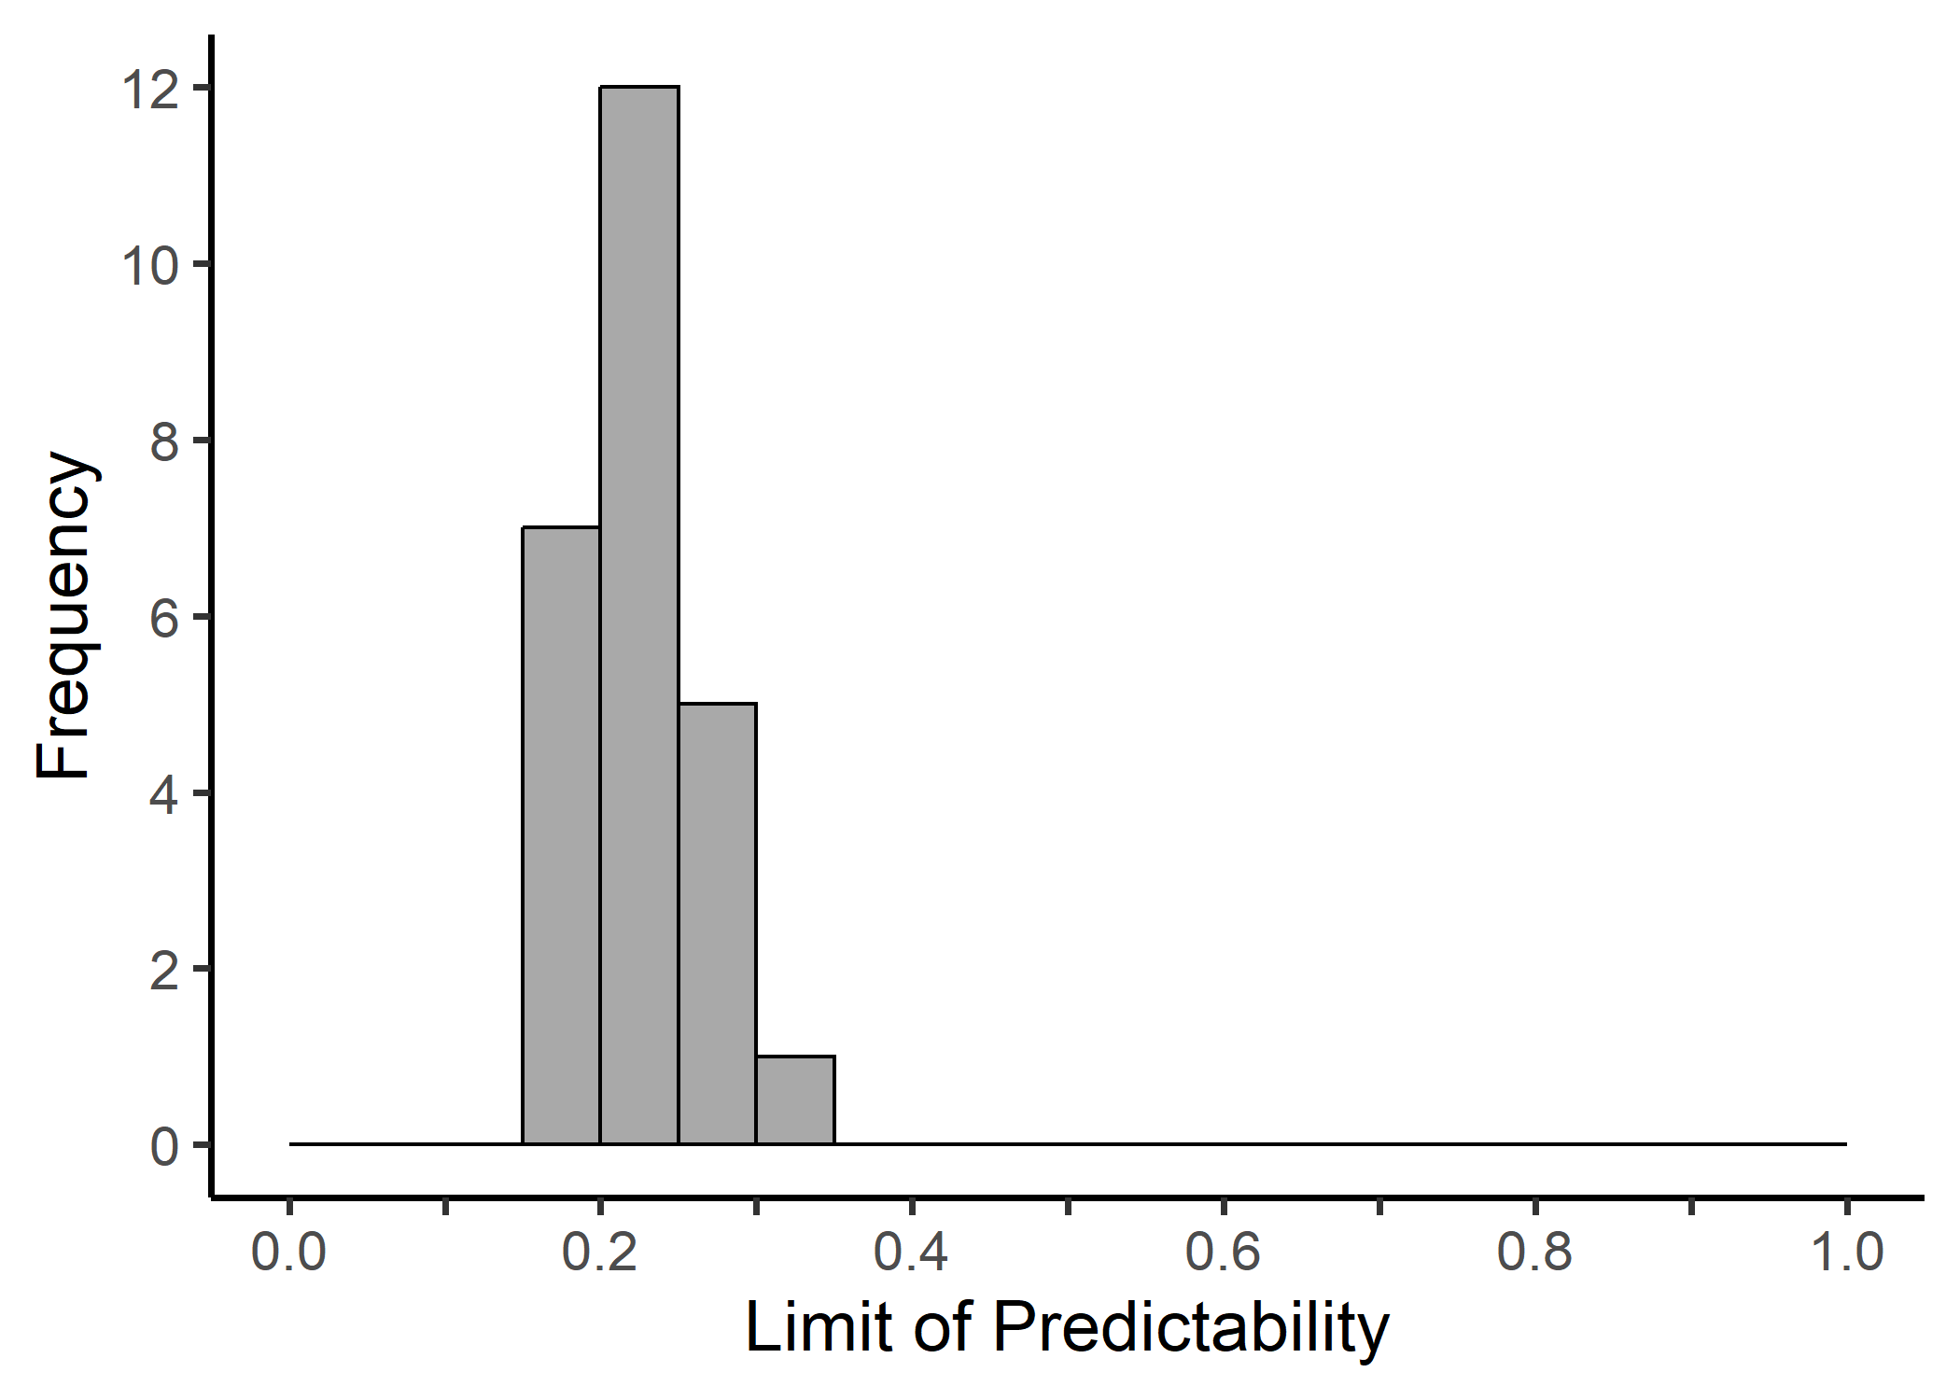
Figure V20 Histogram of predictability scores for tracks dataset determined using Predictability() default parameters and entropy scores from Entropy().
# Preview the first 6 rows of the predictability results
head(Pred)
#> ref Predictability
#> 1 1 0.2761026
#> 2 2 0.2008385
#> 3 3 0.2237396
#> 4 4 0.2152093
#> 5 5 0.2419867
#> 6 6 0.2038908

Probability density function of Entropy results
A pdf of the results from Predictability() can be plotted with the PlotPDF() function when the desc parameter is set to “Predictability” (Figure V21).
# Create a pdf plot of the predictability scores
pdf.pred <- PlotPDF(Pred$Predictability, desc="Predictability")
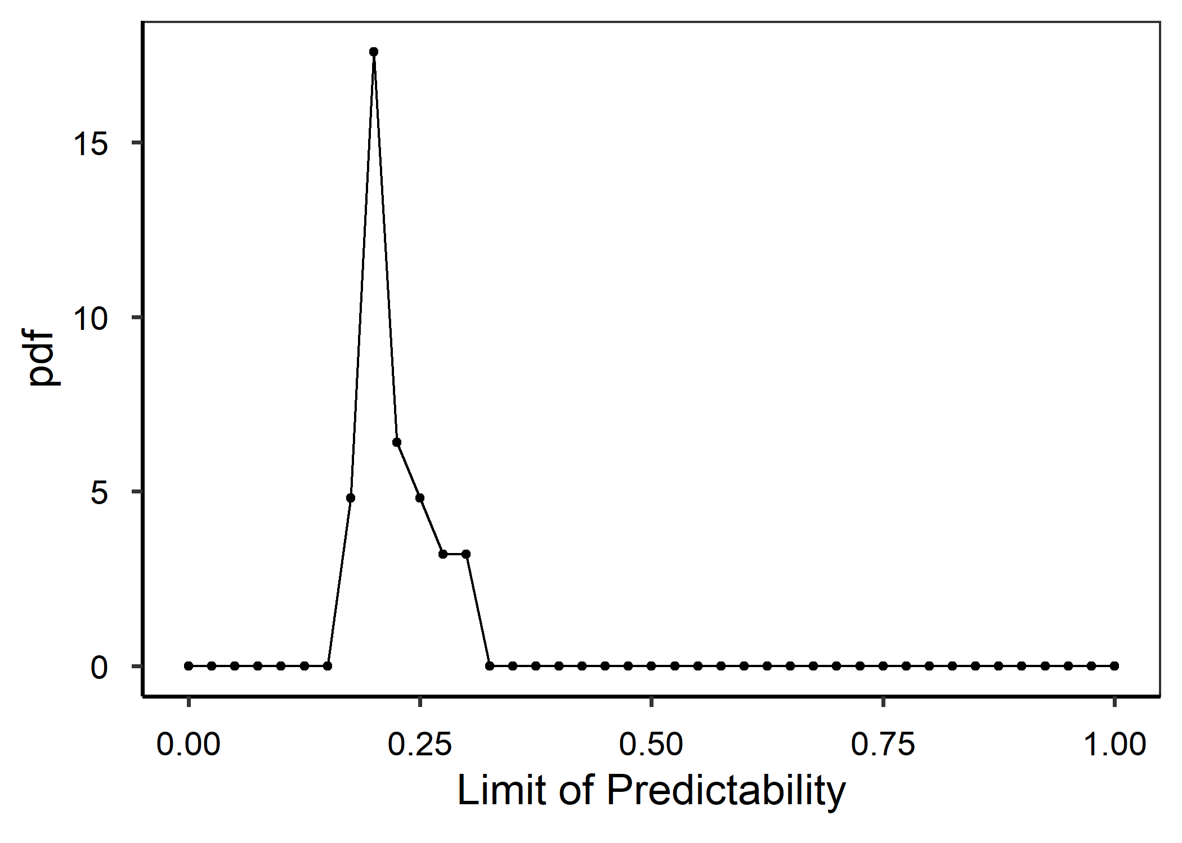
Figure V21 Probability density function (pdf) plot of predictability scores for tracks dataset determined with Predictability() default parameters and results from Entropy(). Plot created using PlotPDF() with desc=“Predictability”.

Back to top

References & Recommended resources
Burnham, K.P. & Anderson, D.R. (2004) Multimodel Inference:Understanding AIC and BIC in Model Selection. Sociological Methods & Research, 33, 261-304.
Calich, H.J. et al. (2021) Comprehensive analytical approaches reveal species-specific search strategies in sympatric apex predatory sharks. Ecography, 44, 1544-1556.
Farage, C. et al. (2021) Identifying flow modules in ecological networks using Infomap. Methods in Ecology and Evolution, 12, 778–786.
Méndez, V., et al. (2013). Stochastic Foundations in Movement Ecology: Anomalous Diffusion, Front Propagation and Random Searches. Berlin, Heidelberg, Germanu, Springer Berlin / Heidelberg.
Rodríguez, J.P. et al. (2017) Big data analyses reveal patterns and drivers of the movements of southern elephant seals. Scientific Reports, 7, 1-10.
Viswanathan, G. M., et al. (2011). The Physics of Foraging: An Introduction to Biological Encounters and Random Searches. Cambridge, Cambridge University Press.
Wickham, H. (2016) ggplot2: Elegant Graphics for Data Analysis. Springer-Verlag, New York.

