PhysMove: Space-Use Patterns
Hannah Calich, Jorge Rodríguez, Víctor Eguíluz & Ana Sequeira

Last updated: 2023-06-14

Index
- Introduction and preparing the data
- Movement patterns
- Space-use patterns
- Intraspecific movements

Space-use patterns
PhysMove includes two metrics for identifying space-use patterns that are based on four functions, including:
- Occupancy patterns: Occupancy() and PlotPDF()
- Community-wide movements(space_use_patterns.html#community-wide-movements: InfomapCommunities() and CommunityMap()

Occupancy patterns
The Occupancy() function helps describe species’ space-use patterns by calculating the total number of location estimates within each grid cell and dividing this sum by the grid cell’s area, calculated using spherical coordinates (Figure V13).
The Occupancy() function requires a data frame with telemetry data (as described above) and includes three optional parameters:
- gridCell: change the grid cell size in degrees (gridCell=0.25, by default),
- map: present results in a map (map=TRUE, by default) and,
- colGrad: edit the colours used in the map to indicate low, moderate, and high occupancy, respectively, which are visualised using scale_fill_gradientn() from the ggplot2 package (Wickham 2016) (colGrad=c(“blue”, “light blue”, “red”), by default).
Occupancy() outputs a data frame of all results, including: * Latitude and Longitude: coordinates for the centre point of each grid cell, * Area: area of the grid cell, * Counts: the number of location estimates recorded in the grid cell, and * Occupancy: occupancy values per grid cell (number of counts/area).
# Create an occupancy map based on the tracks dataset
Occ <- Occupancy(tracks)
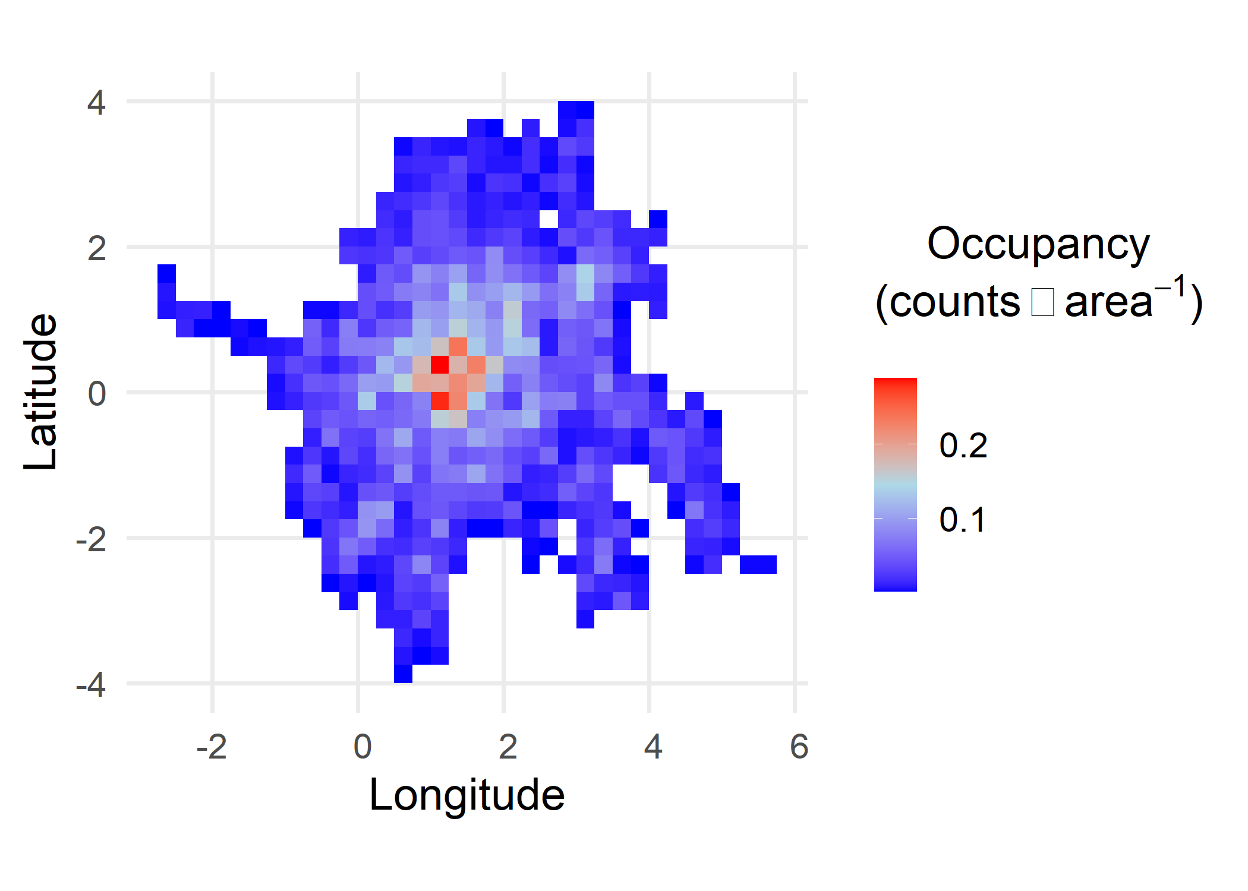
summary(Occ) # Select data frame of occupancy results
#> Latitude Longitude Area Counts
#> Min. :-3.8750 Min. :-2.625 Min. :771.0 Min. : 1.00
#> 1st Qu.:-1.3750 1st Qu.: 0.625 1st Qu.:772.2 1st Qu.: 8.00
#> Median : 0.0000 Median : 1.625 Median :772.5 Median : 20.00
#> Mean : 0.0754 Mean : 1.743 Mean :772.4 Mean : 31.63
#> 3rd Qu.: 1.3750 3rd Qu.: 3.125 3rd Qu.:772.7 3rd Qu.: 41.75
#> Max. : 3.8750 Max. : 5.625 Max. :772.8 Max. :223.00
#> Occupancy
#> Min. :0.001294
#> 1st Qu.:0.010357
#> Median :0.025906
#> Mean :0.040936
#> 3rd Qu.:0.054041
#> Max. :0.288579
Figure V13 Map of occupancy (total count of location estimates in each grid cell per area) based on the tracks dataset. Map created with Occupancy() default parameters.

Probability density function of occupancy results
A pdf of the results from Occupancy() can be plotted with the PlotPDF() function when the desc parameter is set to “Occupancy” (Figure V14).
# Create a pdf plot of occupancy values
pdf.occ <- PlotPDF(Occ$Occupancy, desc="Occupancy")
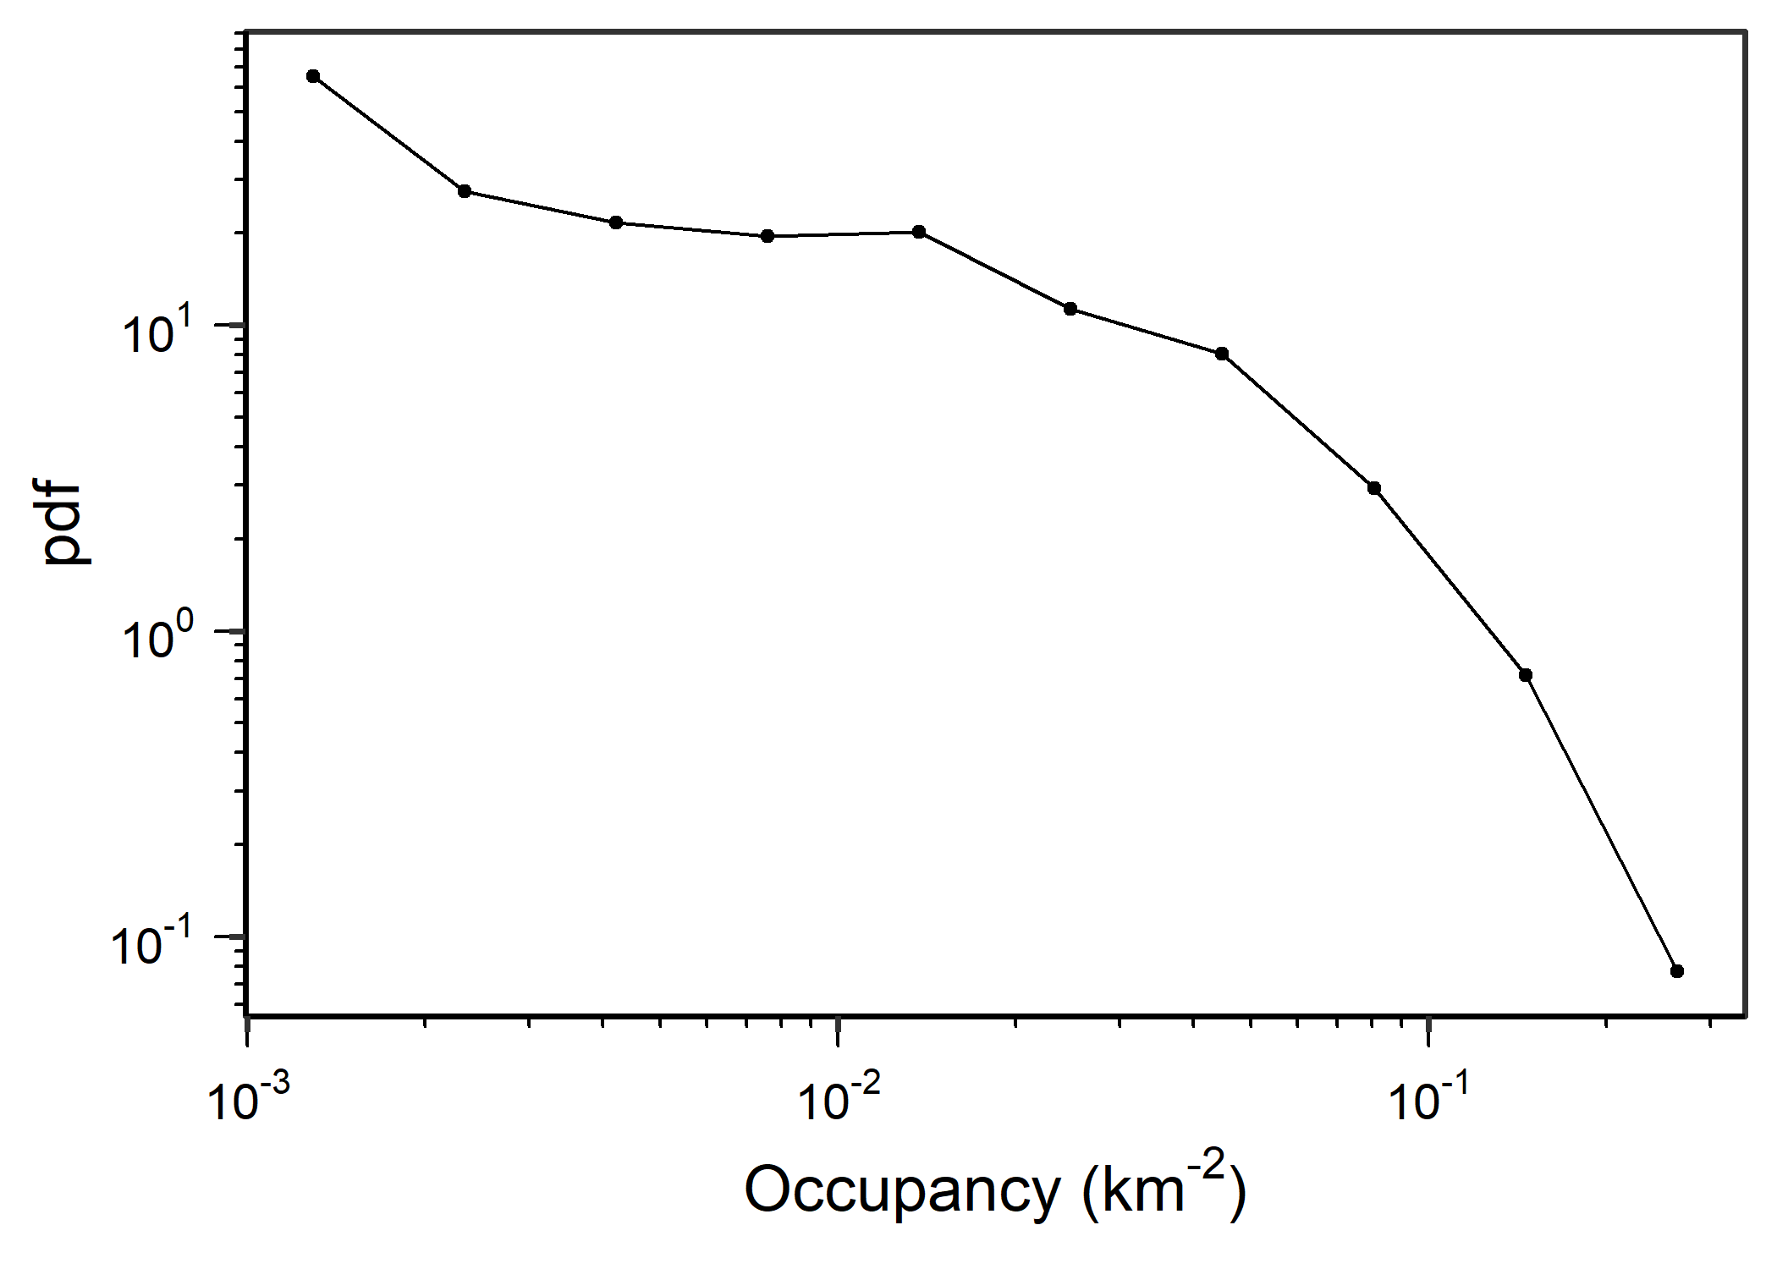
Figure V14 Probability density function (pdf) plot of occupancy per km2 for tracks dataset determined with Occupancy() default parameters. Plot created using PlotPDF() with desc=“Occupancy”.

Community-wide movements
Interactions between species’ movements and their space-use can be described using a network analysis algorithm called Infomap, which to identifies communities where animals follow similar movement patterns and remain for extended periods. To identify Infomap communities, PhysMove requires the infomapecology R package Linked here and a stand-alone Infomap file Linked here. Installation instructions and further details about Infomap can be found at https://ecological-complexity-lab.github.io/infomap_ecology_package/installation and Farage et al. (2021). The following instructions assume both the infomapecology R package and the stand-alone Infomap file have been installed.
The InfomapCommunities() function identifies community-wide movements in two steps:
1.InfomapCommunities() calculates the probability of individuals moving between specific grid cells along their track within a predetermined time window. This step creates a transition probability matrix (tpm), which can also be referred to as a “unipartite edge list”.
2.InfomapCommunities() then feeds the transition probability matrix into a function from the infomapecology package to create an Infomap monolayer object that identifies movement communities.
To ensure the infomapecology algorithm calculates movement patterns consistent with telemetry data, we adapted an infomapecology function to allow for directed movement, self-links (i.e., individuals can remain in the same grid cell over time), and hierarchical partitioning (i.e., the resulting communities are composed of multiple levels). Because we allowed hierarchical partitioning, the resulting communities are associated with different levels; level 1 communities are the most inclusive and have been used to identify community-wide movements (following Rodríguez et al. 2017 and Calich et al. 2021).
The InfomapCommunities() function requires a data frame with telemetry data (as described above) and includes five optional parameters:
- gridCell: change the grid cell size in degrees (gridCell=0.25, by default),
- hours: number of hours between location estimates (hours=24, by default),
- range_hr: time range in hours (range_hr=6, by default). This parameter allows you to identify location estimates that are close to, but not exactly separated by the set number of hours, and
- tpm: save the transition probability matrix to the local environment as TransitionProbabilityMatrix (tpm=FALSE, by default),
InfomapCommunities() outputs a list with up to two list objects. The first list object is an infomap monolayer object that summarizes the hierarchical structure of the Infomap communities (regions where individuals are likely to stay for longer periods of time). See Farage et al. (2021) and the infomapecology package for further details. The second list object is the transition probability matrix, which is only output if tpm=TRUE.
Important: Before running InfomapCommunities() you must set your working directory to the folder that contains the stand-alone Infomap file (Infomap.exe), see instructions above for installation instructions.
# Identify community-wide movements from the tracks dataset with InfomapCommunities,
# Note that the working directory must be set to the folder containing the Infomap file,
# for more information, please visit:
# https://ecological-complexity-lab.github.io/infomap_ecology_package/installation
setwd("~/2023/PhysMove") # Update your working directory to the folder containing the infomap.exe file
library(infomapecology)
infomapResult <- InfomapCommunities(tracks)
# Determine the structure of the Infomap monolayer object
str(infomapResult[["infomap_object"]])
#> List of 8
#> $ call : chr "./infomap infomap.txt . --tree --seed 123 -N 100 -f directed --silent"
#> $ L : num 2.3
#> $ m : num 4
#> $ modules : tibble [495 × 14] (S3: tbl_df/tbl/data.frame)
#> ..$ node_id : num [1:495] 1 2 3 4 5 6 7 8 9 10 ...
#> ..$ node_name : chr [1:495] "Node1" "Node2" "Node3" "Node4" ...
#> ..$ flow : num [1:495] 0.000439 0.00222 0.00276 0.000209 0.001588 ...
#> ..$ levels : num [1:495] 3 3 3 3 3 3 3 3 3 3 ...
#> ..$ module_level1: num [1:495] 3 3 3 3 3 3 3 3 3 3 ...
#> ..$ module_level2: num [1:495] 7 7 7 5 5 5 7 5 7 5 ...
#> ..$ module_level3: num [1:495] 3 3 1 5 5 3 1 1 2 1 ...
#> ..$ module_level4: num [1:495] 2 1 1 2 1 1 2 1 1 3 ...
#> ..$ module_level5: num [1:495] NA NA NA NA NA NA NA NA NA NA ...
#> ..$ module_level6: num [1:495] NA NA NA NA NA NA NA NA NA NA ...
#> ..$ module_level7: num [1:495] NA NA NA NA NA NA NA NA NA NA ...
#> ..$ cell : num [1:495] 496083 497523 498963 497524 497525 ...
#> ..$ long : num [1:495] 0.625 0.625 0.625 0.875 1.125 ...
#> ..$ lat : num [1:495] -3.88 -3.62 -3.38 -3.62 -3.62 ...
#> $ edge_list:'data.frame': 2298 obs. of 3 variables:
#> ..$ from : chr [1:2298] "Node2" "Node1" "Node2" "Node12" ...
#> ..$ to : chr [1:2298] "Node1" "Node2" "Node2" "Node2" ...
#> ..$ weight: num [1:2298] 0.2 1 0.6 0.125 0.1 ...
#> $ L_sim : NULL
#> $ m_sim : NULL
#> $ pvalue : NULL
#> - attr(*, "class")= chr "infomap_monolayer"

Plot Infomap communities
CommunityMap() is used to visualise results from InfomapCommunities() and converts the Infomap monolayer object into a map (Figure V15).
The CommunityMap() function requires the Infomap monolayer object output from InfomapCommunities() and includes two optional parameters:
- subset_communities: used to only map specific level 1 communities. For example, subset_communities = c(1,2,3) would plot level 1 communities 1, 2, and 3.
- colours: change colours of the communities (colours= “Dark2”, by default).
# Create a map of the Infomap communities
CommunityMap(infomapResult)
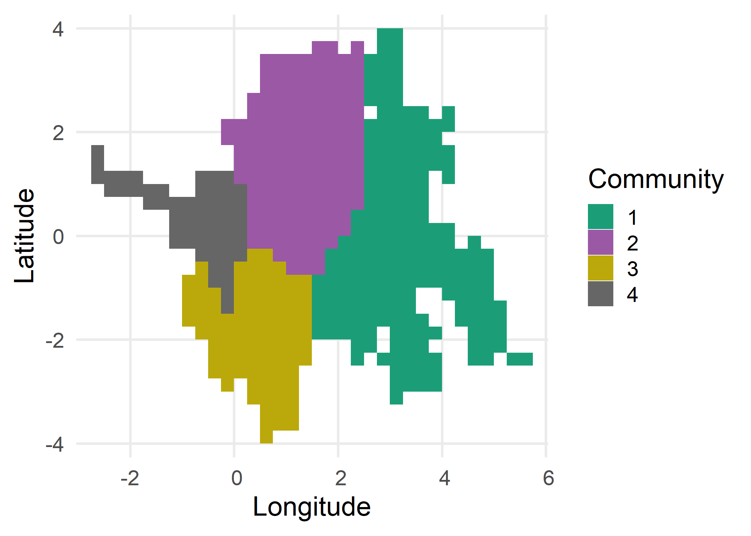
Figure v15 Map illustrating level 1 Infomap communities for the tracks dataset determined using InfomapCommunities() default parameters. Map created with CommunityMap() default parameters.

Proceed to Intraspecific Movements
Back to top

References & Recommended resources
Burnham, K.P. & Anderson, D.R. (2004) Multimodel Inference:Understanding AIC and BIC in Model Selection. Sociological Methods & Research, 33, 261-304.
Calich, H.J. et al. (2021) Comprehensive analytical approaches reveal species-specific search strategies in sympatric apex predatory sharks. Ecography, 44, 1544-1556.
Farage, C. et al. (2021) Identifying flow modules in ecological networks using Infomap. Methods in Ecology and Evolution, 12, 778–786.
Méndez, V., et al. (2013). Stochastic Foundations in Movement Ecology: Anomalous Diffusion, Front Propagation and Random Searches. Berlin, Heidelberg, Germanu, Springer Berlin / Heidelberg.
Rodríguez, J.P. et al. (2017) Big data analyses reveal patterns and drivers of the movements of southern elephant seals. Scientific Reports, 7, 1-10.
Viswanathan, G. M., et al. (2011). The Physics of Foraging: An Introduction to Biological Encounters and Random Searches. Cambridge, Cambridge University Press.
Wickham, H. (2016) ggplot2: Elegant Graphics for Data Analysis. Springer-Verlag, New York.

