R Notebook

This is an [R Markdown](http://rmarkdown.rstudio.com) Notebook. When you execute code within the notebook, the results appear beneath the code.

library(tidyverse)

## ── Attaching packages ─────────────────────────────────────── tidyverse 1.2.1 ──

## ✔ ggplot2 3.0.0 ✔ purrr 0.2.5  
## ✔ tibble 1.4.2 ✔ dplyr 0.7.7  
## ✔ tidyr 0.8.1 ✔ stringr 1.3.1  
## ✔ readr 1.1.1 ✔ forcats 0.3.0

## ── Conflicts ────────────────────────────────────────── tidyverse_conflicts() ──  
## ✖ dplyr::filter() masks stats::filter()  
## ✖ dplyr::lag() masks stats::lag()

library(geojsonio)

##   
## Attaching package: 'geojsonio'

## The following object is masked from 'package:base':  
##   
## pretty

library(sf)

## Linking to GEOS 3.6.1, GDAL 2.1.3, proj.4 4.9.3

library(tmap)  
library(tmaptools)  
#read some data attributes  
LondonData <- read_csv("https://files.datapress.com/london/dataset/ward-profiles-and-atlas/2015-09-24T14:21:24/ward-profiles-excel-version.csv", na = "n/a")

## Parsed with column specification:  
## cols(  
## .default = col_double(),  
## `Ward name` = col_character(),  
## `Old code` = col_character(),  
## `New code` = col_character()  
## )

## See spec(...) for full column specifications.

#read some geometries  
EW <- geojson_read("http://geoportal.statistics.gov.uk/datasets/8edafbe3276d4b56aec60991cbddda50_2.geojson", what = "sp")  
#pull out London  
LondonMap <- EW[grep("^E09",EW@data$lad15cd),]  
#convert to a simple features object  
LondonMapSF <- st_as_sf(LondonMap)  
#append the data to the geometries  
LondonMapSF <- append_data(LondonMapSF,LondonData, key.shp = "lad15cd", key.data = "New code", ignore.duplicates = TRUE)

## Data contains duplicated keys: E09000001

## Over coverage: 626 out of 659 data records were not appended. Run over_coverage() to get the corresponding data row numbers and key values.

#plot a choropleth  
qtm(LondonMapSF, fill = "% Not Born in UK - 2011")

# 

## output: html_notebook

This is an [R Markdown](http://rmarkdown.rstudio.com) Notebook. When you execute code within the notebook, the results appear beneath the code.

Try executing this chunk by clicking the *Run* button within the chunk or by placing your cursor inside it and pressing *Cmd+Shift+Enter*.

(ben, n.d.; hannah, n.d.)

plot(cars)

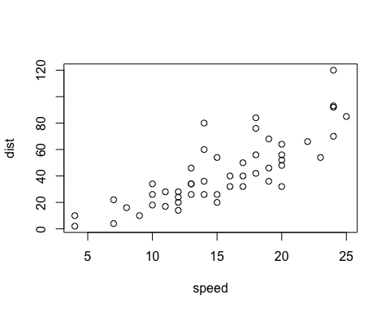

ben, ben ben. n.d. *Hello*.

hannah, hannah, gumble. n.d. *Test2*.