Acknowledgements

This investigation was sponsored by NIH/NIGMS MARC U*STAR T34 HHS 00026 National Research Service Award to UMBC and NSF Plant Genomics Award.





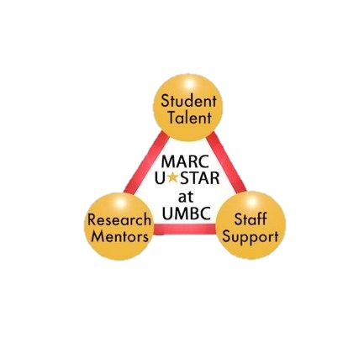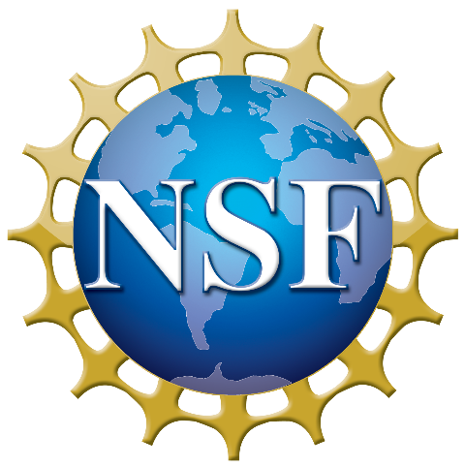

**Robert L. Last**

**Craig A. Schenck**

**Rachel E. Kerwin**

**Cornelius Barry**