Value-based DTW
-Classification-

600 Trainssamples (only generated)
486 Testsamples

Test Accuracy : 0.603
Confusion matrix of testset:
Predicted  True | Class 1 | Class 4 | Class 6 | Class 5
Class 1 | 20 | 0 | 0 | 71
Class 4 | 5 | 20 | 1 | 69
Class 6 | 2 | 1 | 29 | 51
Class 5 | 38 | 0 | 5 | 224

Anmerkungen:
Klassifizierung mit Threshold (0.25).

Found patterns in raw data:

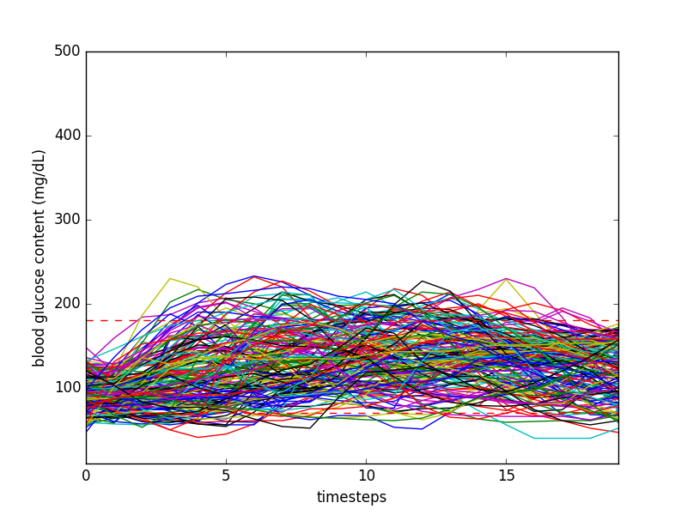
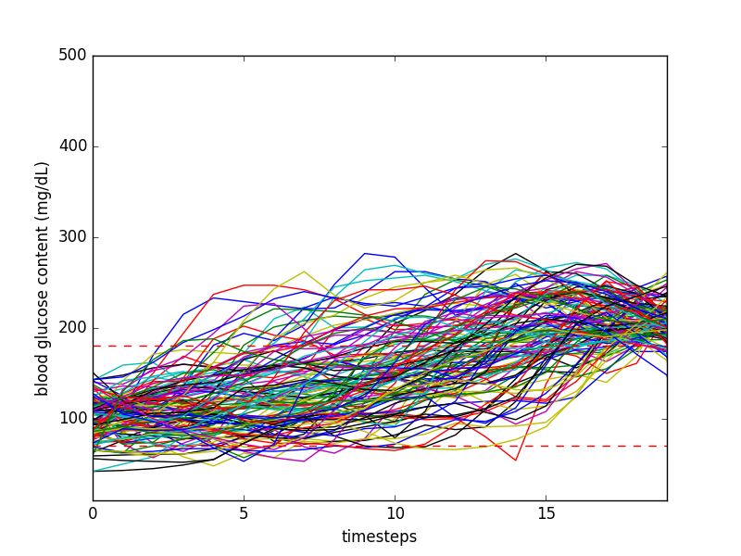
Klasse 1 (171) Klasse 4 (121)

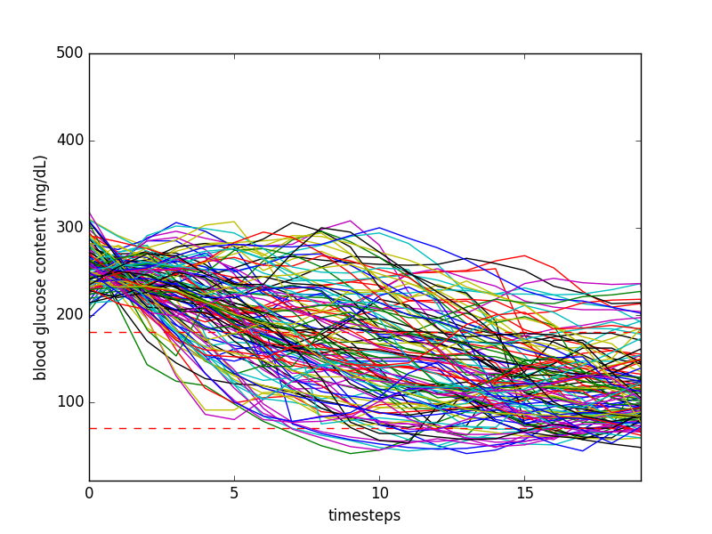
Klasse 6 (120)

