Model Validation Report
Retail Unsecured Loan PD Scorecard
Item | Detail
Model ID / version | CR-PD-001 / 2.3
Model type | Credit risk — probability of default (PD)
Model owner | Retail Credit Risk Modeling
Validation run | 20261023-194444-CR-PD-001-c39695
Automated analysis | 2026-10-23 19:44 UTC (4.9 s)
Reviewed and signed off by | Demo reviewer, 2026-10-23 19:44 UTC
Overall rating | Unsatisfactory
Framework | Federal Reserve / OCC SR 11-7 — Supervisory Guidance on Model Risk Management

1. Executive summary
Overall rating: Unsatisfactory
The model should not be relied on for its intended use until High-severity findings are remediated, or only under compensating controls approved by the model risk committee.
The validation of Retail Unsecured Loan PD Scorecard concludes with an overall rating of Unsatisfactory. The model should not be relied on for its intended use until High-severity findings are remediated, or only under compensating controls approved by the model risk committee. After review, 14 finding(s) were retained: 5 High, 8 Medium and 1 Low severity. The most material are Multicollinearity among model features (severe) (AS-001); Model under-predicts defaults (BT-001); Values outside documented valid ranges in development data (DQ-002).
Executive summary drafted by template from the reviewed findings; ratings and severities are set by the validator.
Severity | Findings | Remediation due within
High | 5 | 90 days
Medium | 8 | 180 days
Low | 1 | 365 days
Review status: 13 accepted, 1 edited, 1 rejected, 0 pending.

2. Model and validation scope
Purpose: Estimate 12-month probability of default for unsecured personal loan applicants.
Intended use: Application approval cut-offs and risk-based pricing; input to CECL PD estimates.
Documented assumptions tested:
- Log-odds of default are linear in the (transformed) features.
- Development sample is representative of the current applicant population.
- Features are available at application time.
- Default definition: 90+ days past due within 12 months of origination.
Documented limitations:
- Not validated for small-business or secured lending.
Validation activities
Review area | SR 11-7 element | Status | Findings proposed
Data Quality | Evaluation of conceptual soundness, Ongoing monitoring | Completed | 8
Assumptions | Evaluation of conceptual soundness | Completed | 3
Backtesting | Outcomes analysis | Completed | 2
Challenger Benchmarking | Ongoing monitoring | Completed | 2
Sensitivity Analysis | Evaluation of conceptual soundness | Completed | 0
Package validated (SHA-256 of each file, first 12 characters): model.json cfaa3e448304; model_package.yaml 00e5f78a0a77; test.csv b094907544c0; train.csv 02df3812dc98

3. Findings summary
ID | Severity | Finding | Area | Review | Due
AS-001 | High | Multicollinearity among model features (severe) | Assumptions | Accepted | 2027-01-21
BT-001 | High | Model under-predicts defaults | Backtesting | Accepted | 2027-01-21
DQ-002 | High | Values outside documented valid ranges in development data | Data Quality | Accepted | 2027-01-21
DQ-003 | High | Suspected target leakage | Data Quality | Accepted | 2027-01-21
DQ-004 | High | Feature distribution shift between development and validation samples (significant) | Data Quality | Accepted | 2027-01-21
AS-002 | Medium | Non-linear relationship with log-odds | Assumptions | Accepted | 2027-04-21
BT-002 | Medium | Predicted PDs do not match observed default rates across risk deciles | Backtesting | Accepted | 2027-04-21
CH-001 | Medium | Gradient boosting challenger outperforms the champion | Challenger Benchmarking | Accepted | 2027-04-21
CH-002 | Medium | Random forest challenger outperforms the champion | Challenger Benchmarking | Accepted | 2027-04-21
DQ-005 | Medium | Missing values in development data | Data Quality | Accepted | 2027-04-21
DQ-006 | Medium | Duplicate records in development data | Data Quality | Accepted | 2027-04-21
DQ-007 | Medium | Extreme outliers in development data | Data Quality | Accepted | 2027-04-21
DQ-008 | Medium | Default rate differs materially between samples | Data Quality | Accepted | 2027-04-21
AS-003 | Low | Features without statistically significant effect | Assumptions | Edited | 2027-10-23

4. Detailed findings

Data Quality
The Data Quality review of Retail Unsecured Loan PD Scorecard identified 7 finding(s) (3 high, 4 medium severity). High-severity items: Values outside documented valid ranges in development data; Suspected target leakage; Feature distribution shift between development and validation samples (significant).

DQ-002 · Values outside documented valid ranges in development data
Severity: High · Evaluation of conceptual soundness · Review: accepted · Remediation due 2027-01-21
Impossible or undocumented values found: age (12 rows outside [18.0, 100.0]).
Evidence
- dataset: development
- violations: {age: {count: 12, allowed: [18, 100], observed_min: -1, observed_max: 150}}
Recommendation: Trace the records to source, correct or exclude them, and add range validation to the data pipeline.

DQ-003 · Suspected target leakage
Severity: High · Evaluation of conceptual soundness · Review: accepted · Remediation due 2027-01-21
On its own, recovery_amount (AUC 1.000) separates defaulters from non-defaulters almost perfectly. A feature this predictive is usually only observable after the outcome.
Evidence
- univariate_auc: {recovery_amount: 1}
- threshold: 0.95
Recommendation: Confirm each feature's availability at the decision (application) date; remove any post-outcome variable and re-estimate the model.

DQ-004 · Feature distribution shift between development and validation samples (significant)
Severity: High · Ongoing monitoring · Review: accepted · Remediation due 2027-01-21
Population Stability Index above 0.25: credit_utilization (PSI 0.662), utilization_6m_avg (PSI 0.449).
Evidence
- psi: {credit_utilization: 0.6625, utilization_6m_avg: 0.449}
- threshold: 0.25
Recommendation: Investigate drivers of the shift (policy, channel, macro) and confirm the model remains fit for the current population; re-test performance on the shifted segment.

DQ-005 · Missing values in development data
Severity: Medium · Evaluation of conceptual soundness · Review: accepted · Remediation due 2027-04-21
1 column(s) in the development sample contain missing values: annual_income (7.9%).
Evidence
- dataset: development
- missing_rate: {annual_income: 0.0788}
Recommendation: Confirm the root cause of missingness (system outage, optional field, data feed), document the treatment applied by the developer, and test whether missingness is correlated with the target or model output.

DQ-006 · Duplicate records in development data
Severity: Medium · Evaluation of conceptual soundness · Review: accepted · Remediation due 2027-04-21
139 of 8160 rows (1.70%) in the development sample are exact duplicates.
Evidence
- dataset: development
- duplicate_rows: 139
- rows: 8160
- rate: 0.017
Recommendation: Remove duplicates before estimation and re-run development tests; duplicated records overweight some observations and understate standard errors.

DQ-007 · Extreme outliers in development data
Severity: Medium · Evaluation of conceptual soundness · Review: accepted · Remediation due 2027-04-21
Values more than 6 robust standard deviations from the median: annual_income (120 rows).
Evidence
- dataset: development
- z_threshold: 6
- features: {annual_income: {count: 120, share: 0.0147, max_value: 1e+08}}
Recommendation: Determine whether these are data-entry errors or genuine extremes; document the capping or winsorisation rule and test model sensitivity to it.

DQ-008 · Default rate differs materially between samples
Severity: Medium · Ongoing monitoring · Review: accepted · Remediation due 2027-04-21
Default rate moved from 12.71% (development) to 21.03% (validation).
Evidence
- train_rate: 0.1271
- test_rate: 0.2103
Recommendation: Assess whether the shift reflects the credit cycle or a population change; consider recalibration.

Assumptions
The Assumptions review of Retail Unsecured Loan PD Scorecard identified 3 finding(s) (1 high, 1 medium, 1 low severity). High-severity items: Multicollinearity among model features (severe).

AS-001 · Multicollinearity among model features (severe)
Severity: High · Evaluation of conceptual soundness · Review: accepted · Remediation due 2027-01-21
Variance inflation factors above 10: credit_utilization (VIF 35.6), utilization_6m_avg (VIF 35.6). Coefficients of collinear features are unstable and their signs cannot be interpreted.
Evidence
- vif: {credit_utilization: 35.6, utilization_6m_avg: 35.6}
- threshold: 10
- correlations: {credit_utilization ~ utilization_6m_avg: 0.986}
Recommendation: Keep one feature from each collinear group (or combine them), re-estimate, and confirm the remaining coefficients have the expected signs.

AS-002 · Non-linear relationship with log-odds
Severity: Medium · Evaluation of conceptual soundness · Review: accepted · Remediation due 2027-04-21
Adding a squared term significantly improves fit (Bonferroni-adjusted) for: annual_income (adjusted p < 0.0001), debt_to_income (adjusted p < 0.0001). This contradicts the documented assumption that log-odds are linear in the features.
Evidence
- lr_test_p_values: {annual_income: 0, debt_to_income: 0}
Recommendation: Consider binning (WoE), a transformation or a spline for these features.

AS-003 · Features without statistically significant effect
Severity: Low · Evaluation of conceptual soundness · Review: edited · Remediation due 2027-10-23
In the independent re-estimation these features are not significant at 5% (|z| < 1.96): credit_utilization (z = 0.97), num_open_accounts (z = 0.14), loan_amount (z = -0.26).
Evidence
- z_statistics: {credit_utilization: 0.97, num_open_accounts: 0.14, loan_amount: -0.26}
Recommendation: Resolve together with AS-001 (multicollinearity).
Validator note (Demo reviewer): Insignificance of utilisation is a symptom of the collinearity in AS-001.

Backtesting
The Backtesting review of Retail Unsecured Loan PD Scorecard identified 2 finding(s) (1 high, 1 medium severity). High-severity items: Model under-predicts defaults.
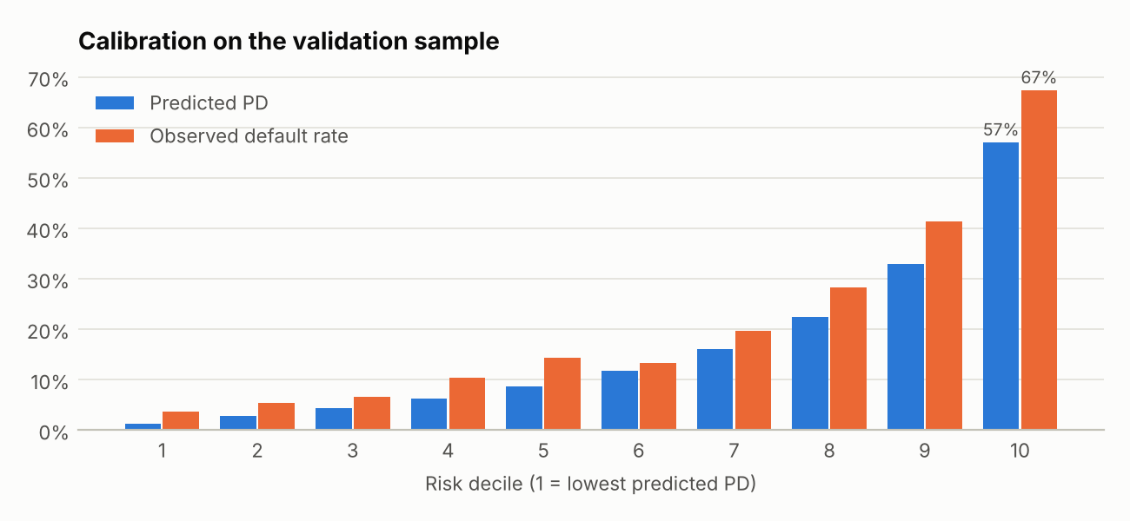
Mean predicted PD and observed default rate by decile of predicted PD.

BT-001 · Model under-predicts defaults
Severity: High · Outcomes analysis · Review: accepted · Remediation due 2027-01-21
631 defaults observed against 491 predicted (observed rate 21.03% vs mean PD 16.35%; z = 7.81, p = 5.7e-15). Under-prediction is non-conservative: losses, pricing and reserves would be understated.
Evidence
- observed_defaults: 631
- expected_defaults: 490.6
- calibration_z: 7.81
- calibration_p: 0
Recommendation: Recalibrate the intercept to the current default rate (or a through-the-cycle target) and document the calibration target.

BT-002 · Predicted PDs do not match observed default rates across risk deciles
Severity: Medium · Outcomes analysis · Review: accepted · Remediation due 2027-04-21
Hosmer-Lemeshow test on the validation sample: statistic 78.6, p = 9.3e-14.
Evidence
- hosmer_lemeshow: {stat: 78.61, p: 0}
- deciles: [{decile: 1, n: 300, predicted_rate: 0.0121, observed_rate: 0.0367}, {decile: 2, n: 300, predicted_rate: 0.0281, observed_rate: 0.0533}, {decile: 3, n: 300, predicted_rate: 0.0441, observed_rate: 0.0667}, …]
Recommendation: Review the decile table for where the model mis-states risk; recalibrate by segment if needed.

Challenger Benchmarking
The Challenger Benchmarking review of Retail Unsecured Loan PD Scorecard identified 2 finding(s) (2 medium severity).
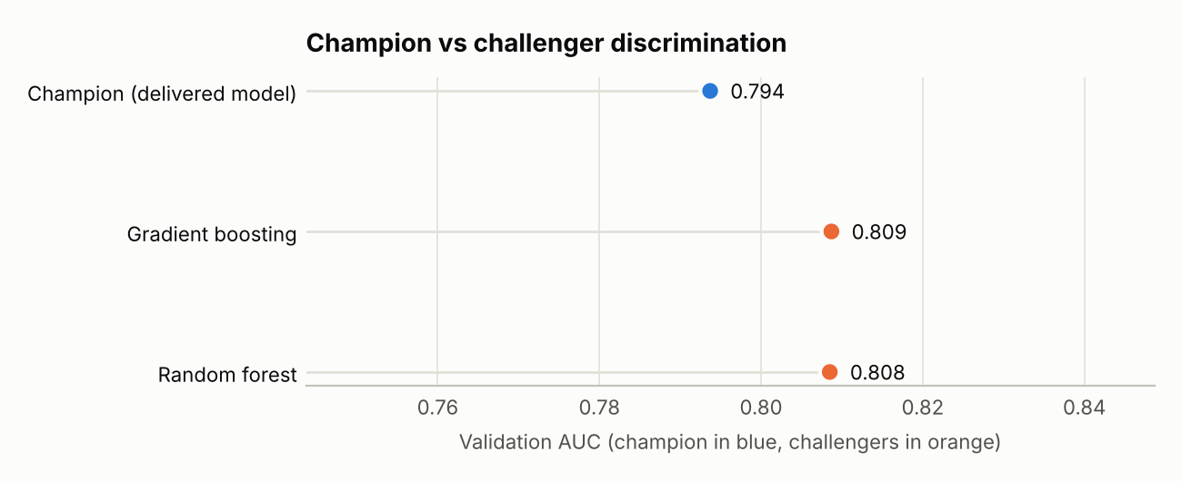
Validation-sample AUC of the delivered model and the validator's challengers.

CH-001 · Gradient boosting challenger outperforms the champion
Severity: Medium · Ongoing monitoring · Review: accepted · Remediation due 2027-04-21
On the validation sample the gradient boosting challenger reaches AUC 0.809 vs 0.794 for the delivered model (gap +0.015, paired-bootstrap 95% interval +0.004 to +0.025). The challenger uses the same features, so the champion's functional form is leaving predictive information unused.
Evidence
- auc: 0.8087
- brier: 0.1259
- auc_gap: 0.015
- auc_gap_95ci: [0.0042, 0.0251]
- rank_correlation: 0.867
Recommendation: Identify where the challenger gains (e.g. partial dependence of the main features) and capture it in the champion through binning or transformations, or document why the simpler model is preferred despite the gap.

CH-002 · Random forest challenger outperforms the champion
Severity: Medium · Ongoing monitoring · Review: accepted · Remediation due 2027-04-21
On the validation sample the random forest challenger reaches AUC 0.809 vs 0.794 for the delivered model (gap +0.015, paired-bootstrap 95% interval +0.003 to +0.025). The challenger uses the same features, so the champion's functional form is leaving predictive information unused.
Evidence
- auc: 0.8085
- brier: 0.1288
- auc_gap: 0.0148
- auc_gap_95ci: [0.0031, 0.0253]
- rank_correlation: 0.835
Recommendation: Identify where the challenger gains (e.g. partial dependence of the main features) and capture it in the champion through binning or transformations, or document why the simpler model is preferred despite the gap.

Sensitivity Analysis
The Sensitivity Analysis review of Retail Unsecured Loan PD Scorecard identified no exceptions.

Appendix A. Findings rejected by the validator
ID | Proposed severity | Finding | Reviewer | Rationale
DQ-001 | High | Conflicting records share an ID in development data | Demo reviewer | Conflicting IDs arise from the duplicate rows already raised in DQ-006; tracked there.

Appendix B. Audit trail and turnaround
Measure | Value
Automated analysis | 4.91 s
Data Quality | 0.176 s
Assumptions | 0.064 s
Backtesting | 0.105 s
Challenger Benchmarking | 4.477 s
Sensitivity Analysis | 0.08 s
Review decisions recorded | 15
Active review (first to last decision) | 0.0 min
Run completion to sign-off | 0.0 h
Total elapsed (start to sign-off) | 0.0 h
Times are taken from the run's append-only audit log (audit.jsonl), which also records every review decision with reviewer, timestamp and rationale.
Sign-off comment: Illustrative review of a synthetic model package.

Appendix C. Limitations of this validation
- Automated tests cover the checks listed in section 2; they do not replace the validator's judgement on conceptual soundness, business use or the appropriateness of the model's design.
- Statistical tests reject a correct model at roughly their significance level; findings are therefore reviewed individually before they are accepted.
- AI-written text (area summaries, commentary, executive summary) is generated from the computed results only and is labelled as such; it cannot add, remove or re-grade findings.

