Model Validation Report
Trading Book 1-Day 99% Historical VaR
Item | Detail
Model ID / version | MR-VAR-004 / 1.4
Model type | Market risk — Value-at-Risk
Model owner | Market Risk Analytics
Validation run | 20261023-194451-MR-VAR-004-9545cb
Automated analysis | 2026-10-23 19:44 UTC (0.1 s)
Reviewed and signed off by | Demo reviewer, 2026-10-23 19:44 UTC
Overall rating | Unsatisfactory
Framework | Federal Reserve / OCC SR 11-7 — Supervisory Guidance on Model Risk Management

1. Executive summary
Overall rating: Unsatisfactory
The model should not be relied on for its intended use until High-severity findings are remediated, or only under compensating controls approved by the model risk committee.
The validation of Trading Book 1-Day 99% Historical VaR concludes with an overall rating of Unsatisfactory. The model should not be relied on for its intended use until High-severity findings are remediated, or only under compensating controls approved by the model risk committee. After review, 14 finding(s) were retained: 4 High, 7 Medium and 3 Low severity. The most material are Exception frequency inconsistent with the VaR confidence level (too many) (BT-001); Duplicate dates in price history (DQ-001); Zero or negative prices (DQ-002).
Executive summary drafted by template from the reviewed findings; ratings and severities are set by the validator.
Severity | Findings | Remediation due within
High | 4 | 90 days
Medium | 7 | 180 days
Low | 3 | 365 days
Review status: 13 accepted, 1 edited, 0 rejected, 0 pending.

2. Model and validation scope
Purpose: Daily 1-day 99% Value-at-Risk for the multi-asset trading book.
Intended use: Daily risk limits monitoring and internal capital reporting.
Documented assumptions tested:
- The past 250 trading days are representative of next-day risk.
- Daily returns are independent across days.
- Portfolio weights are constant over the 1-day horizon.
- Price history is adjusted for corporate actions.
Documented limitations:
- Does not capture intraday liquidity risk.
Validation activities
Review area | SR 11-7 element | Status | Findings proposed
Data Quality | Evaluation of conceptual soundness | Completed | 6
Assumptions | Evaluation of conceptual soundness | Completed | 3
Backtesting | Outcomes analysis | Completed | 3
Challenger Benchmarking | Ongoing monitoring | Completed | 1
Sensitivity Analysis | Evaluation of conceptual soundness | Completed | 1
Package validated (SHA-256 of each file, first 12 characters): model_package.yaml e64f07115ced; prices.csv bcdd0b7b521c
Data treatment applied before model-level tests: kept first of 1 duplicated date(s); treated 1 non-positive price(s) as missing; forward-filled 4 missing price(s).

3. Findings summary
ID | Severity | Finding | Area | Review | Due
BT-001 | High | Exception frequency inconsistent with the VaR confidence level (too many) | Backtesting | Accepted | 2027-01-21
DQ-001 | High | Duplicate dates in price history | Data Quality | Accepted | 2027-01-21
DQ-002 | High | Zero or negative prices | Data Quality | Accepted | 2027-01-21
DQ-003 | High | Implausible one-day price moves | Data Quality | Accepted | 2027-01-21
AS-001 | Medium | Portfolio returns are serially correlated | Assumptions | Accepted | 2027-04-21
AS-002 | Medium | Volatility clustering in portfolio returns | Assumptions | Accepted | 2027-04-21
AS-003 | Medium | Recent volatility differs from the VaR window | Assumptions | Accepted | 2027-04-21
BT-002 | Medium | Basel traffic light in the yellow zone | Backtesting | Accepted | 2027-04-21
CH-001 | Medium | Volatility-sensitive challengers backtest better than the champion | Challenger Benchmarking | Accepted | 2027-04-21
DQ-004 | Medium | Gaps in price history | Data Quality | Accepted | 2027-04-21
DQ-005 | Medium | Stale (unchanged) prices | Data Quality | Accepted | 2027-04-21
BT-003 | Low | VaR exceptions cluster in time | Backtesting | Accepted | 2027-10-23
DQ-006 | Low | Missing prices | Data Quality | Edited | 2027-10-23
SA-001 | Low | Historical worst day far exceeds current VaR | Sensitivity Analysis | Accepted | 2027-10-23

4. Detailed findings

Data Quality
The Data Quality review of Trading Book 1-Day 99% Historical VaR identified 6 finding(s) (3 high, 2 medium, 1 low severity). High-severity items: Duplicate dates in price history; Zero or negative prices; Implausible one-day price moves.

DQ-001 · Duplicate dates in price history
Severity: High · Evaluation of conceptual soundness · Review: accepted · Remediation due 2027-01-21
1 date(s) appear more than once (e.g. 2022-10-10), producing zero or double-counted returns.
Evidence
- duplicate_dates: [2022-10-10]
- count: 1
Recommendation: De-duplicate the time series and confirm which observation is the official close.

DQ-002 · Zero or negative prices
Severity: High · Evaluation of conceptual soundness · Review: accepted · Remediation due 2027-01-21
Non-positive prices found: {'RATES_10Y': 1}. Log returns are undefined and simple returns are -100%.
Evidence
- nonpositive_counts: {RATES_10Y: 1}
Recommendation: Replace with validated closes; if the series can legitimately be negative (e.g. spreads), model it in levels or changes, not returns.

DQ-003 · Implausible one-day price moves
Severity: High · Evaluation of conceptual soundness · Review: accepted · Remediation due 2027-01-21
One-day moves larger than 25% found, e.g. EQ_US -50.2% on 2022-12-19. A single move of this size usually signals an unadjusted corporate action (split, dividend) or a bad tick.
Evidence
- extreme_returns: {EQ_US: [{date: 2022-12-19, return: -0.502}]}
- threshold: 0.25
Recommendation: Verify against corporate-action records; use total-return adjusted prices. If the move is genuine, document it as a stress observation.

DQ-004 · Gaps in price history
Severity: Medium · Evaluation of conceptual soundness · Review: accepted · Remediation due 2027-04-21
1 gap(s) longer than 7 calendar days, e.g. 2023-07-14 to 2023-07-31. Returns spanning a gap overstate one-day moves.
Evidence
- gaps: [{from: 2023-07-14, to: 2023-07-31, days: 17}]
- threshold_days: 7
Recommendation: Back-fill the missing history from an alternate source or exclude returns that span gaps.

DQ-005 · Stale (unchanged) prices
Severity: Medium · Evaluation of conceptual soundness · Review: accepted · Remediation due 2027-04-21
Prices unchanged for 5+ consecutive observations: {'FX_EURUSD': {'runs': 1, 'longest_days': 10}}. Stale data understates volatility and VaR.
Evidence
- stale: {FX_EURUSD: {runs: 1, longest_days: 10}}
- threshold_days: 5
Recommendation: Check the market-data feed for the affected period and replace stale points with observed prices.

DQ-006 · Missing prices
Severity: Low · Evaluation of conceptual soundness · Review: edited · Remediation due 2027-10-23
Missing prices by asset (share of days): {'EQ_EU': 0.003}.
Evidence
- missing_rate: {EQ_EU: 0.003}
Recommendation: Document the forward-fill rule in the methodology.
Validator note (Demo reviewer): Three missing prices out of ~1,000; forward-fill impact is immaterial.

Assumptions
The Assumptions review of Trading Book 1-Day 99% Historical VaR identified 3 finding(s) (3 medium severity).

AS-001 · Portfolio returns are serially correlated
Severity: Medium · Evaluation of conceptual soundness · Review: accepted · Remediation due 2027-04-21
Ljung-Box test on returns (10 lags): Q = 38.1, p < 0.0001. The model assumes daily returns are independent.
Evidence
- q: 38.06
- p: 4e-05
Recommendation: Assess the impact on VaR, and on any square-root-of-time scaling to longer horizons.

AS-002 · Volatility clustering in portfolio returns
Severity: Medium · Evaluation of conceptual soundness · Review: accepted · Remediation due 2027-04-21
Ljung-Box test on squared returns: Q = 42.9, p < 0.0001. Volatility is persistent, so an equally weighted historical window reacts slowly when market conditions change.
Evidence
- q: 42.94
- p: 1e-05
Recommendation: Benchmark against a volatility-weighted (filtered) historical simulation or EWMA approach; monitor exception clustering in backtesting.

AS-003 · Recent volatility differs from the VaR window
Severity: Medium · Evaluation of conceptual soundness · Review: accepted · Remediation due 2027-04-21
Volatility over the last 60 days is 2.69x the rest of the 250-day window (higher). The documented assumption that the window represents next-day risk is weakened.
Evidence
- recent_vs_window_vol_ratio: 2.693
- recent_days: 60
Recommendation: Compare against a shorter or volatility-weighted window; if volatility is higher, VaR is likely understated until the window catches up.

Backtesting
The Backtesting review of Trading Book 1-Day 99% Historical VaR identified 3 finding(s) (1 high, 1 medium, 1 low severity). High-severity items: Exception frequency inconsistent with the VaR confidence level (too many).
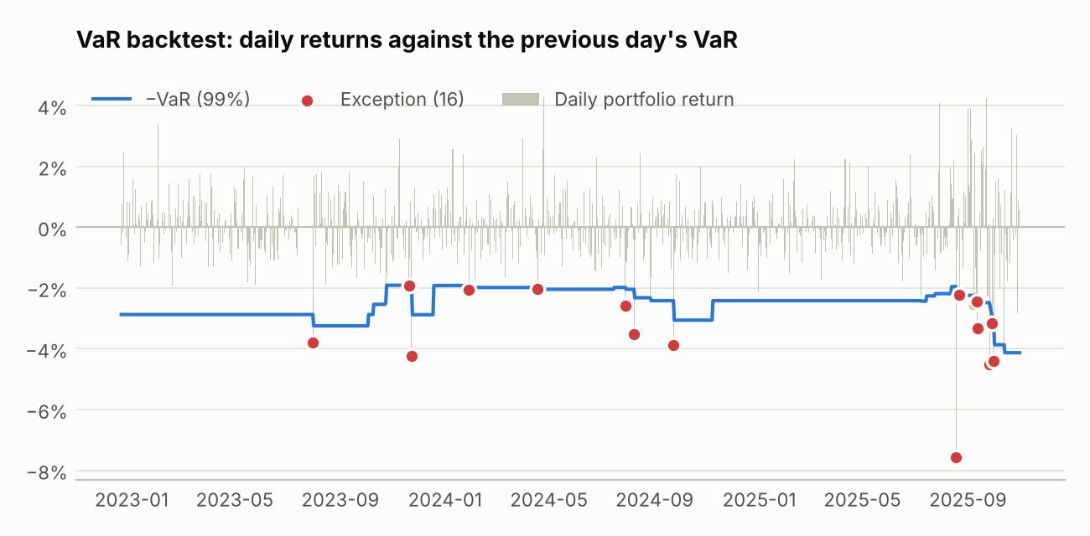
Exceptions are days whose loss exceeded the VaR forecast made the previous day.

BT-001 · Exception frequency inconsistent with the VaR confidence level (too many)
Severity: High · Outcomes analysis · Review: accepted · Remediation due 2027-01-21
Kupiec POF test over 739 days: 16 exceptions vs 7.4 expected (LR = 7.60, p = 0.0058). VaR is understating risk.
Evidence
- exceptions: 16
- expected: 7.4
- lr: 7.6
- p: 0.005835
Recommendation: Re-examine the window length, weighting and data treatment; compare with a challenger VaR.

BT-002 · Basel traffic light in the yellow zone
Severity: Medium · Outcomes analysis · Review: accepted · Remediation due 2027-04-21
8 exceptions in the last 250 trading days against 2.5 expected at 99% confidence (cumulative binomial probability 99.8943%).
Evidence
- days: 250
- exceptions: 8
- zone: yellow
- cumulative_probability: 0.9989
Recommendation: Investigate each exception (model vs. P&L issue), escalate per the backtesting policy, and assess whether a capital multiplier add-on or model change is required.

BT-003 · VaR exceptions cluster in time
Severity: Low · Outcomes analysis · Review: accepted · Remediation due 2027-10-23
Christoffersen independence test: LR = 4.07, p = 0.044; 2 exception(s) followed another exception. The model is slow to react to changing volatility.
Evidence
- lr: 4.067
- p: 0.04372
- n00: 708
- n01: 14
- n10: 14
- n11: 2
Recommendation: Consider volatility scaling (EWMA / filtered historical simulation).

Challenger Benchmarking
The Challenger Benchmarking review of Trading Book 1-Day 99% Historical VaR identified 1 finding(s) (1 medium severity).
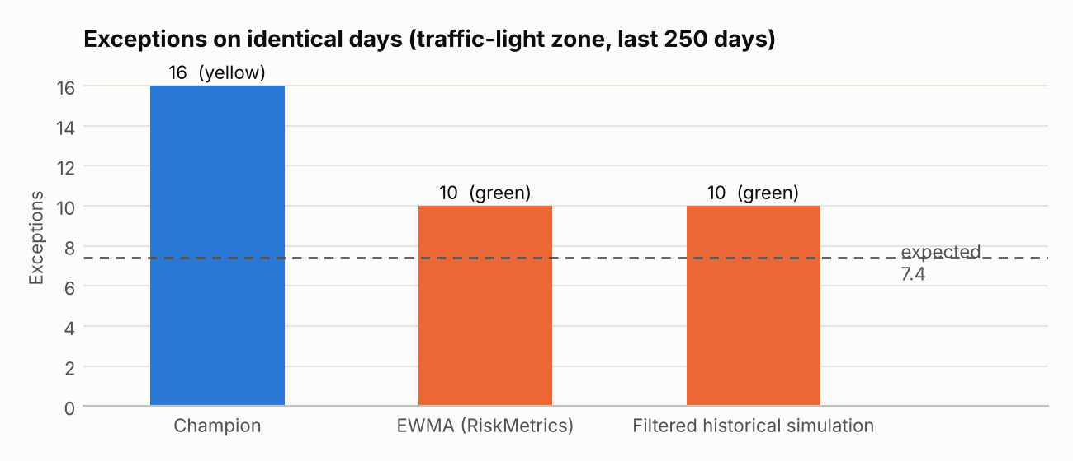
Exception counts over the same backtest days; dashed line = expected count.

CH-001 · Volatility-sensitive challengers backtest better than the champion
Severity: Medium · Ongoing monitoring · Review: accepted · Remediation due 2027-04-21
Over the same 739 days the champion has 16 exceptions (yellow zone), while EWMA (RiskMetrics) has 10 (green zone); Filtered historical simulation has 10 (green zone) against 7.4 expected. The challengers also have lower quantile loss.
Evidence
- Champion: {days: 739, exceptions: 16, expected: 7.4, kupiec_p: 0.00584, christoffersen_p: 0.04372, …}
- EWMA (RiskMetrics): {days: 739, exceptions: 10, expected: 7.4, kupiec_p: 0.3598, christoffersen_p: 0.6002, …}
- Filtered historical simulation: {days: 739, exceptions: 10, expected: 7.4, kupiec_p: 0.3598, christoffersen_p: 0.6002, …}
Recommendation: Evaluate adopting volatility scaling (EWMA / FHS) in the production VaR, or document why the equally weighted window is retained and how its lag is compensated.

Sensitivity Analysis
The Sensitivity Analysis review of Trading Book 1-Day 99% Historical VaR identified 1 finding(s) (1 low severity).

SA-001 · Historical worst day far exceeds current VaR
Severity: Low · Evaluation of conceptual soundness · Review: accepted · Remediation due 2027-10-23
The largest one-day loss in the history, 20.06% on 2022-12-19, is 4.9x the current VaR. Either the history contains a genuine tail event that VaR at this confidence level will not reflect, or the observation is a data error (check the Data Quality findings).
Evidence
- date: 2022-12-19
- loss: 0.2006
- multiple_of_var: 4.86
Recommendation: Confirm the observation; if genuine, cover it through stress testing alongside VaR.

Appendix A. Findings rejected by the validator
None.

Appendix B. Audit trail and turnaround
Measure | Value
Automated analysis | 0.09 s
Data Quality | 0.02 s
Assumptions | 0.008 s
Backtesting | 0.008 s
Challenger Benchmarking | 0.026 s
Sensitivity Analysis | 0.021 s
Review decisions recorded | 14
Active review (first to last decision) | 0.0 min
Run completion to sign-off | 0.0 h
Total elapsed (start to sign-off) | 0.0 h
Times are taken from the run's append-only audit log (audit.jsonl), which also records every review decision with reviewer, timestamp and rationale.
Sign-off comment: Illustrative review of a synthetic model package.

Appendix C. Limitations of this validation
- Automated tests cover the checks listed in section 2; they do not replace the validator's judgement on conceptual soundness, business use or the appropriateness of the model's design.
- Statistical tests reject a correct model at roughly their significance level; findings are therefore reviewed individually before they are accepted.
- AI-written text (area summaries, commentary, executive summary) is generated from the computed results only and is labelled as such; it cannot add, remove or re-grade findings.

