**Assignment 2.2 – Data Modeling**

**Link personal portfolio:**

https://hannahd06.github.io/personal-portfolio/

**ORDs:**

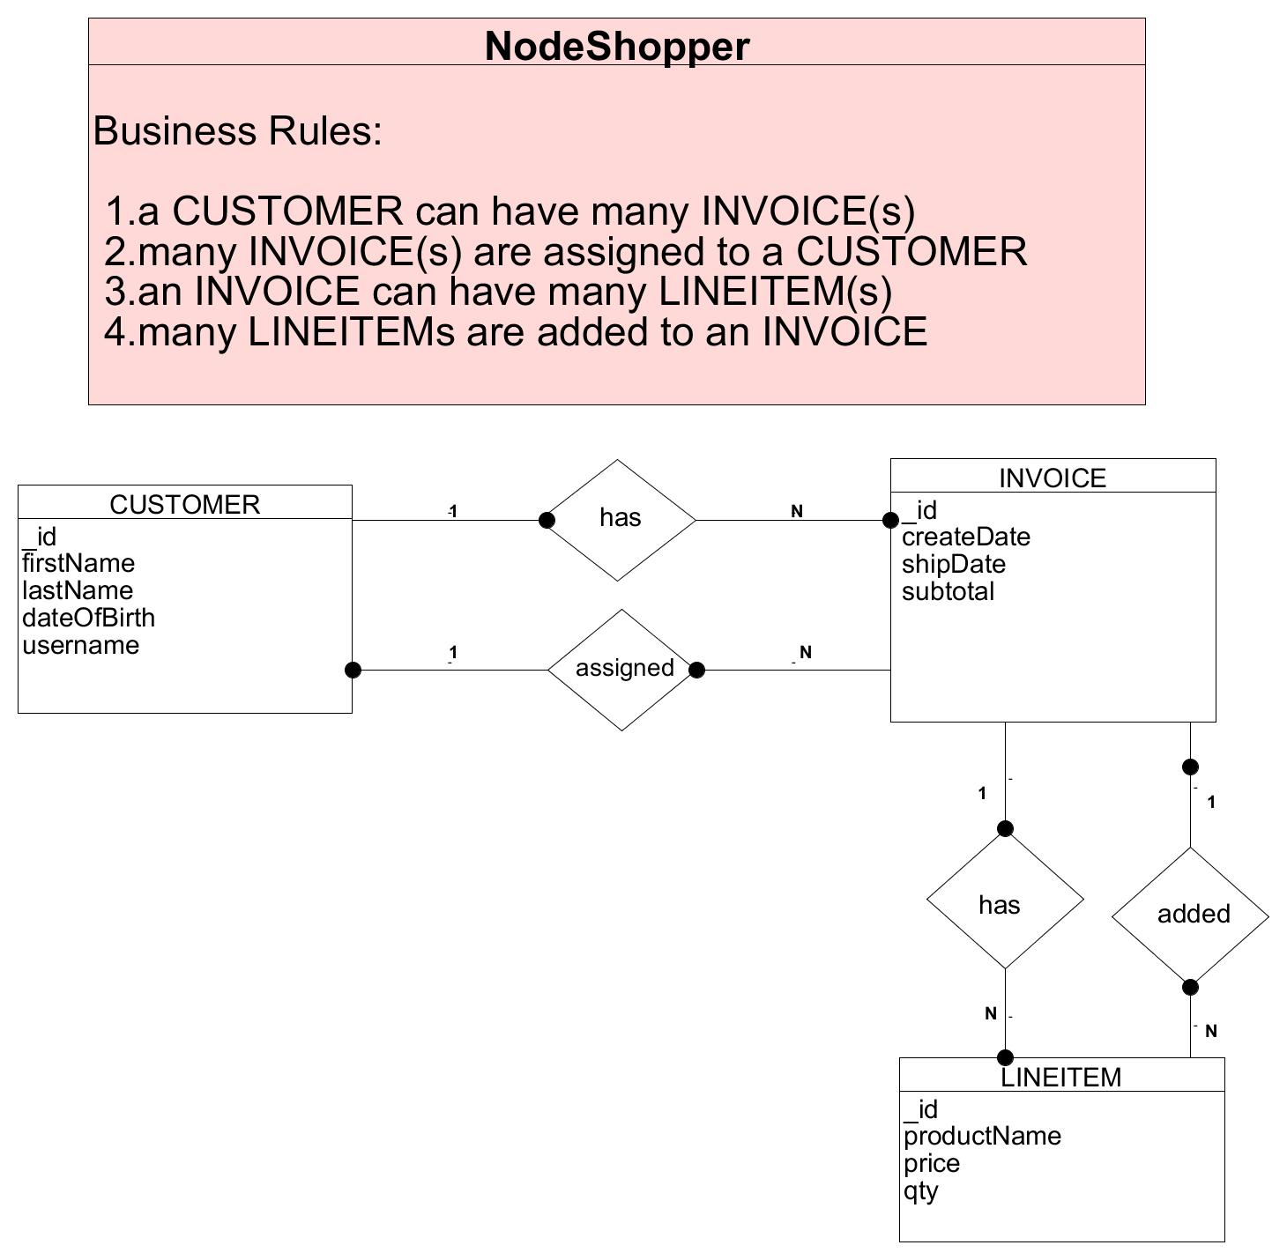

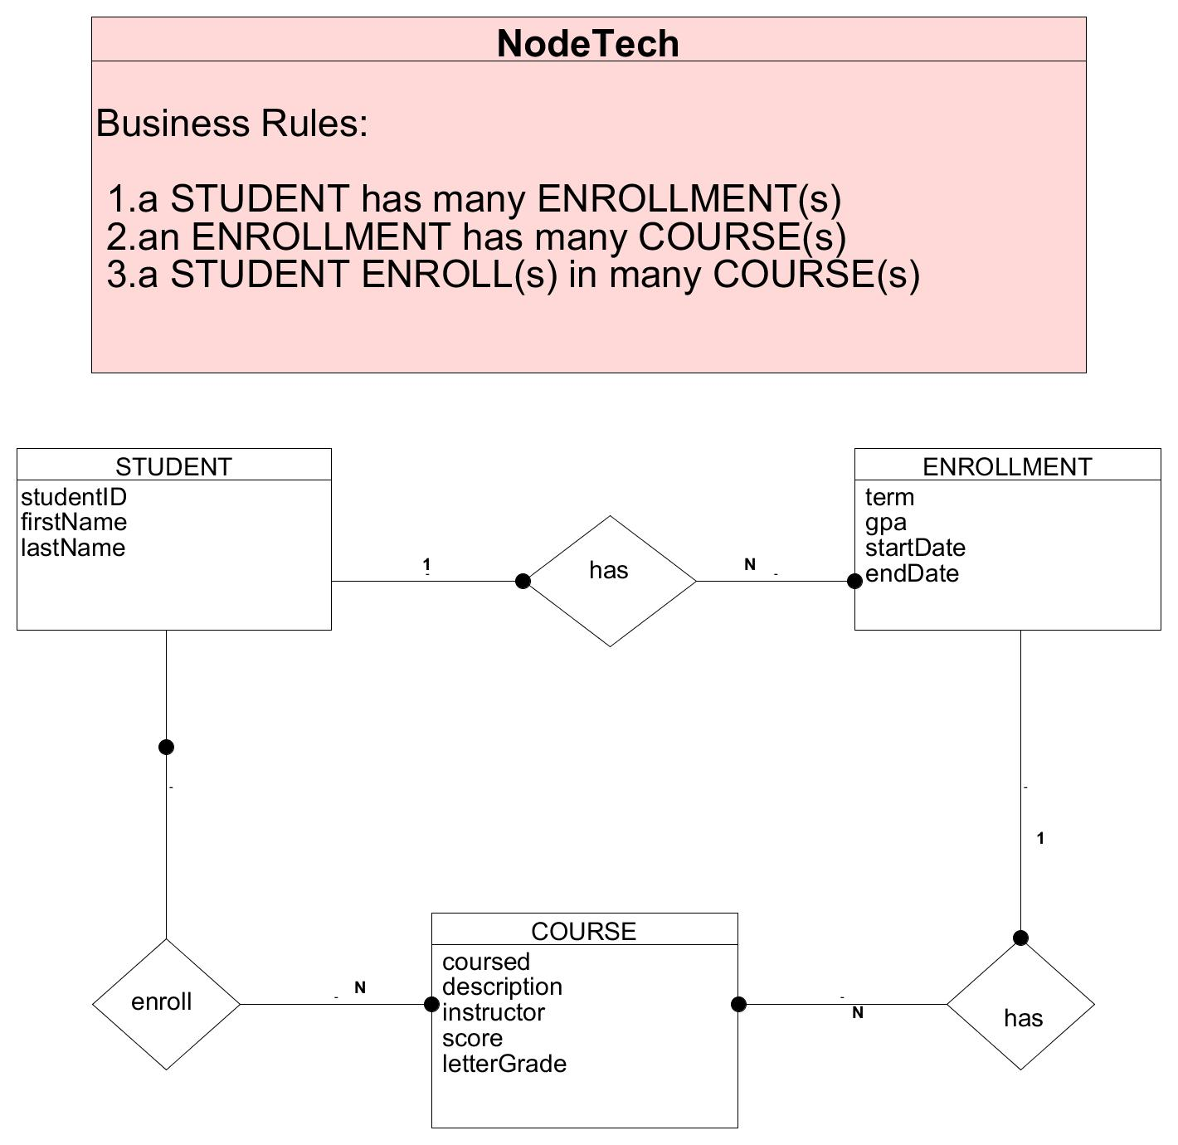

**NoSQL Data Structures:**

NodeShopper:

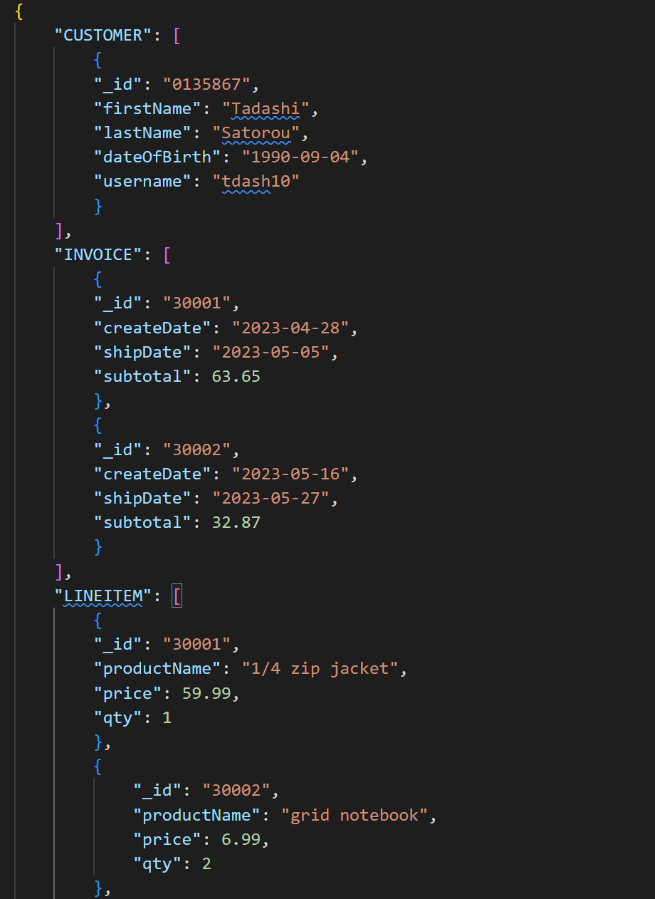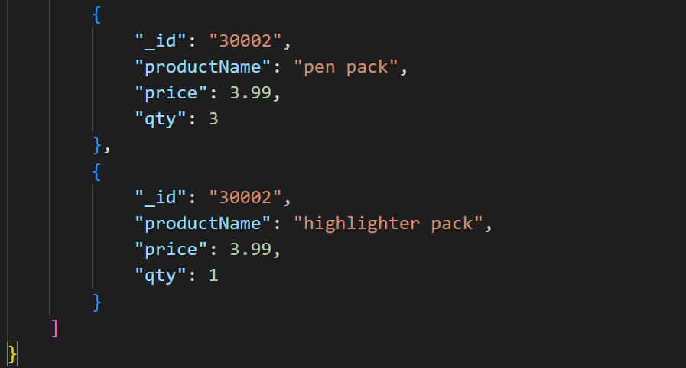

NodeTech:

