**Assignment 3.2- Normalization**

**Link personal portfolio:**

https://hannahd06.github.io/personal-portfolio/

**NodeSecurity**

**ORD:**

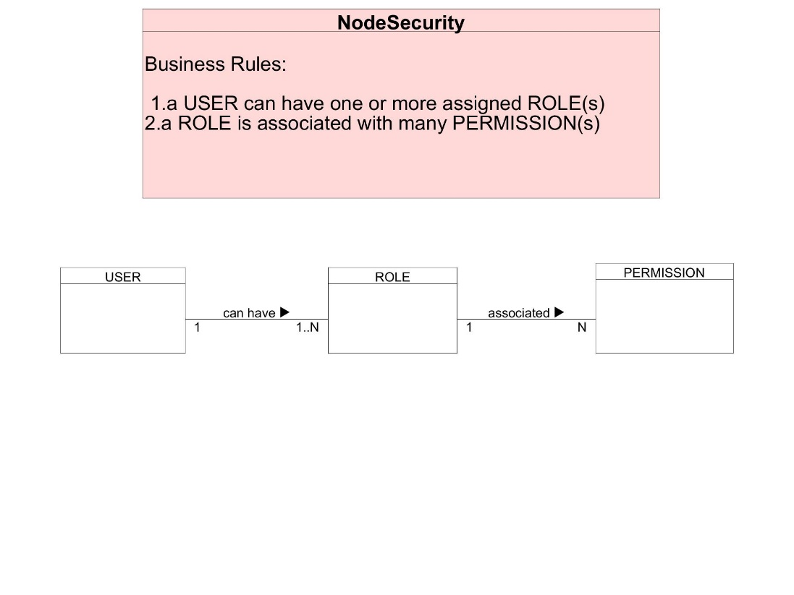

**NoSQL Data Structure:**

**NodeBookCo**

Data Fields

|  |  |  |  |
| --- | --- | --- | --- |
| publisher_name | publisher_code | publisher_address | book_isbn |
| book_name | book_price | author_first_name | author_last_name |
| author_phone | author_email |  |  |

2nf dsta tables

**Publisher**

|  |  |  |  |
| --- | --- | --- | --- |
| publisher_name | publisher_code | publisher_address | book_isbn |
| HarperCollins | 158422 | 195 Broadway, New York, NY 10007 | 9780063078901 |

**Book**

|  |  |  |
| --- | --- | --- |
| book_isbn | book_name | book_price |
| 9780063078901 | The Duke and I | 16.99 |

**Author**

|  |  |  |  |  |
| --- | --- | --- | --- | --- |
| book_isbn | author_first_name | author_last_name | author_phone | author_email |
| 9780063078901 | Julia | Quinn | 123-876-7910 | jquinn@author.com |

**ORD:**

**NoSQL Data Structure:**

