**Exercise 4.3 - MongoDB Shell**

Connect to MongoDB and load user.js

query find the user with an email address of [jbach@me.com](mailto:jbach@me.com).

query to find a user with the last name of Mozart. 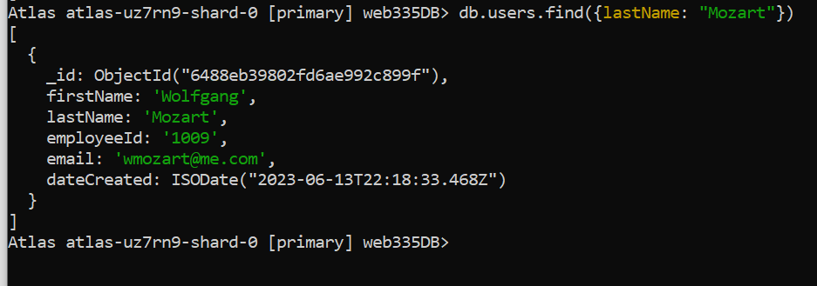

query to find a user with the last name of Mozart. 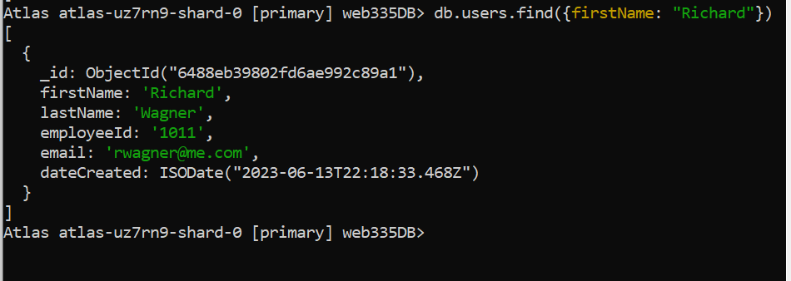

query to find a user with an employeeId of 1010.

