Assignment 6.2 – Aggregate Queries

Query to return all documents in house collection

Query to return all documents in students collection

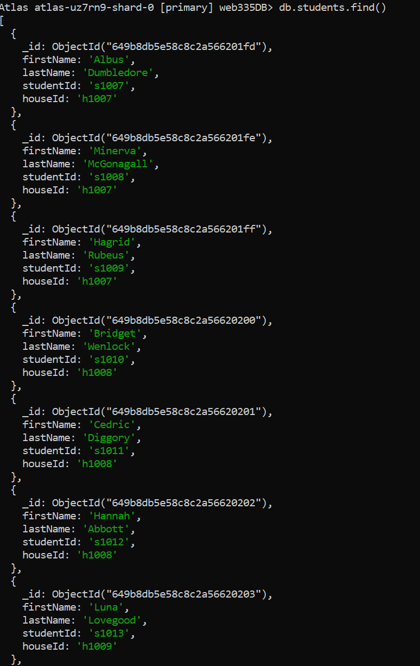

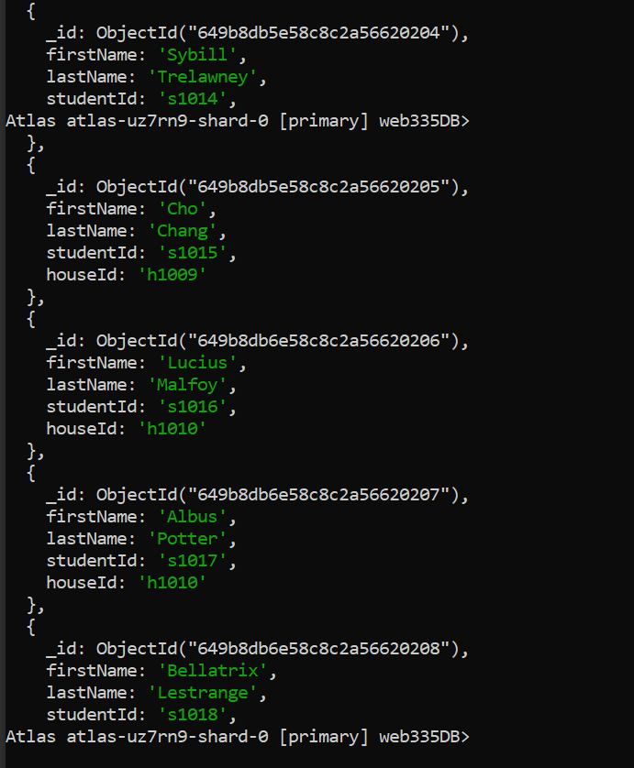

Query to add a document to the student’s collection



Query to validate new student document has been added

Query to delete newly created document

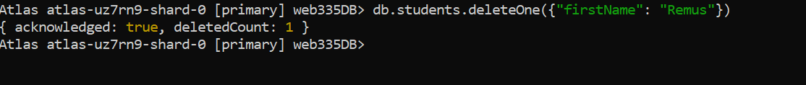

Query to show a list of students by house

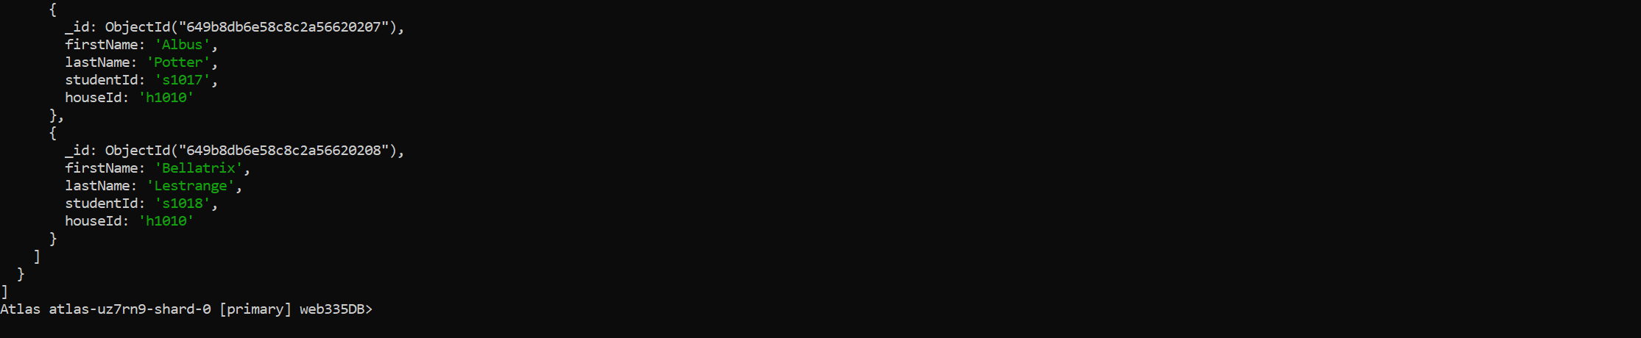

Query to show a list of students for house Gryffindor

Query to show a list of students for Eagle Mascot

