**Assignment 8.2 – ComposerAPI Part 2**

**Swagger:**

**UpdateComposerById**

Successful update:

Incorrect _id error response: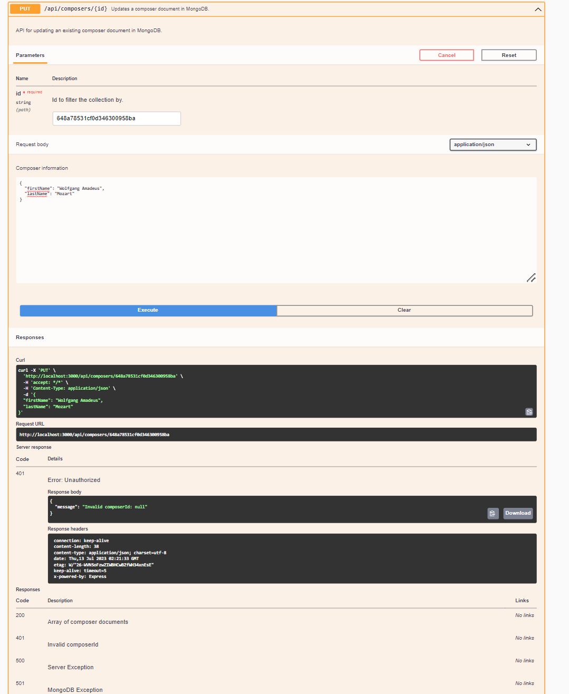

**SoapUI:**

**deleteComposerByID:**

