**Assignment 9.2 - Capstone**

**Swagger:**

**createTeam:**

**

**assignPlayerByTeam**

**SoapUI:**

**findAllPlayersByTeamId:**

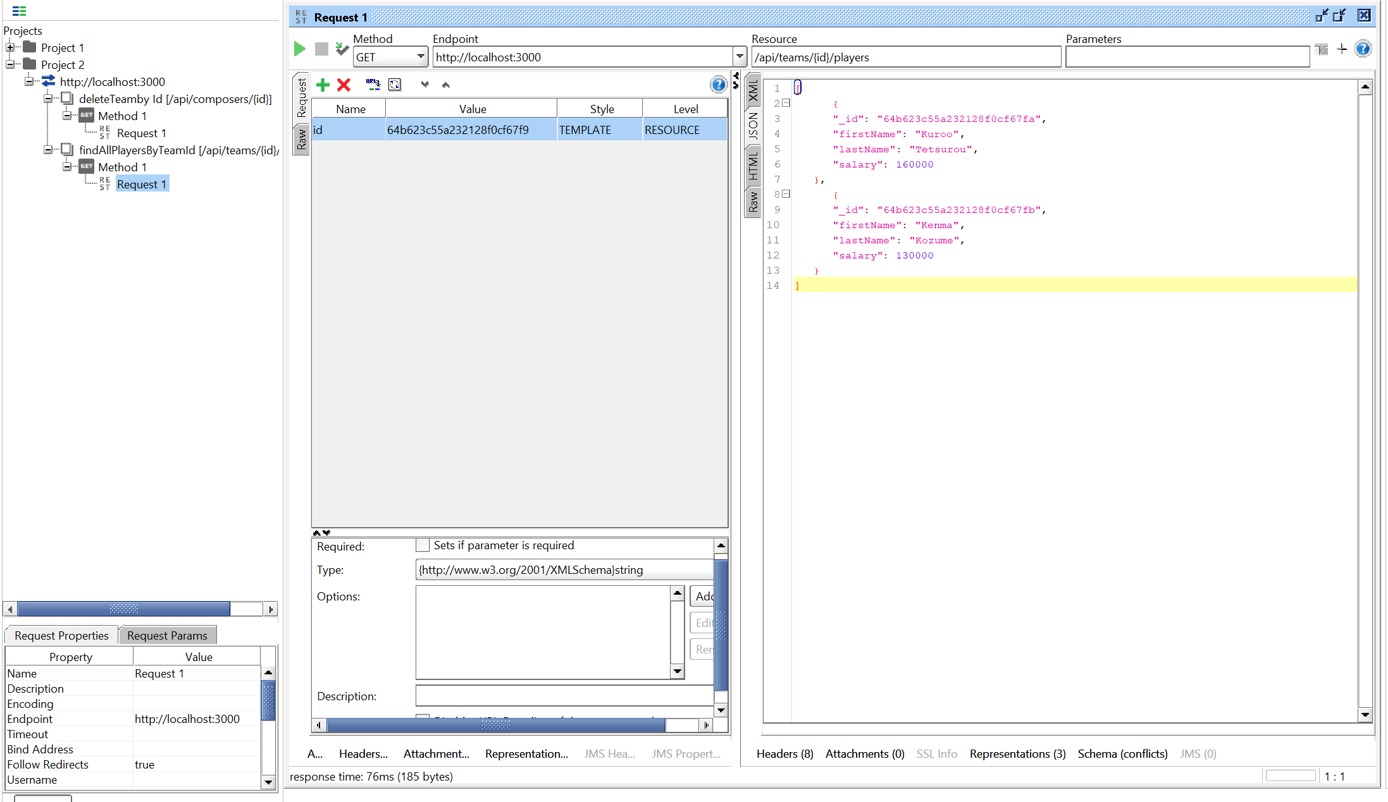

**DeleteTeamById:**

