INTERNSHIP-REPORT

CHERAT CEMENT

MUHAMMAD JUNAID HAMEED

POST-ADP BS BMA

F2023421009
2023-2025

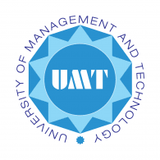

Table of Contents
Scanned Copy 3
Acknowledgement 4
Executive Summary 5
Overview of the Organization 6
Organizational Structure 8
My Internship Program 11
Training Program 12
My Learning 13
Critical Analysis 15
Swot Analysis 15
Conclusion 17
Recommendations 17
References and Sources 18

Scanned Copy
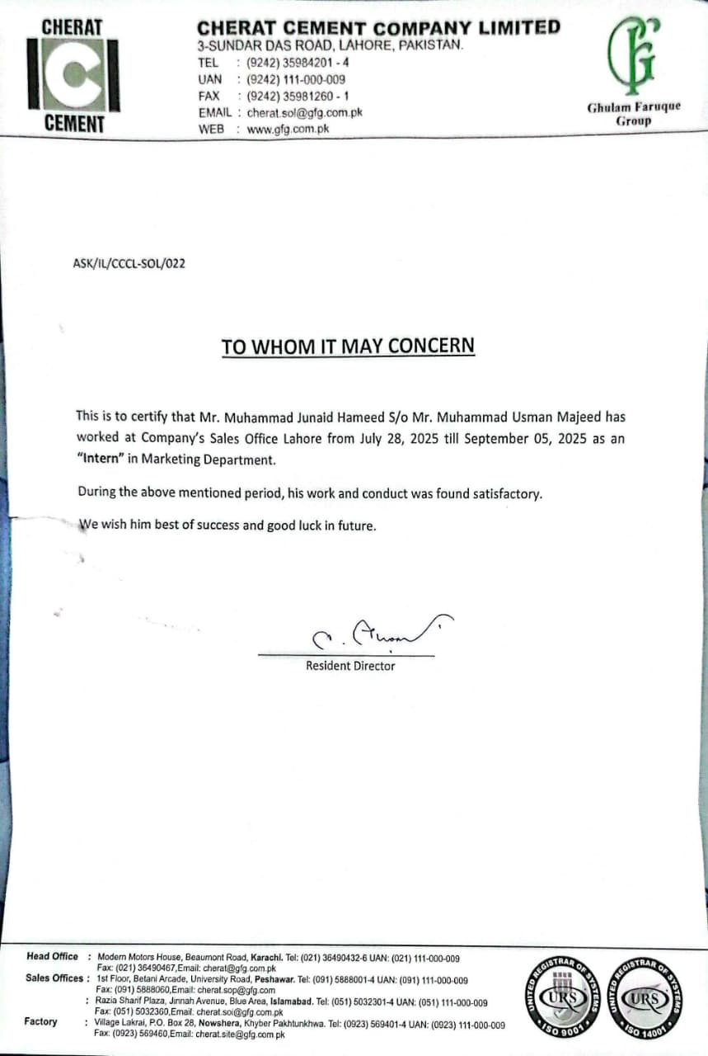

Acknowledgement

I would like to extend my profound gratitude to Mr. Nadeem Ahmad Khan, General Manager Marketing at the Lahore Sales Office of Cherat Cement, whose guidance and mentorship were instrumental throughout the course of my internship. His professional expertise, insightful suggestions, and constant support provided me with the opportunity to enhance my knowledge and understanding of the sales and marketing functions in a highly competitive industry.

Mr. Nadeem Ahmad Khan not only guided me in performing my assigned tasks but also encouraged me to observe, analyze, and learn from real-world business practices. His willingness to share his vast experience, along with his patience in addressing my queries, contributed significantly to my personal and professional growth. I am sincerely grateful for the time and effort he devoted to ensuring that my internship experience was both meaningful and productive.

I am also indebted to the management and staff of Cherat Cement for providing a cooperative and learning-oriented environment, which enabled me to carry out my internship responsibilities effectively. Their support and professionalism made my stay at the organization both comfortable and rewarding.

Furthermore, I wish to express my appreciation to my family for their encouragement and moral support during this period, as well as to my university and instructors for equipping me with the academic foundation that prepared me to undertake this internship.

This report is a reflection of the collective guidance, support, and encouragement I received, and I remain deeply thankful to all those who contributed to its successful completion.

Executive Summary

This internship report provides an overview of the valuable experience I gained during my internship at the Sales and Marketing Department of Cherat Cement, one of the leading cement manufacturers in Pakistan. Established in 1982 as part of the Ghulam Farooq Group, the company has built a strong reputation for producing high-quality cement and contributing significantly to the country’s construction and infrastructure sectors. Over the years, Cherat Cement has expanded its production capacity and modernized its operations to meet the growing demand for cement both domestically and regionally.

The company operates with a broad distribution network and supplies cement to multiple regions across Pakistan, including major markets in Lahore, Gujranwala, Sialkot, Kasur, and surrounding areas. Its long-standing presence and continuous growth reflect the vision of Mr. Ghulam Farooq, whose diversified business portfolio spans across several industries.

During the course of my internship, I was able to closely observe the operational and strategic dimensions of the sales and marketing functions. I discovered how the company’s logistics department efficiently manages the transportation and supply chain of cement, ensuring timely delivery to dealers across different cities. The experience highlighted the importance of coordination between logistics and sales for maintaining smooth business operations.

Additionally, I learned how the sales function is primarily managed through dealership arrangements. The cement sales take place through an extensive dealer network where weekly pricing is mutually decided between the company and the dealers. This practice not only strengthens the relationship between the company and its partners but also ensures transparency and fairness in dealings. One of the most notable observations was the company’s commitment to maintaining strong and long-term relationships with its dealers, offering consistent support and care to sustain mutual growth.

Generally, the internship has enabled me to have practical exposure and hands-on experience on the working environment in a top cement company. I gained a clear picture of the sales process, dealership processes, logistics management and customer relationship strategies. The internship has not only improved my professional skills but it has also given me knowledge on how the concepts of sales and marketing that can be learned in theories, can be implemented in real life situations.

Overview of the Organization

- Brief History

Cherat Cement Company Limited (CCCL) is a subsidiary of the Ghulam Faruke Group (GFG) which is one of the most reputable business groups in Pakistan that has diversified business interests in cement, sugar, packaging, trading and other industrial sectors. Commercial production by the company started in 1985 with the initial production line located at Nowshera District, Khyber Pakhtunkhaw. Cherat Cement is one of the biggest cement manufacturers in the country because it has increased its capacity over the years through the incorporation of modern-fully automated manufacturing units to satisfy the large production volume. The company has been known today as being dedicated to quality, innovation and customer satisfaction and operates the domestic as well as international markets.

- Introduction of the Organization

Cherat Cement is also involved in manufacturing and selling high quality cement which is mainly used in the construction sector of Pakistan infrastructure and housing sector which is booming. The company has a well-organized distribution network which encompasses the large markets such as Lahore, Gujranwala, Sialkot, Kasur, Rawalpindi, Islamabad and Peshawar. Besides local supply, the Cherat Cement has also exported cement to the external markets and this has enhanced the presence of Pakistan in the global cement industry.

The company has a team of professionals of high calibers that guide the organization and the vision of the company is to offer sustainable and reliable cement solutions. The company has its head office in Karachi and a sales office at Lahore with a combination of strategic planning and a high level of technology ensuring efficiency in production, logistics and sales operation of the company.

- Policy of the Organization

Quality, reliability, and sustainability have always been the main principles of an organizational policy of Cherat Cement. The company aims at upholding the best practices in the manufacturing business to achieve the best technology and limit quality standards at all levels of production. Its policies go with customer satisfaction, environmental responsibility as well as employee welfare.

Besides that, the organization believes in ethical business conducts and the transparency in its transactions. It also has much emphasis on corporate social responsibility (CSR) whereby Cherat Cement participates heavily towards community development, education, health, and environmental sustainability activities in the host countries it operates.

- Competitors

The cement industry in Pakistan is highly competitive, with several well-established players operating in the market. Cherat Cement faces competition from companies such as:

Lucky Cement Limited – the largest cement producer in Pakistan.

D.G. Khan Cement Company Limited – a major competitor with a large market share.

Maple Leaf Cement Factory Limited – a leading player in central and northern regions.

Askari Cement Limited and Bestway Cement Limited – significant competitors in the northern zone.

Despite this strong competition, Cherat Cement has been able to maintain a solid market position due to its consistent product quality, efficient logistics, strong dealer network, and customer-focused policies.

Organizational Structure

- Organizational Hierarchy Chart

The Cherat Cement Company Limited (CCCL) adheres to the hierarchical organization structure and it could be summed up as follows:

- The board of directors is at the top headed by the senior leadership of the Ghulam Faruque Group.

- Below the Board is Chief Executive Officer (CEO) who reports to the Board and is in charge of making the overall strategic decisions.

- The CEO is followed by key functional heads such as Chief Operating Officer (COO), Chief Financial Officer (CFO), Chief Technical Officer (CTO), Head of Marketing/ Sales, Head of Logistics/ Supply Chain, Head of Human Resources, Head of Quality and Safety and other Department heads. These are the heads of departments that run their own divisions and report to the COO or the CEO according to the company policy.

- Number of Employees

Cherat Cement currently employs approx. 945 employees as of June 30, 2025.

- Main Offices
Cherat Cement's main offices include:

Head Office: Modern Motors House, Beaumont Road, Karachi, Sindh.

Factory/Plant: Village Lakrai, District Nowshera, Khyber Pakhtunkhwa (KPK) Province.

Sales Offices / Branches: Lahore (Punjab), Peshawar (KPK), Islamabad, and other regional offices to handle marketing, distribution, and customer relations.

- Introduction of all the Departments

- Production / Manufacturing: Responsible for manufacturing of cement and clinker, managing multiple lines (Line I, Line II, Line III), ensuring operations, maintenance, quality control in plant, controlling input materials, energy management.

- Quality Assurance & Control: Ensures the cement produced meets defined standards (e.g. Ordinary Portland Cement, Sulphate Resistant Cement), testing of raw materials and finished goods, implementing ISO 9001 / 14001 standards, safety and environmental policies.

- Marketing & Sales: Manages dealer network, pricing strategy, market research, client relations, advertising / brand image, weekly price negotiations with dealers, regional sales offices oversee distribution in various cities (e.g., Lahore, Gujranwala, Sialkot, etc.). Internal coordination with logistics for supply.

- Logistics / Supply Chain: Responsible for transporting cement from the factory to depots / dealers, scheduling deliveries, fleet management, coordination with transporters, ensuring timely supply to multiple regions. Plays a critical role in ensuring that sales promises are met.

- Finance Department: Handles budgeting, financial reporting, cost accounting, payroll, audits, financial planning, tax compliance. Reports to CFO.

- Comments on the Organizational Structure

- Efficiency & Specialization: The departmental structure shows specialization, which helps ensure each function (manufacturing, marketing, logistics, etc.) has clear authority and responsibility. This is essential for a manufacturing company operating on large scale.

- Communication Flow: Given the hierarchical system, communication flows vertically (from top management down to department heads, and vice versa). Also, coordination across departments (e.g. between sales and logistics, production and quality control) is critical and seems structured.

- Flexibility: While hierarchy ensures clear accountability, there is risk of slower decision making for operational issues that require cross-departmental action. However, Cherat Cement seems to manage this via strong leadership (COO, department heads) and robust internal processes (e.g. quality control, logistics scheduling).

- Alignment with Strategic Goals: The structure is aligned with Cherat Cement’s strategic priorities — maintaining product quality, expanding market reach, ensuring supply chain reliability, and sustaining competitive advantage. The existence of departments like Quality Assurance, Logistics, and strong sales/marketing demonstrates this alignment.

My Internship Program

- Introduction of the Branch / Area Office
- My internship was conducted at the Lahore Sales Office of Cherat Cement Company Limited, located on Sunderdas Road, Lahore. This branch functions as one of the key regional sales offices of the company and plays a critical role in overseeing cement sales and distribution across Punjab, particularly in the regions of Lahore, Gujranwala, Sialkot, and Kasur.

- The Lahore office serves as a hub for managing dealer relations, negotiating weekly pricing, coordinating sales targets, and ensuring smooth supply of cement to the market through effective communication with the logistics department. The office also provides support services related to marketing and customer relationship management, thereby acting as a bridge between the company’s production facilities and its dealers.

- Starting and Ending Dates of the Internship

- I commenced my internship on 28th July 2025 and successfully completed it on 5th September 2025. This six-week period allowed me to gain valuable professional exposure to the practical aspects of sales and marketing operations within the cement industry.

- Departments of Training and Duration

- During my internship, I was placed in the Sales Department of Cherat Cement. The training lasted for a total duration of six weeks. My responsibilities primarily revolved around observing and learning the processes of dealership management, sales negotiation, coordination with the logistics department, and understanding the mechanisms through which cement is supplied to various regions of Punjab.

- This placement provided me with a hands-on understanding of the sales function in a large-scale industrial organization and gave me an opportunity to observe how theoretical marketing and management concepts are applied in practice.

Training Program

- Operations and Activities of the Department

- During my internship, I worked in the Sales Department of Cherat Cement at the Lahore Sales Office. This department is responsible for managing the company’s sales operations, building relationships with dealers, and ensuring smooth supply of cement to different regions. The key activities I observed included:

- Dealer Management: Maintaining communication with dealers, ensuring that their requirements are fulfilled, and addressing their queries.

- Sales Negotiation: Weekly pricing discussions with dealers, where rates were finalized based on market conditions and mutual agreements.

- Logistics Coordination: Working closely with the logistics department to ensure timely delivery of cement to various cities including Lahore, Gujranwala, Sialkot, and Kasur.

- Market Monitoring: Observing how the department keeps track of competitor pricing, demand fluctuations, and regional sales trends to adjust strategies accordingly.

- Customer Care: Ensuring that dealers are satisfied, as the company places strong emphasis on maintaining long-term relationships with its partners.

This exposure helped me understand how sales are not just about transactions but also about trust, coordination, and building strong networks.

- Tasks and Responsibilities Assigned to Me

- As an intern, I was assigned tasks that allowed me to actively engage with the department and learn practically. My responsibilities included:

- Preparing Sales Records: Assisting in maintaining weekly sales data and helping in updating records for dealer transactions.

- Observation of Meetings: Attending dealer meetings where I observed how pricing and supply commitments were negotiated.

- Logistics Support: Assisting in coordinating supply schedules with the logistics team to ensure dealers received their deliveries on time.

- Market Research Assistance: Helping the team in gathering information about competitor products and pricing in the local market.

These tasks provided me with hands-on learning about how the sales department functions on a daily basis, and how different activities—dealer management, logistics, and reporting—are interconnected to achieve the company’s sales objectives.

My Learning

- Learning From Internship

- The internship experience at Cherat Cement made me aware of the great chance to relate the theoretical knowledge with practical business operations. I gained an idea about the execution of sales and marketing strategies in a very competitive industry and how cement companies can use their dealer networks to grow. I also learnt the significance of logistics in having a smooth supply and how the relationship with customers is critical to long term success. Real life negotiations between the representatives of the company and dealers taught me some tips about the way in which prices can be determined and the way in which market tendencies influence the sales.
- This experience enabled me to have more insight into the professional work ethics, organization discipline and the importance of having a team to work towards a shared objective.

- Skills Development

During the course of my six-week internship, I was able to develop and enhance several professional skills, including:

- Communication Skills – I improved my ability to communicate clearly and professionally, particularly when interacting with staff members and observing dealer meetings.

- Analytical Skills – By reviewing sales records and observing pricing decisions, I developed a better understanding of analyzing market trends and interpreting business data.

- Teamwork and Collaboration – Working closely with the sales and logistics staff helped me learn how teamwork ensures efficiency and problem-solving in a professional environment.

- Time Management – I learned how to prioritize tasks and meet deadlines, especially when assisting in preparing weekly sales reports and coordinating schedules.

- Problem-Solving Skills – I gained exposure to how unexpected challenges (such as supply delays or dealer concerns) are addressed with practical solutions by the sales team.

Critical Analysis

During my internship at Cherat Cement, I was able to critically analyze the organization by comparing my academic knowledge with the practical environment of the sales and marketing department.

From a theoretical perspective, concepts of marketing management, supply chain, and organizational behavior were highly relevant to my internship. For example, in marketing theory we study the importance of building customer relationships, dealer networks, and brand loyalty. In practice, I observed how Cherat Cement places great emphasis on nurturing long-term relationships with its dealers through transparent weekly pricing, consistent support, and fair negotiations. This reinforced my understanding that in industrial marketing, customer trust is just as important as the product itself.

Similarly, in supply chain theory, the significance of logistics and distribution channels is highlighted. My internship experience confirmed this, as I observed how the logistics department coordinated with sales to ensure timely deliveries across regions such as Lahore, Gujranwala, Sialkot, and Kasur. Delays in supply could directly impact sales, showing the practical importance of efficient supply chain management.

Swot Analysis

A SWOT analysis of Cherat Cement Company Limited (CCCL) provides an insight into the internal strengths and weaknesses of the organization, as well as the external opportunities and threats it faces in the competitive cement industry of Pakistan.

- Strengths

- Strong Brand Reputation: Cherat Cement has been operating since 1982 and is recognized as a reliable brand that delivers high-quality cement.

- Modern Production Facilities: With continuous expansion and upgradation of manufacturing lines, the company benefits from improved efficiency and consistent product quality.

- Weaknesses

- Regional Concentration of Sales: A significant portion of sales is concentrated in the northern region, making the company vulnerable to regional demand fluctuations.

- Lower Brand Visibility in Exports: Although Cherat Cement has exported to international markets, its global footprint remains limited compared to some competitors.

- Opportunities

- Expansion into Export Markets: By leveraging Pakistan’s geographic position, Cherat Cement can expand its exports to Afghanistan, Central Asia, and beyond.

- Market Diversification: Exploring southern and coastal markets in Pakistan may help reduce dependence on northern regions and increase market share.

- Threats

- Intense Competition: With over a dozen well-established cement companies in Pakistan, competition on pricing, distribution, and branding remains a major threat.

- Economic Instability: Inflation, currency depreciation, and fluctuating interest rates can increase production costs and reduce profitability.

Conclusion

Based on my internship experience, as well as the critical analysis and SWOT assessment, it can be concluded that Cherat Cement Company Limited is a well-structured, competitive, and customer-oriented organization. The company has successfully positioned itself as a reliable cement manufacturer in Pakistan.

One of its greatest strengths lies in its ability to maintain long-term partnerships with dealers through transparent practices and timely support, which has helped the company sustain its reputation in a highly competitive market.

At the same time, certain weaknesses, such as limited export presence, high dependence on energy inputs, and relatively smaller market share compared to industry leaders, remain challenges that the company needs to address.

Recommendations

In light of the weaknesses and challenges identified through the critical and SWOT analyses, the following recommendations are suggested for Cherat Cement Company Limited to strengthen its operations and market position:

- Expand Export Markets

- The company should diversify into international markets such as Afghanistan, Central Asia, and the Middle East. This will reduce reliance on the domestic market and provide additional revenue streams. Establishing stronger brand visibility abroad through partnerships or trade fairs could help Cherat Cement compete with larger exporters.

- Invest in Renewable Energy Sources

- Given the company’s dependence on traditional energy inputs, it is recommended to invest in alternative sources such as waste heat recovery systems, solar power, or coal substitution with biomass. This will help mitigate rising energy costs and align with global sustainability trends.

- Enhance Market Share in Southern Regions

- Currently, sales are concentrated mainly in northern Punjab and Khyber Pakhtunkhwa. Expanding dealer networks and distribution channels in Sindh and southern Punjab would allow the company to capture new markets and balance regional dependence.

References and Sources

• Cherat Cement Company Limited – LinkedIn Profile: https://pk.linkedin.com/company/cheratcement
• EMIS Company Profile – Cherat Cement: https://www.emis.com/php/company-profile/PK/Cherat_Cement_Company_Limited_en_2438046.html
• Pakistan Stock Exchange (PSX) – Cherat Cement (CHCC) Company Profile: https://www.psx.com.pk/
• ACL (Associated Consulting) – Cherat Cement Expansion Project: https://acl.com.pk/portfolio-item/cherat-cement-line-iii-project/
• Stock Analysis – Cherat Cement Company Limited (Employees, Financials, Overview): https://stockanalysis.com/quote/psx/CHCC/company/

