# DATABASE SYSTEMS

## SEMESTER PROJECT



**Anime List System**

Submitted By:

Name: Hannan Aamir M.Noman Shahid

CMS: 287894 301448

Submitted to:

Dr. Shams Ud Din Qazi

Database relational Model:

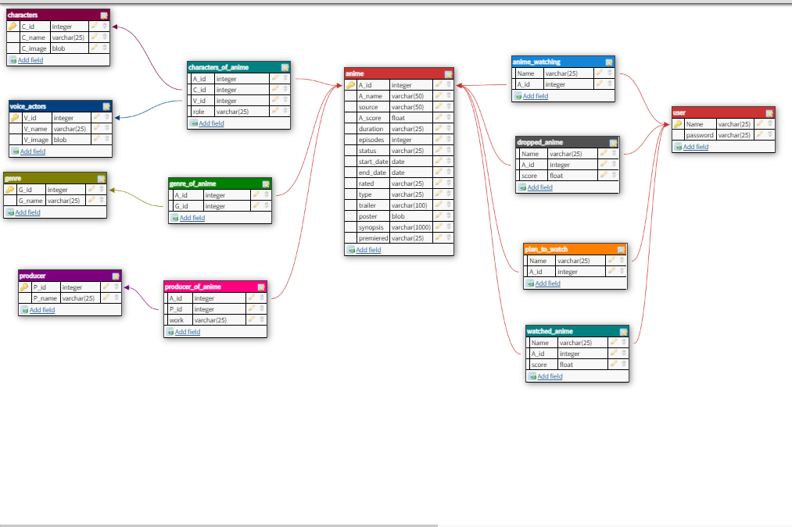

## Assumption:

We assumed that an anime had certain attributes such as an id and name along with a specific score. Then each anime had multiple genres and each genre had a name and id. We created a link table between the genre and id. And then assumed that studios or producers handle the airing and production of the anime. We gave each production studio a name and id then made a link table in which we specified the relation of each production studio with the anime such as producer, licensor, and studio etc.

For characters the assumptions were that each character has an id and name and is voice by a voice actor, but a single voice actor can voice multiple characters. So we first gave the voice actors an id then made a relation table between the anime table, characters table and voice actors table in which character of an anime is defined is voice actor as well as its role in the anime.

For the user we gave it a Name and password the name for each user will be unique and they will have a password each use will have for lists in which they can maintain their anime. In the watched anime list, they can rate the anime they have watched. This table will be related to the user and anime. Similarly they can keep a list of anime they are watching and are planning to watch and also the ones they stopped watching. Each user has their own list but in the same table.

## Functionalities:

* The anime are showed rank wise on the web page.
* All the anime can be viewed and searched without login.
* You can view the anime through its genre, studio, or name.
* You can select a certain anime and see all its details.
* You can view the characters and voice actors of the anime too.
* You can create your own account.
* In your account you can maintain your own lists.
* You can insert any anime you like into your list and delete it as well.
* Admin can remove users.