

INDIVIDUAL ASSIGNMENT

Module Code : COMP60010 02
Module Name : Enterprise Cloud & Distributed Web Apps
Batch Code : HF2561 SE / July Intake

Student ID : CB011253
Student Name : Mohamed Hanaan Mohamed Munas

Hand-Out Date : 23rd May 2026
Hand-In Date : 5th June 2026

Report To : Mr. Yogendrajah Sivanujan

INSTRUCTION TO CANDIDATES
- Students are advised to underpin their answers with the use of references (cited using the Harvard Referencing Style).
- Late submission will be awarded zero (0) unless extenuating circumstances (EC) are upheld.
- Cases of plagiarism will be penalized.
- The assignment should be submitted as a soft copy:
  - The soft copy of the written assignment and source code must be uploaded to the given link in the LMS.

AeroLink
Enterprise Cloud & Distributed Web Application

Executive Summary
AeroLink is a cloud-native airline operations platform developed to address the limitations of traditional monolithic applications in managing modern airline services. The system supports the core passenger journey, including user registration and authentication, flight search, seat reservation, payment processing, web check-in, boarding pass generation, and baggage tracking. Rather than relying on a single application, AeroLink adopts a microservices architecture where each business function operates as an independent service with its own data store and deployment lifecycle. This approach improves scalability, maintainability, and operational flexibility while allowing services to evolve independently.
The platform is built on Amazon Web Services (AWS) and uses event-driven architecture to enable communication between services through Apache Kafka. Key architectural patterns such as Microservices, Saga, and Command Query Responsibility Segregation (CQRS) are employed to support distributed transactions, data consistency, and high-performance access to critical information such as seat availability. Infrastructure provisioning and deployment are automated through Terraform, Kubernetes, and GitOps practices, enabling reliable and repeatable releases. By combining cloud-native technologies with distributed systems principles, AeroLink provides a resilient, scalable, and extensible foundation for airline operations.

Table of Contents
Executive Summary 3
1. Introduction 5
1.1 Context and Motivation 5
1.2 Aims and Objectives 6
1.3 Scope and Boundaries 6
1.4 Technology Selection 7
1. Cloud Based Web Application Design – Task 01 9
2.1 Architecture Overview 9
2.2 Microservice Breakdown 10
2.3 Containerization 11
2.4 Serverless Computing 12
2.5 Cloud Managed Databases 13
2.6 High Availability and Multi-AZ Deployment 13
2.7 Horizontal Pod Auto Scaling 14
3. Distributed Web Application and API Design – Task 02 15
3.1 RESTful API Design 15
3.2 Event Driven Architecture 16
3.3 API GATEWAY 17
3.4 API Documentation 18
3.5 Secure Service to Service Communication 18
4. Data Security, Compliance and Consistency – Task 03 19
5.1 Authentication and Authorization 19
5.2 Role Based Access Control 19
5.3 Encryption 20
5.4 Compliance Considerations PCI-DSS and GDPR 21
5.5 Distributed Data Consistency 22
6. Real Time Data Synchronization – Task 04 23
5.1 WebSocket Implementation 23
5.2 Live Seat Availability 23
5.3 Live Baggage Tracking 23
5.4 Event-Driven Synchronisation 24
7. Fault Tolerance and Resilience – Task 05 25
6.1 Circuit Breaker Pattern 25
6.2 Saga Pattern and Compensating Transactions 26
6.3 Auto-Scaling and Load Balancing 28
8. Performance and Scalability Testing – Task 06 30
9. Monitoring and Observability – Task 07 31
9.1 Metrics and CloudWatch 31
9.2 Health Checks 31
9.3 Structured Logging 31
9.4 Distributed Tracing 31
10. Testing Strategy – Task 09 32
10.1 Unit Testing 32
10.2 Integration Testing 34
10.3 API and Performance Testing 34
10.4 Test Coverage Summary 35
11. Delivery Automation and Implementation. 36
11.1 Continuous Integration (GitHub Actions) 36
11.2 Container Build and Registry 36
11.3 Continuous Deployment 36
11.4 Infrastructure as a Code (Terraform Automation) 37
11.5 Application Implementation 38
12. Reflection and Future Enhancement 39
12.1 Challenges Faced 39
11.2 Lessons Learned 39
11.3 Future Improvements 39
13. Appendices 41
References 41

Introduction

1.1 Context and Motivation
Airlines depend on a web of interlocking digital services. Scheduling, ticketing, check-in, baggage handling, payment settlement and integration with airports and immigration authorities must all operate continuously and consistently. When these functions are delivered by a single monolithic application they become difficult to scale selectively, slow to release, and fragile: a defect or saturation point in one subsystem can propagate to unrelated ones because they share a process and a database.
AeroLink addresses this by modelling the airline domain as a collection of bounded contexts and implementing each as a standalone service. The booking workflow, which naturally spans several of these contexts, is coordinated through domain events rather than synchronous calls, so that the services remain loosely coupled. This introduction sets out the objectives the implementation pursues, the boundaries of what was built, and the technologies selected to build it.

1.2 Aims and Objectives
The project pursues the following objectives, each of which maps to one or more of the assessed criteria of architecture design, implementation, and testing and results.
# | Objective
O1 | Decompose the airline domain into independently deployable microservices, each owning its data and exposing a documented API.
O2 | Provision the supporting AWS environment as reusable Infrastructure-as-Code and deploy it to Kubernetes through a GitOps workflow.
O3 | Coordinate the distributed booking transaction with an event-driven Saga and compensating actions in place of a cross-service ACID transaction.
O4 | Protect customer data through layered authentication, role-based authorisation, encryption, and alignment with GDPR and PCI-DSS obligations.
O5 | Propagate operational state changes — seat availability, baggage status, flight updates — across services with minimal delay.
O6 | Achieve fault tolerance through circuit breaking, retries, health-checked autoscaling and a documented recovery strategy.
O7 | Establish automated quality gates: unit, integration and API testing, plus load and stress testing under a defined methodology.

1.3 Scope and Boundaries
The delivered system comprises seven Node.js (NestJS) microservices, one AWS Lambda function for boarding-pass code generation, and a React single-page web client. These run against managed AWS data services and are deployed to an Elastic Kubernetes Service (EKS) cluster. The following capabilities are within scope:
- Seven domain services — identity, flight, booking, payment, check-in, baggage and notification — plus a serverless QR/barcode generator.
- A Kafka (Amazon MSK) event backbone carrying sixteen domain topics and a dead-letter queue, with schema-validated event envelopes.
- A choreography-based Saga for booking, with compensation on payment or seat-lock failure.
- Terraform modules for the AWS environment and an ArgoCD ApplicationSet for continuous deployment.
- A k6 performance-testing harness and a Jest test suite spanning unit and integration levels.
The following are explicitly out of scope or only partially realised, and are revisited in Section 11: a native mobile client; multi-region active-active replication (the infrastructure is reproducible across regions but is not run active-active); integration with real airline distribution systems; and runtime federation with AWS Cognito and a live WebSocket channel, both of which are provisioned in infrastructure but not yet connected to application logic.

1.4 Technology Selection
Technologies were chosen for fitness to the bounded context rather than uniformity. The table below records each principal technology, its role in the system, and the reasoning behind its selection.
Technology | Role | Justification
NestJS on Fastify (TypeScript) | Service runtime for all seven services | Opinionated module/DI structure gives consistent service skeletons; the Fastify adapter lowers HTTP overhead; TypeScript shares types with the events package.
Prisma ORM | Relational data access (5 services) | Type-safe queries generated from a schema; supports the per-service database pattern with one toolchain.
React 19 + Vite | Web client | Component model and fast build for a single-page operations console with role-aware views.
Apache Kafka (Amazon MSK) | Event backbone | Durable, partitioned log enabling choreography, replay from offset, and lag-based autoscaling.
Amazon Aurora PostgreSQL | Transactional store (5 logical DBs) | ACID guarantees per service with managed Multi-AZ failover on one cost-efficient cluster.
Amazon DynamoDB | Baggage and notification store | Schema-flexible document model with conditional writes for the baggage state machine.
Amazon ElastiCache (Redis) | CQRS read model and distributed locks | Sub-millisecond seat-map reads and atomic SET NX locking to prevent double-booking.
AWS Lambda | Boarding-pass QR/barcode generation | Bursty, stateless, CPU-bound work invoked only at check-in; scales to zero between flights.
Amazon EKS + Helm | Container orchestration | Managed Kubernetes for self-healing, autoscaling and per-service Helm release management.
Terraform (19 modules) | Infrastructure-as-Code | Declarative, reviewable, reproducible provisioning of the whole AWS estate.
GitHub Actions + ArgoCD | CI and GitOps CD | Selective build/test on change, then declarative reconciliation of cluster state from Git.
AWS KMS, WAF, GuardDuty | Security services | Customer-managed encryption keys, edge filtering and continuous threat detection.
OpenTelemetry | Distributed tracing | Vendor-neutral auto-instrumentation of HTTP, Kafka, PostgreSQL and the AWS SDK.
Jest + k6 | Testing | Unit/integration testing and scripted load, stress and spike testing respectively.

Cloud Based Web Application Design – Task 01

Architecture Overview
AeroLink adopts a layered cloud-native architecture designed to support scalability, resilience, and independent service evolution. The platform is deployed as a collection of stateless microservices running on Amazon EKS, with managed AWS services providing networking, data storage, messaging, and security capabilities. This separation of responsibilities enables individual components to scale and operate independently while maintaining clear boundaries between business domains. To simplify management and improve maintainability, the overall architecture is structured into five logical layers: Edge, API, Compute, Data, and Security.
Tier | Component | Responsibility
Edge | CloudFront CDN, WAF, Route 53 | TLS termination, DDoS protection, DNS
API | API Gateway (HTTP + WebSocket) | JWT validation, rate limiting, routing
Compute | EKS cluster (2–6 Spot nodes) | Service pods, platform add-ons
Data | Aurora PG, Redis, DynamoDB, MSK | Aurora PostgreSQL consolidation
Security | KMS, Cognito, Secrets Manager, GuardDuty | Service pods, platform add-ons

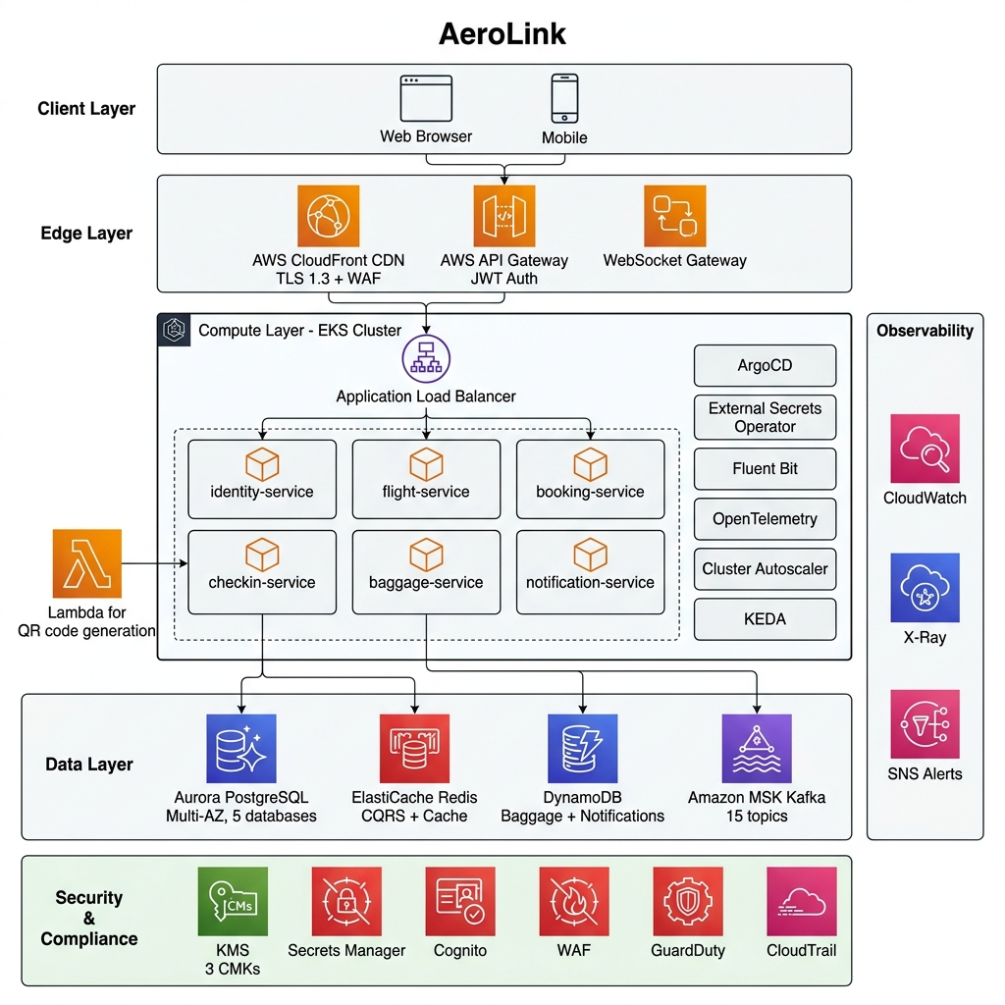
Client requests flow through CloudFront (static assets) or API Gateway (API calls), which validates JWTs via Cognito before forwarding through a VPC Link to the Application Load Balancer inside the EKS cluster. The ALB routes to the appropriate service pod based on path prefixes.

Microservice Breakdown
Each service owns a bounded context, persists in a store it alone writes to, exposes a versioned REST API, and participates in the event backbone as a producer, a consumer, or both. The table summarizes the decomposition.
Cross-cutting logic is factored into three internal packages consumed by every service:
- Event package holding Zod-validated event schemas and the canonical topic list (a single source of truth for the message contract).
- Common-middleware package providing the correlation-id middleware, the RBAC guard, the circuit breaker and retry helpers, the structured request logger and the tracing bootstrap.
- Shared-kernel package containing value objects such as money and shared constants. A continuous-integration rule forbids one service from importing another's source, enforcing the boundary in code rather than convention.
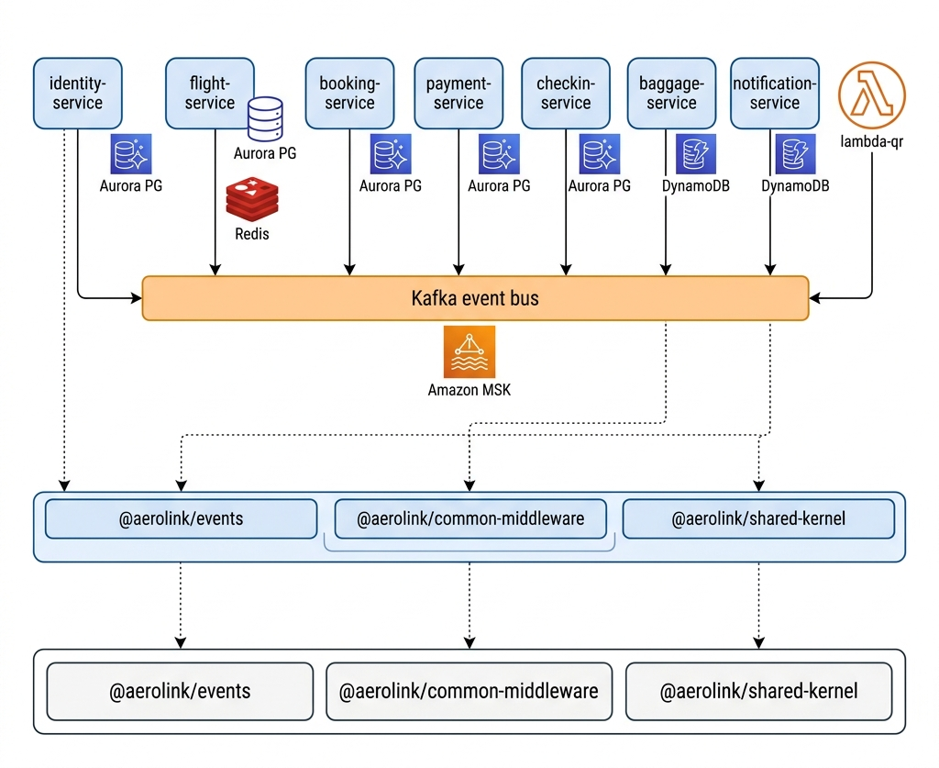

Service | Responsibility | Event Role
Identity-service | Registration, login, JWT issuance, RBAC role records | Produces user.registered
Flight-service | Flight/aircraft data, seat inventory, CQRS seat map, seat locking | Consumes booking.created;  produces seat.lock-confirmed / failed
Booking service | Booking lifecycle and Saga coordination via a saga-history log | Produces booking.;  consumes seat-lock. and payment.
Payment-service | Stripe charge and refund with PCI-safe storage | Consumes payment-initiated;  produces payment.completed / failed
Checking-service | Web check-in, boarding pass, synchronous Lambda QR invocation | Produces checkin.completed
Baggage-service | Seven-state baggage finite-state machine, barcode scanning | Produces baggage.tag-created /  status-updated
Notification-service | Email (SES) and SMS (SNS) dispatch, message persistence | Consumes events across all domains
Lambda-qr | QR and Code128 boarding-pass image generation | Invoked synchronously by checkin-service

Containerization
Every service is packaged with a multi-stage Docker build.
- A first stage on a Node 22 base installs dependencies, generates the Prisma client, compiles the shared packages and the service, then prunes development dependencies
- Second stage copies only the built artefacts and production modules into a slim runtime image.
- Several hardening controls are applied so that the running container conforms to least privileged expectations.
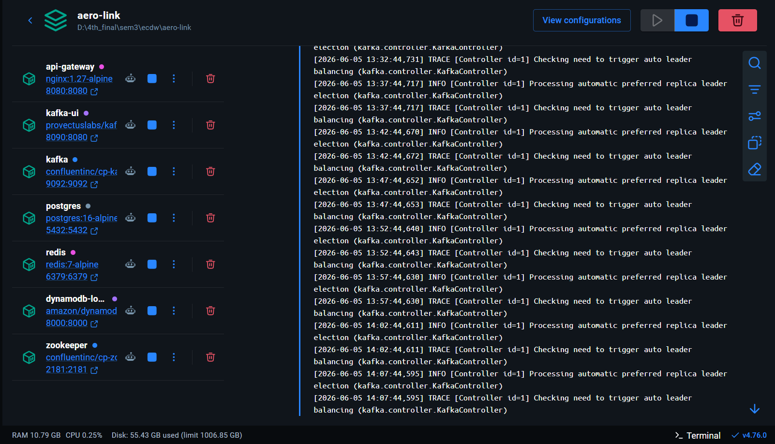

Serverless Computing
Boarding-pass QR and barcode rendering is delegated to an AWS Lambda function deployed as a container image.
This work is a good fit for serverless execution: it is stateless, CPU-bound, and only needed during check-in, so paying for always-on computes would be wasteful. The check-in service invokes the function synchronously through the AWS SDK, wrapped in a circuit breaker; if the function is unavailable the service falls back to issuing a text-only boarding pass, and a local development flag substitutes a placeholder image, so the workflow runs without AWS.
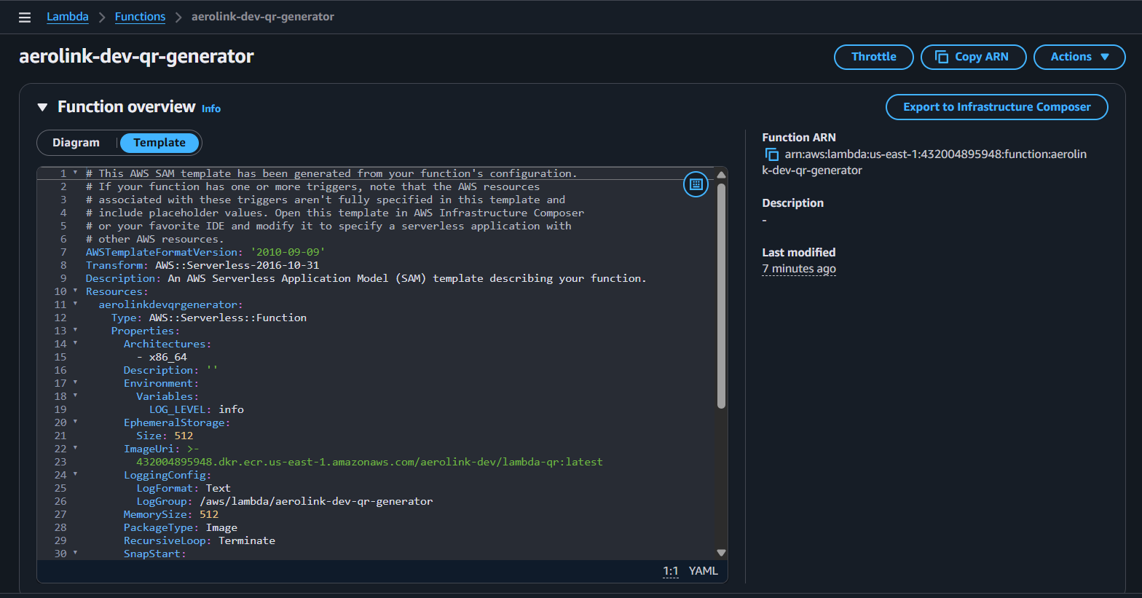
Configuration :
Property | Value
Runtime | Node.js 22 (container image)
Memory | 256 MB
Timeout | 30 seconds
VPC | Deployed in private subnets (same VPC as EKS)
Security | Accessible only from checkin-service's IRSA role
Runtime | Node.js 22 (container image)

Cloud Managed Databases
Rather than imposing one database on every service, the design selects a store per access pattern. Five services share a single Aurora PostgreSQL cluster, but each uses a logically separate database, preserving the per-service ownership rule while keeping cost low.
The flight service additionally uses Redis as a CQRS read model and as a distributed lock manager. The baggage and notification services use DynamoDB, whose key-access model and conditional writes suit the append-and-update nature of baggage events and notification records; secondary indexes on barcode, booking and flight support the query paths the services need.
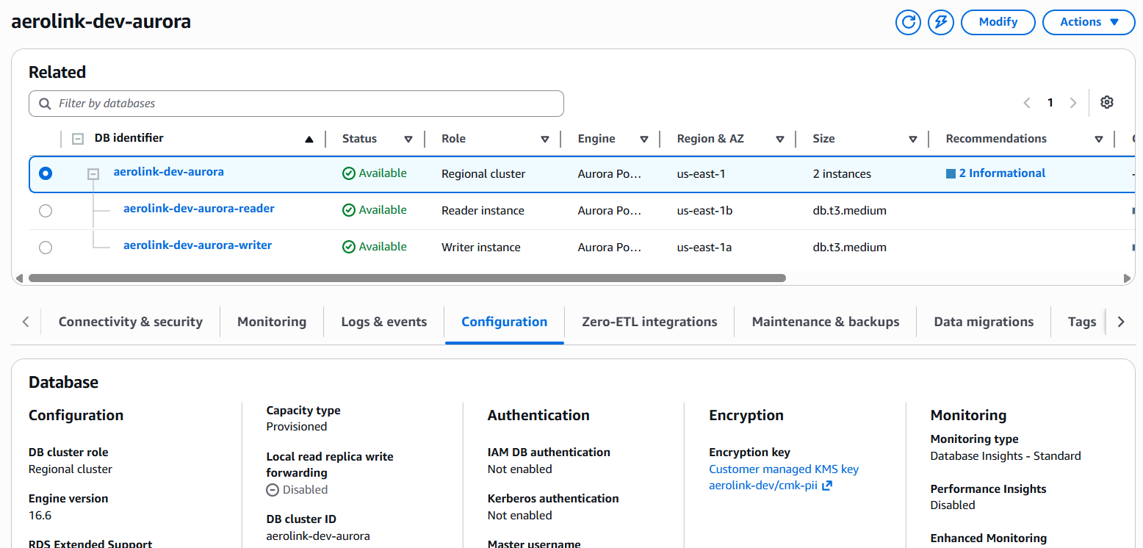
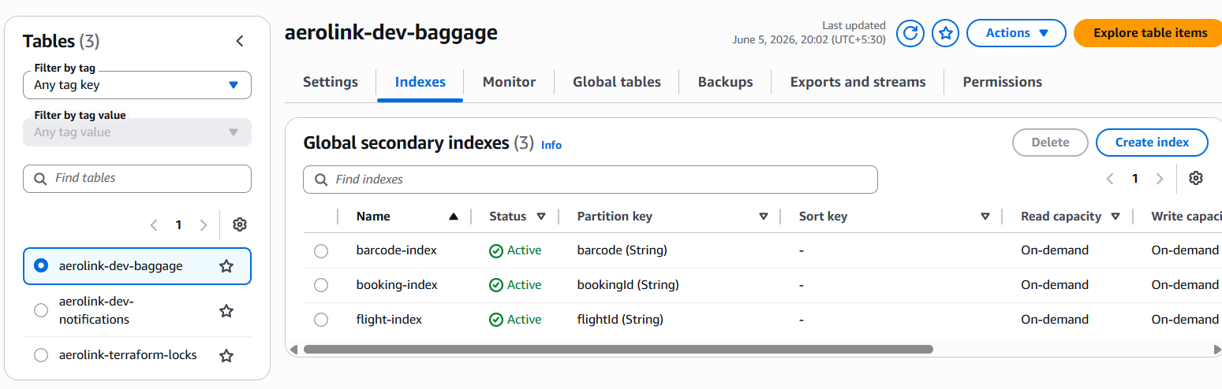

High Availability and Multi-AZ Deployment
Stateful components are replicated across two availability zones.
Aurora runs a writer in one zone and a reader in another with automatic failover; ElastiCache runs a primary with a replica; and MSK runs one broker per zone. At the application tier, each Deployment runs at least two replicas, a PodDisruptionBudget keeps at least one replica available during voluntary disruptions such as node drains, and topology-spread constraints distribute replicas across nodes.
Multi-region operation is supported in the sense that the Terraform modules can recreate the estate in another region, but the system is not run active-active; this distinction is made explicit because the assessment asks specifically about multi-region deployment.
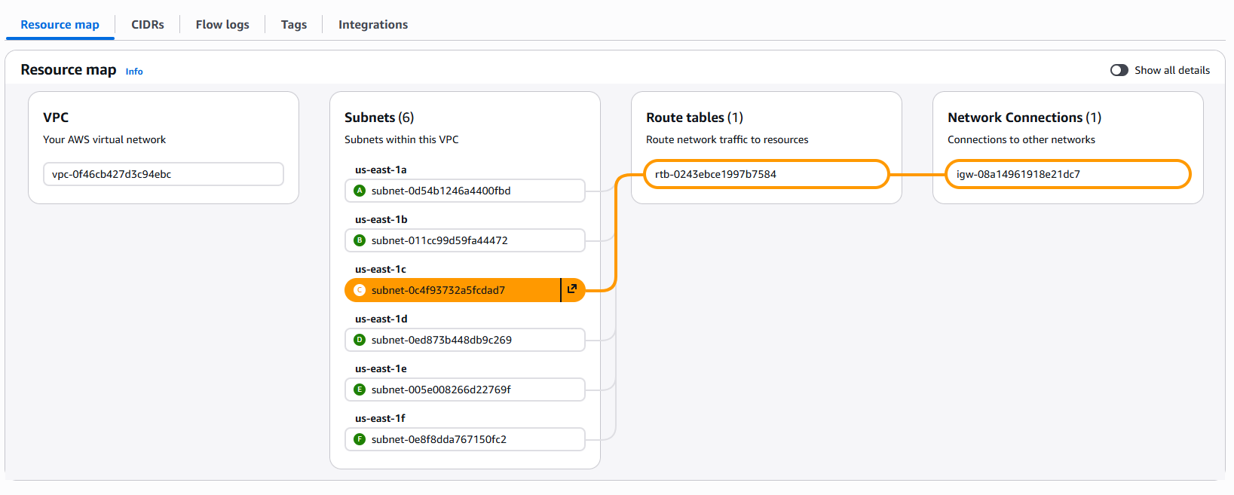

Horizontal Pod Auto Scaling
Scalability is done at both pod and node level.
Scaler | Trigger | Range
HPA (Horizontal Pod Autoscaler) | CPU > 70% | 2 → 6 pods per service
KEDA (Event-Driven Autoscaler) | Kafka consumer lag > threshold | 2 → 6 pods (baggage, notification)
Cluster Autoscaler | Pending pods (insufficient node capacity) | 2 → 6 t3.medium Spot nodes
HPA (Horizontal Pod Autoscaler) | CPU > 70% | 2 → 6 pods per service
KEDA (Event-Driven Autoscaler) | Kafka consumer lag > threshold | 2 → 6 pods (baggage, notification)
Cluster Autoscaler | Pending pods (insufficient node capacity) | 2 → 6 t3.medium Spot nodes

KEDA is used specifically for baggage-service and notification-service because their workload is driven by Kafka event volume rather than HTTP request load. When consumer lag exceeds the threshold, KEDA scales out additional consumer pods.
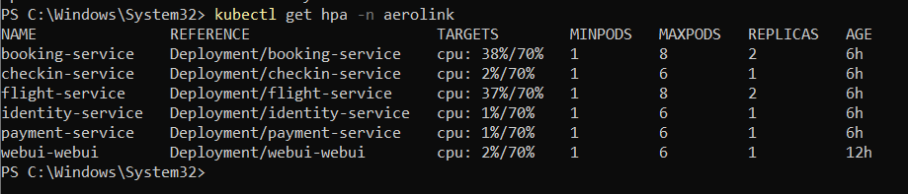

Distributed Web Application and API Design – Task 02

RESTful API Design
Every service exposes a versioned REST API under a common prefix and applies a global validation pipe that strips unknown properties and coerces types from the declared DTOs.
List endpoints are paginated; write endpoints accept an idempotency key so a retried request does not create a duplicate; and a correlation identifier is attached to every request and carried through to the events the request triggers.
The booking endpoint is deliberately asynchronous: creating a booking return 202 Accepted because the work continues as a Saga across several services, and the client then polls the booking's status or, in future, receives a push update.
Scaler | Trigger
Base path | /api/v1/{resource}
Versioning | URI path (v1)
Status codes | 200 OK, 201 Created, 202 Accepted (async), 4xx, 5xx
Pagination | ?page=1&limit=20 with PaginatedResult<T> wrapper
Idempotency | Idempotency-Key header on write operations
Correlation | X-Correlation-ID header propagated across all services

POST /api/v1/auth/register -> 201 Created
POST /api/v1/auth/login -> 200 OK { accessToken, refreshToken }
GET /api/v1/flights?origin=LHR -> 200 OK (paginated)
POST /api/v1/bookings -> 202 Accepted (saga begins)
GET /api/v1/bookings/:id -> 200 OK { status, sagaHistory[] }
POST /api/v1/checkin -> 201 Created { boardingPass }
GET /api/v1/baggage/:barcode -> 200 OK { status, history[] }

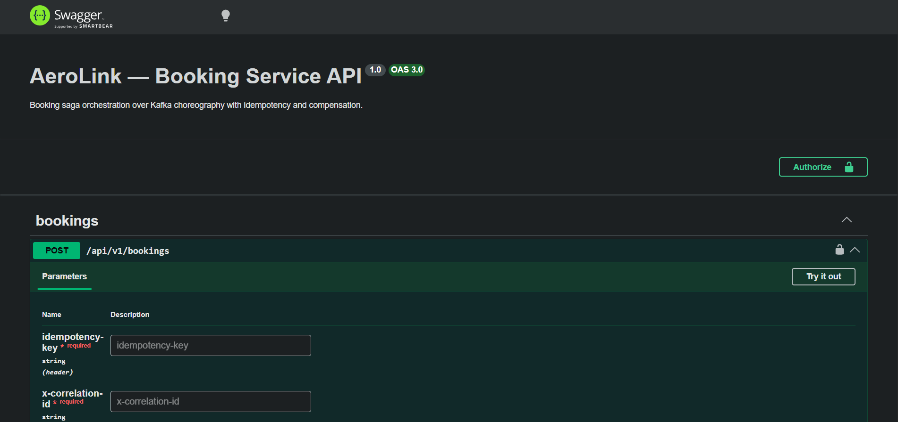

Event Driven Architecture
Inter-service coordination uses Kafka in a choreography style: each service publishes facts about what has happened in its domain and subscribes to the facts it cares about, with no central orchestrator issuing commands. Every message conforms to a shared envelope defined and validated with Zod, so producers and consumers agree on the contract at compile time and reject malformed messages at runtime.
BaseEventSchema = {
eventId: uuid, // unique per event
eventType: string, // e.g. 'aerolink.booking.created'
occurredAt: ISO-8601 datetime,
correlationId: uuid, // ties the event to its originating request
causationId?: uuid, // the event that caused this one
version: positive int // schema version
}

The platform defines sixteen domain topics plus a dead-letter queue. Topics are created idempotently at start-up because the MSK cluster disables automatic topic creation; the helper skips topics that already exist and tolerates a missing admin permission rather than crash-looping. The most significant flows are summarized below.
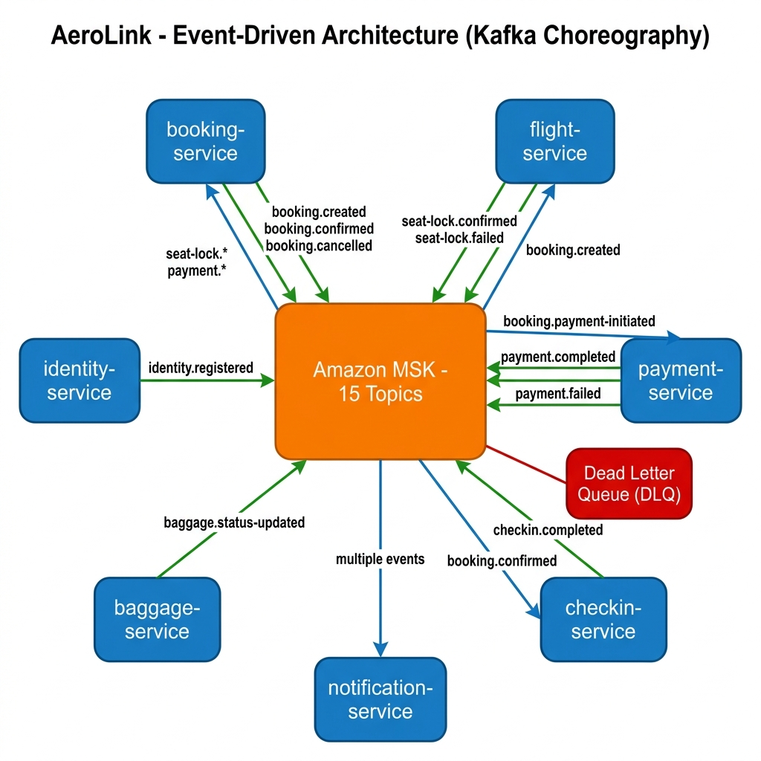
Topic | Producer | Consumer(s) | Purpose
Booking.created | Booking | Flight | Begin the Saga; request a seat lock.
Seat.lock-confirmed | Flight | Booking | Seat secured; advance to payment.
Seat.lock-failed | Flight | Booking | Seat unavailable; cancel the booking.
Booking.payment-initiated | Booking | Payment | Request the Stripe charge.
Payment.completed | Payment | Booking | Confirm the booking.
Payment.failed | Payment | Booking | Trigger compensation.
Booking.confirmed | Booking | Checkin, notification | Enable check-in; send confirmation.
Baggage.status-updated | Baggage | Notification | Notify the passenger of a bag scan.
User.registered | Identity | Notification | Send a welcome message.

API GATEWAY
AWS API Gateway acts as the primary entry point for external client requests. The platform provisions both an HTTP API and a WebSocket API using Terraform, with the HTTP API configured to support JWT-based authentication through Amazon Cognito and backend integration through a VPC Link to the Application Load Balancer within the EKS environment. The gateway is also associated with a custom domain managed through Route 53 and secured using AWS Certificate Manager (ACM).
At the current stage of implementation, API Gateway and its Cognito JWT authorizer are fully provisioned as infrastructure components. However, authentication in the running application is currently performed using tokens issued by the Identity Service, with user identity information forwarded to downstream services through request headers. Similarly, while the WebSocket API and its standard routes have been provisioned, they are not yet integrated into the active application workflow. These capabilities remain planned enhancements and are identified as future work within the project roadmap.
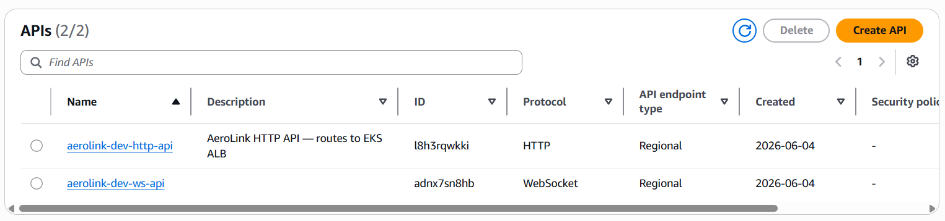

API Documentation
Every microservice exposes interactive Swagger UI at /docs and the raw OpenAPI JSON spec at /docs/json.
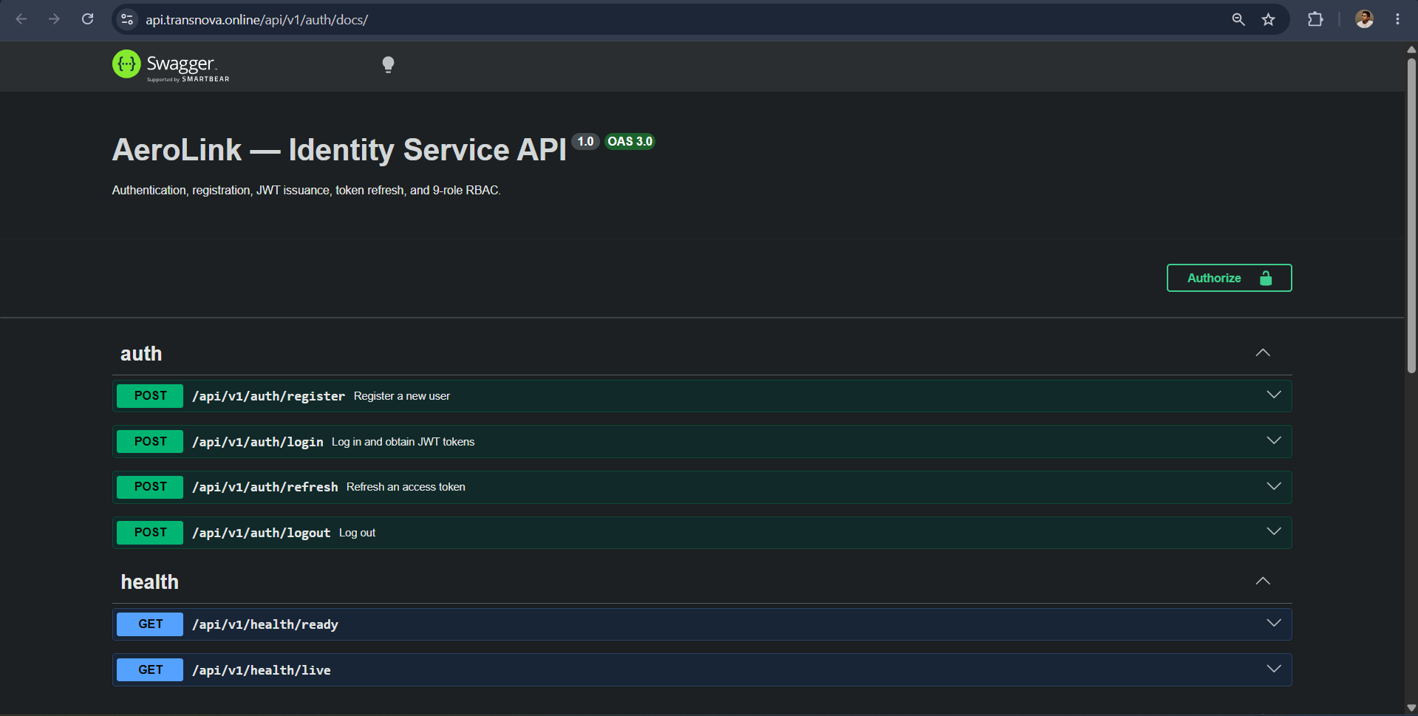

Secure Service to Service Communication
AeroLink enforces a strict service-to-service communication model in which microservices do not directly invoke each other’s REST APIs to complete business workflows. Instead, all inter-service interaction is handled asynchronously through Apache Kafka. This approach provides temporal decoupling between producers and consumers, allowing services to operate independently and recover from temporary failures by resuming processing from their last committed offset. It also creates a durable event log that supports traceability and auditing across the system.
Security for inter-service messaging is enforced through Amazon MSK, which requires TLS encryption for all in-transit communication and uses a customer-managed AWS KMS key for data at rest. Each Kubernetes pod authenticates to the Kafka cluster using IAM Roles for Service Accounts (IRSA), ensuring short-lived, identity-based access without shared credentials. The only exception to the asynchronous model is the check-in workflow, where the check-in service invokes an AWS Lambda function to generate QR-based boarding passes. This synchronous interaction is secured using IRSA authentication and protected with a circuit breaker pattern, with a fallback response available in case of service degradation.
Topic | Producer
Temporal decoupling | Producer and consumer need not be online simultaneously
Guaranteed delivery | Kafka retains messages for 7 days; consumers resume from last offset
SASL/IAM authentication | Each pod authenticates to MSK using its IRSA role — no shared passwords
TLS encryption | All broker-to-broker and client-to-broker traffic encrypted

Data Security, Compliance and Consistency – Task 03

Authentication and Authorization
Authentication in AeroLink is handled through the identity service, which implements secure credential processing and token-based session management. User passwords are hashed using bcrypt (cost factor 12) and are never stored in plaintext. Upon successful login, the service issues short-lived access tokens (15 minutes) and longer-lived refresh tokens (7 days), both in the form of signed JSON Web Tokens. On the client side, tokens are kept in memory rather than persistent storage to reduce exposure to cross-site scripting attacks, and the access token is included in requests as a Bearer credential.
Although a Cognito JWT authorizer is provisioned at the API Gateway for a future edge-authentication model, the current runtime authentication flow relies on tokens issued directly by the identity service. These tokens are validated at the service layer, where role-based access control (RBAC) is enforced using a defined set of nine roles, including PASSENGER, GATE_AGENT, and ADMIN. Authorization is applied both at the API layer and within services, ensuring that access to resources is restricted not only by role but also by ownership rules, such as restricting passengers to their own booking data.
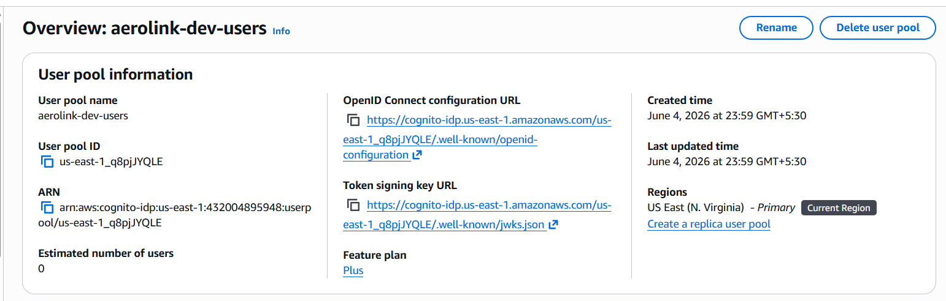

Role Based Access Control
Authorization is role-based. The identity domain defines nine roles in its schema. Protected handlers are annotated with a role’s decorator, and a guard reads the authenticated user's identity and roles from the request and rejects calls that lack a required role.
Resource-level ownership is enforced in addition to role checks: the booking service, for instance, treats a record that does not belong to the requesting passenger as not found, so a valid token for one user cannot read another user's booking. A documented permission matrix maps each role to the actions it may perform across the identity, flight, booking, payment, check-in and baggage domains.

Encryption
Encryption is applied at rest and in transit. Three customer-managed KMS keys separate data by sensitivity one for payment-card data, one for personally identifiable information, and one for infrastructure artefacts such as logs and secrets and all three have automatic annual rotation enabled.
Data in transit is protected with TLS across the public edge and on the connections from services to Aurora, Redis and the Kafka brokers. Secrets are never baked into images or environment files: they are stored in AWS Secrets Manager (and SSM parameter paths) and projected into pods by the External Secrets Operator, with IRSA ensuring a service can read only its own secrets.
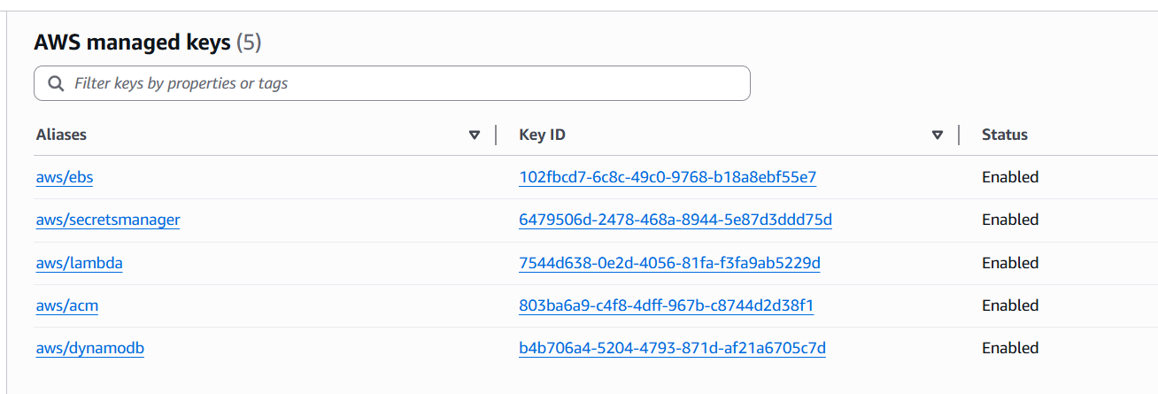
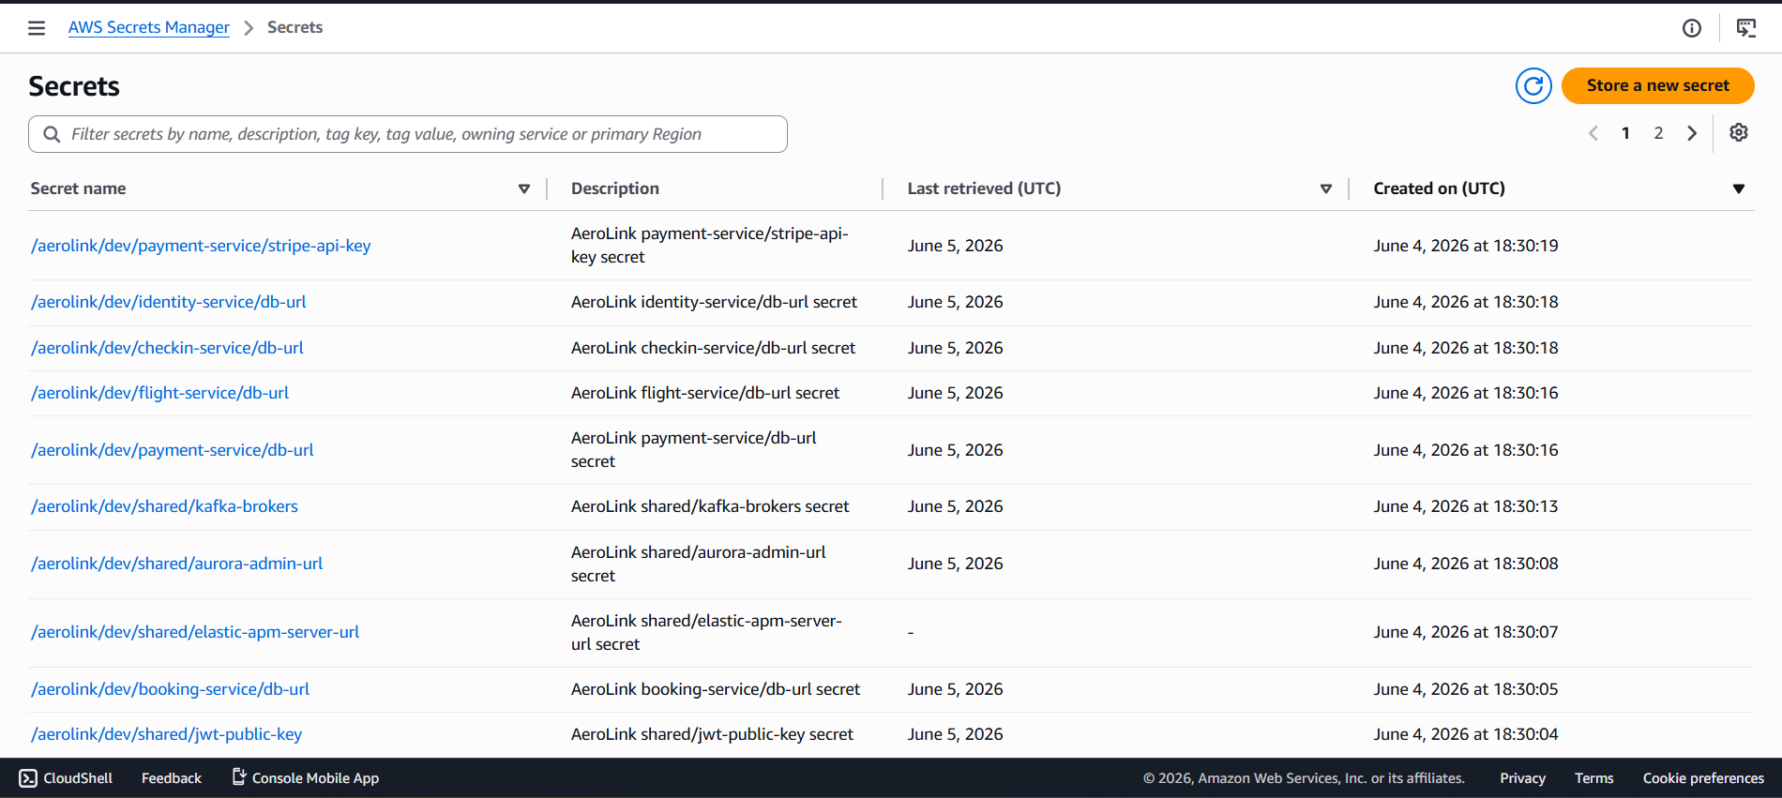
KMS Key | Purpose | Protects
cmk-pci | Payment card data | Aurora payment_db, Stripe secrets
cmk-pii | Personal identifiable information | Aurora (other DBs), DynamoDB, Redis, MSK
cmk-infra | Infrastructure data | S3, CloudTrail, EBS, Secrets Manager
cmk-pci | Payment card data | Aurora payment_db, Stripe secrets

Compliance Considerations PCI-DSS and GDPR
For PCI-DSS, the platform is designed to stay out of scope for storing cardholder data: card details are tokenised on the client by Stripe, and the payment service persists only a Stripe payment reference and the last four digits of the card, encrypted under the PCI key. Card numbers and security codes are never received or stored by AeroLink.
For GDPR, the design supports the data-subject rights of access, portability and erasure; erasure is approached through cryptographic shredding, whereby discarding a subject's key renders their encrypted data unrecoverable without bulk deletion. Edge filtering (WAF) and continuous threat detection (GuardDuty) provide additional defensive layers, and CloudTrail provides an audit trail of sensitive operations such as key use.
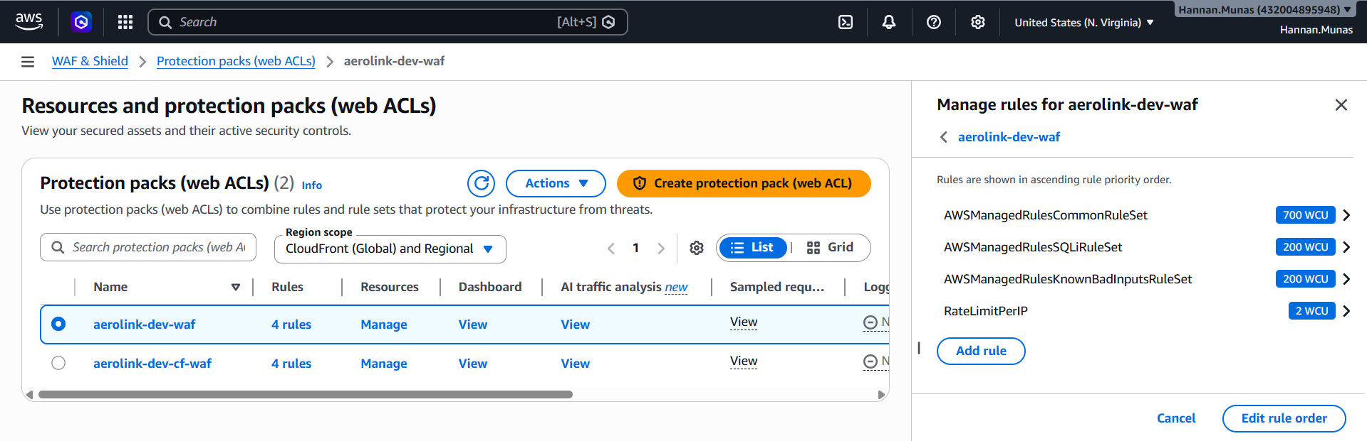
PCI-DSS
PCI Req | Implementation
Never store PAN/CVV | Stripe.js tokenisation on client
Encrypt cardholder data | KMS cmk-pci for payment_db
Restrict access | IRSA — only payment-service can decrypt with cmk-pci
Audit all access | CloudTrail logs all KMS decrypt operations

GDP
Right | Implementation
Right to Access | GET /users/{id} returns all stored personal data
Right to Erasure | Cryptographic shredding — each user's PII is encrypted with a unique data key; deleting the key renders all data permanently unreadable
Right to Portability | GET /users/{id}/export — JSON export
Right to Access | GET /users/{id} returns all stored personal data

Distributed Data Consistency
A distributed system cannot offer a single ACID transaction across service boundaries, so AeroLink adopts an eventual-consistency model with targeted strong guarantees where correctness demands them. The booking workflow is a Saga: each step commits locally and emits an event, and failures are handled by compensating actions rather than a global rollback (Section 6.2). Seat selection, where a stale read could otherwise cause a double-booking, is protected by an atomic Redis SET NX lock — only one booking can acquire a given seat key — so even if the CQRS read model briefly shows a seat as free, the lock acquisition is the authoritative arbiter. Idempotency keys on booking and payment make retries safe, and the CQRS read model in Redis is rebuilt from the write model on each relevant event, giving fast reads with a short and bounded convergence window.

Real Time Data Synchronization – Task 04

5.1 WebSocket Implementation
AeroLink uses the AWS API Gateway WebSocket API for real-time push communication. When a domain event occurs (e.g., seat locked, baggage scanned), the relevant service publishes to Kafka, and the WebSocket gateway pushes the update to connected clients.
Connection Flow:
Client opens WSS connection to the WebSocket API endpoint
API Gateway validates the JWT token on $connect
Connection ID is stored (mapped to user ID)
Events are pushed to the client as they occur
Client automatically reconnects on disconnection with exponential backoff

5.2 Live Seat Availability
The flight-service implements CQRS (Command Query Responsibility Segregation) for the seat map:
When a seat is locked or released:
- flight-service writes to PostgreSQL
- Publishes seat-lock.confirmed / seat.availability-updated to Kafka
- Kafka consumer updates the Redis projection
- WebSocket gateway pushes the change to all clients viewing that flight's seat map
Consistency window: ~100–200ms between write and Redis projection update. The seat-lock itself uses Redis SET NX (atomic compare-and-swap), so even if a stale read shows a seat as available, the lock operation will fail atomically — preventing double-booking.

5.3 Live Baggage Tracking
The baggage-service implements a 7-state finite state machine:
Each state transition:
- Validated against allowed transitions (e.g., cannot go from TAGGED to ARRIVED)
- Written to DynamoDB with a conditional expression
- Published as baggage.status-updated to Kafka
- notification-service sends an SMS/email to the passenger
- WebSocket pushes the update to the passenger's baggage tracker UI
Baggage progresses through a seven-state machine — tagged, checked-in, loaded, in-transit, arrived, and then either collected or lost. The service validates each requested transition against an explicit allowed-transitions table and rejects illegal jumps, writes the new state to DynamoDB with a conditional expression, and publishes a status-updated event that the notification service turns into a passenger message. Modelling baggage as an explicit state machine makes invalid sequences impossible and gives every scan a clear, auditable meaning.

5.4 Event-Driven Synchronisation
All real-time features are driven by Kafka events rather than polling:
Feature | Trigger Event | Consumer
Seat map update | seat.availability-updated | WebSocket gateway → browser
Booking status | booking.confirmed / booking.cancelled | WebSocket → passenger
Baggage tracking | baggage.status-updated | notification-service → SMS/email
Flight status | flight.status-changed | notification-service + WebSocket

This ensures consistency: the same event that updates the database also triggers the notification, eliminating the risk of the UI showing stale data while the backend has moved on.

Fault Tolerance and Resilience – Task 05

6.1 Circuit Breaker Pattern
AeroLink implements the circuit breaker pattern in @aerolink/common middleware to prevent cascading failures. The implementation follows a three-state finite automaton:
State Machine:
State | Behaviour
CLOSED | Requests pass through; failures counted
OPEN | Requests fail immediately (no downstream call); cooldown timer running
HALF_OPEN | Limited test requests allowed; if successful → CLOSED, if failed → OPEN

Implementation (from packages/common-middleware/src/circuit-breaker.ts):
A CircuitBreakerFactory singleton manages named instances so that every call to the same downstream (e.g., stripe-api) shares a single failure counter.
Per-service configuration:
Service | Downstream | Threshold | Cooldown | Fallback
payment-service | Stripe API | 3 failures | 60s | Queue for retry, return 503
checkin-service | Lambda QR | 5 failures | 30s | Text-only boarding pass
notification-service | AWS SES | 5 failures | 120s | Log notification, retry later
notification-service | AWS SNS | 5 failures | 120s | Log notification, retry later

Impact: Without circuit breakers, a Stripe outage would cause 30-second timeouts cascading through payment → booking → API Gateway. With circuit breakers, the failure is detected in <1ms, and the user sees "try again later" within 100ms.
Retry Policy works alongside the circuit breaker:
- Max retries: 3
- Backoff: exponential (1s × 2^attempt + 20% jitter)
- Max delay cap: 30 seconds
- Non-retryable errors (validation, duplicates) skip retries entirely

6.2 Saga Pattern and Compensating Transactions
The booking flow is a distributed transaction spanning 4 services. Since traditional ACID transactions cannot span service boundaries, AeroLink uses a choreography-based Saga pattern with compensating transactions for rollback.
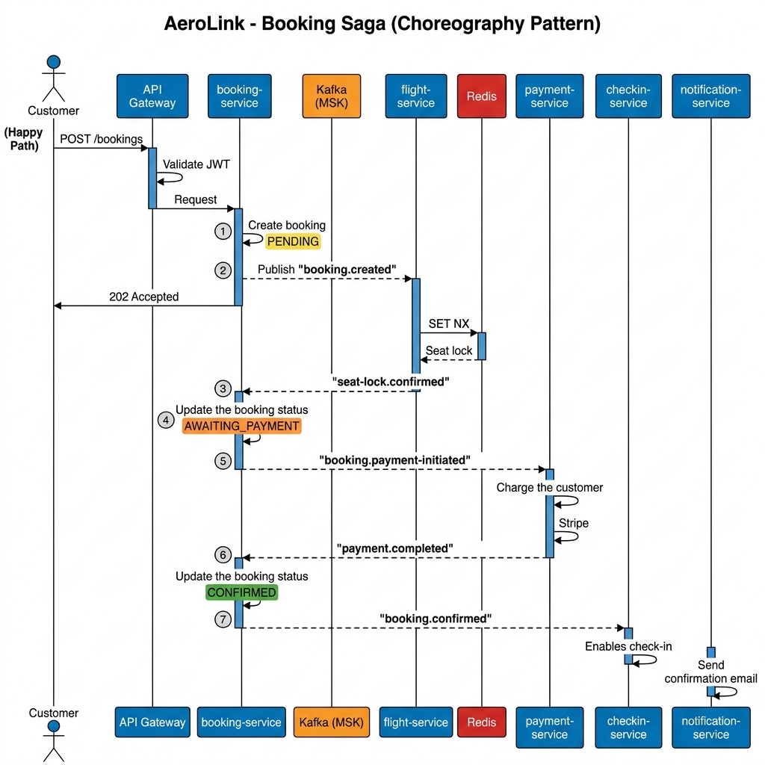

Happy Path:
Step | Service | Action | Event Published
1 | booking | Create booking (PENDING) | booking.created
2 | flight | Lock seat via Redis SET NX | seat-lock.confirmed
3 | booking | Update to AWAITING_PAYMENT | booking.payment-initiated
4 | payment | Charge via Stripe | payment.completed
5 | booking | Update to CONFIRMED | booking.confirmed
6 | checkin | Create check-in eligibility | —
7 | notification | Send confirmation email | —

Each incoming event is validated against a Zod schema before processing; malformed messages are silently dropped to prevent poison-pill crashes.
Distributed Seat Lock (from services/flight-service/src/seats/seats.service.ts):
Redis SET NX (set-if-not-exists) guarantees that exactly one booking can acquire the lock on a given seat, even under concurrent requests. The 15-minute TTL (SEAT_LOCK_TTL_SECONDS = 900) automatically releases abandoned locks.
Compensation Path — Payment Failure:
Step | Action
1 | payment-service publishes payment.failed
2 | booking-service transitions to COMPENSATING
3 | booking-service publishes booking.seat-released
4 | flight-service releases the Redis seat lock
5 | booking-service transitions to CANCELLED
6 | notification-service sends failure email

Compensation Path — Seat Lock Failure:
Step | Action
1 | flight-service publishes seat-lock.failed
2 | booking-service transitions directly to CANCELLED
3 | notification-service sends "seat unavailable" email

Why choreography over orchestration:
- No single point of failure (no orchestrator service)
- Lower coupling — services react to events, not direct commands
- Independent scaling and deployment
- Adding a new step (e.g., loyalty points) requires only subscribing to booking.confirmed
Traceability: Every event carries a correlationId and the booking-service maintains a sagaHistory JSON array recording each step, timestamp, and outcome.

6.3 Auto-Scaling and Load Balancing
Pod-level scaling:
Service | Trigger | Min → Max Pods
identity, flight, booking, checkin | CPU > 70% (HPA) | 2 → 6
payment | CPU > 70% (HPA) | 2 → 4
baggage, notification | Kafka lag (KEDA) | 2 → 6
webui | CPU > 70% (HPA) | 2 → 4

Node-level scaling: Cluster Autoscaler monitors pending pods and provisions additional Spot instances (2 → 6 nodes).
Load Balancing:
- External: Application Load Balancer distributes traffic across service pods
- Internal: Kubernetes Service (ClusterIP) provides round-robin across pod replicas
6.4 High Availability and Disaster Recovery
Single AZ failure recovery: All components auto-failover to the surviving AZ. Total recovery: < 5 minutes.
Complete region failure: Terraform IaC enables re-deployment to a different region:
- Update aws_region in terraform.tfvars
- terraform apply — creates entire infrastructure (~25 minutes)
- Restore data from cross-region backups
- ArgoCD syncs services automatically

Backup Strategy:
Component | Frequency | Retention
Aurora | Daily snapshot + continuous PITR | 35 days
ElastiCache | Daily snapshot | 7 days
DynamoDB | Continuous PITR | 35 days
MSK | Log retention | 7 days
CloudTrail | Continuous | 7 years (Glacier)
Terraform state | On change (S3 versioning) | 30 days
EKS
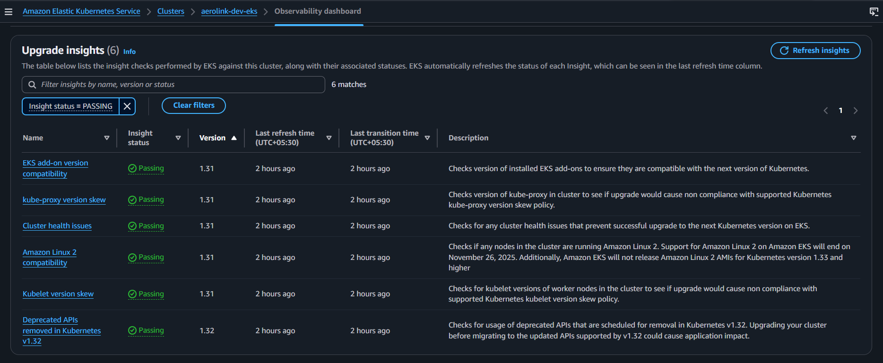
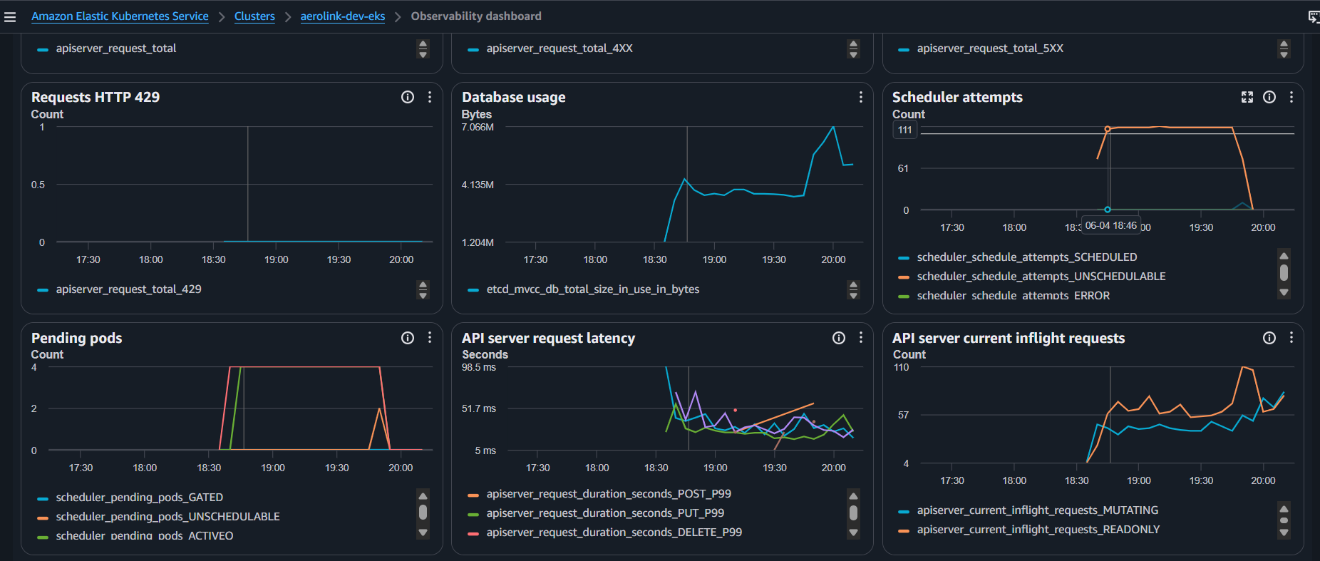

Performance and Scalability Testing – Task 06

Monitoring and Observability – Task 07

Metrics and CloudWatch
Cluster and container metrics are collected by CloudWatch Container Insights, and a CloudWatch dashboard defined as a JSON artefact in the repository presents the key signals in one place. Alarms are defined as Terraform resources so they are version-controlled and reproducible across environments, and they notify by email through SNS.
Alarm | Condition (illustrative)
API Gateway 5xx errors | Elevated server-error count over a short window
API Gateway latency | p99 above the latency budget
Aurora CPU / free storage | Sustained high CPU or low free storage
Redis memory | Memory utilisation above threshold
Kafka consumer lag | Lag above a message-count threshold
Lambda QR errors | Error count above threshold in a short window
[Insert Screenshot: CloudWatch dashboard — service metrics; CloudWatch alarms list]

Health Checks
Every service exposes two health endpoints. A liveness endpoint reports only that the process is running; if it fails, Kubernetes restarts the pod. A readiness endpoint reports whether the service can actually serve traffic — that its database and broker connections are established; if it fails, the pod is removed from the load-balancer rotation but left running so it can recover. The probes use distinct initial delays so that a newly started pod is given time to connect before being judged.

Structured Logging
A request-logger interceptor in the common-middleware package emits one structured JSON record per request, including the timestamp, level, correlation identifier, originating service, HTTP method and path, status code and duration. Emitting logs as structured JSON keyed by correlation identifier makes it possible to follow a single request across services in a log query, which is essential when a workflow is spread over several pods. The records are written to standard output for collection by the cluster's log shipper into CloudWatch Logs.

Distributed Tracing
Tracing is implemented with OpenTelemetry. Each service imports a tracing bootstrap as its very first action so that the SDK can auto-instrument the libraries the service uses — HTTP, the Kafka client, the PostgreSQL driver and the AWS SDK — without manual span code. Spans are exported over OTLP, and the correlation identifier links the trace to the structured logs.

Testing Strategy – Task 09

Unit Testing
Booking Service Test
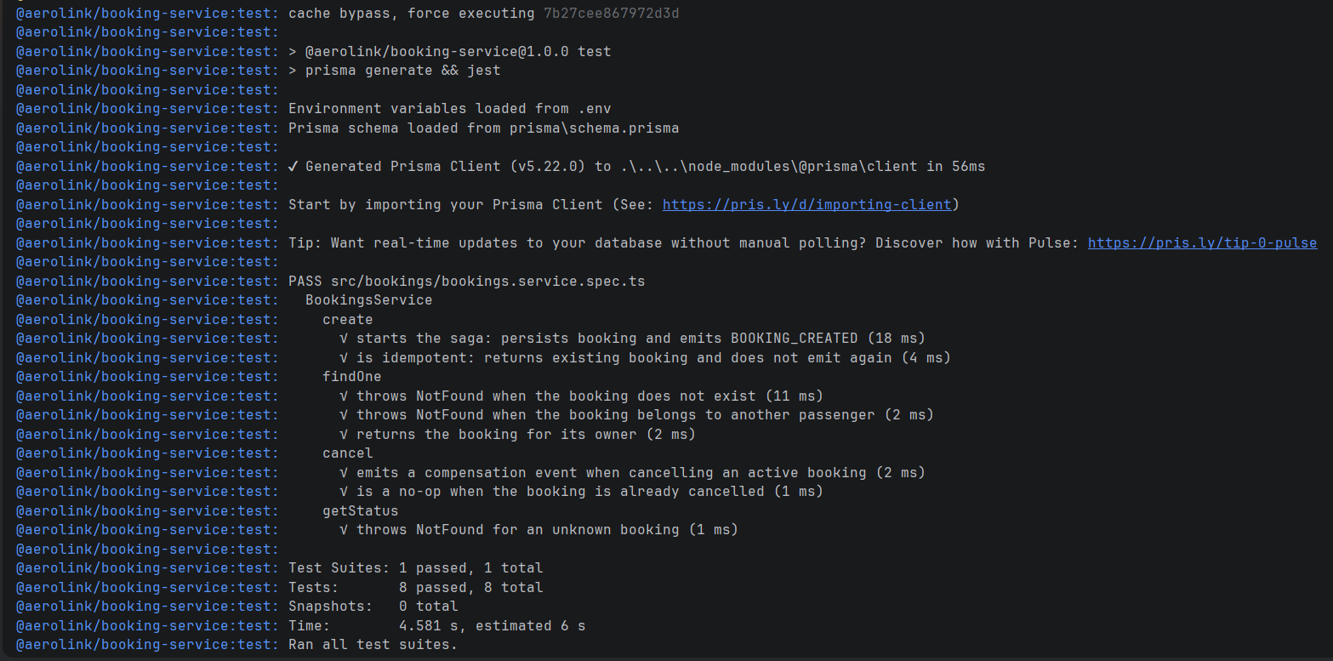
Identity Service Test
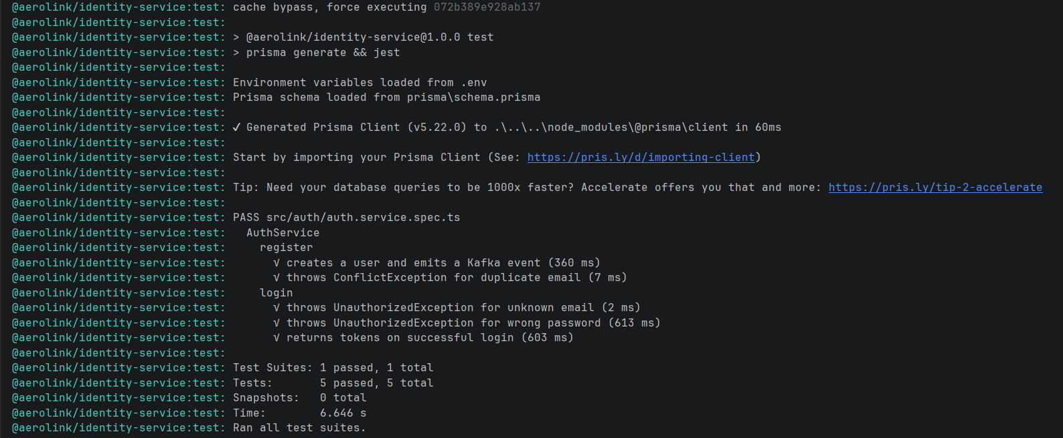
Baggage Service Test
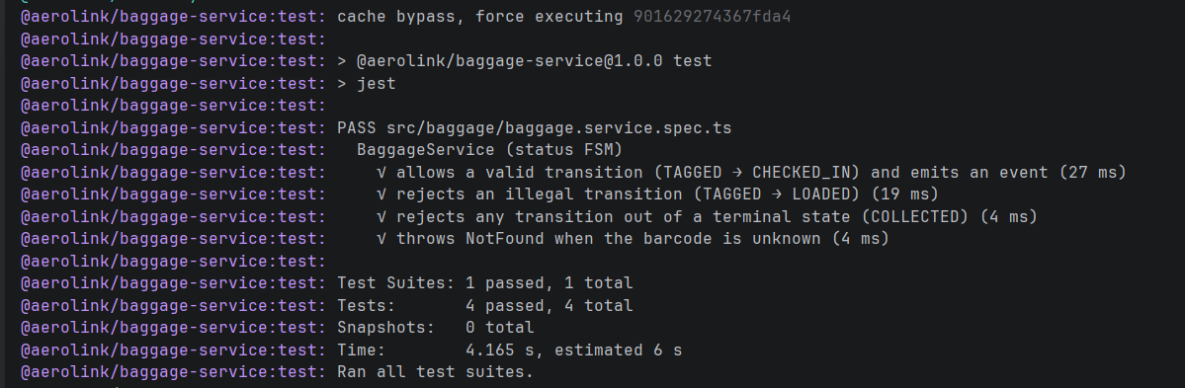
Flight Service Test
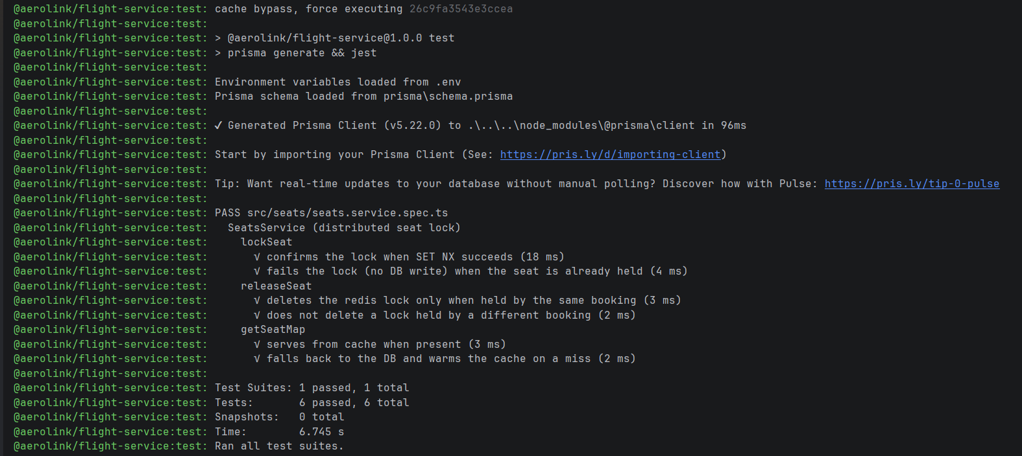
Payment Service Test
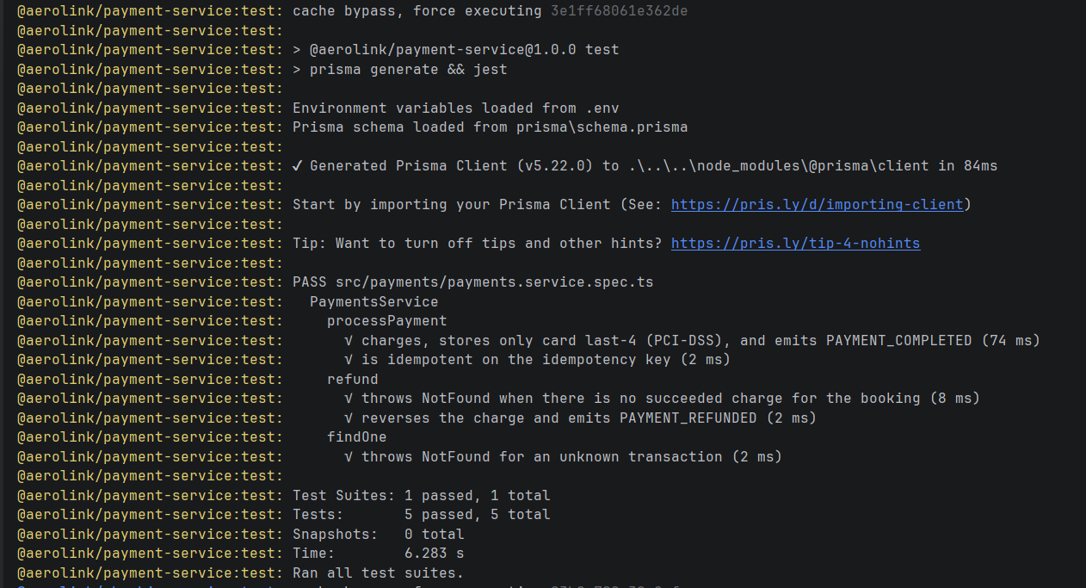
Checkin Service Test
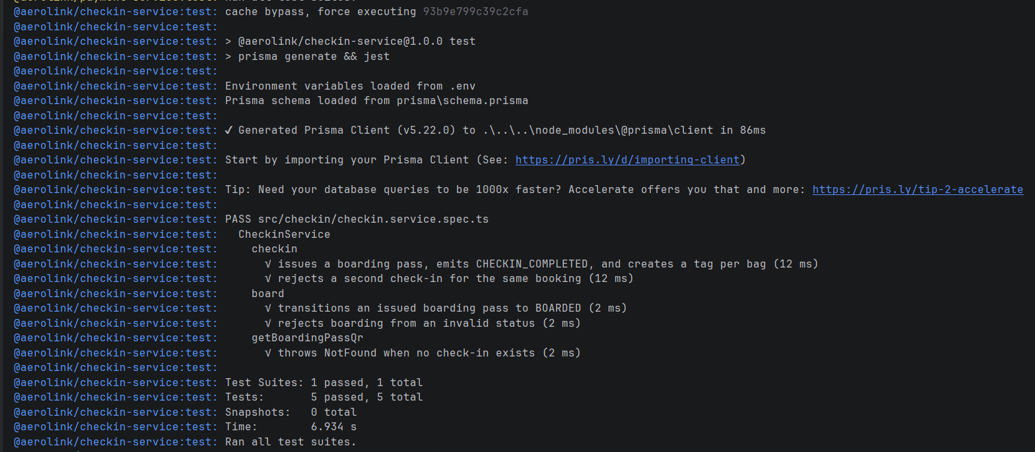
Notification Service
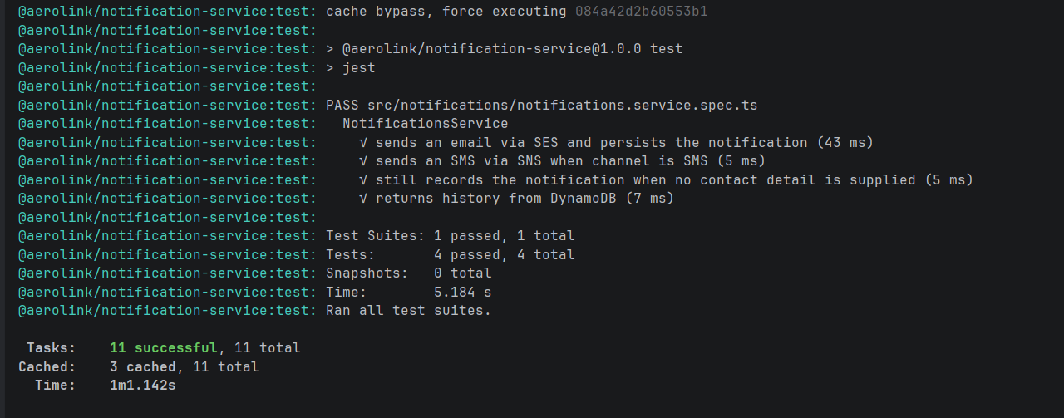

Integration Testing
Integration test drives the booking Saga against real infrastructure started with Docker Compose. It creates a booking over REST, asserts that the expected events are produced in order, and verifies the status progression from awaiting-seat-lock through awaiting-payment to confirmed; it also exercises the compensation path by simulating a payment failure and confirming that the seat lock is released. This validates the contract between services, which unit tests with mocked brokers cannot.
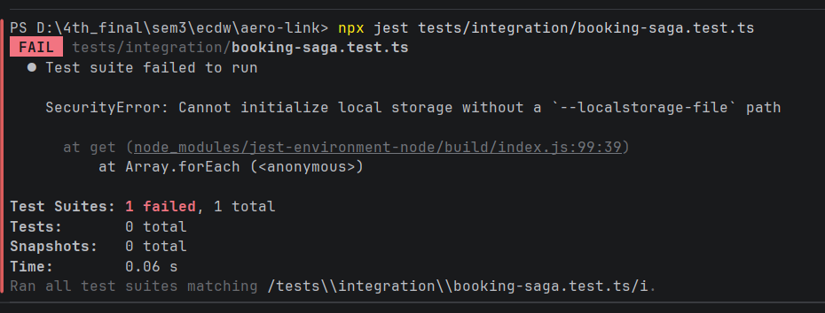

API and Performance Testing
Stress Testing for Stress Test (Ramping 10 → 500 VUs):
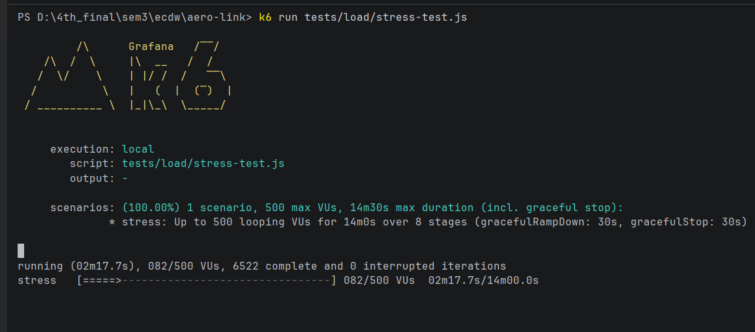
Load Testing on Booking Flow
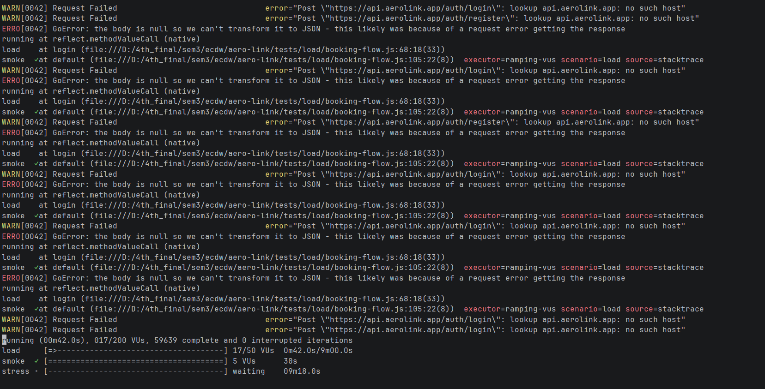

Test Coverage Summary
Level | Tooling | Scope
Unit | Jest (mocked dependencies) | Core logic in all seven services
Integration | Jest + Docker Compose | End-to-end booking Saga, including compensation
API | Swagger + Postman | Happy path, payment failure, seat conflict, RBAC
Performance | k6 | Smoke, load, stress, spikes, baggage-scan

Delivery Automation and Implementation.

Continuous Integration (GitHub Actions)
The CI pipeline is defined in .github/workflows/service-ci.yml and triggers on push to main/develop and pull requests to main
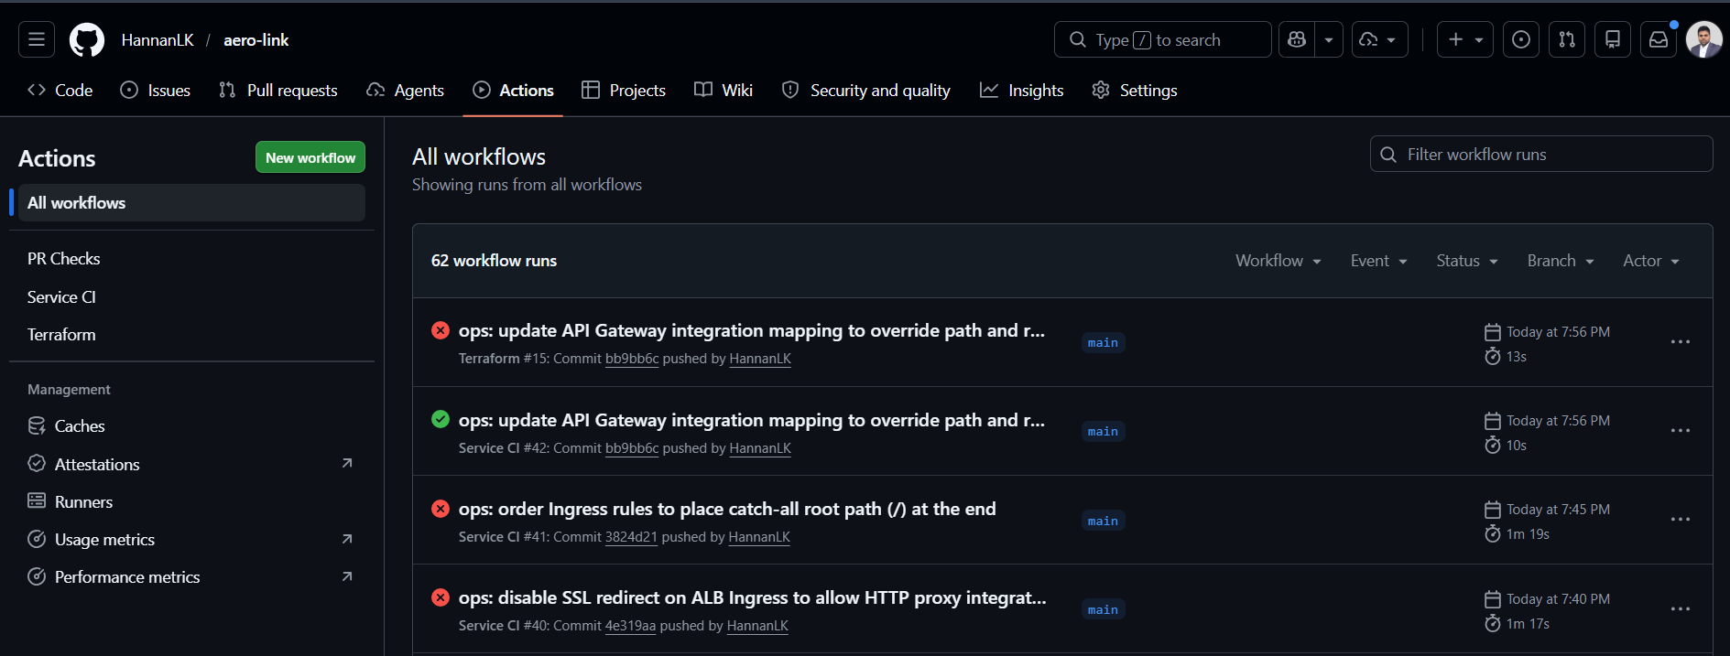
Pipeline Stages
Stage | Description
Detect Changes | dorny/paths-filter identifies which services have changed files
Lint & Test | Only changed services are linted and tested (matrix strategy)
Build & Push | Docker images built and pushed to ECR (only on main branch)
Update Helm Values | Image tag updated in values.yaml and committed back to repo

Container Build and Registry
For changed services on the main branch, the workflow authenticates to AWS — preferring short-lived OIDC credentials and falling back to static keys only if a deployment role is not configured — logs in to Elastic Container Registry, and builds and pushes each image tagged with both the short commit SHA (for traceability) and a moving latest tag, using registry-backed layer caching to speed rebuilds.
It then updates the image tag in the service's Helm values and commits that change back to the repository, which is the hand-off point to continuous deployment.

Continuous Deployment
Deployment follows the GitOps model: the Git repository is the single source of truth for the desired cluster state, and Argo CD continuously reconciles the live cluster toward it. When CI commits a new image tag, Argo CD detects the change and rolls it out without anyone running a deploy command.

Each service acts as a separate application.
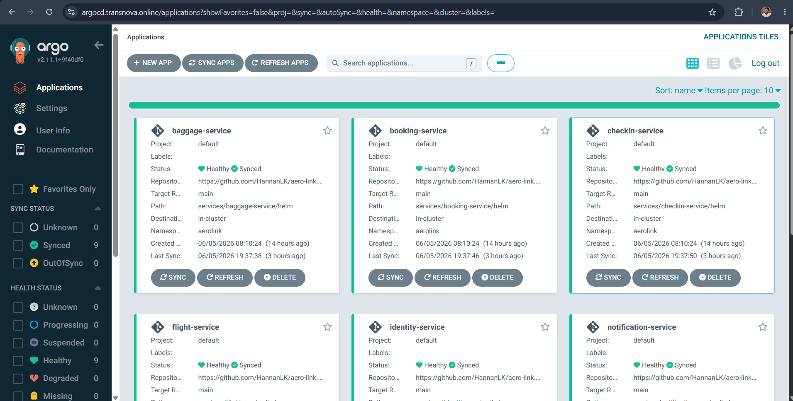
Identity Service.

Infrastructure as a Code (Terraform Automation)
The AWS environment is defined as 19 Terraform modules.
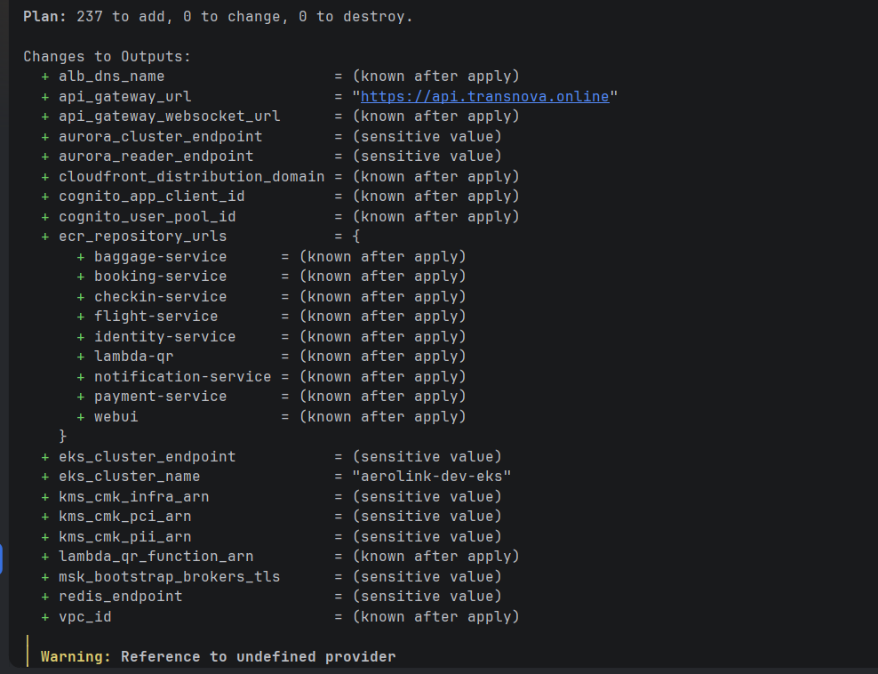

Application Implementation
Landing Page
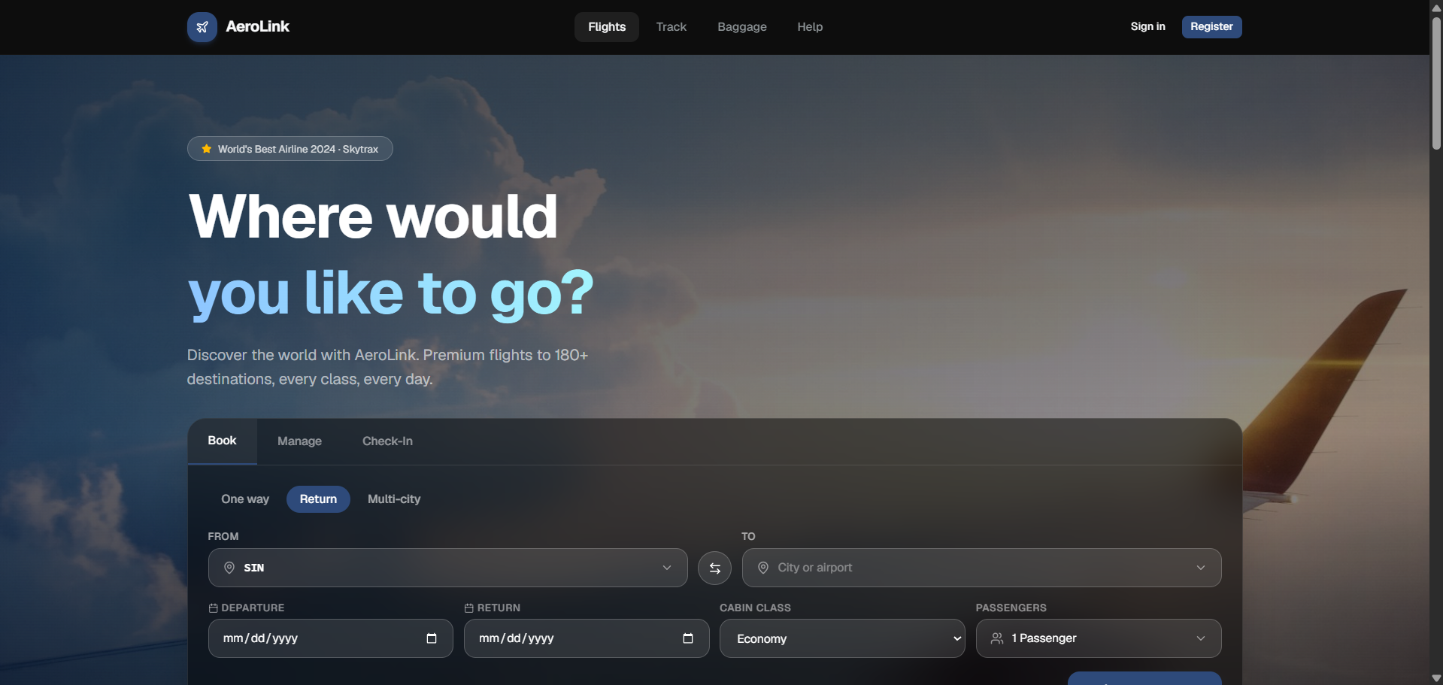
Flight Tracking
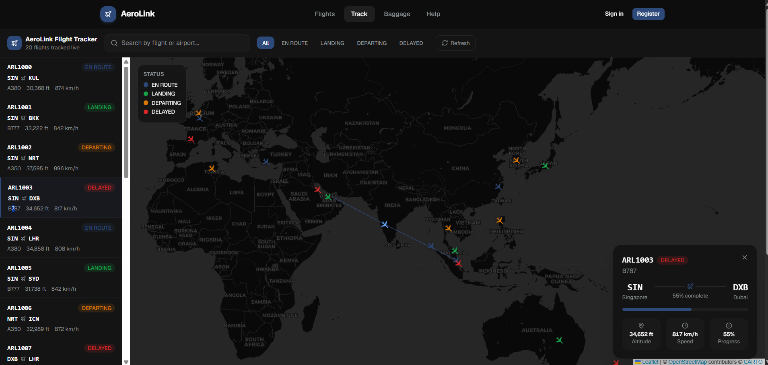

Reflection and Future Enhancement

Challenges Faced
During implementation, several technical challenges were encountered. Managing a choreography-based Saga proved more complex than traditional orchestration because business workflows were distributed across multiple services. This was addressed using correlation identifiers, booking-level history tracking, and distributed tracing to improve visibility. Another challenge was supporting both local Kafka development and Amazon MSK, which use different authentication mechanisms. A shared Kafka client factory was implemented to switch between configurations based on the deployment environment. Database initialization on Kubernetes also required additional effort, as Prisma migrations were unavailable during early development; this was resolved using schema deployment through init containers and a dedicated database bootstrap process.

Finally, the operational cost of maintaining a cloud-native environment influenced several design decisions, leading to the adoption of Infrastructure-as-Code and automated environment provision to simplify deployment and teardown.

11.2 Lessons Learned
The project highlighted several important lessons about distributed systems development. First, distributed transactions require a different approach from traditional ACID-based applications, with Saga-based compensation demanding careful workflow design and observability. Second, observability is a core architectural requirement rather than an optional enhancement; structured logging, tracing, and monitoring are essential for diagnosing failures that span multiple services.

Third, Infrastructure-as-Code and GitOps significantly improve consistency across environments, although they introduce new challenges related to dependency management and deployment sequencing. More broadly, the project reinforced the practical trade-offs between consistency, availability, and system resilience that underpin cloud-native architectures.

11.3 Future Improvements
Several enhancements have been identified for future development. The provisioned WebSocket API can be fully integrated to support real-time notifications and reduce reliance on polling. Similarly, the Cognito authorizer configured at the API Gateway can be enabled as the primary authentication mechanism, moving authentication enforcement closer to the edge. Additional improvements include implementing the

Transactional Outbox pattern to eliminate the possibility of lost events, introducing a service mesh for mutual TLS and advanced traffic management, extending the platform to support multi-region deployment, and performing automated chaos testing to validate resilience under failure conditions. Performance benchmarking and load testing would also provide quantitative evidence of the platform’s scalability characteristics.
- Conclusion
AeroLink demonstrates the design and implementation of a cloud-native airline platform built using microservices, event-driven communication, and managed AWS services. The system successfully decomposes core airline functions into independently deployable services, supports distributed transactions through the Saga pattern, and incorporates security, resilience, and automated deployment practices. Infrastructure provisioning through Terraform and deployment through Kubernetes and GitOps further reinforce the platform’s scalability and maintainability.

The project satisfies the key objectives of designing, implementing, and testing a distributed cloud application while applying modern software architecture principles. Although features such as WebSocket-based real-time updates and API Gateway Cognito authentication have been provisioned but not fully integrated, the current implementation provides a solid foundation for future enhancement. Overall, the project highlights the practical challenges and trade-offs involved in distributed systems design and demonstrates how cloud-native technologies can be used to build reliable, scalable, and secure enterprise applications.

Appendices

References
- Amazon Web Services, “Amazon EKS User Guide,” AWS Documentation, 2026. [Online]. Available: https://docs.aws.amazon.com/eks/
- Amazon Web Services, “Amazon MSK Developer Guide,” AWS Documentation, 2026. [Online]. Available: https://docs.aws.amazon.com/msk/
- Amazon Web Services, “AWS Well-Architected Framework,” 2026. [Online]. Available: https://docs.aws.amazon.com/wellarchitected/
- Amazon Web Services, “Amazon Aurora User Guide,” 2026. [Online]. Available: https://docs.aws.amazon.com/AmazonRDS/latest/AuroraUserGuide/
- Amazon Web Services, “Amazon DynamoDB Developer Guide,” 2026. [Online]. Available: https://docs.aws.amazon.com/dynamodb/
- Amazon Web Services, “AWS Key Management Service Developer Guide,” 2026. [Online]. Available: https://docs.aws.amazon.com/kms/
- The Kubernetes Authors, “Kubernetes Documentation,” 2026. [Online]. Available: https://kubernetes.io/docs/
- HashiCorp, “Terraform AWS Provider Documentation,” 2026. [Online]. Available: https://registry.terraform.io/providers/hashicorp/aws/latest/docs
- Argo Project, “Argo CD — Declarative GitOps CD for Kubernetes,” 2026. [Online]. Available: https://argo-cd.readthedocs.io/
- Apache Software Foundation, “Apache Kafka Documentation,” 2026. [Online]. Available: https://kafka.apache.org/documentation/
- KEDA, “Kubernetes Event-Driven Autoscaling Documentation,” 2026. [Online]. Available: https://keda.sh/docs/
- NestJS, “NestJS Documentation,” 2026. [Online]. Available: https://docs.nestjs.com/
- Prisma, “Prisma ORM Documentation,” 2026. [Online]. Available: https://www.prisma.io/docs/
- Stripe, “Stripe API Reference,” 2026. [Online]. Available: https://stripe.com/docs/api
- OpenTelemetry, “OpenTelemetry JavaScript Documentation,” 2026. [Online]. Available: https://opentelemetry.io/docs/languages/js/
- Grafana Labs, “k6 Load Testing Documentation,” 2026. [Online]. Available: https://k6.io/docs/
- C. Richardson, Microservices Patterns: With Examples in Java. Shelter Island, NY, USA: Manning, 2018.
- S. Newman, Building Microservices: Designing Fine-Grained Systems, 2nd ed. Sebastopol, CA, USA: O’Reilly Media, 2021.
- M. Kleppmann, Designing Data-Intensive Applications. Sebastopol, CA, USA: O’Reilly Media, 2017.
- M. Fowler, “CircuitBreaker,” martinfowler.com, 2014. [Online]. Available: https://martinfowler.com/bliki/CircuitBreaker.html
- M. T. Nygard, Release It! Design and Deploy Production-Ready Software, 2nd ed. Raleigh, NC, USA: Pragmatic Bookshelf, 2018.

