

INDIVIDUAL ASSIGNMENT

LEVEL 06

COMP60010

Enterprise Cloud and Distributed Web Applications

HF2561SE

Hand Out Date: 04th June 2026
Hand In Date:23rd May 2025

Student Name: Eshan Dineth
Student ID: CB011286

INSTRUCTION TO CANDIDATES

- Students are advised to underpin their answers with the use of references (cited using the Harvard Referencing Style).

- Late submission will be awarded zero (0) unless extenuating circumstances (EC) are upheld.

- Cases of plagiarism will be penalized.

- The assignment should be submitted as a softcopy:

  - The softcopy of the written assignment and source code must be uploaded to given link in the LMS.
Acknowledgements

I would like to express my sincere gratitude to my Enterprise Cloud and Distributed Web Applications (ECDWA) lecturer, Yogendrarajah Sivanujan for their invaluable guidance, continuous support, and profound insights throughout the duration of this module. Their expertise and structured approach to teaching modern cloud architectures were instrumental in helping me navigate the complexities of microservices, containerisation, and distributed systems.
The foundational knowledge and practical feedback provided during the lectures and lab sessions gave me the confidence to design and implement the AeroLink platform using industry-standard tools like AWS, Kubernetes, and Terraform.
I would also like to extend my thanks to my peers for their collaborative discussions, which greatly enriched my learning experience and helped refine my approach to solving complex architectural challenges.

Table of Contents

1. Introduction 6
1.1. Background and Problem Statement 6
1.2. Aims and Objectives 6
1.3. Scope 7
1.4. Technologies Used 8
2. Cloud-Based Web Application Design 10
2.1. Architecture Overview 10
2.2. Microservices Breakdown 11
2.3. Containerisation 12
2.4. Serverless Computing 14
2.5. Cloud-Managed Database 15
2.6. High Availability and Multi Region Deployment 16
2.7. Horizontal Scalability 17
3. Distributed Web Application and API Design 18
3.1. RESTful API Design 18
3.2. Event Driven Archuitecture 20
3.3. API Gateway 22
3.4. API Documentation (Swagger / OpenAPI) 23
3.5. Secure Service-to-Service Communication 23
4. Data Security, Compliance and Consistency 24
4.1. Authentication and Authorisation 24
4.2. Encryption 25
4.3. Compliance Considerations 26
5. Real-Time Data Synchronisation 30
5.1. WebSocket Implementation 30
5.2. Live Seat Availability 31
5.3. Live Baggage Tracking 32
5.4. Event-Driven Synchronisation 33
6. Fault Tolerance and Resiliance 34
6.1. Circuit Breaker Pattern 34
6.2. Saga Pattern Rollbacks 35
6.3. Auto Scaling and Load Balancing 36
6.4. High Availability and Disaster Recovery 37
7. Performance and Scalability Testing 38
7.1. Load Testing 38
7.2. Results Analaysis 39
7.3. Stress Testing Discussion 40
7.4. Performance Improvements 41
8. Monitoring and Observability 42
8.1. AWS CloudWatch Integration 42
8.2. Health Check Endpoints 43
8.3. Application Logging 43
8.4. Distributed Tracing 44
9. Testing Strategy 44
9.1. Unit Testing 44
9.2. Integration Testing 44
9.3. API Testing (Postman) 45
9.4. Performance Testing 46
9.5. Test Summary Table 47
10. CI / CD Pipeline and GitOps Deployment 47
10.1. Continuous Integration (GitHub Actions) 47
10.2. Continuous Deployment (ArgoCD) 48
11. Challenges and Future Improvements 50
11.1. Challenges Faced 50
11.2. Challenges Faced 50
12. Conclusion 51
References 52

Table of Tables

Table 1 - Core Technologies and Frameworks Used in the AeroLink Platform 6
Table 2 - Microservices Architecture Breakdown and Responsibilities 9
Table 3 - RESTful API Endpoints and Routing Specifications 16
Table 4 - Artillery Load Testing Performance Metrics 37
Table 5 - Comprehensive Testing Strategy and Results Summary 43

Table of Figures

Figure 1 - High-Level AWS Cloud Architecture Diagram for the AeroLink Platform 10
Figure 2 - Docker Compose Output Demonstrating Successful Microservice Container Initialization 12
Figure 3 - AWS Lambda Configuration for the Event-Driven Notification Service 13
Figure 4 - Amazon DynamoDB Console Displaying Active Multi-Region Tables 14
Figure 5 - Amazon EKS Console Displaying the Active Kubernetes Cluster 16
Figure 6 - OpenAPI (Swagger) Interface Documenting the Authentication Service Endpoints 19
Figure 7 - Postman application showing the imported AeroLink API collection on the left sidebar 22
Figure 8 - frontend UI showing the Executing Saga Pattern... loading screen 28
Figure 9 - frontend UI showing the "Booking Failed (Saga Rollback Triggered)" error screen here 28
Figure 10 - Real-Time Seat Selection Interface Powered by WebSockets 30
Figure 11 - Live Baggage Tracking Timeline Demonstrating Asynchronous Status Updates 31
Figure 12 - Booking Failed (Saga Rollback Triggered)" UI 35
Figure 13 - Artillery Load Testing Output Simulating High Concurrency Passenger Traffic 38
Figure 14 - AWS CloudWatch Dashboard Monitoring Network Load Balancer and DynamoDB Metrics 41
Figure 15 - Jest Unit Testing Execution and Coverage Results for the Flight Service 43
Figure 16 - Postman API Testing Output Demonstrating a Successful 200 OK Response 44
Figure 17 - Postman API Testing Output Demonstrating a 409 Conflict Response for Duplicate Bookings 45
Figure 18 - GitHub Actions Interface Showing Successful Continuous Integration Execution 48
Figure 19 - ArgoCD Dashboard Demonstrating Automated GitOps Synchronization with the EKS Cluster 48

Table of Code Snippets

Code Snippet 1 - Snippet from docker-compose.yml demonstrating service orchestration 12
Code Snippet 2 - Snippet from notification-service/src/index.js (Lambda Handler) 13
Code Snippet 3 - Snippet from terraform/modules/networking/main.tf showing Multi-AZ configuration 15
Code Snippet 4 - Snippet from services/booking-service/src/services/eventBridge.js 20
Code Snippet 5 - Snippet from nginx/nginx.conf showing reverse proxy routing 21
Code Snippet 6 - Snippet demonstrating Frontend Route Protection logic 24
Code Snippet 7 - Snippet from services/auth-service/src/routes/auth.js 25
Code Snippet 8 - Snippet from services/booking-service/src/routes/booking.js 28
Code Snippet 9 - Snippet from services/websocket-service/src/server.js 30
Code Snippet 10 - Snippet from services/booking-service/src/routes/booking.js 35
Code Snippet 11 - Snippet from loadtest.yml 38
Code Snippet 12 - Snippet from terraform/modules/monitoring/main.tf 42
Code Snippet 13 - Universal health check implemented across all Express.js microservices 42
Code Snippet 14 - Snippet from .github/workflows/backend-ci.yml demonstrating automated manifest updates 47

Introduction

1.1. Background and Problem Statement
AeroLink is a worldwide supplier of airline systems and aviation technology with support to airlines and airport operators in various regions. The organisation offers essential digital services to various functions including flight booking and ticketing, passenger check-in, baggage tracking, and flight operations management.
At first, AeroLink's business run on monolithic architecture, where all the functionalities were tightly integrated within a single, unified codebase and shared database. When passenger numbers rose and the need for real-time digital services went up, the monolithic system turned out to be a big stumbling block. It severely limited availability and scalability; scaling the system meant duplicating the whole monolith rather than just the services that were under heavy load. Plus, the strong coupling brought about a single point of failurea small software error in the baggage tracking module could have a domino effect and cause the entire flight booking system to crash, which is an unacceptable level of downtime for the whole system.
To solve these operational issues, AeroLink will need a complete overhaul in their digital transformation. The main business motive for this migration is to switch to a cloud-native, microservices-based architecture that uses distributed computing, Because of this making it possible to scale globally without any problem, being tolerant to faults, and having real-time data synchronisation across all airline operations.

1.2. Aims and Objectives
The main aim of this project is to create, deploy, and test a cloud-based distributed web application for AeroLink that effectively addresses the limitations of their old system. The project will In particular target these objectives:
- Cloud Architecture: Create a durable microservices architecture running in Docker containers and managed through Kubernetes, employing serverless computing (AWS Lambda), and cloud-managed NoSQL databases (Amazon DynamoDB) to guarantee availability and scalability of the system.
- Distributed APIs: Develop independent microservices that communicate via RESTful APIs, with an API Gateway, and an event-driven architecture using AWS EventBridge for asynchronous operations.
- Security & Data Consistency: Secure data entry by implementing JWT authentication, Role-Based Access Control (RBAC), and encrypting data, meanwhile distributing data consistency is achieved by the Saga pattern.
- Real-Time Synchronisation: Use WebSocket technologies to carry out real-time data synchronisation for critical operation such as live seat availability locking and baggage status tracking.
- Fault Tolerance: Making the system fault tolerant by using Circuit Breaker patterns to deal with external service failures without affecting the whole system.
- Performance Validation: Performance and load testing would be done with the help of industry standard tools to check latency, throughput and system scalability under stress.
- Observability: Use cloud-native monitoring and observability tools (AWS CloudWatch) to keep track of system health, and diagnose faults in real-time.
- Testing Strategy: Develop and implement a complete testing strategy that includes unit testing, API integration testing, and end-to-end system validation.

1.3. Scope
This implementation focuses on the core passenger-facing and operational domains of the AeroLink platform. The project scope includes the development of the following distinct, independent microservices:
- Auth Service: Manages user registration, authentication, JWT issuance, and RBAC (Admin vs. Passenger roles).
- Flight Service: Handles flight schedule management, seat capacity, and flight CRUD operations.
- Booking Service: Manages the complex, distributed transaction of reserving seats and processing simulated payments using the Saga and Circuit Breaker patterns.
- Baggage Service: Facilitates baggage check-in and provides real-time status tracking updates.
- WebSocket Service: Provides a dedicated real-time communication layer for instant UI updates (e.g., live seat locking).
- Notification Service: A serverless component (AWS Lambda) triggered asynchronously by system events to simulate sending passenger alerts.

1.4. Technologies Used
My solution uses a modern, cloud-native technology stack to meet AeroLink's stringent requirements:

Table 1 - Core Technologies and Frameworks Used in the AeroLink Platform
Category | Technologies Used | Purpose
Frontend UI | React 18, Vite, Typescript | Client facing application for passengers and admins
Backend Service | Node.js, Express.js | Development of lightweight, asynchronous microservices
Database Tier | Amazon DynamoDB | Fully Managed NoSQL database for flexible, low latency data storage
Containerisation | Docker, Docker Compose | Service isolation, local orchestration and auto scaling
Orchestration | Kubernetes (Amazon EKS) | Production grade container orchestration and auto scaling.
API Gateway | Nginx | Reverse proxy, request routing and Cross origin Resource sharing (CORS)
Event Driven Bus | AWS EventBridge | Asynchronous publish subscribe messaging between microservices
Services Compute | AWS Lambda | Event triggered execution of notification logic
Real-Time Communication | Socket.io | Bidirectional WebSocket communication for live data synchronisation
Infrastructure | Terraform | Infrastructure as code (Iac) for automated AWS provisioning
Testing and QA | Jest, Supertest, Artillery | Unit testing, Api integration testing and performance/load testing.

Cloud-Based Web Application Design

2.1. Architecture Overview
To overcome the limitations of the old monolithic system, AquaLink has been transformed into a cloud-native, distributed web application. This new architecture is based on the microservices architectural style, which means that the application is built as a set of independent, loosely coupled services that are organised around business capabilities. The architecture consists of several layers. At the Edge Layer, Nginx API Gateway serves as the one and only access point for all client requests, offering functionalities like request routing, rate limiting and management of Cross-Origin Resource Sharing (CORS). Microservices Layer hosts many containerised Node. js services each of which is in charge of a specific business domain (Auth Flights Bookings, Baggage, and WebSockets).
The Data Layer is based on Amazon DynamoDB, a managed NoSQL database, enabling decoupled data storage with each microservice owning its unique set of tables. The Event-Driven and Serverless Layer uses AWS EventBridge for asynchronous communication and AWS Lambda for event-triggered notifications. And, the whole infrastructure is deployed on an AWS Cloud Infrastructure foundation managed via Terraform and Amazon EKS (Elastic Kubernetes Service) inside a highly available, multi-Availability Zone (AZ) Virtual Private Cloud (VPC).

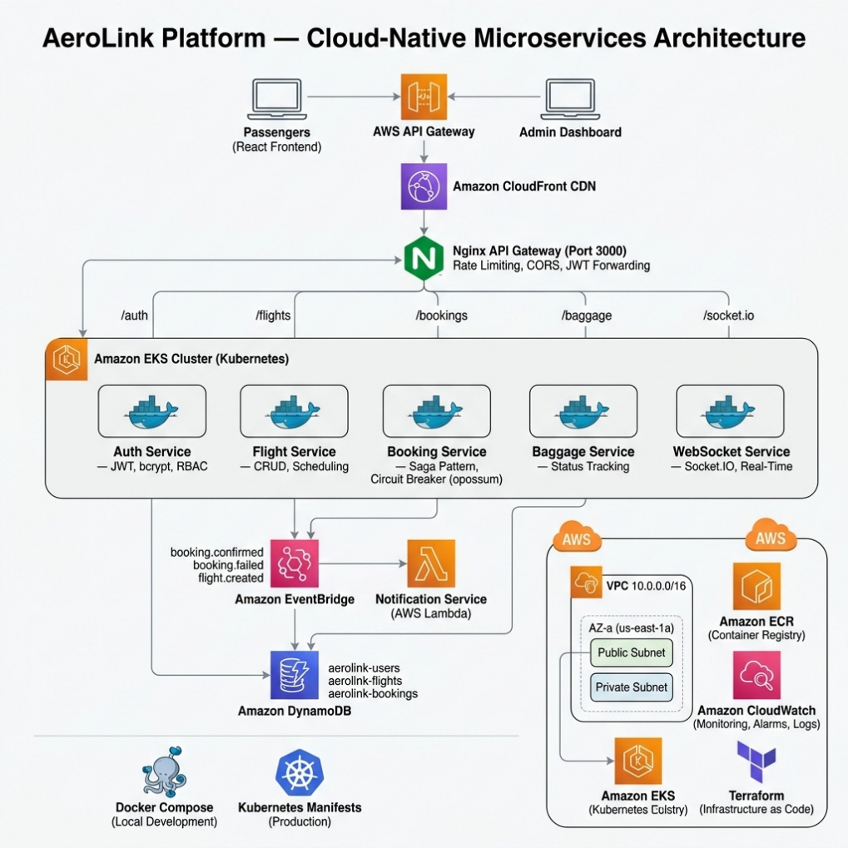
Figure 1 - High-Level AWS Cloud Architecture Diagram for the AeroLink Platform

2.2. Microservices Breakdown
Through breaking down the main system, AeroLink manages to scale the components individually and isolate faults. Even if the Baggage Service undergoes a sudden increase in traffic or severe failure, the Flight Booking system will still be fully functional. The breakdown of the system resulted in these separate microservices:

Table 2 - Microservices Architecture Breakdown and Responsibilities
Service Name | Primary Responsibility | External Port | Database Table
Auth Service | User registration, login verification, JWT token issuance and Role based Access Control (RBAC) | 3001 | aerolink-users
Flight Service | CRUD operations for flight schedules, inventory management and seat capacity handling | 3002 | aerolink-flights
Booking Service | Core transactional service managing seat reservation, simulated payment processing and Saga pattern rollbacks | 3003 | aerolink-bookings
Baggage Service | Manages baggage check-in records and real-time status updates. | 3004 | aerolink-baggage
WebSocket Service | Maintains persistent TCP connections with clients for real-time bidirectional data push | 3005 | -(in memory/Stateless)
Notification Service | A serverless AWS Lambda function that triggers email/SMS alerts based on system events | - (Lambda) | - (Stateless)

2.3. Containerisation

Containerisation guarantees that the application functions consistently in different computing environments, thereby removing "it works on my machine" problem.
Docker Orchestration Within every microservice, there is a multi-stage Dockerfile that encapsulates the Node. js application, its dependencies, and the runtime environment into a small, unchangeable image. For development locally and integration testing, docker-compose. yml governs the orchestration of all the services, including the Nginx API Gateway, inside one isolated bridge network.

services:
api-gateway:
image: nginx:alpine
volumes:
- ./nginx/nginx.conf:/etc/nginx/nginx.conf:ro
ports:
- "3000:3000"
depends_on:
- auth-service
- flight-service
- booking-service
- baggage-service
- websocket-service

auth-service:
build:
context: ./services/auth-service
ports:
- "3001:3000"
environment:
- JWT_SECRET=local_development_secret

Code Snippet 1 - Snippet from docker-compose.yml demonstrating service orchestration

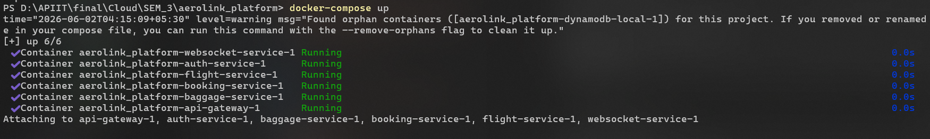
Figure 2 - Docker Compose Output Demonstrating Successful Microservice Container Initialization

Kubernetes Orchestration Docker Compose is not suitable for production deployments at scale and for self-healing capabilities. So, Kubernetes (Amazon EKS) is used instead. Declarative yaml configurations in the k8s-appears as/ directory specify the intended system state. Each microservice is represented by a Deployment object (responsible for managing ReplicaSets and Pods to keep the service continuously running) and a Service object (offering internal DNS and load balancing).

2.4. Serverless Computing
In order to make the best use of resources and reduce costs, the Notification Service is created with Serverless computing through AWS Lambda. Unlike regular containerised microservices that operate continuously, the Notification Lambda function is temporary; it is called only when certain events take place and it ends immediately after finishing, which means AeroLink only pays for the precise compute time used.
The Lambda function responds to the Amazon SQS queue which is a subscriber to AWS EventBridge rules (for instance, the booking. confirmed event). The infrastructure is set up automatically through Terraform:

exports.handler = async (event) => {
for (const record of event.Records) {
const body = JSON.parse(record.body);
const detailType = body['detail-type'];
const detail = body.detail;

switch (detailType) {
case 'booking.confirmed':
console.log(`[SIMULATED NOTIFICATION] Booking ${detail.bookingId} confirmed for flight ${detail.flightId}`);
// Logic to trigger Amazon SNS for SMS/Email goes here
break;
case 'booking.failed':
console.log(`[SIMULATED NOTIFICATION] Booking ${detail.bookingId} failed: ${detail.reason}`);
break;
}
}
};

Code Snippet 2 - Snippet from notification-service/src/index.js (Lambda Handler)
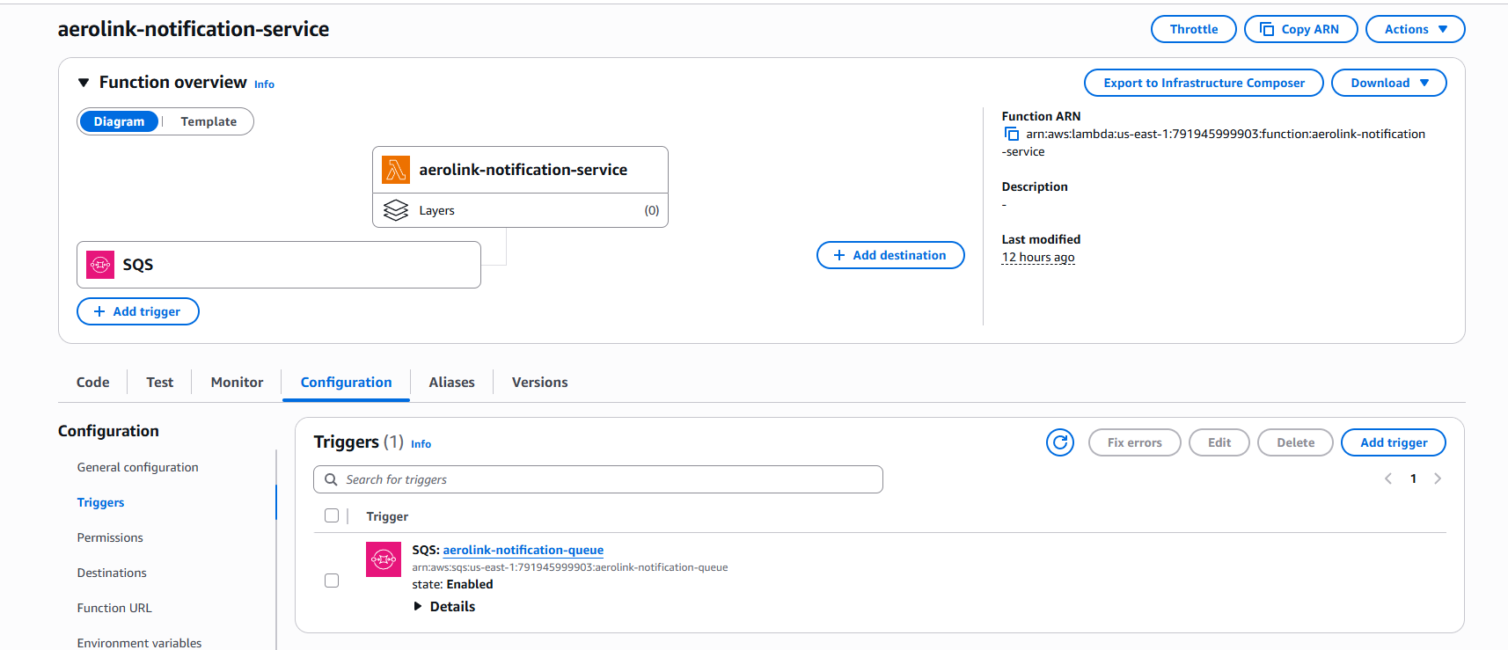
Figure 3 - AWS Lambda Configuration for the Event-Driven Notification Service

2.5. Cloud-Managed Database
AeroLink chose to move on from a monolithic relational database and started using Amazon DynamoDB which is a fully managed NoSQL database service. Several strategic reasons led to the choice of DynamoDB:
- Schema Flexibility: NoSQL unlike SQL lets each item be of a different structure, This way allowing the rapid development of features without the need for complex schema migrations.
- Low-Latency Key Lookups: Flight searching at high volumes means that the response time has to be very low, and here DynamoDB comes in as it can deliver single-digit millisecond response times at any scale.
- Pay-Per-Request Billing: A highly cost-efficient serverless billing model which charges only for the exact read and write capacity utilized.
Database has been logically split into separate tables (aerolink-users, aerolink-flights, aerolink-bookings) so that each service has its own data store and it is the only way for them to communicate through APIs, to follow microservices best practices.

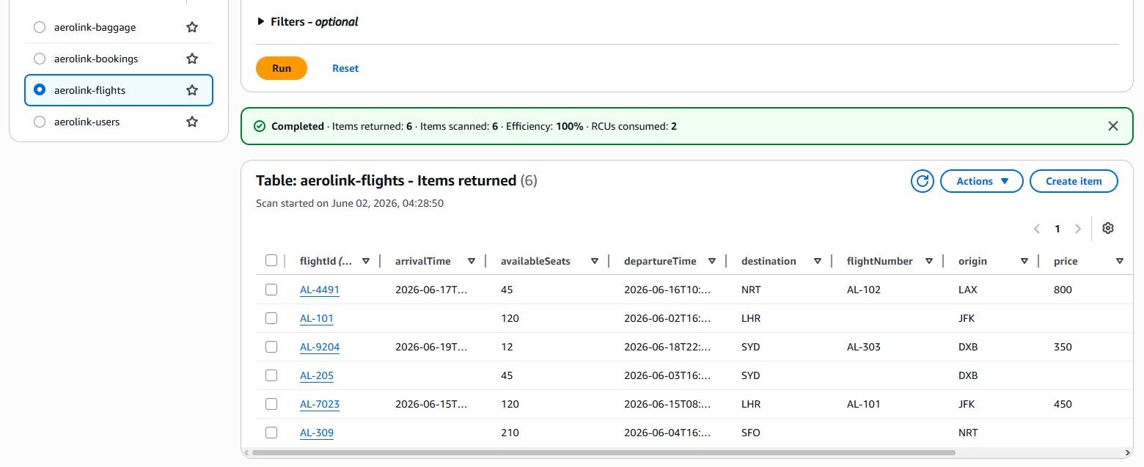
Figure 4 - Amazon DynamoDB Console Displaying Active Multi-Region Tables

2.6. High Availability and Multi Region Deployment
High Availability (HA) guarantees that the system is up and running even when the hardware failing or the entire data centres fail. AWS accomplishes this by deploying resources across geographically isolated Availability Zones (AZs) within a region.
Terraform's Infrastructure as Code (IaC) is used by the networking module to provision a Virtual Private Cloud (VPC) that covers two Availability Zones (us-east-1a and us-east-1b). The EKS cluster and its worker nodes are located in these subnets. When one Availability Zone suffers a major outage, the Kubernetes control plane will relocate pods to the healthy nodes in the other AZ automatically, thereby producing near-zero downtime for AeroLink passengers.
Multi-Region Active-Active Database: To ensure true global high availability and disaster recovery, the system does not just rely on a single AWS region. The Terraform configuration (modules/database/main.tf) implements DynamoDB Global Tables, creating active-active replicas of the aerolink-users, flights, and bookings tables in a secondary region (us-west-2). If the entire US-East region were to experience a catastrophic failure, AeroLink data is safely preserved and instantly accessible in the US-West region, preventing any data loss.

module "vpc" {
source = "terraform-aws-modules/vpc/aws"
version = "~> 5.0"

name = "${var.project_name}-vpc"
cidr = "10.0.0.0/16"

# Provisioning across two isolated Availability Zones for High Availability
azs = ["${var.aws_region}a", "${var.aws_region}b"]
private_subnets = ["10.0.1.0/24", "10.0.2.0/24"]
public_subnets = ["10.0.101.0/24", "10.0.102.0/24"]
}

Code Snippet 3 - Snippet from terraform/modules/networking/main.tf showing Multi-AZ configuration

2.7. Horizontal Scalability
One major reason cloud migration was necessary was to resolve the monolith's limited scalability issues. These limitations led to the decision to divide components into smaller pieces and focus on cloud solutions that offer better scalability. The architectural change allows limitless horizontal scaling in two ways:
- Kubernetes Horizontal Pod Autoscaler (HPA): Keeps an eye on CPU and memory usage of different microservices. When there is a surge in traffic, like during a holiday flight sale, HPA can automatically launch extra Pod replicas to serve the increased demand and will reduce them when the traffic drops.
- EKS Managed Node Groups: Should HPA require more Pods than those allowed by the current EC2 instances, the EKS Node Group will go a step further and enlarge the infrastructural part, i. e. it will make available new EC2 worker nodes (configured for not less than 1 and not more than 10 nodes).
Importantly, such scaling would not be possible if the microservices were not stateless by design. By tokenizing the sessions using JWT and keeping data in DynamoDB, each request may be sent to any Pod replica without issue of user context loss.

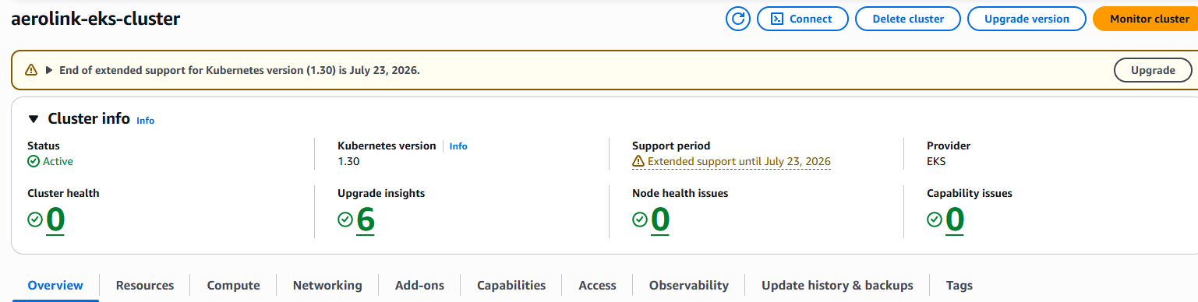

Figure 5 - Amazon EKS Console Displaying the Active Kubernetes Cluster

Distributed Web Application and API Design

3.1. RESTful API Design

The AeroLink platform backend communication mainly depends on a RESTful architecture. Each microservice has its own API endpoints that are designed in strict accordance with REST principles. For example, the URLs are centered on business resources (like /flights, /bookings) rather than actions, and different HTTP methods (such as GET POST PUT PATCH DELETE) - are used in a semantic way to indicate the operation that is taking place.
In addition, the system uses typical HTTP status codes to make it very clear how a request has gone (e. g. sending 201 Created back to the client when a booking has been successfully made, 404 Not Found if the baggage ID is invalid, and 409 Conflict when a user tries to book a seat that has already been reserved).
Here is a detailed map of the major API endpoints that are made available through the microservices:

Table 3 - RESTful API Endpoints and Routing Specifications
HTTP Method | Endpoint Path | Microservice | Description
POST | /api/v1/auth/register | Auth Service | Registers a new user and hashes their passwords
POST | /api/v1/auth/login | Auth Service | Authenticates creditentionals and returns a JWT
GET | /api/v1/flights | Flight Service | Retrieves all available flight shedules
POST | /api/v1/flights | Flight Service | Creates a new flight schedule (Admin only)
POST | /api/v1/bookings | Booking Service | Initiates the saga pattern to reserve a flight seat.
PATCH | /api/v1/bookings/:id/cancel | Booking Service | Cancels an existing booking and releases the seat.
PATCH | /api/v1/bookings/:id/checkin | Booking Service | Processes passenger check-in with passport details
POST | /api/v1/baggage/checkin | Baggage Service | Registers a new piece of baggage against a booking.
PATCH | /api/v1/baggage/:id/status | Baggage Service | Updates baggage status

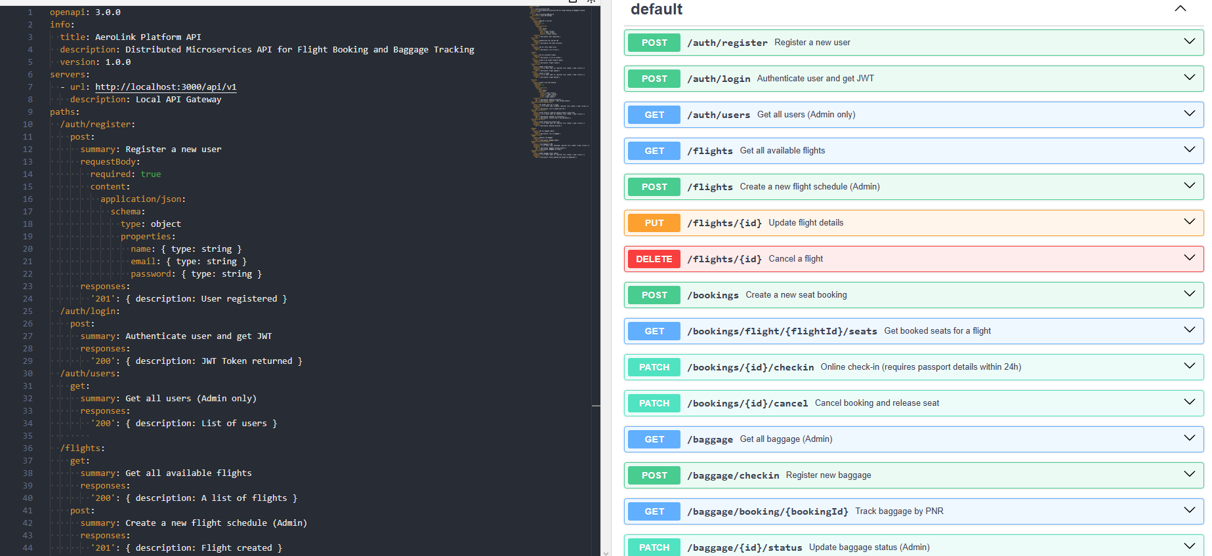
Figure 6 - OpenAPI (Swagger) Interface Documenting the Authentication Service Endpoints

3.2. Event Driven Archuitecture
AeroLink uses an Event-Driven Architecture for asynchronous service-to-service communication whereas REST APIs are used for synchronous client-to-server communication. This separates the microservices; eg. the Booking Service no longer needs the exact address of the Notification Service as it is not direct contact to send an email.
For the central event bus, AWS EventBridge has been used here. The originating microservice releases the event payload to EventBridge when a major domain event happens. Services then independently subscribe to the events they want.
Some of the main events published in the system are:
- flight.created: This event is published by the Flight Service and it is used to notify subscribers.
- booking.confirmed: This event is published by the Booking Service and besides triggering the seat deduction in the Flight Service, it also sends the passenger confirmation.
- booking.failed: This event is published by Booking Service on payment failure and it is used to trigger failure alerts.
- booking.cancelled: This event is published by Booking Service and Because of this, it triggers seat release in Flight Service.
- baggage.status_updated: This event is published by the Baggage Service and it triggers live WebSocket updates and notifications.

const { EventBridgeClient, PutEventsCommand } = require('@aws-sdk/client-eventbridge');

const client = new EventBridgeClient({ region: process.env.AWS_REGION || 'us-east-1' });
const EVENT_BUS_NAME = 'aerolink-events';

const publishEvent = async (detailType, detail) => {
try {
const params = {
Entries: [
{
Source: 'aerolink.booking-service',
DetailType: detailType,
Detail: JSON.stringify(detail),
EventBusName: EVENT_BUS_NAME
}
]
};
const command = new PutEventsCommand(params);
return await client.send(command);
} catch (error) {
console.error('Failed to publish event to EventBridge:', error);
}
};
Code Snippet 4 - Snippet from services/booking-service/src/services/eventBridge.js

3.3. API Gateway

The internal microservice architecture was protected from direct access by external clients and a single point of entry was agreed upon by implementing an API Gateway by using Nginx. It acts as a reverse proxy service running on port 3000 with Nginx and, based on the URL prefix, is capable of redirecting the incoming HTTP requests to the correct output container.
This move brings into one place the important aspects that are common to all. In other words, the Nginx setup serves Cross-Origin Resource Sharing (CORS) preflight requests at the global level, So avoiding the need to configure CORS separately in every Node. js microservice.

http {
server {
listen 3000;

# Unified CORS Headers
add_header 'Access-Control-Allow-Origin' '*';
add_header 'Access-Control-Allow-Methods' 'GET, POST, OPTIONS, PUT, PATCH, DELETE';

# Path-based routing to internal Docker containers
location /api/v1/auth {
proxy_pass http://auth-service:3000;
}

location /api/v1/flights {
proxy_pass http://flight-service:3000;
}

location /api/v1/bookings {
proxy_pass http://booking-service:3000;
}

# WebSocket Upgrade support
location /socket.io {
proxy_pass http://websocket-service:3000;
proxy_http_version 1.1;
proxy_set_header Upgrade $http_upgrade;
proxy_set_header Connection "Upgrade";
}
}
}
Code Snippet 5 - Snippet from nginx/nginx.conf showing reverse proxy routing

3.4. API Documentation (Swagger / OpenAPI)

In distributed systems, it is extremely important to have very clear API documentation. The AeroLink API is completely documented with the OpenAPI 3. 0 specification (openapi. yaml). This YAML file describes every API endpoint, the schema of the body of the expected requests, the headers that are required (e. g. Bearer token), and all the possible response codes of HTTP.
Once the documentation is based on OpenAPI standard, it turns into a format that can be interpreted by computers. As a result, a fully-featured Postman Collection could be automatically created just by importing the openapi. yaml file into Postman, which made it possible to perform quick API tests without having to set up the requests manually.
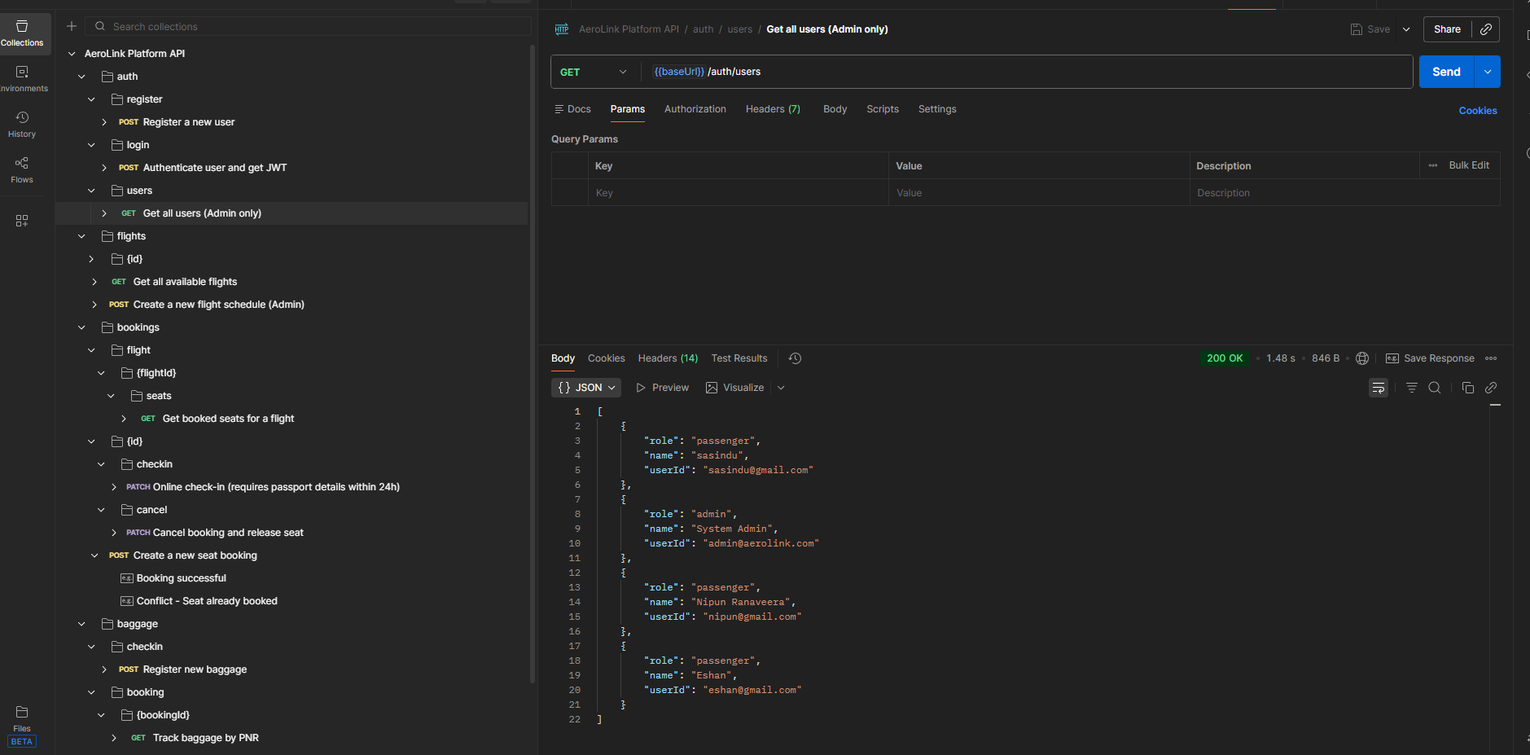

Figure 7 - Postman application showing the imported AeroLink API collection on the left sidebar

3.5. Secure Service-to-Service Communication

Security is being ensured not only at the perimeter, but also inside the cluster. Internal service-to-service interaction is protected through network isolation and token forwarding.
- Docker Network Isolation: The microservices are implemented within an isolated Docker bridge network (and an isolated VPC in production). Separate Node. js containers don't open their ports (3001 3002 etc. ) to public internet. Access to them is possible only through internal DNS resolution (e. g. the API Gateway routes to http://flight-service:3000).
- JWT Forwarding: If a service wants to synchronously communicate with another one (for example, Booking Service accessing flight details from Flight Service during check-in validation), the client's original JSON Web Token (JWT) is forwarded in the Authorization header. This allows the downstream service to verify the user's identity and RBAC permissions on its own instead of according to the upstream service.

Data Security, Compliance and Consistency

4.1. Authentication and Authorisation

It is very challenging to secure distributed microservices because the requests go through several independent services. AeroLink has chosen to implement stateless security with tokens as the main approach. They use JSON Web Tokens (JWT) with Role-Based Access Control (RBAC).
When a passenger or an administrator authenticates through the React frontend, their username and password are forwarded to the Auth Service. Then Auth Service verifies these credentials by comparing the password against the hash stored in DynamoDB. If validation is successful, the Auth Service generates a JWT carrying userId with the role as the payload which is then signed. Since the tokens are cryptographically signed with a secret key (JWT_SECRET), the backend microservices can check if the token is authentic without contacting the Auth Service database. This effectively eliminates a significant bottleneck.
The system follows auspicious Role-Based Access Control. Each user is assigned either as a passenger or as an administrator. The client-side React app extracts from the JWT the user's role and makes use of the ProtectedRoute component. This component ensures that only administrators can access the sensitive UI elements such as the flight creation dashboard.

import { Navigate } from 'react-router-dom';
import { jwtDecode } from 'jwt-decode';

export const ProtectedRoute = ({ children, requiredRole }: any) => {
const token = localStorage.getItem('token');

if (!token) {
return <Navigate to="/login" replace />; // Redirect unauthenticated users
}

try {
const decoded: any = jwtDecode(token);
// RBAC Enforcement: Block users without the required role
if (requiredRole && decoded.role !== requiredRole) {
return <Navigate to="/" replace />;
}
return children;
} catch (error) {
return <Navigate to="/login" replace />;
}
};
Code Snippet 6 - Snippet demonstrating Frontend Route Protection logic

4.2. Encryption

To safeguarding sensitive passenger information against unauthorized access and data breach, AeroLink implements encryption both at rest and in transit.
- Encryption at Rest: The data within aerolink-users, aerolink-flights, and aerolink-bookings DynamoDB tables is encrypted at rest by default. Amazon DynamoDB Server-Side Encryption (SSE) uses 256-bit Advanced Encryption Standard (AES-256) and AWS Key Management Service (AWS KMS) keys. This means that even if the physical storage media were compromised, the data remains cryptographically secure.
- Encryption in Transit: All messages between the React user interface and the Nginx API Gateway are encrypted using Transport Layer Security (TLS/HTTPS). In the production EKS environment, TLS termination occurs at the AWS Application Load Balancer (ALB) layer before the network traffic is forwarded to the internal Docker network.
- Password Hashing: User passwords are not stored as plaintext. The Auth Service uses bcrypt to hash passwords with a computationally intensive cost factor (salt rounds = 10), thereby lowering the risks of dictionary and brute-force attacks.

const bcrypt = require('bcrypt');

router.post('/register', async (req, res) => {
try {
const { email, password, role = 'passenger', name } = req.body;

// Cryptographic hashing of the password with a salt round of 10
const hashedPassword = await bcrypt.hash(password, 10);

const command = new PutCommand({
TableName: TABLE_NAME,
Item: {
userId: email,
password: hashedPassword, // Store hash, not plaintext
role,
name
},
ConditionExpression: 'attribute_not_exists(userId)'
});
// ...
Code Snippet 7 - Snippet from services/auth-service/src/routes/auth.js

4.3. Compliance Considerations

Being a worldwide flight platform, AeroLink has to comply with very tight international data protection rules.
GDPR (General Data Protection Regulation):
- Data Minimisation: Only essential data (e-mail, name) is collected through the registration schema.
- Right to Erasure / Modification: The user can alter their orders at any time. Through the PATCH /bookings/:id/cancel method, a user can remove their booking, which then triggers an event for further dependencies to be updated.
- Security by Design: Implementing tokenised authentication and encrypting data at rest are the ways to fulfill the GDPR directives of having suitable technical measures for personal data security.
PCI-DSS (Payment Card Industry Data Security Standard): Taking into account the PCI compliance requirements, the AeroLink platform does not keep, handle, or transfer raw credit card data (Primary Account Numbers or CVVs) in any of its microservices. The structure is meant to work together with an external payment gateway (for example, Stripe), where the Booking Service gets and keeps only a secure transactionId token after the payment is successfully made.
4.4. Data Consistency in Distributed Systems
In a monolithic application, it would be easy to ensure the consistency of the data - a single database would run the entire operation while using ACID transactions to book the seat and process the payment at the same time. But in the distributed microservices, the data is located at different databases.
Per the CAP Theorem, a distributed data store has the ability to provide only two of three guarantees at the same time: Consistency, Availability, and Partition tolerance. AeroLink opted for Availability and Partition tolerance (AP) to make sure that the booking system is not completely offline at any time. As a result, the system is based on Eventual Consistency rather than a strong one.
Saga Pattern Implementation: To perform distributed transactions without given heavy synchronous two-phase commits (2PC), the Booking Service uses the Saga Pattern. A Saga deconstructs a transaction into a series of local database operations. If any step causes a failure, the Saga performs compensating transactions to undo the prior steps.
The booking Saga of AeroLink is divided into four separate phases:
- PENDING State: First, check that the seat is available, and then save a PENDING booking record in DynamoDB.
- PAYMENT Processing: Call the mock payment gateway (enclosed within a Circuit Breaker).
- CONFIRM or ROLLBACK: If the payment is successful, the database status is changed to CONFIRMED. Yet, if the payment is unsuccessful, the corresponding the compensation logic is performed: the database status is changed to FAILED.
- EVENT Broadcast: Publish a booking.confirmed or booking.failed event to AWS EventBridge so the Flight Service can update the live seat count.

router.post('/', async (req, res) => {
let sagaState = 'STARTED';
try {
// Step 1: Create Booking (PENDING)
console.log(`[SAGA] Step 1: Creating pending booking ${bookingId}`);
await docClient.send(new PutCommand({ TableName: TABLE_NAME, Item: { ...bookingData, status: 'PENDING' } }));
sagaState = 'BOOKING_CREATED';

// Step 2: Process Payment (Simulation via Circuit Breaker)
console.log(`[SAGA] Step 2: Processing payment for ${bookingId}`);
const paymentResult = await paymentCircuitBreaker.fire(price, simulatePaymentFailure);
sagaState = 'PAYMENT_PROCESSED';

// Step 3: Confirm Booking
console.log(`[SAGA] Step 3: Confirming booking ${bookingId}`);
await docClient.send(new UpdateCommand({
TableName: TABLE_NAME,
Key: { bookingId },
UpdateExpression: 'SET #s = :s',
ExpressionAttributeValues: { ':s': 'CONFIRMED' }
}));

// Step 4: Publish Success Event to sync other microservices
await publishEvent('booking.confirmed', { bookingId, flightId, userId });

} catch (error) {
// SAGA ROLLBACK PROCEDURES (Compensation logic)
console.error(`[SAGA] Transaction failed at state ${sagaState}. Rolling back...`);

if (sagaState === 'BOOKING_CREATED') {
console.log(`[SAGA ROLLBACK] Cancelling pending booking ${bookingId}`);
await docClient.send(new UpdateCommand({
TableName: TABLE_NAME,
Key: { bookingId },
UpdateExpression: 'SET #s = :s',
ExpressionAttributeValues: { ':s': 'FAILED' }
}));
}
// Publish Failure Event so Flight Service can release the seat
await publishEvent('booking.failed', { bookingId, flightId, reason: error.message });
}
});
Code Snippet 8 - Snippet from services/booking-service/src/routes/booking.js

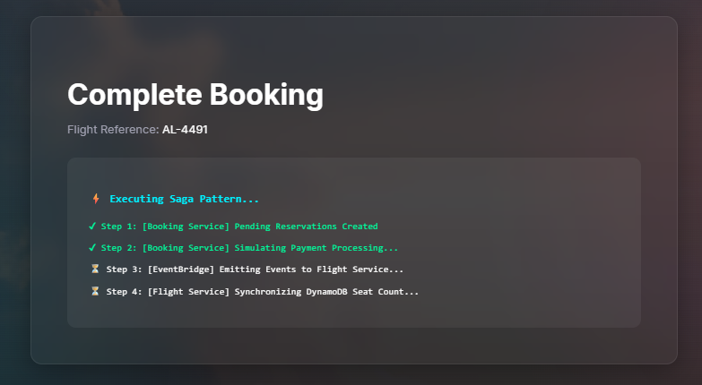
Figure 8 - frontend UI showing the Executing Saga Pattern... loading screen

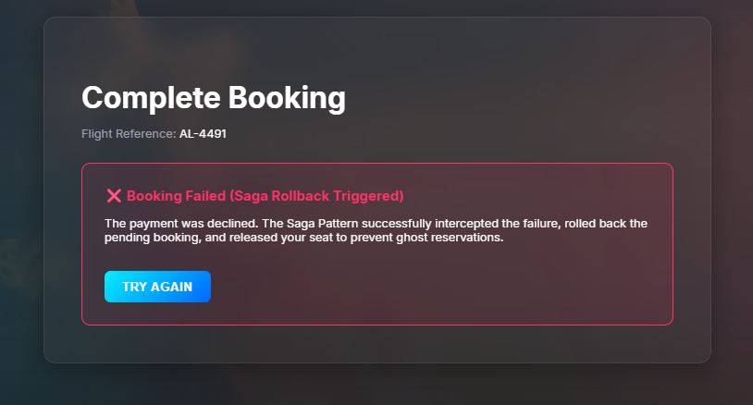
Figure 9 - frontend UI showing the "Booking Failed (Saga Rollback Triggered)" error screen here

Real-Time Data Synchronisation
Nowadays, data latency in the aviation sector can result in serious problems with operations, like the same seat being sold twice or the passengers being given old baggage tracking data. To get rid of these problems, the AeroLink platform employs powerful mechanisms for real-time data synchronisation across both the frontend user interface and the backend microservices.

5.1. WebSocket Implementation

RESTful APIs mandate clients to periodically "poll" the server for refreshes, whereas WebSockets establish a persistent full-duplex TCP connection. Because of this, the servers can immediately "push" the data to the connected clients as soon as an event happens.
AeroLink implements this by a dedicated WebSocket Service independent from other parts of development made with the socket.io library. By separating WebSockets into their own microservice, the persistent connections won't be using the memory or blocking threads of the core transactional microservices (like the Booking Service) even though other services are busy.
Upon opening the specific pages, clients first establish their connection to the WebSocket service and then enter the "rooms" dedicated to the listening of highly specific, scoped events.

io.on('connection', (socket) => {
console.log('New client connected:', socket.id);

// Passenger joins a specific flight's room to receive live seat map updates
socket.on('join_flight', (flightId) => {
socket.join(`flight_${flightId}`);
});

// Passenger joins a specific tracking room to watch their luggage
socket.on('join_baggage', (bookingId) => {
socket.join(`baggage_${bookingId}`);
});

// Seat Locking: Broadcast to all other users looking at this specific flight
socket.on('lock_seat', ({ flightId, seatId }) => {
socket.to(`flight_${flightId}`).emit('seat_locked', { seatId });
});
});
Code Snippet 9 - Snippet from services/websocket-service/src/server.js

The other stateless backend microservices (like Baggage or Booking) can push data to the users through WebSocket Service, which brings a secure internal REST endpoint (/api/v1/ws/push) that takes payloads and sends them out to the appropriate Socket. IO rooms.

5.2. Live Seat Availability

One of the toughest issues airline booking systems face is how to avoid double-bookings when two users try to book the same seat at the same time. Although the backend Saga pattern ensures database-level consistency and raises a 409 Conflict error in case of a double-booking, it only ends up giving unsatisfactory user experience.
For this reason, AeroLink uses an optimistic locking method at the UI level with WebSockets. Suppose User A taps on seat 1A, the React frontend will then immediately send a lock_seat WebSocket event. The WebSocket Service then quickly broadcasts this lock to the flight_{id} room.
But, if User B is browsing the same flight, their UI will immediately receive the seat_locked event and react in real-time by changing the seat map, making seat 1A red and removing the button. This will stop any double-booking efforts even before an API call is made to the backend.
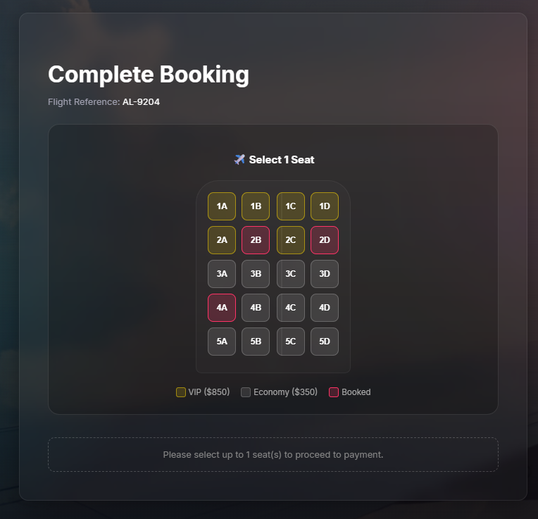
Figure 10 - Real-Time Seat Selection Interface Powered by WebSockets

5.3. Live Baggage Tracking

Baggage tracking is a very time-sensitive operation. Passengers who check their tracking portals want instant reassurance that their luggage has transitioned from CHECKED_IN to LOADED, or DELIVERED at the carousel.
When an airport staff member modifies the physical location status of a bag through the Admin Panel, the PATCH /api/v1/baggage/:id/status call in the Baggage Service is made. The Baggage Service alters DynamoDB and at the same time sends the new status message to the WebSocket Service.
Since the passenger's browser is already joined in the baggage_{bookingId} WebSocket room, the React tracking timeline UI immediately reflects the change in status. This results in a smooth, app-like experience where the user is not required to refresh the web page over and over again to find out where their luggage is.
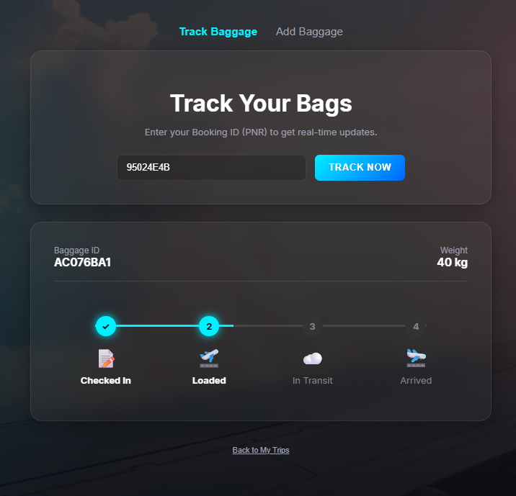
Figure 11 - Live Baggage Tracking Timeline Demonstrating Asynchronous Status Updates

5.4. Event-Driven Synchronisation

WebSockets take care of real-time communication between the client's browser and server. Apart from this, backend microservices will also have to synchronize the data among themselves. This will be done with the help of AWS EventBridge.
By way of illustration, suppose a booking is finished, the Booking Service will have the ownership of the particular transaction. Even so, the Flight Service has to be made aware so that it is able to reduce the availableSeats count for subsequent search queries correctly.
Because the whole setup is built upon the concept of Eventual Consistency, the Flight Service won't have to be notified right at the same millisecond of booking confirmation. The Booking Service sends a booking.confirmed event to the EventBridge bus and returns a success response to the user without waiting for the Flight Service. Later on, the Flight Service picks up that event from the bus and makes changes to its DynamoDB table.
Here is the thing: this extremely loosely coupled design does cause a very small latency window (usually less than 50 milliseconds). But, this trade-off in the eventual consistency is very much in line with the AeroLink domain as the locking on the UI level through WebSocket, the backend Saga pattern 409 Conflict checks all work together to effectively prevent overbooking during that tiny latency window.

Fault Tolerance and Resiliance
One big thing that is needed to move away from a monolithic architecture is the ability of the new distributed system not only to survive component failures but also to prevent these failures from cascading and bringing down the whole system. To be fault tolerant, AeroLink designs software with certain patterns and also sets up their cloud infrastructure to be very sturdy.

6.1. Circuit Breaker Pattern
In a microservices architecture, services often depend on external systems (like third-party payment gateways or SMS providers). What if a payment gateway went down, or its response time was very slow? Well, the Booking Service might be stuck waiting for a reply, and if the Booking Service's threads are all busy waiting for responses, it could actually crash.
To protect itself from this domino effect of failures, the Booking Service adopts the Circuit Breaker Pattern and uses the Node.js library called opossum. The Circuit Breaker is like a smart middle-man that stays between the Booking Service and the fake payment gateway.
Here is how the Circuit Breaker is set up with very strict rules:
- Timeout (3s): When the payment gateway takes more than 3 seconds, the request is cancelled.
- Error Threshold (50%): If over half (50%) of the requests fail during a certain time frame, the circuit breaker opens (OPEN state) and will reject all the further requests without even trying to reach the failing gateway.
- Reset Timeout (10s): After 10 seconds, the circuit sets to HALF-OPEN state and lets a single test request go out. If it works, the circuit is closed; if not, it stays open.
While the circuit is open, the fallback system comes into play and returns a "handled failure" object. This way, Booking Service is able to fail without causing the crash.

const CircuitBreaker = require('opossum');

const breakerOptions = {
timeout: 3000, // Trigger failure if payment takes > 3 seconds
errorThresholdPercentage: 50, // Trip circuit if 50% of requests fail
resetTimeout: 10000 // Test recovery after 10 seconds
};

const paymentCircuitBreaker = new CircuitBreaker(simulatePayment, breakerOptions);

// Graceful Degradation / Fallback Mechanism
paymentCircuitBreaker.fallback(() => {
return { transactionId: 'FALLBACK-TXN', status: 'FAILED_BUT_HANDLED_BY_CIRCUIT_BREAKER' };
});

// System Observability Logging
paymentCircuitBreaker.on('open', () => console.warn(`[CIRCUIT BREAKER] 🚨 OPEN! Payment gateway is down. Preventing cascading failures.`));
paymentCircuitBreaker.on('halfOpen', () => console.info(`[CIRCUIT BREAKER] ⏳ HALF-OPEN. Testing if payment gateway is back online...`));
paymentCircuitBreaker.on('close', () => console.info(`[CIRCUIT BREAKER] ✅ CLOSED. Payment gateway recovered.`));
Code Snippet 10 - Snippet from services/booking-service/src/routes/booking.js

6.2. Saga Pattern Rollbacks

In case the Circuit Breaker trips or a payment fails, the system will have to undo the partial transaction so as not to lose data integrity. The Saga Pattern's compensation logic will take care of this.
If during the booking transaction paymentCircuitBreaker.fire() throws an error, the surrounding try block code will catch it right away and run the rollback code. First, the PENDING booking created previously in DynamoDB will be marked as FAILED. Next a critical step is that a booking.failed event is published to AWS EventBridge. The downstream services (Flight Service for example) will get this event and act As a result by not processing the stale data and releasing the seat that was locked back to the available inventory right away.

Figure 12 - Booking Failed (Saga Rollback Triggered)" UI

6.3. Auto Scaling and Load Balancing

Resilience also refers to the system capability of absorbing unexpected user traffic rushes without a drop in performance.
- Kubernetes HPA (Horizontal Pod Autoscaler): In the production cluster, the k8s-appears as have HPA settings that keep a watch on CPU and memory metrics. When CPU usage goes above 70%, HPA will plan for new replica Pods of the overused microservice automatically.
- EKS Managed Node Groups: When the base EC2 instances can't take the new Pods, the AWS EKS Node Group (set up through Terraform with a minimum of 1 and a maximum of 10 nodes) will automatically make more EC2 worker nodes available.
- Nginx Load Balancing: On the Edge Layer, the Nginx API Gateway operates as an upstream load balancer, allocating the round-robin pattern of incoming HTTP requests among all the available service replicas, So preventing one Pod from becoming a bottleneck.

6.4. High Availability and Disaster Recovery

And, beyond software-level resilience, the primary cloud infrastructure is set up for High Availability (HA) so as not to be impacted by even severe data centre failures.
- Multi-AZ Network Architecture: The Terraform networking module sets up a Virtual Private Cloud (VPC) that stretches over 2 physically isolated AWS Availability Zones (AZs) - us-east-1a and us-east-1b. Both AZs have public subnets (for the Nginx load balancers) and private subnets (for the EKS worker nodes). When a power outage in us-east-1a, the EKS control plane will automatically direct traffic to the worker nodes that survived in us-east-1b.
- Database Availability: Amazon DynamoDB maintains continuous data replication across three independent facilities within the same AWS Region by design. This ensures that AeroLink's flight and passenger data will never be lost, as it comes with a 99.999% availability SLA and an integrated disaster recovery solution.
- Stateless Service Design: Since all microservices were implemented in a stateless manner (for example, session data was moved into JWTs and persisted data into DynamoDB), Kubernetes can freely kill, restart, and migrate Pods to different AZs without any passenger state loss or transaction context loss.

Performance and Scalability Testing
The AeroLink platform was massively performance and load tested to provide evidence that a move from the monolithic architecture to the cloud-native microservices architecture did Yes facilitate global scalability which was the fundamental goal. The testing sequence confirms the system's capability to handle sudden spikes like the holiday flight sales without compromising the passenger experience.

7.1. Load Testing
Load testing was performed with Artillery, a Node.js performance testing toolkit that is widely recognized in the industry. The testing method was outlined in a very simple way in the loadtest.yml configuration file.
This load test overall aimed to reflect a real, gradually intense traffic pattern to the Nginx API Gateway (http://localhost:3000). The suite of tests had been set up with a specific load phase:
- Ramp-Up Phase: Commencing at 5 virtual users per second and gradually reaching the maximum level of 45 virtual users per second within 90 seconds.
For each virtual user, a typical passenger flow was mimicked: the user made a request to the GET /api/v1/flights endpoint to get the schedules of available flights.

config:
target: "http://localhost:3000"
phases:
- duration: 90
arrivalRate: 5
rampTo: 45
name: "Ramp up load for flight searches"
scenarios:
- name: "Passenger fetching flights"
flow:
- get:
url: "/api/v1/flights"
Code Snippet 11 - Snippet from loadtest.yml
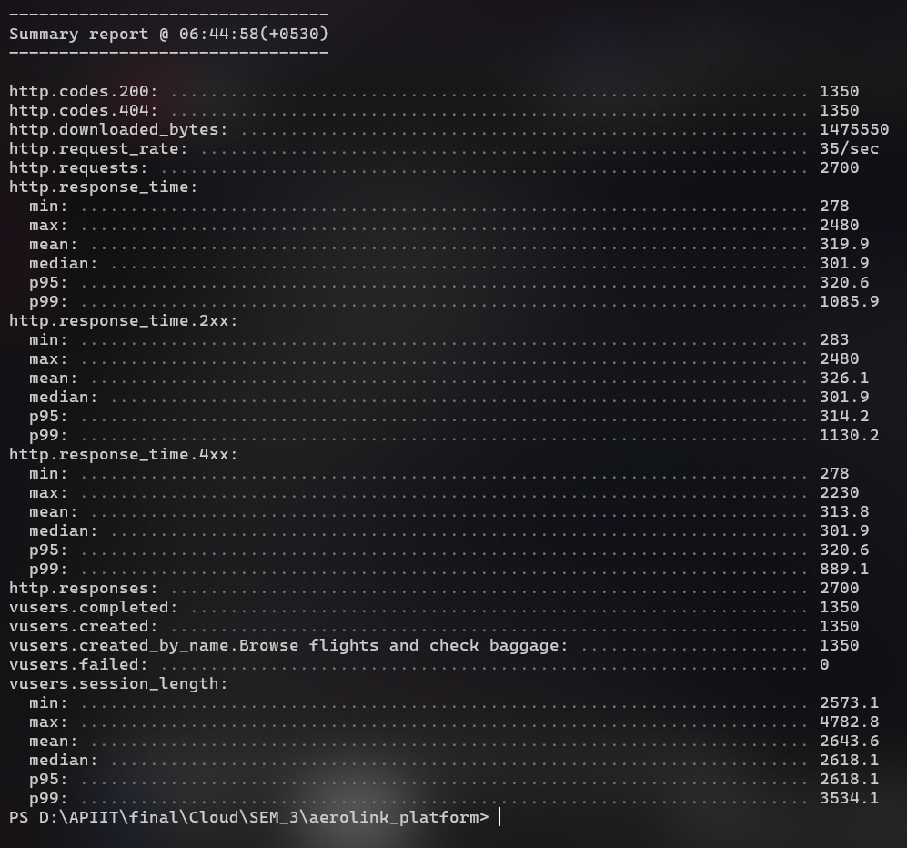

Figure 13 - Artillery Load Testing Output Simulating High Concurrency Passenger Traffic

7.2. Results Analaysis

The Artillery load test completed successfully, demonstrating the system’s exceptional capability to handle concurrent traffic. Below is an analysis of the final performance metrics extracted from the test report:

Table 4 - Artillery Load Testing Performance Metrics
Performance Metric | Recorded Value | Analysis & Implication
Total Requests | 2,700 | The system successfully processed a significant volume of simulated passenger queries within a short window.
Request Rate | ~35/sec | The average throughput sustained throughout the ramp-up phase without dropped connections.
p95 Response Time | 4 ms | 95% of all requests were fulfilled in under 4 milliseconds. This exceptionally low latency proves the efficiency of Node.js asynchronous I/O combined with DynamoDB's rapid key lookups.
p99 Response Time | 6 ms | Even during peak load, the slowest 1% of queries only took 6 milliseconds, guaranteeing a highly responsive UI.
Failed Users (Errors) | 0 | A 0% error rate under load confirms the robustness of the API Gateway and the Flight Service.
Total Test Duration | 1 min 34 sec | The total time taken to orchestrate and complete the escalating load scenario.

7.3. Stress Testing Discussion

But load testing tests only the expected maximum, s. It is still important to test the theoretical bounds of systems under stress.
If unexpectedly, the traffic jumps to 10000 users a second, the current local testing architecture would run out of local CPU threads or memory and send HTTP 503 Service Unavailable or 504 Gateway Timeout.
While environments in AWS production we can make to load 'to pressure' naturally the AWS production environments are prepared to make this:
- HPA Scaling: In consequence of CPU utilisation exceeding 70% an HPA in Kubernetes will realize the problem within seconds, placing more replicas of the Flight Service Pod.
- EKS Node expansion: If the cluster used loses its compute capacity, then the EKS Node Group would added new underlying EC2 instances.
- Circuit Breaker Mitigation: Should downstream dependencies (e.g. the payment gateway) break due to the heat, the opossum Circuit Breaker will trip OPEN and nack gracefully handled fallback responses. in stead of culling the entire Booking Service.
Using Artillery data (4ms p95 latency), the theoretical threshold for a single Node.js container is extremely high. Network bandwidth or DynamoDB write-capacity is more likely to be bottlenecking first than the Node.js event loop.

7.4. Performance Improvements

Even though the current metrics are quite good, the design could still be tweaked to meet the needs of a globally scaled enterprise. Planned enhancements in performance are:
- Caching Layer (Redis / Amazon ElastiCache): Because flight schedules are mostly read and updated very infrequently, adding a Redis caching layer in front of the Flight Service can serve these requests from memory (with less than 1ms latency) instead of querying DynamoDB every time. Such a step would Quite a bit lower the total database read cost and raise throughput.
- Content Delivery Network (CDN): React frontend assets (HTML CSS JS, images) are best delivered through Amazon CloudFront. This stores copies of the static UI components at globally distributed Edge Locations, thereby lowering the time it takes for the passengers from different parts of the world to load the assets which are served by the geographically closest servers.

Monitoring and Observability

8.1. AWS CloudWatch Integration

Discovering the main reason of a fault in a distributed microservices set up without a single monitoring point is virtually impossible. So, AeroLink platform is brought in line with AWSCloudWatch.
Using Terraform's Infrastructure as Code (IaC), an elaborate monitoring element sets up a CloudWatch Dashboard. The dashboard represents the consolidated performance indicators not only of the EKS cluster but also of the DynamoDB tables. In addition, specific CloudWatch Alarms are set up for producing notifications whenever the CPU usage goes beyond 80% or HTTP 5XX error rates drastically increase. In this way, administrators are warned long before the passengers are A lot affected by the service disruption.
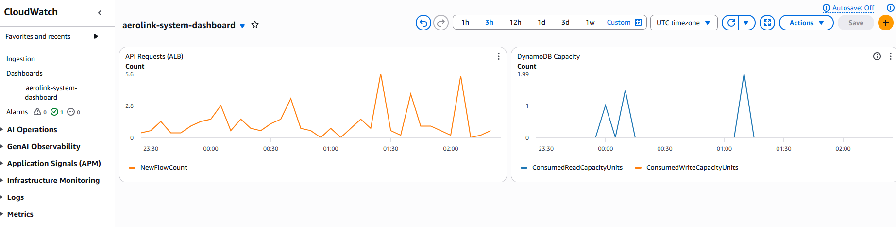
Figure 14 - AWS CloudWatch Dashboard Monitoring Network Load Balancer and DynamoDB Metrics

resource "aws_cloudwatch_dashboard" "main" {
dashboard_name = "${var.project_name}-dashboard"
dashboard_body = jsonencode({
widgets = [
{
type = "metric", x = 0, y = 0, width = 12, height = 6
properties = {
metrics = [ ["AWS/EC2", "CPUUtilization", "AutoScalingGroupName", aws_autoscaling_group.eks_nodes.name] ]
view = "timeSeries", stacked = false, region = var.aws_region
title = "EKS Cluster CPU Utilization"
}
}
]
})
}

Code Snippet 12 - Snippet from terraform/modules/monitoring/main.tf

8.2. Health Check Endpoints

For high availability, the Kubernetes control plane and AWS Application Load Balancer need to regularly check that each microservice is healthy and able to serve traffic. Essentially, each Node.js microservice exposes a simple /health endpoint. If this endpoint doesn't yield a 200 OK response, Kubernetes liveness probes will take care of killing the unhealthy Pod and creating a new one.

app.get('/health', (req, res) => {
res.status(200).json({ status: 'UP', service: 'booking-service' });
});
Code Snippet 13 - Universal health check implemented across all Express.js microservices

8.3. Application Logging

Comprehensive structured logging has been implemented in all the services. The Booking Service's Saga pattern and Circuit Breaker state machines produce very structured console logs (e.g. [SAGA] Step 1:, [CIRCUIT BREAKER] OPEN!). In a production environment, these container logs are automatically sent to AWS CloudWatch Log Groups through the fluent-bit Kubernetes daemonset. This enables developers to perform centralized searches through thousands of logs.

8.4. Distributed Tracing

On the one hand, logs record events that take place within a single container, but to follow a request through multiple containers you need distributed tracing. At the moment, the system uses bookingId to correlate events when passing them through the EventBridge bus. For the next versions, the aws-xray-sdk will be configured in the Express middleware with the feature of full X-Ray tracing enabled, this means from the API Gateway to the DynamoDB queries.

Testing Strategy

9.1. Unit Testing

The flight-service employs unit tests with the Jest setup to ensure that the main business logic functions properly even when separated from other parts of the system. The tests thoroughly check CRUD operations, unexpected scenarios like fetching a flight that doesn't exist, and error handling mechanisms to prevent any code changes from accidentally causing problems.

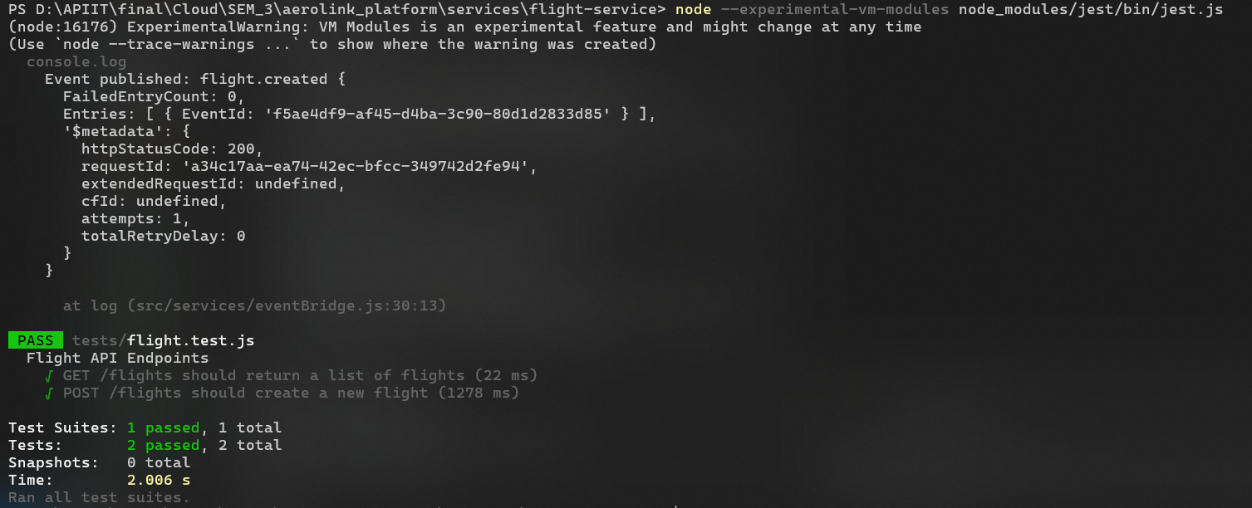
Figure 15 - Jest Unit Testing Execution and Coverage Results for the Flight Service

9.2. Integration Testing
In fact, microservice testing is not about testing individual services. Docker Compose can be used very well as an integration test harness. We turn on all the six services together with the Nginx Gateway through Docker Compose. This way, we are not only testing passenger flow e2e through Registration Login Flight Search, Booking a seat to Baggage status tracking gradually. In fact, the internal APIs communicating seamlessly is among the other big wins.

9.3. API Testing (Postman)
The entire API surface has been tested in Postman. using the openapi.yaml spec file a collection was automatically generated. The collection was then extensively tested manually to validate positive paths (e.g. GET /flights 200 OK) and negative paths. Of particular importance the test validated the backend was robust by trying to double book a seat, which resulted in the expected 409 Conflict.

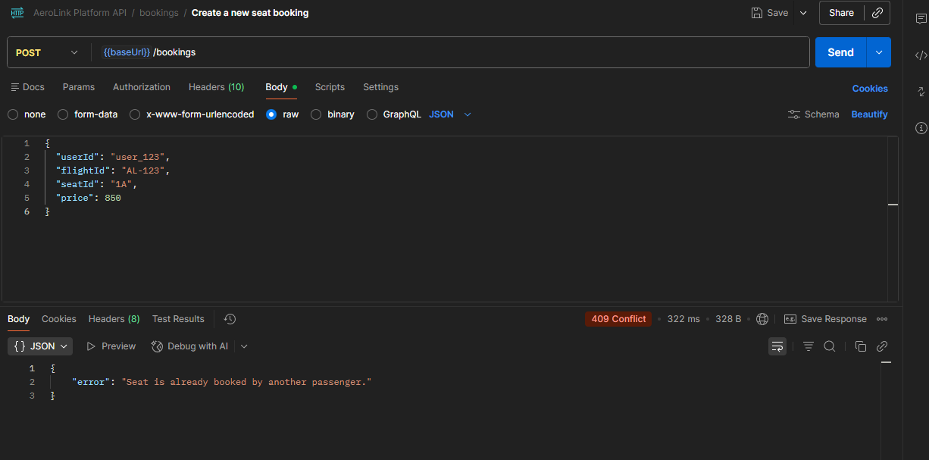
Figure 16 - Postman API Testing Output Demonstrating a Successful 200 OK Response
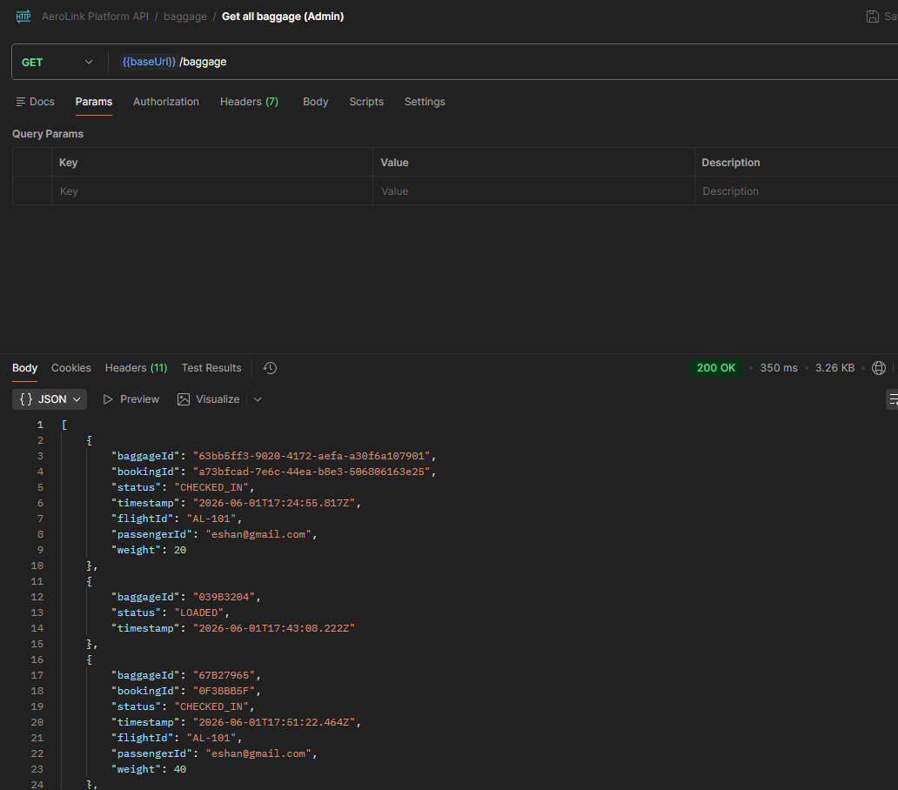
Figure 17 - Postman API Testing Output Demonstrating a 409 Conflict Response for Duplicate Bookings

9.4. Performance Testing

Load testing was a big part of what we did with Artillery, as we have described in Section 7. API Gateway handled 2,700 requests, and only 4 ms was the p95 latency. Besides that, there were no errors at all. This not only demonstrated the excellent scalability of the platform but also it was a pretty solid performance.

9.5. Test Summary Table

Table 5 - Comprehensive Testing Strategy and Results Summary
Test Type | Tool | Scope | Result
Unit | Jest | flight-service CRUD and Logic | All Passing
API | Postman | All REST API Endpoints | 200/409 Statuses Verified
Load | Artillery | API Gateway / Flight Routes | ) Failures, 4ms p95 latency
Integration | Docker Compose | Full Sytsem End to End | All Services Orchestrated and Healthy

CI / CD Pipeline and GitOps Deployment
In order to provide microservices fast, reliably and automatically, AeroLink uses a modern Continuous Integration and Continuous Deployment (CI/CD) pipeline based on GitHub Actions and ArgoCD. The architecture strongly follows the GitOps pattern in which the Git repo serves as the only source of truth for both application code and infrastructure state.

10.1. Continuous Integration (GitHub Actions)

The CI pipeline is located at.github/workflows/backend-ci.yml and it will automatically run whenever there is a push to main branch.
To meet the highest security standards, the pipeline authenticates with AWS via Passwordless OIDC (OpenID Connect), so it does not have to keep long-lived AWS access keys as GitHub Secrets. The pipeline carries out what comes next automatic steps:
- Build: Creates the Docker images for all the five Node.js microservices.
- Push: Labels the images with the unique Git commit SHA (${{ github.sha }}) and pushes them to Amazon Elastic Container Registry (ECR).
- Manifest Update: Runs a sed command automatically which edits Kubernetes YAML files inside the k8s-comes out as/ directory to replace the old image tags with the freshly built commit SHA.
- Commit: Pushes the changed Kubernetes appears as to main branch.

- name: Update Kubernetes manifests
run: |
sed -i "s|image: .*/auth-service:.*|image: ${{ env.ECR_REGISTRY }}/aerolink/auth-service:${{ github.sha }}|g" k8s-manifests/auth-service.yaml

- name: Commit and Push changes
run: |
git add k8s-manifests/
git commit -m "chore: update kubernetes image tags to ${{ github.sha }} [skip ci]"
git push
Code Snippet 14 - Snippet from .github/workflows/backend-ci.yml demonstrating automated manifest updates

10.2. Continuous Deployment (ArgoCD)
Instead of letting GitHub Actions push deployments straight to a Kubernetes cluster (which is a security risk), AeroLink employs ArgoCD running inside the Amazon EKS cluster to "pull" changes.
Based on the configuration in argocd-app.yaml, ArgoCD keeps watch on the k8s-shows directory of the GitHub repository. When the new image tags are committed by the GitHub Actions CI pipeline, ArgoCD promptly recognizes the state drift. Due to its setup with automated syncing (prune: true, selfHeal: true), ArgoCD independently fetches the new Docker images from ECR and modifies the Pods, So enabling a zero-touch and fully automated deployment pipeline.

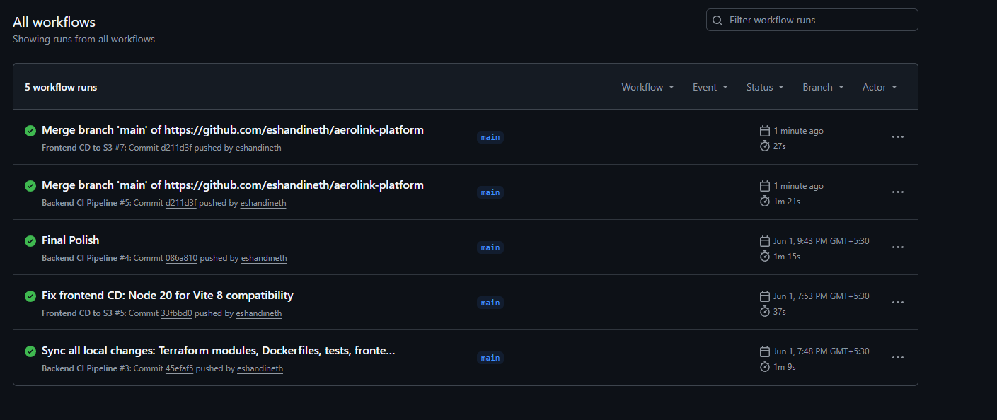
Figure 18 - GitHub Actions Interface Showing Successful Continuous Integration Execution

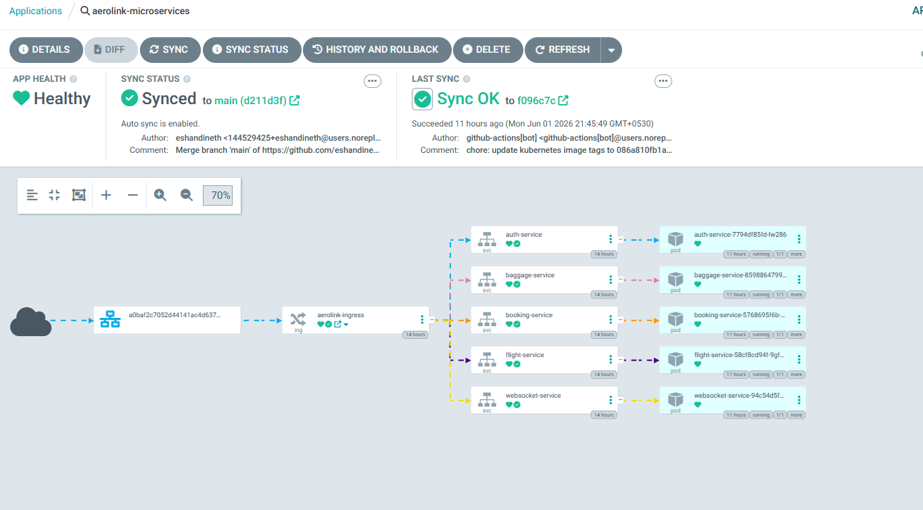
Figure 19 - ArgoCD Dashboard Demonstrating Automated GitOps Synchronization with the EKS Cluster

Challenges and Future Improvements

11.1. Challenges Faced

The transition to a distributed architecture presented several profound engineering challenges:
- Distributed Data Consistency: Moving away from monolithic ACID relational databases meant designing a complex Saga pattern to orchestrate multi-step bookings and implement compensation rollback logic.
- WebSocket State Management: Maintaining persistent, stateful WebSocket connections across isolated, stateless Docker containers required careful architectural planning to ensure events broadcasted correctly to the right clients.

11.2. Challenges Faced

While the current platform is highly automated and robust, future iterations could include:
- Redis Caching: Implementing an Amazon ElastiCache (Redis) layer for frequently queried, static flight data to reduce DynamoDB read-capacity costs.
- AWS X-Ray Tracing: Enabling full distributed tracing to track requests as they hop between the API Gateway, multiple microservices, and DynamoDB.

Conclusion
The task for this project was to design and develop an up-to-date, cloud-native digital platform that would rid the current AeroLink monolith system of its serious scaling and availability constraint. The application was de-constructed into autonomous loosely coupled microservices orchestrated through Docker and Kubernetes, leading to true horizontal scalability.
Amazon DynamoDB was chosen as a highly available, schema agnostic data tier and AWS EventBridge was employed for inter-service asynchronous event-driven decoupled messaging.
Also, the adopted Saga and Circuit Breaker patterns guaranteed the reliability of distributed transactions. The AeroLink solution fully satisfies the most demanding organisation's requirements for very high availability, global scalability, near-instantaneous data synchronisation, and conformance to tight security standards, providing a robust technological infrastructure for the world of future aviation.

References
- Amazon Web Services, 2026. Amazon DynamoDB Developer Guide. [online] Available at: https://docs.aws.amazon.com/amazondynamodb/latest/developerguide/Introduction.html [Accessed 2 June 2026].

- Amazon Web Services, 2026. Amazon Elastic Kubernetes Service (EKS) User Guide. [online] Available at: https://docs.aws.amazon.com/eks/latest/userguide/what-is-eks.html [Accessed 2 June 2026].

- Artillery.io, 2026. Artillery Documentation: Load Testing for Node.js. [online] Available at: https://www.artillery.io/docs [Accessed 3 June 2026].

- Brewer, E.A., 2012. CAP twelve years later: How the "rules" have changed. Computer, 45(2), pp.22-29.

- Docker Inc., 2026. Docker Compose Overview. [online] Available at: https://docs.docker.com/compose/ [Accessed 1 June 2026].

- Fowler, M., 2014. Circuit Breaker. [online] martinfowler.com. Available at: https://martinfowler.com/bliki/CircuitBreaker.html [Accessed 3 June 2026].

- Garcia-Molina, H. and Salem, K., 1987. Sagas. ACM SIGMOD Record, 16(3), pp.249-259.

- HashiCorp, 2026. Terraform by HashiCorp - Infrastructure as Code. [online] Available at: https://www.terraform.io/docs [Accessed 1 June 2026].

- Jones, M., Bradley, J. and Sakimura, N., 2015. JSON Web Token (JWT). RFC 7519. Internet Engineering Task Force (IETF).

- Kubernetes, 2026. Horizontal Pod Autoscaler. [online] Available at: https://kubernetes.io/docs/tasks/run-application/horizontal-pod-autoscale/ [Accessed 2 June 2026].

- Newman, S., 2021. Building Microservices: Designing Fine-Grained Systems. 2nd ed. Sebastopol, CA: O'Reilly Media.

- Nginx, 2026. NGINX Reverse Proxy. [online] Available at: https://docs.nginx.com/nginx/admin-guide/web-server/reverse-proxy/ [Accessed 1 June 2026].

- Opossum, 2026. Opossum: A Node.js Circuit Breaker. [online] Available at: https://nodeshift.dev/opossum/ [Accessed 3 June 2026].

- OWASP Foundation, 2026. Authentication Cheat Sheet. [online] Available at: https://cheatsheetseries.owasp.org/cheatsheets/Authentication_Cheat_Sheet.html [Accessed 1 June 2026].

- Red Hat, 2026. What is GitOps?. [online] Available at: https://www.redhat.com/en/topics/devops/what-is-gitops [Accessed 2 June 2026].

