INSHA MUSHTAQ  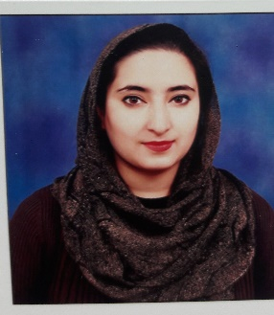

Inshamushtaq007@gmail.com

+91-7298980276

+91-7889582256

CAREER OBJECTIVE

My past Six Years as an engineering student have been an enormous journey in getting to encounter new technological core developments going around and I want to have the opportunity to learn a lot from real world experience as well. I am keen to contribute to the success and growth of the organization by undertaking the challenging assignments and delivering timely results by applying best of my knowledge and skills. Please review my resume as it contains all information which matches your requirements closely.

PERSONAL SNIPPETS

* Date of Birth : 14thAugust,1992
* Languages Known : English, Hindi, and Kashmiri.
* Marital Status  : Unmarried.
* Nationality : Indian
* Hobbies : Cooking & Observing Nature.
* Aadhaar No : 787501967046

INDUSTRIAL TRAININGS & PROJECTS DONE

* 1 Month Summer Training in Radio Kashmir Srinagar
* 1 Month Summer Training in Entrepreneurship development Ambala

Projects:

1. Automatic PC controlled using Remote.
2. Paid charging-station for electronic devices at Public spots.
3. Hi-Tech Hi-definition with night vision camera Quad copter.
4. Automatic car parking with slots.

SCHOLASTICS

|  |  |  |  |
| --- | --- | --- | --- |
| **Qualification** | **University/Board** | **Institute** | **Year of Passing** |
| B.tech (ECE) | KUK | Emax Group of Inst. | 2017 |
| Diploma (ECE) | JKSBOTE | Kashmir Govt. Polytech. | 2014 |
| H.SC | JKBOSE | G.H.S.S.Sonwar | 2010 |
| S.SC | JKBOSE | G.H.S.S.Sonwar | 2008 |

STRENGTHS

* Leadership: An experienced team leader
* Influencing, leading, and delegating abilities
* Ability to initiate/manage cross-functional teams and multi-disciplinary projects.
* Critical thinking, decision making and problem solving skills.
* Planning and organizing – Organizational abilities
* Result oriented: Ability to achieve the target within given time
* Excellent Communication skills.
* Negotiating skills
* Conflict resolution.
* Adaptability – Efficient under pressure, always meet deadlines
* Sound expertise in sales
* Good communicator
* Strong Presentation skills
* Persuasiveness – Know-how to demonstrate, promote and sell
* Strong networking skills

COMPUTER PROFICIENCY

* Windows (All versions)
* MS Office (Word, PowerPoint, Excel)
* Internet applications.
* Operating System Handling
* Software Installation
* Software Maintenance.
* Operating System Installation.

DECLARATION

I hereby declare that the information furnished above is true to the best of my knowledge.

Place: Srinagar Insha Mushtaq