NAME: HANAN KHAN
ENROLLMENT: 03-135232-024

📘 Content Management Systems (CMS)

🧪 Lab Manual – Week 2

🔹 Lab Title
CMS Architecture, Themes & Plugins (WordPress Practical)

🔹 Lab Duration
2–3 Hours

🔹 Lab Objectives
After completing this lab, students will be able to:
- Understand CMS architecture in practice
- Differentiate frontend and backend of a CMS
- Explore WordPress dashboard in detail
- Install, activate, and customize themes
- Install and manage plugins
- Understand database-driven content flow

🔹 Software / Tools Required
- Computer or Laptop
- Internet Browser (Chrome / Firefox)
- XAMPP Server (Installed & Running)
- WordPress (Installed – from Week 1)

🔹 Pre-Lab Requirement
- WordPress must be installed on localhost
- Apache & MySQL services must be running
- Student must have WordPress admin login

🧪 Lab Task 1: Identify Frontend and Backend

Steps:
- Open browser
- Visit: http://localhost/wordpress
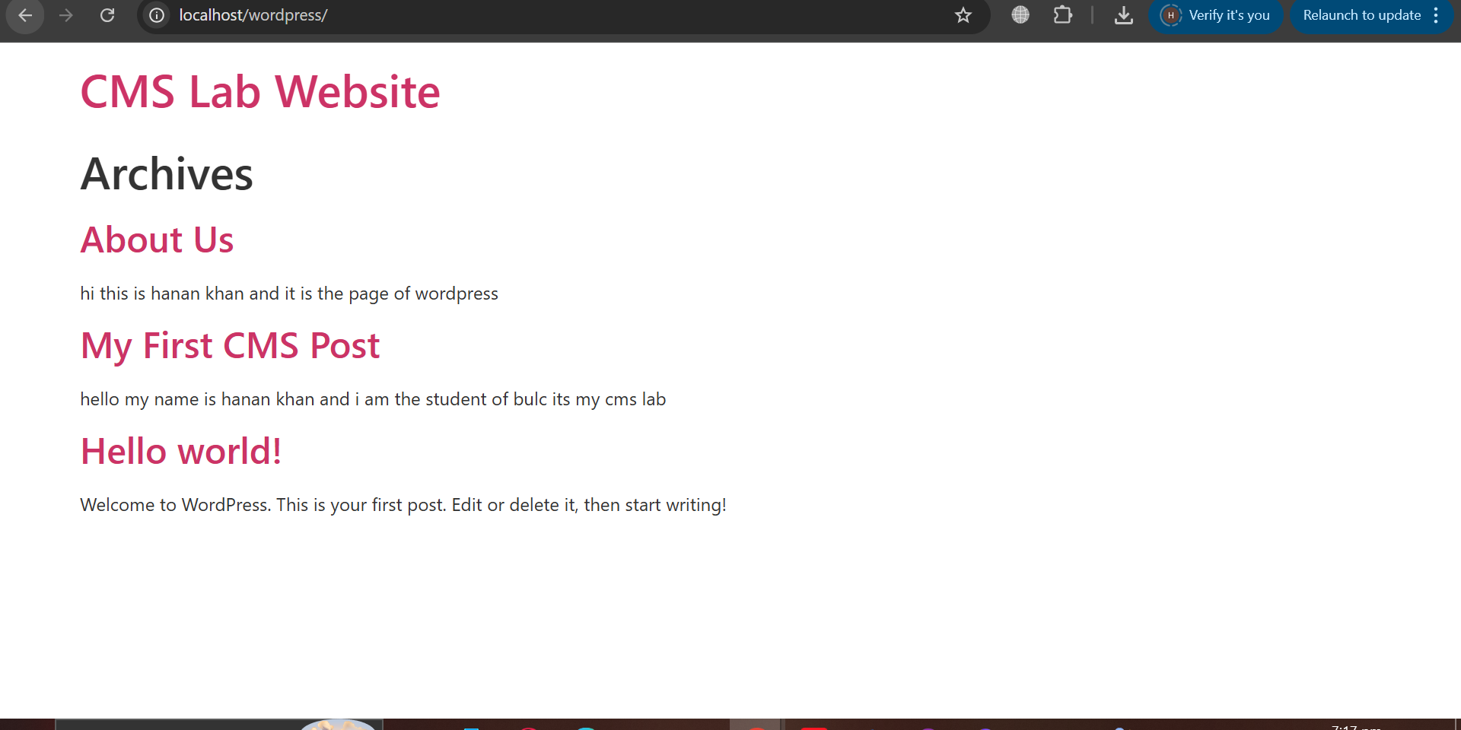
- Observe website appearance (Frontend)
- Login to WordPress admin panel
- Visit: http://localhost/wordpress/wp-admin
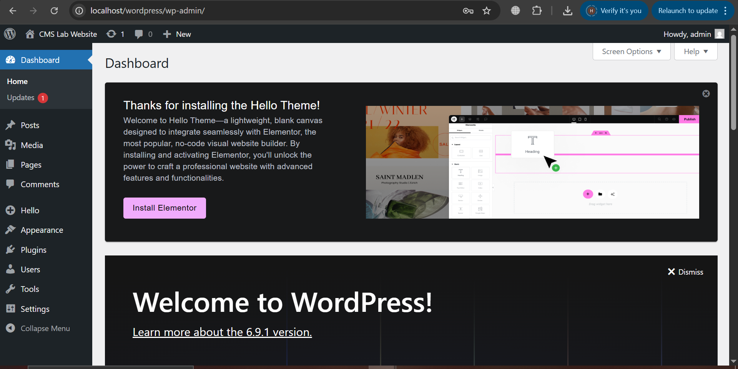

Task:
- Write 3 differences between frontend and backend
Frontend and backend differ primarily in user visibility, purpose, and technology stack
. The frontend is the "client-side" interface users see and interact with, while the backend is the "server-side" engine managing data and logic. Key differences include:

- Visibility: Frontend is what users see (buttons, layout, design). Backend is the invisible, behind-the-scenes "under the hood" functionality.
- Purpose: Frontend focuses on user experience and interaction. Backend focuses on data storage, business logic, and server operations.
- Technologies: Frontend uses HTML, CSS, and JavaScript. Backend uses languages like Python, Java, SQL, PHP, or Node.js.

🧪 Lab Task 2: Explore WordPress Dashboard Menus

Instructions:
Explore the following menus and write their purpose:
- Dashboard
- Posts
- Pages
- Media
- Appearance
- Plugins
- Users
- Settings

Expected Outcome:
Students understand backend structure of CMS.
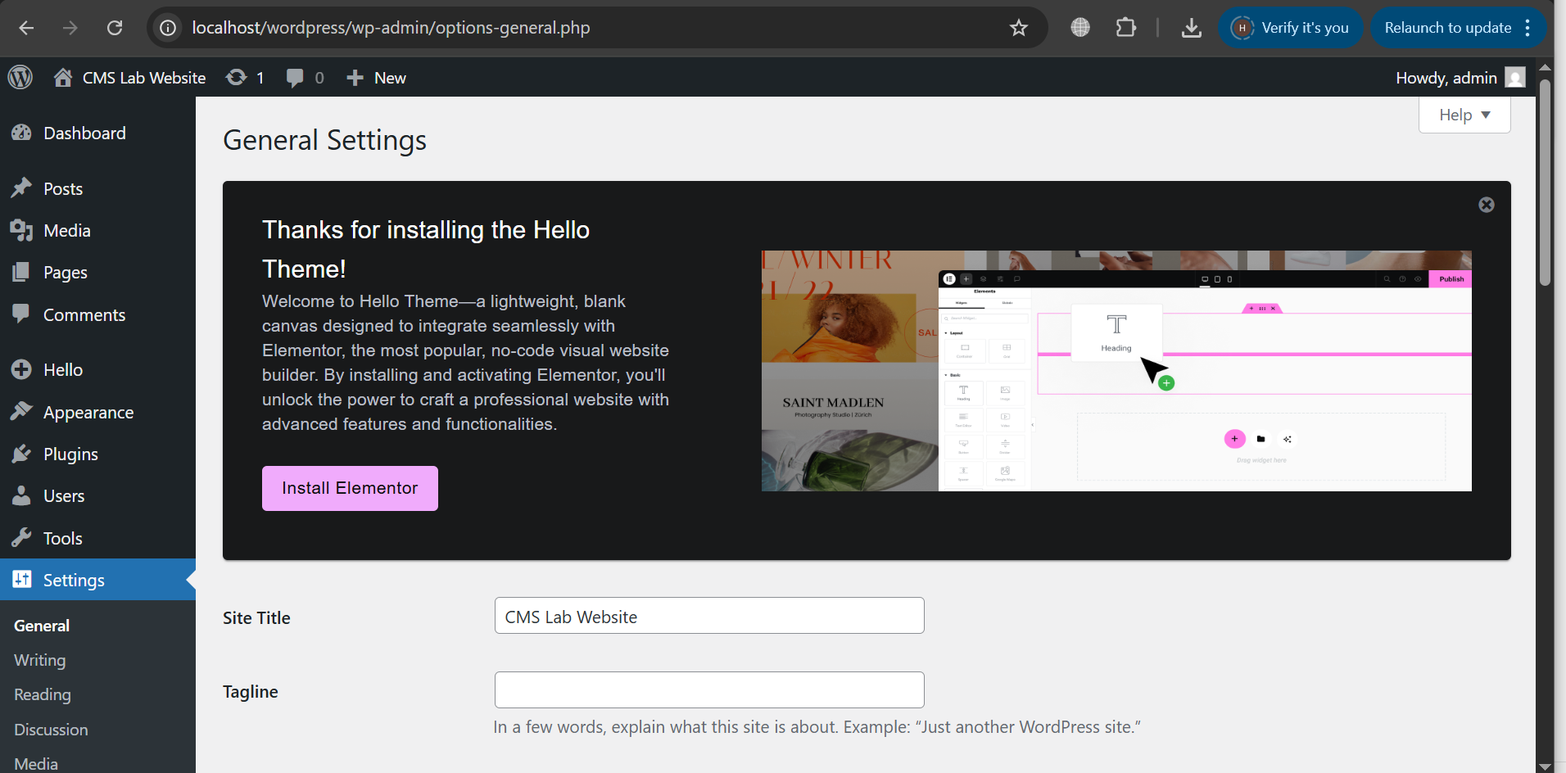

🧪 Lab Task 3: Understand Database-Driven Content

Steps:
- Open browser
- Go to: http://localhost/phpmyadmin
- Select database created earlier (e.g., cms_lab)
- Observe tables like:
  - wp_posts
  - wp_users
  - wp_options
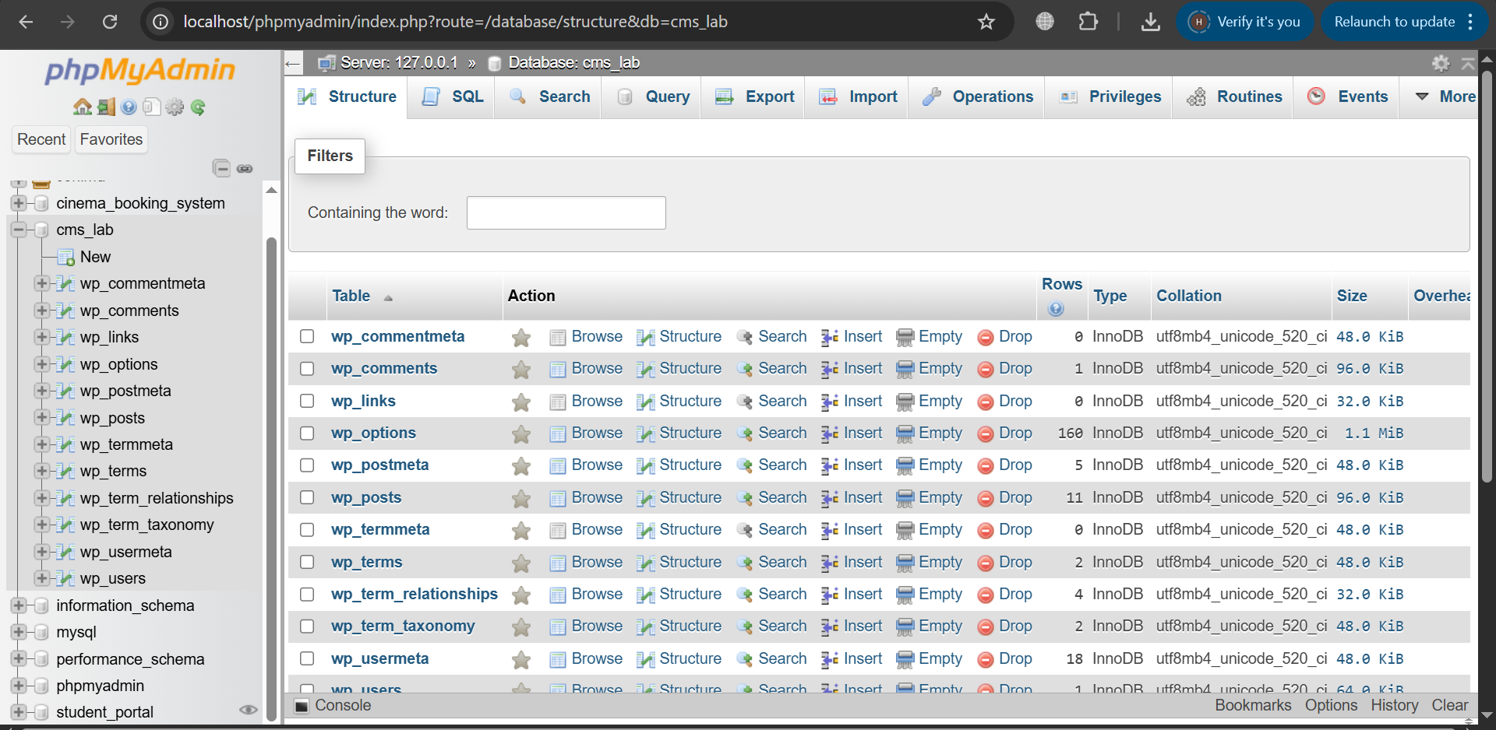

Task:
- Identify which table stores:
  - Posts
  - Pages
  - Users
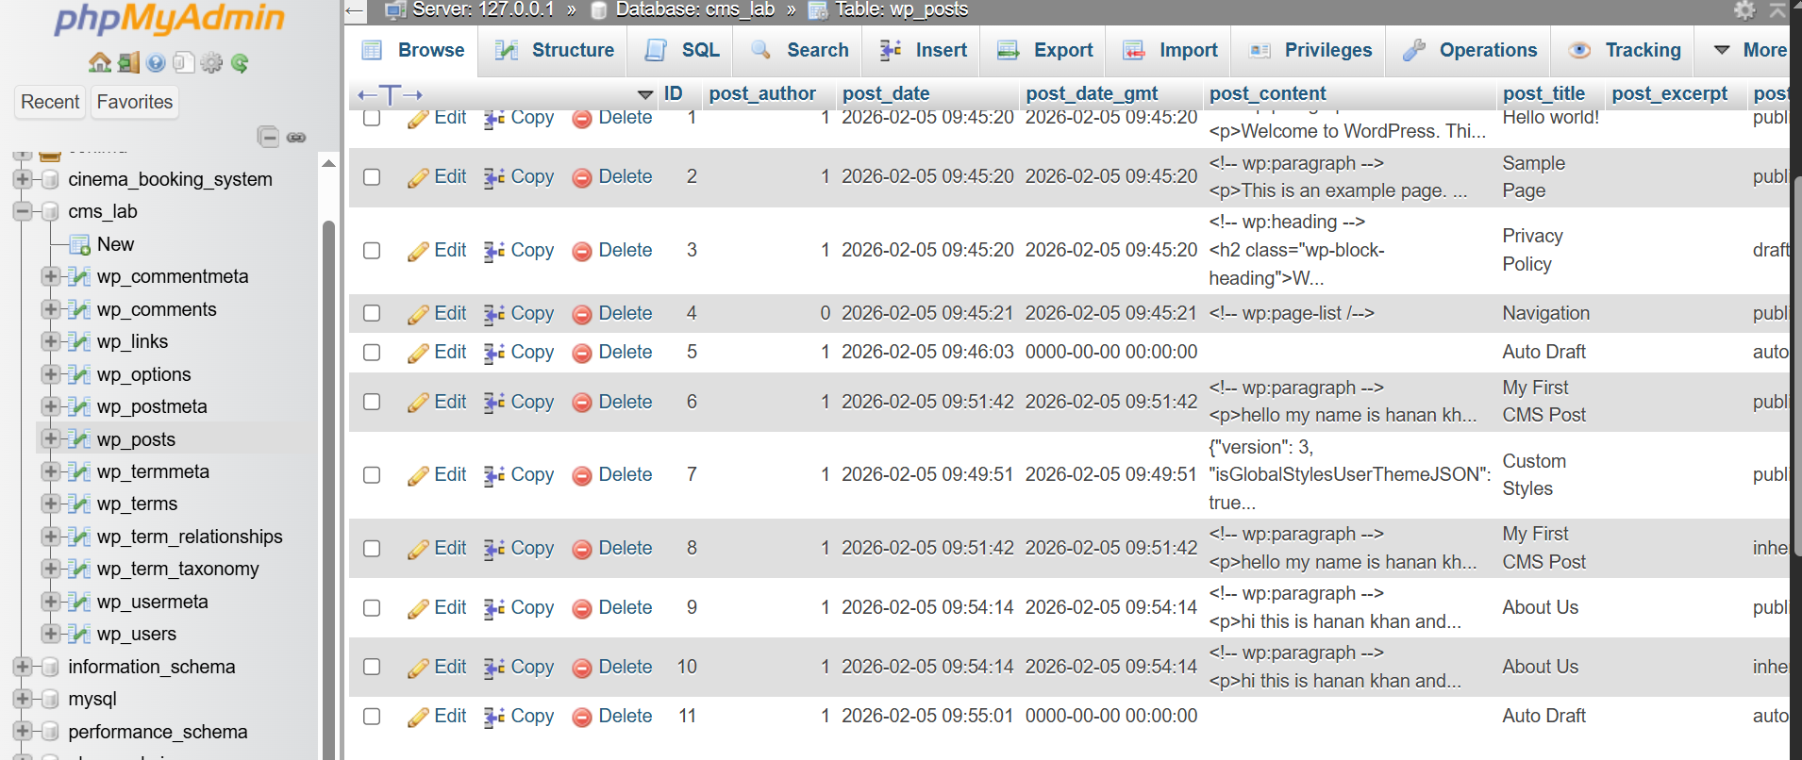
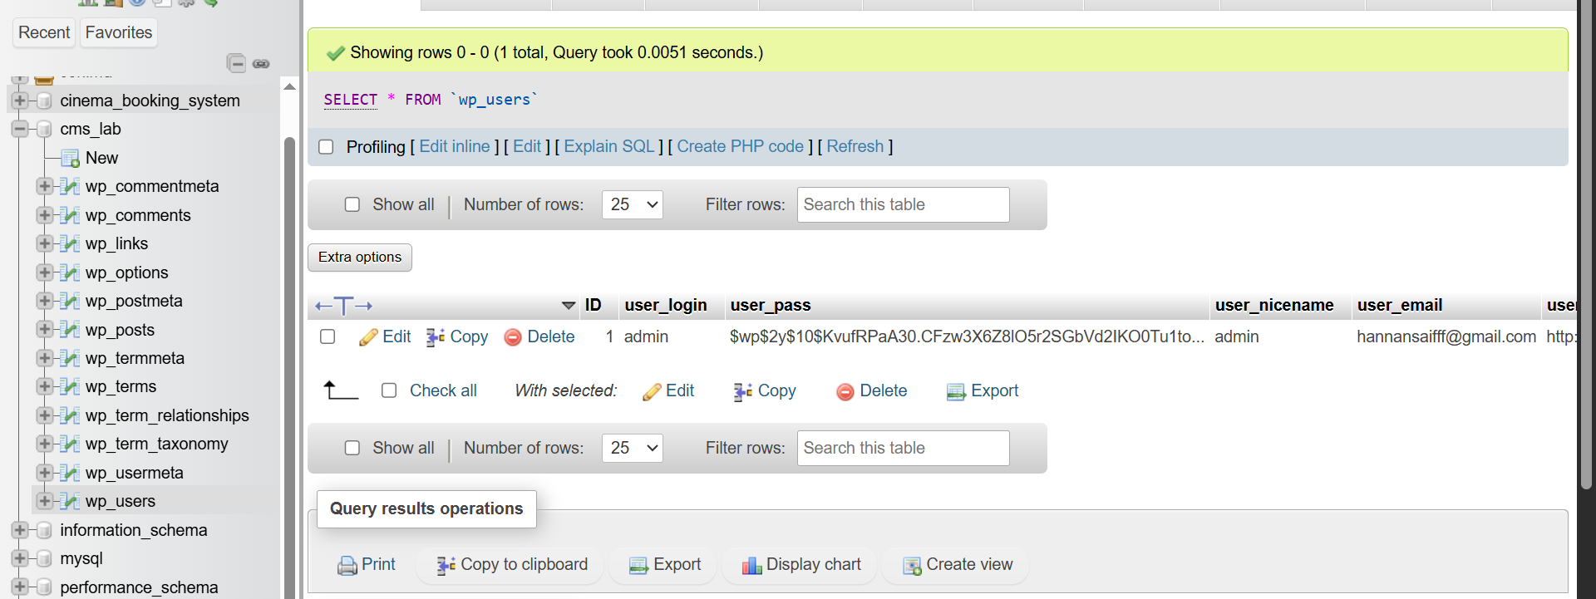

🧪 Lab Task 4: Install a New Theme

Steps:
- Login to WordPress admin panel
- Go to Appearance → Themes
- Click Add New
- Choose any free theme
- Click Install → Activate
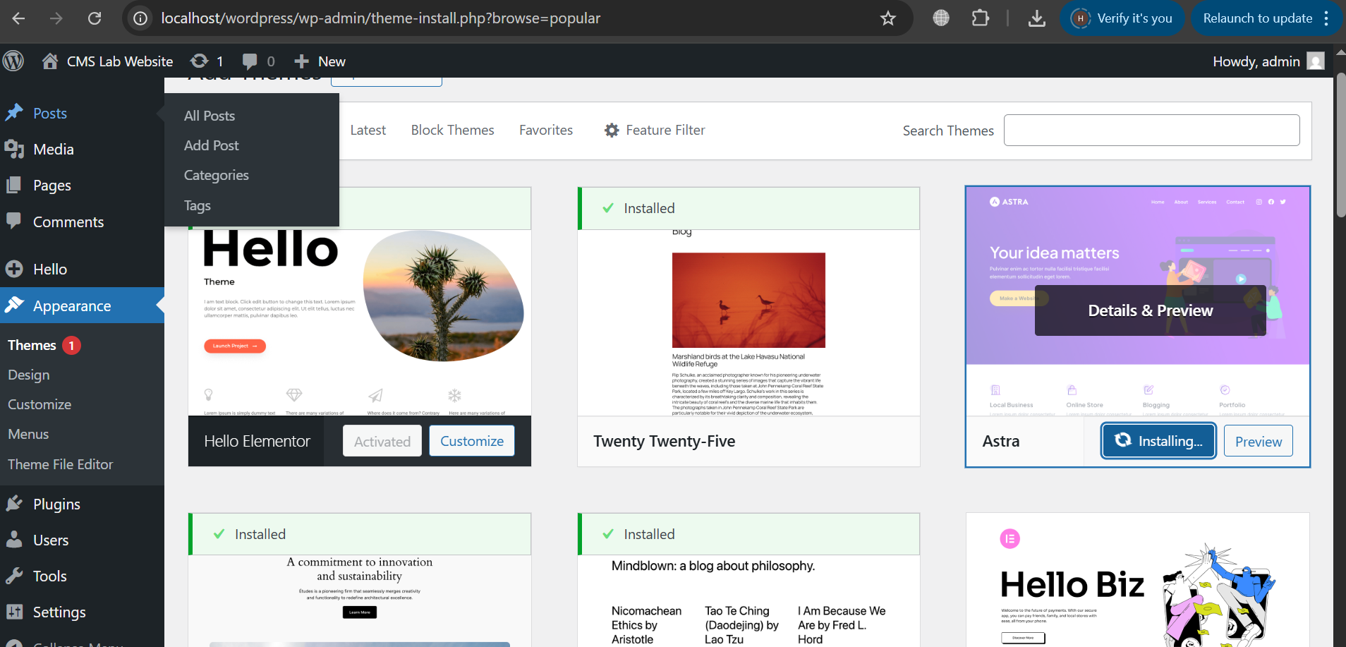

Observation:
- Website design changes instantly
- Content remains unchanged
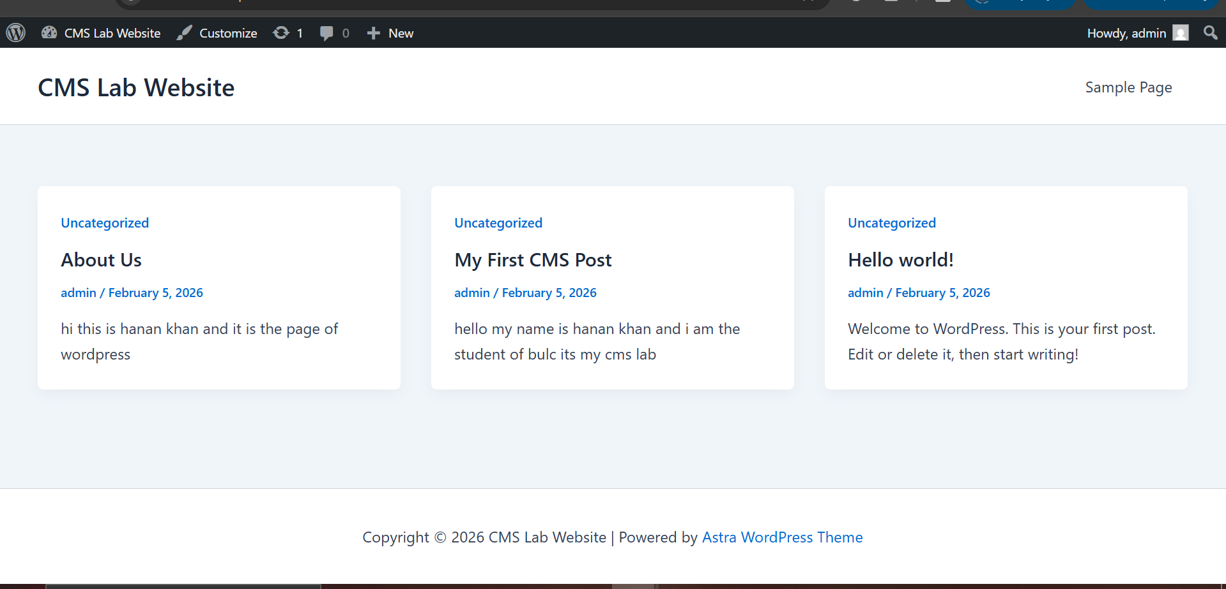

🧪 Lab Task 5: Customize Theme Settings

Steps:
- Go to Appearance → Customize
- Change:
  - Site title
  - Logo (if available)
  - Colors (if supported)
- Click Publish

Task:
- Note down changes you applied

🧪 Lab Task 6: Install Plugins

Steps:
- Go to Plugins → Add New
- Search and install:
  - Contact Form 7
  - Yoast SEO (or any SEO plugin)
- Activate plugins
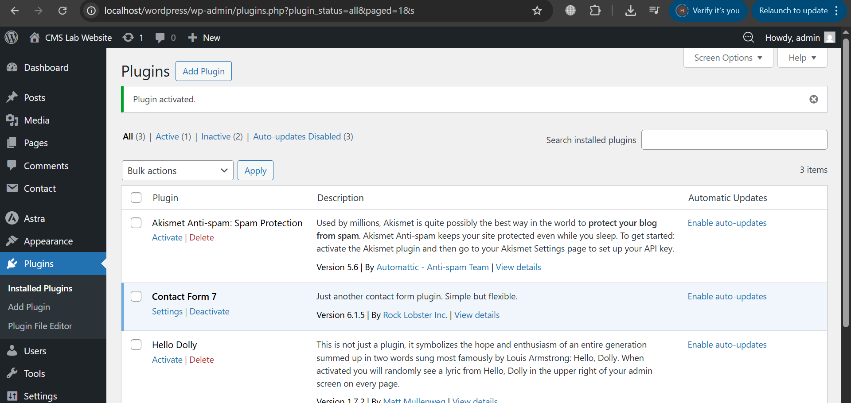

🧪 Lab Task 7: Use a Plugin (Contact Form)

Steps:
- Open Contact Form 7
- Create a new contact form
- Copy generated shortcode
- Create a new page named Contact Us
- Paste shortcode into page
- Publish page
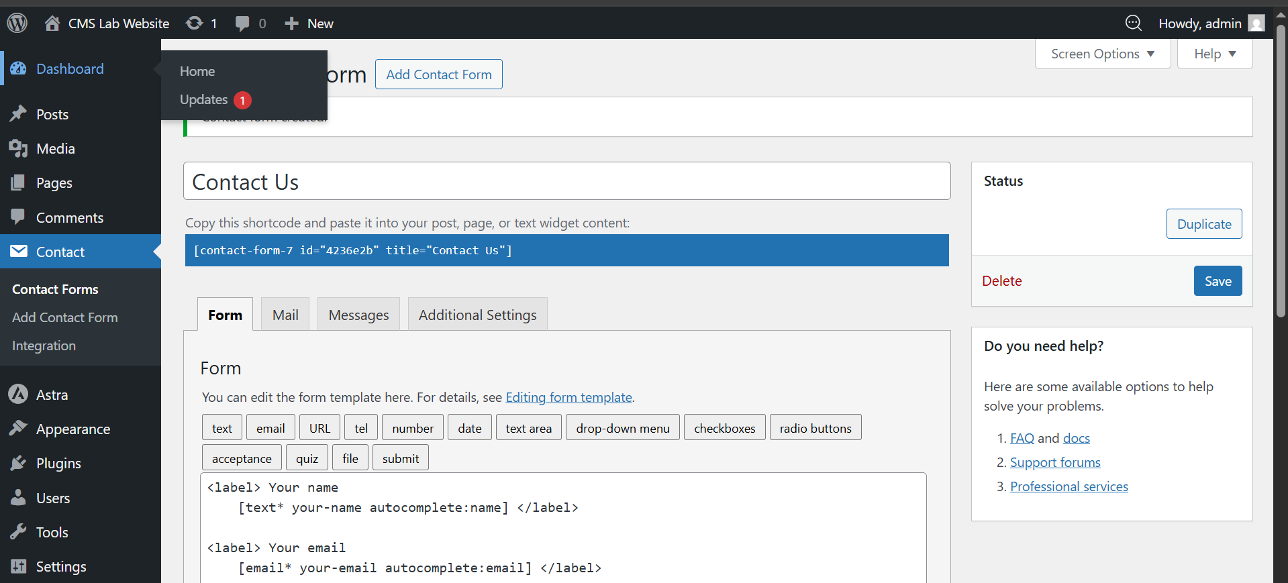
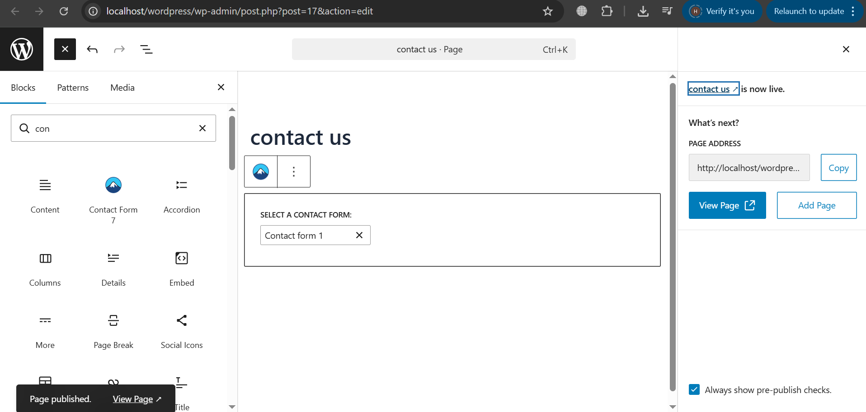

Output:
- Contact form visible on frontend
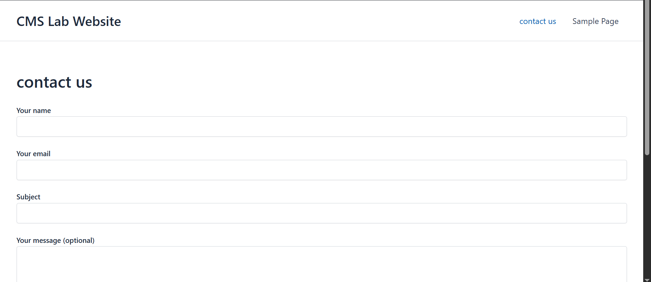

🧪 Lab Task 8: Plugin Management

Steps:
- Go to Plugins → Installed Plugins
- Deactivate one plugin
- Observe website behavior
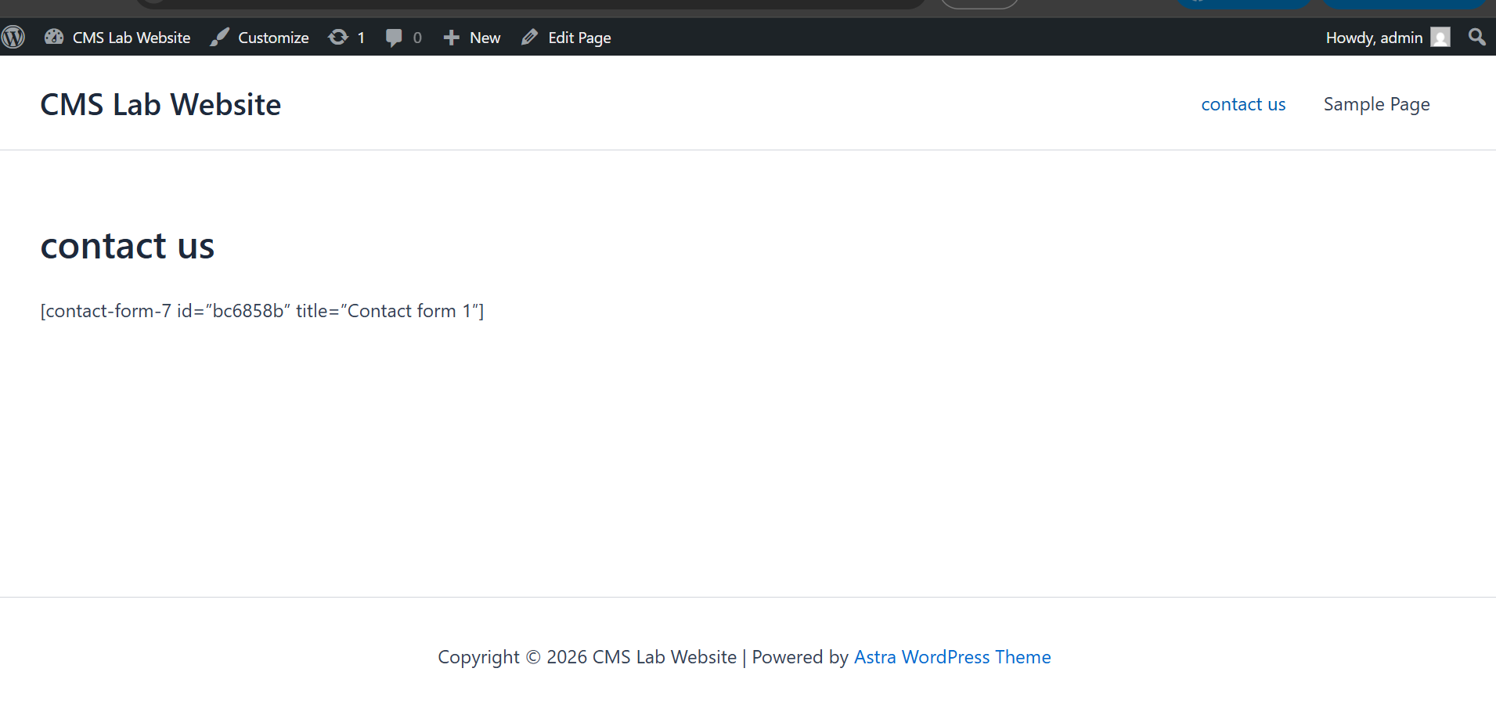
- Reactivate plugin

Learning Outcome:
Students understand plugin control and impact.

🧪 Lab Task 9: Theme vs Plugin Understanding

Task:
Write short answers:
- What does a theme control?
A theme controls the design, layout, and appearance of a website (colors, fonts, templates, pages ka look)
- What does a plugin control?
A plugin adds extra features and functionality to a website (forms, SEO, security, e-commerce, etc.).
- Can website work without plugins?
Yes, a website can work without plugins, but it will have only basic features—no advanced functionality.

🔚 Conclusion
In this lab, students practically learned:
- CMS architecture in action
- Frontend vs backend usage
- Theme customization
- Plugin installation and control
This lab strengthens CMS fundamentals.

📅 Next Lab Preview (Week 3)
- Overview of popular CMS platforms
- WordPress vs Joomla vs Drupal
- Wix & Squarespace exploration
- Headless CMS overview

