# TESTING

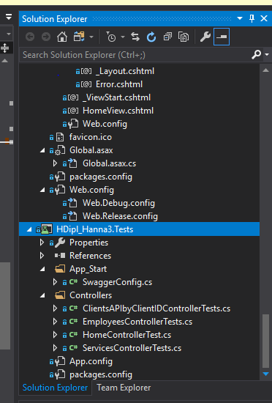

# ClientsAPIbyClientIDControllerTests.cs

using Microsoft.VisualStudio.TestTools.UnitTesting;

using HDipl_Hanna3.Controllers;

using System;

using System.Collections.Generic;

using System.Linq;

using System.Text;

using System.Threading.Tasks;

using HDipl_Hanna3.Models;

using System.Web.Mvc;

namespace HDipl_Hanna3.Controllers.Tests

{

[TestClass()]

public class ClientsAPIbyClientIDControllerTests

{

[TestMethod()]

public void IndexTest()

{

ClientContext clContext = new ClientContext();

Clients clients = new Clients()

{

ID = 1,

AppointmentDate = new

DateTime(2020, 8, 1, 10, 00, 00),

ServiceId = "HIFU",

EmployeeId ="Amanda",

Name = "Saroo",

Surname =

"Nann",

PhoneNumber = "0855565521",

EmailAddress = "sar@sar.ie.com"

};

}

[TestMethod()]

public void CreateTest()

{

ClientContext cl = new ClientContext();// object of db

Services ser = new Services()

{

ServiceId = "7",

ServiceDescritption =

"Vampire Facelift",

Price = 25

};

cl.Service.Add(ser);

//adding service in order to book appointment

cl.Client.Add(

new Clients()

{

ID = 1,

AppointmentDate = new

DateTime(2020, 8, 1, 10, 00, 00),

ServiceId = "HIFU",

EmployeeId = "Amanda",

Name = "Saroo",

Surname ="Nann",

PhoneNumber = "0855565521",

EmailAddress = "sar@sar.ie.com"

});

}

}

}

# EmployeesControllerTests.cs

using Microsoft.VisualStudio.TestTools.UnitTesting;

using HDipl_Hanna3.Controllers;

using System;

using System.Collections.Generic;

using System.Linq;

using System.Text;

using System.Threading.Tasks;

using HDipl_Hanna3.Models;

using System.Web.Mvc;

namespace HDipl_Hanna3.Controllers.Tests

{

[TestClass()]

public class EmployeesControllerTests

{

[TestMethod()]

public void IndexTest()

{

ClientContext employeesContext = new ClientContext();

Assert.IsNotNull(employeesContext.Service);

}

[TestMethod()]

public void CreateTest()

{

{

ClientContext cl = new ClientContext();

Employees employees = new Employees()

{

EmployeeId = "3",

FirstName ="Adam",

Surname = "Braun"

};

cl.Employee.Add(employees);

}

}

}

}

# HomeControllerTest.cs

using System;

using System.Collections.Generic;

using System.Linq;

using System.Text;

using System.Web.Mvc;

using Microsoft.VisualStudio.TestTools.UnitTesting;

using HDipl_Hanna3;

using HDipl_Hanna3.Controllers;

namespace HDipl_Hanna3.Tests.Controllers

{

[TestClass]

public class HomeControllerTest

{

[TestMethod]

public void Index()

{

// Arrange

HomeController controller = new HomeController();

// Act

ViewResult result = controller.Index() as ViewResult;

// Assert

Assert.IsNotNull(result);

}

[TestMethod()]

public void AboutTest()

{

var controller = new HomeController();

var result = controller.About();

Assert.IsNotNull(result);

Assert.IsInstanceOfType(result, typeof(ViewResult));

}

[TestMethod]

public void Contact()

{

// Arrange

HomeController controller = new HomeController();

// Act

ViewResult result = controller.Contact() as ViewResult;

// Assert

Assert.IsNotNull(result);

}

}

}

# ServicesControllerTests.cs

using Microsoft.VisualStudio.TestTools.UnitTesting;

using HDipl_Hanna3.Controllers;

using System;

using System.Collections.Generic;

using System.Linq;

using System.Text;

using System.Threading.Tasks;

using HDipl_Hanna3.Models;

using System.Web.Mvc;

namespace HDipl_Hanna3.Controllers.Tests

{

[TestClass()]

public class ServicesControllerTests

{

[TestMethod()]

public void IndexTest()

{

ClientContext servicesContext = new ClientContext();

Assert.IsNotNull(servicesContext.Service);

}

[TestMethod()]

public void CreateTest()

{

{

ClientContext cl = new ClientContext();

Services services = new Services()

{

ServiceId = "8",

ServiceDescritption =

"TCA",

Price = 150

};

cl.Service.Add(services);

}

}

}

}

# Test Results

