RAG: TASK-01 – Build Your Own Knowledgebase
Name: Hannath C Shabeer
Date: 26 June 2026

Section 1: Objective 1 – IPSR Courses Knowledgebase

Screenshot 1: Completed n8n Workflow

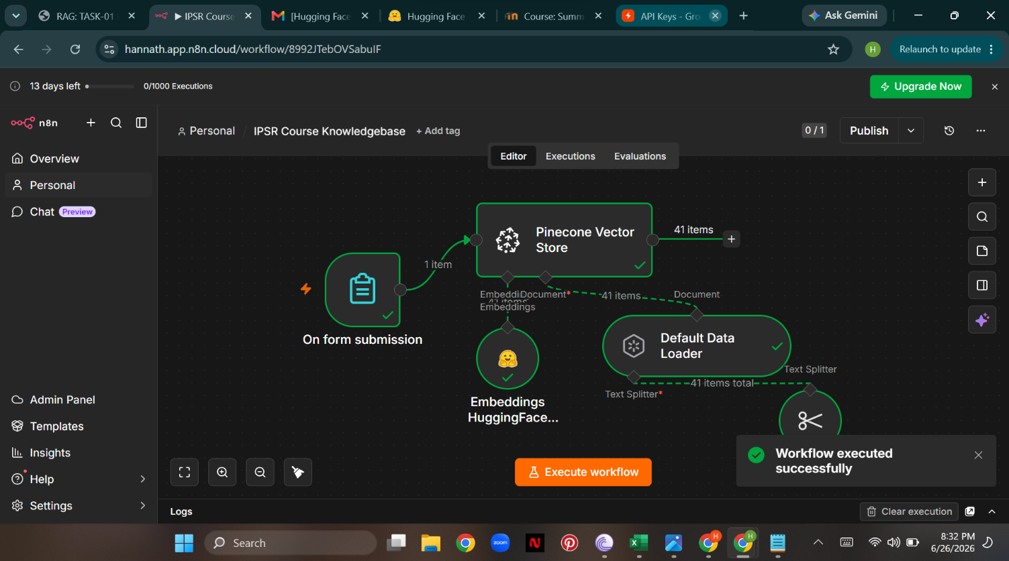
Figure 1: Completed n8n workflow for the IPSR Courses Knowledgebase.

Screenshot 2: Pinecone Vector Database

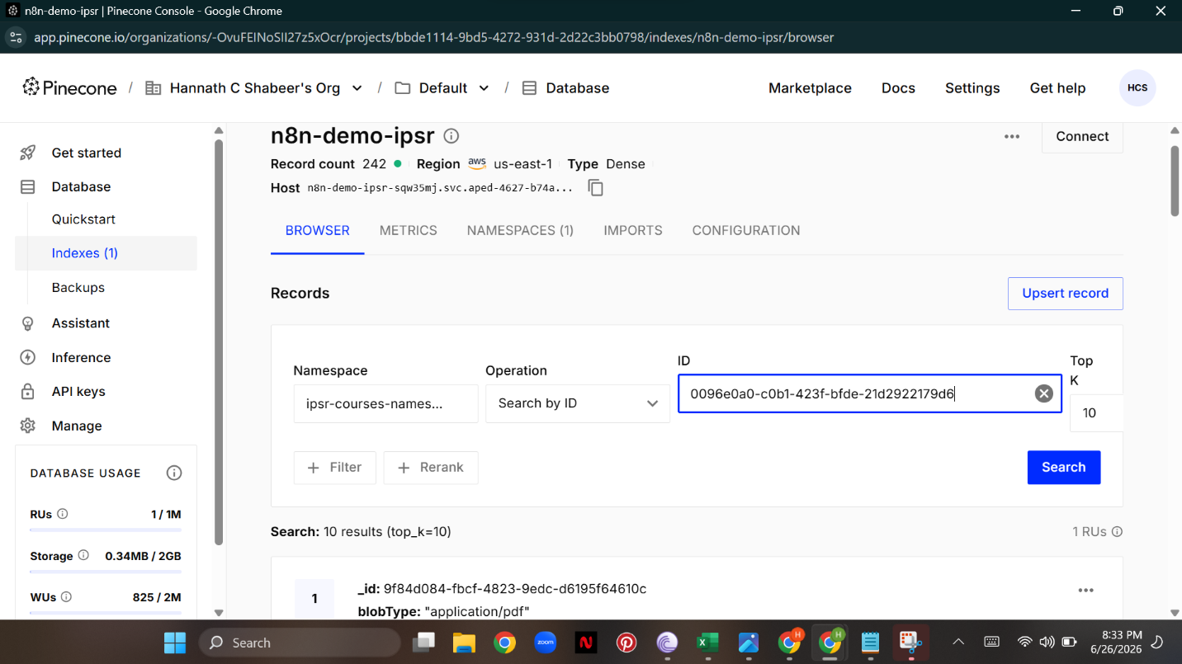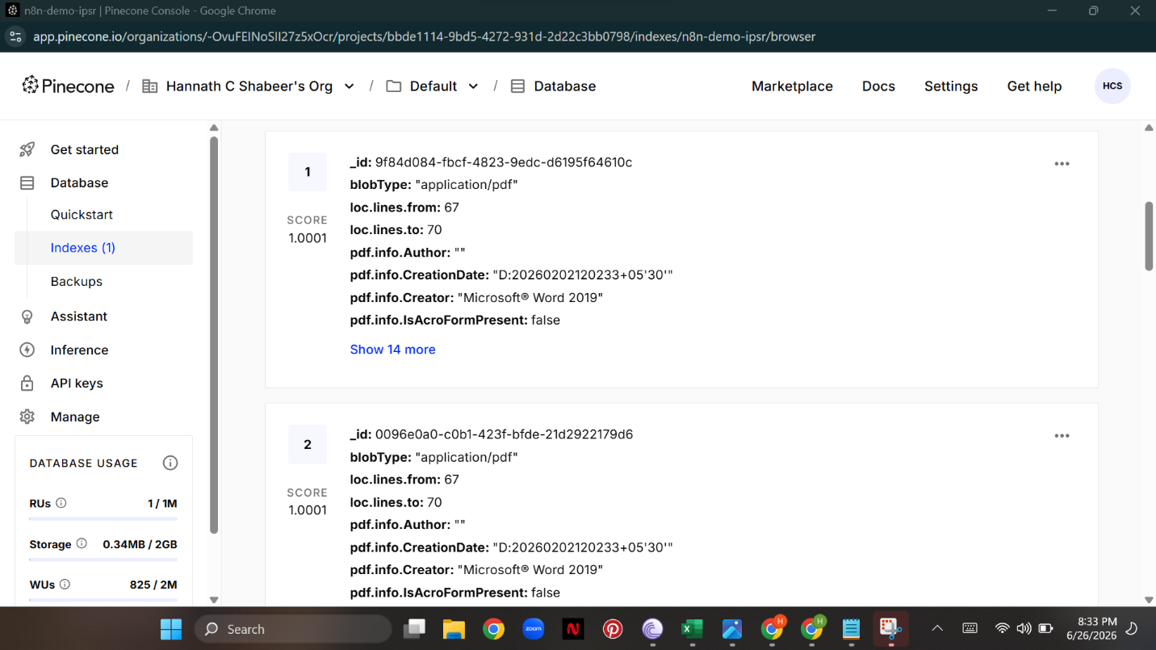

Figure 2: Pinecone index showing successfully stored embeddings for the IPSR Courses Knowledgebase.

Section 2: Objective 2 – Union Budget Chatbot

Screenshot 1: Completed n8n Workflow
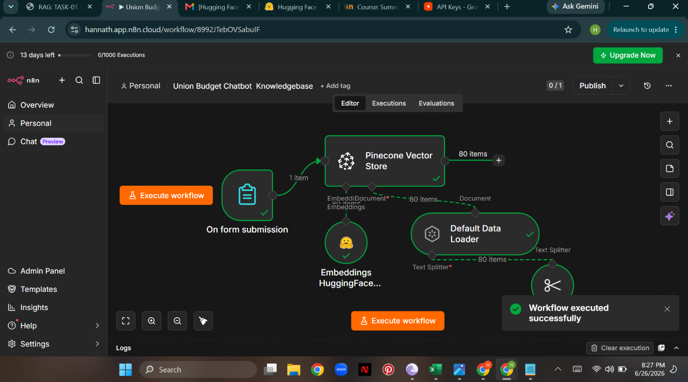Figure 3: Completed n8n workflow for the Union Budget Chatbot.

Screenshot 2: Pinecone Vector Database
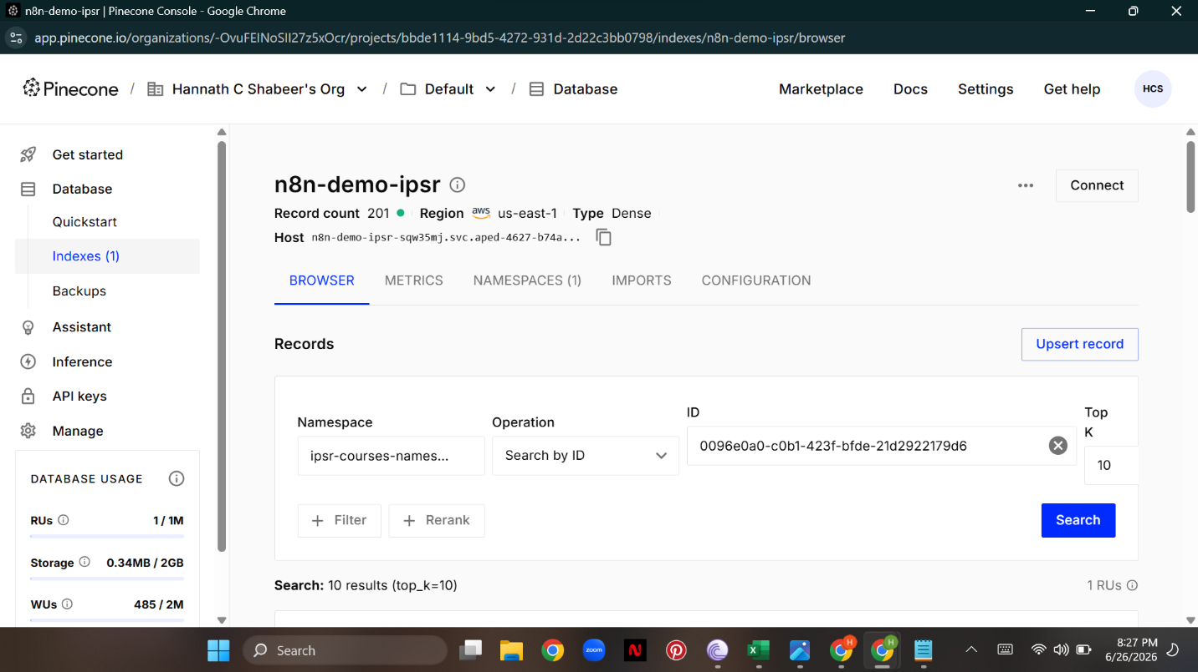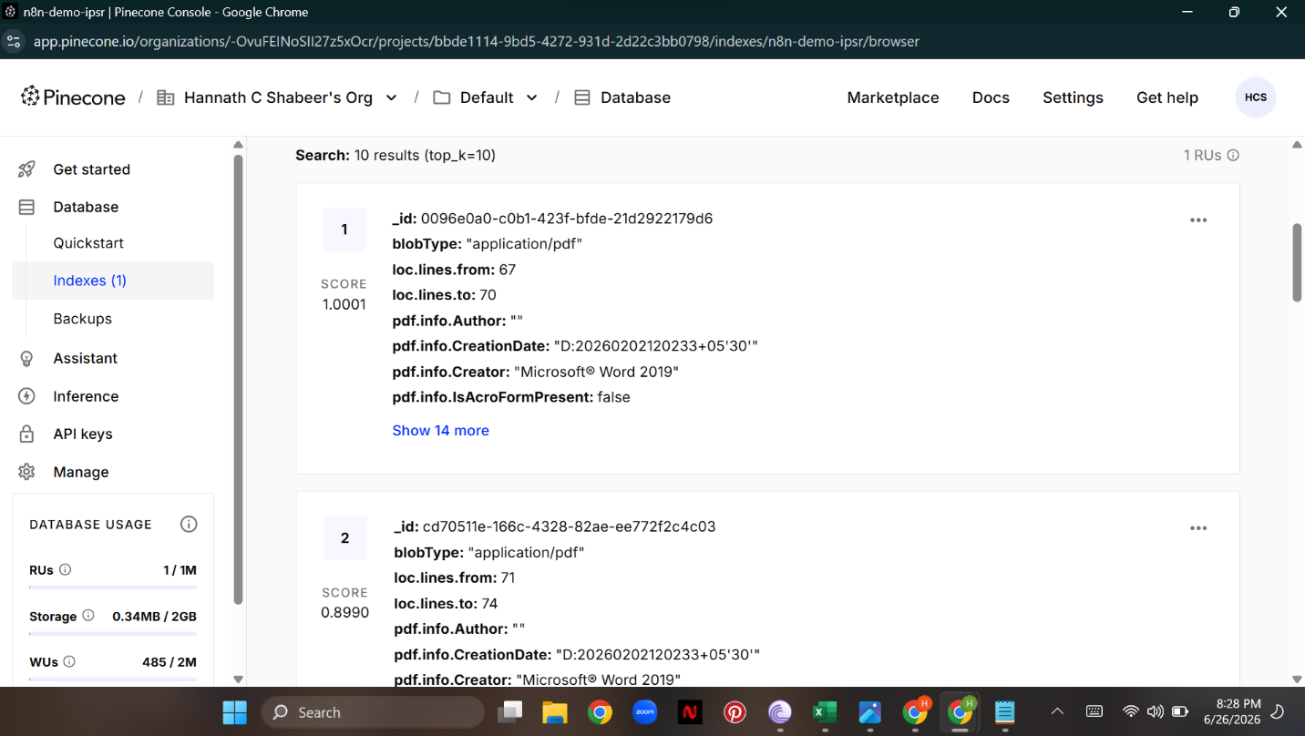Figure 4: Pinecone index showing successfully stored embeddings for the Union Budget Knowledgebase.

Section 3: Explanation

Objective 1 – IPSR Courses Knowledgebase
The IPSR Courses Knowledgebase was developed using a Retrieval-Augmented Generation (RAG) workflow in n8n. The workflow processes the IPSR Courses document, converts the text into vector embeddings, and stores them in Pinecone. When a query is made, the system retrieves the most relevant document chunks from Pinecone, enabling an AI application to provide accurate and context-aware responses.

Nodes Used

1. On Form Submission
- Triggers the workflow when a document is uploaded through the form.
- Starts the document processing pipeline automatically.

2. Default Data Loader
- Loads the uploaded document.
- Extracts the textual content for further processing.

3. Recursive Character Text Splitter
- Splits the extracted text into smaller chunks.
- Preserves context while creating chunks suitable for embedding generation.

4. HuggingFace Embeddings
- Converts each text chunk into a high-dimensional vector representation.
- Captures the semantic meaning of the document for similarity search.

5. Pinecone Vector Store
- Stores the generated embeddings in a Pinecone vector database.
- Enables efficient semantic retrieval of relevant document chunks.

6. Pinecone Index
- Maintains the stored vectors.
- Supports fast similarity search for Retrieval-Augmented Generation (RAG) applications.

Objective 2 – Union Budget Chatbot
The Union Budget Chatbot follows the same Retrieval-Augmented Generation (RAG) architecture. The Union Budget PDF document is processed through n8n, split into smaller text chunks, converted into embeddings using the HuggingFace Embedding model, and stored in a separate Pinecone index. During user queries, the most relevant document chunks are retrieved from Pinecone, allowing the chatbot to generate accurate and context-aware responses.

Nodes Used

1. On Form Submission
- Initiates the workflow when the Union Budget document is uploaded.

2. Default Data Loader
- Reads and extracts text from the uploaded PDF document.

3. Recursive Character Text Splitter
- Divides the extracted text into smaller chunks for efficient embedding generation.

4. HuggingFace Embeddings
- Generates semantic vector embeddings for each text chunk.

5. Pinecone Vector Store
- Stores the generated embeddings in a dedicated Pinecone index.

6. Pinecone Index
- Organizes the stored vectors and supports fast semantic search during information retrieval.

Conclusion
Two independent Retrieval-Augmented Generation (RAG) knowledge bases were successfully developed using n8n and Pinecone. One knowledge base was created from the IPSR Courses document, while the second was built using the Union Budget document. In both workflows, the documents were loaded, split into smaller text chunks, converted into vector embeddings using the HuggingFace Embedding model, and stored in separate Pinecone indexes. The successful creation of the indexes and storage of the embeddings demonstrate the effective implementation of a RAG pipeline capable of supporting efficient semantic search and context-aware information retrieval.

