RAG TASK–02
Build Your Own RAG Chatbot

Name: Hannath C Shabeer
Task: RAG: TASK–02
Project: Build Your Own RAG Chatbot
Date: 29 July 2026

1. Task Overview
This task focuses on building Retrieval-Augmented Generation (RAG) chatbots in n8n. Two chatbot objectives are covered: an IPSR Courses Recommendation Assistant and a Union Budget 2026–27 Query Assistant. The workflows use an AI Agent, a chat model, conversation memory, vector-store retrieval, and embeddings.

2. Objective 1 – IPSR Courses Recommendation Assistant
The IPSR Courses Assistant is designed to help users obtain course-related information and recommendations from the IPSR Courses knowledge base. The saved workflow JSON contains a Chat Trigger, AI Agent, Groq Chat Model, Simple Memory, Vector Store Tool, Pinecone Vector Store, and Hugging Face Embeddings.

2.1 Workflow Architecture
The workflow follows the following logical structure:
Chat Trigger → AI Agent → Vector Store Tool → Pinecone Vector Store
Groq Chat Model
Simple Memory
Pinecone Vector Store ← Hugging Face Embeddings

2.3 Custom System Message
You are the IPSR Courses Assistant, an AI chatbot designed to help users understand IPSR courses, training programs, certifications, admissions, placement assistance, and other information available in the IPSR Courses knowledge base.
Use the information retrieved from the IPSR Courses knowledge base as the primary source for your answers. Do not invent, assume, or present unsupported information as fact.
When answering:
- Give clear, accurate, concise, and relevant responses.
- If the retrieved context contains the required information, summarize it without changing its meaning.
- If multiple courses are relevant, present them clearly and explain why they may match the user's stated interests or requirements.
- If the user's question is unclear, ask a short follow-up question when necessary.
- If the requested information is not available in the retrieved knowledge base, clearly state that it is not available rather than guessing.
- Do not create course names, fees, durations, eligibility requirements, placement statistics, certifications, or other details that are not supported by the retrieved information.
- Use short paragraphs, bullet points, or simple comparisons when they improve readability.
- Maintain a friendly, professional, and helpful tone throughout the conversation.
Always prioritize factual accuracy and knowledge-base context over unsupported general knowledge.

2.5 Suggested Test Questions
- What courses are available at IPSR?
- I am interested in data analytics. Which IPSR course would be suitable for me?
- What are the eligibility requirements for the course?
- Does IPSR guarantee a job with a specific salary?
- Which of the recommended courses would be suitable for a beginner?

3. Objective 2 – Union Budget 2026–27 Query Assistant
The Union Budget Assistant is designed to answer questions using the Union Budget 2026–27 knowledge base. The uploaded knowledge-base document is the PRS Legislative Research analysis of the Union Budget 2026–27.

3.1 Knowledge Base Coverage
Topic | Key information
Total expenditure | Rs 53,47,315 crore in 2026–27; 7.7% higher than the revised estimate of 2025–26.
Fiscal deficit | 4.3% of GDP in 2026–27, compared with 4.4% in 2025–26.
Revenue deficit | 1.5% of GDP in 2026–27.
Defence allocation | Rs 7,84,678 crore in 2026–27.
VB-G RAM G | Rs 95,692 crore allocated in 2026–27.
State capital-expenditure loans | Rs 1,85,000 crore budgeted as special interest-free loans.
States' share of central taxes | 41% recommended by the 16th Finance Commission.

3.2 Workflow Architecture
The recommended chatbot structure mirrors the working IPSR RAG workflow, with the retrieval source changed to the Union Budget knowledge base:
Chat Trigger → AI Agent → Vector Store Tool → Pinecone Vector Store
↘ Groq Chat Model
↘ Simple Memory
Pinecone Vector Store ← Hugging Face Embeddings

3.4 Custom System Message
You are the Union Budget 2026-27 Assistant, an AI chatbot designed to answer questions about the Union Budget 2026-27 using information retrieved from the connected knowledge base.
Use the retrieved Union Budget knowledge base as the primary source for factual answers. Do not invent, assume, or present unsupported information as fact.
When answering:
- Provide clear, accurate, concise, and relevant responses.
- Use the retrieved context whenever the question relates to the Union Budget 2026-27.
- Preserve numerical values, percentages, units, and financial figures accurately.
- When comparing figures, clearly identify the years or estimates being compared.
- Explain technical budget terms in simple language when useful.
- If the requested information is not available in the retrieved knowledge base, clearly state that it is not available rather than guessing.
- Do not create budget figures, schemes, allocations, tax proposals, deficit figures, or policy details that are not supported by the retrieved information.
- Use bullet points or tables when they make comparisons or numerical information easier to understand.
- Maintain a neutral, professional, and informative tone.
- Distinguish between budget estimates, revised estimates, and actual figures whenever the retrieved information provides that distinction.
Always prioritize information retrieved from the Union Budget knowledge base over unsupported general knowledge.

3.6 Suggested Test Questions
- What is the total expenditure estimated for 2026–27?
- What is the fiscal deficit target for 2026–27?
- How much is allocated for capital expenditure in 2026–27?
- Which ministry has the highest allocation in 2026–27?
- How much has been allocated to VB-G RAM G?
- What share of central taxes has the 16th Finance Commission recommended for states?
- What will India's GDP be in 2040?

4. Major Node Explanations
Node / Component | Purpose
When Chat Message Received | Starts the workflow when a user sends a message through the chatbot interface.
AI Agent | Acts as the main orchestration and response-generation component. It processes the user's question and can use connected tools and memory.
Groq Chat Model | Provides the language model used by the AI Agent to understand questions and generate responses.
Simple Memory | Maintains conversational context so follow-up questions can be understood in relation to earlier messages.
Vector Store Tool | Makes the knowledge-base retrieval capability available to the AI Agent.
Pinecone Vector Store | Stores and retrieves embedded knowledge-base chunks using semantic similarity search.
Hugging Face Embeddings | Converts text into vector representations used for semantic retrieval.
Knowledge Base | Contains the source material that grounds the chatbot's responses and reduces unsupported answers.

6. Evidence Status
• IPSR workflow: genuine screenshot shows the RAG workflow and Published status.
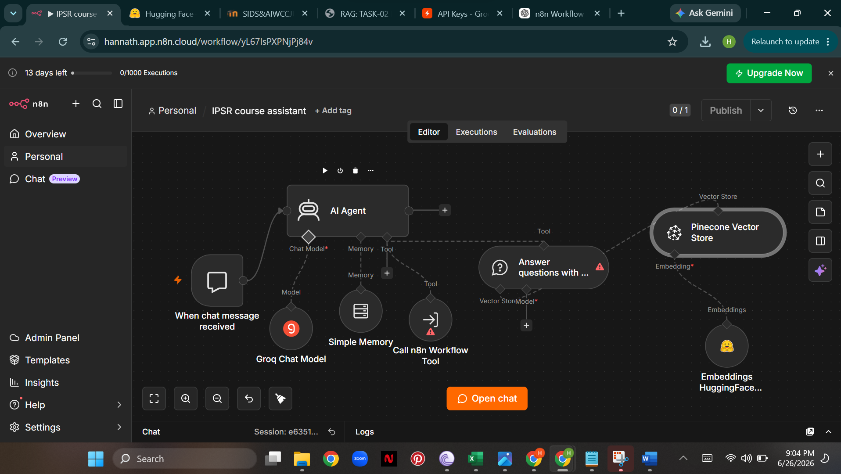

• Union Budget knowledge base: genuine screenshot shows successful execution with 80 items.
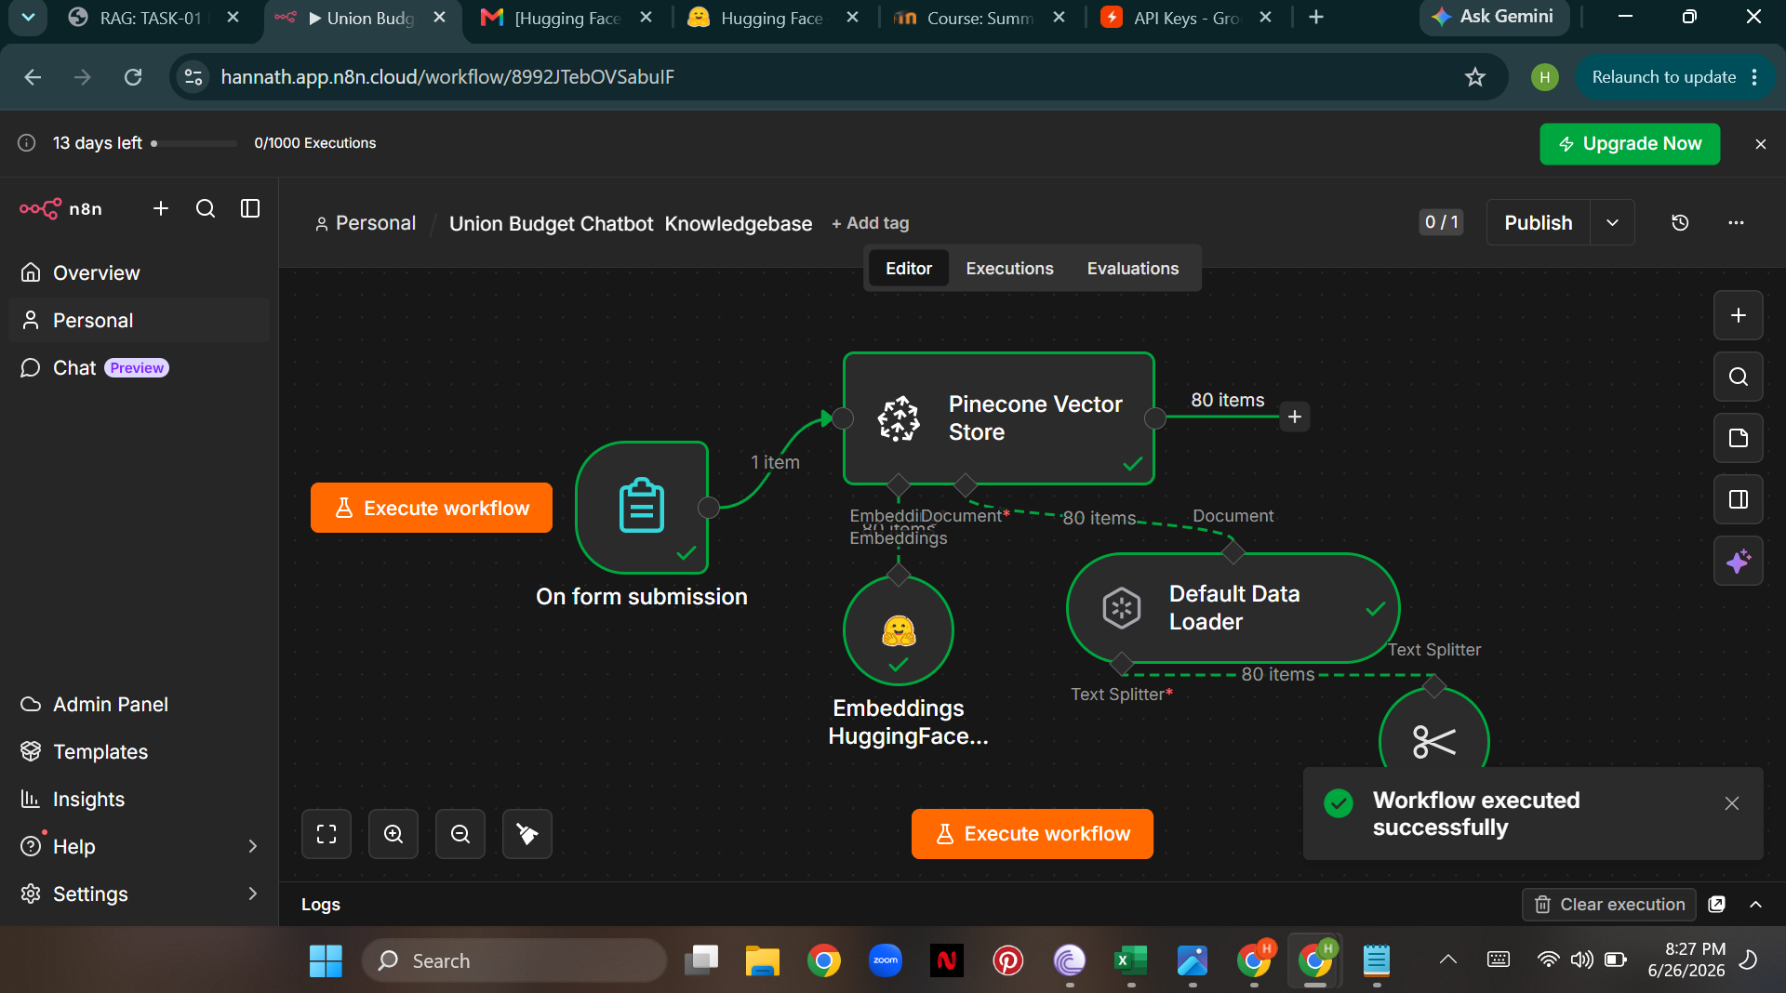

• Union Budget chatbot public URL: not available because the n8n workspace became inaccessible before the URL was captured.

7. Conclusion
The task demonstrates the use of Retrieval-Augmented Generation to build domain-specific chatbots. The IPSR assistant focuses on course-related recommendations, while the Union Budget assistant focuses on retrieving and explaining information from the 2026–27 budget knowledge base. The use of vector retrieval, embeddings, memory, and an AI Agent provides a structured approach for grounding responses in the selected source material.

