Definitions
Reinforcement Learning:
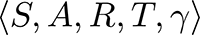

Imitation learning (or apprenticeship learning):

