rough ideas

### Overarching principles to keep sight of:

* Begin with an interesting story of AI to hook the audience
* Clearly establish the goals of the presentation and the “why you need to listen”
  + Empowerment parameters
* Frequent checkpoints to the goals of the presentation
  + Cycle on the problem without coming across as condescending
  + Repeat the intro and goal of the talk slide so that we can jump back on board at each new idea
  + Ask a question at the end of each section so that we can get people back on track and engaged
    - Not too easy or hard
* Make several onramp points for if someone loses concentration
* Take questions
* Lock in the keypoints in a short intuitive summary
* End off with a joke
* Always exhibit passion
* Express vision and passion in the first 5mins
* Have one really cool demo that does something amazing!
  + Pretrained bible translator?
  + Joke maker?

## Structure

* Intro
  + Start with a story of AI or LLMs
    - Move 37 of alphaGo?
  + Goal of the talk
    - We’re going to build up an LLM model together conceptually
    - At the end you will know
      * Situating LLMs in the AI landscape
      * Basic goals of AI models and how supervised learning models are built
      * Basic intuition of how LLMs work
      * Know what are common pitfalls to look out for when using LLMs
        + Be able to have a sort of gut-feel for what tasks you can or cannot trust LLMs on
      * Have learnt some common LLM terminology and know how to “hang” when someone talks about LLMs
    - Common pitfalls and issues with how we work with LLMs
  + Landscape slide
  + Background
    - What is AI
    - Basic goal of ML models is to learn how to intelligently extract info from supervised training data with the goal to ignore noise and “generalise”
      * Short linear interpolation example
        + Overfitting and underfitting
        + “noise”
    - What is supervised learning
      * Common AI models and a landscape overview
    - Where do LLMs fit into this landscape
    - What are LLMs
      * Lossy zip file of the internet
* Landscape slide
* Intuition of how LLMs work
  + How would we build a model that has information about everything? Where would we start? Question: internet, books, private data
    - Why do it
      * Capture the average of ground truth of all information that we have access to
      * Build a distribution of truth over what we have access to
  + Question: How would we feed in this information about the internet or whatever our sources is into something like an AI model that can only work with numbers
  + What are tokens and why do we need them
    - Character level vs word level quick overview
  + Landscape slide
  + Pretraining
    - How does pretraining work
    - Next token predictors
      * Show example from a base model [hyperbolic](https://app.hyperbolic.ai/models/llama31-405b-base-bf-16)
        + Example from wikipedia
      * Show AI studio example with low top p and high temp
        + Indicate how randomness increases the possibility of non-perfect next token
        + “Perfect” next token is just a statistical determination of what word occurs next to the preceding word in the dataset given the info before
  + How do we store this info in the model’s weights
    - Biggest case: memorise it all - no generalization
    - Smallest case: store and regurgitate only the most common word found overall - no generalization
    - Case that we’re going for is a blend of those
      * Allows for generalization where necessary
      * Allows for memorization where necessary
    - Model size is a lossy .zip file of the internet
    - Generalized and intelligent compression of information that strives to ignore “noise”
    - Show that base models can learn how to understand the data by doing a translation task with the base model
      * My favourite food is anything that my wife, makes
  + Landscape slide
  + Post training
    - Question: How would we turn this base-model into an assistant that can answer questions
      * Question: what is the capital of japan? Answer:
      * Question: How do you get a Dr to use an e-scripting platform instead of paper scripts? Answer:
      * Question: Please repeat this number back exactly 123456 with no other text. Answer:
  + Landscape slide
* LLM pitfalls
  + Copy-pasting
    - Copy a very large list and show that it’s not correct
  + Mental math
    - Big numbers multiplication breaks
  + Hallucinations and factual retrieval
  + Stochasticity
    - Ask for a poem multiple times, different results
    - Temperature increases randomness
* What LLMs are very good at
  + Summarization
  + Grammar
  + Code syntax
  + Coding overall
    - Getting better every day
* How to use LLMs effectively
  + RAG/context engineering
  + How to use as a dev
    - Templates
    - AI Studio
  + Multiple attempts
  + New chats
    - Try to get it in one-shot
      * Multiple questions create confounding attention

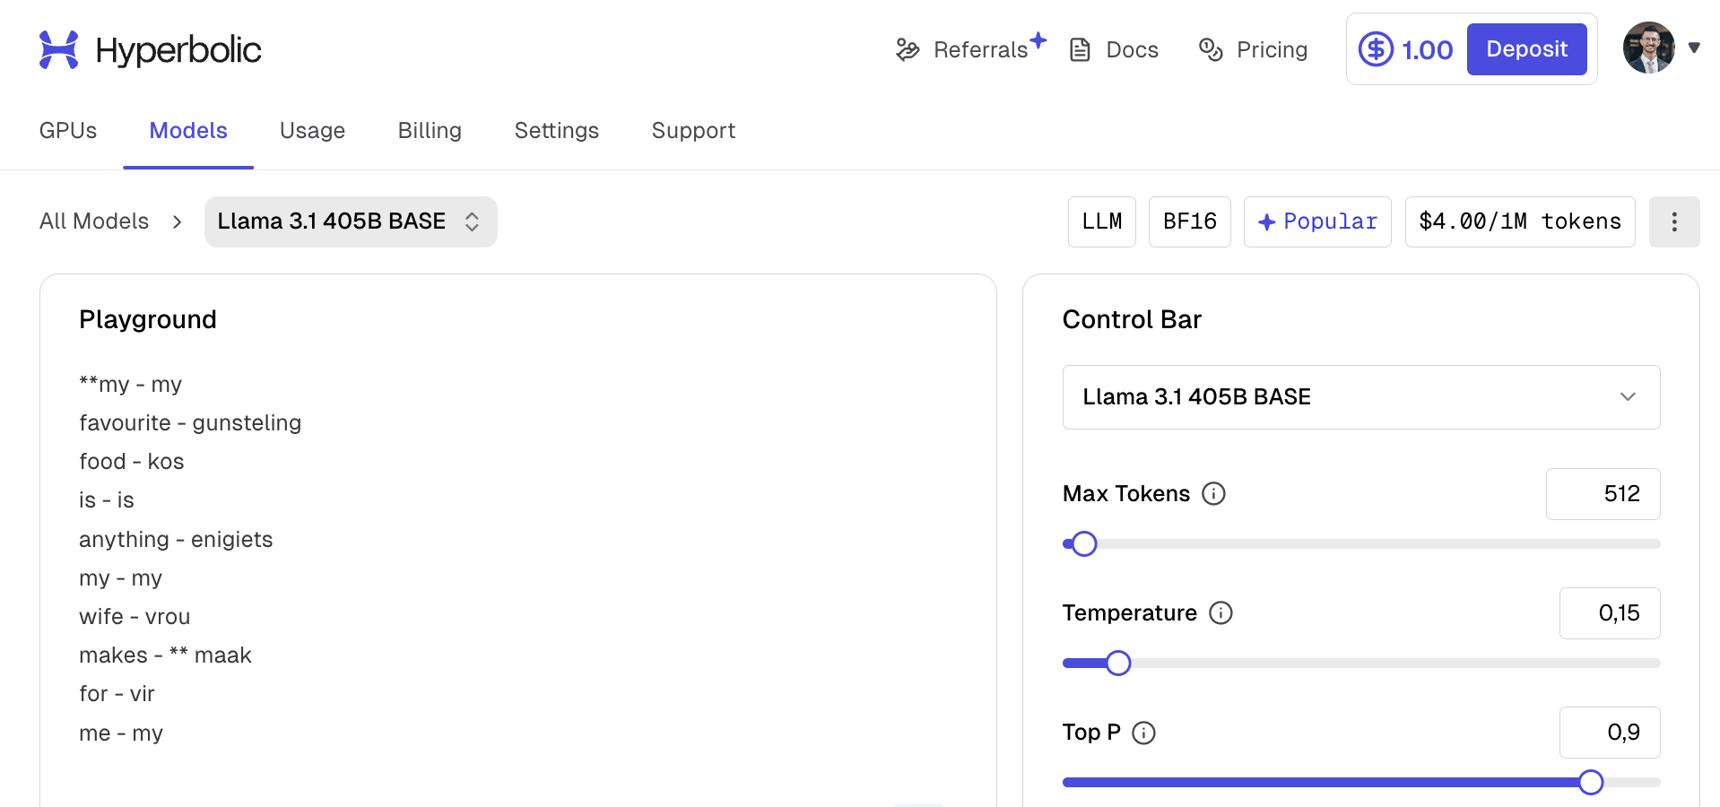

my - my

favourite - gunsteling

food - kos

is - is

anything - enigiets

my - my

wife - vrou

makes -