AI6124 Assignment 2
Cancer vs. Non-Cancer Classification with Equal-Error-Rate Decision Boundaries
Hanny (NTU MSAI) | Matric # G12345678X
2026-08-23

1 Problem definition
The task (from Lecture 6 slides) is to build a supervised decision tool that separates cancerous from non-cancerous cases, to determine the decision boundary that yields the best equal error rate, and to plot the ROC curve obtained by varying that boundary. Every model studied here therefore outputs a continuous score $s(x)∈R$ (a logit, an SVM margin, a probability, a goodness difference, …), and the decision rule is $\hat{y}=1[s(x)≥θ]$. Two terms are kept distinct throughout: the decision threshold $θ$ is the scalar cut on the score, and the decision boundary is the level set $\{x:s(x)=θ\}$ it induces in feature space. The model fixes the family of boundaries; $θ$ selects one member of that family, so “varying the decision boundary” is realised by sweeping $θ$. Sweeping $θ$ from $+∞$ to $-∞$ traces the ROC curve $(FPR(θ),TPR(θ))$. The EER is the point where $FPR(θ)=FNR(θ)=1-TPR(θ)$, i.e. the intersection of the ROC curve with the anti-diagonal; I obtain it by linear interpolation between the two adjacent ROC vertices and record the corresponding threshold $θ_{EER}$, which defines the equal-error decision boundary of that model.

2 Data

2.1 NUH ovarian-cancer blood assays
The data accompany the CLFNN/FALCON-AART paper of Tan, Quek, Ng and Razvi [1]. Patients diagnosed at the NUH Department of Oncology and Gynaecology on the basis of 30 blood tests (age, haemostatic panel, CA-125, CASA, …; Table 3 of [1]). The files provided dataset are not documented, so I reverse-engineered and verified the structure as:
- Each *Train.txt starts with a header line “$N$ 1”; *Test.txt has none. Rows are tab-separated feature values followed by a 0/1 label.
- Within a group (g1: 30 features, 35 patients; g2: 28 features, 109 patients) the files c1 … cN contain the same patients with different labels: every patient is positive in exactly one file. They are one-vs-rest labellings of the clinical sub-groups of [1], not cross-validation folds. For g2, after the de-duplication described next: c1 = borderline (5), c2 = benign/normal (56), c3 = stage I–II (14), c4 = stage III–IV (34), i.e. 109 patients.
- g2c1Test.txt contains three rows (all borderline) that duplicate training rows; they were removed to avoid leakage.
- The column order of g2 does not follow Table 3 of the paper, so features are referred to as $f_{1},…,f_{28}$.
I use group g2 (the largest) and, following [1], define cancer = borderline $∪$ stage I–II $∪$ stage III–IV and non-cancer = benign/normal, giving a balanced problem: 55 training patients (27 cancer) and 54 test patients (26 cancer). Three assays ($f_{23}$, $f_{24}$, $f_{28}$) are strongly right-skewed (maximum/median ratio above 20; $f_{24}$ reaches $4.86×{10}^{5}$, a range consistent with the tPA-antigen assay of [1]); these columns are $log(1+x)$-transformed before standardisation.

2.2 Wisconsin Diagnostic Breast Cancer
WDBC contains 569 fine-needle aspirates with 30 real-valued features (mean, standard error and “worst” value of ten nuclear measurements); 212 are cancerous and 357 benign. A stratified 80/20 split (seed 0) gives 455 training and 114 test cases. WDBC is nearly linearly separable and serves as a low-variance sanity check for the method comparison, whereas NUH is considered as the small, noisy clinical real problem.

3 Methods
All models consume the same standardised feature vector and generate a scalar score. Hyper-parameters were fixed to a prior (or chosen by an inner cross-validation inside the training fold for the SVM) and are identical on both data sets; no test data were used for any choice.

3.1 Classical baselines
Logistic regression ($L_{2}$, $C=1$) provides a linear boundary. SVM (Support Vector Machine with RBF kernel) selects $C∈\{0.1,1,10,100\}$ and $γ∈\{\text{scale},0.01,0.1\}$ by inner 5-fold AUC; the signed margin is the score. Random forest (500 trees) scores by the fraction of trees voting “cancer”. The ELM (extreme learning machine) uses 200 random $tanh$ hidden units and a ridge-regression read-out ($λ=1$) fitted in closed form—a single-shot network that needs no iterative training at all.

3.2 Back-propagation MLP (reference)
A $d$-64-32-1 network with $tanh$ hidden units trained for 300 full-batch epochs with Adam (learning rate ${10}^{-3}$, weight decay ${10}^{-3}$) on the binary cross-entropy. The same architecture is reused by the predictive-coding and neuro-evolution variants below, and the same 64-32 hidden layout by Forward-Forward (which necessarily differs in its input and read-out), so that differences are mainly attributable to the learning rule.

3.3 Supervised predictive coding (Whittington & Bogacz, 2017)
Each layer $l$ carries value nodes $x^{l}$ and error nodes $ϵ^{l}=x^{l}-μ^{l}$ with the top-down prediction $μ^{l}=W^{l}f(x^{l-1})+b^{l}$. The network minimises the free energy F=12l​∥ϵl∥2 in two phases. With the input and the target clamped, the hidden value nodes relax for $T=20$ steps,
$$x^{l}←x^{l}+γ\left(-ϵ^{l}+f^{'}(x^{l})⊙(W^{l+1})^{​⊤}ϵ^{l+1}\right), γ=0.1,$$
after which every synapse is updated with a purely local, Hebbian-like rule
$$ΔW^{l}=η ϵ^{l}f(x^{l-1})^{​⊤}, Δb^{l}=η ϵ^{l},$$
that only involves the error at the post-synaptic layer and the activity at the pre-synaptic layer. No gradient is ever propagated backwards through the network (our implementation uses no automatic differentiation); Adam-style re-scaling of the local updates and 300 epochs of mini-batches of 128 give the same epoch budget as BP (on NUH, with 55 training patients, this is also full-batch; on WDBC it is four updates per epoch against one for the full-batch BP run). At test time the output node is left free and the score is the feed-forward prediction $μ^{L}$.

3.4 Forward-Forward (Hinton, 2022)
The label is embedded in the input by appending a scaled one-hot vector. A positive example is $(x,y)$ and a negative example is $(x,1-y)$. Each layer is trained on its own objective, with goodness $g=mean(h^{2})$ of its ReLU activities,
$$L_{l}=softplus\left(-(g_{pos}-ϑ)\right)+softplus\left(g_{neg}-ϑ\right), ϑ=2,$$
and passes its length-normalised, detached output to the next layer, so no error signal crosses a layer boundary. Two forward passes replace the forward/backward pair of BP. At test time the score is l​gl(x,y=1)-gl(x,y=0).

3.5 Neuro-evolution of the same MLP
The 64-32 MLP weights (3 969 parameters for $d=28$) are optimised without gradients. The fitness of an individual is the training cross-entropy plus a small $L_{2}$ penalty; a whole population is evaluated with one batched forward pass. CMA-ES uses the separable (diagonal-covariance) variant, population 32, $σ_{0}=0.3$, 300 generations. The GA is real-coded: population 60, tournament selection ($k=3$), BLX-$α$ crossover ($α=0.5$, $p_{c}=0.9$), Gaussian mutation ($p_{m}=0.05$, $σ=0.1$), elitism of 2, 300 generations.

3.6 ANFIS
A first-order Takagi–Sugeno system with $R=4$ rules, “IF $x_{1}$ is $A_{r1}$ AND …AND $x_{d}$ is $A_{rd}$ THEN $y_{r}=a_{r}^{​⊤}x+b_{r}$”. Gaussian membership functions are combined with the product t-norm (in log space to avoid underflow over 28 antecedents); rule centres are initialised by $k$-means (a scatter partition, avoiding the $2^{d}$ grid) with width $\sqrt{d}$, and all premise and consequent parameters are tuned by gradient descent on the cross-entropy.

3.7 TabPFN
TabPFN [8] is a transformer pre-trained on millions of synthetic tabular tasks that classifies new data by in-context learning: the training set is passed as context and no gradient step is taken on the data at hand. It is a strong tabular foundation model on small tables and is included as a SOTA reference. I used the v3 classifier checkpoint (2026) shipped with version 8.4.0 of the tabpfn package, with no task-specific hyperparameters tuned.

4 Experimental Setup
- Given split. The pre-processing pipeline and the model are fitted on the training set only. A stratified 5-fold cross-validation inside the training set yields out-of-fold (OOF) scores, on which $θ_{EER}$ is chosen. The model is then refitted on the whole training set and scored on the test set. I report the test AUC, the EER of the test ROC (the equal-error operating point of the test data themselves, with its threshold) and the test FPR/FNR/accuracy obtained with the pre-chosen $θ_{EER}$, which is the honest estimate of deployed performance.
- Repeated cross-validation. Because the NUH test set has only 54 patients (one misclassified patient moves FPR by $≈0.04$), all 109 patients are also pooled and evaluated with $5×$ repeated stratified 5-fold CV (25 fits); AUC and EER are reported as mean $±$ standard deviation. The same is done on WDBC.
- Cost-sensitive threshold (secondary). In a screening setting a missed cancer (FN) is more serious than a false alarm (FP). The equal-error threshold required by the task treats both equally; as an additional analysis I also set the threshold at the OOF value that minimises $5⋅FNR⋅p+FPR⋅(1-p)$ and report the resulting test sensitivity/specificity. This does not affect the main comparison.
All experiments use seed 0, run on a single CPU (R7-6800H).

5 Results

5.1 NUH ovarian-cancer data
Table 1 and Figure 1 summarise the NUH results; Figure 2 shows the repeated-CV AUC with its spread. The cross-validated numbers are the ones to rank the models: the test set has only 54 patients, and a model’s test AUC can sit up to 0.15 below its CV mean (GA-MLP 0.64 vs. $0.79±0.06$; MLP-BP 0.64 vs. $0.76±0.08$) while others land on it (Forward-Forward 0.82 vs. $0.81±0.08$). By both CV metrics the random forest is first and TabPFN second; the latter is notable because it performs no training and has no hyper-parameter to tune, so its in-context prior alone is competitive with the best tuned model on 87-patient training folds.
Table 1: NUH-g2, cancer vs. non-cancer. AUC and EER are measured on the 54-patient test set; the $θ_{EER}$ column gives the threshold at the test-set EER and, after the slash, the one chosen on training out-of-fold (OOF) scores, both on the model’s own score scale (vote fraction or probability for random forest and TabPFN, logit or margin otherwise); FPR/FNR/Acc are obtained on the test set with the OOF threshold; CV columns are 5×5-fold repeated cross-validation on all 109 patients (mean $±$ s.d.). Fit time is for one fit on 55 patients (CPU); for TabPFN it excludes the prediction-time compute (Section 3.7).
Model | AUC | EER | $θ_{EER}$ test / OOF | FPR@$θ$ | FNR@$θ$ | Acc@$θ$ | CV AUC | CV EER | Fit (s)
LogReg | 0.691 | 0.346 | 0.17 / 0.33 | 0.250 | 0.346 | 0.704 | 0.773 ± 0.083 | 0.272 ± 0.083 | 0.01
SVM-RBF | 0.805 | 0.250 | 0.04 / −0.15 | 0.250 | 0.192 | 0.778 | 0.809 ± 0.085 | 0.282 ± 0.091 | 0.14
RandomForest | 0.789 | 0.231 | 0.49 / 0.48 | 0.214 | 0.231 | 0.778 | 0.845 ± 0.066 | 0.245 ± 0.089 | 1.60
ELM | 0.696 | 0.346 | 0.07 / −0.03 | 0.393 | 0.308 | 0.648 | 0.722 ± 0.116 | 0.330 ± 0.100 | 0.02
MLP-BP | 0.640 | 0.357 | 2.29 / 0.12 | 0.429 | 0.269 | 0.648 | 0.764 ± 0.083 | 0.286 ± 0.074 | 0.57
PC-2017 | 0.765 | 0.269 | 0.59 / 0.47 | 0.321 | 0.269 | 0.704 | 0.756 ± 0.097 | 0.294 ± 0.078 | 2.95
Forward-Forward | 0.820 | 0.269 | −0.03 / −0.09 | 0.357 | 0.231 | 0.704 | 0.813 ± 0.082 | 0.272 ± 0.090 | 1.32
CMA-ES-MLP | 0.746 | 0.231 | 0.76 / −0.29 | 0.250 | 0.192 | 0.778 | 0.801 ± 0.073 | 0.269 ± 0.063 | 5.18
GA-MLP | 0.639 | 0.385 | −0.76 / 0.97 | 0.321 | 0.423 | 0.630 | 0.785 ± 0.058 | 0.271 ± 0.071 | 10.12
ANFIS | 0.673 | 0.385 | 0.32 / −0.16 | 0.464 | 0.346 | 0.593 | 0.749 ± 0.121 | 0.302 ± 0.108 | 0.62
TabPFN | 0.765 | 0.250 | 0.47 / 0.40 | 0.250 | 0.231 | 0.759 | 0.828 ± 0.064 | 0.255 ± 0.076 | 3.80
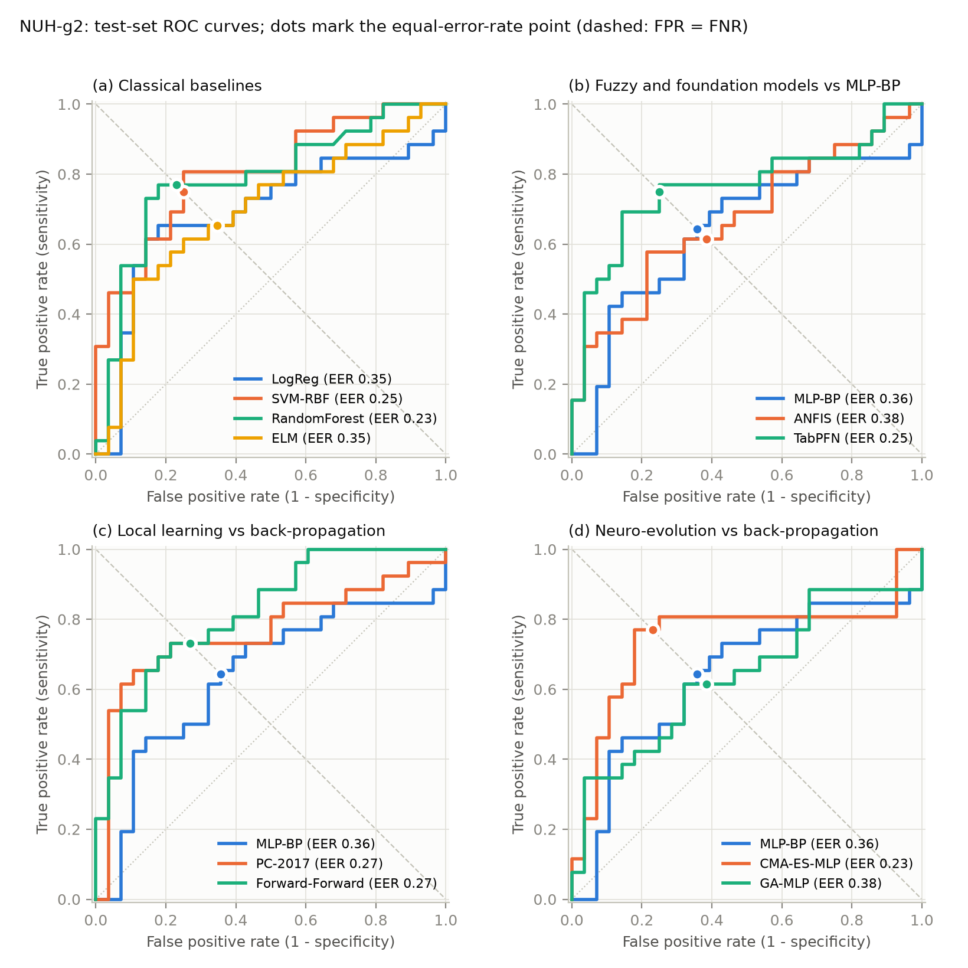
Figure 1: NUH-g2 test-set ROC curves obtained by sweeping each model’s decision threshold. Dots mark the equal-error-rate point (intersection with the dashed FPR = FNR line). (a) classical baselines; (b)–(d) MLP-BP (blue, identical in all three panels) against the fuzzy and foundation models, local-learning rules and neuro-evolution.
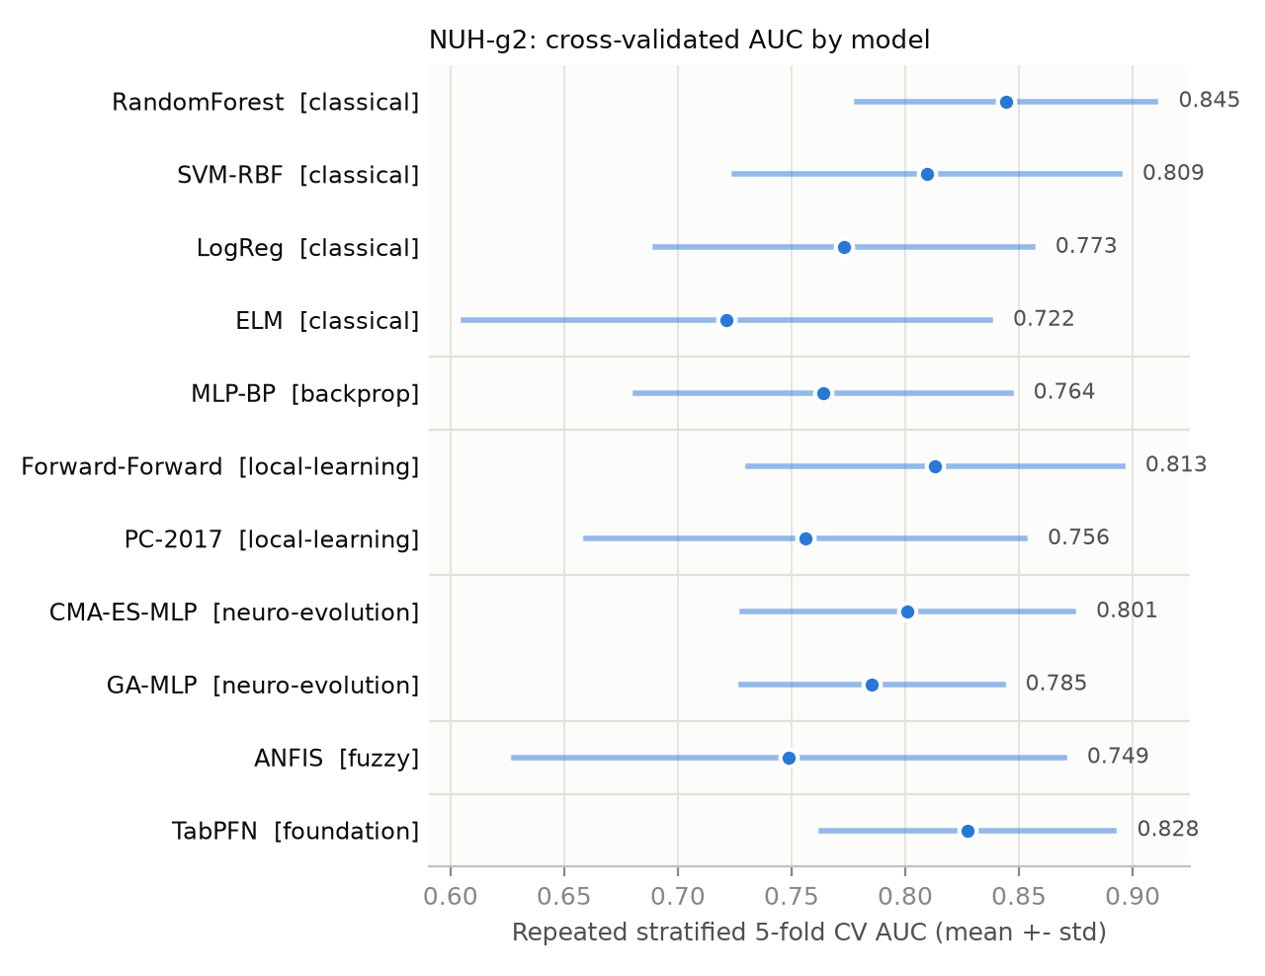
Figure 2: NUH-g2: cross-validated AUC (mean $±$ s.d. over 25 folds) grouped by model family.
Best decision boundary. On the NUH test set the lowest EER is $0.231$, reached by random forest ($θ_{EER}=0.49$ on the vote fraction) and CMA-ES-MLP ($θ_{EER}=0.76$ on the logit); the equal-error boundaries these thresholds define call $≈77\%$ of cancers and $≈77\%$ of benign cases correctly. The $θ_{EER}$ column of Table 1 lists, for each model, this test-set threshold next to the one chosen on training OOF scores; the two are on the model’s own score scale and are close for the well-calibrated models (random forest $0.49$ vs. $0.48$, TabPFN $0.47$ vs. $0.40$) but far apart for others (CMA-ES-MLP $0.76$ vs. $-0.29$ on the logit). When the threshold is fixed beforehand on training OOF scores, the realised test operating points stay close to the anti-diagonal for the well-behaved models (random forest FPR $0.21$ / FNR $0.23$; CMA-ES-MLP $0.25$ / $0.19$; SVM $0.25$ / $0.19$; TabPFN $0.25$ / $0.23$) but drift for the over-fitting ones (MLP-BP FPR $0.43$ / FNR $0.27$; ANFIS $0.46$ / $0.35$), a direct consequence of their OOF scores being poorly calibrated on 44-patient folds.
Comparison with the source paper. Table 9 of [1] reports, on a related split of the same blood-test data, accuracies of 60–79% (SVM 60%, MLP 73%, FALCON-AART 79%) with sensitivities of 70–100% and specificities of 33–60%. Our EER-thresholded accuracies (59–78%) and the cross-validated EERs of 0.25–0.33 are in the same range, which supports the labelling reconstructed in Section 2.

5.2 WDBC
Table 2 and Figure 3 show that WDBC is nearly solved by every model (near saturation): test AUC 0.977–0.997, test EER 0.024–0.071 and cross-validated EER 0.023–0.041. TabPFN is the best on every metric (test AUC $0.997$, test EER $0.024$, i.e. one misclassified positive case; CV EER $0.023±0.019$), but the runners-up—ELM on the test EER ($0.028$) and SVM, PC-2017 and Forward-Forward on the CV EER (all $0.028$)—differ from it by only one or two patients. At the pre-chosen $θ_{EER}$ the realised test sensitivities are 0.90–0.98 and specificities 0.85–0.97.
Table 2: WDBC, malignant vs. benign (114-case test set; 5×5-fold CV on all 569 cases). Columns as in Table 1.
Model | AUC | EER | $θ_{EER}$ test / OOF | FPR@$θ$ | FNR@$θ$ | Acc@$θ$ | CV AUC | CV EER | Fit (s)
LogReg | 0.993 | 0.048 | −0.40 / −0.74 | 0.083 | 0.048 | 0.930 | 0.995 ± 0.005 | 0.029 ± 0.020 | 0.01
SVM-RBF | 0.994 | 0.048 | 0.04 / −0.23 | 0.069 | 0.048 | 0.939 | 0.996 ± 0.006 | 0.028 ± 0.022 | 0.16
RandomForest | 0.977 | 0.048 | 0.63 / 0.42 | 0.069 | 0.024 | 0.947 | 0.990 ± 0.009 | 0.041 ± 0.021 | 1.33
ELM | 0.994 | 0.028 | −0.10 / −0.22 | 0.069 | 0.024 | 0.947 | 0.992 ± 0.011 | 0.033 ± 0.015 | 0.02
MLP-BP | 0.989 | 0.071 | −0.99 / −0.84 | 0.028 | 0.095 | 0.947 | 0.995 ± 0.006 | 0.032 ± 0.019 | 0.67
PC-2017 | 0.994 | 0.048 | 0.41 / 0.38 | 0.069 | 0.048 | 0.939 | 0.992 ± 0.011 | 0.028 ± 0.018 | 13.49
Forward-Forward | 0.988 | 0.069 | −1.06 / −2.08 | 0.153 | 0.048 | 0.886 | 0.994 ± 0.008 | 0.028 ± 0.017 | 2.96
CMA-ES-MLP | 0.984 | 0.069 | −0.71 / −3.28 | 0.069 | 0.071 | 0.930 | 0.994 ± 0.008 | 0.032 ± 0.020 | 12.74
GA-MLP | 0.989 | 0.048 | 0.50 / −3.08 | 0.056 | 0.048 | 0.947 | 0.992 ± 0.008 | 0.037 ± 0.019 | 22.91
ANFIS | 0.992 | 0.048 | 0.59 / −0.49 | 0.111 | 0.048 | 0.912 | 0.994 ± 0.006 | 0.030 ± 0.019 | 0.48
TabPFN | 0.997 | 0.024 | 0.47 / 0.25 | 0.069 | 0.024 | 0.947 | 0.997 ± 0.004 | 0.023 ± 0.019 | 9.91
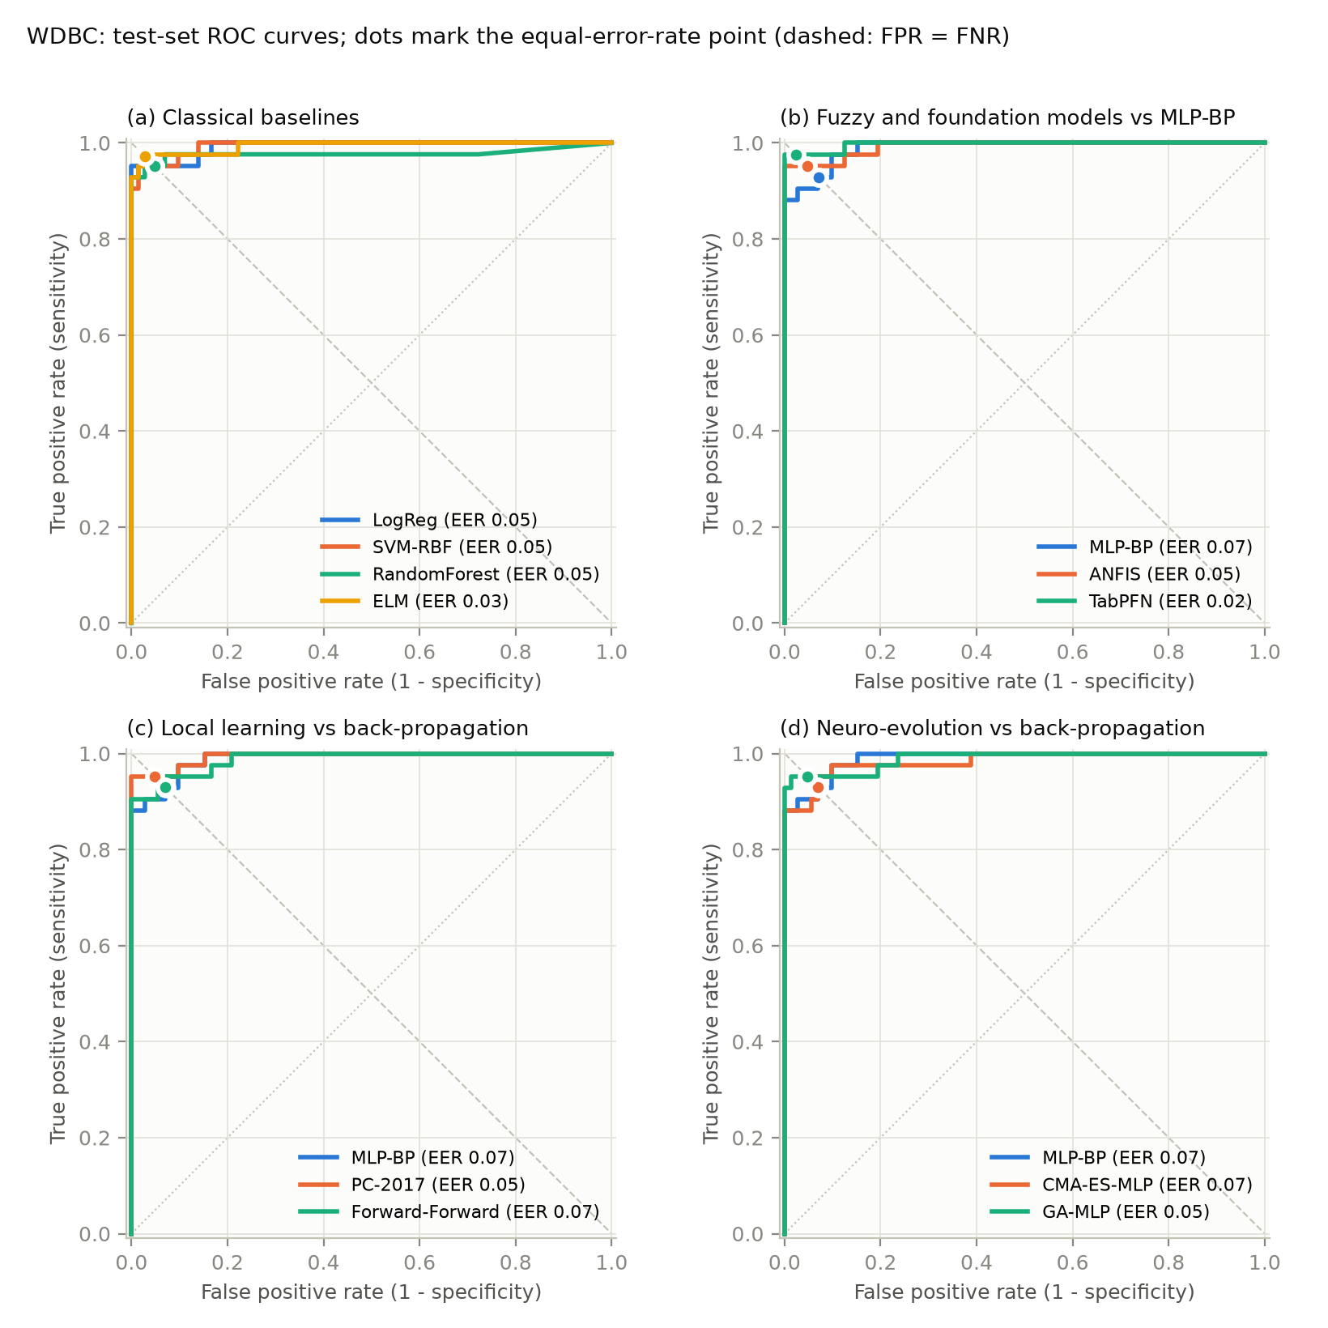
Figure 3: WDBC test-set ROC curves and EER points (same layout as Figure 1).

5.3 Back-propagation versus local learning and neuro-evolution
PC-2017, CMA-ES and the GA train exactly the MLP-BP architecture ($d$-64-32-1, $tanh$), and Forward-Forward keeps the same 64-32 hidden widths but differs in detail (ReLU units, a label-augmented input and a goodness read-out instead of an output layer), so the comparison in Table 3 and Figure 4 largely, though not perfectly, isolates the learning rule.
Table 3: Networks with the same 64-32 hidden layout trained by different rules: cross-validated AUC/EER (mean $±$ s.d.) and fit time per model on the full training set.
Training rule | NUH CV AUC | NUH CV EER | WDBC CV AUC | WDBC CV EER | Fit NUH (s) | Fit WDBC (s)
Back-propagation (Adam) | 0.764 ± 0.083 | 0.286 ± 0.074 | 0.995 ± 0.006 | 0.032 ± 0.019 | 0.6 | 0.7
Predictive coding (local Hebbian) | 0.756 ± 0.097 | 0.294 ± 0.078 | 0.992 ± 0.011 | 0.028 ± 0.018 | 3.0 | 13.5
Forward-Forward (layer-local) | 0.813 ± 0.082 | 0.272 ± 0.090 | 0.994 ± 0.008 | 0.028 ± 0.017 | 1.3 | 3.0
sep-CMA-ES (gradient-free) | 0.801 ± 0.073 | 0.269 ± 0.063 | 0.994 ± 0.008 | 0.032 ± 0.020 | 5.2 | 12.7
Real-coded GA (gradient-free) | 0.785 ± 0.058 | 0.271 ± 0.071 | 0.992 ± 0.008 | 0.037 ± 0.019 | 10.1 | 22.9
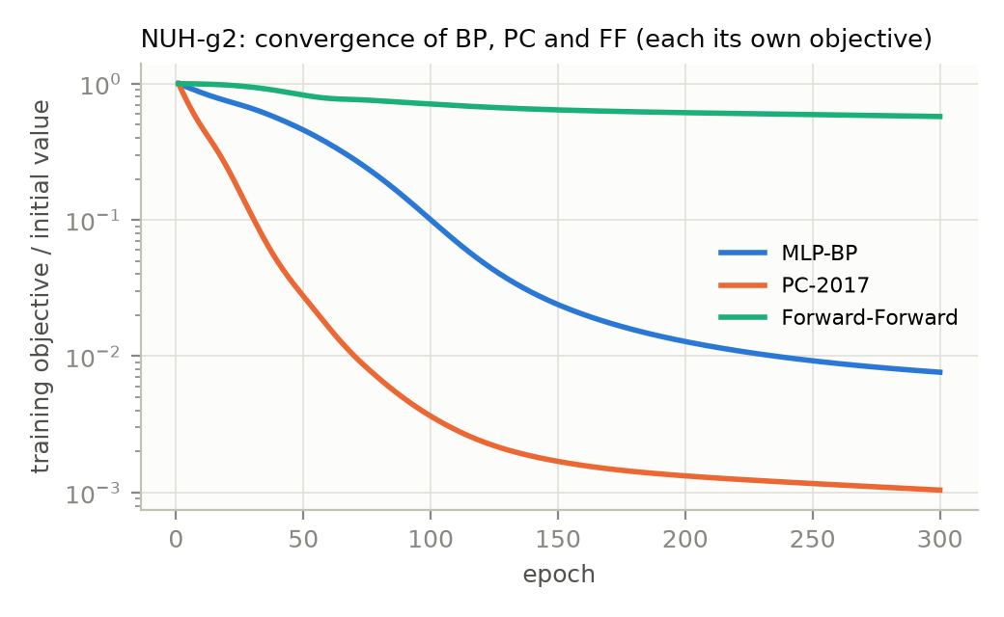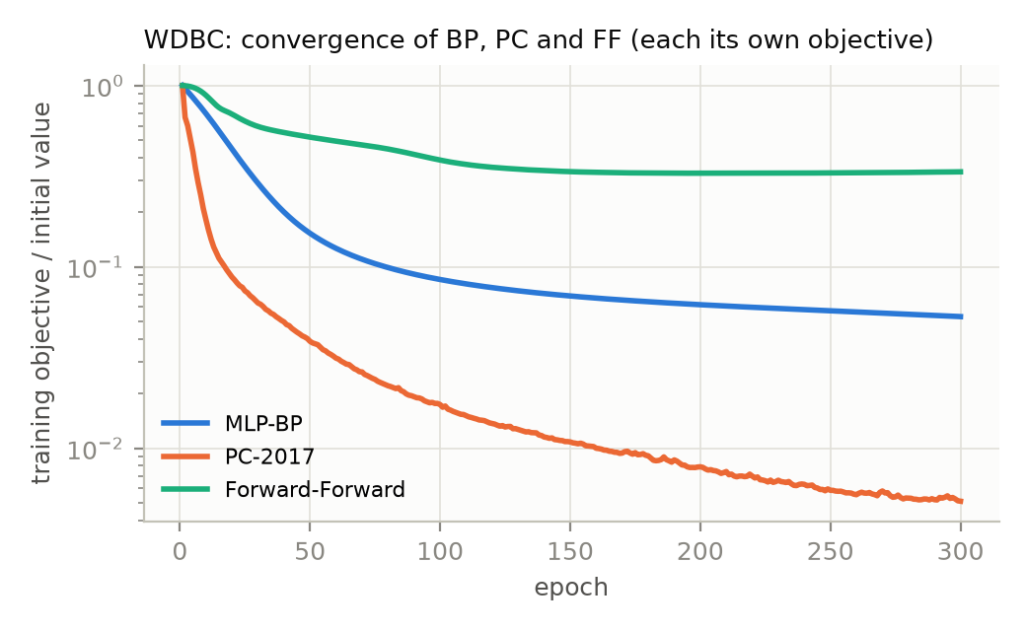
Figure 4: Convergence of the three gradient-style paradigms on the full training set (each curve normalised by its own initial objective: BCE for BP, output-layer squared prediction error for PC, summed layer-wise FF losses for Forward-Forward). The FF objective plateaus well above zero by construction—it is a margin loss on goodness, not a likelihood—yet its classifier is the best of the three on NUH.
On WDBC the five rules are practically tied (CV EER 0.028–0.037, differences well inside one standard deviation); the non-BP rules therefore reach the same level as BP on a well-conditioned problem. On NUH the ordering is Forward-Forward $≈$ CMA-ES $>$ GA $>$ BP $≈$ PC, but the spread ($±0.06$–$0.09$) is larger than any gap, so the defensible statement is that no alternative appears worse than back-propagation at this sample size. Two mechanisms plausibly explain the small advantage of FF and the evolutionary optimisers on 44-patient folds: FF’s contrastive goodness objective with length normalisation is a strong implicit regulariser (its training loss never reaches zero, Figure 4), and CMA-ES/GA with an $L_{2}$ fitness term explore a much smaller effective hypothesis space than Adam, which drives the BP network to a training cross-entropy of $≈0.005$ and the PC network to a vanishing output prediction error (memorisation of 55 patients). Compute cost is the price: PC needs $T=20$ relaxation steps per batch (20$×$ the forward passes of BP) and the evolutionary methods need ${10}^{4}$ fitness evaluations; on these data sizes that is still seconds.

6 Discussion
Choosing the threshold: EER versus cost. The equal-error threshold answers the task as posed and is a convenient reference point for comparing models, because it does not depend on prevalence or on a cost assumption. Clinically, however, a missed cancer is more serious than a false alarm. Our secondary analysis moves the threshold to the OOF point minimising $5⋅FNR⋅p+FPR⋅(1-p)$. On WDBC this barely changes the operating point (sensitivity 0.90–0.98, specificity 0.83–0.97) because the ROC curve is almost a right angle. On NUH, with AUC $≈0.8$, a 5:1 cost ratio pushes the models to sensitivity 0.81–1.00 at specificity 0.00–0.25: eight of the eleven models (TabPFN included) end at sensitivity $≥0.88$ with specificity $≤0.11$, i.e. close to “refer everyone”, and the other three (ELM, MLP-BP, CMA-ES-MLP) retain a specificity of only 0.14–0.25 at sensitivity 0.81–0.89. This is not a failure of the models but a property of the ROC shape: at this discriminative power a strongly asymmetric cost cannot be satisfied without giving up specificity. In practice the decision should be presented to the clinician as the full ROC curve (Figure 1) with the EER point as the neutral default and a cost-weighted point chosen with realistic prevalence and cost figures.
Small-sample effects. The NUH experiments are a case study in variance. The inner grid search of the SVM on 44-patient folds produced an OOF AUC of only 0.54 while the refitted model scored 0.81 on the test set; the MLP-BP and GA-MLP drove their training loss below $0.01$ and have the lowest test AUCs ($0.64$); the 25-fold CV standard deviations ($0.06$–$0.12$ in AUC) exceed all differences between models. Any claim that one method “wins” on NUH should be read in that light; the robust findings are that (i) tree ensembles and kernel methods are competitive with every neural variant, (ii) the non-BP training rules are not inferior to BP, (iii) a pre-trained tabular foundation model with nothing to tune (TabPFN) is within one standard deviation of the best model on both CV metrics, and (iv) heavy-tailed assays should be log-transformed (without it the standardised $f_{24}$ column is dominated by one patient).
Interpretability. ANFIS was included for its interpretability (explicit fuzzy rules), the theme of [1]; TabPFN sits at the opposite end of that spectrum, a 213 MB black box. On NUH ANFIS over-fits with the fixed hyper-parameters; with only 4 rules it is essentially a gated mixture of four linear models, and its poor OOF calibration (FPR 0.46 at $θ_{EER}$) shows that the rule firing strengths do not transfer between folds. Stronger regularisation or feature selection (Table 11 of [1] reports large gains from a 10-feature subset) would be the first improvement.
Limitations. Hyper-parameters were fixed a prior and shared across data sets rather than tuned per model, which favours methods that are robust by default (random forest, FF, CMA-ES) over those that are sensitive (ANFIS, PC learning rates). TabPFN was run with its default v3 checkpoint and ensemble settings; it is by far the largest and least transparent of the tools, its licence-gated weights limit reproducibility, and its tabulated fit time excludes the prediction-time compute. Only group g2 of the NUH data was used; g1 (35 patients, all 30 assays) is too small to evaluate.

7 Conclusion
Eleven decision tools were evaluated under one protocol that sweeps the decision threshold to obtain the ROC curve and sets it at the equal error rate. On WDBC every model attains AUC $≥0.98$ and an EER of 2–7%, with the pre-trained TabPFN best (test EER $0.024$). On the NUH ovarian-cancer blood tests the best cross-validated tool is the random forest (AUC $0.845$, EER $0.245$), closely followed by TabPFN (AUC $0.828$, EER $0.255$) without any training on the data, and the best test-set EER ($0.231$) is shared by random forest and the CMA-ES-trained MLP, corresponding to about 77% sensitivity at 77% specificity. The central methodological result is that replacing back-propagation by predictive coding, by the Forward-Forward algorithm or by neuro-evolution of a network of the same size does not measurably reduce discrimination on either data set and, on the small NUH data, the Forward-Forward and CMA-ES variants are the most robust of the neural models. The cost-weighted threshold analysis shows that, at the discriminative power available from blood assays alone, prioritising sensitivity sacrifices most of the specificity, so the ROC curve itself—not a single operating point—is the deliverable a clinician should see.

References
[1] T. Z. Tan, C. Quek, G. S. Ng, K. Razvi. Ovarian cancer diagnosis with complementary learning fuzzy neural network. Artificial Intelligence in Medicine 43:207–222, 2008.
[2] Wolberg, W., Mangasarian, O., Street, N., & Street, W. (1993). Breast Cancer Wisconsin (Diagnostic) [Dataset]. UCI Machine Learning Repository. https://doi.org/10.24432/C5DW2B
[3] J. C. R. Whittington, R. Bogacz. An approximation of the error backpropagation algorithm in a predictive coding network with local Hebbian synaptic plasticity. Neural Computation 29(5):1229–1262, 2017.
[4] G. Hinton. The Forward-Forward algorithm: some preliminary investigations. arXiv:2212.13345, 2022.
[5] N. Hansen. The CMA evolution strategy: a tutorial. arXiv:1604.00772, 2016.
[6] J.-S. R. Jang. ANFIS: adaptive-network-based fuzzy inference system. IEEE Trans. SMC 23(3):665–685, 1993.
[7] G.-B. Huang, Q.-Y. Zhu, C.-K. Siew. Extreme learning machine: theory and applications. Neurocomputing 70:489–501, 2006.
[8] N. Hollmann et al. Accurate predictions on small data with a tabular foundation model. Nature 637:319–326, 2025.
[9] W. N. Street, W. H. Wolberg, O. L. Mangasarian. Nuclear feature extraction for breast tumor diagnosis. IS&T/SPIE, 1993.

