1. **Explain the following terms/concepts as they are used by Kimball**
   1. **Bubble Chart [2]**
      1. A high level graphical representation of a business process dimensional data model. Useful for communicating data models to a non-technical audience.
   2. **Data stewardship [2]**
      1. An organizational function to address data definitions, consistency, integration, quality and knowledge in an enterprise.
   3. **View [3]**
      1. SQL statement that creates logical copies of a table or a complete query that can be used separately in a ‘select’ statement. Views are semantically independent, so the separate roles of a role-playing dimension usually are implemented as views.
2. **Provide a high-level overview of the dimensional modelling process flow using a diagram. Briefly describe the nature of the process, as well as the steps and the key deliverables. [15]**
3. 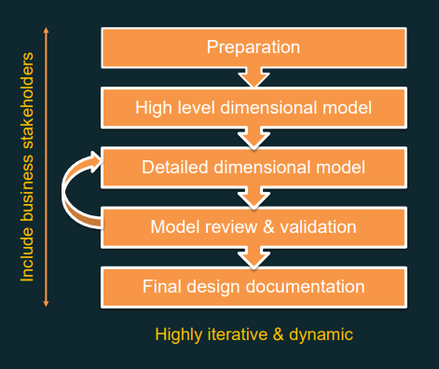**Preparation**

Deliverables:

* Business Requirements
* High level bus matrix
* Preliminary data profiling
* Tools
* Naming conventions

Steps:

1. Identify Participants, especially business representatives

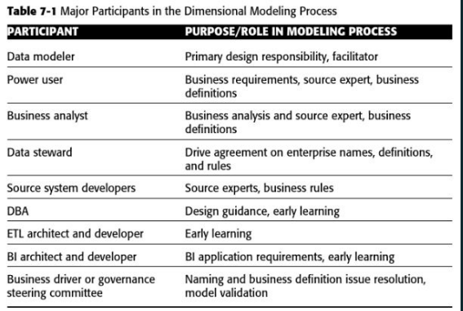

1. Review the business requirements
   1. Proposed data elements, sample questions and reports
   2. Bring modelling team up to date and get their input
2. Select modelling tools
   1. Spreadsheets are handy to start with and can easily be modified
   2. List attribute, metrics, business and ETL rules, metadata
3. Preliminary data profiling
   1. To explore source data content and relationships
4. Establishing naming conventions
   1. Agree on common definitions and labels
   2. Labels must be descriptive and consistent: Think UX
      1. PrimeWord_Qualifiers_ClassWord
5. Coordinate calendars and facilities
   1. Schedule design sessions and book conference rooms
6. **High Level Dim Model**

Deliverables:

* Initial high level model diagram
* Initial attributes and metric list
* Issues List

Steps:

* Follow the four-step process:
  1. Identify the business process
  2. Declare the grain of the business process
  3. Identify the dimensions
  4. Identify the facts
* Initial high level model
  + Diagram (Bubble chart)
  + From Bus matrix
  + Include the grain!

1. **Detailed dim model**

Deliverables:

* Detailed dimensional design worksheets
* Updated bus matrix
* Updates issues list