

**Gift Card Shop Management**

**Documentation**

|  |  |
| --- | --- |
| **<C1708M> <Group2>** | |
| **Group Members** | Hung Vu Phi : T1804I05 (L)  Trung Do Quang : T1804I50  Hung Nguyen Xuan : C1708M68 |
| **Instructor** | Lan Dinh Ngoc |

- Hanoi, 5/2020 -

INDEX

**1. Problem Definition 3**

1.1. Problem Abstraction 3

1.2. The Current System 3

1.3. The Proposed System 3

1.4. Hardware and Software Requirements 5

1.4.1. Minimum Requirements 5

1.4.2. Recommended Requirements 5

**2. Customer Requirements Specification 6**

2.1. Users of the System 6

2.2. System functions 6

**3. Architecture & Design of Project 9**

3.1. Data Flow Diagram 9

3.2. Entity Relationship Diagram 14

3.3. Database Structure 17

3.3.1. Table Design 17

3.3.2. Database Diagram 19

3.4.Site map20

**Task Sheet 23**

**4. Install Guide 24**

**5. User Manual 30**

# Problem Definition

## Problem Abstraction

Along with the non-stop development of 4.0 technology is the rapid development of Gaming Esport. Regarding Gaming Esport, there are big companies in the Esport village such as Steam, Garena, etc. Steam provides us with many famous Gaming products in the world.

Therefore, the distribution of products on Copyright Games, leading software and utilities has become more necessary than ever. Divine Shop was born with the desire to provide Vietnamese gamers with the best quality copyrighted games in the world with the simplest payment method, the best price andenthusiastic and attentive customer service.

We want to become a companion and advise you in all matters related to Copyright Game, making your gaming experience the best. We believe that proper entertainment will bring good values to life.

With the above objectives, the focus of this topic will be on research and development of a "Game Store Management" software. It is a practical topic and meets the needs of management. To meet the demand for easy and convenient store management, our team decide to build this application.

## The Current System

Customers search for information in the shop. If they find the book they need, they have to call the employee to ask about the information of the book, then they will decide whether to buy it or not. It will take them for a while to get to the store to see it.

The disadvantages of manual book store management methods:

+ Confusion cause loss of customer information, transaction contract.

+ A detail transactions on a regular statistical report is not available.

## The Proposed System

Game Store Management System is a System for customers to see the detail of Game, so they can easily find the information about the Game such as: name, price, etc. which will help their purchase experiment more effectively and also save a lot of time.

## The system we build will include the following main functions:

1. User system
2. Admin system

The system has overcome the disadvantages of pawn store management by manual methods as follow:

+ Easy to manage game store: we can view different lists of games, add, edit, delete, watch game detail. Easy to navigate in the menu of game management.

1. Add Game.
2. Edit Game.
3. Delete Game.
4. Watch Game Detail.
5. Watch All Games.

+ Easy to manage Game Collection:

1. Add Game Collection.
2. Edit Game Collection.
3. Delete Game Collection.
4. Watch Game Collection. Detail.
5. Watch All Game Collection.

+ Easy to manage Publisher:

1. Add Publisher.
2. Edit Publisher.
3. Delete Publisher.
4. Watch Publisher Detail.
5. Watch All Publisher.

+ Easy to manage orders:

1. Unconfirmed Orders.
2. Delivering Orders.
3. Delivered Orders.

+ When using the system, the storage and preservation of Games information, invoices will be much safer than the manual method and the functions of the system support the user select should also avoid mistakes. more confused.

For users, our system has the following remarkable features:

1. Search game by name
2. Filter game by collections
3. Add game to cart
4. Manage user’s own cart

## Hardware and Software Requirements

### Minimum Requirements

|  |  |
| --- | --- |
| *Hardware* | - Minimum of a Pentium 166 PC  - 1GB RAM  - HDD 10GB free space available |
| *Software* | - OS: Windows 7  - Java Virtual Machine  - Java SE 6  - Net beans 7.0  - DBMS: SQL Server 2005 |

### Recommended Requirements

|  |  |
| --- | --- |
| *Hardware* | - Minimum of Core2 Duo or higher  - 2GB of RAM or higher  - HDD 10GB free space available |
| *Software* | - OS: Windows 10  - Java Virtual Machine  - Java SE 8 OS: Windows10  - Java SE 8  - Apache NetBeans IDE 8.2  - DBMS: SQL Server 2012 |

# Customer Requirements Specification

## Users of the System

* + 1. Administrator
* Administrator has permissions to manage employees.
* Administrator has permissions to manage game.
* Administrator has permissions to manage publisher.
* Administrator has permissions to manage game collection.
* Administrator has permissions to manage orders.
* General statistics.
  + 1. Customer
* Customer has permissions to view and search for games.
* Check information about detail of games.
* Add item to cart then decide buying method

## System functions

* + 1. Administrator
* *Login:*

|  |  |
| --- | --- |
| **Description** | Administrator can login to system with Username and Password. |
| **Input** | Input Username and Password |
| **Process** | Check data in the Database. |
| **Output** | - Move to the manage administrator interface if login successful.  - Return to the login if failure |

* *Game Management*

|  |  |
| --- | --- |
| **Description** | Administrator can add, edit, delete and view a game |
| **Input** | *Game* information to CRUD |
| **Process** | Check data in the Database. |
| **Output** | - Add / Edit / Delete / Show game if all inputs valid  - Return to Add / Edit / Delete / Show interface if failure |

* *Category Management*

|  |  |
| --- | --- |
| **Description** | Administrator can add, edit, delete and view a collection |
| **Input** | Collection information to CRUD |
| **Process** | Check data in the Database. |
| **Output** | - Add / Edit / Delete / Show category if all inputs valid  - Return to Add / Edit / Delete / Show interface if failure |

* *Admin Management:*

|  |  |
| --- | --- |
| **Description** | Administrator can add, edit, delete and view a publisher |
| **Input** | Publisher information to CRUD |
| **Process** | Check data in the Database. |
| **Output** | - Add / Edit / Delete / Show author if all inputs valid  - Return to Add / Edit / Delete / Show interface if failure |

* *Order management:*

|  |  |
| --- | --- |
| **Description** | Administrator can execute, edit, delete and view 1 of 3 kinds of orders:  + Unconfirmed Order  + Delivering Order  + Delivered Order |
| **Input** |  |
| **Process** | Check data in Database |
| **Output** | System perform each function correspondingly |

* + 1. *Customer*
* *Filter:*

|  |  |
| --- | --- |
| **Description** | Customer can filter game by collection. |
| **Input** | Enter collection name |
| **Process** | Search in the database for game that match the collection name |
| **Output** | Display all matched game information. |

* *Search:*

|  |  |
| --- | --- |
| **Description** | Customers can search for game via name. |
| **Input** | Enter keywords they need to find and price range if needed |
| **Process** | Search the database for all game containing the keywords entered |
| **Output** | Display game detail information that customer has entered. |

* *Order:*

|  |  |
| --- | --- |
| **Description** | Customer can order game. |
| **Input** | Add game to cart and customer information |
| **Process** | Update customer information in database base on their input and add game to cart |
| **Output** | Show the report successfully or failed.  If successfully, show deliver method and confirm message box. |

# Architecture & Design of Project

## Data Flow Diagram

**Level 0: Context Diagram**



**Level 1: Relationship**

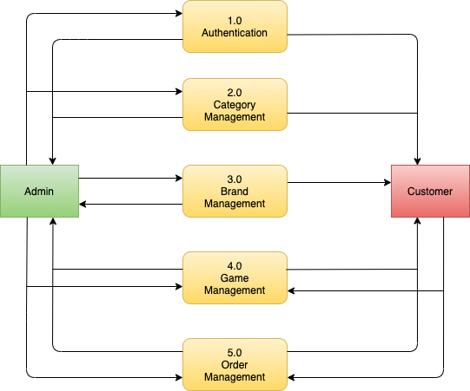

**Level 2:**

1.0: Authentication

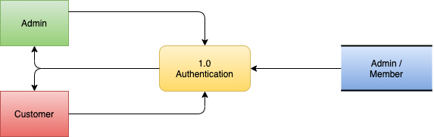

2.0: CategoryManagement

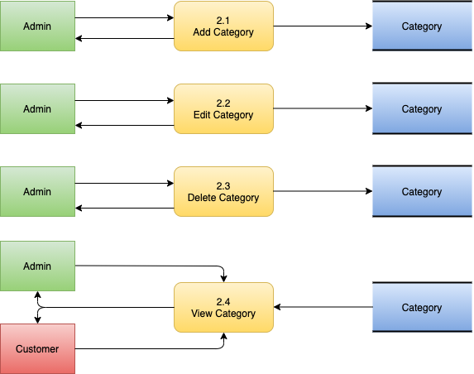

3.0: Brand Management

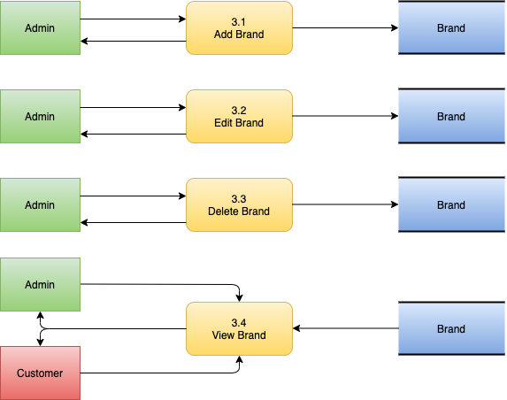

4.0: Game Management

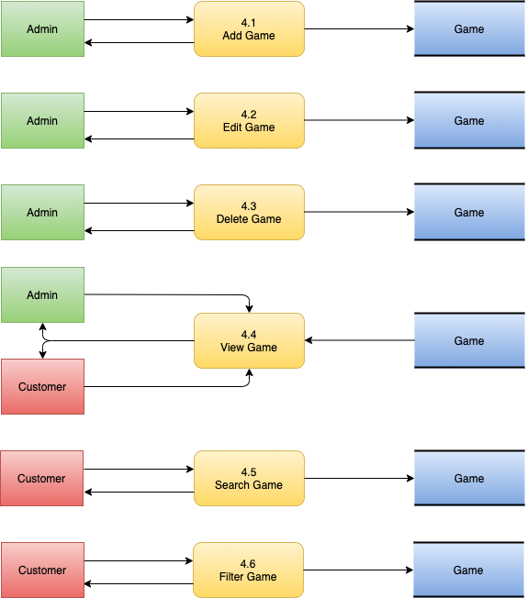

5.0: Order Management

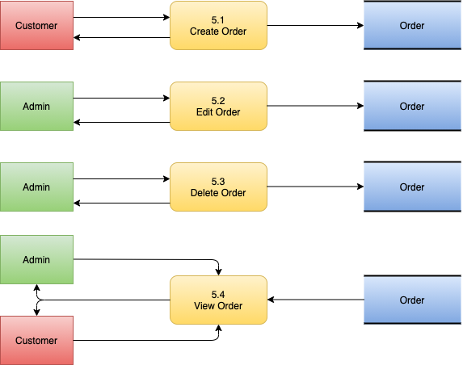

## Entity Relationship Diagram

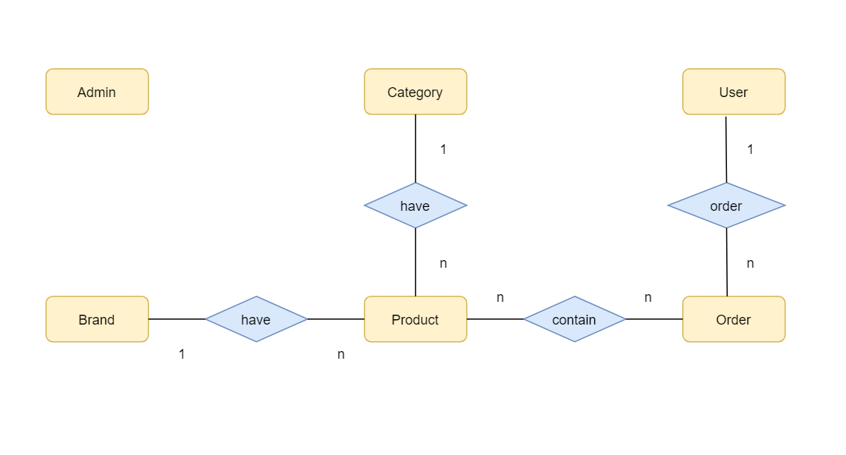

***Entity Lists:***

* Entity Admin:

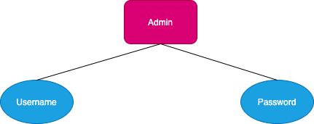

* Entity User:

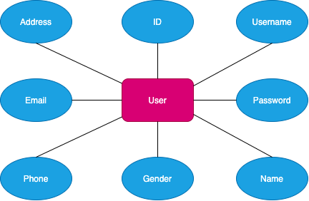

* Entity Product:

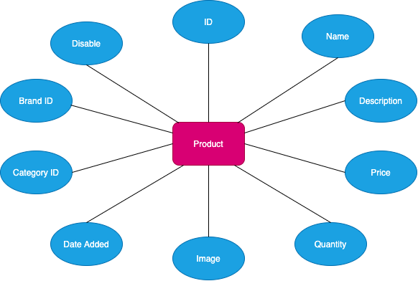

* Entity Order:

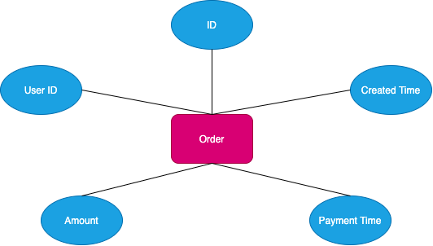

* Entity Category:

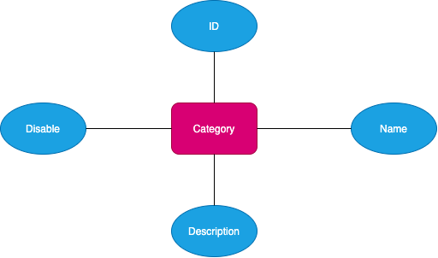

* Entity Brand:

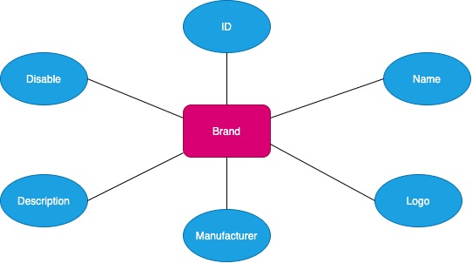

## Database Structure

### Table Design

* + - 1. Table [Admin]

|  |  |  |  |  |
| --- | --- | --- | --- | --- |
| **Key** | **Field Name** | **Data Type** | **Length** | **Description** |
| Not null | username | Varchar | 30 |  |
| Null | [password] | Varchar | 30 |  |

* + - 1. Table Category

|  |  |  |  |  |
| --- | --- | --- | --- | --- |
| **Key** | **Field Name** | **Data Type** | **Length** | **Description** |
| Not null | ID | Int |  |  |
| Not null | name | nvarchar | 50 | unique |
| Null | description | ntext | 50 |  |
| Null | disable | bit | 1 | default 0 |

* + - 1. Table Brand

|  |  |  |  |  |
| --- | --- | --- | --- | --- |
| **Key Key** | **Field** | **Data Type** | **Length** | **Description** |
| Not null | ID | Int |  |  |
| Not null | name | nvarchar | 50 | unique |
| Null | logo | varchar | 50 | default 'brand.png' |
| Null | manufacturer | nvarchar | 50 | default 'unknown' |
| Null | description | ntext |  |  |
| Null | disable | bit | 1 | default 0 |

* + - 1. Table Product

|  |  |  |  |  |
| --- | --- | --- | --- | --- |
| **Key** | **Field** | **Data Type** | **Length** | **Description** |
| Not null | ID | Int |  |  |
| Not null | name | nvarchar |  | unique |
| Null | description | ntext |  |  |
| Not null | price | Int |  |  |
| Not null | quantity | Int |  |  |
| Null | image | varchar | 50 | default 'product.png' |
| Null | date_added | datetime |  | DEFAULT CURRENT_TIMESTAMP |
| Not null | category_id | Int |  | Category(id) |
| Not null | brand_id | Intr |  | Brand(id) |

* + - 1. Table [User]

|  |  |  |  |  |
| --- | --- | --- | --- | --- |
| **Key** | **Field** | **Data Type** | **Length** | **Description** |
| Not null | ID | Int |  |  |
| Not null | username | varchar | 30 |  |
| Not null | password | varchar | 30 |  |
| Null | name | nvarchar | 50 |  |
| Null | gender | Bit |  |  |
| Null | phone | varchar | 20 |  |
| Null | email | varchar | 50 |  |
| Null | address | nvarchar | 255 |  |

* + - 1. Table Orders

|  |  |  |  |  |
| --- | --- | --- | --- | --- |
| **Key** | **Field** | **Data Type** | **Length** | **Description** |
| Not null | ID | Int |  |  |
| Null | created_time | DateTime |  | DEFAULT CURRENT_TIMESTAMP |
| Null | payment_timeID | DateTime |  | DEFAULT '01/01/1970 00:00:00' |
| Not null | amount | Int |  |  |
| Not null | user_id | Int |  | [User](id) |

* + - 1. Table OrderDetail

|  |  |  |  |  |
| --- | --- | --- | --- | --- |
| **Key** | **Field** | **Date Type** | **Length** | **Description** |
| Not null | ID | Int |  |  |
| Not null | status | Varchar | 50 |  |
| Not null | product_id | Int |  | Product(id) |
| Not null | order_id | Int |  | [Order](id) |
| Not null | purchased_quantity | Int |  |  |

### Database Diagram

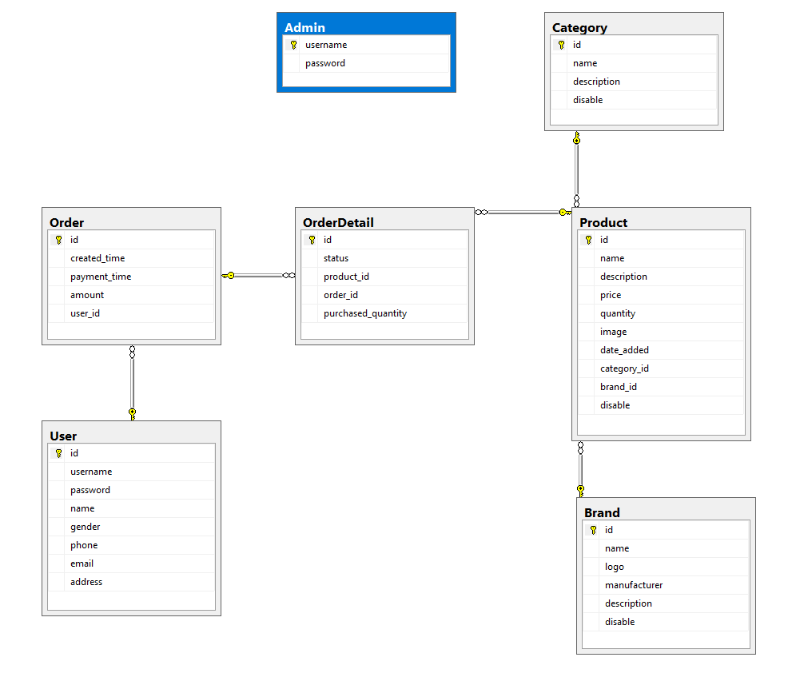

# 

# 

# *Site map*

* + 1. From App

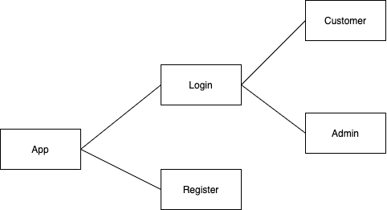

* + - 1. From Customer

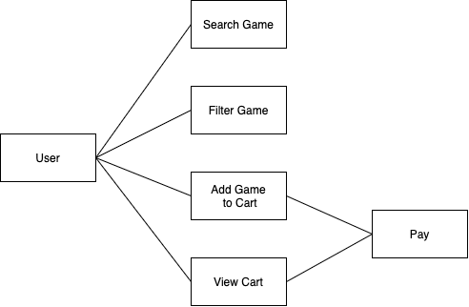

* + - 1. From Admin

# 

# *Screen Design*

# Login

# 

# Index

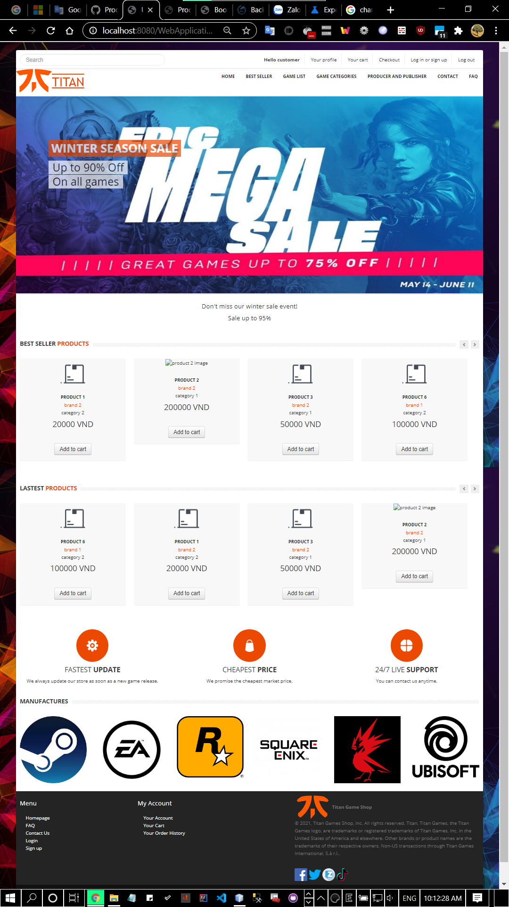

**Game Detail**

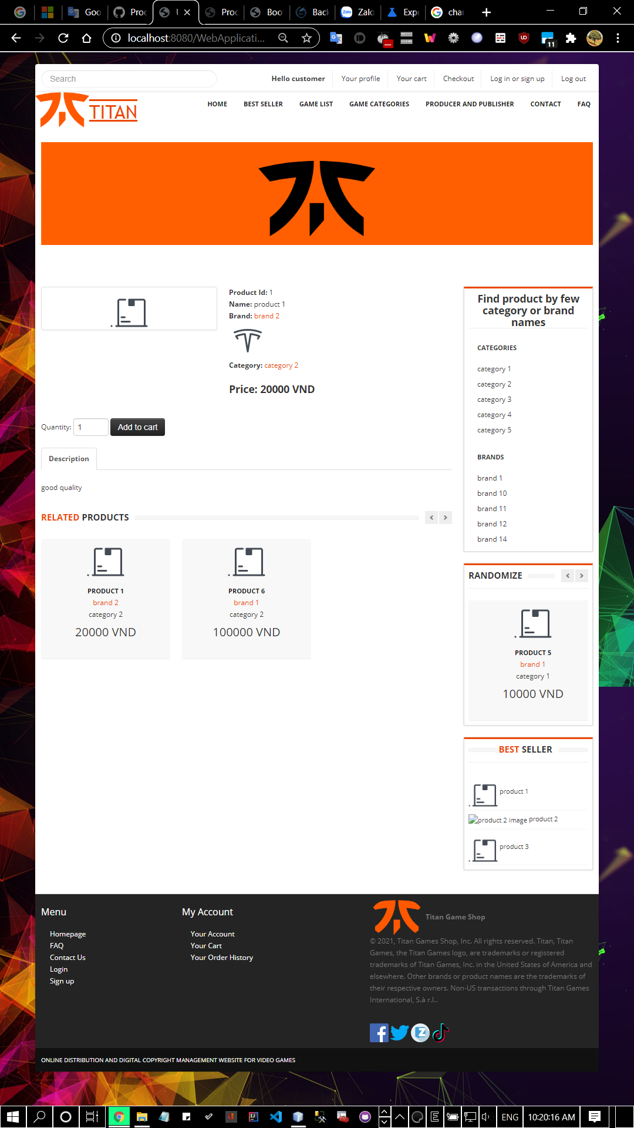

**Cart**

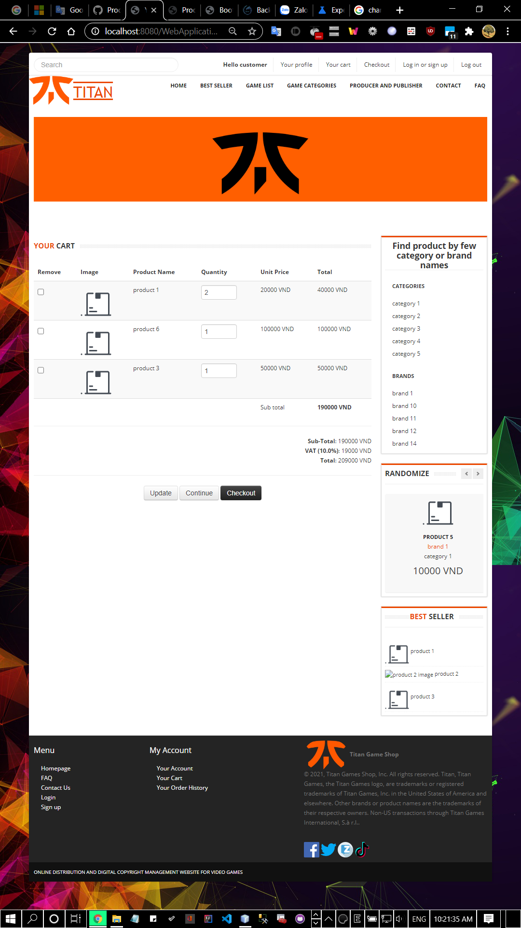

**Checkout**

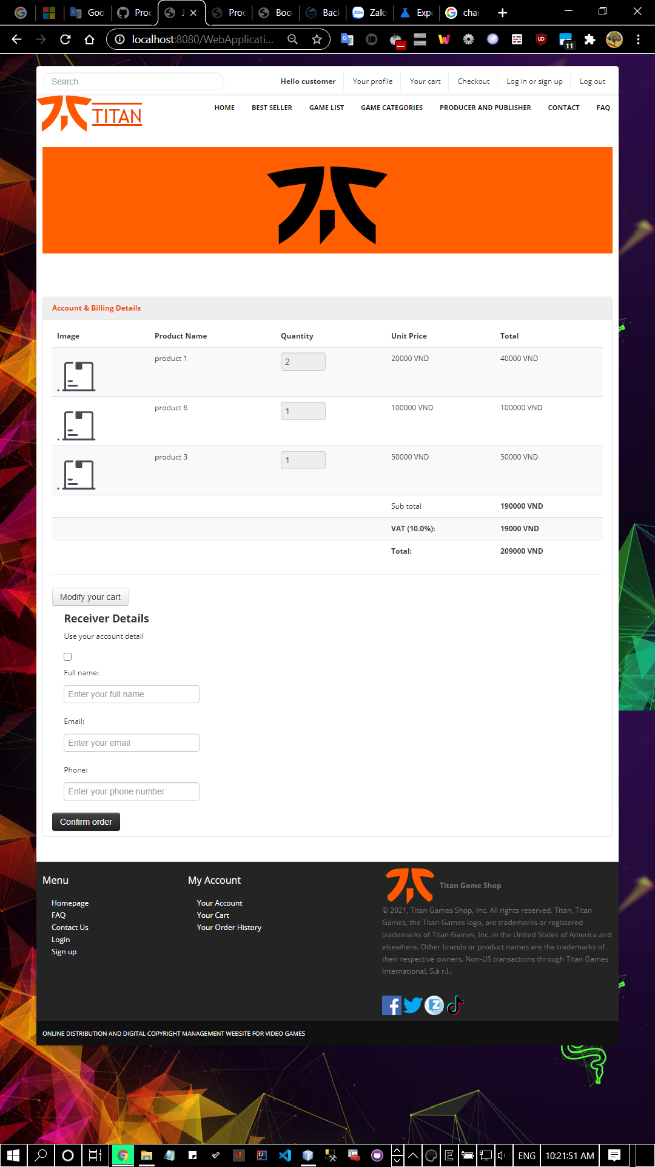

# Task Sheet

|  |  |  |
| --- | --- | --- |
| **STT** | **Task** | **Member Name** |
| 1 | Document | Trung Do Quang  Hung Nguyen Xuan  Hung Vu Phi |
| Slide | Trung Do Quang |
| 2 | Main developer | Hung Vu Phi |
| Sub developer | Trung Do Quang |
| 3 | Test | Trung Do Quang  Hung Nguyen Xuan  Hung Vu Phi |

# Install Guide

1. **NetBean IDE 8.2 or lower**

## Required Software

The Java SE Development Kit (JDK) 8 is required to install NetBeans IDE. You can download the latest update of JDK 8 at [http://www.oracle.com/technetwork/java/javase/downloads](http://www.oracle.com/technetwork/java/javase/downloads/index.html).

The PHP and C/C++ NetBeans bundles only require the Java Runtime Environment (JRE) 8 to be installed and run. JDK 8 is required if you are planning to use any of the Java features.

JDK 8 is required to use JavaFX 8 features in NetBeans IDE 8.2.

**Note:**

* JavaFX 8 is bundled with JDK 8 for Windows, Mac and Linux.
* Unlike previous versions of NetBeans IDE, NetBeans IDE 8.2 does not require that you set up an "FX-enabled" Java platform in order to utilize JavaFX support in the IDE. You can develop JavaFX projects in the IDE if you install JDK 8.
* To use JavaFX features in NetBeans IDE, we strongly recommend you use JDK 8.

## Installer Download Options

On the NetBeans IDE [Download page](https://netbeans.org/downloads/), you can obtain one of several installers, each of which contains the base IDE and additional tools.

The following installers are available:

* **Java SE**. Supports all standard Java SE development features as well as support for NetBeans Platform development and JavaFX 2.2 SDK (or newer) or JavaFX 8 SDK.
* **Java EE**. Provides tools for developing Java SE and Java EE applications as well as support for NetBeans Platform development and JavaFX 2.2 SDK (or newer) or JavaFX 8 SDK. This download option also includes GlassFish Server Open Source Edition 4.1.1, and Apache Tomcat 8.0.27 software.
* **HTML5/JavaScript**. Provides tools for HTML5/Javascript development. Includes Java Runtime Environment and does not require a separate Java installation.
* **PHP**. Provides tools for PHP 7 development, Zend and Symfony Framework support. Includes Java Runtime Environment and does not require a separate Java installation.
* **C/C++**. Supports development in the C, C++, Qt, Fortran and Assembly languages. Includes Java Runtime Environment and does not require a separate Java installation.
* **All.** This is a full download option, which contains all the runtimes and technologies available for the NetBeans IDE.

## Customizing Your Installation

If you download the **All** download option, you can choose exactly what tools and runtimes to install. Click Customize at the Welcome page of the installer and select the features that you want to use. For more information, see [Installing the Software](https://netbeans.org/community/releases/82/install.html#installation).

If you want to add functionality to your NetBeans IDE configuration, use the NetBeans Plugin Manager. For example, assume that you start out by downloading and installing the PHP pack. You then decide that you want to try out the C/C++ functionality. To do this, go to the NetBeans Plugin Manager from the IDE (choose Tools > Plugins) and add the C/C++ pack to your existing installation.

There are several important notes about installation and configuration of some NetBeans IDE features:

* Glassfish is provided with NetBeans IDE as a reference implementation of Java Enterprise Edition (EE). It is not intended for use in production environments.  
    
  Application developers should ensure that any applications developed using Glassfish as a reference version use up-to-date, secure cryptographic protocols and algorithms, and are tested accordingly, before deploying those applications in production.   
    
  Note that the version of Glassfish provided with NetBeans IDE is not up to date with security fixes and is provided as a convenience. As a consequence, NetBeans users should upgrade to the most recent version of Glassfish when deploying NetBeans IDE and should upgrade to new versions of Glassfish whenever Glassfish distributions include new security fixes. Glassfish upgrade instructions are provided at My Oracle Support (MOS) note 2073920.1.   
    
  GlassFish Server Open Source Edition 4.1.1 is included in the **Java EE** and **All** download options but it is not installed by default from either of these options. To install GlassFish Server Open Source Edition 4.1.1, select the appropriate option below:
  + from the **Java EE** download, launch the installer and select the GlassFish Server Open Source Edition 4.1.1 checkbox at the Welcome page;
  + from the **All** download, launch the installer and select GlassFish Server Open Source Edition 4.1.1 in the Customize Installation dialog box.

You should change the default administrator password after you install the GlassFish server, refer to [FaqSettingGlassFishPassword](http://wiki.netbeans.org/FaqSettingGlassFishPassword) for details.

* Apache Tomcat 8.0.27 is included in the **Java EE** and **All** download options but it is not installed by default from either of these options. To install Apache Tomcat, select the appropriate option below:
  + from the **Java EE** download, launch the installer and select the Apache Tomcat 8.0.27 checkbox at the Welcome page;
  + from the **All** download, launch the installer and select Apache Tomcat 8.0.27 in the Customize Installation dialog box.
* For C/C++ development (applicable for the **C/C++** and **All** downloads), you need to additionally install compilers and tools.
* For HTML5 and JavaScript development for mobile devices (Android and iOS), you need to additionally install SDKs and other development tools for the target development platform. For more information, refer to the [Mobile Browsers](http://wiki.netbeans.org/MobileBrowsers) wiki page.
* For OS X, you can customize the NetBeans IDE installation from the **All** and **Java EE** downloads. The IDE installation from **Java SE**, **HTML5/JavaScript**, **PHP**, and **C/C++** downloads cannot be customized.
* You can also download [a platform-independent zip file](https://netbeans.org/community/releases/82/install.html#install_zip) and run the NetBeans IDE executable file. Note that the GlassFish Server Open Source Edition and Apache Tomcat are only available with platform-specific installers.
* To make sample project templates unreachable in the NetBeans IDE installation, see the [Hide Sample Projects FAQ](http://wiki.netbeans.org/FaqHideSampleProjects) page.

## Starting the Download

1. Go to [**https://netbeans.org/downloads/**](https://netbeans.org/downloads/).
2. In the upper right area of the page, select the language and platform from the drop-down list. You can also choose to download and use the platform-independent zip file.
3. Click the Download button for the download option that you want to install.
4. Save the installer file to your system.

## Installing the Software

Follow the instructions in this section to install the IDE on your system. These installation instructions apply to all supported platforms. For the list of supported platforms and system requirements, see the [release notes](https://netbeans.org/community/releases/82/relnotes.html#system_requirements).

### Microsoft Windows

1. **To install the software:** After the download completes, run the installer.
   * For Windows, the installer executable file has the .exe extension. Double-click the installer file to run it.
   * For Linux platforms, the installer file has the .sh extension. For these platforms, you need to make the installer files executable by using the following command: chmod +x <*installer-file-name*>. Type ./<*installer-file-name*> to run the installer.
2. If you downloaded the **All** or **Java EE** bundle, you can customize your installation. Perform the following steps at the Welcome page of the installation wizard:
   * 1. Click Customize.
     2. In the Customize Installation dialog box, make your selections.
     3. Click OK.
3. At the Welcome page of the installation wizard, click Next.
4. At the License agreement page, review the license agreement, click the acceptance check box, and click Next.
5. At the NetBeans IDE installation page, do the following:
   * 1. Accept the default installation directory for the NetBeans IDE or specify another directory.

**Note:** The installation directory must be empty and the user profile you are using to run the installer must have read/write permissions for this directory.

* + 1. (Applicable only to **All** or **Java EE** bundle.) Accept the default JDK installation to use with the NetBeans IDE or select a different installation from the drop-down list. If the installation wizard did not find a compatible JDK installation to use with the NetBeans IDE, your JDK is not installed in the default location. In this case, specify the path to an installed JDK and click Next, or cancel the current installation. After installing the required JDK version you can restart the installation.

**Note:** If the JDK version is older than the recommended JDK 8, download and install the latest JDK update from [Java SE Downloads](http://www.oracle.com/technetwork/java/javase/downloads/index.html) page and restart the NetBeans IDE installer.

1. Click Next.
2. If the GlassFish Server Open Source Edition 4.1.1 installation page opens, accept the default installation directory or specify another installation location and click Next.
3. If you are installing Apache Tomcat, on its installation page, accept the default installation directory or specify another installation location. Click Next.
4. At the Summary page, do the following:
   1. Verify that the list of components to be installed is correct.
   2. Select the Check for Updates check box if you want to check the Update Center for possible updates.
   3. Verify that you have adequate space on your system for the installation.
5. Click Install to begin the installation.
6. At the Setup Complete page, provide anonymous usage data if desired, and click Finish.

**Note:** If you encounter problems successfully completing the software installation, see [Troubleshooting](https://netbeans.org/community/releases/82/install.html#troubleshooting) for descriptions and suggested workarounds for unresolved issues that could affect the installation process.

1. **Microsoft SQL Server 2005 or higher**

1. Insert the SQL Server installation media. From the root folder, double-click **Setup.exe**. To install from a network share, locate the root folder on the share, and then double-click **Setup.exe**. Proceed with the SQL installation.

2. The Installation Wizard runs the **SQL Server Installation Center**. To create a new installation of SQL Server, select the Installation option on the left side, and then click **New SQL Server stand-alone installation or add features to an existing installation**:

3. Setup is now preparing to launch **Setup Support Rules window**.

4. **Setup Support Rules** will run to identify problems that may occur during the Setup Support Files installation:

5. Once this step finishes, click **OK** to proceed to **Product Key** window. In the **Product Key** window, enter the **Product license key** (if required), and click **Next** to continue:

6. In the **License Terms** window, tick the box **I accept the license terms** and then click **Next** to continue.

**You must accept the license agreement before you can continue the installation of SQL Server. Send feature usage data to Microsoft option is optional.**

7. Click **Install to Install Setup Files**.

**Allow SQL to scan for important product updates and install them prior to any further action.**

Setup files are necessary to perform the actual installation. Following the installation of the setup support files, you will be presented with another compatibility check. Following dialog appears once you successfully pass these checks. You can click the **Show Details** button under the green progress bar if you want to see the individual checks listed.Click **Next**.

8. In the **Setup Role** window, select **SQL Server Feature Installation**.Click **Next** to continue to **Feature Selection**.

**In case of any warning of a setup support rule action, please take any remedy action and press Re-scan**.

9. Select the following features for installation: **Database Engine Services**, **Management Tools - Basic**, **Management Tools - Complete**.You can also specify the shared feature directory where share features components will be installed.

10. Click **Next** to continue to the **Installation Rules** window.

11.Instance name should be DLS. **Note:** If the instance name here is not DLS, then the DB instance field in "MSSQL specific entries" in DLS Multinode installer must match the entry filled here.

12. Click **Next** to proceed to the **Disk Space Requirements** window. This is just a information page that does not require you to make any choices. Click **Next** to go to Server Configuration window.

13.In **Server Configuration**, you can specify service startup and authentication.Under the **Service Account** tab, for the services SQL Server Agent and SQL Server Database Engine, enter the data of that user which the DLS nodes utilize for connecting to the database. This user must be part of the administrators group. In Startup Type, select **Manual** for the SQL Server Agent, and **Automatic** for the SQL Server Database Engine.

14.Click on the **Collation** tab and then click the **Customize** button to specify the collation for your Database Engine and Analysis Services instance that best matches your application need.

15.During installation of SQL Server the administrator must be defined.

a. Click **Add Current User** if current user is going to be the SQL Server administrator. Add any other domain user in case the current local user is not the database user to be used in DLS.

b. Alternate configuration : Since there are numerous GVS cases where the domain or local user changed, deleted, etc, and forgotten from our engineers ,define mixed mode authentication with a strong provided password and there will always be a default user **sa** that we could connect using the provided password.

16. Click **Next** to advance to **Error Reporting**.Tick the check box if you want to send Windows and SQL Server error reports to Microsoft.

17. **Installation Configuration** will run some more rules that will validate your computer configuration with the SQL Server features you have specified.Correct any errors reported in the **Installation Configuration Rules** screen and click on **Next**.

18. The **Ready to Install** page shows a tree view of installation options that were specified during Setup. Click on the **Install** button to start SQL Server installation. The Setup will first install the required prerequisites for the selected features followed by the feature installation. The **Installation Progress** window provides status so that you can monitor the installation progress as Setup continues.

19. When the installation is complete, click on **Next** to **Complete** window.

# User Manual

1. Copy everything from the usb.
2. Run BookStoreDB.sql with SQL Server Management then press F5 when it open.
3. Open NetBean IDE, click File > Open Project > choose the link to the project > click Open Project.
4. Add New JDBC Driver for BookStoreDB – In the service menu, right click on Drivers and select **New Connection** from the menu.

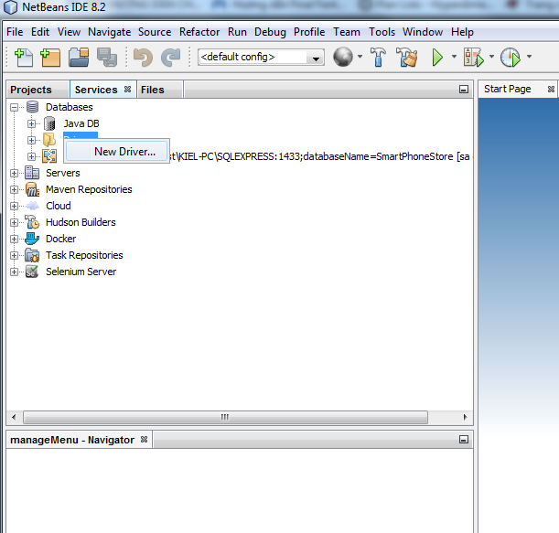

1. Add the driver files for your New JDBC Driver – Click Add button and select sqljdbc42.jar files.
2. Click OK.
3. In the service menu, right click on **Database** and Select **New Connection** from the menu.
4. Select the driver you create.
5. Click Next.
6. Input Username and Password of your SQL server then click Finish.
7. In the service menu, click + beside **Database**, right click like the image then choose **Rename**, copy it:

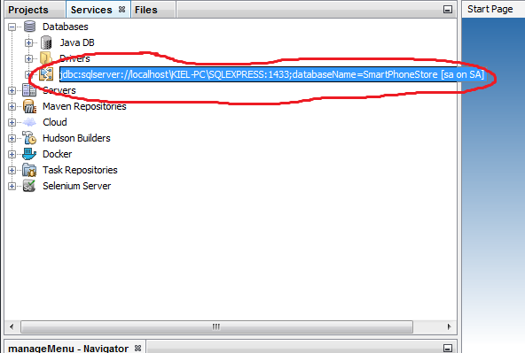

1. In the Projects menu, open model folder > open DBConnection.java > change the line in the image with one you just copy then click File > Save or Ctrl+S.
2. In the Projects menu, right click GameShop > Run.
3. When application is running:

a) Login with system admin role: this will let you manage your store with admin role.

b) Home: this will open homepage and you can see list of books.