Sau khi connect ssh được như lab 1.

1. Mở port 3000 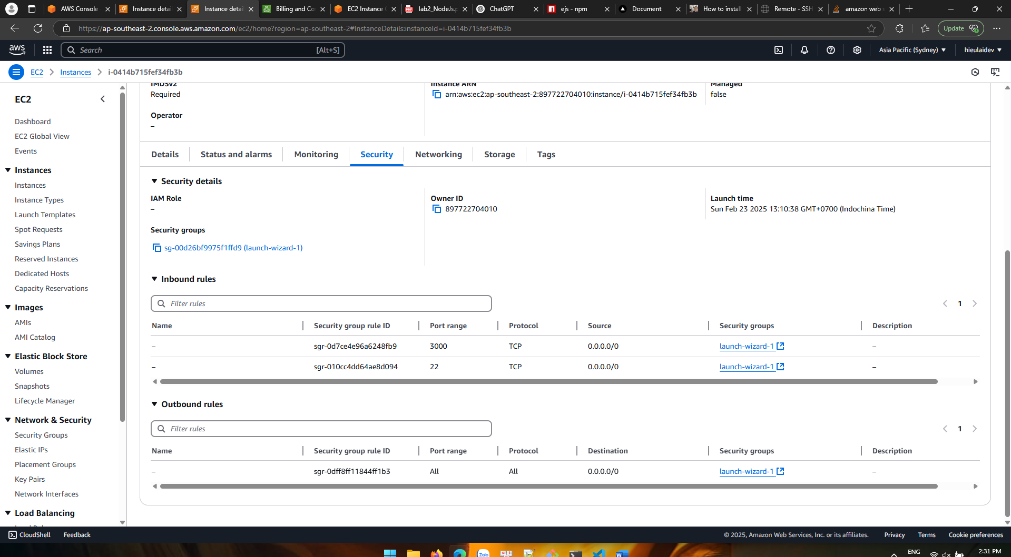  
   2) Code ở local  
   A screen shot of a computer program

   AI-generated content may be incorrect.

3)Copy lên EC2

4. Lên EC2 cài môi trường node  
5. Chạy npm start với port 3000

