**Excite Learn Evolve**

Contents

Purpose 2

Objective 2

Starting Point (to create focus) 2

Areas of Interest 3

Areas of Concern 3

Proposed Questions 3

The Platform 4

Play 4

Purpose 4

Registration of Interest 4

Rules of Engagement 4

Maturity Level 4

Collaborate 5

Purpose 5

Registration of Interest 5

Rules of Engagement 5

Maturity Level 5

Commercialize 5

Purpose 5

Registration of Interest 5

Rules of Engagement 5

Maturity Level 5

Next Steps 6

Whiteboard from Session 6

# Purpose

Provide a platform where people can work on projects that **excite**, that will assist them to **learn** new technologies, and potentially let it **evolve** into a sellable product.

# Objective

Learn new stuff

# Starting Point (to create focus)

The picture below serves as a starting point to provide focus.

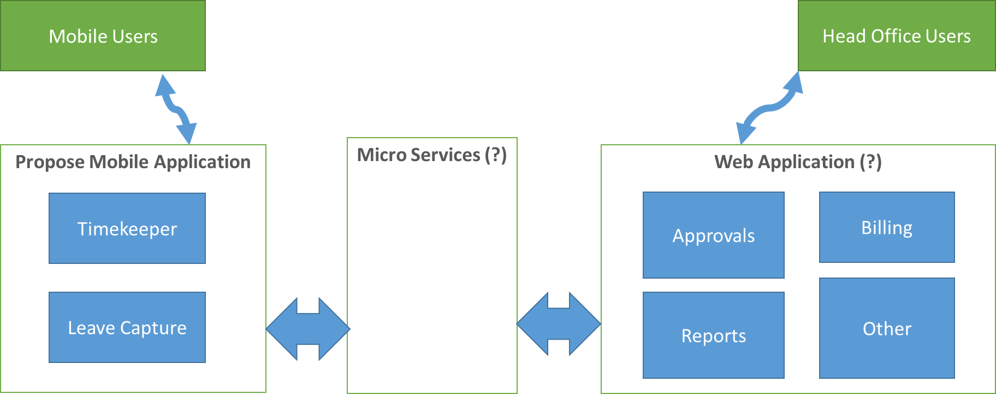

# Areas of Interest

1. Cloud Computing
2. Geo Location
3. Calendar Integration
4. Micro Services
5. Chatbots
6. Social
7. Sharing / Collaboration
8. Artificial Intelligence
9. Google Two-Step Authentication

# Areas of Concern

1. No mobile knowledge in-house

# Proposed Questions

1. Market research to be performed on what is trending in the mobile space
2. How can we move the timekeeper into a mobile application
3. How can real-time analytics be implemented?
4. How can two-way communication be implemented?
5. How can a timekeeper entry be completed based on your current location and calendar?
6. How can real-time reporting be available to view billable vs non-billable?
7. Can an Excel import be done for timekeeper?
8. How can this platform be incorporated into “InSite”
9. How do we extend beyond Enabill?
10. How do we create an “Alacrity” mobile-app shell, which can host a varity of “applications”?

# The Platform

In order to do this we have identified three phases through which any project would potentially go:

1. Play
2. Collaborate
3. Commercialize

Each Phase will identify the following characteristics:

1. Purpose
2. Registration of interest
3. Rules of engagement
4. Maturity level

## Play

### Purpose

1. Only requirement is that you register your interest

### Registration of Interest

1. Define the project
2. Register project on the platform
3. Gather specific questions to be addressed by this project

### Rules of Engagement

1. During this phase there is no rules.
2. You do what you want to do the way you want to do it.

### Maturity Level

Need to establish if this is ready for people to start collaborating on this.

1. Show and tell what has been done
2. Code Reviews
3. Architecture Review
4. Testability

## Collaborate

### Purpose

Allow multiple people to work on the same project towards a common goal.

### Registration of Interest

1. Define the project
2. Identify the technologies currently used
3. Identify the desired type of skills required

### Rules of Engagement

1. Resources should be accessible
2. Project structure should be established
3. Features are agreed upon
4. Development process should be agreed upon.

### Maturity Level

1. It should use a single framework (where possible)
2. Code reviews
3. Architecture well understood

## Commercialize

### Purpose

Sell the product

### Registration of Interest

1. Define the project
2. Define the target sales
3. Define marketing plan

### Rules of Engagement

1. Target market has been identified
2. Distribution channels has been identified

### Maturity Level

1. Product feature are fully tested
2. Product has been packaged in a production-ready form
3. Support structure has been established

# Next Steps

1. Do a marketing drive (internally) to build excitement around this platform
   1. This would mainly be driven by Robyn & CoP’s (key individuals)
2. Define a “simplified” timekeeper.
3. Research existing ideas around mobile applications.
4. Break-down the timekeeper feature into smaller modules.
5. Look at HoneyBee to see ideas of how things are being done
   1. <http://www.honeybeeapp.com/#features>

# Whiteboard from Session

