THE CLAUDE
BEGINNER MANUAL
Level Zero
Everything worth knowing before you start using Claude.
Now with diagrams, worked examples and step-by-step procedures.
OneDrive · Cowork · Code · the Sandbox · Truncation · Limits
A starter's guide — from zero to your first real task.
By Hans Tandt
Ardennes, Wallonia, Belgium
Version 3.4 — September 2026


How to use this manual
This is the beginner book. It assumes you have never used Claude for real work and starts from absolute zero. Read it in order the first time, then keep it open as a reference.
Never used an AI at all? Read the two-page Start here guide first. It gets you a first result on the free plan in ten minutes.
When this book feels easy, its sequel — Level One, also in this collection — takes you further: real prompting, Projects, connectors, a gentle step into Code and Git, and your first agent.
In a hurry? Chapter 1 gets you a real result in ten minutes. The chapters after it explain what just happened and how to go further. Diagrams and worked examples are here to make each idea concrete.
The three boxes you will see
GREEN = a tip that saves you time.
YELLOW = a note worth remembering.
RED = a trap. Read these carefully — they are the mistakes that cost the most time.
This book is a snapshot — Claude changes fast
Everything here reflects the Claude app as checked on 29 September 2026: the models Opus 5.5, Sonnet 5.5, Haiku 4.5 and Fable 5.1, and the new single app where Chat and Cowork share one message box. Anthropic ships updates extremely fast — often in days, not months — so a screen, a menu name, or a model number may already have moved. When what you see does not match this page, trust the app and claude.com over the book. The ideas and habits here stay true even when the buttons move.
Chat and Cowork are now one app
Since late September 2026, Chat and Cowork share one message box, with a Chat | Cowork switch under it (first on Pro and Max, other plans follow). This edition is written for that new app.

 | What is new in version 3.4  Rewritten for the new Claude app, checked on 29 September 2026: Chat and Cowork in one message box, Effort instead of Extended Thinking, Web search in the + menu, Scheduled and Devices. Current models: Opus 5.5, Sonnet 5.5, Haiku 4.5, Fable 5.1.

Table of Contents

1. Quick start in 10 minutes
You will understand Claude far faster after you have made it do one real thing. So before any theory, do this. It takes about ten minutes and produces a finished document you can keep.
On the free plan? Do this instead
Cowork needs a paid plan. On the free plan, open claude.ai and start a chat (the switch under the message box stays on Chat).
Paste the text of a short document and type: "Summarise this in one page, then give me three key takeaways."
Then refine it, exactly as in step 6. Come back to Cowork when you upgrade.

- Install and sign in. Get the desktop app from claude.com/download (Windows or macOS) and sign in with a paid plan. Work on your files always runs on your PC through this app.
- Set the engine. Click the model name next to the message box, choose Opus (the everyday model for serious work), and leave Effort on Medium (how hard Claude thinks before it answers). In the + menu, make sure Web search (it checks facts online) has a tick.
- Switch to Cowork under the message box (Claude working on the files in one folder) and choose a folder that contains one document you know — a PDF or a Word file.
- Paste this, with your file's name: "Read FILENAME. Before you start, ask me any questions you need. Then write a clear one-page summary, save it as a Word file in this folder, and show me the link."
- Answer its question, then open the result from the file card it shows you.
- Refine it: "Make it half the length and add three key takeaways at the top."
That's the whole loop
Read → produce → save → refine. That single loop is about 90% of everyday Cowork. The rest of this book explains what just happened, how to avoid the traps, and how to go further.

2. What Claude actually is
Most people meet Claude as a chat box on a website: type a question, get an answer, move on. That is like buying a smartphone and only ever using it to make calls. Claude is one app with one brain, but it can do very different jobs. The switch under the message box (Chat | Cowork) and a few menus decide which job it does.

2.1 The five faces of Claude
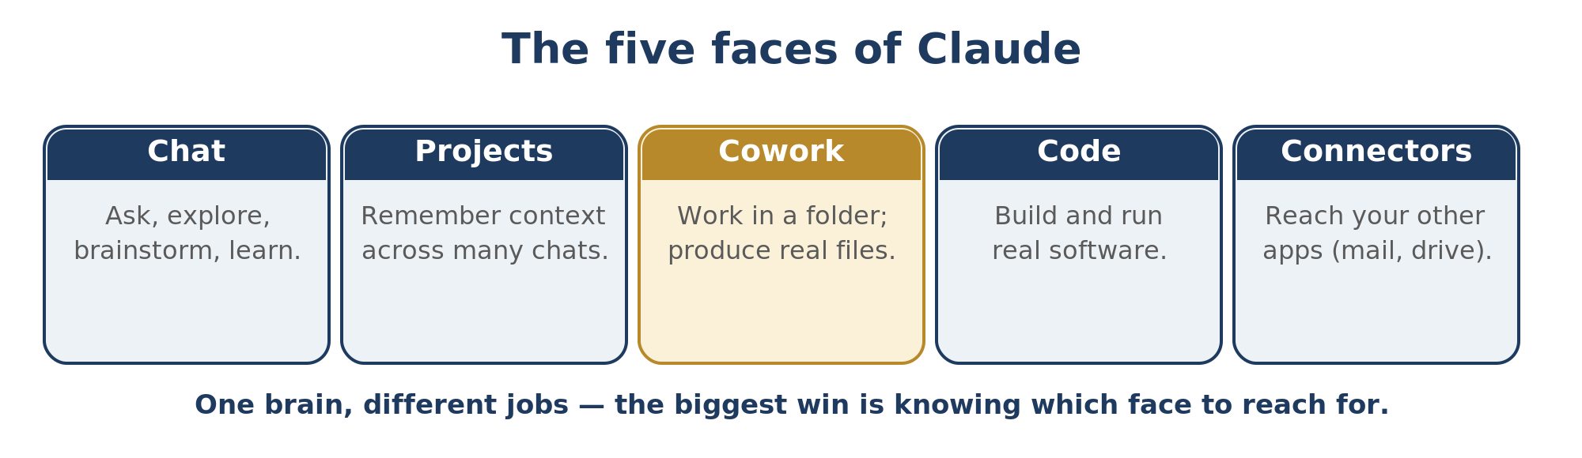
Face | What it is | Use it when…
Chat | The Chat side of the message box, on the website, desktop or phone. | You want to ask, explore, brainstorm, or learn.
Projects | A folder of chats that share instructions and files. | You repeat the same kind of task and want Claude to remember the context.
Cowork | The Cowork side of the same box: Claude works on the files in a folder on your PC. | You want a finished file: a report, spreadsheet, slide deck.
Code | Claude that writes and runs real software. | The thing you want IS a program (a script, an app, an agent).
Connectors | Links to your other tools (Gmail, Outlook, Drive…). | You want Claude to act on data living in another app.

The single biggest jump in usefulness comes from learning which face to reach for. A report belongs in Cowork. A script belongs in Code. A repeated weekly task belongs in a Project or under Scheduled.

2.2 The five levels — a map of where you are going
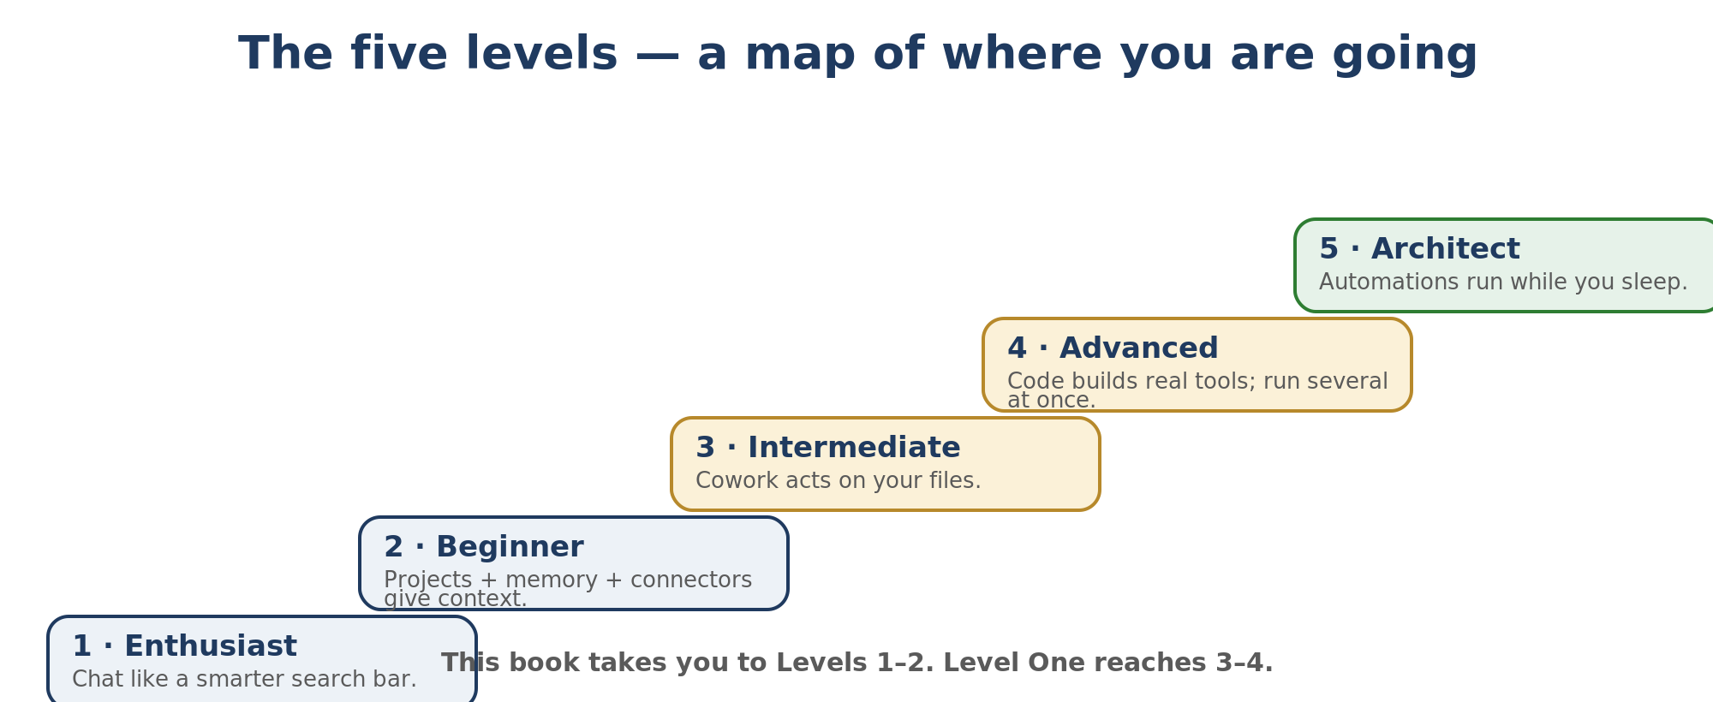
A useful way to picture your progress. This book takes you comfortably to Levels 1–2; Level One reaches 3–4.

2.3 The one idea to take away
Old habit: the cleverness is in the question. New reality: the cleverness is in the context — how much of your work, your standards, and your files Claude can see before it answers. A good context with a plain prompt beats a brilliant prompt with no context. Almost everything in this manual is really about giving Claude better context.

3. Getting set up from zero
Chapter 1 rushed you through setup to get a quick win. Here it is properly, once.
- Get an account and a paid plan. Cowork and Code need a paid plan. Prices below are current as of August 2026 — they change, so check claude.com.
Plan | Rough price | Good for
Free | €0 | Trying Chat only. No Cowork.
Pro | ~$20 / month | One person, normal daily use. Enough for Cowork.
Max | ~$100–200 / month | Heavy daily use, long sessions, fewer limits.
Team / Enterprise | Per seat | A company with shared admin controls.

- Download the desktop app from claude.com/download (Windows or macOS). You can start Cowork on the website or your phone too, but the work on your files runs on your PC through the desktop app (+ menu → Devices shows which computer).
- Sign in with the same account everywhere so your projects and history follow you.
Use an email you will keep — you cannot change it later
Sign up with a personal email you will always control, not a work or school address you could lose. Claude ties your account, memory and history to that email and does not let you change it afterwards. People who used a company address lose everything the day they leave. (Switching from another AI? Chapter 13 shows how to bring your memory across.)
- Pick a model and its effort. Click the model name next to the message box. The model is the engine; Effort is how hard it thinks. In a normal chat you can switch model per message — but in a Cowork task the model locks once you send the first message, so choose it before you start.
Model | Personality | When
Opus (5.5) | The smartest, most careful. | Anything that matters or needs reasoning. Default for real work.
Sonnet (5.5) | Fast and capable. | Quick drafts, simpler tasks, when you want speed.
Haiku (4.5) | Cheapest and quickest. | Trivial, high-volume jobs.

The model locks when a Cowork task starts
In Chat you can switch model between messages. In a Cowork task the model is fixed the moment you send the first message — to use a different one you start a new task (and lose its built-up context). So choose deliberately up front. And mind the trade-off: a more capable model or a higher Effort gives better answers but uses more of your allowance.
How much can it read at once?
The most capable models (Opus and Sonnet) can hold about 1,000,000 tokens at once (this is called the context window) — very roughly 555,000 words on the newest models (about 750,000 on older ones), since a token is a little more than half a word; the small fast one (Haiku) holds about 200,000. That is huge — but, as Chapter 12 explains, fuller is not always better.
Model names and numbers keep moving — trust the picker
Think in tiers, not version numbers: a small fast one (Haiku), an efficient one for simpler tasks (Sonnet), the everyday model for complex work (Opus), and a flagship for the toughest challenges (Fable). Anthropic releases new versions constantly — Fable 5.1, Opus 5.5 and Sonnet 5.5 all arrived in 2026 — so the exact numbers on this page will drift. Whatever the model picker shows you today is the truth.
- Set Effort and keep Web search on. Effort (Low, Medium, High, Extra, Max) is how much Claude reasons before answering; Medium is recommended, and higher levels are slower and use your limits faster. Web search, a tick in the + menu, lets it check facts instead of guessing — the best cure for making things up.
The 60-second rule
In my experience, Opus with Effort on Medium (High for the hard jobs) and Web search on makes the biggest difference to your results. It takes one minute to set up.

4. Your first session, in detail
Chapter 1 was the sprint; this is the slow walk, so you understand each move.

4.1 Exercise A — summarize a document and save it
Copy-paste prompt
Read FILENAME in this folder. Before you start, ask me any questions you need. Then write a clear one-page summary in plain language, save it as a Word file in this same folder, and show me the link.
- Claude may ask a short question first — answer it. (That habit is Chapter 5, and it is the most useful one in the book.)
- It reads the file, writes the summary, and saves it as a new Word file in your folder.
- It shows a clickable file card. Open it — that is your finished deliverable.
- Refine: "Make it half the length and add three key takeaways at the top." You did not start over — you steered.

4.2 A complete example, end to end
Real work is usually more than one step. Here is a small business example that strings several together — a supplier's price offer arrives as a PDF and you need to act on it.
- Summarise. "Read the offer PDF in this folder and give me a half-page plain-language summary: what is offered, the price, the deadline, and anything unusual."
- Pull the numbers out. "Now extract the line items into an Excel file in this folder — description, quantity, unit price, total — and add a total row."
- Draft the reply. "Draft a short, polite reply asking for a 5% discount and a firm delivery date. Keep it under 120 words."
- Check before you send. "Re-read the offer and confirm the numbers in the Excel match it. Tell me anything you are unsure about."
What this shows
One folder, one conversation, three real deliverables (a summary, a spreadsheet, a draft email) — and a verification step at the end. This is the shape of most useful work in Cowork.

4.3 Exercise B — let Claude tidy up (optional)
Feel the "agent" side (Claude acting on its own, step by step): "Look at the loose files in this folder. Propose a tidy subfolder structure and show me the plan before moving anything." Claude explains its plan first and waits for your yes.
 | If you can't find the file it made  It is almost certainly still in Claude's temporary workspace and was never saved into your folder. Say "save the final file into my folder and show me the link." More in Chapters 10 and 11.

5. Two habits that beat any prompt
People spend hours hunting for the perfect "magic prompt." It is wasted effort. Two simple habits do more for your results than any template. Build these two and everything else gets easier.

5.1 Let Claude ask YOU the questions first
The instinct of every beginner is to write the perfect instruction. The faster path is the opposite: let Claude interview you. It knows what it is missing; you usually do not.
End your request with four words: "Ask me questions first." Claude asks a few short questions — often as clickable choices — then does the work. Better result, far less typing.
Copy-paste this
Before you start, ask me any questions you need to do this well — one at a time — and wait for my answers before doing the work.
Second half: for anything big, make Claude show its plan before it acts. "Show me your plan first and wait for my go-ahead" turns a risky one-shot into something you can steer.

5.2 Never trust a confident answer — make Claude check
Claude sounds exactly as sure when it is wrong as when it is right. Confidence is a setting, not a fact-check. Treat a smooth, certain-sounding answer as a draft, not a verdict.
- Keep Web search on (a tick in the + menu) so Claude verifies facts against live sources instead of guessing from memory.
- Ask it to audit itself: "Check your own answer before I trust it. Verify the facts and tell me what you are unsure about."
One more trap: Claude is agreeable — if you push back it may fold even when it was right. Don't take agreement as proof; ask it to argue the other side.
The lesson behind this chapter
It is not because something is written down that it is correct — that applies to notes, web pages, and anything Claude itself produces. Always check important claims against a reliable source, such as Anthropic's official help pages. This manual was fact-checked that way.

6. Common myths about Claude
Beginners lose the most time to a handful of wrong beliefs. Here they are, with the reality.
The myth | The reality
A longer chat remembers more. | It gets worse as it fills up. Start a fresh chat for a new topic (Chapter 12).
If Claude agrees, you must be right. | Claude is agreeable. Make it argue against you before you believe it.
Confident means correct. | It sounds just as sure when it is wrong. Confidence is a setting, not a fact-check.
You need to master prompting. | You need four words: "ask me questions first." Claude interviews you.
A longer prompt is a better prompt. | A clear goal beats a 200-word masterpiece. Say the destination, not every step.
Cowork is only for the desktop app. | You can start Cowork on the website or your phone, but the work on your files runs on your PC through the desktop app. Install it.
Claude is just a chatbot. | Chat is one face of several (Chapter 2). Most people never leave the lobby.
Skills are only for developers. | A skill is just a playbook Claude runs for itself. No code required.
Pasting your logins helps Claude help you. | Never paste a password. Connect apps through connectors instead (Chapter 13).
The first draft is the deliverable. | The first draft is yours to fix, not to ship.
You are too far behind to start. | Open Claude tonight and do the Chapter 1 exercise. That is how everyone starts.

7. Where your files live — OneDrive and the big beginner trap
This is the chapter that trips up almost everyone. Understand it and half of the mysterious problems disappear.

7.1 Three different places
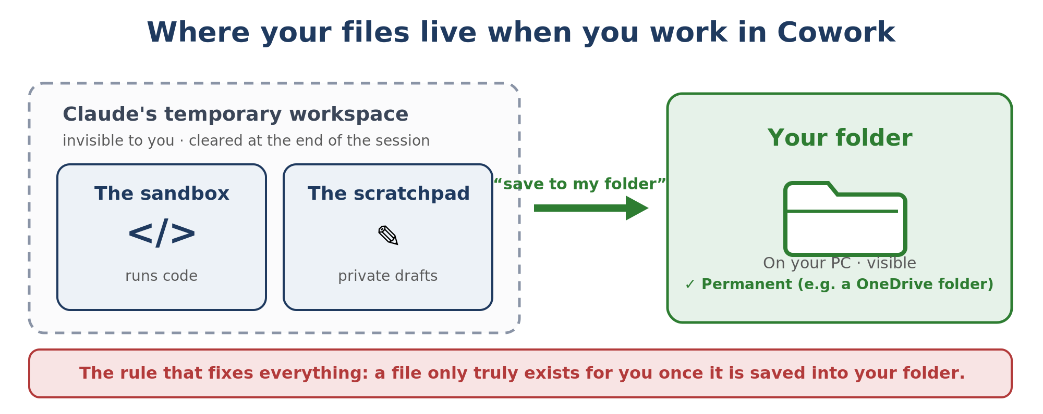
The rule that fixes everything: a file only really exists for you once it is saved into the folder you selected. If Claude says it made something but you cannot find it, it is almost always still in the scratchpad (Claude's private draft area) or the sandbox (a temporary, closed-off computer Claude works in) and needs saving to your folder.

7.2 OneDrive — friend and trap
If you keep your work in OneDrive (for example C:\Users\you\OneDrive\Documents\…), it backs everything up and syncs across devices — but it has two behaviours every beginner must know.
- "Files On-Demand." OneDrive can show a file while the real content lives only in the cloud (a cloud icon, not a green check). A tool may then read an empty placeholder. Fix: right-click the folder, choose "Always keep on this device."
- Sync while writing. If OneDrive syncs a file at the exact moment Claude is writing it, you can end up with a half-written file — one cause of the truncation problem in Chapter 11.
The OneDrive trap
Two machines editing the same OneDrive file, or OneDrive syncing mid-write, can create "conflict copies" or a file cut off halfway.
Habits that avoid it: keep the folder set to "Always keep on this device"; let a write finish before opening the file; and after a long file is created, open it once to confirm the end is really there.

7.3 Keep the folder simple
A messy folder makes Claude slower and more likely to read the wrong thing. The recommended shape for any general workspace is just three subfolders, explained in Chapter 8.

8. Cowork, explained simply
Cowork is the most important shift in how Claude is used. Switch the message box to Cowork and Claude works in a folder on your computer as its workspace. It reads your files, writes new ones, runs code in the background, and asks you questions before doing anything important.
If Chat is a conversation, Cowork is more like an employee. You describe the outcome, it reads the relevant files, asks for clarifications through a clickable form, and comes back with a finished deliverable. It is available on the paid plans (Pro, Max, Team and Enterprise). You can start a task on the website, your phone or the desktop app; the work on your files runs on your PC through the desktop app. The + menu → Devices shows which computer.
Scope its access — it can delete files
Cowork can read, edit, and permanently delete files in the folder you give it. Always point it at a specific project folder, never at your whole Documents or your entire drive.

8.1 The folder structure that saves hours
Claude Cowork/
ABOUT ME/ -> who you are, how you work, what to avoid
OUTPUTS/ -> finished deliverables (Claude organises by project)
TEMPLATES/ -> reusable structures Claude saves on request
- ABOUT ME is read at the start of every session. Keep these files short.
- OUTPUTS is where finished work lands. Cowork does not read it unless you point at a file — which keeps things fast.
- TEMPLATES fills itself: say "save this as a template" and it keeps the structure, not the content.

8.2 The first thing to type in a new project
Copy-paste this into any new Cowork project
I just created this project. Read every file in the folder. Then tell me, in plain language, what is here, what you think I use it for, and what instructions you will follow. If anything is unclear, ask me with a multiple-choice question before doing real work.

8.3 Connectors, scheduling, and working from your phone
- Connectors link Cowork to your live tools (Gmail, Outlook, Calendar, Drive, Notion, Slack). Connect only what a task needs.
- Scheduled (in the left sidebar) lets a saved routine run on its own — a digest every weekday at 7am (your computer has to be awake).
- Devices (+ menu in Cowork) lets you start a task from your phone or the website and choose which of your computers runs it; the desktop app does the work and you open the result later.

8.4 Cowork vs Code — which one?
Short answer: if the thing you want is a document, stay in Cowork. If the thing you want is software, use Code. Cowork can still run code in its sandbox when a task needs it. Truncation is handled by good saving habits (Chapter 11), not by switching products.

9. Mistakes to avoid in Cowork
Seven habits that separate a smooth setup from a frustrating one, with the fix for each.
The mistake | Do this instead
Using Chat for real file work. | Point Cowork at the folder and let it produce the file. Chat is for thinking, Cowork for doing.
No "about me" file, so output sounds generic. | Put a short about-me and a list of words/phrases you never use in ABOUT ME.
Vague global instructions ("be helpful"). | Be specific: where to save, what tone, when to ask, what never to do.
Opus for absolutely everything. | Use Opus where it matters; switch to Sonnet for short, simple tasks to save your allowance.
No skills installed. | Turn a task you do often into a reusable skill — one skill can replace twenty prompts.
Giving access to too much of your computer. | Scope Cowork to one project folder. It can delete files; keep the blast radius small.
Nothing under Scheduled. | Let recurring work (briefings, digests) run automatically while you sleep.

10. The sandbox and your security perimeter
When Claude needs to run something — convert a file, crunch numbers, build a spreadsheet — it does it inside a sandbox: a small, isolated Linux computer (Linux is an operating system, like Windows) that spins up just for your session.

10.1 What the sandbox is, and how much access you give
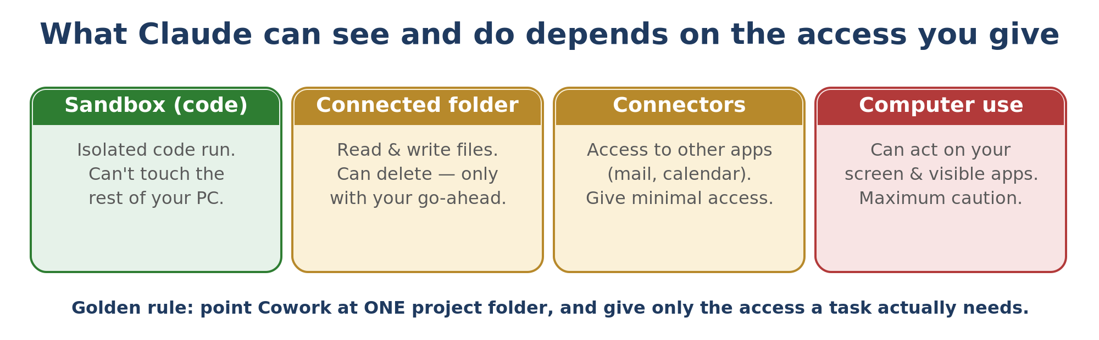
- Isolated. The sandbox cannot touch the rest of your PC — only the folder you connected and its own temporary space. That is what makes running code safe.
- Temporary. At the end of the session it is wiped, so files must be saved to your folder to survive.
- A real computer. It has Python and Node (programming languages) and common tools, so Claude can genuinely build and test, not just describe.
Your "security perimeter" is simply the sum of the access you grant — the folder you connect, the connectors you switch on, and whether you allow computer use (Claude moving your mouse and typing on your screen). Keep each as small as the task needs.
The disappearing-file trap
If Claude builds something and you cannot find it, it was probably created only in the sandbox or scratchpad and never copied to your folder. Say "save the final file into my folder and show me the link."

11. Truncation — the "trunking" problem, solved
Truncation is when a long file gets silently cut off — usually the end is missing — while Claude reports that it saved successfully. You only find out when you open the file and the last pages are gone. It is avoidable.
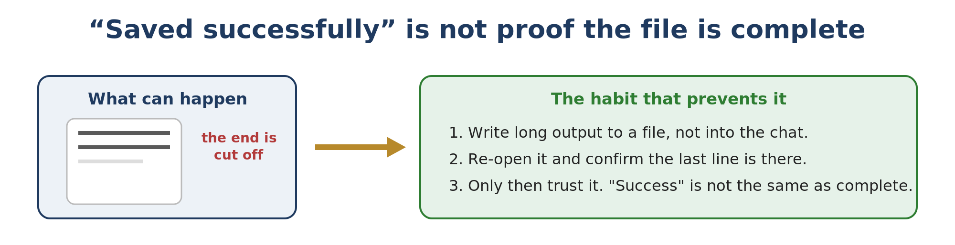

11.1 Why it happens (possible causes)
- A synced folder (like OneDrive) saves a half-written copy while the real content is still being written.
- A format converter (for example Markdown, a plain-text format with simple formatting, to Word) occasionally drops the tail of the document.
- A tool says "success" before the whole file has actually landed on disk.

11.2 How to prevent it
- Ask for files, not walls of text. For anything long, have Claude write to a file rather than printing it all in the chat.
- Make Claude verify the end. "Re-open the file and confirm the last section is really there."
- Convert long PDFs to Markdown before uploading. Cleaner input, less truncated output.
- Keep OneDrive calm. "Always keep on this device" and let writes finish (Chapter 7).
A reliable backup if a download button fails
Open the file in the Claude interface, select all, copy the raw text into a plain editor (e.g. Notepad++), and save it with the right filename.

12. Sessions, limits, and good habits
Claude is powerful but not unlimited. Knowing how sessions and limits work keeps you from hitting a wall mid-task.

12.1 The two limits
Limit | What it means
5-hour rolling limit | A cap on how much you can do within any 5-hour window. It refills as time passes.
7-day weekly limit | A larger cap across the week. Heavier plans (Max) have more headroom.

Timing
In my experience, the busy window in Europe is roughly 14:00–20:00. When you can, do heavy sessions in the morning — it is faster and you waste less of your allowance waiting.

12.2 The "smart zone" — why fuller is not better
Even though the context window is huge, Claude is sharpest when it is not crammed full. As a conversation fills with files and back-and-forth, answers slowly get duller. Keep each task small and start clean often rather than letting one chat swell to the brim.

12.3 How long to stay in one session
My rule of thumb: start a fresh chat when the conversation passes roughly 50 messages or you have uploaded several big files; when you change topic; or when Claude starts repeating itself. A good rhythm: one topic per session, an hour or two at most.

12.4 Session notes — never explain yourself twice
Because each new chat starts blank, keep a short session-notes file per project (for example project_session_notes.md). Start a new chat by uploading it and saying "Continue this project — read the notes above," and ask Claude to update it at the end. Chapter 13 explains how memory does the same thing automatically.

12.5 Habits that stretch your allowance
- Keep instruction files short (in my experience, under 500 words works best).
- Batch your asks — several related requests in one message.
- Convert PDFs to Markdown before uploading; they cost far fewer tokens.
- Turn off connectors you are not using so they don't quietly eat context.

13. Projects, Skills, and Memory
Three features that turn Claude from a clever stranger into a colleague who remembers.

13.1 Projects
A Project is a folder of chats that share instructions and files. Make one per recurring deliverable — not one giant project for everything. Upload only what that deliverable needs, and write five to eight lines of instructions describing what it is, who it is for, and the quality bar. Since mid-2026 your projects live in the left sidebar, shared between Chat and Cowork — pin the ones you use so they are easy to find.

13.2 Skills
A Skill is your standard way of doing one job, written so Claude runs it the same way every time. If you already have a checklist, you basically have a skill.
- It is just a file. A skill lives in a small text file (SKILL.md). Only a one-line description sits in Claude's memory until a task matches it — then the full instructions load.
- Build it from real work. "Turn what we just did into a reusable skill, and add a section of gotchas." Claude writes the file, not you.
- You manage them in the app, under Customize, then Skills. A skill only improves when its file is edited.
The easiest way to make a skill: record yourself doing it
New in Cowork (mid-2026): in the desktop app, open the + menu and choose "Record a skill" (if you see it). Claude records your screen and your voice while you do the task once — you talk through your choices as you go — and turns it into a reusable skill. No writing required, which makes it the easiest on-ramp for a job that is simpler to show than to describe. Do not record passwords, secrets, or private information.

13.3 Memory and session notes
Memory lets Claude carry facts between sessions. A MEMORY.md file plus small notes capture your setup and preferences, so a brand-new session already knows who you are — the automatic version of the session-notes habit.
Coming from ChatGPT? Import your memory in one minute
If you are switching from ChatGPT, Gemini or Grok, you do not have to start from zero. Go to claude.com/import-memory, copy the short prompt it gives you, paste that into your old assistant, then copy its answer back into Claude under Settings, Capabilities, Memory. Claude folds in what it learns (it can take a few hours to settle). Do this once when you switch, then keep using the session-notes habit above. On Pro and Max.

14. Safety and good practice

14.1 Classify your data before you paste
Sensitive data — classify before you paste
Chat, Cowork, and Code are about workflow, not confidentiality: all three send your content to Anthropic's servers, so "it runs on my computer" does NOT make sensitive data safe. Before pasting, classify it — green (public/harmless), orange (internal/operational), red (personal data, legal or warranty disputes, contracts, accident files). Keep red out, anonymise it, or get approval first. The one-page rule is reproduced in the Annex.

14.2 The rest of the checklist
- Work in a dedicated folder. Point Cowork or Code at a project folder, never your whole Documents.
- Be careful with "skip permissions" (letting Claude act without asking you first). Only turn it off where the files could be replaced.
- Never paste secrets. API keys (secret codes that let a program use a service) and passwords belong in a local settings file, not a chat.
- Keep a backup. OneDrive version history and timestamped ZIP backups mean a bad edit is never fatal.
- Verify anything that matters. For numbers, legal or money decisions, check the source — and use Web search so Claude checks too.
Work you build on the job
Anything built on company time or equipment can raise ownership questions. Agree up front who owns it — and if it is meant to be personal, keep it on personal equipment and time.

14.3 Can I keep my data local?
Short answer: no — but you can limit its use
Chat, Cowork and Code all send your content to Anthropic's servers to be processed. Claude does not run on your computer, and no setting makes your data stay local. What you CAN do: stop your conversations being used to train the models, which also shortens how long they are kept. For truly local, offline AI you would need a different, self-hosted model — which is not Claude.
How to opt out of training
1. Open Settings, then Privacy. 2. Turn off the model-training toggle (often labelled 'help improve Claude' or 'use my data to improve Claude'). 3. It applies to new and resumed conversations going forward. Team, Enterprise and API accounts do not train on your data by default. Note: content flagged for safety review may still be used, regardless of this setting.

Annex — AI Data Rules (one page)
Keep this rule in front of anyone using Claude for work. The key idea: Chat, Cowork and Code are about workflow, not confidentiality — all three send your content to Anthropic's servers, so classify the data first.
Light | Means | Examples | What to do
GREEN | Public / harmless | Public info, marketing text, general questions. | Use freely.
ORANGE | Internal / operational | Internal procedures, non-personal company data. | Approved tools; avoid detail.
RED | Sensitive | Personal data, legal/warranty disputes, contracts. | Anonymise, get approval, or keep out.

- Confidential material only in approved tools and accounts.
- A human always reviews before anything is used or sent.

15. Quick-start cheat sheet

Your first 30 minutes
- Install the desktop app from claude.com/download and sign in.
- Set the model to Opus, Effort on Medium; check that Web search is ticked in the + menu.
- Create a working folder with ABOUT ME / OUTPUTS / TEMPLATES inside it.
- Switch the message box to Cowork and choose that folder.
- Do the Chapter 1 exercise: summarize a document and save it.
- Paste the "read every file" prompt from Chapter 8.2 to brief Claude on the folder.

Prompts worth keeping
Let Claude ask first
Before you start, ask me any questions you need — one at a time — and wait for my answers before doing the work.
Make it check itself
Audit your own answer before I trust it. Verify the facts with web search and tell me what you are unsure about.
Safe long file
Write this to a file in my folder, then re-open it and confirm the last section is complete before you tell me it's done.

16. Plain-language glossary
AI words
Term | In plain words
Model | The engine doing the thinking (Opus, Sonnet, Haiku). Smarter engines use more of your allowance.
Prompt | What you type. The kick-off, not the whole job.
Context | Everything Claude can see while answering. The real source of quality.
Token | A chunk of text, roughly half to three-quarters of a word, depending on the model. Limits and costs are counted in tokens.
Context window | How much text Claude can hold at once (about 1M tokens on Opus/Sonnet, 200K on Haiku).
Effort | How hard Claude thinks before answering: Low, Medium (recommended), High, Extra, Max.
Web search | Lets Claude check facts online instead of guessing. A tick in the + menu.
Agent | Claude working toward a goal on its own, step by step.

Where your files live
Term | In plain words
Cowork | The mode of the message box where Claude works inside a folder and produces finished files.
Sandbox | A temporary, isolated Linux computer Claude uses to run code safely.
Scratchpad | Claude's private draft area, before a file is saved into your folder.
Truncation | A file getting silently cut off, usually at the end. See Chapter 11.
Files On-Demand | A OneDrive setting where the real file stays in the cloud until you open it.
Markdown | A plain-text format with simple formatting. Cheap in tokens, easy for Claude to read.

Connecting, remembering and staying safe
Term | In plain words
Project | A folder of chats sharing instructions and files.
Skill | A reusable instruction file (SKILL.md) that teaches Claude one job.
Memory / MEMORY.md | Facts Claude keeps between sessions so it remembers your setup.
Connector | A bridge that lets Claude reach another app, like Gmail or Outlook.
MCP | The shared standard that connectors use to talk to Claude.
Devices | Choosing which of your computers runs a Cowork task (+ menu → Devices).
Code | Claude that writes and runs real software.
API key | A secret code that lets a program use a service. Never paste it in a chat.
Skip permissions | A mode where Claude acts without asking first. Use it only on files you can replace.
Computer use | Claude moving your mouse and typing on your screen. Give it the least access you can.

Where to learn more — video tutorials
If you prefer watching, these beginner-friendly videos (search for the titles on YouTube) are a good next step. They are in English, where the most information is.
- FULL Claude Cowork Tutorial for Beginners — set up a folder first, and watch Cowork ask questions before it acts.
- Learn 97% of Claude in 16 Minutes — a fast tour of the whole product.
- Every Level of Claude Explained — the five-level map from Chapter 2.
A note on these videos
Several name older models and quote out-of-date numbers. For model names, trust the model picker in the app over any video or book.

What's next — Level One
This book gets you comfortable at Levels 1–2 of the map in Chapter 2: set up Claude, run a task in Cowork, find your files, avoid truncation, manage sessions. Level One moves you to Levels 3–4 — real prompting, Projects in depth, your first Skill, connectors, a gentle step into Code and Git, and your first small agent.
In one line: Level Zero is learning to drive; Level One is planning routes and building the car. Finish the Chapter 1 exercise, use Claude for a week, then move up.
By Hans Tandt

