TA-Installation-Manager V0.01.03

Test on W10
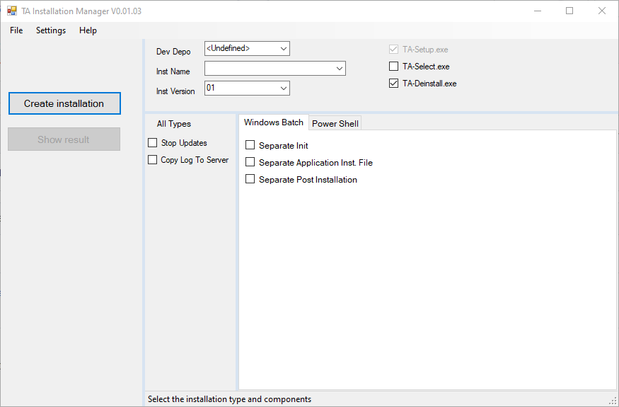

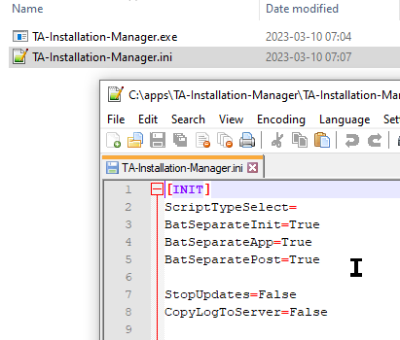

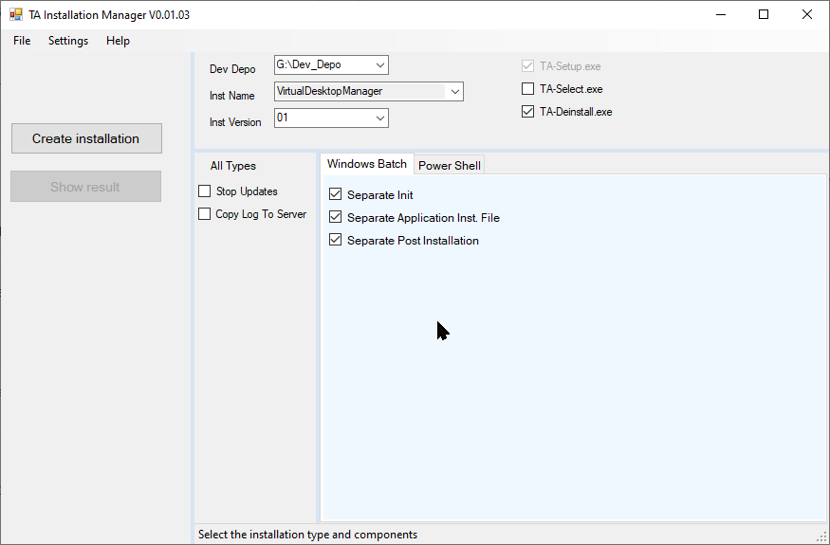

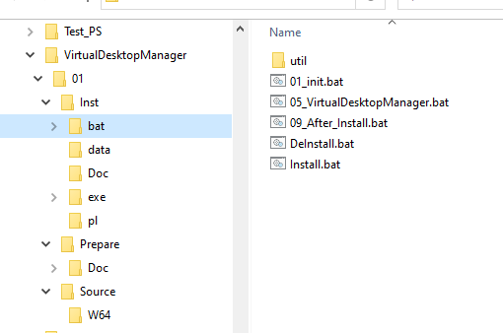 (Show result)
Works in every aspect!

Log
"C:\apps\TA-Installation-Manager\TA-Installation-Manager.exe"
TA-Installation-Manager V0.01.03
Timestamp = 2023-03-10 07:05:06
AppRoot = C:\apps\TA-Installation-Manager
Temp = C:\Users\nly10677\AppData\Local\Temp\TAIS
Log level to con = 1
Log level to logfile = 2
=== Log Cache ===
|->xtrace_init (1)
| | * Standard Log Module / V-0.03 / 2023-03-03
| | * TimeStamp = 2023-03-10 07:05:06
| |->InitTemp (2)
| | | * Temp = C:\Users\nly10677\AppData\Local\Temp\TAIS
| |<-InitTemp (2)
| |->SetLogFileName (2)
| | |->Read_Trace_Command_Line_Arg (3)
| | |<-Read_Trace_Command_Line_Arg End (3)
| | | * LogFileAppendix =
| | | * LogFileName = TA-Installation-Manager
| |<-SetLogFileName (2)
| | * LogFile = C:\Users\nly10677\AppData\Local\Temp\TAIS\TA-Installation-Manager.log
| | * LogFile Ready
=== End Cache ===
|<-xtrace_init (1)
|->Form1_Load (1)
TA-Installation-Manager V0.01.03
Timestamp = 2023-03-10 07:05:06
AppRoot = C:\apps\TA-Installation-Manager
Temp = C:\Users\nly10677\AppData\Local\Temp\TAIS
Log level to con = 1
Log level to logfile = 2
| | Log file = C:\Users\nly10677\AppData\Local\Temp\TAIS\TA-Installation-Manager.log
| | Initializing
| |->ReadDefaults (2)
| | | Failed to read:
| | | C:\apps\TA-Installation-Manager\TA-Installation-Manager.ini
| | | Or C:\apps\TA-Installation-Manager\Data\TA-Installation-Manager.ini
| | |->Read_Command_Line_Arg (3)
| | |<-Read_Command_Line_Arg (3)
| |<-Form1_Load (2)
| |->Form1_Load2 (TimerInit) (2)
| | |->Set_TAISDevDepo (3)
| | | | * TAISDevDepo = <Undefined>
| | |<-Set_TAISDevDepo (3)
| |<-Form1_Load2 (2)
| |->File, Save (2)
| | |->WriteIniFile (3)
| | |<-WriteIniFile (3)
| |<-File, Save (2)
| |->TabControl1_MouseClick (2)
| | |->SelectScriptType (3)
| | | |->SelectScriptTypeBat (4)
| | | |<-SelectScriptTypeBat (4)
| | |<-SelectScriptType (3)
| |<-TabControl1_MouseClick (2)
| |->ButtonStartCreate_Click (2)
| | |->Create_Depo (3)
| | | | * TAISDevDepo = G:\Dev_Depo
| | | | * TA_InstLib = G:\Dev_Depo\TA_InstLib
| | | | * TA_InstLibV = G:\Dev_Depo\TA_InstLib\04
| | | | * TA_InstLib_Inst = G:\Dev_Depo\TA_InstLib\04\Inst
| | | | * Check : G:\Dev_Depo\TA_InstLib\04\Inst\bat
| | | | * Check : G:\Dev_Depo\TA_InstLib\04\Inst\data
| | | | * Check : G:\Dev_Depo\TA_InstLib\04\Inst\exe
| | | | * Check : G:\Dev_Depo\TA_InstLib\04\Inst\exe\W64
| | | | * Check : G:\Dev_Depo\TA_InstLib\04\Inst\pl
| | | | * TA_Template = G:\Dev_Depo\TA_Template
| | | | * TA_TemplateV = G:\Dev_Depo\TA_Template\06
| | | | * TA_Template_Inst = G:\Dev_Depo\TA_Template\06\Inst
| | | | * Check : G:\Dev_Depo\TA_Template\06\Inst\bat
| | | | * Check : G:\Dev_Depo\TA_Template\06\Inst\data
| | | | * Check : G:\Dev_Depo\TA_Template\06\Inst\exe
| | | | * Check : G:\Dev_Depo\TA_Template\06\Inst\exe\W64
| | | | * Check : G:\Dev_Depo\TA_Template\06\Inst\pl
| | |<-Create_Depo (3)
| | |->Create_Installation_Base (3)
| | | | * DepoPath = G:\Dev_Depo\VirtualDesktopManager\01
| | | | * CreateDirectory
| | | | * InstRoot = G:\Dev_Depo\VirtualDesktopManager\01\Inst
| | | | * CreateDirectory
| | | | * Check : G:\Dev_Depo\VirtualDesktopManager\01\Inst\bat
| | | | * CreateDirectory
| | | | * Check : G:\Dev_Depo\VirtualDesktopManager\01\Inst\data
| | | | * CreateDirectory
| | | | * Check : G:\Dev_Depo\VirtualDesktopManager\01\Inst\exe
| | | | * CreateDirectory
| | | | * Check : G:\Dev_Depo\VirtualDesktopManager\01\Inst\exe\W64
| | | | * CreateDirectory
| | | | * Check : G:\Dev_Depo\VirtualDesktopManager\01\Inst\pl
| | | | * CreateDirectory
| | | | * Check : G:\Dev_Depo\VirtualDesktopManager\01\Inst\Doc
| | | | * CreateDirectory
| | | | * Check : G:\Dev_Depo\VirtualDesktopManager\01\Source
| | | | * CreateDirectory
| | | | * Check : G:\Dev_Depo\VirtualDesktopManager\01\Source\W64
| | | | * CreateDirectory
| | | | * Check : G:\Dev_Depo\VirtualDesktopManager\01\Prepare
| | | | * CreateDirectory
| | | | * Check : G:\Dev_Depo\VirtualDesktopManager\01\Prepare\Doc
| | | | * CreateDirectory
| | | | * Check : G:\Dev_Depo\VirtualDesktopManager\01\Prepare\Doc\Err
| | | | * CreateDirectory
| | | | * Check : G:\Dev_Depo\VirtualDesktopManager\01\Prepare\Doc\ChangeReq
| | | | * CreateDirectory
| | | | * Add: G:\Dev_Depo\VirtualDesktopManager\01\Inst\TA-Setup.exe
| | | | * CopyFile
| | | | * Add: G:\Dev_Depo\VirtualDesktopManager\01\Inst\TA-Deinstall.exe
| | | | * CopyFile
| | |<-Create_Installation_Base (3)
| | |->Add_Installation_Components_Bat (3)
| | | | * Check : G:\Dev_Depo\VirtualDesktopManager\01\Inst\bat\util
| | | | * CreateDirectory
| | | | * Create \bat\Install.bat
| | | |->Add_Installation_Init (4)
| | | | | * Create \bat\01_init.bat
| | | |<-Add_Installation_Init (4)
| | | |->Add_Installation_Application (4)
| | | | | * Create \bat\05_VirtualDesktopManager.bat
| | | |<-Add_Installation_Application (4)
| | | |->Add_Post_Installation (4)
| | | | | * Create \bat\09_After_Install.bat
| | | |<-Add_Post_Installation (4)
| | | |->Add_Util_Exit (4)
| | | | | * Create \bat\util\exit.bat
| | | |<-Add_Util_Exit (4)
| | | |->Add_DeinstallationBat (4)
| | | | | * Create \bat\DeInstall.bat
| | | |<-Add_DeinstallationBat (4)
| | | | * Add: G:\Dev_Depo\VirtualDesktopManager\01\Inst\Exe\wait.exe
| | | | * CopyFile
| | |<-Add_Installation_Components_Bat (3)
| | |->Finalize_Installation (3)
| | | | * Wait 1
| | |<-Finalize_Installation (3)
| |<-ButtonStartCreate_Click (2)
| |->Menu, Settings, Show log file (2)
| |<-Show log file (2)

