Hot Topic [Quarter 2, 2019]

**502.714 – Hot Topic in Software**

## ****563.783 – Hot Topic in Networking****

The Imperial Management

Hotel Application

Cara Hanson

11110448

Krishal Kishor

10925996

Sanjit Birla

120008396

1. Introduction

## 1.1 The Accommodation Industry

The accommodation industry is quite large on a global scale. People are forever coming and going, whether it is for vacation or for business, and there will always be a demand for accommodation for those who are temporarily visiting a location. This directly influences the demand for Housekeepers – staff who clean rooms after they have been used for the room to be fit for use by another customer. In small-to-medium accommodation businesses, communication can often be a bit of a struggle between Housekeeping and Front Desk staff, generally requiring in-person communication in order to assign a room that requires cleaning, and it can take a lot of time bringing two busy people together for information to be passed between the pair.

## 1.2 Our Scope, Aim and Objectives

Having identified that a lot of time can be lost between Front Desk and Housekeeping while relaying information, we saw an opportunity to create a subscription-based android application that will aid in the communication between Front Desk and Housekeeping staff members, removing the need for face-to-face relaying and will essentially save time – which is our aim; To save time between Housekeeping and Front Desk staff members.

As we have limited time to work on our application, we have been very selective as to what our objectives should be while keeping in mind as to what future features could be incorporated into our android application.

Our objectives for our application are:

1. For the application to have a UI which will be easy enough for staff - of all ages - to find easy enough to use while minimizing distractions as much as possible.

2. The application must have a clear display of all rooms and their status for Front Desk, which they can then assign a certain room to a Housekeeping staff member to clean.

3. The application must display all rooms assigned to a Housekeeping staff member, where they can then change the status of the room to ‘Currently Cleaning’ or ‘Cleaned’.

## 1.3 Measurable Organisational Value(s) (MOVs)

Operational Impact is one of our main areas of impact, as the application will allow accommodation staff to change how they communicate required tasks. We can safely say, through observation, that each staff member that manually reports a rooms status can roughly take 10 minutes a day in doing so. It might not look like much, but any smart businessman/businesswoman can easily identify how a few minutes each day can accumulate over the week, the month and year per staff member working for them - and a loss of time is a loss of money. This brings encouragement for those experiencing these issues in to finding a better solution, to which we offer via our android application.

This leads us into another area of impact that affects us directly – finance. As our application is subscription based, we’ll see an income head our way. We’ve set our monthly subscription price to $99NZD, including GST – and for one client, that’d total up to $1,188NZD for a year. We aim to have 150 clients by the end of the first year of our launch, though there is no real way to calculate how much that’d bring in as we won’t be able to effectively predict when throughout the year they’d join. However, with the 150 carried over into the second year of our launch, that’d pull in $178,200* – without calculating in any new clients we may have gained along the way. As you can see, we may start off slow in the beginning, but over time we will pick up and earn more revenue.

* This figure does not consider taxes and other costs we will have, such as maintenance.

# **2. Literature Review**

**Research Question**

Can we create an easy to use housekeeping reporting application which will assist small to medium size accommodation suppliers to reduce waste of time and hence reducing the cost?

**Literature Review**

* 1. **Introduction:**

(Ivanović, 2008). In most accommodation industry the most significant cost of running an accommodation tends to be associated with human resources. In most hotels and motels the payroll is the single biggest cost, Where as the in a restaurant and or a bars it tends to be second, to cost of materials, such as food and beverages. In small accommodation suppliers line manager tends to be the owner that manages the staff whereas in larger industry the line manager will be assisted by the staff management issued by human resource and or personnel managers.

As the accommodation industries worldwide are a very large industry therefore it is fair to ensure that a literature review is conducted. This Literature review will revolves around the accommodation industries processes in housekeeping and their PMS (Property Management System). We will be comparing other systems which are available in the market which utilize either android based application and or application which has the features to assists the accommodation supplier with housekeeping reporting to the front desk and looking at features on the bigger platform to try and utilize them in more user friendly manner.

* 1. **HI Box**

(HIBOX, 2019). HiBox is a multi platform application thus provides advanced interactive information and entertainment solutions for customer and commercial application. One of which is the Hibox hospitality which provides the customers with user interface to better manage the housekeepers and is integrated to PMS (Property Management System) which has been created by

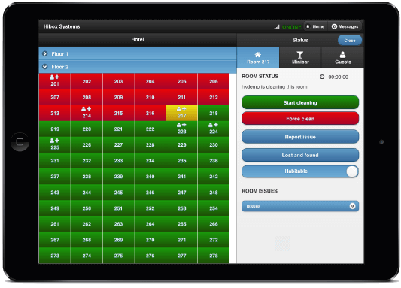

**Fig1: HIBOX website**

**Fig1: HIBOX website**

Staffan Granholm CEO and the team of the company. This application is subscription based, this allows small companies to afford it and to use it and to see how or if it benefits the company. Application features consists of allowing housekeeping staff to report the usage of mini bar within the units and that information automatically registers it to the PMS therefore allows the front desk to view it. The application also allows housekeepers to take photos and report any broken or lost and found items within that room so the front desk is aware of items lost or damages done by the guest so the front desk can chase them up regarding lost items or charge them for damages to the property. There system operates on the browser therefore you just need a provided URL and login with your credentials and your basically ready to use the program.

(Knowcross, 2019) Knowcross was founded in the year 2002 which prides its self to be quote “Help improve guest service and enhance staff productivity and increase guest loyalty” which this company stands by. This company spans to more than 40 countries and provides 24/7 support. The company offers Saas (Software as a service) therefore it mean that the companies services are cloud based and that it’s a subscription based software and can be accessed online Via browser, which mean that the software doesn’t

* 1. **Know cross**

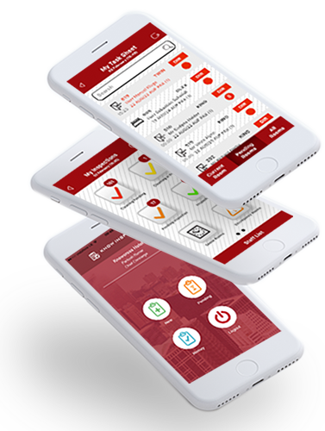

**Fig 2. KnowCross Website**

have to be installed on any computer and therefore doesn’t require any extra hardware requirements to run this application however they do provide an option to clients to have a hard copy of the software if the customer requires it. Know housekeeping does also provide easy to use application on android and IOS devices hence making it much easier to the user built into the application has options to select Multilanguage interface to reduce language barrier. This application also can contacts to your PMS therefore the front desk will be aware of rooms which are dirty, clean, inspected. Know Housekeeping applications automatically allocated rooms and will prioritization rooms depending on guest requests of early check-in. Know Housekeeping will also look at your linen count and will report to front desk to order more linen and will calculate depending on how many check out of how much linen is required.

* 1. **HotelFriend**

(HotelFriend AG, 2019)Hotel friend provides multiple management application such as [Hotel Management System](https://hotelfriend.com/products), [Central Reservation System](https://hotelfriend.com/central-reservation-system), [Property Management System](https://hotelfriend.com/hotel-pms), [and Software for Small Hotels](https://hotelfriend.com/software)

[Deal, Package Composer](https://hotelfriend.com/deal-manager), [Mobile concierge app](https://hotelfriend.com/hotel-mobile-app)

[Hotel Guestbook Mobile App](https://hotelfriend.com/b/mobile-app-guestbook), [Room Service Mobile App](https://hotelfriend.com/b/hotel-room-service-mobile-app) and also [Hotel Website Development](https://hotelfriend.com/b/hotel-website-development) applications. Hotel Housekeeping System is one of their most requested software by hotel industries as this

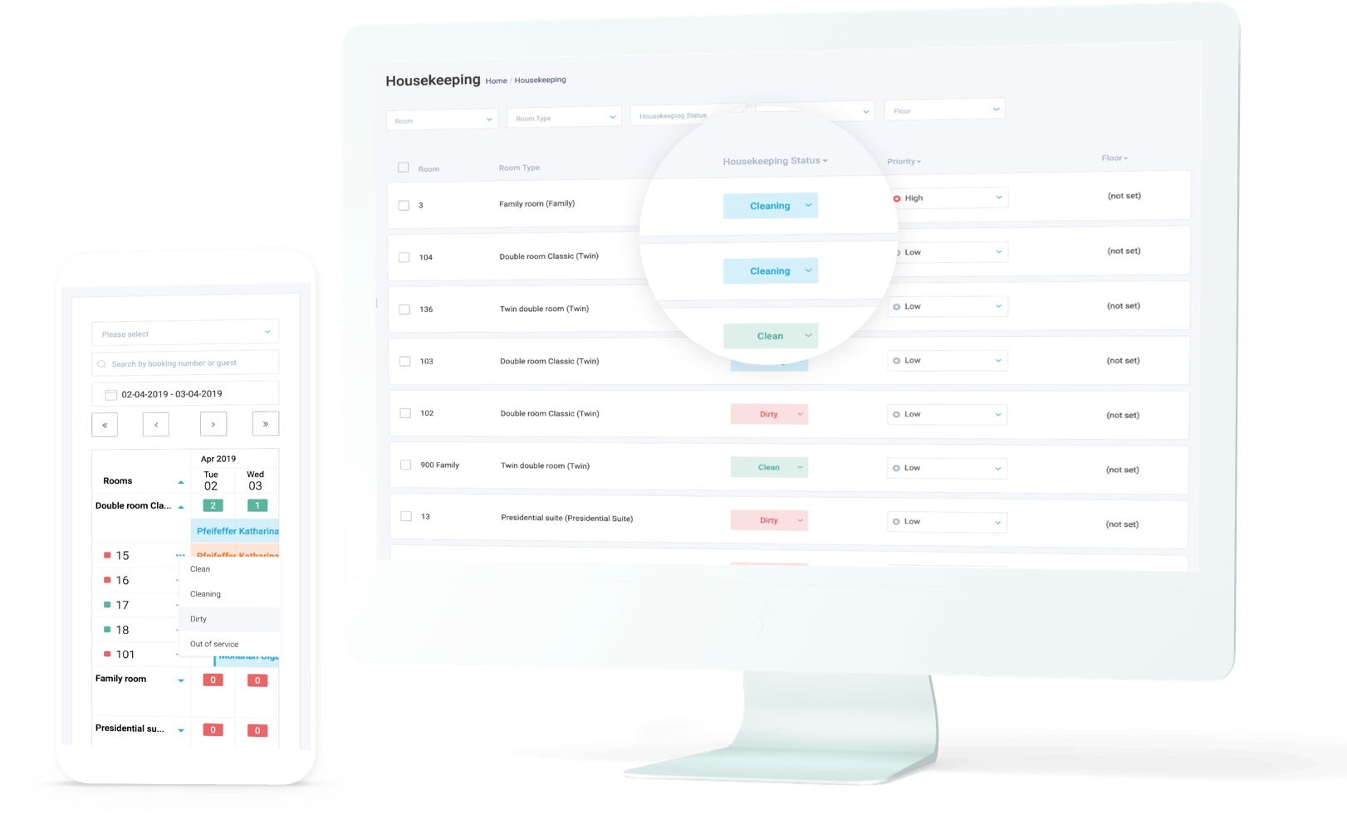

**Fig 3. HotelFriend website**

application offers housekeeper with a list of rooms that needs to be cleaned and also provides live update on rooms that have been prioritized by the front desk this is normally done to adhere to customers requests such as they requested a early check in or they have requested a service early during the day. Hotel Friend housekeeping application also provides housekeeper to report if the room has been cleaned or requires something to be fixed within the room and or if the room is dirty and will require more time to get the room cleaned, therefore allowing the front desk to arrange repairs and or to allow more time for the housekeeper to complete their rooms.

**2.5. Cloud beds Reservation System** – This app is multi task that can connect to hundred of channels from your property such as booking.com and Orbitz and it allow guests to make direct booking from their desktop, phone and through Facebook so, this app so handy and gives good impact for small business e.g. - Hotel and Motel.

* Easy to use and 24/7
* Customer support online
* Credit card system integrated by third parties.

**What we would like to improve or add in the future for our system.**

* Online support
* We would add payment from credit card in the future.

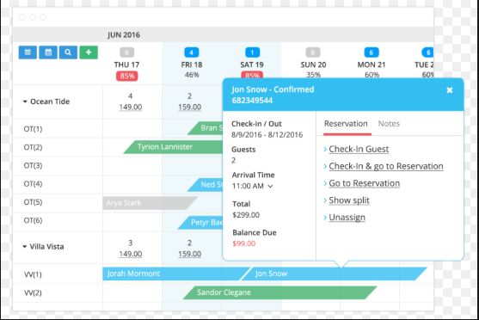

**2] eZee Front Desk –** App is mainly used by small lodge, hotel and motel and company claim that app is using in 140 countries all around the world and more than 1 million transaction in a day and across hotel management property resulting in 90,000 room manged and 70,500 users by eZee Front Desk app.

* Receive application report on phone and tablets.
* Event Management.
* Self-service check in Kiosk.

**What we would like to improve or add in the future for our system.**

* We could add any language pack based on Client majority.
* Online help.

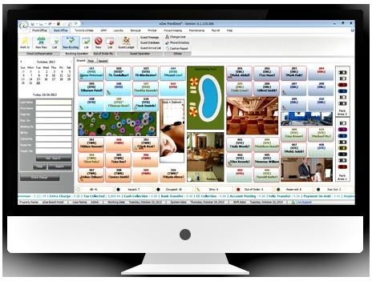

# **3. Problem Identification**

The problem that was identified by the Literature Review that was conducted found that majority of applications used within the accommodation industries are mainly for larger corporate and hence costs for those applications are not affordable for small industries such as Backpackers and motels and other smaller accommodation industries. Applications that we are going to create will allow us to tap into the smaller industries by creating a small, simple and affordable system. We also have seen that most of the companies offering cloud based database for the systems however we believe that providing an application on a physical platform will assist small business as getting a cloud based service will contribute to costs to the company and therefore won’t be interested in the software.

# **4. Methodology**

The methodology we will be using throughout this project will be that of the Agile methodology – more specifically, the Agile Scrum methodology, as we have limited time and require flexibility to change parts of our project as it goes through development. This means we will have our product owner (supervisor in this case), work closely with us - the team - to prioritize what needs to be accomplished in the next ‘sprint’ (Blueprint, n.d.).

## 4.1 Resources

### **4.1.1 Lucidchart**



Fig. -. (Lucidchart, 2019)

Lucidchart has been an important tool for us to use to create our diagrams, such as our ERD for our database design.

### **4.1.2 Android Studio**



Fig. -. (Android Studio, n.d.)

Android Studio’s IDE will be our main tool used throughout our conceptualization phase. We’ll be creating our application using Java, as it’s the most familiar with our developer.

### **4.1.3 Office 365**

Three programs provided from Microsoft Office 365 has been and will continue to be used throughout this project. Word will be predominantly for documentation and proposals, PowerPoint for our presentations, and Project used for the creation of our Gantt Chart – which will be followed closely for scheduling throughout the project.

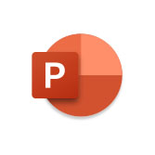

Fig. -. (Microsoft, n.d.) Fig. -. (Microsoft, n.d.) Fig. -. (Stratel, n.d.)

### **4.1.4 Google Docs**

Fig. -. (Google, n.d.)

We have created a Google Docs via our group on Canvas, where we could throw up our notes throughout the project, which allowed everyone to be able to proof-read each other’s work and assess where everyone was and what needed to be done.

### **4.1.5 Photoshop**

Fig. -. (Fred the Oyster, 2014)

Photoshop was used only for our UI design for the application, as it provided layers that made edits a lot easier as they were required.

### **4.1.6 Messenger**



Fig. -. (Facebook, 2019)

Messenger is used between the team for communication purposes.

# **5. Risks and Limitations**

* **Lack of Experience and Skills-** Lack of experienced our team has only one software developer and required to create a Hotel reservation app its big job for us as a team to produce app and that’s going to be challenging. We simply lack expertise but we both Networking student will try our best to help our Developer out during these 8 weeks to make efficient app for our staff.

**Mitigation-** Discussion with senior Software developer and learning from them, what need to be done on time as of Knowledge side it doesn’t matter who’s is younger or older it all about asking and doing own research putting effort so, I think If developer could do that it would be another chance to gain some more experience and adding skills.

* **Technology Failure**-If technology is failing could put huge failure impact on project as we all know system could be fail at any time and that cause a massive loss to our group through technology as technology has number of good reason but never know what could have happened to machine in couple of second because all work is going to be save on our computer.

**Mitigation-** All we can do to have a backup on a different computer at the same while doing a project that’s the only way we could save our work or on Google Drive.

**Miscommunication**- Bad communication is the biggest thing especially when doing a project work with different members as we all know ned to know what the task are of another member. Improper communication could lead to fail project or Assignment and give unnecessary problem that we don’t want especially, when you have only 8 weeks to create an app so, Communication must be good between members.

**Mitigation-** Having meeting with your group members exclude class meeting trying to make a time for them and that would help everyone to lead successful project

**Time**- Our group is very inexperienced regards of creating a hotel reservation app for our group and only have 8 weeks to do so. We could be fall behind in this project due to lack of experience and we never done like this before so, it’s so new for us that could reach failure to reach our milestone or could be fail the project.

**Mitigation-**  It’s important that we distribute our task between members so, everyone has fair chance to do during time given as time is super crucial for this project because no body want to fail this course so, every single member need to use time very efficiently to have nice impact on our project.

# **6. Timetable**

­

**Breakdown:** Cara – Development

Krishal and Sanjit – Research and Documentation

# **7. References**

Blueprint. (n.d.). Agile Methodologies. Retrieved from

<https://www.blueprintsys.com/agile-development-101/agile-methodologies>

Adobe. (n.d.). Photoshop Logo [Logo]. Retrieved from https://en.wikipedia.org/wiki/Adobe_Photoshop#/media/File:Adobe_Photoshop_CC_icon.svg

Android Studio. (n.d.). [Logo]. Retrieved from https://developer.android.com/studio

Facebook. (n.d.). [Logo]. Retrieved from https://www.messenger.com/)

Google. (n.d.). Google Docs [Logo]. Retrieved from https://docs.google.com/document/u/0/

Lucidchart. (n.d.). [Logo]. Retrieved from https://www.lucidchart.com/blog/)

Microsoft. (n.d.). PowerPoint logo [Logo]. Retrieved from https://www.microsoft.com/en-nz/education/products/office/default.aspx

Microsoft. (n.d.). Word logo [Logo]. Retrieved from https://www.microsoft.com/en-nz/education/products/office/default.aspx

Stratel. (n.d.). [Logo]. Retrieved from https://www.stratel.com.au/project