**2448021**

**Lab 10**

**Java Programming**

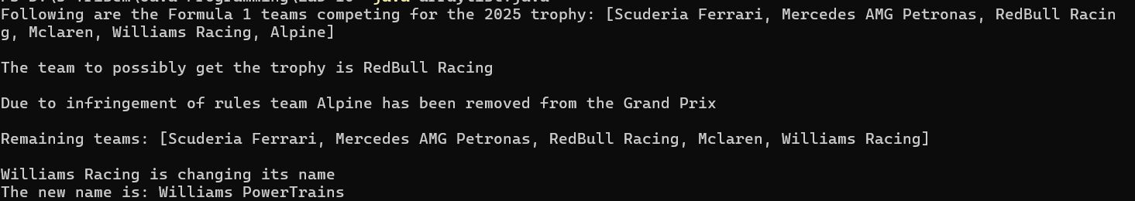**Array List Output**

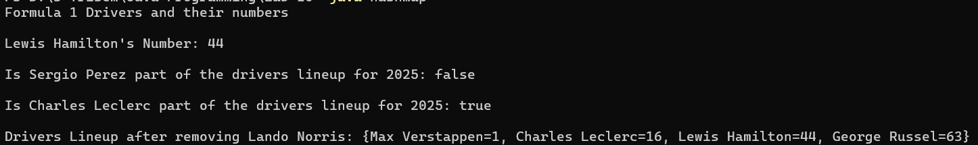**Hash Map Output**

**Hash Set Output**

