# Music Theory Algorithm Keyboard Companion App

Hans Stephen B. Bautista, Raphael Ferdinand A. Dominado

BS - CPE, BS – ECE2

hans_bautista@dlsu.edu.ph, raphael_dominado@dlsu.edu.ph

# Abstract

An application of the common piano app with 49 key notes, 7 major chords, and 7 minor chords. Other functionalities include a circular beat visualizer for controlled tempo, a record option to save compositions, and a hotkey feature for each chord in the piano for user convenience. The main functionality of this app, however, is the simple algorithm that accompanies the keyboard, designed to guide users through basic music compositions using a calculated musical scale. This project would encompass numerous basic scales used in different genres of music: Major scale, Minor scale, Pentatonic scale, and other parent scales. These musical scales are the basis for the algorithm to highlight the next notes to be played alongside the note initialized by the user in accordance with the scale selected. With the recording option, it would also record the tune made and possibly textualize the notes and chord progressions the user composed.

The application is envisioned to be a companion app for beginner composers in their first steps towards learning music theory. It aims to help and attract new and amateur song writers by providing hands on guides and materials essential to compose simple jingles, basic chord progressions, arpeggios, and all the way to even complex tunes. Experience alongside this app gives an exciting experience and necessary insights towards music theory as, with enough skill, they would be able to come up with more intricate melodies over time. In addition, through its hotkey features, the app also provides users the familiarity needed to skillfully play the piano as its hotkey feature loosely mimics the sound of a piano piece by actual piano compositions.

# Introduction

In this section, introduce the background of the application you want to do. Provide us some context on related applications / variations that already exist. Additionally, try also to ask yourself these questions:

* Who is your target user?
* Amateur and beginner composers exploring music theories and scales.
* What problems does your user encounter?
* Music composing is an arduous task that requires significant skills and knowledge. Memorization of musical scales takes time and dedication that does not give immediate results.
* What *value* do I want to provide to the user?
* A guiding program designed to accompany amateur composers in their first steps of understanding music theory.
* Why is this application significant?
* It would further encourage and elate new and learning composers in the world of music theory. Furthermore, amateur composers using this app will have more capabilities and applications in writing melodies, chord progressions, and simple chimes as their first step towards the world of music.

# Functionalities

In this section, describe how you list of features/functionalities that you want to build as part of the application. Preferably, this list should be as granular as possible.

#### You can possibly create by using some tables and its description as shown below.

TABLE I. Table Type Styles

|  |  |  |
| --- | --- | --- |
| Functionality Name | Description | Benefit |
| 49 Key Piano | A piano diagram with a classical look. It represents 49 keys all played in staccato using mouse. | The piano provides the best platform for understanding musical concepts and scales from music theory for our users. Its classical design allows a user-friendly GUI and the familiarity of a typical piano. |
| Chordal Keys and Slider Panel | A set of 14 keys that plays 7 major chords and 7 minor chords. Each button can be played using mouse or its hotkey. | It allows users to play multiple keys at the same time, all according to the common chords used when playing the piano. The hotkey functions of these chords allow the user to play the chords simultaneously alongside the leads played through the mouse, allowing a more realistic sounding composition. The “weight” of these chords can also be controlled through the slider. |
| Musical Scale Algorithm and Control Panel | An algorithm that uses scales from music theory to highlight the correct keys on the piano. A panel dedicated to control this algorithm’s settings contains the following: an “initialize” button that accepts an input note for the algorithm to formulate its scale, and a selection of musical scales to use such as Major, Minor, Major Pentatonic, Minor Pentatonic, Harmonic Minor, etc. | The algorithm allows and teaches users the natural harmonic progressions of notes during composing by suggesting the notes recommended by scales from music theory. The panel allows users to pic k different types of scales for different genres of songs. |
| Recording Function | A feature that allows the user to record their piece. It records the sound and saves it as an MP3 and writes down the notes played and saves it as a txt file. | Users are given materials to archive their work in audio and written form. |

# Walkthrough

For each functionalities mentioned above, please show the step-by-step procedure on performing transactions as stated on the Functionalities. (Note: Please add step-by-step screenshots)

Hello!

Let us introduce you to the Composer Buddy!

This music companion piano app allows users to be given visual guidance whenever they're composing music.

Pick different musical scales common in music theory, create your ideas, and record and save your pieces.

To start:

1. Open up the ComposerPiano folder and inside, run the ComposerPiano .mlapp file.

1. Explore around the GUI for a bit. Learn about the 49 keys of the piano.

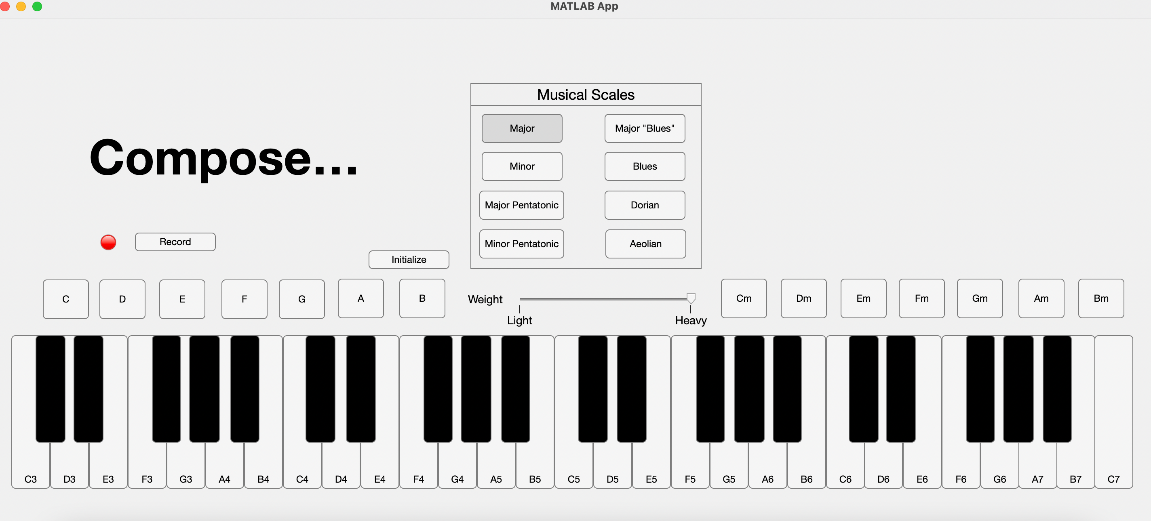

1. 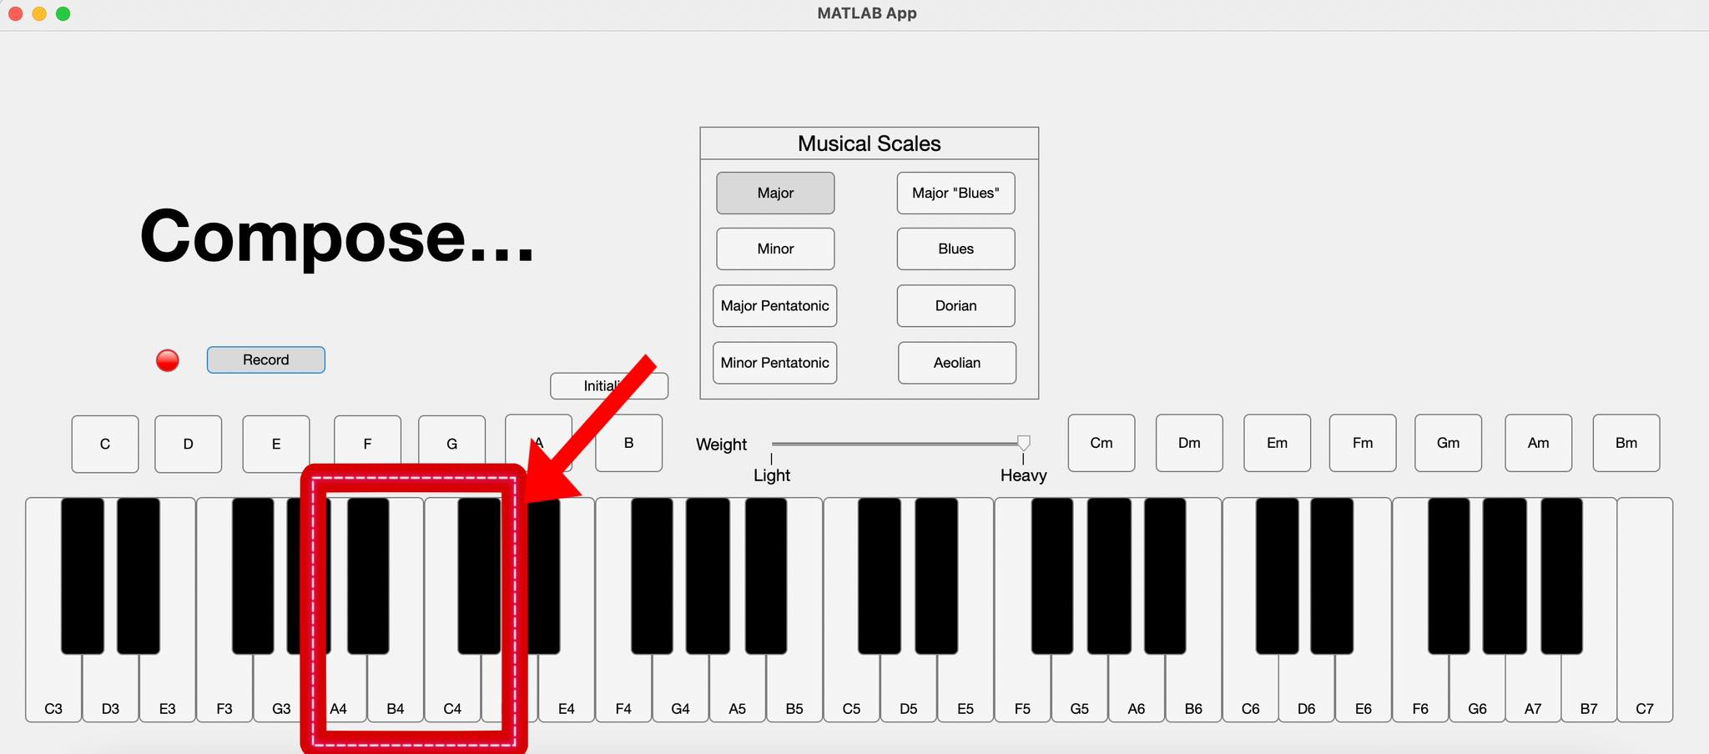Learn the hotkeys for the chords! Major chords can be played from "A to J" and minor chords can be played from "Q to U"
2. Pick your scale! Choose from 8 different musical scales used in different genre of music.

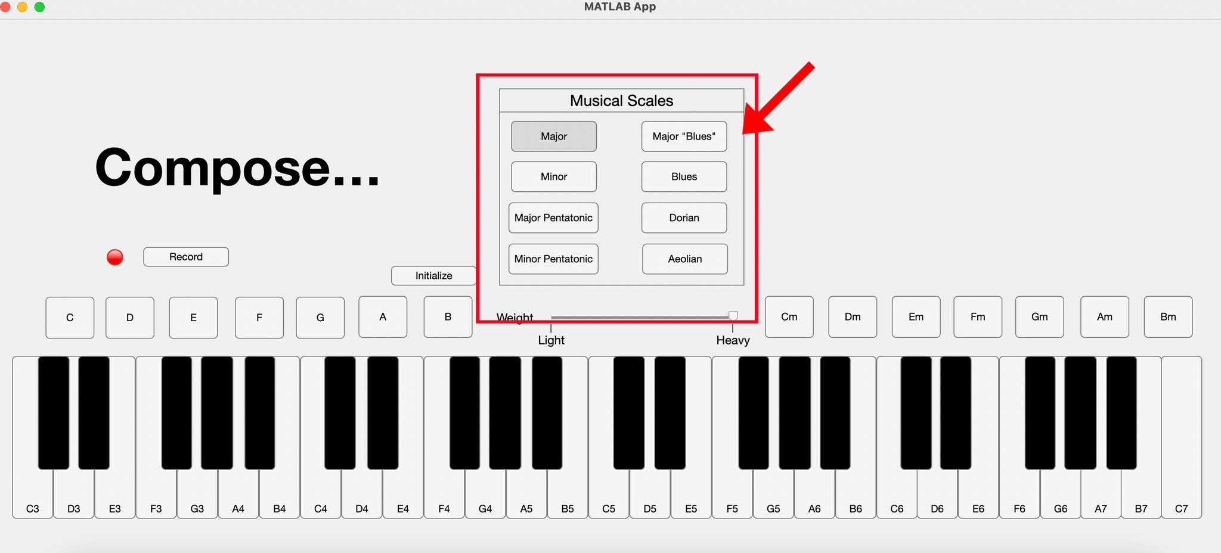

1. 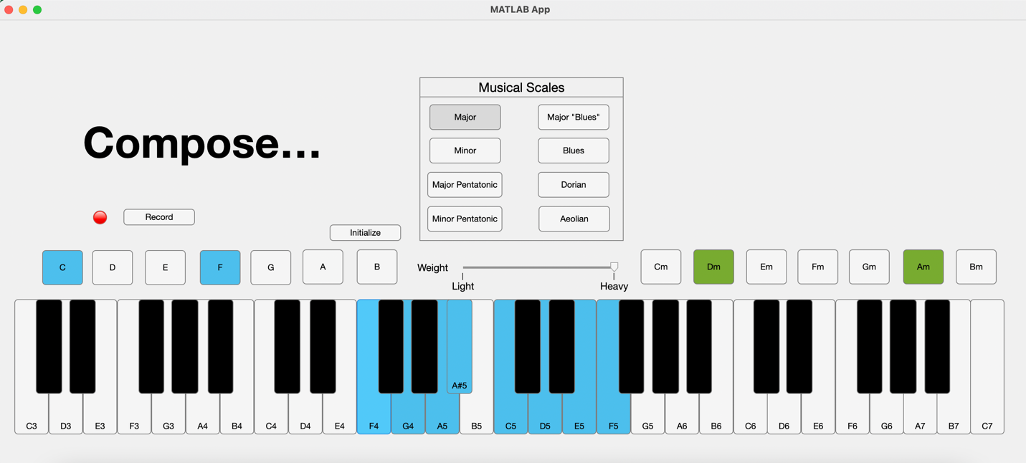Set-up your scale! Press the initialize button and press a key you want to start with. Watch the keys of that scale light up.

Create and practice! You may start adlibbing musical pieces to your heart's content.

1. Record your masterpiece! Press the record button and start playing the jams!

