## Importing and exporting localization files

1. Export the localization files using the “Translation | Export for Translation” menu item. Select all languages that you wish to translate. One .CSV file will be created for each of them in the format “<SelectedFileName>_Lang-Country.CSV”  
   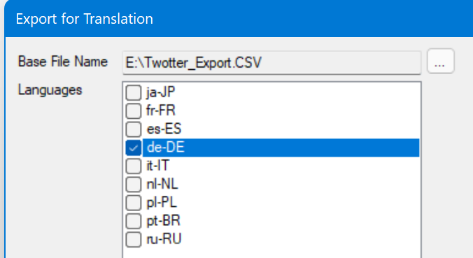
2. Open Microsoft Excel with a new document and select “Data | From Text/CSV”. Now select a localization file to work on and click “Import”  
   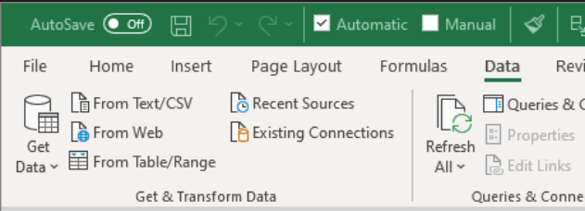
3. In the following window, click “Transform data” and select “Use First Row as Headers”. Then click “Close & Load”:

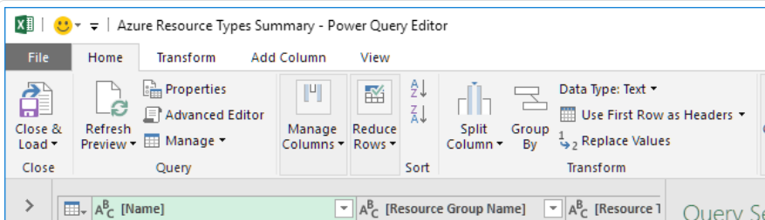

1. The imported data now looks like this:  
   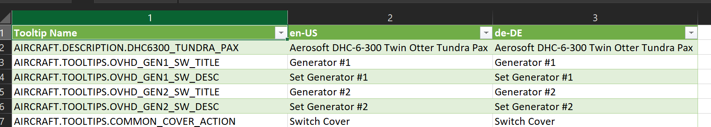  
   Enter your translated text in column 3 (de-DE in this example).
2. Use “File | Save as” to save the translated file. Make sure to change the file format from .XLSX to .CSV.
3. Go back to MSFS Localizer and select the menu item “Translations | Import Translation”. Select the file you exported. The language will be automatically detected.   
   Note that the whole import process is done on a copy of your current data, so there will be no data corruption in case something goes wrong. Your current data will only be updated when the import process has successfully completed.

Note: It’s important that the structure of the CSV files remains as it was. The only things that may be edited/changed are the texts in column 3.