Grammar | Semantic Rules
Program -> Statement StmtList | { Program = Statement StmtList }
StmtList -> Statement StmtList₁ | { StmtList = Statement StmtList₁ }
StmtList -> ε | { StmtList = ε }
Statement -> Declaration | { Statement = D.exp }
Statement -> PrintStatement | { Statement = P.val }
Declaration -> Type Var = Expresion ; | { si E.type ≠ Type.type → SDT error (Type Mismatch)  si no: D.exp = Type.type Var.val ‘=’ E.value ‘;’ }
Type -> int | { Type.type = int }
Type -> float | { Type.type = float }
Type -> string | { Type.type = string }
Var -> id | { Var.val = id.lexval }
PrintStatement -> print ( Expresion ) ; | { P.val = print ( E.value ) ‘;’ }
Expresion -> Termino Expresion' | { E'.inh = T.value  E.value = E'.syn }
Expresion' -> + Termino Expresion'₁ | { E'₁.inh = E'.inh + T.value  E'.syn = E'₁.syn }
Expresion' -> - Termino Expresion'₁ | { E'₁.inh = E'.inh - T.value  E'.syn = E'₁.syn }
Expresion' -> ε | { E'.syn = E'.inh }
Termino -> Factor Termino' | { T'.inh = F.value  T.value = T'.syn }
Termino' -> * Factor Termino'₁ | { T'₁.inh = T'.inh * F.value  T'.syn = T'₁.syn }
Termino' -> / Factor Termino'₁ | { si F.value = 0 → SDT error (Division by zero)  si no: T'₁.inh = T'.inh / F.value  T'.syn = T'₁.syn }
Termino' -> % Factor Termino'₁ | { si F.value = 0 → SDT error (Modulo by zero)  si no: T'₁.inh = T'.inh % F.value  T'.syn = T'₁.syn }
Termino' -> ε | { T'.syn = T'.inh }
Factor -> constant | { F.value = constant.lexval ; F.type = int }
Factor -> decimal | { F.value = decimal.lexval ; F.type = float }
Factor -> literal | { F.value = literal.lexval ; F.type = string }
Factor -> ( Expresion ) | { F.value = E.value ; F.type = E.type }

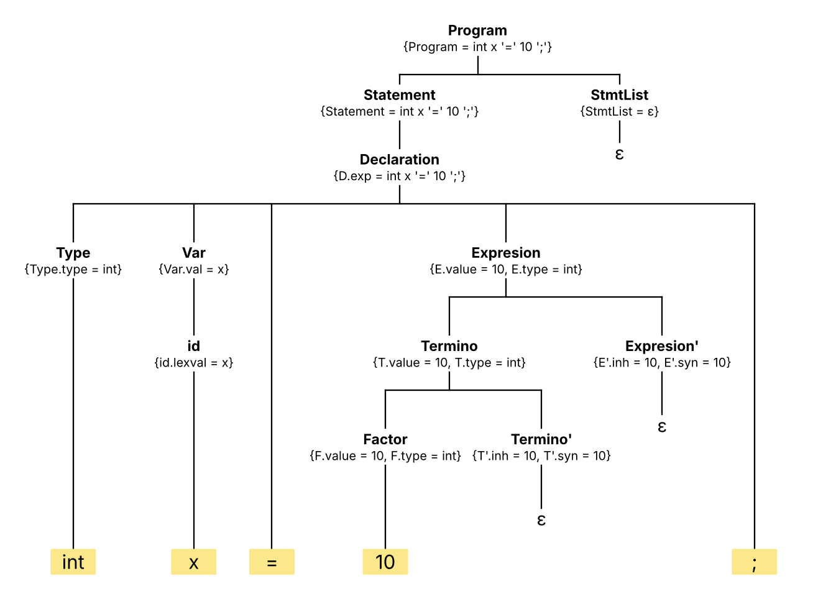
Figura 1. Árbol sintáctico anotado para la entrada: int x = 10;

