Project 3 GT-Lost & Found

1. Team Introduction
1.1 Team Name:
GT-Lost & Found
1.2 Team Members:
Hamilton Baker: HamiltonBaker@gatech.edu
Hans: hansreich25@gmail.com
Tianjun Ye: tye7@mail.gatech.edu
Jia Zhao: jbamboo2009@gmail.com

2. Project Accomplishment Report:
2.1 Project Description:
If you are a student, did you left your key in the classroom? Did you forget to plug out USB driver in the computer lab? If you are not lucky enough to remember where you left it, you have to look for it everywhere.
If you are an administrator of library, you may collect hundreds of USB drivers in one week, however, you don't know how to contact with the owners. You may write your contact information on the white board, or paste a sticker on the door, however, they are easy to be erased and people would not pay attention
In this project, we built a native Android application for the Lost & Found. This application allows administrator to enter the items they found in the building, including found date, time, item description, and the pick up location. On the other hand, students could search their lost items by lost location or lost date. We believe that this application should be great helpful for Georgia Tech Community.
2.2 Application Architecture:
The architecture of our application is as the following diagram.
- We used a Debian server as our back-end host. We built MySQL database on the server to store our lost & found data. Then we wrote PHP script as our API to interact with database, retrieving and posting data. To retrieve data, we encode the data into JSON format, and post it on the website.
- We used Android SDK to build the front-end GUI. We used HttpClient to obtain data from the website, and converted them into JSON object. Then we wrote JSON parser to retrieve information we need and display them on the Android.
2.3 Future Improvements
There are three areas we could improve our application:
- For the database part, we plan to incorporate more GT-places and add more lost item categories. Then we will display them as drop-list on the Android GUI. That would be convenient for administrator to organize the items categories, and also helpful for students to search their item. Also, we consider to separate the description of the lost item into public description and private description, to protect the private of users.
- For the API part, we plan to write more API to allow users search items flexible. So far, the users can only search by items or location. We plan to add more API to allow users search by date, time or classroom.
- For the Android GUI part, we plan to add more function to interact with dependent services. For example, we could add function to send e-mail or make a call when the user touches the contact e-mail or contact phone number. It would be efficient for our application.

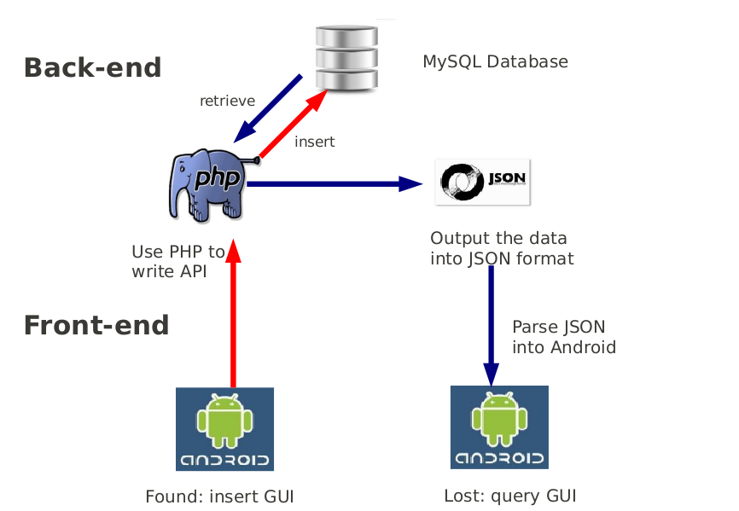
Application Architecture: Task Flow Diagram

2.4 interaction with dependent services
So far, we don't have any interaction with dependent services. However, in our future improvements section, we mentioned adding function to send e-mail or make a call when the user touches the contact e-mail or contact phone number. It would be and extension for our application.
2.5 Problem areas and how the team overcame them:
In this project, our main problem is how to connect Android with remote MySQL database. Finally, we solved this problem by using PHP to write API, encode the data into JSON format. And then used JSON parser in Android to retrieve the information.

3. References:
Programming: Java, Android SDK, MySQL, PHP
Tutorial: http://www.helloandroid.com/tutorials/connecting-mysql-database

4. Acknowledgement:
Here we would like to give a special thank to Matt Pinkston, for lending us the server, and helping us connect the Android with remote database. Also, we would like to thank Brian Davidson for his help of GTmob server.

