# $ + K Contents
ACKNOWLEDGMENTS
INTRODUCTION
WorldMail Packaging Options
WorldMail Components
Key WorldMail Features
What's New in Version 3.0
INSTALLATION
System Requirements
Installation Contents
Installing WorldMail
Modifying WorldMail
Repairing WorldMail
Upgrading WorldMail
UnInstalling WorldMail
Silent Installations
QUICK START
MAILBOXES
Mailbox Types
Adding Mailboxes
Converting Mailboxes
Automatic Mail Handling
Mailbox Quotas
Web Mailbox Administration
MAIL LISTS
Mail List Types
How Mail Lists Work
Mail List Tasks
Creating a Digest List
Mail List Processor Commands
List Processor Examples
List Agent
Mail List Directories
Mail List Content Moderation
Archiving List Messages
DOMAINS
Selecting the Domain Type
Setting the Default Domain Name
Creating the DNS Entries
Adding the Virtual Domains
Adding the Mailboxes
Forwarding Domains
Testing the Configuration
ALIASES
Setting up an alias
Deleting an alias
Wildcard aliases
Map table order
Importing and Exporting
Aliases versus Synonym Domains
DELIVERY PRECEDENCE
INTERMITTENT CONNECTIVITY
Central Hub with Dialup Satellite Servers
Dialup Satellite Server
Mail Delivery Schedules
Dialup Support
BACKUP
Performing a Comprehensive Backup
Transferring WorldMail to another computer
SECURITY
Message Store Security
Password Security
WorldMail Security
Advanced SMTP Security
Security for Mail Lists
Transport Layer Security (TLS/SSL)
MAIL FILTERS
Filter Levels
Using Filters
Message Quaratine
Advanced Filter Options
VIRUS SCANNING
Kaspersky Anti-Virus Filter
Virus Scanning Policy
Server Virus Scanning
Domain Virus Scanning
Mailbox Virus Scanning
SPAM SCANNING
Spam Scanning Policy
Server Scanning
Domain Scanning
Mailbox Scanning
AGENTS
Server Agent
Mailbox Agents
List Agents
List Processor Agents
Archive Agent
DATABASES
Setting Up Database Access
Database Mailbox Plugin
Database Mail List Plugin
MONITORING
Logging
Performance Monitor
Disk Maintenance
Monitoring Spam Traffic
WORLDMAIL ENGINE
SMTP Receiver Service
SMTP Delivery Service
POP3 Server
IMAP4 Server
LDAP3 Server
HTTP Management Server
MAILMA Server
Working Directories
WINDOWS MANAGEMENT CENTER REFERENCE
WorldMail Systems
Server
Security
DHAP
Logs
Schedules
Services
Mailbox Plugins
Domains
Mailboxes
Mail Lists
WEB MANAGEMENT CENTER REFERENCE
Logon Page
Server Page
Domain General Page
Domain Mailboxes Page
Domain Mail Lists Page
Mailbox Properties Page
Mail List Properties Page
List Moderation
Confirm Page
Report Page
Logoff Page
TROUBLESHOOTING PROCEDURE
Debugging TCP/IP Connections
Debugging with Telnet
Technical Support
DNS OVERVIEW
SOFTWARE LICENSE AGREEMENT
APPENDIX A - UTILITIES
MSALIAS
MSBACK
MSBOX
MSCVTDIR
MSDOMAIN
MSIMPORTEXPORT
MSLDIF
MSLIST
MSPOP
MSPURGE
MSQUOTA
MSRETRY
MSSEND
MSSENDMESSAGES
MSSTART
MSCONV
MSCONVUSER
MSCONVUSER2
APPENDIX B - CUSTOMIZING WEB ADMINISTRATION
Home Page
Sample Template Files
Advanced Templates
APPENDIX C - CUSTOMIZING EUDORA WEB CLIENT
Eudora Web Client Files
Configuration Parameters
Language Settings
Graphics
Frame Layout
Inserting Banner Ads
Adding Virtual Directory to IIS
Virtual Domains
APPENDIX D - CUSTOMIZING MAIL LIST ARCHIVING
Archive Template Files
APPENDIX E - LIST HEADER PROCESSING
APPENDIX F - DATABASE PLUGIN EXAMPLES
APPENDIX G - DATABASE LOGGING
APPENDIX H - EMERALD INTEGRATION
APPENDIX I - SERVICE COMMAND LINE SYNTAX
APPENDIX J - IMAP4 ACLS
APPENDIX K - SMTP PROTOCOL
APPENDIX L - EVENT ID'S
APPENDIX M - GLOSSARY
#$K+ Acknowledgments
Eudora WorldMail is based on the Freeware IMS for Windows NT that was developed under the EMWAC project. EMWAC was funded by Datalink Computers, Digital, Microsoft, Research Machines, Sequent and the University of Edinburgh.
Certain algorithms used in parts of this software are derived from the RSA Data Security, Inc. MD5 Message-Digest Algorithm.

#$K+ Introduction
Welcome to Eudora WorldMail™, from QUALCOMM, Incorporated.®
WorldMail is an Internet Mail and List Server for Microsoft Windows platforms. WorldMail allows your computer to host e-mail accounts and mail lists, and to communicate with other Internet mail servers to send and receive e-mail. WorldMail is 100% compliant with Internet electronic mail standards, including the SMTP, POP3, IMAP4, and LDAP3 RFC specifications.
WorldMail's main job is to host mailboxes, which correspond to individual e-mail users. Each WorldMail mailbox can be configured to forward mail to another address, and to automatically respond to incoming mail with a pre-defined message. You can create one or more aliases for each mailbox, allowing a single user to receive e-mail sent to multiple addresses. Users can access e-mail in their WorldMail mailboxes with any POP3 or IMAP4 mail client, such as Eudora, and can also use a web browser to check their mail through the Eudora Web Client webmail application. Users can even manage their own mailboxes through a standard web browser.
You can also create mail lists on your WorldMail server. Mail lists allow messages sent to a single e-mail address to be broadcast to any number of members. You can control the access and security of each list, and delegate mail list administrative duties.
WorldMail includes extensive spam blocking, virus detection, and other SMTP security features. WorldMail can automatically protect your site from destructive or offensive emails, denial-of-service attacks, and third-party relaying.
WorldMail provides powerful mail routing capabilities. It can act as a staging post for mail destined for another host, which is useful for creating an e-mail proxy or relay server.
WorldMail supports virtual domains, so you can configure a single WorldMail server to send and receive mail for multiple domains.
WorldMail also supports dialup networking, allowing your WorldMail server to connect to your ISP or central office to send and receive mail intermittently.

#$K+ WorldMail Packaging Options

Eudora WorldMail
Eudora WorldMail is a full-featured mail server that is easy to install and maintain. It has been designed with the nonprofessional administrator in mind. It does not require extensive training or advanced certification in order to install and operate. This means that smaller companies don't need to employ a full time administrator to run their email system. WorldMail is also an attractive choice for service providers who offer dedicated hosted email services.

WorldMail Spam Filter
WorldMail Spam Filter is a part of the new WorldMail 3 product line introduction. It is a next-generation spam blocking solution that uses a "cocktail" approach of technologies to detect and eliminate spam. By providing end-user controls, false positives are avoided. WorldMail Spam Filter analyzes email during processing, to identify spam before it's delivered. Configuration options allow end users to review their server-identified spam, or an automated server quarantine of spam can be used.

WorldMail Virus Filter
WorldMail Virus Filter is an integrated WorldMail add-in that blocks viruses at their network entry point - the email server. This prevents them from getting past user defenses and protects corporate data. WorldMail Virus Filter detects and removes viruses, worms and Trojans from incoming, outgoing and internal email traffic in real time, before viruses can enter or leave the network.

#$K+ WorldMail Components
KWorldMail is comprised of two basic components: the Engine, which provides e-mail-related services, and Management Centers, which provide administrative access to configuration values and mailbox data. If your license supports it, WorldMail also provides access to mailboxes through the Eudora Web Client webmail interface.

Engine K
At the heart of WorldMail is the Engine, a series of services that allow WorldMail to send, receive, and deliver e-mail messages. The Engine also includes services that provide access to mailbox and mail list configuration information, and others that allow end users to retrieve their mail. The Engine's services typically run continuously on your server machine, and are equivalent to UNIX daemons such as sendmail and pop3.
The Engine includes the following services, which can be started and stopped independent of each other:
- SMTP Receiver Service. The Receiver Service listens for incoming messages from other mail servers on the Internet. It stores incoming messages for processing by the Delivery Service.
- SMTP Delivery Service. The Delivery Service is the core of the Engine. It delivers mail addressed to local users to their mailboxes and forwards other mail out onto the Internet. It uses MX records from your DNS server for routing mail.
- POP3 Service. The POP Service allows users to download mail from their mailboxes to their own computer using a POP3 mail client, such as Eudora.
- IMAP4 Service. The IMAP Service allows users to read mail in their mailboxes using an IMAP4 mail client. IMAP users can also create folders within their mailboxes to organize messages.
- LDAP3 Directory Service. The LDAP Directory Service allows users to search for names and addresses of other users who have mailboxes on your site. It is fully compatible with e-mail clients that support the LDAP3 protocol for address searches.
- HTTP Management Agent. The HTTP Management Agent allows administrators and users to remotely manage mailboxes and mail lists using a web browser. It is fully compatible with web browsers that support the HTML 2.0 and later standards, such as Microsoft Internet Explorer and Netscape Navigator.
- Mail Management Service. The Mail Management Service allows you to remotely manage the mail server using the Windows Management Center. It also allows users of the Eudora mail client to change their password from Eudora.

Windows Management Center K K
The Windows Management Center is a Windows desktop application that allows you to configure all aspects of WorldMail, including the Engine services, domains, mailboxes, and mail lists. Among the operations that you can perform in the Windows Management Center are starting and stopping services, setting security policies, setting delivery schedules, creating and modifying mailboxes, and creating and modifying mail lists. Although the Web Management Center provides access to managing mailboxes and mail lists, the Engine can be managed only from Windows Management Center.
The Windows Management Center can be installed on a different computer than the one that runs the WorldMail Engine. This means that you can run the Engine on a large server system but still manage it from your desktop computer using the Windows Management Center. The Windows Management Center can manage multiple instances of WorldMail, so if you have WorldMail installed on two or more server machines, you can manage all of them from one Windows Management Center.

Web Management Center K K
The Web Management Center provides access to WorldMail mailboxes and mail lists through a web browser, and can be used remotely. The Web Management Center supports Internet Explorer 2.0 (and above), Netscape Navigator 2.0 (and above), and any other browser that supports HTML 2.0 and later. This interface is typically used by domain administrators, mail list moderators, and end users.

Eudora Web Client K
Eudora Web Client is a full-featured web-based mail client that allows users to access their mailboxes through a web browser from any computer on the Internet. This allows your users to send and receive e-mail even if they are away from their own computers. Users can also organize their messages into folders and maintain an address book. Eudora Web Client is implemented using HTML and JavaScript, and does not require any complex installation of Java or ActiveX controls. Eudora Web Client is compatible with Internet Explorer 4.0 (and above) and Netscape Navigator 4.0 (and above).

Eudora Connect K
Eudora Connect is an email client for Wireless Access Protocol (WAP) devices. Eudora Connect allows users to access their mailboxes through any WAP-compatible device, such as cellular phones and other wireless Internet devices. Users can read messages, move messages between folders, and delete messages.

#$K+ Key WorldMail Features
KThis section provides an overview of some of WorldMail's many features. If you are upgrading from a previous version of WorldMail and want to know which features are new to this version, see the following section.

Extremely Scalable
WorldMail can support an extremely large number of users, scaling to over 100,000 mailboxes on a single Windows 2000 server or on a cluster of servers. WorldMail can also support over 100,000 members in a single mail list. Administrators can configure all WorldMail servers in a cluster to be clones or to have specified roles (e.g. just inbound SMTP, just IMAP, etc.)

High Performance Engine
WorldMail has a multi-threaded and multi-processing Engine that quickly and efficiently sends and receives large volumes of messages.

Rock Solid
WorldMail is extremely reliable and has been engineered as Rock Solid Internet Software for sites where server down time cannot be tolerated.

Internet Standards
WorldMail is based on open standards and protocols of the Internet, and is completely interoperable with other Internet mail systems. This means that WorldMail does not require a gateway to communicate with remote Internet e-mail servers. WorldMail is 100% compatible with the Internet RFC Standards for SMTP, POP3, IMAP4 and LDAP3.

Anti-Spam Security
Eudora has integrated the acclaimed spam-scanning engine from Sophos into the WorldMail 3 server. WorldMail 3 uses a "cocktail" approach to spam filtering; combining heuristics, profiles, keywords, white and black lists to offer very sensitive and accurate spam filtering. This approach offers the advantage of analyzing email and identifying spam during processing, before it is delivered to the users' inbox.
As the Sophos spam scanning engine analyzes messages, it calculates a spam score for each message based on techniques such as pattern matching, spam definitions, and heuristic analysis. Regular updates to the spam engine heuristics ensure continued effectiveness against the changing tactics of spammers. The spam scores for each message can be used to determine how the message is handled by the system.

Anti-Virus Security
WorldMail Virus Filter can automatically scan all incoming mail for the presence of viruses. This allows your mail system to block e-mail borne viruses before they enter your network. WorldMail's virus scanning facility is provided by Kaspersky Labs, a leading developer of centrally managed security solutions for the mobile enterprise.

Message Filtering (Sieve rules)
In addition to its anti-spam and anti-virus features, WorldMail includes message filtering. With filters, you can create sophisticated rules for handling incoming messages based on the contents of their headers, bodies, and attachments.

Directory Harvest Attack Prevention (DHAP)
WorldMail 3 includes the ability to protect corporate data and further reducing spam by detecting directory harvest attacks and automatically dropping the harvester's connection and blacklisting the IP address for a configurable period of time.
Spammers use directory harvest attacks to steal corporate directories from their victims. They use this information to make their subsequent spam attacks easier for themselves and more costly to recipients. In addition to the obvious spam problem, directory harvest attacks can cause performance degradation issues while the harvesting action is in progress. WorldMail now detects these attacks and automatically drops inbound harvest connections, and then denies future connections to the sender. This safeguards sensitive corporate data.

Choice of Any Internet Mail Client
Because WorldMail adheres to Internet e-mail standards, your users can choose any desktop operating system and any POP3 or IMAP4 e-mail client to access their WorldMail mailbox.

Windows and Web Management Centers
WorldMail provides two Management Center interfaces for managing mailboxes and mail lists, providing flexibility for both local and remote administration. These include a stand-alone application (Windows Management Center) and a browser-based interface (Web Management Center), both of which can be used to create, modify, and delete mailboxes and mail lists.

Multi-Level Administration Privileges
WorldMail supports multiple levels of administration. In addition to the server administrator, who has access over all domains and mailboxes, you can assign domain administrators, who can manage only the mailboxes and mail lists in their domain. The administration of mail lists can be delegated to mail list moderators, who can define parameters associated with their lists, moderate membership requests, and moderate the content of list postings.

Mailbox Self-Administration
WorldMail also allows end users to modify certain information related to their mailboxes. This allows each user to change their password, set delivery preferences, and enable a vacation message--all without requiring the help of the server administrator.

Custom Default Mailbox Properties
The configuration data associated with a mailbox are called mailbox properties. Common mailbox properties items include mailbox quota size, POP/IMAP/webmail access, or anti-virus and anti-spam scanning options. WorldMail 3 now provides the ability to customize these default mailbox properties to ideally suit customer implementation requirements.
Mailbox property defaults can be modified through a special mailbox named MailboxTemplate, which is automatically created and located in the default domain. All mailboxes properties that have not been explicitly set will inherit that property from the new MailboxTemplate. Changing a property in the MailboxTemplate mailbox can also change that same property for all mailboxes for which that property has not been explicitly set.

Database Integration
WorldMail allows you to access mailbox and mail list data stored in an ODBC database. This allows you to authenticate email users against an existing user database, and to create mail lists whose membership is based on users in a database table.

Web-Based Mailbox Access
Eudora Web Client provides end users with access to their WorldMail mailbox through a web browser from any computer on the Internet. This allows your users to send and receive e-mail even if they are away from their own computers.

Wireless Mailbox Access
Eudora Connect provides users with mailbox access through WAP-compatible wireless Internet devices, such as cell phones and personal digital assistants (PDAs).

Fast Installation
WorldMail's Installation Wizard allows you to quickly and effortlessly install the application. The WorldMail Engine's services are installed as NT services, allowing them to be automatically started when the machine boots up. You can also start these services at the conclusion of the installation without rebooting your server.

Powerful Integrated List Server
WorldMail includes a list server, which allows groups of users--such as employees, customers, and discussion groups--to easily exchange messages. A message sent to a mail list is quickly broadcast to all of its members, allowing users to distribute mail to multiple users by sending it to one e-mail address. WorldMail's comprehensive list server features include multiple moderators, e-mail moderation, e-mail subscription, message size limitation, digest distributions, configurable welcome and goodbye messages, web-based message archiving, and powerful header editing macros.

Automatic Reply Facility K
Each WorldMail mailbox includes an optional auto-reply message, which defines a response that should be automatically sent to each user who sends a mail to the mailbox. You can use the auto-reply feature to create mailboxes dedicated to providing frequently requested information, such as product literature, newsletters, and product support assistance. Your users can also make use the auto-reply feature to set up an automatic response for when they are away from the office and unable to receive e-mail.

Integrated With Windows Account Passwords
WorldMail allows you to create mailboxes that correspond to Windows users on your server system. When an Windows mailbox is created, its password is automatically taken the Windows login password for the user, allowing your users to have a single password for your server. When you change a user's Windows login password, the user's WorldMail mailbox immediately uses the new password.

Secure Logon
You can enhance security on your e-mail system by encrypting mailbox passwords (including NT User passwords) using the secure APOP K, AUTH K, AUTHORIZE K or SPA K protocols, which are all supported by WorldMail.

Flexible Logging
WorldMail includes flexible logging options that support extensive message tracking and error detection information. You can direct logging information to a file, to a database, and to the NT Event Viewer.

Virtual Domains K K
You can configure a single WorldMail server to send and receive mail for multiple domains. This allows your site to host e-mail for "virtual" domains. Mailbox names need not be unique across domains, so you can use a particular mailbox name in each domain on your server.

Performance Monitoring
The WorldMail Engine is fully integrated with the performance monitoring and security features of Windows NT. All Engine services can be monitored with the NT Performance Monitor, which can be used to track information such as the number of active connections, the amount of message data received, and the number of failed POP/IMAP logins.

Flexible Mailbox Authentication
User login data can be authenticated in several ways, allowing you to integrate existing user databases into WorldMail. Users can be authenticated against the NT user database, an ODBC database, or mailbox data stored in the NT registry.

Programmability
You can extend the capability of WorldMail using agents K, which are programs that are executed on individual e-mail messages that arrive for the server, for a particular mailbox, or for a particular mail list. For example, you could use an agent to automatically scan all incoming messages for virus attachments, or to forward messages to your pager if they contain the word "emergency" in the subject header. Agents are extremely flexible and allow you to build-in almost any message-processing functionality.

#$K+ What's New in Version 3.0

Domain Forwarding Support
The domain properties have been enhanced to make it easier to use WorldMail as an SMTP gateway to relay mail to and from other email servers. A new tab entitled "Relay Host" has been added to simplify the configuration of WorldMail as an Internet gateway.

Dynamic Host Configuration Protocol (DHCP) Support
DHCP is a protocol that provides a means to dynamically allocate IP addresses to computers on a local area network. The system administrator assigns a range of IP addresses to DHCP and each client computer on the LAN has its TCP/IP software configured to request an IP address from the DHCP server. The request and grant process uses a lease concept with a controllable time period.
In order to use DHCP with WorldMail, the administrator must configure the DNS settings in Windows rather than adding a DomainNameServer via WorldMail. This is done by configuring the IP settings for the application server, nominating a DNS server and deciding whether the server is to be DHCP enabled. No application specific configuration is required for WorldMail to resolve DNS queries. There are no WorldMail user interface changes for DHCP support. DHCP is defined in RFC 2131.

Enhanced Sieve Rules Wizard
The Sieve Rules Wizard screen has been enhanced to include a checkbox for quarantine instead of relying on the name "Junk Mail" in the fileinto edit control. It is now also possible to insert spam score X-headers and tag subject headers at the Mailbox Delivery Script level. In previous versions of WorldMail, this was only possible in Server Receive Scripts. This is particularly useful for system administrators who want to provide anti-spam services to a subset of their total WorldMail user population.

IP Address Binding
WorldMail services (POP, IMAP, SMTP, etc.) running on multi-homed hosts can now bind to specific IP addresses rather than binding to any available IP address.

Secure Messaging (TLS/SSL) over IMAP, POP, and SMTP Protocols
Transport Layer Security (TLSv.1) is the new Internet Standard by the Internet Engineering Task Force (IETF) for authenticating and encrypting transmissions across open networks. TLS is the evolution of Netscape's Secure Sockets Layer (SSLv.3), the implementation standard universally accepted on the World Wide Web for authenticated and encrypted communication between clients and servers.

Kaspersky Labs Anti-Virus Filter
Kaspersky Labs award winning anti-virus engine is now fully integrated with WorldMail with no additional application instalation or configuration required. Automatic updates to both the engine and the virus definition files ensure maximum protection with minimum administration.

UIDPLUS Support
The UIDPLUS extension of the Internet Message Access Protocol [IMAP4] provides a set of features intended to reduce the amount of time and resources used by some client operations. The features in UIDPLUS are primarily intended for disconnected-use clients.
WorldMail "advertises" the use of the UIDPLUS extension in its response to the IMAP Capability command. No WorldMail set-up or configuration is required. UIDPLUS will only be utilized if the Mail Client (MUA) supports this IMAP extension. There are no WorldMail user interface changes for UIDPLUS support. IMAP UIDPLUS extension is defined in RFC 2359
#$K+ Installation
KThis section contains information on installing WorldMail and Eudora Web Client, including system requirements and an overview of the installation wizard.

#K System Requirements
WorldMail Platform Availability
- Windows XP Professional (SP1)
- Windows 2000 Professional (SP4)
- Windows 2000 Server (SP4)
- Windows 2000 Advanced Server (SP4)
- Windows Server 2003 Standard Edition
- Windows Server 2003 Enterprise Edition
WorldMail System Requirements K
- Intel-compatible Processor (700 Mhz or faster CPU)
- 256MB Minimum (512MB or higher recommended)
- Additional message filtering and scanning may require additional CPU and RAM
- Internet Explorer 6.0 or higher
- 50MB Hard Disk space (To install)
- DNS client installed and working
- NTFS file system
- TCP/IP transport installed and working
KEudora Web Client and Eudora Connect Requirements
- Windows Scripting Host
- Internet Explorer 6.0 or higher
- Windows 2000 Server or higher
- Microsoft Scripting Engine 5.0 or higher
- Microsoft Internet Information Server 5.0 or higher
- Wireless Access Protocol (WAP) compatible wireless device for Eudora Connect

#K Installation Contents
KThe WorldMail Windows Management Center is the program that you use to configure and manage your WorldMail post office. The Windows Management Center can run on any Windows 2000/2003 computer. It can manage local and remote WorldMail post offices on your network, and can even manage remote WorldMail installations over the Internet.

#K WorldMail Engine
KThe WorldMail Engine is the component that receives sorts, addresses and delivers email. It is like the sorting office at your local post office. It does all of this work in the background and is not visible on your computer desktop.

#K WorldMail Management Center
KThe WorldMail Windows Management Center is the program that you use to configure and manage your WorldMail post office. The Windows Management Center can run on any Windows 2000/2003 computer. It can manage local and remote WorldMail post offices on your network, and can even manage remote WorldMail installations over the Internet.

#K Eudora Web Client
KEudora Web Client is a fast and efficient web messaging program that integrates fully with WorldMail. Eudora Web Client requires Windows 2000 with Internet Information Server (IIS) version 5.0 or later.

#K Eudora Connect
KEudora Connect is a WAP wireless messaging program. Like Eudora Web Client, Eudora Connect requires Microsoft Internet Information Server (IIS) version 4.0 or later.

#K WorldMail Command-Line Utilities
The WorldMail Command-Line utilities can be used to manage data for WorldMail mailboxes, mail lists, domains, aliases, and other information from the Windows command prompt. These tools are particularly useful for creating scripts and batch files to automate WorldMail configuration operations. Refer to the Utilities Appendix for more information on these utilities.

#K Mail System Conversion Utilities
The Mail System Conversion utilities allow you to migrate e-mail accounts and messages from your existing mail server to WorldMail. Install these tools if you are upgrading from another mail server product. Refer to the Utilities Appendix for information on MSCONV on MSCONVUSER conversion utilities.

#$K+ Installing WorldMail
To install any or all of the WorldMail components, follow these steps on your mail server system:
- Log into Windows 2000/2003 as a user with administrative privileges.
- WorldMail is distributed as a single SETUP.EXE file. Begin the installation by executing this file.
- The installer displays a welcome dialog. To begin the installation, click Next. This displays the WorldMail license agreement for your approval:
{bmc install 02 256c.bmp}
- Click I accept the terms of the License Agreement, then Next to proceed with the installation.
{bmc install 03 256c.bmp}
- To evaluate WorldMail free for 30 days, enter the word DEMO as the license key. Otherwise, enter your valid WorldMail 3 license key and click Next.:
{bmc install 04 256c.bmp}
- This displays a prompt for the location for the WorldMail files to be installed.
- Select a location and click Next. This displays all the components that are available to be installed.
{bmc install 05 256c.bmp}
- Select the components you want to install and click Next. If you chose to install the WorldMail services then the installer will prompt you for the default e-mail domain for your site:
{bmc install 06 256c.bmp}
- By default, the domain name that is used is the same as that of the server you are installing to, but you can set a different domain if you choose. Once you have chosen a default domain name click Next.

A progress dialog will then be displayed to show the progress of the install.
{bmc install 10 256c.bmp}
- Once the installation is complete you will see a confirmation dialog indicating that WorldMail has successfully installed on your computer:
{bmc install 11 256c.bmp}
You have successfully completed the installation of Eudora WorldMail. Depending upon the options chosen during the installation you are ready to use WorldMail and configure users or you will need to manually turn on the WorldMail Services.

#$K+ Modifying WorldMail
If you wish to add or remove components to your existing WorldMail installation, you can do so by following the following steps.

KTo modify a WorldMail installation:
- Locate the Setup file that you chose when you installed WorldMail.
- Run the Setup file.
- The following dialog will be displayed:
{bmc install 12 256c.bmp}
- Select the Modify option to begin changing your WorldMail installation. The installer will display a dialog containing all the WorldMail components and their current state.
- Make the required changes then click Next. A progress dialog will be displayed showing the progress of the modifications:
- Once the modifications are complete you will see a confirmation dialog indicating that WorldMail has successfully been modified:

#$K+ Repairing WorldMail
If your WorldMail installation has become corrupt, or is missing files you may want to repair it. To do so, follow the following steps.

KTo repair a WorldMail installation:
- Locate the Setup file that you chose when you installed WorldMail.
- Run the Setup file.
- The following dialog will be displayed:
{bmc install 12 256c.bmp}
- Select the Repair option to begin repairing your WorldMail installation. The installer will immediately begin repairing your installation.
- A progress dialog will be displayed showing the progress of the repair:
- Once the repair is complete you will see a confirmation dialog indicating that WorldMail has successfully been repaired:

#$K+ Upgrading WorldMail
To upgrade WorldMail, follow these steps on your mail server system:
- Log into Windows 2000/2003 as a user with administrative privileges.
- WorldMail is distributed as a single SETUP.EXE file. Begin the upgrade by executing this file.
- The installer displays a welcome dialog. To begin the installation, click Next. This displays the WorldMail license agreement for your approval:
{bmc install 02 256c.bmp}
- Click I accept the terms of the License Agreement, then Next to proceed with the upgrade..
- The installer will show you a dialog confirming the upgrade.
- Verify that the information is correct then click Next to begin upgrading WorldMail. A progress dialog will be displayed showing the progress of the upgrade:
- Once the upgrade is complete you will see a confirmation dialog indicating that WorldMail has successfully been upgraded:

#$K+ UnInstalling WorldMail
If you wish to completely remove WorldMail from you computer follow the following steps.

KTo remove WorldMail from your computer:
- Locate the Setup file that you chose when you installed WorldMail.
- Run the Setup file.
- The following dialog will be displayed:
{bmc install 12 256c.bmp}
- Select the Remove option to begin removing WorldMail. The installer will show a dialog prompting you to confirm the complete removal of WorldMail.
- Click Next to begin removing WorldMail from your computer. A progress dialog will be displayed showing the progress of the removal:
- Once the repair is complete you will see a confirmation dialog indicating that WorldMail has successfully been repaired:

#$K+ Silent Installations
The SETUP.EXE installation program may be run with an INI file for silent installations. The values given in the INI file will provide the parameters normally specified by the administrator during installaton. This method of installation is useful for sites that deploy multiple instances of WorldMail.
To install WorldMail silently, execute the installer from the command line with the /S flag:
setup.exe /S
When executed with this flag, the installer skips the user interface dialogs normally displayed during installation and takes its parameters from the file WorldMail.ini. This file must be stored in the same directory as SETUP.EXE, and must contain the following form (with your values specific for each parameter):
[settings]
COMPONENTS=ABCDEF
LICENSEKEY=35XX-XXXX-XXXX-XXXX-XXXX-XXXX-XXXX
MAILDOMAIN=mydomain.com
GROUP=Eudora WorldMail
POSTMASTERPASS=pAsSwOrD
WEBSITENAME=Default Web Site
[services]
BOOTCONFIG=A
STARTSERVER=A
RUNASSYSTEM=B
RUNASNEW=A
RUNASNAME=WorldMail-user
RUNASPASSWORD=pAsSwOrD
RUNASDOMAIN=MYDOMAIN
RUNASNT=A
[directories]
INSTALLDIR=C:\Program Files\QUALCOMM\WorldMail
MAILINBOXDIR=C:\Program Files\QUALCOMM\WorldMail\BOX
MAILLOGDIR=C:\Program Files\QUALCOMM\WorldMail\LOGS
MAILSPOOLDIR=C:\Program Files\QUALCOMM\WorldMail\SPOOL

The parameters included in this form are as follows:
Field | Description
COMPONENTS | The WorldMail components to install. This value can include any or all of the following: A (Engine), B (Management Center), C (Eudora Web Client), D (Eudora Connect), E (command-line utilities), F (conversion utilities).
LICENSEKEY | Your WorldMail license key.
MAILDOMAIN | Default e-mail domain.
GROUP | Windows Program Manager group where WorldMail icons are created.
POSTMASTERPASS | Postmaster (administrative) password
WEBSITENAME | IIS web site where Eudora Web Client and/or Eudora Connect virtual directories are created.
BOOTCONFIG | Option to automatically start WorldMail services during system start-up. Available values: A (start automatically), B (start manually).
STARTSERVER | Option to start WorldMail services immedately after installation. Available values: A (start after installation), B (do not start).
RUNASSYSTEM | Installation security policy. Available values: A (install services as SYSTEM), B (install as specific Windows user), C (maintain existing settings; valid only for upgrades).
RUNASNEW | When installing as a specific Windows user, this flag specifies if the user is a new or existing user. Available values: A (new user), B (existing user).
RUNASNAME | Name of the Windows user that WorldMail services run as.
RUNASPASSWORD | Password of the Windows user that WorldMail services run as.
RUNASDOMAIN | Domain of the Windows user that WorldMail services run as.
RUNASNT | Option to grant operating system privileges to the WorldMail user account. This option is required to use WorldMail's NT mailboxes and NT mail lists features. Available values: A (enabled), B (disabled).
INSTALLDIR | WorldMail installation directory.
MAILINBOXDIR | Mailbox root directory for the default domain.
MAILLOGDIR | Directory where file logs are written.
MAILSPOOLDIR | WorldMail spool directory, used for temporary message storage.

Ensure that you specify all of the parameters with correct values. The installation may fail if any parameter is missing or is incorrect.

#$K+ Quick Start
This section provides a quick-start overview of getting WorldMail up and running on your site. To verify that WorldMail is successfully installed, follow these steps:

#K 1. Verify your Default Domain
K KYour Default Domain is the part of your e-mail address after the @ character. If your e-mail address is joe@abc.com, then your default domain is abc.com. This is the default email domain that you should have entered during installation. If you need to change the default domain set during installation, you can do this in the WorldMail Management Center in the Domains Folder: select the default domain, click on the right mouse button, and select Rename domain.

#K 2. Check your DNS Setup
KYour DNS server should resolve abc.com to the IP address of your server. To verify this, run NSLOOKUP:
nslookup
> set type=mx
query type = MX
> abc.com
abc.com. -> 0, mail.abc.com.
> set type=a
query type = A
> mail.abc.com
mail.abc.com. -> 204.147.233.1
This session indicates that the MX record for abc.com points to mail.abc.com, which points to the IP address 204.147.233.1.

#K 3. Start the WorldMail Services
Run the WorldMail Management Center program, select the Services Folder, and start all of the services (if they are not already running).

#K 4. Check Client Connectivity
To verify TCP/IP connectivity from your client, telnet to the SMTP port on your WorldMail server:
C:\>telnet mail.abc.com 25
220 abc.com WorldMail SMTP Receiver Version 5.3.0 Ready

#K 5. Configure your Mail Client
Configure your mail client as follows:
- Set the e-mail address to postmaster@abc.com
- Set the SMTP Server to mail.abc.com
- Set the POP3/IMAP4 Server to mail.abc.com

#K 6. Send a Test Message
Create a new message addressed to postmaster@abc.com and send the message.

#K 7. Check for New Mail
Click on the button to check for new mail. You should have one new message.
If you have trouble see the Troubleshooting section.
#$K+ Mailboxes
KA mailbox is an individual e-mail account that typically corresponds to a person who uses it to send and receive mail. Each WorldMail mailbox is comprised of two things:
- Mailbox information, which defines the e-mail address, name, auto-reply settings, and other information related to the account
- KA mailbox directory, which contains the e-mail messages received for the account.
Mailbox directories are stored on the file system, while mailbox information may be stored in a variety of locations, depending on your preferences (and WorldMail license). The following sections describe the types of mailboxes available and the tasks associated with managing mailboxes.

#K Types
KWorldMail supports three different types of mailboxes, depending on your license key: Registry Mailboxes, NT Mailboxes, and Database Mailboxes.
 Registry Mailboxes are local to WorldMail and do not have access to any other parts of your operating system. The password and user configuration information is stored in the Registry. Use Registry Mailboxes if your users will only use the server to send and receive mail. This will limit their permission to mail and will definitely prevent them from accessing any other part of the operating system.
 NT MailBoxes are authenticated against the Windows NT User Database. NT Users may have
access to other aspects of your NT system, such as part of the file system. The password is
maintained in the NT user Database. Use this type of mailbox if you want your users to access other
components of your NT server, such as the file system. This means that they can use the same user
name and password to red their mail that they use to log into the Windows network and connect to
the file system.

 Database Mailboxes are authenticated against a table in an ODBC database. The password is maintained in the database table. Your license key may not enable this mailbox type. Use this type of mailbox if you have a database that stores all of your usernames and passwords and wish to authenticate against this database.

#K Adding Mailboxes
KBefore your users can send and receive mail with WorldMail, you must create a mailbox for each user. To create mailboxes from the WorldMail Management Center program, open the Domains folder, select one of the existing domain directories within it, and open that domain's Mailboxes directory.
To create a new mailbox, click on one of these buttons:

Create a new Registry Mailbox by selecting this button on the toolbar. A New Registry Mailbox icon will be displayed and you can enter the name of the mailbox in the field next to the icon.

Create a new NT Mailbox by selecting this button on the toolbar. The Add NT User form will be displayed. NT Users are created through the User Manager program. Select the User Manager icon in the WorldMail program group to run this program.

Create a new Database Mailbox by selecting this button on the toolbar. The Add Database Mailbox form will be displayed. Your license key may not enable this mailbox type.

Each WorldMail mailbox can have one or more aliases. If you wish to create aliases for the user, click on the Aliases Folder.

#K Postmaster Mailboxes K K
In WorldMail, a mailbox called postmaster is created automatically in the default domain (this mailbox is not counted for licensing purposes.) If you wish messages addressed to the postmaster to go to a different address, you can use either the mail forwarding facility or the alias table to achieve this.
Mail addressed to postmaster@virtual.domain will be delivered to postmaster@default.domain, unless a mailbox called postmaster is created in the virtual domain.

#K Catchall Mailboxes K K
The mailbox name catchall is special. If the catchall mailbox exists in the virtual domain abc.com, then incoming mail addressed to a non-existent mailbox, such as unknown@abc.com, will instead be delivered to the catchall@abc.com mailbox. If the catchall mailbox does not exist in the virtual domain, the message will be delivered to the catchall mailbox in the default domain, if it exists.

#K Converting Mailboxes
KAs described above, there are four different types of WorldMail mailboxes. Although you will typically create mailboxes of one type, you can also convert your existing mailboxes to any of the four types. For example, as your user base grows, you may want to convert your Registry Mailboxes to Database Mailboxes.
To convert a mailbox from on type to another, use the MSBOX utility. This utility includes options for listing mailboxes by type and changing the type of one or more mailboxes. For example, you can convert all of your existing Database Mailboxes to Registry Mailboxes by executing the following commands in the Command Prompt:
msbox -list mydomain.com 2 > users.txt
msbox -plugin @users.txt 0
With these two commands, MSBOX generates a list of Database Mailboxes (type 2) and saves the list to the file users.txt, and then converts each mailbox listed in this file to Registry Mailboxes (type 0). Refer to the Utilities Appendix for more information on MSBOX.

#K Automatic Mail Handling
WorldMail provides very powerful features for automatically handling incoming messages. This can be useful in a variety of circumstances.
The automatic mail handling features are set up on an individual mailbox basis. These features include Automatic Reply and Automatic Forwarding. These features are configured using the Mailbox AutoReply page in the WorldMail Management Center.

#K Automatic Reply Facility K
You can configure WorldMail to automatically reply to incoming messages for a specific mailbox. The Auto Reply feature is set up on an individual mailbox basis. To set up the auto reply feature for a particular mailbox, invoke the Properties form by double clicking on the appropriate icon in the Mailbox folder in the WorldMail Management Center.
The Automatic Reply feature can be useful in a variety of circumstances:
- You may wish to setup a mailbox for receiving sales inquiries for your corporation. For instance, you can create a sales mailbox and configure WorldMail to send an automatic reply that acknowledges receipt of the message and forwards the message to the appropriate destination.
- You may wish to setup special mail handling for a former employee. For instance, you can configure WorldMail to automatically reply to all messages for that employee with a new message with a forwarding address explaining that the person is no longer employed with your company. You can also configure WorldMail to automatically forward the messages to the former employee's new address.
- A user who is on vacation may wish to automatically reply to new mail with a message explaining that she is on vacation and when she will return.
Here are some detailed examples of these scenarios:

Former Employee
Enter the text of the reply in the Message field on the Mailbox AutoReply form:
Ms Smith has left the ABC organization. Her new address is
smith@xyz.com. Please do not send further
correspondence to smith@abc.com.
Select Echo Message to repeat the original message in the replied message. You should select to Reply Just Once to prevent mail bouncing off a mail list server. Enter postmaster@abc.com in the Reply From field. You should also enter Ms Smith's new address in the Forward To field and select Don't Deliver to this mailbox.

Vacation
Enter the text of the vacation reply in the Message field on the Mailbox AutoReply form:
Thanks for your mail. This is an automatic reply.
I'm on vacation until 13 July, and will attend to your
message then. You can send me more mail, and you won't get a
second copy of this message.
Select Echo Message to repeat the original message in the reply message. You should select to Reply Just Once to ensure that each sender just gets one vacation message. Make sure that you do not have a Forward To address.

#K Automatic Forwarding K K
You can configure WorldMail to automatically forward messages arriving for a specific mailbox. You can forward messages to one or more addresses by separating each address with a comma.
Automatic Forwarding can be useful in a variety of circumstances. For example:

Sales Inquiries
You can create a sales mailbox for prospects to use when inquiring about your products and prices. Set the Forward To field in the Properties form to forward all incoming mail messages to the employee in your company that deals with these inquiries. You have the option of discarding the original message after it has been forwarded, or selecting to deliver the message to the sales mailbox.

#K Mailbox Quotas
KWorldMail provides support for Mailbox Quotas, which allow you to limit the size to which a mailbox can grow. This is particularly useful for IMAP mailboxes, where the messages typically remain on the server.
Mailbox Quotas can be set at three different levels: for the whole server, for all users in a domain, or for a specific mailbox. Each quota setting has two levels: Quota Level and Warning Level. When the size of a mailbox reaches the Warning Level, the user (and optionally the postmaster) receives a warning message from the system. When the size of a mailbox reaches the Quota Level, all new messages addressed to the user are rejected. Delivery of new messages to the mailbox will resume once the user deletes some messages from his mailbox.
Refer to the section on Quotas for more information.

#K Web Mailbox Administration
K KYou can administer mailboxes from any Web browser on the Internet. The HTTP Management Agent provides this function. To login to the Web Management Center, connect to the following URL:
- http://host.domain.com:port
Where host.domain.com is the TCP/IP name of your WorldMail server, and port is the HTTP Port configured in the properties of the HTTP Management Service. The default port number is 90.
This will display the Logon Page of the Web Management Center:
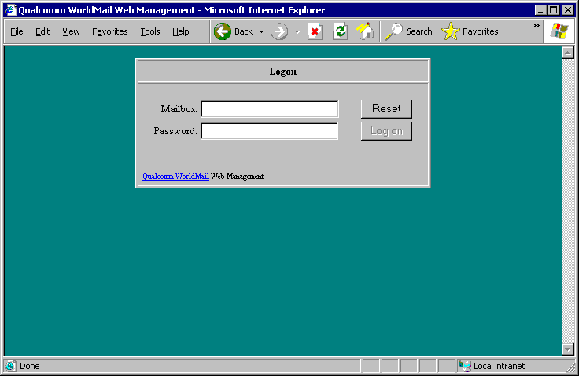
Enter your e-mail address and password. Your e-mail address consists of the name of your mailbox, the @ character, and the name of your mail domain. If your mailbox is in the default domain, then you can omit your mail domain.
Your privilege level determines whether you can administer your own mailbox, other mailboxes in your domain, or mailboxes in all domains. Your privilege level also determines which mail lists you can administer. The Privilege Level is a property of your mailbox and is set in the Mailbox General form. The choices are Server, Domain, or None.
If your privilege level is None, then you will be logged onto your Mailbox Properties form. You can set all of your mailbox properties using this form (except your privilege level). You can also administer mail lists that you moderate.
If you have Domain privilege, then you will be able to add, delete and modify mailboxes and mail lists in your own domain. If you have Server privilege, then you will be able to add, delete and modify mailboxes and mail lists in all domains. Refer to the Web Management Center Reference section for more information.
#$K+ Mail Lists
KMail Lists allow messages to be easily distributed to groups of users. By using a mail list, you can broadcast a message to all members of the list by sending it to a single e-mail address. This is useful in a number of scenarios, such as:
- Broadcasting a news letter to subscription list
- Hosting an e-mail based discussion forum.
WorldMail includes an integrated mail list processor to provide this capability. This section explains how to perform common mail list tasks, how mail lists work, and how to use the list processor commands.

#K Types
KWorldMail supports five types of Mail Lists, which each use a different method to store membership information.

 Registry Lists K K store list membership in the NT registry. You can add and remove members through the Management Center or by SUBSCRIBING and UNSUBSCRIBING.
 NT Lists K K derive list membership from an NT Group. Use this type of list if you want to send mail to all users of a particular NT Group in your domain.
 Text File Lists K K store list membership in a text file. You can add and remove members through the Management Center or by SUBSCRIBING and UNSUBSCRIBING, or by editing the text file directly. Use this type of list if you want greater flexibility in changing list membership.
 Database Lists K K read list membership from a table or view in an ODBC database. You must maintain list membership with your database program outside of WorldMail. Use this type of list if you want to include membership information from an existing database. This is also the ideal list type if you want to create a web-based tool for subscribing and unsubscribing users from lists.
 Server Lists K K derive list membership from selected mailboxes on the server itself. Use this type of list if you want your mail list to broadcast messages to all users on your server, all users in a particular domain, or all users of a particular privilege level (Server, Domain, or None). Server Lists also include filters that allow certain mailboxes to be excluded from these lists.

#K How Mail Lists Work
When WorldMail receives a message it checks the domain name component in the To: address. If the domain name corresponds to a domain registered on your server, WorldMail assumes the message is for a local user or for a mail list. It checks the list names to see if a list with a matching name exists. If so, the message is temporarily delivered to that list directory.
Note that if a mailbox has the same name as a mail list, messages will be sent to the mailbox and not to the mail list. Refer to the section on Delivery Precedence for more information.
WorldMail will explode messages delivered to the mail lists by sending them onward to all list members. It handles messages delivered to -request directories by parsing them for commands and creating a journal file that it then returns to the sender.

#K Mail List Tasks

#K Creating a Mail List K
Use the Mail Lists Folder in the Management Center program to create a new mail list in a specific domain. Messages addressed list@host.domain.com will be sent to members of this new mail list.

#K Joining a Mail List K
Anyone can join a WorldMail mail list. To join a list called info, send a message to info-request@host.domain.com containing:
- SUBSCRIBE
or
- JOIN
as the first and only line in the message body. WorldMail will respond with a message indicating success or failure.
If a list is moderated and Moderator Control Join is enabled, any SUBSCRIBE request will be forwarded to the moderator. The moderator can determine whether the subscription request should be permitted, and if so can add the address to the list of members.
If you wish to subscribe under an alias e-mail address, include a Reply-to: header in your mail message. This is the address that will be subscribed to the list and the response to your command will be sent to that address.

#K Leaving a Mail List K
Leaving a list is similar to joining a list. To leave a list called info, send a mail message to info-request@host.domain.com containing:
- UNSUBSCRIBE
or
- LEAVE
as the first and only line in the message body. If a list is moderated and Moderator Control Leave is enabled, any UNSUBSCRIBE request will be forwarded to the moderator. The moderator can determine whether the unsubscription request should be permitted, and if so can remove the address manually.
If you have changed your mail address, and wish to unsubscribe your old address subscribing your new address, then include a Reply-to: oldname@old.domain.com header in your mail message. oldname@old.domain.com will be removed from the list (but the response to your command will be sent to that old address).

#K Removing a Mail List
To remove a mail list, use the Delete button in the Mail Lists Folder of the WorldMail Management Center.

#K Creating a Digest List
K KSuppose you've created a popular mailing list called cars, which receives 10 or 20 messages per day. There may be people who would like to subscribe to the list, but don't want to receive every message the moment it is sent. You can set up a digest mail list (in this case, cars-digest) which accumulates all the messages received in one day and sends them in a single message.
With WorldMail, you create a digest mailing list that is associated with an existing WorldMail mailing list. To do this, select the Mail List folder in the Management Center. Select the domain containing the list you want to create a digest for, and use the normal list-creation mechanism to create a new mailing list. Assign the same name as the existing list with the word -digest appended to it. So if you want to create a digest list for an existing list called discuss, create a new list called discuss-digest. The -digest postfix tells WorldMail to treat the list specially.
As far as the mail list subscriber is concerned, the digest list can be subscribed to and unsubscribed from just like other mailing lists. For instance, to subscribe, the user would send a JOIN command to discuss-digest-request@myco.com. Note that a digest mailing list must be in the same domain as the list that it digests.
You cannot submit messages to the digest list. Any attempt to do so will result in a non-delivery message being returned. Messages must be submitted to the main list (discuss@myco.com).
When you open the properties for a digest list in the Management Center, you will find that there is an extra page called Digest. You can use this page to control the extra properties of the digest list.
In the List General Page, you will find that the fields relating to list moderation have been disabled. This is because list moderation is not necessary for digests.
Also in the List General Page, the function of the Maximum message size field is slightly different for digest lists. If this is non-zero, then messages will be accumulated until the maximum size is reached, or the normal digest accumulation period is reached (whichever is sooner).
If a mail list has a digest, you can use the Members and digesters radio button to specify that members of the list itself and members of the digest list may both submit messages to the list.

#K Mail List Processor Commands
K KCommands understood by the mail list processor are as follows.
HELP K | Replies with a help message
JOIN K [listname] [address] | Subscribe to mailing list
LEAVE K [listname] [address] | Unsubscribe from mailing list
STOP K | Stop processing commands  (e.g. to avoid processing a signature)
SUBSCRIBE K [listname] [address] | Subscribe to mailing list
UNSUBSCRIBE K [listname] [address] | Unsubscribe from mailing list
REVIEW K | Request a membership listing
The extended form of the JOIN and LEAVE command using the [listname] [address] is disabled by default. It can be enabled through the List Security Page. The [address] can be in any valid RFC822 form.
The REVIEW command is available to the list moderator if enabled on the List Security Page.

#K List Processor Examples
Here are some example extended JOIN and LEAVE commands. Note that SUBSCRIBE and UNSUBSCRIBE are synonyms for JOIN and LEAVE.
JOIN thelist "John Smith" jsmith@myco.co.uk
LEAVE thelist smith@domain.com (Joe Smith)
SUBSCRIBE thelist Jane Doe <janed@super-isp.net>
UNSUBSCRIBE thelist peter@my-university.edu

#K List Agent
K K KA message to a mailing list (or to a mail list's -request address) may be pre-processed by an external program before being acted upon by WorldMail. The external program must be a command-line program or a batch file. It must not be an interactive program (i.e. requiring user keyboard input), nor may it be a Windows program. It must be efficient and must terminate reasonably quickly, since WorldMail will not process any other list messages while it is running.
Mailbox agents can be used to implement a wide range of features. Some examples are:
- A program that filters LEAVE and UNSUBSCRIBE messages
- A program that checks a mail message for offensive language
- A program that provides additional mail list processor commands
- A program that implements additional mail loop prevention techniques

#K Mail List Directories
K KWhen WorldMail receives a message addressed to a mail list in one of it's local domains, the message is temporarily delivered to an appropriate subdirectory under the lists directory.
For example, suppose the mail spool directory is C:\Program Files\QUALCOMM\WorldMail\SPOOL. WorldMail will automatically create a subdirectory called lists. Inside this lists directory, there will be two subdirectories for each mail list in the default domain: one for messages to the list itself, and one for messages to the list-request address. Subdirectories will also be created for each virtual domain to contain the list directories for lists within those domains. Thus, if there is a list called staff in the default domain, and there is another list called chat within the virtual domain xyz.com, then the directory structure would be:
C:\Program Files\QUALCOMM\WorldMail\SPOOL\lists
C:\Program Files\QUALCOMM\WorldMail\SPOOL\lists\staff
C:\Program Files\QUALCOMM\WorldMail\SPOOL\lists\staff-request
C:\Program Files\QUALCOMM\WorldMail\SPOOL\lists\~xyz.com
C:\Program Files\QUALCOMM\WorldMail\SPOOL\lists\~xyz.com\chat
C:\Program Files\QUALCOMM\WorldMail\SPOOL\lists\~xyz.com\chat-request
These directories are created automatically by WorldMail as needed. Note that domain subdirectories are preceded by a tilde (~), to distinguish them from list directories. Mail list names may not contain a tilde.
Messages are only held briefly in these directories, so you will typically find them empty. However, you may place certain files in these directories, which will affect how WorldMail deals with mail list messages. Refer to the section on List Messages for details.

#K Mail List Content Moderation
K KContent Moderation is a feature that allows mail list moderators to approve or reject messages sent to a mail list. This level of list administration requires that the user have an account in a local domain. To enable this feature, select the Moderator controls content feature in the List General Page.
When a new mail list message arrives to WorldMail, it will first be checked to see if its author may post to the list. If the author does not have posting permission (e.g. if he is not a member of the mail list and the mail list is set to disallow posting by non-members), the message will be returned to the author with an appropriate rejection message. If the author does have permission, delivery processing depends on whether content moderation is enabled for the list.
If content moderation is enabled, then the message will be placed in the pending directory for that list. If content moderation is not enabled, then the message is placed directly into the mail list directory. List messages will remain in the pending directory until one of the mail list moderators logs in to the Web Management Center and select the Review page to review pending messages. Messages may be reviewed, and rejected, accepted or discarded where appropriate.
Refer to the section on the Web Management Center for more information.

#K Archiving List Messages
K KMessages sent to a mail list can be archived in HTML format so that they can be read through a web browser. Use the Web Archive mail list property page to enable this feature. When viewing a mail list archive, users can sort messages by sender, subject, date, or message thread:
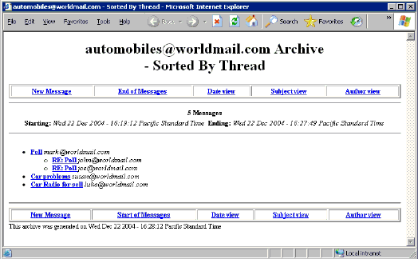

The format of the web archive is controlled not only by the settings on that property page, but also by Archive Template files. For more information on customizing mail list archiving, see the appendix on Customizing Mail List Archiving.

#$K+ Domains
KWorldMail allows you to receive messages addressed to multiple domains on a single server. This section discusses the steps you should follow to configure this feature.

#K Selecting the Domain Type
KBefore creating an additional domain, you need to understand which type of domain you want. There are three types of domains: Synonym Domains, Virtual Domains with Separate IP Addresses, and Virtual Domains with Shared IP Addresses.

#K Synonym Domains K K
Use Synonym Domains if you wish to deliver messages addressed to multiple domains into mailboxes in one domain. For example, you may receive messages for joe@mail.abc.com and joe@abc.com but wish to deliver them to mailbox joe in the default domain abc.com. The following restrictions apply:
- The DNS record for each domain must point to the IP address of the domain
- Users can login as joe or as joe@domain.com
- The WorldMail services will display the name of the default domain in the greeting message
For more information about the way that synonym domains affect the way the WorldMail delivers mail, see the section on Delivery Precedence.

#K Virtual Domains with Separate IP Addresses K K
Use this configuration if you wish to create true virtual domains on your mail server. All of the mailboxes and mail lists will be created and managed separately under each domain. If you are an Internet Service Provider and you are hosting e-mail services for many business customers on a single server, then you may wish to choose this option. The following restrictions apply:
- You must have one IP address available for each domain
- The DNS record for each domain must point to the correct IP address
- You can have a separate postmaster for each domain
- Users can login as joe or as joe@domain.com
- The WorldMail services will display the name of the virtual domain in the greeting message

#K Virtual Domains with a Shared IP Address K K
Use this configuration if you wish to create virtual domains on your mail server. All of the mailboxes and mail lists will be created and managed separately under each domain. If you are an Internet Service Provider and you are hosting e-mail services for many business customers on a single server, then you may wish to choose this option. The following restrictions apply:
- All domains can share a single IP address
- The DNS record for each domain must point to the single IP address
- You can have a separate postmaster for each domain
- Users must login as joe@domain.com or joe%domain.com
- Some e-mail clients do not support logging in as joe@domain.com. WorldMail has implemented an alternative joe%domain.com to work around this limitation.
- The WorldMail services will display the name of the default domain in the greeting message

#K Setting the Default Domain Name
K KThe Default Domain is identified in the WorldMail Management Center by a gray folder with a red dot. You can rename the Default Domain by selecting the domain, clicking on the right mouse button, and selecting Rename.
If you wish to receive mail addressed to joe@abc.com and have it delivered to mailbox joe in the default domain, then you must set the name of the default domain to abc.com.

#K Creating the DNS Entries
KEnabling WorldMail to receive messages for multiple domains begins with your DNS configuration. You must create MX or A records in your DNS server for each domain. Each DNS record must resolve to the correct IP address. The IP address may be different if you selected domain option (2).
The TCP/IP addresses for your computer are maintained through the Network icon in the Control Panel. See the DNS Overview section for more information on configuring your DNS server.

#K Adding the Virtual Domains
If you selected domain option (2) or option (3), then the next step is to add a complete list of the domain names. You do this in the Domains folder in the WorldMail Management Center. If you selected option (2), then you must associate an IP address with each domain. Do this by double-clicking on the Domain Properties Folder and setting the IP Address.

#K Adding the Mailboxes
Every user in each domain must have a unique mailbox. Create the mailboxes using the Mailboxes Folder in the WorldMail Management Center. To create mailboxes in one of the virtual domains, select the name of the domain in the tree view.

#$K+ Forwarding Domains
WorldMail can also be used as an SMTP gateway to relay mail to and from other email servers. Once you have your domain created and your DNS configured properly, you can specify the mail server you want to forward mail to by entering this hostname in the Domain Properties: Relay Host option through the WorldMail Admin Management Center.

#K Testing the Configuration
WorldMail should be ready to send and receive mail for all of the domains at this point. Use an e-mail client to verify this. If you have problems, check the Troubleshooting section.
#$K+ Aliases
KAn alias is a rule that redirects messages sent to an address in a domain hosted by WorldMail to another address. Aliases can be configured in WorldMail Management Center by double clicking on the Aliases icon within the server's Services folder. The following dialog will be displayed:
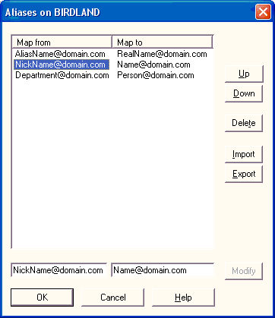
When WorldMail processes a message, it first checks the addressee's name against this list. If a matching entry is found, the message will be redirected to the replacement address that is specified in this table.

#K Setting up an alias
In the Map from field (bottom left), type the address that you wish to redirect (for example, jane@mycompany.com). In the Map to field (bottom right), type the address to which messages should be sent (for example, j.smith@abc.com) . Then click the Add button. Once this alias is added, any message sent to jane@mycompany.com will be redirected to j.smith@abc.com.
If you omit the domain part from the Map from field, the default domain is assumed. Note that the domain name of the Map from field must be the name of a virtual domain, or of the default domain. You cannot use the alias mechanism to redirect mail addressed to a recipient elsewhere on the Internet.

#K Deleting an alias
Select one or more aliases in the list box and click Delete.

#K Wildcard aliases
KYou can specify wildcards in the Map from field. This can be used to redirect mail for all names matching a pattern. For instance, specifying T*Y would match Tony, Tiny, toby, terry, etc. (Note that matching is not case sensitive.)
You can also specify a single wildcard as the first character of the Map to field. This will be replaced by the actual addressee's name when the table entry is used. For instance, if the Map from is f* and the Map to is *-blue@abc.com, then a message for fargle@thismachine.mycompany.com will be redirected to fargle-blue@abc.com

#K Map table order
The order of entries in the map table is significant. It is processed top-to-bottom, and the first matching entry is used. Thus, more specific entries (i.e. those not containing wildcards) should be positioned near the top of the list, and less specific entries (those containing wildcards) towards the end of the list. Use the Up and Down buttons to move entries around.

#K Importing and Exporting
The list of aliases may be exported and imported to and from text files using the Export and Import buttons.

#K Aliases versus Synonym Domains
K KSynonym domains are discussed in the preceding section. There is some similarity between synonym domains and aliases. For example, an alias of the form
- *@xyzcompany.com -> *@xyz.com
has the same effect as a synonym of xyzcompany.com for the virtual domain xyz.com.
The advantage of using synonym domains comes when you need to use aliases in addition to them. For example, if you have synonyms of abccompany.com and abcinc.com for the virtual domain abc.com, you can alias an individual user (say jim@abc.com) to another address using a single entry in the alias table such as:
- jim@abc.com -> james.smith@abc.com
Because synonym domains affect aliases the same way that they do mailboxes, the addresses jim@abccompany.com and jim@abcinc.com are synonymous with the alias jim@abc.com shown above.
#$K+ Delivery Precedence
WorldMail delivers messages to destination recipients based on an address precedence order. WorldMail matches the To: address in this order:
1. Aliases K
2. Mail Lists
3. Mailboxes
If a match is not found among these address types, the message will be delivered to a catchall K K mailbox (if one exists), or rejected by WorldMail. The following diagram illustrates these delivery precedence rules in action:
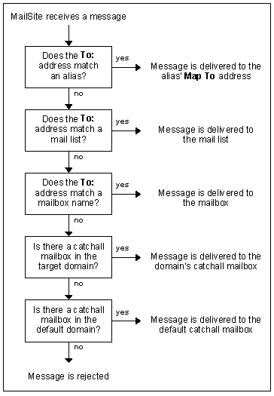
#$K+ Intermittent Connectivity
WorldMail supports mail servers that do not have a full time Internet connection. This is useful in two situations:
- WorldMail is used as a central mail hub for dialup satellite mail servers.
- WorldMail is used as a satellite mail server with a dialup connection to an ISP or a central hub.

#K Central Hub with Dialup Satellite Servers
KThe SMTP Receiver supports the ETRN K command, defined in RFC 1985, which allows a remote client to request delivery of mail queued for it's domain. The MSSTART K utility connects to a mail server and uses the ETRN command to initiate a mail download. An intermittently connected satellite server can initiate delivery of mail queued for its domain by establishing a TCP/IP connection and then running MSSTART.

#K Dialup Satellite Server
WorldMail can be configured to dialup to the central hub on a predefined schedule. Once connected, WorldMail can deliver any queued outgoing mail and can trigger delivery of any queued incoming mail.
Delivery of incoming mail can be triggered in one of two ways:
- If the central hub is configured as a SMTP relay for the satellite, and it supports the ETRN command, then the MSSTART command will trigger incoming delivery.
- If the central hub is configured to deliver all mail for the domain into a single POP mailbox, then the MSPOP K command will pickup the mail and redistribute it to local mailboxes.
The dialup schedule and the incoming delivery trigger are set in the Time Of Day window in the WorldMail Management Center. A batch file can be run as the incoming delivery trigger if MSSTART or MSPOP must be executed multiple times.

#K Mail Delivery Schedules
KWhen WorldMail attempts to deliver a message to a foreign domain (i.e. a domain other than the default domain or a virtual domain), it may encounter a number of problems. For example, the mail server for that domain may be down or otherwise temporarily inaccessible, or the server may not have enough disk space for the message.
A temporary delay of this nature will not cause the message to be treated as undeliverable. Instead, WorldMail will store the message on disk (in the holding directory), and try again at some later time. Eventually, if the message still cannot be transmitted after a reasonable time, it will be treated as undeliverable. The Delivery Schedule Management Ktells WorldMail when to attempt delivery of such stored messages.
WorldMail supports two types of mail delivery schedules:
- The Elapsed Time Schedule. K Under this schedule, attempts to contact a domain will be made at a series of pre-configured intervals, commencing from the time at which the message was received.
- The Time-Of-Day Schedule. K Under this schedule, attempts to contact a domain will be made at specific, configurable, times of day.
You can control which destination domains use which kind of schedule. You can also force all domains to use Time-Of-Day Schedule by specifying !* in the Delivery Schedule Management dialog.
The elapsed time schedule is ideal when WorldMail has a continuous, uninterrupted connection to the Internet. The time-of-day schedule is more appropriate when the Internet connection is intermittent - typically, a dialup connection.
You can also request WorldMail to attempt immediate delivery of all messages for one or more domains.
WorldMail can manage a dialup connection for you, if you so wish. Refer to the next section for more information.
Mail delivery schedules are managed through the Schedules Folder in the Windows Management Center. Refer to Schedule Management in the Windows Management Center Reference section for more information.

#K Dialup Support
The WorldMail supports dialup connectivity to the Internet through the Microsoft Remote Access Service (RAS). This allows a computer running WorldMail to dial into an Internet Service Provider (ISP) to exchange mail on a predetermined schedule.
In order to use the dialup support, you must install RAS. See the Microsoft documentation concerning RAS installation. You will need to create at least one RAS phonebook entry, containing the phone number of your ISP. Before configuring the dialup support in WorldMail, check the basic RAS setup by dialing out to your ISP using the Dialup Networking tool provided with RAS. If this does not work, WorldMail will not be able to dial out.
Dialup support in WorldMail works like this: At regular intervals (which you can configure), WorldMail dials your ISP. Once connected, it will execute a command to request the ISP's mail server to send mail to WorldMail. It will also attempt to deliver outgoing mail through the normal WorldMail mail routing mechanism (i.e. the DNS and the manual routing table). If you wish, you can configure the manual routing table such that all outgoing mail is routed to your ISP's mail server for it to forward--this may help reduce the time spent connected. When there is no more outgoing mail to send, and there are no incoming connections, the dialup connection will be closed and the phone disconnected.
Refer to Schedule Management in the Windows Management Center Reference section for more information.
#$K+ Backup

#K Performing a Comprehensive Backup
KTo perform a comprehensive backup of your WorldMail post office, you need to save several components:

#K Registry Configuration
When run with the Registry connector (the default mode), WorldMail stores all of its settings in the Windows Registry of your server.
WorldMail comes with a utility, MSBACK, that you can use to backup your registry configuration data to a text file. This file can then be included in your backup schedule. We highly recommend that you run this command in your daily backup script. Refer to the Utilities Appendix for more information on MSBACK.

#K Spooled Mail Messages K
These files are located in the directories specified in the Directories dialog in the WorldMail Management Center. All of these directories, together with any lower level directories, should be included in your backup schedule.

#K Mailbox Directories K K
These directories store e-mail messages for the mailboxes on your system, and are located in the mailbox root directory for each domain. The mailbox directory is defined in the General page of the Domain Properties window. All mailbox directories should be included in your backup schedule.

#K Directory Store Database
If you are using SQL mailboxes, you should also backup the SQL Server database file that contains account information.

#K Transferring WorldMail to another computer
If you need to transfer your WorldMail installation to another computer, you can do so by following this procedure:
- Install the same version of WorldMail on the destination computer
- Stop the WorldMail services on the source and destination computers
- Run MSBACK K on the source computer to save the configuration to a text file
- Copy the text file to the destination computer
- Edit the text file using NOTEPAD
- Search for InstallDir, MailInBoxDir, MailLogDir and MailSpoolDir
- Verify that these directories are correct on the destination computer
- Run MSBACK to restore the configuration on the destination computer
- XCOPY the spool and mailbox directories from the source to the destination computer
- Reconfigure the DNS records to point to the IP address of the destination computer
- Check the configuration on the destination computer using the Management Center
- Start the WorldMail services on the destination computer
- Test the destination server by sending a message to yourself with your mail client
Refer to the Troubleshooting section if you have problems getting the destination server to work correctly. Refer to the Utilities Appendix for more information on MSBACK.
#$K+ Security
KInternet messaging protocols depend on messages, user names, and passwords that are mostly transmitted in clear text over TCP/IP connections. Without special configuration, the SMTP protocol allows unscrupulous Internet users to illegally relay messages through your server or send messages in bulk to mailboxes on your server. As the administrator of this system, you need to be aware of these security issues. This knowledge will help you set acceptable security policies for your site and configure your WorldMail server accordingly.

#K Message Store Security
Mail messages and log files are stored on the file system on the WorldMail server in plain text format. Mail messages may contain confidential information and log files may contain user names and message contents. We recommend that you take the following steps to prevent unauthorized access to these files:
- Store mail messages and log files on an NTFS partition.
- Use the File Manager or Windows Explorer to ensure that only the Windows account that the WorldMail services run as has access to these files and directories. If you installed using the Simply security policy, WorldMail runs as the SYSTEM user. If you installed using the Secure policy, WorldMail runs as WorldMail-user (or whatever account was specified during installation).

#K Password Security
In most cases, mailbox passwords are transmitted in clear-text over the network. It is possible for an unscrupulous computer expert to "sniff" the password by watching the TCP/IP packets pass by over the network. This risk is increased if your users are logging in to WorldMail from a remote Internet site.
Passwords are exposed in the following transactions:
- Checking mail from a POP or IMAP client.
- Changing the password from a POP or IMAP client.
- Logging in to the mailbox from a Web Browser.
- Changing the password from a Web Browser.
There are a few precautions that you can take to minimize these risks:
- Use APOP, AUTH and AUTHORIZE to logon whenever possible. These commands provide a method by which a POP3 or IMAP4 client can log into the server with an encrypted password. If you POP3 or IMAP4 client supports this capability, then we recommend that you use it.
- Change Passwords regularly. It is good practice to establish a procedure that requires that your users change their passwords on a regular basis. This minimizes the exposure to sniffed passwords. You can use the WorldMail Password Server to do this if your mail client supports this capability.
- Do not create Mailboxes for NT Administrators. Your exposure is magnified if you create a WorldMail mailbox based on an NT User with Administrative privileges. If the password for this user is sniffed then your whole NT Server is compromised. You can use WorldMail Aliases and Auto Forwarding capabilities to forward incoming mail for administrative users to a secure Registry Mailbox. The drawback of this configuration is that the administrative users will have to maintain two passwords.
- Track Login Failures with the Performance Monitor. You can use the Windows NT Performance Monitor to keep track of failed login attempts. This is useful to monitor password hacking attempts on the POP3 and IMAP4 servers. See the Performance Monitor section for more information.

#K WorldMail Security
WorldMail includes numerous security features that allow you control the flow of mail to your site. These include features to block junk email (a.k.a., "spam"), combat third-party relay, and verify the identity of end users who send mail through your site. Setting proper security policies is one of the most important tasks for email administrators, and is crucial for those whose mail server systems are accessible from the Internet.
WorldMail Ksecurity settings are invoked by double clicking on the Security Properties icon in the WorldMail Management Center. You can also use an Anti-Relay Wizard and Anti-Spam Wizard to assist you in setting these policies.
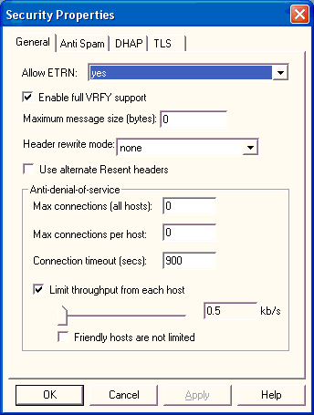

#K General Security Settings
Included among the options in the General Security Properties window are the following general security preferences:

#K Enable full VRFY support K
By default, an SMTP command of the form VRFY name@domain.com will return a "success" response if the server will accept mail for domain.com, regardless of whether the name is valid. If you check the Enable full VRFY support box, then the command will only succeed if name@domain.com is a valid mailbox or a mail list (or is an alias). If you leave this box unchecked, it reduces the amount of information an attacker or spammer can find out about your users. For that reason, it is recommended that you do not enable this option.

#K Authenticated ETRN K
The SMTP ETRN command is used to request an SMTP server to start sending mail for a particular domain. (This command is used by the MSSTART utility.) If you check the Authenticated ETRN option, then the SMTP client must be authenticated (using the AUTH command with a valid mailbox name and password), otherwise the ETRN command will be rejected.

#K Maximum Message Size K
The maximum message size in bytes that the SMTP Receiver will accept. The default is 0, which means that there is no size limit (apart from memory and disk space constraints). To prevent excessively large messages from impacting your system, it is recommended that you set this value to 10 MB (10,000,000 bytes) or less.

#K Anti-Denial of Service Policies
In addition to spam and relaying, denial-of-service (DoS) attacks are a significant threat to the smooth operation of a mail server. DoS attacks involve one or more systems bombarding your SMTP server with millions of connections and/or messages. These attacks can cause you mail server system to perform very poorly as it tries to cope with the exceptionally high loads.
WorldMail includes policies that allow you to contain DoS attacks to prevent them from overwhelming your server system. The anti-DoS features provided in the WorldMail Security window are the following:

Max connections (all hosts)
This setting provides a limit to the total number of incoming SMTP connections that WorldMail will respond to at any time. When this number of connections are active, SMTPRA will no longer accept new connections until a current connection has been closed.

Max connections per host
This setting limits the number of incoming SMTP connections allowed from any one system. When this number of SMTP connections from any one host are active, SMTPRA will no longer accept new connections from that host. This option is very useful for containing potential damage from an abusive system without blocking incoming connections from other (non-abusive) systems.

Connection timeout
This option sets a limit to the number of seconds that WorldMail will keep open a non-responsive SMTP connection.

Limit throughput from each host
This option provides a throttle on the amount of data (in kilobytes per second) that SMTPRA will accept from any one host. This allows you to control DoS attacks that send large amounts of data over relatively few connections. When using this option it is recommended that you exempt your "friendly" hosts from this limit to avoid slowing mail traffic from your own network.

#K Anti-Spam Policies
KWorldMail's anti-spam policies allow you to block mail from specific hosts or users, and include the following options:
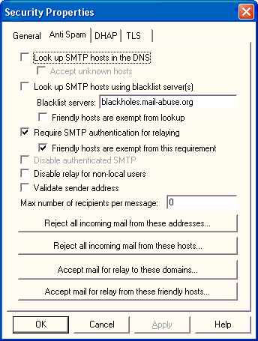
- Block mail from unknown hosts. Most legitimate sources of email are hosts that can be located in the DNS. In other words, these machines are well-established and correspond to known host.domain names. Many systems used to distrubute spam are not defined in the DNS, and are accessible only through TCP/IP address (i.e., 12.34.56.78). Be aware that blocking mail from unknown hosts is a very conservative policy and may lead to legitimate mail being blocked from your users.
- Block mail from blacklisted hosts. Sources of high-volume spam are tracked by Kblacklist services, which provide lists of sites that have been responsible for such mailings. WorldMail allows you to block all messages from hosts named by a blacklist service, and also allows you to select the blacklist service you wish to use. The default service is the MAPS Realtime Blackhole List (RBL). Use of this feature is recommended for ISP sites.
- Block mail from specific hosts. In addition to unknown hosts and blacklisted hosts, you can block mail from any other source. You can choose to block mail from servers based on hostname or IP address. As with other blocking methods, this prevents the named system from sending any mail - spam or otherwise - to your site, so it should be used conservatively.
- Block mail from specific users. Mail can also be blocked from specific users, as defined by the envelope return address (MAIL FROM). This option is particularly useful if one or more specific users are sending junk mail to your users. When blocking addresses, you can use wildcard notation (*@domain.com) to block mail coming from all addresses within a domain.
- Set maximum recipients per message. Because spam is typically sent to large numbers of users, setting a maximum on the number of recipients per message allows you to combat mass mailings. When you set a limit to the number of recipients, messages sent to more than this number of addresses (as given by the RCPT TO command) will have all recipients after the maximum number rejected. For example, if you set a maximum of 20, and a message arrives for 50 of your users, only the first 20 users will receive the message.
All of these policies can be set in the Anti-Spam tab of the Security Properties window. WorldMail also provides an Anti-Spam wizard that leads you through the process of implementing an anti-spam strategy for your site. Using the wizard is highly recommened, particularly for new users. For more information, double-click the Anti-Spam Wizard icon in the WorldMail Management Center's Server folder.
Experienced users can also use mask lists to specify hosts and addresses which should be blocked from sending mail to your site. These lists can be opened from the Anti-Spam Tab of the Security Properties window by clicking the buttons Reject all incoming mail from these addresses, and Reject all incoming mail from these hosts. See the following section on Advanced SMTP Security for more information.
Mail Filters (described in the following chapter) provide an additional mechanism to combat spam. Filters allow you to search the contents of the message (headers, body, and attachments) for specific content and block it from entering your system. For example, using filters you can reject all mail that contains the subject "Make money fast!", regardless of the host used to send the mail.

#K Anti-Relay Policies
KAlong with spam, mail administrators must contend with a type of abuse known as third-party relay. Relay occurs when your mail server accepts a message addressed to another site and sends it to the proper destination. Third-party relay is a scenario in which a distributor of junk mail uses another site's mail server to distribute his/her mass mailing. This can result in a loss of your network resources and can even cause your site to be blacklisted as a source of spam.
To combat third-party relay WorldMail includes policies to restrict relaying, including:
- Require SMTP authentication for relay. The simplest technique for combating third-party relay, this option requires that users provide a login name and password that matches a mailbox on your site before they are allowed to relay mail to other sites. You can also specify that users connecting from "friendly" sites (for example, your own network) are exempt from this requirement.
- Allow relay only from specific hosts. This option specifies the hosts from which relay is allowed. Typically, this is a range of IP addresses that correspond to your own network. When relay is allowed only from your own network, third-party relay from outside your network is prevented.
- Disable relay for non-local users. This option disallows relay if the return address of a message is not within one of your domains.
- Require valid return address for relay. This option disallows relay if the return address of a message contains an unknown domain (or a domain for which no mail records exist in the DNS).
- Allow relay to specific domains. This option allows WorldMail to accept relay for specific domains, such as friendly sites. This allows you to set strict relay-prevention policies while still allowing delivery to domains for which your site is a gateway.
As with anti-spam features, all of these relay policies can be set in the Anti-Spam tab of the Security Properties window or with a wizard. Because of the complexities of relay, it is highly recommended that administrators use the Anti-Relay Wizard to set these policies. For more information, double-click the Anti-Spam Wizard icon in the WorldMail Management Center's Server folder.
Experienced users can also use mask lists to specify hosts and addresses for which relay is allowed or disallowed. These lists can opened from the Security window by clicking the buttons Accept mail for relay to these doimains, and Accept mail for relay from these friendly hosts. See the following section on Advanced SMTP Security for more information.

#K SMTP Authentication
KAs described above, SMTP autentication is one of the best ways to combat third-party relay because it requires that relay is permitted only for authorized users of your site. Because it requires a login name and password, SMTP authentication makes relay as secure as POP3 and IMAP4 mailbox access. However, this option requires that your users have mail clients that support SMTP authentication, which is not included with all clients.
When using SMTP authentication, you can also specify that users are exempt from this requirement if they are within your own network (or from other specific hosts). This allows you to support your dial-up users whose mail clients do not support SMTP authentication.

#K Directory Harvest Attack Protection (DHAP) Settings
WorldMail provides a mechanism for identifying a directory/dictionary harvest attack or DHA (otherwise known as email harvesting) and preventing the attack from continuing for a "block duration" configurable in the WorldMail Management Center. When the block duration expires the host regains access but may be blocked again.
When a host is deemed a harvester its IP address, host name, the time of blocking, block duration and the total number of times blocked is written to the SMTPRA log and the host is disconnected.
You may wish to permanently block an IP address that has been identified as a harvesting address using the "Reject all incoming mail from these hosts option" in the SMTP security dialogue or by using your firewall.
DHAP settings are invoked by clicking on the DHAP Settings tab in the Security Properties dialog in the WorldMail admin Management Center.
For more information on how to configure WorldMail DHAP settings, please refer to the Windows Administration Management Center section of this manual.

#K Advanced SMTP Security
When setting up SMTP security features you can use the Anti-Spam and Anti-Relay wizards to easily set these policies. If you want greater control over SMTP security, you can also modify certain settings directly through the Security window. This section provides information on manually setting spam and relay policies through the use of mask lists.

#K Using the mask lists
If a call comes in to WorldMail's SMTP server from a host whose name, IP address, or EHLO identification matches the Reject all incoming mail from these hosts list, then all attempts by that host to transfer mail to WorldMail will be rejected when the client issues the MAIL FROM command. (Note that you should check the Lookup SMTP hosts in the DNS box to get maximum benefit from this feature.)
If a connection comes in to WorldMail from a host that does not appear in the Accept mail for relay from these friendly hosts list, then WorldMail will refuse to accept mail from that host for recipients other than local mailboxes, unless the destination mail domain appears in the Accept mail for relay to these domains list.
If a MAIL FROM: command is issued with an e-mail address that appears in the Reject all incoming mail from these addresses list, the MAIL FROM command will be rejected.

#K Spam Policies
When SMTP mask lists are enabled, WorldMail uses these masks to define a spam policy for each SMTP connection. These policies define which (if any) messages will be accepted during the SMTP session. The spam policies used by WorldMail are:
- AcceptAllMail, which causes all messages to be accepted regardless of sender and recipient.
- AcceptLocalMailOnly, which causes messages to be accepted only if they are addressed to mailboxes or mail lists within your WorldMail domains.
- RejectAllMail, which causes all messages to be rejected regardless of sender and recipient.
- RejectAllMailFrom, which causes messages to be rejected only if they are from one or more specific users.

#K Procedure when receiving mail
The procedure that WorldMail follows to determine what to do with incoming mail is as follows:

Connection establishment
When the client establishes an SMTP connection, WorldMail does the following:
- If so configured, will look up the client IP address in the DNS, and record the host name.
- If so configured, will look up the client IP address in the given blacklist service.
- Accept the connection by replying with the normal greeting message.

EHLO command
When an SMTP client sends an EHLO or HELO, WorldMail determines the spam policy for the connection as follows:
- If the DNS reverse lookup failed, and the Accept unknown hosts flag is not set, the spam policy is RejectAllMail.
- Otherwise, if the blacklist lookup succeeded, the spam policy is RejectAllMail.
- Otherwise, if the client's IP address/host name/EHLO identification is in the Reject all mail from these hosts list, the spam policy is RejectAllMail.
- Otherwise, if the client's IP address/host name is in the Accept for relay from list, the spam policy is AcceptAllMail.
- Otherwise, the spam policy is AcceptLocalMailOnly.

AUTH command
At this point in the conversation the client may choose to authenticate using the AUTH command. If the spam policy was AcceptLocalMailOnly, and authentication succeeds, the spam policy becomes AcceptAllMail.

MAIL FROM command
When the client sends the MAIL FROM command, WorldMail performs the following:
- If the spam policy is RejectAllMailFrom, it rejects the command with a 5XX response code and an appropriate text message.
- If the Disable relay for non-local users box is checked, it determines whether the return path corresponds to a local mailbox or alias. If not, or if the return path is empty, the spam policy (for this message only) is AcceptLocalMailOnly.
- If the supplied return path is in the Reject all mail from these addresses list then it rejects the command with a 5XX code and appropriate text message.
- If the Validate sender address box is checked, it looks up the domain of the supplied return path in the DNS to check that it has a valid A or MX record. If not, it rejects the command with a 5XX code and appropriate text message.
- Otherwise, it accepts the command.

RCPT TO command
When the client sends a RCPT TO command, WorldMail does the following:
- If the number of recipients exceeds the configured limit, it rejects the recipient with a 5XX reply code and a suitable text message.
- If the recipient address is not local and the destination domain is not in the Accept for relay to list, and if the spam policy is AcceptLocalMailOnly, then the recipient is rejected with a 5XX reply code and a suitable text message.
- Otherwise, accept the recipient.

#K Security Examples
Here are examples of how to use the Reject all incoming mail from these hosts, Accept mail for relay from these friendly hosts and Accept mail for relay to these domains features for certain situations:

Organization with permanent Internet connection
Reject all incoming mail from these hosts | *.spammer.com  known.troublemaker.com
Accept mail for relay from these friendly hosts | *.myco.com
Accept mail for relay to these domains
This causes all mail which comes on connections from host known.troublemaker.com and hosts with names which match *spammer.com to be rejected. This mail will not reach users within your company.
Mail addressed to non-local users from all other hosts (except those which match *myco.com) will be rejected. This ensures that mail users within the company can use the server to send mail anywhere, while preventing the server being used for mail reflection by others.

Mail received via ISP
Reject all incoming mail from these hosts: | !*.myco.com  !*.myisp.com  *
Accept mail for relay from these friendly hosts: | 123.123.123.*
Accept mail for relay to these domains:
This causes all mail to be rejected unless it comes on a connection from either the ISP or from within the company. Nobody can send mail out onto the Internet unless their IP address matches 123.123.123.*, but users within the company can use the server for local mail.

ISP relaying mail to customers
Reject all incoming mail from these hosts:
Accept mail for relay from these friendly hosts: | *.thisisp.com, mailserver.customer.com
Accept mail for relay to these domains: | *.customer.com
The mail server is providing mail services to an ISP's customers, most of whom get their mail using POP, using PC clients with domain names matching *.thisisp.com. Mail from and to them will be accepted. However, the ISP also handles mail for large customers with their own mail server. Mail from that server will be accepted for relaying, and mail from anywhere else for *.customer.com addresses will be accepted and relayed, no matter which host it comes from.

#K Security for Mail Lists
You can block mail with a specific From: addresses at a mail list level by excluding those addresses from the list. To do this, use the fields: Don't accept messages from and Don't accept commands from in the List Security Page. For example:
Don't Accept Messages From: | spammer@spamdomain.com  !knownperson@evildomain  *@evildomain
This setting rejects mail that is addressed to this mail list and from spammer@spamdomain.com. Likewise mail from any user in evildomain (except mail from knownperson@evildomain) would be blocked. All other messages to the mailing list would also be processed as usual.
Don't Accept Commands From: | me@mydomain  *
This setting rejects all mail to the list-request address unless it is from me@mydomain.
It is relatively easy for knowledgeable people to forge e-mail addresses so that messages appear to come from someone else. This feature will not block these messages.
Refer to the List Security Page in the Management Center section for more information.

#K Transport Layer Security (TLS/SSL)
Security is a critical issue for system administrators. The best system administrators work to protect their email systems and are on constant guard against unauthorized system access.
A protocol is a standard format that enables two devices to transmit and receive date. In the world of Internet communications, protocols are the agreed-upon rules for messaging components, such as handshaking, message delimitation, and transmission mode and rate.
Email communications, Web server and browser interactions (such as online commerce), and telecommuting would not be possible⎯or safe⎯without these accepted protocols.
In this software release, Eudora has increased the security of WorldMail with the inclusion of the Secure Sockets Layer (SSL) protocol. Secure Sockets Layer protocol, initially developed by Netscape Corporation, is a security protocol that provides communications privacy over the Internet. The protocol allows client/server applications to communicate in a way that is designed to prevent eavesdropping, tampering, or message forgery.
Transport Layer Security (TLS), more commonly known as SSL, is a popular mechanism for enhancing TCP communications with privacy and authentication. TLS or Transport Layer Security is the IETF-endorsed version of SSL. TLS is a standard closely related to SSL 3.0, and is sometimes referred to as "SSL 3.1". WorldMail now supports both TLS 1.0 ("SSL 3.1") and SSL 3.0.
The SSL/TLS protocol uses signed digital certificates and a special cryptography method, called public key, for authentication. This method of authentication furnishes a way to verify the identity of each communicating pair, providing improved security not only for a particular email exchange, but also for the mail server and the system that host the exchange. In short, the SSL/TLS protocol enables the secure encryption of messages transmitted between client and server and between server and server. Administrators should be aware, however, that this added encryption and decryption activity places an extra processing load on the server.
While a full examination of digital certificates and public key cryptography is beyond the scope of this manual, brief descriptions of both are provided to assist system administrators in their duties.

Certificates
Digital certificates provide:
- Authentication⎯information stored on a certificate verifies that the person sending a message is who he or she asserts to be.
- Encryption⎯the encryption safeguards email so that it only those who are authorized can read it.
- Security⎯certificates help safeguard private information that is shared during exchanges, such as credit card information shared during online commerce transactions.
A certificate provides this protection by means of the information that is stored on it and the cryptographic keys that are linked with this stored data. The distinguished name (DN) format (the X.509 standard) defines how and what information is stored on certificates. Much like a paper-based driver's or business license that is kept in a wallet or in an office file and proffered to prove identity, a digital certificate contains identification information that is stored on a machine's hard disk. This identification information includes the common name (CO), organization name, city, state, and country location associated with a particular computer. Each certificate includes a serial number and the time period for which the certificate is valid (different certificates expire at different times). The private key and public key pair provides the encryption used with the certificate (see "Public Key Cryptography" below).
A company or entity that generates certificates is known as a certificate authority (CA). Many companies, including VeriSign/Thawte, GeoTrust, and Comodo (InstantSSL), sell digital certificates to individuals and businesses. An alternative to third-party certificates are self-signed certificates. Usually these certificates are created by an administrator that acts as his or her own certificate authority. (See the "Certificate Requirements" section of this chapter for more information about creating and installing certificates).
Although WorldMail will work with self-signed certificates, we recommend that you obtain a certificate from a known and trusted certificate authority (CA).

Public Key Cryptography
Public key cryptography was developed over a quarter of a century ago. It is sometimes referred to as asymmetric encryption because it uses two keys⎯a public key and a private key. This cryptography system provides the authentication safeguards for digital certificates. Private key security is safeguarded by the numeric formulas and the number of digits (more than 100) used in these cryptographic operations.
As its name implies, the public key is known to everyone and is used to encrypt an email message. The private key is known to only one entity (the message recipient) and is used to decrypt the message. Here is how it works: Jack sends an encrypted message to Jill by using Jill's public key. Once she receives this message, Jill uses her private key to decrypt the email.
Of course, Jack and Jill don't really have to worry about such encryption and decryption chores⎯their mail software and certificates manage this activity in the background.

Configuring WorldMail to Use SSL/TLS
The system administrator must perform the following steps to configure WorldMail to enable the new SSL/TLS protocol feature:
- Obtain a certificate from a trusted certificate authority or create a self-signed certificate (see the "Generating a Test Certificate" section that follows). A system administrator may want to use a self-signed certificate for testing purposes.
- Install the certificate in the Personal folder of the Computer certificate store using the MMC Certificates snap-in.
- Use the WorldMail Security Properties window to configure the appropriate level of SSL/TLS deployment. The three possible levels are: Disable TLS, Allow TLS, and Require TLS.
- Use the WorldMail Security Properties window to "Enable alternate SSL port" usage for POP and IMAP. Check the "Enable" checkbox in both the POP3 and IMAP4 areas of the Security Properties window and specify the port to be used in each of the adjacent text boxes.
- Start or restart the WorldMail services.
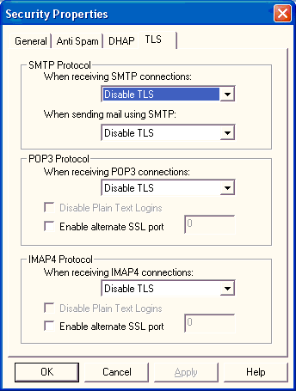

Certificate Requirements
The certificate must meet several requirements before the WorldMail server is able to use it to secure email connections.
- The Intended Purposes of the certificate must include Server Authentication. Certificates purchased from trusted certificate authorities or issued by a domain certificate authority using the Web Server template will include this intended purpose.
- The Common Name (CN) of the certificate must match the hostname of the Reverse DNS (PTR) record for the IP addresses that the WorldMail services are listening on or the Windows HOSTS file must be updated to override the PTR record returned by your DNS servers. WorldMail does a reverse DNS lookup to find out the Common Name of the certificate to use before searching the certificate store for an appropriate certificate.
Example: The network adapters in your mail server are assigned the IP addresses 192.168.1.10 and 192.168.1.11 and your DNS servers report that the reverse DNS entries for 192.168.1.10 and 192.168.1.11 are both mail.yourcorp.com. WorldMail will look for a certificate with a common name of mail.yourcorp.com in the certificate store.
If WorldMail is unable to locate an appropriate certificate it will log the following error indicating the name of the Common Name of the certificate that it attempted to locate:
TLS/SSL: The service failed to find a suitable certificate in the predefined MY System store for the LocalMachine
: No certificates were found matching the Subject 'smtp.yourcorp.com'.
The HOSTS files located in the %SYSTEMROOT%\SYSTEM32\DRIVERS\ETC on your server can be updated to override the reverse DNS entries and point WorldMail to the appropriate certificate.
- The certificate must be stored in the Personal folder of the Computer certificate store. This is the same location where web server certificates are stored.
- The WorldMail services must have permission to read and use the private key of the certificate in the certificate store. If the WorldMail services are running in a secured mode as a user account without administrator privileges then the system administrator must explicitly grant the necessary permissions.
The WinHTTP Certificate Configuration Tool (WinHTTPCertCfg) is a command-line tool that enables administrators to import certificates and set permissions. It is located in the WorldMail installation directory.
Example: Listing accounts with access to the private key
The task in this example is to determine which Windows accounts have permission to access the certificate's private key. To do this use the /l to request a list of accounts, /c local_machine\my to select the Personal folder of the Computer certificate store and /s mail.mycorp.com for the certificate with a Common Name of mail.mycorp.com.
winhttpcertcfg /l /c local_machine\my /s mail.mycorp.com
Example: Granting Access to a Private Key from a User Account
The task in this example is to grant access to a certificate's private key to a user account. To do this, use /g to grant access, /c local_machine\my to select the Personal folder of the Computer certificate store, /s mail.mycorp.com to select the certificate with the common name mail.mycorp.com and /a MYCORP\WorldMail-User to grant access to the WorldMail-User account in the MYCORP domain.
winhttpcertcfg /g /c local_machine\my /s mail.mycorp.com /a MYCORP\WorldMail-User
- Certificates use a variety of cryptographic algorithms. WorldMail requires a certificate that specifies the Microsoft RSA SChannel Cryptographic Provider and the SHA-1 hash algorithm. The cryptographic provider and hash algorithm are specified when requesting your certificate from the certificate authority.

Generating a Test Certificate
For testing purposes, create a self-signed X.509 certificate using the makecert utility provided with the Core SDK component of the Windows Platform SDK. The certificate must identify the common name of the WorldMail server as specified above in the Certificate Requirements and the extended key usage as "server authentication" (OID 1.3.6.1.5.5.7.3.1). For example:
makecert -r -pe -n "CN=mail.mycorp.com" -b 01/01/2001 -e 01/01/2099 -eku 1.3.6.1.5.5.7.3.1 -ss my -sr localMachine -a sha1 -sky exchange -sp "Microsoft RSA SChannel Cryptographic Provider" -sy 12
Open the Microsoft management console and add the local computer certificate snap-in. Check that the certificate has been created in the personal store and copy it to the trusted root certification authority.

Resources
You can obtain the Windows Platform SDK from the following URL:
http://www.microsoft.com/msdownload/platformsdk/sdkupdate/
Be aware that you must download the entire SDK. This utility is free; however, the file size is almost 500 MB. Make sure that your system has adequate disk space and that you have enough time to oversee the operation before you begin downloading the file.
Specific documentation for the makecert utility can be found at the following URL:
http://msdn.microsoft.com/library/default.asp?url=/library/en-us/cptools/html/cpgrfcertificatecreationtoolmakecertexe.asp
You can obtain the Windows HTTP Services SDK from the following URL:
http://www.microsoft.com/downloads/details.aspx?familyid=c42e27ac-3409-40e9-8667-c748e422833f&displaylang=en
Specific documentation for the winhttpcertcfg utility can be found at the following URL:
http://msdn.microsoft.com/library/default.asp?url=/library/en-us/winhttp/http/winhttpcertcfg_exe__a_certificate_configuration_tool.asp?frame=true

SSL/TLS Settings
All SSL/TLS security settings are available via the TLS tab of the Security Properties window. WorldMail allows you to specify the level of TLS deployment separately for each of the three mail protocols⎯ SMTP, POP3, and IMAP4. Each protocol has a separate area within the window. All three protocols use the same drop-down menu settings.

SMTP Protocol
When receiving SMTP connections, the settings available from the drop-down menu are:
- Disable TLS (default) ⎯ WorldMail communicates in clear text mode.
- Allow TLS ⎯ WorldMail negotiates with the mail client and optionally encrypts messages if the client has SSL/TLS configured.
- Require TLS ⎯ WorldMail forces messages to be encrypted.
When the "Allow TLS" setting is selected, you must specify how mail will be sent when using SMTP. The two settings available from that drop-down menu are:
- Use TLS if available ⎯ WorldMail optionally encrypts messages.
- Require TLS is supported ⎯ WorldMail forces the client to encrypt messages, but only if the client software supports TLS.

POP3 Protocol and IMAP4 Protocol
The POP3 and IMAP4 Protocol areas of the Security Properties window provide the same configuration setting choices. To limit redundancy, they are described together in this subsection.
When receiving POP3 connections or IMAP4 connections, the settings available from the drop-down menu are:
- Disable TLS (default) ⎯ WorldMail communicates in clear text mode.
- Allow TLS ⎯ WorldMail negotiates with the mail client and optionally encrypts messages if the client has SSL/TLS configured.
- Require TLS ⎯ WorldMail forces messages to be encrypted.
Two checkboxes may also be set:
- Disable Plain Text Logins ⎯ Checking this box forces the client to encrypt login details (when both the server and client have agreed to use SSL/TLS).
- Enable alternate SSL port ⎯ Checking this box supports the use of an alternate secure port (this feature is required when the client software supports SSL 3.0 but not TLS 1.0). The alternate port number must be entered in the adjacent text box.

#$K+ Mail Filters
KWorldMail includes support for mail filters. Filters are rules for mail handling that allow you to specify that messages should be handled in special ways - for instance, forwarded to a specific email address, saved to the file system, or rejected - based on characteristics of the message. Filters are especially useful for identifying messages that may contain email viruses and preventing them from entering your system.

#K Filter Levels
WorldMail supports mail content filters at three different levels:
- Server filters, which are applied to every message received by WorldMail's SMTP server.
- Domain filters, which apply only to messages sent to or from a mailbox in a specific domain.
- Mailbox filters, which apply only to messages sent to or from a specific mailbox.
For all three types, the user WorldMail Management Center interface described in this section can be used by the administrator to create, modify, and delete filter rules. Mailbox filters can also be defined by end users through the Eudora Web Client interface.

#K Using Mail Filters
To use mail filters, open the Security folder in the WorldMail Management Center and double-click Sieve Filter. This displays the Sieve Filter Rules window, which lists the sever-level content filters currently defined on your site. An identical window for managing domain filters can be accessed by clicking the Sieve Filter icon within the domain's folder in the WorldMail Management Center.
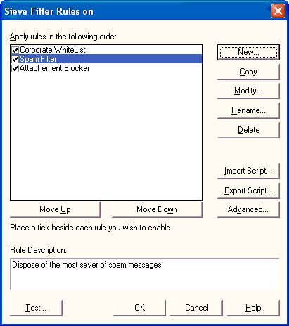
The rules defined in this list are applied sequentially, so if a message is rejected by an initial filter it will not be subject to subsequent rules. You can move filters up and down in this list to refine your filtering strategies. To create a new filter rule click New, which launches the Rule Wizard.

#K Name and Description
KThe first panel of the Rule Wizard defines the name and description of your new filter rule. Both the name and description of each filter appears in the Sieve Filter Rules window.
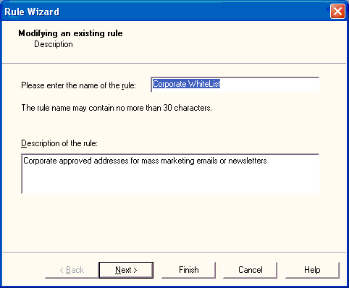
Filter names must be unique and can be contain up to 30 characters. When you finish entering your filter rule's name and description, click Next.

#K Adding Filter Criteria
The next panel of the Rule Wizard displays the filtering criteria for your filter rule. These are the conditions that will cause a message to be subject to the filter rule.
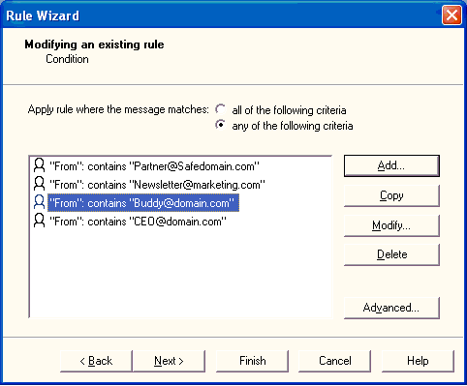
By default, a message must match all of the criteria defined in this list to be subject to the filter rule. You can modify this behavior to filter messages that match any of the given criteria by selecting the appropriate option at the top of this panel. To add criteria to your filter rule, click Add.
To define filter criteria, select the part of the message that you want to search and the text string for which you are searching. You can also use regular expressions to define sophisticated text searches.
When defining filtering criteria, you can search for the given text in either the headers (From, Subject, To, Cc, Bcc, Sender, Reply-To, etc.) or body of the message. You can also test for the existance of a header, as well as for the size of the entire message (including headers, body, and all attachments). To search in a header not given shown in the menu, click in the menu value and enter the header you wish to search. Attachments are considered part of the message body, so when searching for attachment content select <Message Body>.
For example, to filter messages that contain the attachment virus.vbs, use the following criteria:
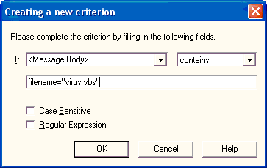
To specify a regular expression search, enable the Regular Expression option. This also enables a Test button that allows you to test your regular expression syntax on sample message content. See the following section on Advanced Filter Options for more information.
After you have finished adding criteria for your filter rule, click Next.

#K Set a Filter Action
The next panel of the Rule Wizard defines the action to be taken against messages that satisfy the criteria for the filter rule. In other words, if a message contains the characteristics that you set for this rule, WorldMail will handle that message according to the actions you set here.
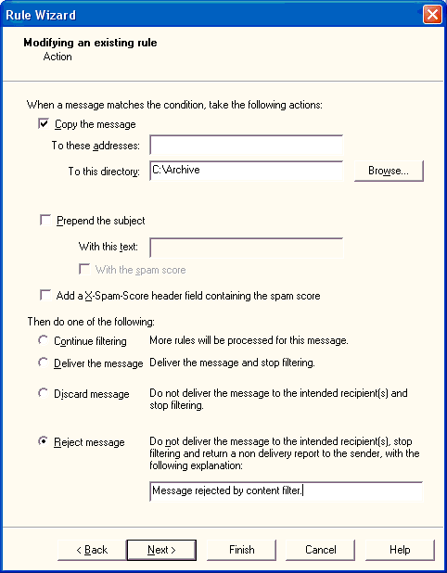
You can specify that messages caught by your filter rule should be rejected, forwarded, saved to a given file system directory, or any combination of the above. If the message is not rejected, you can also choose whether or not the message should be delivered to its intended recipients.
The choices you should make here are dependent on the type of filter rule you are creating. For example, if your filter rule scans for messages that have virus attachments, you will probably want to reject any such messages; if your filter rule archives urgent messages sent to the postmaster, you should save copies of these messages and also allow normal delivery.
Note that the actions available in this panel change slightly when creating domain or mailbox filters. For domain filters, copying a message to a file is not available. For mailbox filters, a message can only be copied to a folder within the recipient's mailbox folder.

#K Testing Filters
After you have created filter rules you can test their behavior on sample messages. Testing filter rules is important to verify the affect that they will have on your site's mail activity, and to confirm that they work as intended.
To test your filter rules, open the Sieve Filter Rules window and click Test. The following window is displayed:
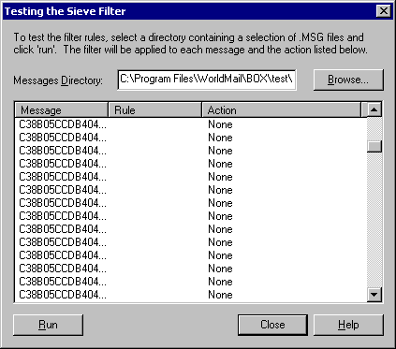
Filter tests are run against all messages in a specific directory. Use the Browse button to select a test message directory, such as an existing mailbox. If you have created filter rules to screen out specific viruses, be sure that your test directory includes messages that include the targeted viruses. You should also test your filters against "normal" messages to insure that the filters do not catch them by mistake.
After you select a message directory, click Run. This will cause your filtering rules to be applied to the messages in this directory exactly as if they are incoming messages. If a message is subject to a filter rule, then this window displays the name of the message file, the filter rule that applies to it, and the action(s) taken against the message. The possible actions are Reject (message blocked), Forward (message forwarded to the given address), Copy (copy of the message is saved), Discard (message is not delivered to its recipients), and Stop (no more filter rules are applied to the message). If a message is shown with no rule or action, then that message would be delivered normally.
The order of entries in the Filter Rules window is significant: rules are applied in the order that they appear in this list. This means that if the first filter rejects a message (Reject), or specifies that additional filter rules should not be applied to it (Stop), then the remaining filter rules are irrelevant for that message. It is therefore important to test your general filtering strategy, not just individual filter rules. Move entries up and down in the rules list to fine-tune mail filtering on your site.

#K Message Quarantine
WorldMail sieve scripts have the ability to file messages into any folder in the recipient's mailbox. When WorldMail is installed it will have a default rule named 'Spam Trap' in the 'Mailbox' server script which files spam messages into a special folder 'Junk Mail'. The rule is by default turned off, but the administrator may choose to enable this rule immediately and modify the trigger level. The intention of this rule is to allow administrators to enable a message quarantine for messages considered to be spam without having to configure the details of the script.
The WorldMail message quarantine is bound to the special folder 'Junk Mail'. Messages filed into this folder will remain there until the recipient explicitly deletes the message or until a thirty day quarantine period has passed, after which they will be automatically deleted. You may choose to file these messages into a differently named folder, but the quarantine operation only works with the 'Junk Mail' folder.
The recipient is able to override actions taken by the 'Mailbox' server script by editing their own mailbox sieve script using the Eudora Web Client web interface.

#$K+ Advanced Filter Options
In addition to the standard filter functionality, there are two advanced methods of creating filters in WorldMail: by editing the scripts that define filter rules, and by specifying regular expressions, which define sophisticated text searches.

#K Script Editing
Within WorldMail, filter rules are defined by scripts. These scripts are generated automatically when you create filter rules in the WorldMail Management Center, but can be manually edited to refine filter rules. To edit a filter script, click the Advanced button on the Condition panel of the Rule Wizard.
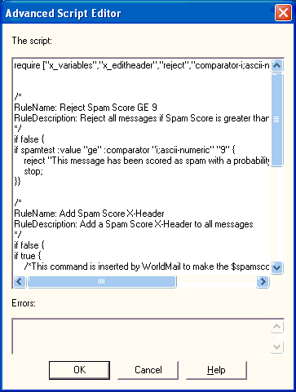
The scripts shown in this dialog consist of one or more clauses, which are statements that are either true or false. WorldMail's script syntax is based on the Sieve filtering language, and includes the following types of clauses:

Header Clause
Header clauses search specific headers (such as "Subject", "From" and "To") for a given value. These searches can be for a substring using the contains test, or for an exact match using the is test. Header clauses are defined in the format:
header :contains "HeaderName" "SearchString"
header :is "HeaderName" "SearchString"
For example:
header :contains "Subject" "I love you"
header :is "From" "postmaster@example.com"

Exists Clause
Exist clauses test the existence of a particular header (such as "Subject", "From" and "To") in a message. Exists clauses are defined in the format:
exists "HeaderName"
For example:
exists "Reply-To"

Body Clause
Body clauses search the body of a message (including attachments) for a given value. Body clauses are defined in the format:
x_body :contains "SearchString"
For example:
x_body :contains "virus.vbs"

Size Clause
Size clauses test for the total size of a message, and can test for whether is message size is over or under a specific size. The comparison size is defined in bytes, but you can use K, M, and G to denote kilobytes, megabytes, and gigabytes (respectively). Size clauses are defined in the format:
size :over Bytes
size :under Bytes
For example:
size :under 5000
size :over 300K

Allof Clause
Allof clauses consist of two or more individual clauses, and are true if (and only if) all of the enclosed clauses are true. Allof clauses are defined in the format:
allof (Clause, Clause, ...)
For example:
allof (
exists: "From",
header :contains "Subject" "URGENT"
size :under 100K
)
This clause is true for a message if it contains a "From" header and also includes the word URGENT in the "Subject" header.

Anyof Clause
Anyof clauses consist of two or more individual clauses, and are true if any of the enclosed clauses is true. Anyof clauses are defined in the format:
anyof (Clause, Clause, ...)
For example:
anyof (
exists "To",
exists "Cc",
exists "Bcc"
)
This clause is true for a message if it contains a "To" header, a "Cc" header, or a "Bcc" header; in any of these cases, the entire clause is true.

Not Clause
Not clauses contain a single clause, and are true if (and only if) the enclosed clause is false. Not clauses are defined in the format:
not Clause
For example:
not header :contains "From" "postmaster"

#K Regular Expressions
For each type of clause, you can use regular expressions instead of simple text strings as your search criteria. To use a regular expression as your search criteria, enable the Regular Expression option on the filter rule criteria dialog. This also enables the Test button, which allows you to test your expression syntax.
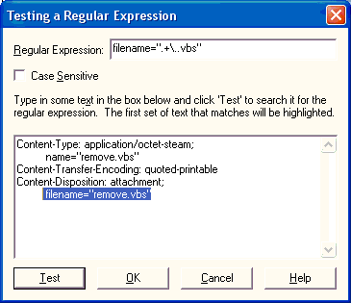
When testing your regular expression, enter sample message text in the field provided. This allows you to run simulations of the mail filter on the type of content you are looking for. When you click Test, the sample text will be searched for text that matches your search criteria.
The following table provides syntax rules for regular expressions:
Expression | Syntax | Description
Any Character | . | Matches any one character.
Zero or More | * | Matches zero or more occurrences of the preceding expression.
One or More | + | Matches at least one occurrence of the preceding expression.
Zero or One | ? | Matches zero or one occurrence of the preceding expression.
Set of Characters | [] | Matches any one of the characters within the []. To specify a range of characters, list the starting and ending character separated by a dash (-), as in [a-z].
Character Not in Set | [^] | Matches any character not in the set of characters following the ^.
Grouping | () | Groups a sub-expression.
Or | | | Matches the expression before or after the |. Mostly used within a group. For example, "(sponge)|(mud) bath" matches "sponge bath" and "mud bath."
Beginning of Line | ^ | Starts the match at the beginning of a line. Significant only at the start of an expression.
End of Line | $ | Anchors the match to the end of a line. Significant only at the end of an expression.
Tagged Expression | {} | Tags the text matched by the enclosed expression, You can match another occurrence of the tagged text using \N and +. Useful to repeated expressions such as repeated characters.
Nth Tagged Text | \N | Matches the text matched by the Nth tagged expression, where N is a number from 1 to 9. For example <{.}\1+> would match any repeated character surrounded by angle brackets.
Escape | \ | Matches the character following the backslash (\). This allows you to find characters used in the regular expression notation, such as { and ^.
Prevent Match | ~X | Prevents a match when X appears at this point in the expression. For example, "rea~(ity)" matches the "real" in "realty" and "really," but not the "real" in "reality."
Repeat N Times | ^N | Matches N occurrences of the preceding expression. For example, "[0-9]^4" matches any 4-digit sequence.
Whitespace | \s | Matches space, tab, newline, etc
A word boundary | \b | Matches the end or start of a word
Alphanumeric Character | \a | Matches the expression ([a-zA-Z0-9]).
Alphabetic Character | \c | Matches the expression ([a-zA-Z]).
Decimal Digit | \d | Matches the expression ([0-9]).
Quoted String | \q | Matches the expression (("[~"].*")|('[~'].*')).
Alphabetic String | \w | Matches the expression ([a-zA-Z]+).
Decimal Integer | \z | Matches the expression ([0-9]+).
Tab Character | \t | Matches a tab character

#$K+ Virus Scanning
KWorldMail includes support for integrated virus scanning. These features allow WorldMail to identify messages that have potentially destructive virus content and block them before they enter your network. When virus scanning is enabled and a message that contains a virus is received by WorldMail, it will reject the message and inform the sender of the infection.

#K Kaspersky Anti-Virus Filter
WorldMail's virus scanning engine is provided by the Kaspersky Labs. This is integrated into WorldMail, and so no configuration of the engine is required for use with WorldMail.

#K Virus Scanning Policy
WorldMail supports three different virus-scanning policies:
- Server-level virus scanning, which causes every message received by WorldMail' SMTP server to be scanned for viruses. This policy is typically used by offices, universities, and other organizations.
- Domain-level virus scanning, which specifies that messages should be scanned for viruses only if they are sent to or from a mailbox in specific domains. This policy is typically used by mail hosting companies that wish to sell virus scanning as a value-added feature for hosted domains.
- Mailbox-level virus scanning, which specifies that messages should be scanned for viruses only if they are sent to or from specific mailboxes. This policy is typically used by ISPs that wish to sell virus scanning as a value-added feature for their subscribers.
Note that the domain and mailbox virus scanning policies can be used together. This means that you can configure virus scanning to occur for all mailboxes in one domain, while scanning only for selected mailboxes in a second domain.

#$K+ Server Virus Scanning
To configure WorldMail's virus scanning policies, open the WorldMail Management Center and double-click the Kaspersky Anti-Virus Filter icon in the Security folder. This displays the Virus Scanning Filter window:
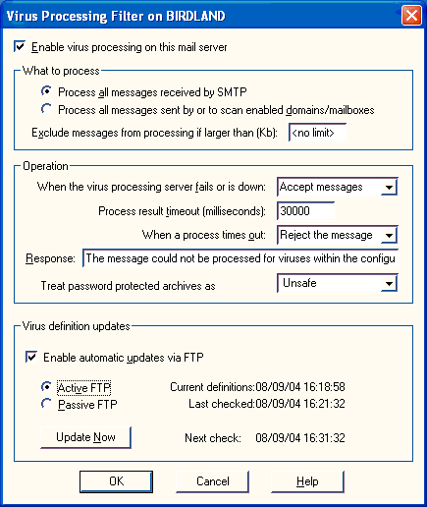
The option Enable virus scanning on this mail server controls the global virus scanning policy. If this option is disabled, WorldMail will not scan any messages. Otherwise, WorldMail will scan messages according to the other settings here.
If you want to protect all users on your site from viruses and scan every incoming message, select Scan all messages received by SMTP. When this option is selected, all mail received by WorldMail's SMTP server will be scanned for viruses regardless of sender or destination.
If you want to instead use domain or mailbox-level virus scanning, select Scan all messages sent by or to enabled mailboxes/domains. When this option is selected, WorldMail will scan mail based on the virus scanning preferences of the sender or recipient domains on your site.

When the virus scanner fails or is down, WorldMail can be configured to defer or accept messages.

The maximum time allowed for a scan is configurable in milliseconds.

When a scan times out, we can accept, reject or defer the message.

The SMTP server's response when rejecting a message due to a timeout can be set.

Some viruses are transmitted via password protected archives which are encrypted and can not be scanned by WorldMail. WorldMail can be set to reject messages containing password protected archives by treating them as unsafe or to accept by treating them as safe.
Included in the Virus Scanning Filter window are controls for downloading updated virus definition files, which are needed for WorldMail to block new viruses as they are discovered. By default, WorldMail polls once an hour for updates to virus definition files. You can force an immediate update by clicking Update now. Note that your license may not support virus updates; in this case, WorldMail will automatically disable polling for updates.

#K Domain Virus Scanning
To configure domain virus scanning options, open the domain folder in the WorldMail Management Center double-click the Kaspersky Anti-Virus Filter icon. This displays the Virus Scanning Filter window:
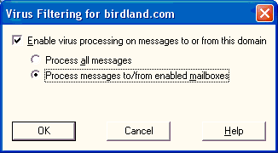
The option Enable virus scanning on messages to or from this domain controls the virus scanning policy for this domain. If this option is disabled, WorldMail will not scan any messages sent to or from this domain. Otherwise, WorldMail will scan messages according to the other settings here.
If you want virus scanning to occur for all users in the domain, select Scan all messages. When this option is selected, all mail received by WorldMail's SMTP server that is sent to or from a mailbox within this domain will be scanned.
If you want to instead use mailbox-level virus scanning, select Scan messages sent to/from enabled mailboxes. When this option is selected, WorldMail will scan mail based on the virus scanning preferences of the sender or recipient mailbox.

#K Mailbox Virus Scanning
To configure mailbox virus scanning, open the mailbox in the WorldMail Management Center and select the Security tab:
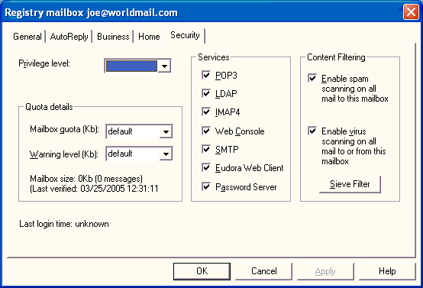
The Enable virus scanning on all mail to or from this mailbox controls virus scanning for the individual mailbox. When this option is enabled, messages received by WorldMail's SMTP server will be virus scanned if they are sent to or from this mailbox. If disabled, no virus scanning occurs for this mailbox. Note that this field will be disabled if the server or domain virus scanning policies are not configured for mailbox-level scanning.
#$K+ Spam Scanning
WorldMail includes support for integrated spam scanning. These features allow WorldMail to determine how likely it is that a given message is spam. Customers can then take appropriate action using sieve scripts. Typically, messages likely to be spam are delivered to a "bulk mail" folder.

Sophos Anti-Spam Filter
WorldMail's spam scanning engine is provided by Sophos. This is integrated into WorldMail, and so no configuration of the engine is required for use with WorldMail.

#$K+ Spam Scanning Policy
WorldMail supports three different spam-scanning policies. If spam scanning is enabled, WorldMail scans appropriate messages as they arrive, and it is the associated sieve scripts that determine the action taken. Scanning can be enabled at three levels:
- Server-level spam scanning, which causes every message received by WorldMail' SMTP server to be scanned for potential spam. This policy is typically used by offices, universities, and other organizations.
- Domain-level spam scanning, which specifies that messages should be scanned for spam only if they are sent to or from a mailbox in specific domains. This policy is typically used by mail hosting companies that wish to sell spam scanning as a value-added feature for hosted domains.
- Mailbox-level spam scanning, which specifies that messages should be scanned for spam only if they are sent to or from specific mailboxes. This policy is typically used by ISPs that wish to sell spam scanning as a value-added feature for their subscribers.
Note that the domain and mailbox spam scanning policies can be used together. This means that you can configure spam scanning to occur for all mailboxes in one domain, while scanning only for selected mailboxes in a second domain.

Taking Action On Spam with Sieve Filters
While the Sophos spam-scanning engine provides the power to determine how likely it is that a given message is spam, WorldMail's enhanced Sieve rule implementation provides administrators and end-users alike the power to implement and enforce their own personal spam policy. Actions include: reject, redirect, annotate, quarantine, and deliver.

Spam Quarantine
Rather than immediately discarding or rejecting messages suspected of being spam, WorldMail administrators have the option of sending these messages to a special spam quarantine folder which is automatically created for each user and is located in each users mailbox.
End-users can periodically review their spam quarantine folder to identify any false positives, which may be eliminated through a whitelisting process. This "Junk Mail" folder can be reviewed by end-users through Eudora Web Client or any standard IMAP email client.
End-users can also implement their own policy for sending messages to the spam quarantine. This special quarantine folder automatically purges messages every 30 days in order to avoid any over-quota concerns.

Personal Whitelisting
A white list is a list of addresses of trusted senders whose messages are delivered unchecked. The white list can be used to recognize mailing list traffic and opt-in marketing messages that might otherwise be classified as spam. With WorldMail 3, end-users can create and manage their own personal white lists, thus relieving the system administrator of this task.

#$K+ Server Spam Scanning
To configure WorldMail's spam scanning policies, open the WorldMail Management Center and double-click the Sophos Anti-Spam Filter icon in the Security folder. This displays the Spam Scanning Filter window:
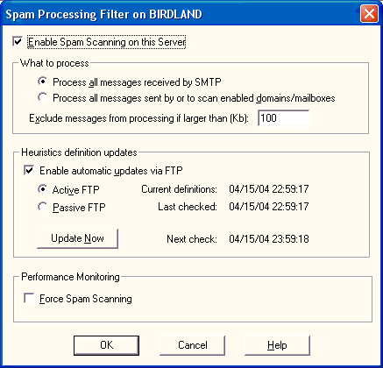
The option Enable spam scanning on this mail server controls the global spam scanning policy. If this option is not selected, WorldMail will not scan any messages. Otherwise, WorldMail will scan messages according to the other settings here.
Note: Upon entering this dialog the following test will be performed. If there are more mailboxes provisioned for Anti-Spam then there are licenses for, this option will be unchecked. Upon exiting the dialog another test for this same condition is done. If the licensed amount of mailboxes has been exceeded, then the user will be notified that this option will be turned off.
If you want to protect all users on your site from spam and scan every incoming message, select Process all messages received by SMTP. When this option is selected, all mail received by WorldMail's SMTP server will be scanned for spam regardless of sender or destination.
Note: If there are more mailboxes in the server than there are Anti-Spam licenses for, this option will be disabled.
If you want to instead use domain or mailbox-level spam scanning, select Process all messages sent by or to enabled mailboxes/domains. When this option is selected, WorldMail will scan mail based on the spam scanning preferences of the sender or recipient domains on your site.
By default, WorldMail will not scan messages of over 100KB for spam. Unsolicited mails are typically very small, but this value can be changed if required.
Included in the Spam Scanning Filter window are controls for downloading updated anti-spam heuristics files, which are needed for WorldMail to block new forms of spam as they are discovered. By default, WorldMail polls once an hour for updates to heuristics files. You can force an immediate update by clicking Update now.
Spam scanning can be forced on. This allows an administrator to monitor the level of spam passing through the system even if the license does not allow scanning.

#$K+ Domain Spam Scanning
To configure domain spam scanning options, open the domain folder in the WorldMail Management Center double-click the Sophos Anti-Spam Filter icon. This displays the spam Scanning Filter window:
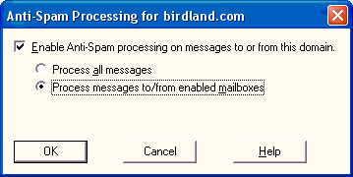
The option Enable Anti-Spam scanning on messages to or from this domain controls the spams scanning policy for this domain. If this option is not selected, WorldMail will not scan any messages sent to or from this domain. Otherwise, WorldMail will scan messages according to the other settings here.
If you want spam scanning to occur for all users in the domain, select Process all messages. When this option is selected, all mail received by WorldMail's SMTP server that is sent to or from a mailbox within this domain will be scanned.
Note: If the number of mailboxes in this domain plus the number of mailboxes provisioned for Anti-Spam in all other domains is greater than the Anti-Spam licensed mailbox count, this option will be disabled.
If you want to instead use mailbox-level spam scanning, select Scan messages sent to/from enabled mailboxes. When this option is selected, WorldMail will scan mail based on the spam scanning preferences of the sender or recipient mailbox.
If you are processing Anti-Spam at the server level, then no options on this dialog will be enabled.

#$K+ Mailbox Spam Scanning
To configure mailbox spam scanning, open the mailbox properties in the WorldMail Management Center and select the Security tab:
The Enable spam scanning on all mail to or from this mailbox controls spam scanning for the individual mailbox. When this option is selected, messages received by WorldMail's SMTP server will be spam scanned if they are sent to or from this mailbox. If not selected, no spam scanning occurs for this mailbox.
Note: This field will be disabled if the server or domain spam scanning policies are not configured for mailbox-level scanning or if by provisioning this mailbox for Anti-Spam, you would exceed the count of licensed mailboxes for Anti-Spam.

Monitoring Spam Traffic
WorldMail 3 provides new Windows performance monitor counters to assist administrators with tracking the flow of spam through the system. These new performance monitor counters can be used to display a spam histogram, which indicated the distribution of spam scores for scanned messages across all possible spam score values. This monitoring is particularly helpful for administrators in setting up spam disposition policies.

#K Spam Score Logging
The likelihood that each message is spam is written to the SMTPRA log:
---- SMTPRA log entry made at 06/20/2003 17:35:13
Message B0000155144@rlouk001.example.com received spam score of: 8
#$K+ Agents
KAn agent is an external program or command, supplied by you, that manipulates a mail message. WorldMail supports the following types of agents:
- The Server Agent is executed for every incoming message.
- Mailbox Agents are run when a message is delivered to a mailbox.
- List Agents are run when a message is delivered to a mail list.
- List Processor Agents are run when a message is delivered to a list command address.
- Archive Agent is a built-in agent which copies all incoming messages to an archive directory.
An agent must be a command-line program or batch file (not an interactive program requiring keyboard input, nor a Windows program).

#K Server Agent
KEvery time WorldMail receives a message, it invokes the Server Agent. The agent is told the names of two files: the message file itself, and a file containing SMTP envelope information.
The message file has extension MSG. The file containing the SMTP envelope information is known as the recipients file, although it contains more than just recipient information. When it is passed to the incoming mail agent, it will have extension RCO; when the agent terminates, WorldMail will rename the file to its normal RCP extension.
Server agents are configured through the Agents dialog in the WorldMail Management Center. Possible uses for Server agents include:
- Checking messages for viruses
- Checking for unsolicited commercial e-mail
- Adding a server wide message footer
- Automatically adding a disclaimer to mail being sent outside the company
- Generating statistics

#K Mailbox Agents
K KEach mailbox may be configured with a unique Mailbox Agent. This is an external program that will be executed whenever a message is delivered to a local user's mailbox directory.
The Mailbox General Page includes a Mailbox Agent field. This field should contain a command-line template that will have various substitutions performed on it before being executed. The substitutions are:

Special Symbol | Replaced By
%f | Full file name of the message which was received
%u | Name of the mailbox
%h | Mailbox directory
%d | Domain to which the mailbox belongs
%% | Single percent character
The message file (%f) is placed in the mailbox INBOX directory with an MSF extension. If no mailbox agent is defined, the MSF file extension is renamed immediately to MSG. If a mailbox agent is defined, the agent is executed. The mailbox agent may change the message contents or may delete the file. When the agent terminates, the MSF file (if it still exists) is renamed to MSG.
Multiple commands can be executed by interposing the & character between them, or by using a batch file.
The agent is executed by SMTPDA and therefore inherits the NT access rights of SMTPDA. Only when the agent has finished executing will the message be made available to IMAP4A and POP3A.
It is important that the Mailbox agent should not take too long to execute. Otherwise, a busy mailbox could cause the server to run out of memory or saturate its processor.

#K Mailbox Agent Example
This Mailbox agent example uses a tool called KeyTo, which searches incoming messages for keywords. If the keyword is present then KeyTo sends a short message to a specified address. For example, you may wish to send a message to your pager whenever you receive a message containing the word "emergency".
The KeyTo utility is a Windows Management Center program that takes several parameters:
-k Keyword to search for
-i file to search
-n Number of lines to search
-s SMTP relay server
-f From address
-t To address
-c CC address
-u "Subject"
To use this agent with a mailbox, open the mailbox from the WorldMail Management Center. In the Mailbox General Page, enter the full KeyTo execution statement in the Mailbox agent field:
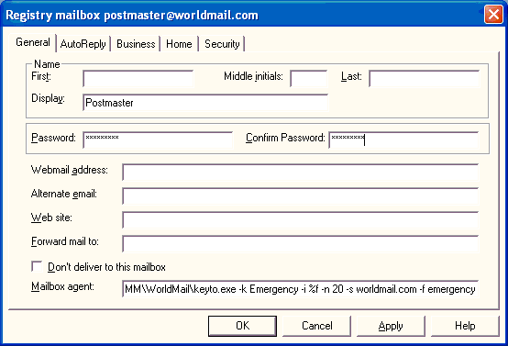
After this information is saved, KeyTo will be executed with these parameters on all messages that arrive for this mailbox.

#K List Agents
K KEach mail list may be configured with a unique List Agent that pre-processes each message to a mail list before it is delivered by WorldMail.
The List General Page includes a List Agent field. This field should contain a command-line template that has various substitutions performed on it before being executed. These substitutions are listed below:
Special Symbols | Replaced By
%f | Full file name of the message which was received
%m | Moderator address of the mail list, or - if no moderator
%n | Name of the mail list
%d | Domain to which the mail list belongs
%% | Single percent character
The message file (%f) will be located in the mail list directory, but will not have a MSG extension. The external program may change the message contents or delete the message file. When the external program completes, WorldMail will automatically rename the file (if it still exists) to have a MSG extension, and will process it as normal.
Multiple commands can be executed by interposing the & character between them, or by using a batch file.
The agent is executed by SMTPDA and therefore inherits the NT access rights of SMTPDA. When the agent has finished executing the message will be distributed to list members. Note that the message is queued for content moderation before the agent executes.
It is important that the agent should not take too long to execute, since WorldMail will not process any other messages for the mail list while the agent is running.
List agents can be used to implement a wide range of features, such as:
- Filter out LEAVE and UNSUBSCRIBE messages sent to the main list address
- Check a mail message for offensive language
- Implement additional mail loop prevention techniques

#K List Agent Example
This List agent example uses a tool called SubjectTag, which inserts a configurable block of text into the Subject header of each message sent by the list. Setting a subject prefix allows users to filter their incoming list messages from their normal e-mail. For example, if you are running a mailing list related to cars, you might add the subject prefix "[Cars]:" to each list message; in this case, a message sent with the subject "parts for 68 Camaro?" will arrive to list members with the subject "[Cars]: parts for 68 Camaro?".
The SubjectTag utility is a Windows Management Center program that takes two parameters: the header prefix value, and the name of the message file to modify (%f). To use this agent with a mail list, open the list from the WorldMail Management Center. In the List General Page, enter the full SubjectTag execution statement in the Mail list agent field:
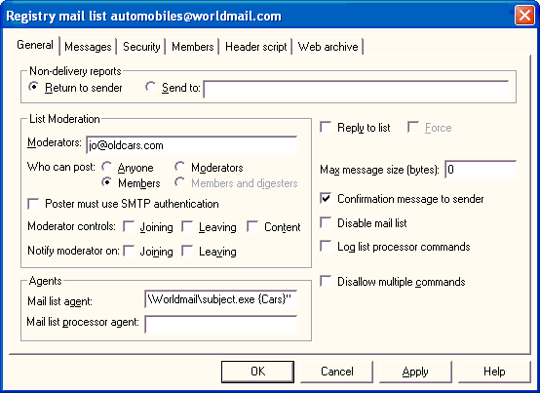
After this information is saved, SubjectTag will insert this subject prefix on all messages that arrive for this mail list.

#K List Processor Agents
KEach mail list may be configured with a List Processor Agent that pre-processes messages sent to a mail list's -request address before they are interpreted by WorldMail.
The List General Page includes a List Processor Agent field. This field should contain a command-line template that will have various substitutions performed on it before being executed. These substitutions are:
Special Symbols | Replaced By
%f | Full file name of the message which was received
%m | Moderator address of the mail list, or - if no moderator
%n | Name of the mail list
%d | Domain to which the mail list belongs
%% | Single percent character
The message file (%f) will be located in the mail list directory, but will not have a MSG extension. The external program may change the message contents or delete the message file. When the external program completes, WorldMail will automatically rename the file (if it still exists) to have a MSG extension, and will process it as normal.
Multiple commands can be executed by interposing the & character between them, or by using a batch file.
The agent is executed by SMTPDA and therefore inherits the NT access rights of SMTPDA. When the agent has finished executing then the message will be interpreted by the mail list processor.
It is important that the agent should not take too long to execute, since WorldMail will not process any other mail list messages while it is running.
Mail list processor agents can be used to implement a wide range of features, including providing additional mail list processor commands.

#K Archive Agent
K KUnlike other agents, the Archive Agent is built in to the mail server. Its purpose is to make a copy of every message received by the mail server. The Archive Agent can help to satisfy the legal requirement to retain all e-mail sent by a company in some jurisdictions.
To enable the Archive Agent, click on the Agents icon in the Window Management Center's Server folder, which displays the Agents dialog. Enter the archive directory name in the Archive directory field of this window.
The archive directory will be automatically created if it does not already exist. Under this directory, the agent will create a new subdirectory each day for that day's messages. The archive subdirectories will have a name of the form YYYYMMDD, where YYYY is the year, MM is the month (01 to 12) and DD is the day of the month (01 to 31). The agent will copy each RCP file and MSG file that is received by WorldMail into this directory.
Note that the agent will archive not only messages received by WorldMail, but also messages generated by the mail server itself, such as delivery status notifications and messages expanded by the mail list processor.
#$K+ Databases
KWorldMail can integrate with a relational database through ODBC (Open Database Connectivity). WorldMail can use a database for three things - mailbox authentication; storing mail list membership; and logging. This chapter describes how WorldMail can be configured to do this.
You must have ODBC drivers installed if you wish to use this feature. Note that you should not attempt to use this these features if you are not familiar with databases and their terminology.

#K Setting Up Database Access
If your ODBC database is running on a different machine than the WorldMail Engine, you may need to take additional setup steps. By default, WorldMail services run as the Windows SYSTEM account, which can access to other machines only via TCP/IP. This means that if your database does not allow connections via TCP/IP, WorldMail will not be able to access the database.
To enable database access between systems, you must do one of the following:
- Configure your database to allow TCP/IP connections (refer to your database's documentation for instructions on doing this).
- Change the account that the WorldMail services run as from SYSTEM to an NT account that has access rights to the database. You can do this from the Services Control Panel.

#K Database Mailbox Plugin
K KThe database mailbox plugin allows you to base authentication on a database. You will find this useful if you have an existing database of users to whom you wish to offer mailbox facilities. Note that you should not attempt to use this plugin unless you are familiar with databases and their terminology.
To configure the database mailbox plugin, select the Plugins Folder in the Management Center and double click on the Database Mailbox Plugin. The Database Mailbox Plugin supports two kinds of databases: Generic and Emerald Radius Server databases.

#K Emerald Database K
Information on using the Database Plugin with an Emerald Database is provided in the appendix on Emerald Integration.

#K Generic Database
The Generic database assumes a very straightforward database schema. User information is contained in a single table, Mailboxes, with columns Mailbox, FullName, Password and Domain. You can override these defaults by filling in the fields on the configuration form.
An example of using the Database Mailbox Plugin is provided in the appendix on Database Examples.

#K Database Mail List Plugin
K KThe Database Mail List Plugin makes use of some default properties. This makes it possible to create Database Mail Lists with minimal configuration. For the default configuration, the following applies:
- An ODBC data source can be used for all domains. This will need to be entered into the Mail list properties in the Database Tab of the Database Mail List.
- A separate table is used for each mail list. The name of the table must be the same as the name of the mail list, except that where the mail list name contains a dot or hyphen character. If the list name contains a dot or hyphen you must create the table using the underscore character. This is because dot and hyphen are not legal table name characters in some databases.
- The table must contain at least two columns, called EmailAddress and FullName. These columns must contain the e-mail addresses and names of the mail list members.
For example, create a database mailing list called customers in the virtual domain abc.com. The list address would be customers@abc.com. To map this to a database, create a data source called abc.com and a table customers in this data source. The table customers must have columns EmailAddress and FullName.
An example of using the Database Mail List Plugin is provided in the appendix on Database Examples.
#$K+ Monitoring
KThere are two ways that you can monitor the operation of your WorldMail server. You can monitor activity using the Performance Monitor, or log a range of information to one or more log files, to the Event Viewer, and to an ODBC database.

#K Logging
KWorldMail supports three categories of logging: server logging, operation logging and error logging.
- Server logging is concerned with events such as services starting up and closing down, manual commands to retry domains, and configuration reloads.
- Operation logging is concerned with network connections made and released, protocol exchanges and transaction summaries.
- Error logging is concerned with protocol syntax/sequence errors, failed protocol commands, authentication errors, and network or file I/O errors.
You can record this log information in three different places:
- In log files. Each of the three logging categories has its own log file, created in a configurable log directory.
- In the Application Event Log. Use the Event Viewer application, which you can find in the Administrative Tools program group, to examine the Event Log.
- In an ODBC database.
To control logging, use the Logs Folder in the Windows Management Center. Refer to the Eudora web site for a comprehensive list of error codes.

#K Performance Monitor
KOn Windows NT you can monitor the dynamic activities of WorldMail by using the Performance Monitor. The Performance Monitor is a standard NT utility and can be found in the program group Administrative Tools. The WorldMail Installation Wizard creates a shortcut to the Performance Monitor in the WorldMail group. You can start it from the program group, or execute PERFMON from the Command Prompt.
Eight performance objects are provided: POP3A, IMAP4A, SMTPDA, SMTPRA, LDAP3A, MAILMA, HTTPMA and Spamtest Result. These tables list the performance objects, counters and an explanation text for each::

#K POP3A Object K
Counter Name | Explanation Text
Active Connections | The number of currently active connections to the service. Indicates current service activity.
Bytes Sent/Sec | The number of bytes the service has sent to the network for messages retrieve operations. Indicates how busy the service is.
Connection queue size | The number of incoming connections awaiting processing.
Connections processed/Sec | The rate of connection requests being processed and responded to.
Connections received/Sec | The rate of connections being opened by request.
Messages Retrieved/Sec | The number of messages retrieved per second. Indicates how busy the service is.
Total Connections | Total Connections includes all connections (successful logons and failed logons) to the service since the service is last restarted.
Total Logon Failures | The number of failed logon attempts to the service since the service is last restarted. Can indicate whether password-guessing programs are being used to crack the security on the service.

#K IMAP4A Object K
Counter Name | Explanation Text
Active Connections | The number of currently active connections to the service. Indicates current service activity.
Bytes Sent/Sec | The number of bytes the service has sent to the network in response to commands. Indicates how busy the service is.
Commands Received/Sec | The number of commands received from clients per second.
Connection queue size | The number of incoming connections awaiting processing.
Connections processed/Sec | The rate of connection requests being processed and responded to.
Connections received/Sec | The rate of connections being opened by request.
Total Connections | Total Connections includes all connections (successful logons and failed logons) to the service since the service is last restarted
Total Logon Failures | The number of failed logon attempts to the service since the service is last restarted. Can indicate whether password-guessing programs are being used to crack the security on the service

#K SMTPDA Object K
Counter Name | Explanation Text
Bytes Sent/Sec | The number of bytes the service has sent on the network. Indicates how busy the service is.
Currently Active Connections | The number of outgoing SMTP connections which are currently open.
Messages Delivered Locally/Sec | The number of messages delivered from the service per second.
Messages Sent/Sec | The number of messages sent from the service per second.
Total Messages Delivered locally | The number of messages delivered locally by the service since the service was last restarted
Total Messages Sent | The number of messages sent to other mail servers since the service was last restarted.

#K SMTPRA Object K
Counter Name | Explanation Text
Active Connections | The number of currently active connections to the service. Indicates current service activity.
Bytes Received/Sec | The number of bytes the service has received from the network. Indicates how busy the service is.
Connection queue size | The number of incoming connections awaiting processing.
Connections processed/Sec | The rate of connection requests being processed and responded to.
Connections received/Sec | The rate of connections being opened by request.
Message Received/Sec | The number of messages received per second.
Total Connections | Total Connections includes all connections to the service since the service was last restarted.
Total Messages Received | The total number of messages per second received by the service since it was last restarted.

#K Spamtest Result Object K
Counter Name | Explanation Text
Messages Scanned | The percentage of messages scanned by the anti spam engine. Indicates the distribution of spam scores for scanned messages across all spam score values.
Messages Scanned/Sec | The number of messages per second scanned by the anti spam engine. Indicates the rate of spam scores for scanned messages.
Note: The Spamtest Result object has 11 instances corresponding to the 11 possible spam score values [0-10]. When all instances are viewed as a bar chart the columns will be sorted from Band 0 to Band 10. The Messages Scanned counter will then provide a histogram of the spam score distribution.

#K LDAP3A Object K
Counter Name | Explanation Text
Connections/Sec | Connections/Sec is the rate at which the server is receiving LDAP transaction requests.
Total Bytes/Sec | Total Bytes/Sec is the rate at which the server is transmitting transaction response data.

#K HTTPMA Object K
Counter Name | Explanation Text
Connection queue size | The number of incoming connections awaiting processing.
Connections processed/Sec | The rate of connection requests being processed and responded to.
Connections received/Sec | The rate of connections being opened by request.
Connections/Sec | Connections/Sec is the rate at which the server is receiving HTTPS transaction requests.
Total Bytes/Sec | Total Bytes/Sec is the rate at which the server is transmitting transaction response data.

#K MAILMA Object K
Counter Name | Explanation Text
Active Connections | The number of currently active connections to the service. Indicates current service activity.
Connection queue size | The number of incoming connections awaiting processing.
Connections processed/Sec | The rate of connection requests being processed and responded to.
Connections received/Sec | The rate of connections being opened by request.
Total Connections | Total Connections includes all connections (successful logons and failed logons) to the service since the service is last restarted.
Total Logon Failures | The number of failed logon attempts to the service since the service is last restarted. Can indicate whether password-guessing programs are being used to crack the security on the service.

#K Disk Maintenance
K KHigh volumes of mail traffic can cause NT disk drives to become fragmented, which can lead to decreased disk performance. For this reason it's recommended that you regularly run a defragmenting utility such as Norton Disk Doctor on your disk partitions where mail is stored.

#$K+ Monitoring Spam Traffic
There are two ways to monitor the operation of a WorldMail server. Activity can be monitored using the Windows performance monitor or information can be logged to one or more log files, to the Event Viewer, and to an ODBC database. Spam-related information such as message spam scores, spam processing activity, and DHAP activity is written to one or more logs within WorldMail. Additionally, you can monitor the dynamic activities of WorldMail from the Windows Performance Monitor.
The Performance Monitor is a standard utility and can be found in the program group Administrative Tools. Eight Windows performance-monitoring objects are provided with WorldMail 3, including the newest addition - the Spamtest Result Object.
Spamtest Result- A New Performance Monitoring Object
Counter Name | Explanation Text
Messages Scanned | The percentage of messages scanned by the anti spam engine. Indicates the distribution of spam scores for scanned messages across all spam score values.
Messages Scanned/Sec | The number of messages per second scanned by the anti spam engine. Indicates the rate of spam scores for scanned messages.
For more information regarding the other performance monitoring objects provided with WorldMail, please refer to the section entitled "Monitoring" in the WorldMail Administration Guide.
Monitoring Spam Traffic from Windows Performance Monitor
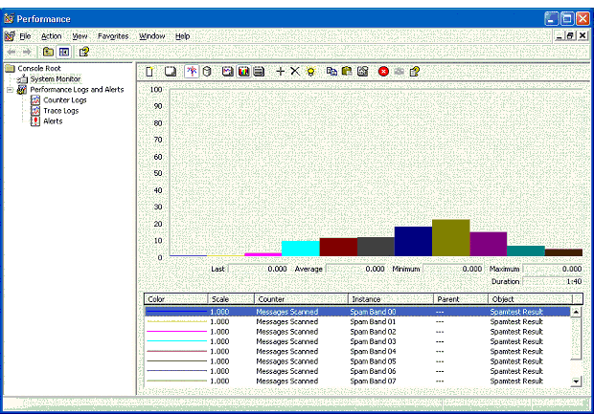
The Spamtest Result object has 11 instances corresponding to the 11 possible spam score values [0-10]. When all instances are viewed as a bar chart the columns will be sorted from Band 0 to Band 10. The Messages Scanned counter will then provide a histogram of the spam score distribution.

#$K+ WorldMail Engine
KThe WorldMail Engine consists of seven services, which are equivalent to UNIX daemons such as sendmail and pop3. These services are:
- SMTPDA, which handles outgoing SMTP transactions. This is the service responsible for routing messages to remote domains.
- SMTPRA, which handles incoming SMTP transactions. This is the service that receives mail from other sites.
- POP3A, which provides mail client access through the POP3 protocol.
- IMAP4A, which provides mail client access through the IMAP4 protocol.
- MAILMA, which is used by the WorldMail Management Center to remotely manage mailbox and mail list data, and allows Eudora users to change their e-mail password.
- HTTPMA, which allows users to access to the Web Management Center with a web browser.
- LDAP3A, which provides access to account information through the LDAP protocol.
The following sections provide details about these services and other WorldMail resources.

#K SMTP Receiver Service
KThe Receiver implements the SMTP Internet mail standard. It appears to the outside world exactly the same as a UNIX sendmail server.
The Receiver listens for incoming messages on TCP/IP port 25. It places the messages in the incoming mail directory.
A message is stored as two separate files, named uniquename.MSG and uniquename.RCP. The uniquename is a unique identifier by which the message is known while it is in the system.
The MSG file contains the message itself. The file is byte-stuffed (i.e. a redundant dot is inserted at the beginning of lines which start with a dot), and the end of the file is indicated by a single dot on a line by itself.
The RCP file contains the names of the recipients of the message, and the originator of the message (to whom non-delivery reports will be sent).
The Receiver will log incoming and outgoing transactions if the Logging options are set. This can be useful for analyzing mail transactions and errors.
The service is multi-threaded. This means that it can handle multiple connections from other mail servers at the same time.
The SMTP Receiver Service implements the SMTP and Extended SMTP protocols (ESMTP) defined in RFCs 821, 1652, 1869, 1870, 1985. Refer to http://www.rfc-editor.org for a complete list of RFCs.
The following SMTP commands are supported:
HELO DATA
EHLO RSET
QUIT NOOP
MAIL VRFY
RCPT
The following Extended SMTP commands are supported:

SIZE 8BITMIME
By default, a command of the form VRFY name@domain.com will return a successful response if the server accepts mail for domain.com. If Enable Full VRFY Support is set using the Security window, then this service will give information about whether name@domain.com is a mailbox or a mail list (or is unknown).

#K SMTP Delivery Service
KThe SMTP Delivery Service is the internal sorter for WorldMail. It deals with messages that have been received by the SMTP Receiver.
It moves messages from the incoming directory, and stores them in a holding directory. For each distinct domain in the list of message recipients, the service creates a subdirectory (within the domains directory), where it places information about the recipients in that directory.
For local deliveries, the service temporarily stores recipient information in a special $local$ subdirectory within the domains directory. It then copies messages into each local recipient's inbox directory.
For mail that is destined elsewhere, the service will submit a DNS request for a MX record for the corresponding domain. (It determines the DNS server address from the computer's TCP/IP configuration, so you must configure your computer with a correct DNS server address.) It uses the MX record to determine the TCP/IP address(es) to which it should attempt to send messages for that domain. The service will attempt to establish contact with the mail server at that domain and transmit the message. If unsuccessful, it will wait a while before attempting to contact the mail server again. It will persistently try to contact the mail server for several days, according to the Retry Schedule.
The message files in the holding directory are of the form uniquename.MSG. These files are byte-stuffed (i.e. a redundant dot is inserted at the beginning of lines which start with a dot), and the end of the file is indicated by a single dot on a line by itself.
The files in the domains directory are of the form uniquename.RCP. These files contain the names of the recipients of the message, and the originator of the message (to whom non-delivery reports will be sent).
The domains directory also contains a file DOMAIN.MRI that records routing information and details of how many times the SMTP Delivery Agent has attempted to contact each domain.
The SMTP Delivery Agent is multi-threaded and can deliver mail to multiple destinations at the same time.

#K POP3 Server
KThe POP3 server implements the Post Office Protocol version 3 Internet standard. It is responsible for passing incoming mail messages to e-mail clients.
It listens on TCP/IP port 110 for connections from e-mail clients. When a mail client connects, the server authenticates the username and password. If the username and password are valid then the server transfers messages from a user's inbox directory to the mail client program.
The server logs transactions if the Logging options are set. The service is multi-threaded. This means that multiple clients can pickup their mail at the same time.
The POP3 Service implements RFCs 1734, 1939, and 2095. Refer to http://www.rfc-editor.org for a complete list of RFCs.
The following POP3 commands are supported:
USER name
PASS string
APOP string
AUTH
STAT
LIST [msg]
RETR msg
DELE msg
NOOP
RSET
TOP msg n
UIDL [msg]
QUIT

#K IMAP4 Server
KThe IMAP4 server implements the Internet Mail Access Protocol version 4 standard. The IMAP4 protocol provides a rich interface for managing mail in a mailbox on a remote server.
The IMAP4 server provides an alternate way for mail users to logon and read their e-mail. It provides all of the capabilities of the POP3 service, with some major enhancements.
The IMAP4 protocol makes it possible for mail users to leave their messages on the server and organize them into folders.
This is very useful for people that use more than one computer to read their mail. Using the IMAP protocol, they can walk up to any computer that has an IMAP client installed, can log onto their mailbox and read their e-mail.
The IMAP4 Service implements RFCs 2060, 2086, 2095. Refer to http://www.rfc-editor.org for a complete list of RFCs.

#K LDAP3 Server
KThe LDAP3 server implements the Lightweight Directory Access Protocol version 3 standard. The LDAP3 protocol allows e-mail clients to search for names and addresses of users on the server.
Users search the LDAP3 server by creating a new directory service account in their e-mail client and submitting a query from the address book.

#K HTTP Management Server
KThe HTTP server provides a way for WorldMail users to configure their mailbox properties through any Web browser.
When a user connects with a Web browser, a Login form is displayed. If the user enters a valid username and password then the Mailbox Properties form will be displayed. This form allows the user to change his mailbox properties, such as the AutoReply and Reply Message. This is useful if the user is going on vacation and wants WorldMail to automatically reply to all of his incoming mail with a vacation message.

#K MAILMA Server
KThe function of the Mail Management Agent is to listen on port 106 and allow Eudora mail clients to change mailbox passwords. It also communicates with the WorldMail Management Center to allow WorldMail administration to be performed remotely over a TCP/IP connection.
The Change Password protocol is very simple, and is best documented by example. Here S is the server, C is the client:
S: 200 HELLO
C: USER yourloginname
S: 300 Please send your password now
C: PASS yourcurrentpassword
S: 200 Ok
C: NEWPASS yournewpassword
S: 200 Ok
C: QUIT
S: 200 Bye-bye\r\n
S: <closes connection>
C: <closes connection>

#K Working Directories
This section describes how WorldMail uses directories to spool mail.

#K Mailbox Directory K K
Each WorldMail user has a separate mailbox directory. The Mailbox Directory in the Domain General Page in the WorldMail Management Center sets the mailbox directory location. The SMTP Delivery Agent delivers mail into this directory. The POP3 and IMAP4 services may remove mail from this directory under control of a e-mail client.
It is highly recommended that you store your mailboxes on an NTFS partition. During installation, the Windows user that the WorldMail services run as is granted Full Control the default mailbox root directory. If you move this directory after installation, or if you create additional mailbox root directories for virtual domains, you must manually grant the WorldMail user Full Control over these directories (and all subdirectories).

#K Mail Spool Directory K K
You can use the Management Center to specify the Mail Spool Directory. The spool directory contains a number of subdirectories that are used as staging posts for messages. On Windows NT it is recommended that the Mail Spool Directory is on an NTFS partition. The directory structure under the Mail Spool Directory is as follows.

incoming K
This directory holds messages received by the SMTP Receiver. The SMTP Delivery Agent also places messages here, for example, non-delivery reports and messages which are sent to mail lists.

holding K
The SMTP Delivery Agent moves messages from the incoming directory into this directory.

domains K
When a message is moved into the holding directory, the SMTP Delivery Agent creates a subdirectory within the domains directory for each separate domain to which the message is addressed. If the message is addressed to a local user, it creates a subdirectory called $local$. In each subdirectory it stores routing information and information about the message recipients in that domain. (The message itself stays in the holding directory.)

dead K
This directory collects messages which are both undeliverable and un-returnable.

lists K
This directory contains subdirectories corresponding to mail lists. For every mail list, two directories are created: one corresponding to the list itself, and one corresponding to the -request address for the list. Messages are moved into these directories temporarily while they are being delivered to list members.
#$K+ Windows Management Center Reference
K KThe Windows Management Center allows you to configure your local or remote WorldMail Engine. You can use the Windows Management Center to manage WorldMail on the local system as well as on servers elsewhere on the network.

#$K+ WorldMail Server Administration
When you start the Windows Management Center it displays a list of registered WorldMail computers. Select the WorldMail server that you wish to administer by double-clicking on the name of the server in the tree view, or selecting the Register New Mail Server button and entering the computer name.
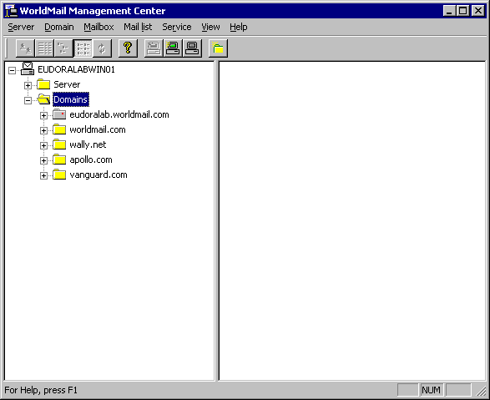
Initially, the left-hand pane contains only one icon, representing the computer on which you have just installed WorldMail, and on which you are running the Windows Management Center. Click on the [+] symbol to the left of the icon to see the items that you can configure on the server.
If you have not yet entered a valid License Key for WorldMail, you will see only a License Key icon, which you should double-click to allow you to enter your License Key (see later in this chapter). Otherwise, you will see folders labeled Server and Domains. Click on the [+] symbol to the left of the folder icons to expand the tree further.
You may double-click on the configuration icons (some of which are within their own folders) to configure that particular feature.

#$K+ Registering a New Server
KTo register a new server, select Register from the Server menu (or use the corresponding toolbar button, or right-click on an existing server icon and select Register from the popup menu). This will display the following form:
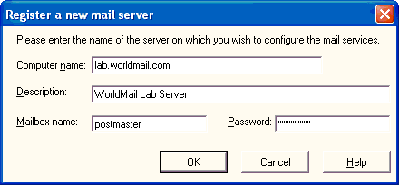
You can repeat this process for all WorldMail servers on your network. Server registration information is maintained on a per-user basis, so that if you log on to computer under a different name, you will have to register the servers again.

Computer Name
Enter the name of the target system here. You must specify the system name by its host.domain name or IP address.

Description
You may also enter a description for the computer, which will appear beside the computer name in the Windows Management Center.

Mailbox Name & Password
Enter the name and password of a mailbox on the target server that has server-level access. If this user and password is not valid on the target computer, or if the permissions are not sufficient, then the connection will fail.

#K De-registering a Server
KDe-registering a server is also very straightforward, using the same techniques. Note that de-registering a server does not mean that the server's configuration information is lost--it simply means that the Management Center cannot access it until you re-register the server.

#K Editing a Server
You can change the server comment using the Edit command from the Server menu (or the popup menu).

#K Disconnecting from a Server
If you have connected to a registered server (for instance, if you have expanded the server icon by clicking on the [+] symbol to its left), you may disconnect by selecting Disconnect from the Server menu. This can be useful if the server you are administering goes down--in this case you should disconnect from it and then reconnect after it has been rebooted.

#$K+ Server
Under each server shown in the list of WorldMail systems on the left side of the WorldMail Management Center are two folders: Server and Domains. The Server folder contains icons corresponding to the many options that can be configured for the WorldMail Engine.
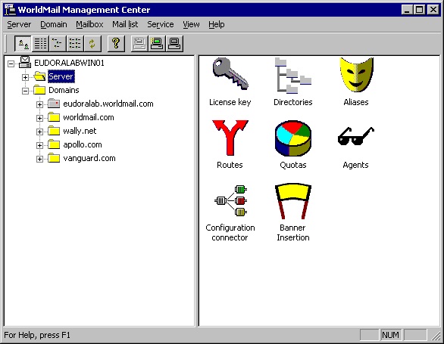
The following sections contain complete information on all of the items in the Server folder and its sub-folders.

#$K+ License Key
KIf you did not enter a valid License Key during the installation process, you can enter it in the License key dialog. Display this dialog by clicking on the License key icon:
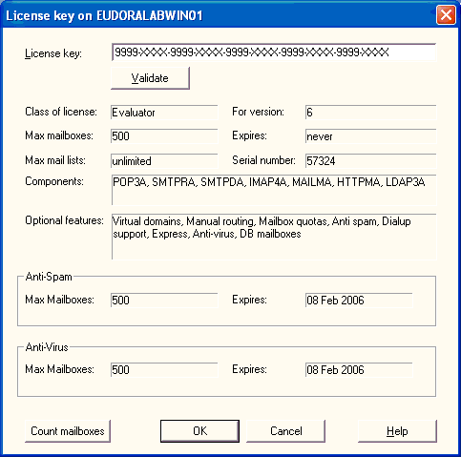
The License Key unlocks WorldMail features. If you are using an evaluation key, then your license will expire in 30 days. If you are using a purchased key, then the license will not expire.

License Key
Type your License Key into the field provided. License Keys consist of five groups of four characters. Each group is separated by a hyphen. The characters will always be between 0 to 9 and A to F. The letters must be entered in uppercase, and make sure that you do not confuse the character O (upper-case "o") with the number 0. You will never be issued with a key that contains the upper-case "o" character.
Click the Validate button to ensure that you've not made a typing mistake, and to see exactly what the License Key entitles you to do. The License Key determines:
- Your WorldMail Serial Number.
- The maximum number of mailboxes you may create.
- The maximum number of mail lists you may create.
- The date on which your license to use the software expires.
- Any optional features which you are licensed to use.
Remember that your WorldMail license does not permit you to disclose your License Key to anyone else.
Click the Count mailboxes button to get the total number of domains, mailboxes, and mail lists on your system.

#$K+ Directories
K KClick on the Directories icon to set the mail spool directory for WorldMail.
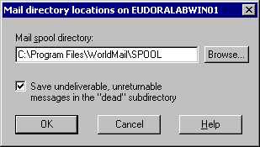

Mail Spool Directory
The Mail Spool Directory is a staging post for messages in transit through the system. Enter the name of the directory that you wish to use as the mail spool directory. WorldMail will create subdirectories under this directory. For further information refer to the section on the WorldMail Engine.
Under Windows NT it is recommended that the mail spool directory is located on a NTFS partition. See the Message Store Security section for additional information. The default is: C:\Program Files\QUALCOMM\WorldMail\SPOOL.
To configure the location where the mail server will store messages for local mailboxes, see the section on Domains later in this chapter.

Save Messages to Dead Directory
By default, messages that are both undeliverable and un-returnable are stored under the Spool directory in a subdirectory named dead. Keeping these messages allows you to diagnose potential mail delivery problems. However, if your site is particularly busy or hosts a large number of mailboxes, saving dead messages can be an unnecessary use of disk space. Use the option in the Directories dialog to specify whether these messages should be saved to dead. If this option is disabled, WorldMail will discard all undeliverable and un-returnable mail.

#$K+ Aliases
KClick on the Aliases icon to open the Aliases dialog:
You can configure WorldMail to redirect incoming messages using Aliases. When the server receives a message and the To: address matches an entry in this alias table, then the mail is redirected.

Adding Aliases
Enter the Map From and Map To entries and click on the Add button.

Modifying Aliases
To modify an alias, select it in the list. Enter the new Map From and Map To entries and click on the Modify button.

Deleting Aliases
To delete one or more aliases, select them using the Shift and Ctrl keys then click the Delete button.

Map From
Type the address that you wish to alias. The alias can be a simple user name (such as fred), or can be a fully qualified Internet Mail Address. This is especially useful if you have configured WorldMail to support multiple domains. See the section on Multiple Domains for more information.

Map To
Type the address to which messages should be sent. This address could be a local mailbox listed in the Mailboxes folder (for example, fred) or it can be a remote user (for example, fred@abc.com).

Wildcard Aliases
You can specify wildcards in the Map From field. This can be used to redirect mail for all names matching a pattern. For instance, specifying a user name of t*y would match Tony, Tiny, toby, terry, etc. (Note that matching is not case sensitive.)
You can also specify a single wildcard as the first character of the Map To field. This will be replaced by the actual user name when the table entry is used. For instance, if the Map From string is f* and the corresponding Map To string is *-blue@xyz.com, then a message for fred@abc.com will be redirected to fred-blue@xyz.com.
This feature can be used to redirect all mail for one domain to a second domain. The second domain could be local to this machine, or on a remote machine. This is done by specifying a Map From string of *@abc.com and a Map To string of *@xyz.com.

Map Table Order
The order of entries in the alias table is significant. It is processed top-to-bottom, and the first matching entry is used. Thus, specific entries should be positioned near the top of the list, and less specific entries (containing wildcards) towards the end of the list. Use the Up and Down buttons to move entries around.

Import Aliases
The Import button allows you to import aliases from a text file. The button displays the Open file dialog. Locate the text file containing the list of Aliases that you wish to import. Click on the OK button to import the Aliases. Each line of the text file should consist of the Alias, followed by a colon, followed by the address. For example:
jgd: johnd
john*: johnd
jd: johnd
krg: keving
kev*: keving
kg: keving
gg: gregg
greg*: gregg
greg: gregg

Export Aliases
The Export button allows you to export aliases to a text file. This button displays the Save As file dialog.
Enter the name of text file for exporting the list of Aliases. Click on the OK button to export the Aliases. Each line in the text file will consist of the Alias, followed by a colon, followed by the Address. For example:
jgd: johnd
john*: johnd
jd: johnd
krg: keving
kev*: keving
kg: keving
gg: gregg
greg*: gregg
greg: gregg

#$K+ Routes
KClick on the Routes icon to display the Routing dialog, which is used to set rules for how messages are routed through WorldMail:
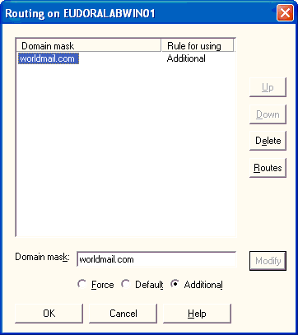
Normally, WorldMail uses DNS MX records to decide which host to contact in order to deliver mail for a particular domain. In some circumstances it may be necessary to augment or replace the use of the DNS records by manual routing information. For example, you may wish to use WorldMail on a proxy relay server to route incoming messages to a secure mail server on the LAN. This form allows you to set up a manual routing table to do this.
The manual routing table consists of an ordered list of entries that are shown in a scrolling list. Each entry consists of a domain mask, a combination rule, and one or more associated routes.
The order of the entries in the manual routing table is significant. It is processed top-to-bottom, and the first matching entry is used. Thus, more specific entries (not containing wildcards) should be positioned near the top of the list, and less specific entries (containing wildcards) towards the end of the list. Use the Up and Down buttons to move entries around.
To specify the routes on which messages for the domain are sent, select a domain mask and click the Routes button.

Domain Mask
Enter the name of the domain for which a route is being defined. The domain may include one or more wildcards (*). For instance, a domain of *abc.com will match both user@one.abc.com and user@two.abc.com. Do not use the @ symbol with the domain in this field. Routing is done strictly on the mail domain name not on the user name.

Option
The option determines how the manual route relates to the information returned by the DNS. It can have three values:
- Force: The manual route overrides any routes in the DNS records
- Default: The manual route will only be used if the DNS does not return any routing information for the domain
- Additional: The manual route will be merged with the routes returned by the DNS.

#$K+ Route Definition
Use this dialog to set manual routes for the selected domain.
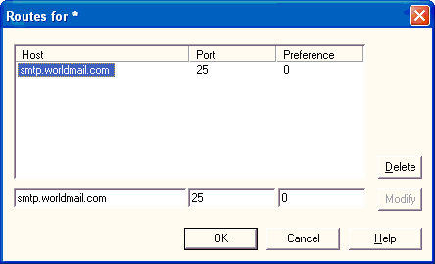
Each domain can have one or more manual routes.

Host
Enter the name (or IP address) of the host for the manual route. This will override or supplement the DNS record for this domain (depending on the preference setting).

Port
Enter the port number on the destination host to which WorldMail will connect to deliver outgoing mail. The default is 25. It is usually not necessary to change the default.

Preference
Enter the preference number for this route. Lower preferences are tried first. This is equivalent to the MX preference number in DNS.

#$K+ Quotas
KTo enable support for mailbox quotas, open the Server folder in the Windows Management Center and select the Quotas icon. To configure the domain-wide default quotas (which apply if a mailbox does not have an explicit quota set), use the Domain General Page. To configure individual mailbox quotas, use the Mailbox General Page.
The Quotas dialog looks like this:
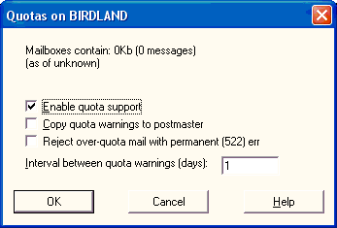
The Quotas dialog displays the approximate number of messages and their total size, and allows you to set certain associated parameters.

Enable quota support
Check this box to turn on quota checking. If quota support is enabled, then incoming mail to an over-quota mailbox will be rejected.

Copy quota warnings to postmaster
When a mailbox exceeds a warning level, and when it exceeds its quota limit, a message is placed in the mailbox. This flag controls whether this message is also sent to the domain postmaster.

Interval between quota warnings
This controls how often the quota warning message is generated.

#$K+ Agents
K KClick the Agents icon to configure the Server Agent and the Archive Directory:
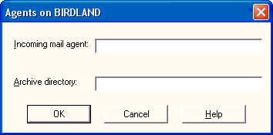

Incoming Mail Agent
WorldMail executes the Server Agent for every message that is received. The agent is passed the names of two files: the message file itself, and a file containing SMTP envelope information.
The message file is a text file with a MSG extension. The file containing the SMTP envelope information is known as the recipients file, although it contains more than just recipient information. The recipients file is a text file with a RCO extension when it is passed to the Server Agent. When the agent terminates, WorldMail will rename the file to its normal RCP extension.
This field should contain a command-line template. An occurrence of %r in the template is replaced by the name of the recipients file, and an occurrence of %m in the template is replaced by the name of the message file. The resulting command line is then passed to the command-line interpreter to execute.
Thus, if the template were:
- copy "%r" c:\temp & copy "%m" c:\temp
WorldMail would copy both the message file and the recipients file to the c:\temp directory.
Multiple commands can be executed, as in the above example, by separating each command with the & character (or by using a batch file).
The agent is executed by the SMTPRA service and agent inherits the access rights of the SMTPRA service. If you installed WorldMail to run its services as a specific Windows user, you must grant this user execute access for the agent application.
It is important that the Server Agent should not take too long to execute. Otherwise, a busy mail server could easily run out of memory or saturate its processor.
It is possible for the Server Agent to delete or move the message file and recipients files - for instance if the agent determines that the message contains a virus. In this case, the agent should respect the wishes of the sender regarding delivery status notifications, as expressed in the recipients file. This means that the agent may need to send a Delivery Status Notification message. Not to do so may be a violation of the SMTP protocol.

Archive Directory
K KA copy of every incoming message can be archived to a directory by entering the directory name in this field. WorldMail will create a folder under this directory with the name equal to the current date. WorldMail will copy every incoming MSG message file and corresponding RCP recipients file into this directory.

#$K+ Configuration Connector
The Configuration Connector controls the method that WorldMail uses to store its configuration and mailbox data. WorldMail is installed using the Registry Connector, which stores all configuration data in the Windows registry. Your license does not allow you to configure this option.

#$K+ Banner Insertion
Click the Banner Insertion icon to configure the e-mail banners to be added to all messages received via SMTP:
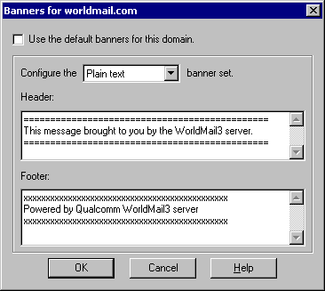
Banners can be defined at the domain level and the server level. Domain-level banners are added to all messages sent that domain, while server banners are added to all mail sent from remote domains (that is, domains not defined in WorldMail).
There are two types of banners: Header and Footer. Headers are inserted at the top of the body of the email message, while footers are appended to the bottom of the message body (above all attachments).
You can set separate banners for plain text messages and HTML messages. This allows you to insert sophisticated HTML content (including banner advertisement graphics) in messages that contain HTML. If an HTML banner is not defined, the plain text banners for the domain are applied to both text and HTML messages.

#$K+ Security
WorldMail provides security features to help protect your server against abuse and unsolicited commercial e-mail (also known as spam K). WorldMail Security features can be seen by double-clicking on the Security icon:
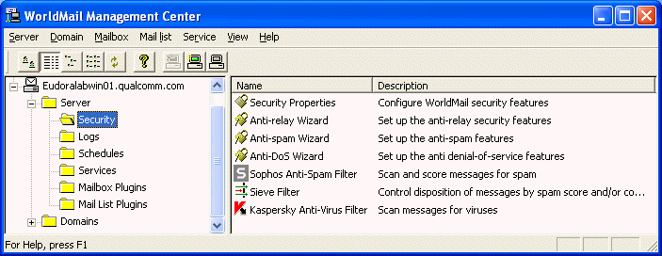
These Security properties help you block unauthorized use of your mail server. It is easy to block authorized access to your mail server by mistake, so take great care to set these properties. Refer to the section on Advanced SMTP Security for more information. You can also set these policies through the Anti-Relay Wizard and Anti-Spam Wizard.

#$K+ General Security Settings
KThe Security Properties dialog is invoked by double-clicking on the Security Properties icon:

Enable Full VRFY Support
VRFY K is an SMTP command that allows sending mail servers to verify the To: address. By default, a command of the form VRFY name@domain.com will return a successful response if this server accepts mail for domain.com.
If Enable Full VRFY Support is set, then WorldMail will respond to the VRFY command with information about whether name@domain.com is known, and if so whether it is a mailbox or a mail list.
If you leave this box unchecked, it reduces the amount of information an attacker or spammer can find out about your users.

Authenticated ETRN K
The SMTP ETRN command is used to request an SMTP server to start sending mail for a particular domain. (This command is used by the MSSTART utility.) If you check this box then the SMTP client must be authenticated (using the AUTH command with a valid mailbox name and password), otherwise the ETRN command will be rejected.

Maximum message size (bytes)
Enter the maximum message size in bytes that the SMTP Receiver will accept. The default is 0, which means that there is no size limit apart from memory and disc space constraints.

Header Rewrite Mode K
Select a format that WorldMail will use to rewrite an invalid From header address. The choices are:
- None
- "Jane User" <user@domain>
- user@domain (Jane User)

Use Alternate Resent Headers K
This option controls the way that WorldMail defines Resent headers, which are used to save information about forwarded messages. By default, resent headers are created in the format Resent-Header, such as Resent-To and Resent-From. You can change the format of resent headers by enabling this field, which causes these headers to be created in the format X-Resent-Header.

Anti-Denial-of-Service: Max connections (all hosts)
This setting provides a limit to the total number of incoming SMTP connections that WorldMail will respond to at any time. When this number of connections are active, SMTPRA will no longer accept new connections until a current connection has been closed.

Anti-Denial-of-Service: Max connections per host
This setting limits the number of incoming SMTP connections allowed from any one system. When this number of SMTP connections from any one host are active, SMTPRA will no longer accept new connections from that host. This option is very useful for containing potential damage from an abusive system without blocking incoming connections from other (non-abusive) systems.

Anti-Denial-of-Service: Connection timeout
This option sets a limit to the number of seconds that WorldMail will keep open a non-responsive SMTP connection.

Anti-Denial-of-Service: Limit throughput from each host
This option provides a throttle on the amount of data (in kilobytes per second) that SMTPRA will accept from any one host. This allows you to control DoS attacks that send large amounts of data over relatively few connections. When using this option it is recommended that you exempt your "friendly" hosts from this limit to avoid slowing mail traffic from your own network.

#$K+ Anti-Spam Security Properties
The Anti-Spam Security Properties dialog is invoked by clicking on the Anti Spam tab:

Lookup SMTP hosts in the DNS
KWorldMail can be configured to perform a reverse lookup of the IP address of the incoming SMTP host. The resulting host name is used in the log files and in the Received: header. If the reverse lookup fails then connection is rejected unless the Accept Unknown Hosts option is turned on.
This option can help block unauthorized SMTP relay because many junk mail distributors do not have a valid reverse DNS record.
This option can have a serious impact on performance. WorldMail must submit a reverse DNS lookup query for each incoming connection. If your DNS server is slow then incoming connections may experience significant delays.

Lookup SMTP hosts using blacklist server(s)
This option allows WorldMail to block messages coming from known sources of junk email, as compiled by blacklist servers. If you check this box, and a host listed with the given blacklist server connects to WorldMail, then all mail from that server will be rejected. Note that checking this box may slow down the rate at which you can accept mail because of the extra time required to perform the lookup.
To use this option, specify the host name of the blacklist server in the Blacklist servers field. When entering multiple values in field separate each entry with a comma.
When using blacklist servers it is recommended that you exempt your "friendly" hosts from blacklist lookup. This will prevent numerous unnecessary blacklist queries that would otherwise slow WorldMail's SMTP performance.

Require SMTP authentication for relaying K
Checking this option requires that anyone relaying mail through your SMTP server must log in via Authenticated SMTP. This prevents unknown users from using your server to relay junk mail. However, this also requires that all of your end users have mail clients that support Authenticated SMTP and that they enable this feature in their client.
This feature also includes and option to exempt your "friendly" hosts from SMTP authentication. Enabling this option allows non-authenticated SMTP traffic from hosts listed under the Accept mail for relay from these friendly hosts… option.
When this option is selected, the Disable authenticated SMTP option in this window is automatically disabled.

Disable relay for non-local users
Checking this box is a quick way to stop your mail server being used to relay spam to other sites. If you check this, then WorldMail will not accept mail for relay unless the MAIL FROM: address in the SMTP envelope refers to a local domain. (Note that the MAIL FROM: address specifies the return address for non-delivery reports - it is not necessarily the same as the From: address in the message header.)
This option will not protect your mail server against determined spammers, who are capable of forging the MAIL FROM: address. You can get better protection using the Require SMTP authentication for relaying option, or through the Accept mail for relay from these friendly hosts mask list. (Note that if you set up the Accept mail for relay from these friendly hosts list, you should turn off this option since it overrides the value in that field.)

Validate sender address
If you check this box WorldMail will look up the domain name supplied in the MAIL FROM: command, to ensure that there is a valid A record or MX record in the DNS for it. If there is not, the address is assumed to be illegal, and the mail will be rejected. Turning this on may reduce performance since the DNS server may take some time to respond.

Max number of recipients per message
You can specify the maximum number of recipients allowed for an individual message. These are the recipients specified on the SMTP envelope (that is, given by the RCPT TO: command). If you specify 0, there is no maximum.

Disable authenticated SMTP K
Check this option if you do not want to use authenticated SMTP to control mail relay. Enabling this field automatically disables the Require SMTP authentication for relaying field.

#$K+ Reject All Incoming Mail From These Addresses
If you click on Reject All Incoming Mail From These Addresses from the Anti-Spam tab of the Security Properties window, the following form will be displayed:
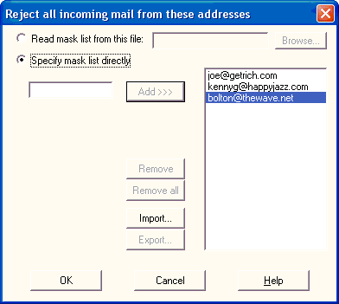
If a message arrives from an e-mail address that is listed in this form, then the message will be rejected.
Refer to the section on Security Masks and Advanced SMTP Security for more information. You can also set these policies with the Anti-Spam Wizard.

#$K+ Reject All Incoming Mail From These Hosts
If you click on Reject All Incoming Mail From These Addresses from the Anti-Spam tab of the Security Properties window, the following form will be displayed:
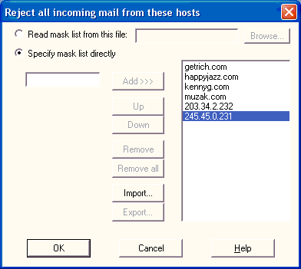
If a message arrives from a host that is listed in this form then the message will be rejected.
If you specify host names as opposed to IP addresses, you must check Look up SMTP hosts In The DNS so that WorldMail can determine the host name.
Refer to the section on Security Masks and Advanced SMTP Security for more information. You can also set these policies with the Anti-Spam Wizard.

#$K+ Accept Mail For Relay To These Domains
If you click on Accept Mail For Relay To These Domains from the Anti-Spam tab of the Security Properties window, the following form will be displayed:
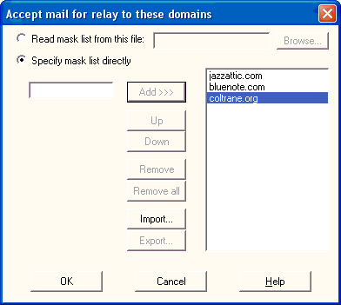
This feature is useful if your server acts as a secondary SMTP relay host for some other domains. In this case you would enter a list of all of the relay domains in this field.
If a message comes in from a host not listed in Accept Mail For Relay From These Hosts, and the To: address is not local, then the server will refuse to accept the message unless the destination mail domain is listed in this field.
Refer to the section on Security Masks and Advanced SMTP Security for more information. You can also set these policies with the Anti-Relay Wizard.

#$K+ Accept Mail For Relay From These Friendly Hosts
If you click on Accept Mail For Relay From These Friendly Hosts from the Anti-Spam tab of the Security Properties window, the following form will be displayed:
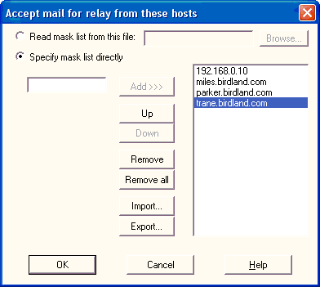
Use this form to enter a list of host names or IP addresses that are permitted to relay mail through this server. The default entry is *, meaning all hosts can relay mail through this server.
If a message comes in from a host that is not listed in this field, and the To: address is not local, then the server will refuse to accept the message unless the destination mail domain is listed in Accept Mail For Relay To These Domains.
If you specify host names as opposed to IP addresses, you must check Look up SMTP hosts In The DNS so that WorldMail can determine the host name.
WARNING! It is very easy to block valid messages with this feature. Be careful to make correct entries. Test your settings by sending e-mail from a variety of client machines.
Refer to the section on Security Masks and Advanced SMTP Security for more information. You can also set these policies with the Anti-Relay Wizard.

#$K+ Security Masks
You can use the security forms to specify a list of name or address masks. They are called masks because they can contain the asterisk character * as a wildcard. They can also be preceded by an exclamation point, !, meaning negation. The list of names can be read from a text file, or you can specify the names directly in the scrolling list.
If you plan to maintain a list of names in a text file, select the Read mask list from this file option and enter the full name of the text file in the corresponding field. If you are running the Windows Management Center on the same machine as you are administering, you can use the Browse button to browse for the file. The text file must contain a list of name (or address) masks, one per line.
Alternatively, you can use the Specify mask list directly option. You may then enter a mask in the edit field to the left of the Add button, and click Add to add it to the list. The order of items in the list is significant--use the Up and Down buttons to move them around. The Remove button removes a single entry from the list, while Remove All clears the list entirely. There are also buttons to allow you to import and export name lists to and from text files.
What you are allowed to put in the mask list depends on which button you clicked:
Mask list | Contains | ! (Negation marker)
Reject all incoming mail from these addresses | E-mail addresses | Not allowed
Reject all incoming mail from these hosts | Host names or IP addresses | Yes
Accept mail for relay from these friendly hosts | Host names or IP addresses | Yes
Accept mail for relay to these domains | Mail domain names | Yes
A mask list works as follows. A host name (or IP address, domain name or e-mail address, depending on the list in question) either matches or does not match the list. The host name is tested against each mask in the list in turn, starting from the top. If it fits the mask, this is treated as a match, unless the mask is preceded by an exclamation point (meaning "exclude from the list"). This is treated as a failure to match the list, and no further masks in the list will be examined. If the end of the list is reached without a match being found, the host name is deemed not to match the list.

#$K+ DHAP Security Properties
DHAP settings are invoked by clicking on the DHAP Settings tab in the Security Properties dialog.
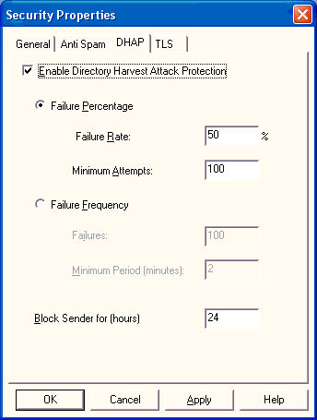

Enabling DHAP
DHAP is not enabled by default.
To enable DHAP check the "Enable Dictionary Harvest Attack Prevention" checkbox.
WorldMail can prevent a DHA in two ways. Only one of these methods will be active at any time when DHAP is enabled. Enabling DHAP will allow you to choose and configure one of the two detection methods.

Disabling DHAP
To disenable DHAP uncheck the "Enable Directory Harvest Attack Protection" checkbox. This will halt the collection of any statistics on connecting hosts and allow hosts that have been deemed harvesters to reconnect

DHAP Detection Methods
WorldMail can prevent a DHA in two ways. Only one of these methods will be active at any time when DHAP is enabled. Enabling DHAP will allow you to choose and configure one of the two detection methods.

Percentage failure detection method
To select this method of detection select the Failure Percentage option.
If you do not wish to use the default values you may now configure the failure rate that you deem a DHA and the minimum number of attempts that the failure rate is calculated over. Finally you can configure the block duration that a host deemed a harvester is blocked for.
The failure rate is the percentage of non-existent email addresses with respect to the total number of email addresses attempted by a connecting host.
With the configuration above, if a connecting host attempts to sends over 50% of its mail (minimum email address sample size 100) to invalid email addresses, that host will be disconnected and blocked from reconnecting for a period of 24 hours.

Failure frequency detection method
To select this method of detection select the Failure Frequency option.
If you do not wish to use the default values you may configure the number failures that must occur within a configurable minimum period to determine a DHA. Finally you can configure the block duration that a host deemed a harvester is blocked for.
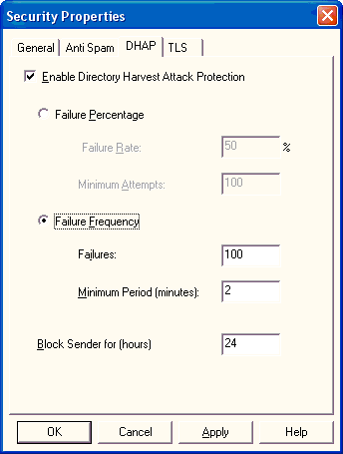
With the configuration above, if a connecting host attempts to send mail to 100 invalid email addresses within a 2-minute period of time, that host will be disconnected and blocked from reconnecting for a period of 24 hours.

#$K+ TLS Security Properties
TLS settings are invoked by clicking on the TLS settings tab in the Security Properties dialog.
All SSL/TLS security settings are available via the TLS tab of the Security Properties window. WorldMail allows you to specify the level of TLS deployment separately for each of the three mail protocols⎯ SMTP, POP3, and IMAP4. Each protocol has a separate area within the window. All three protocols use the same drop-down menu settings.

SMTP Protocol
When receiving SMTP connections, the settings available from the drop-down menu are:
- Disable TLS ⎯ WorldMail communicates in clear text mode and does not advertise TLS to the client.
- Allow TLS (default) ⎯ WorldMail negotiates with the mail client and optionally encrypts messages if the client has SSL/TLS configured.
- Require TLS ⎯ WorldMail forces messages to be encrypted.
You must also specify how mail will be sent (relayed) by SMTP. The two settings available from the drop-down menu are:
- Disable TLS ⎯ WorldMail communicates in clear text mode even if the remote server advertises TLS.
- Use TLS if available (default) ⎯ If the remote SMTP server advertises support for TLS it will attempt to use TLS but will send in clear text mode if unable to establish a secure connection.
- Require TLS if supported ⎯ If the remote SMTP server advertises support for TLS but is unable to establish a secure connection then it is treated as a temporary failure and WorldMail wil attempt to redeliver. If the remote SMTP server does not advertise support for TLS then WorldMail will send in clear text mode.
- Require TLS ⎯ WorldMail will only send messages to remote SMTP servers that advertise support for TLS if it is able to establish a secure connection.

POP3 Protocol and IMAP4 Protocol
The POP3 and IMAP4 Protocol areas of the Security Properties window provide the same configuration setting choices. To limit redundancy, they are described together in this subsection.
When receiving POP3 connections or IMAP4 connections, the settings available from the drop-down menu are:
- Disable TLS ⎯ WorldMail communicates in clear text mode.
- Allow TLS (default) ⎯ WorldMail negotiates with the mail client and optionally encrypts messages if the client has SSL/TLS configured.
- Require TLS ⎯ WorldMail forces messages to be encrypted.
Two checkboxes may also be set:
- Disable Plain Text Logins ⎯ Checking this box forces the client to encrypt login details (when both the server and client have agreed to use SSL/TLS).
- Enable alternate SSL port ⎯ Checking this box supports the use of an alternate secure port (this feature is required when the client software supports SSL 3.0 but not TLS 1.0). The alternate port number must be entered in the adjacent text box.

#$K+ Anti-Relay Wizard
KTo simplify the task of setting anti-relay policies, WorldMail includes an Anti-Relay Wizard. This wizard leads you step-by-step through options that combat third-party relay. To start the wizard, double-click on the Anti-Relay Wizard icon in the WorldMail Management Center.
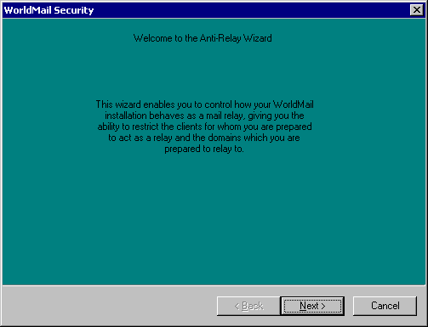

#$K+ Anti-Spam Wizard
KTo simplify the task of setting anti-spam policies, WorldMail includes an Anti-Spam Wizard. This wizard leads you step-by-step through options that combat the flow of junk mail ("spam") to your site. To start the wizard, double-click on the Anti-Spam Wizard icon in the WorldMail Management Center.
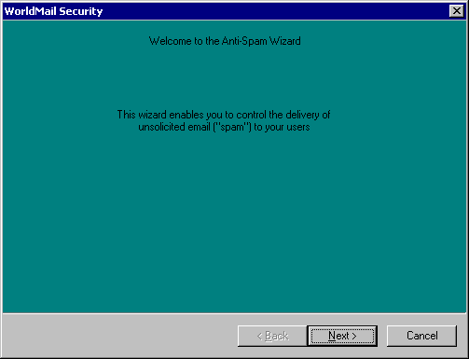

#$K+ Anti-DoS Wizard
KTo simplify the task of setting anti-denial of service (Dos) attack policies, WorldMail includes an Anti-DoS Wizard. This wizard leads you step-by-step through options that combat potentially crippling denial-of-service attacks. To start the wizard, double-click on the Anti-DoS Wizard icon in the WorldMail Management Center.
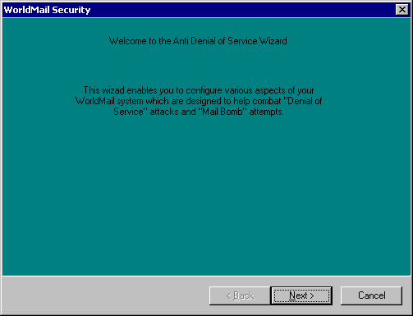

#$K+ Sieve Filter Rules
The Sieve Filter Rules window lists the content filters currently defined on your site, and allows you to add new filter rules. To open this window, double-click on the Sieve Filter icon in the Security folder. You can also create filter rules that apply to only a specific domain by similarly opening the Sieve Filter icon within the target domain's folder in the WorldMail Management Center.
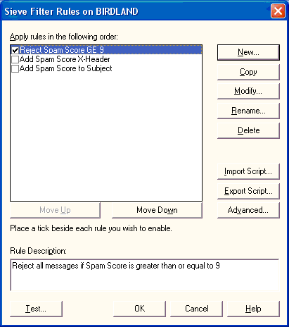
The rules defined in this list are applied sequentially, so if a message is rejected by an initial filter it will not be subject to subsequent rules. You can move filters up and down in this list to refine your filtering strategies. You can also enable/disable filters by checking the box at the left of each filter rule in this list. To create a new filter rule click New, which launches the Rule Wizard.
To bypass the Rule Wizard and edit the Sieve script directly, click the Advanced button. This displays an editor window that allows you to create, modify, and delete filter rules by editing the Sieve filtering syntax.

#$K+ Description
KUse this panel of the Rule Wizard to enter a name and description of your new filter rule. Both the name and description of each filter appears in the Mail Filter Rules window.
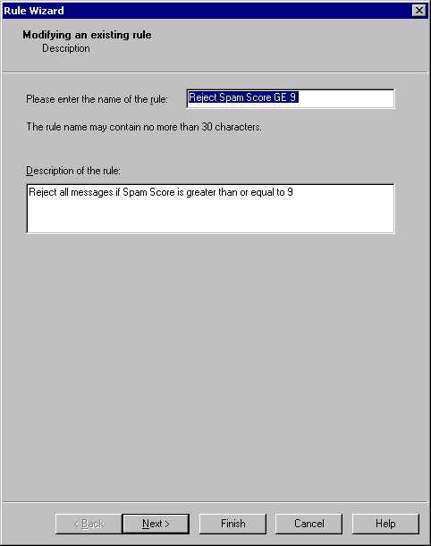
Filter names must be unique and can contain only alphanumeric (A-Z, a-z, 0-9), dot (.) and dash (-) characters.

#$K+ Condition
This panel of the Rule Wizard displays the filtering criteria for your filter rule. These are the conditions that will cause a message to be subject to the filter rule.
By default, a message must match all of the criteria defined in this list to be subject to the filter rule. You can modify this behavior to filter messages that match any of the given criteria by selecting the appropriate option at the top of the Condition dialog.
To add criteria to your filter rule, click Add. If you would like to edit the filter rule in the Advanced Condition Editor, click the Advanced button. When you are done adding criteria, click Next.

#$K+ Creating a New Criterion
Use this dialog to create new criteria for your filter rule. To define a criterion, select the part of the message that you want to search in and the text string for which you are searching. You can also use regular expressions to define sophisticated text searches.
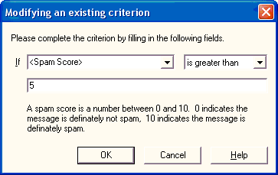
When defining filtering criteria, you can search for the given text in either the headers (From, Subject, To, Cc, Bcc, Sender, and Reply-To) or body of the message. For each message header, your criteria can specify the following types of tests:
contains the search string
does not contain the search string
exactly matches the search string
does not exactly match the search string
exists
is absent
exists and is not empty
is absent or is empty
For the body of the message, your criteria can specify the following types of tests:
contains the search string
does not contain the search string
size is over the given value
size is under the given value
When searching for specific text in the headers or body, you can also enable the Regular Expression option to specify a regular expression search. This also enables a Test button that allows you to test your regular expression syntax on sample message content. Testing regular expression syntax is highly recommended. For information on regular expression syntax, refer to the section on Regular Expressions.

#$K+ Advanced Script Editor
This dialog allows you to manually edit the scripts that WorldMail uses to define filter rules. These scripts are generated automatically when you create filter rules in the WorldMail Management Center, but can be manually edited here to refine filter rules.
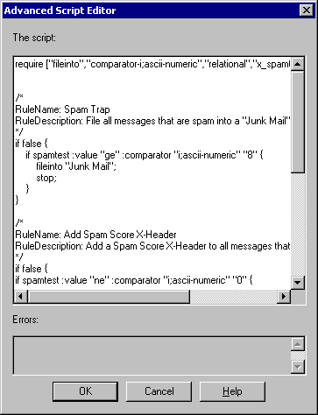
The scripts shown in this dialog consist of one or more clauses, which are statements that are either true or false. For complete message syntax and examples, refer to the section on Script Editing.

#$K+ Testing a Regular Expression
Use this dialog to test the syntax of your regular expression filter rule. Testing regular expressions before using them in filters is highly recommended.
Enter sample message text in the field provided to test your regular expression. This allows you to simulate the mail filter on the type of content you are looking for. When you click Test, the sample text will be searched for text that matches your search criteria.
For information on regular expression syntax, refer to the section on Regular Expressions.

#$K+ Action
This panel of the Rule Wizard defines the action to be taken against messages that satisfy all of the criteria for the filter rule. In other words, if a message contains all of the characteristics that you set for this rule, WorldMail will handle that message according to the actions you set here.

Copy the message
This action is optional, and causes a copy of the message to be forwarded to a specific e-mail address and/or stored in a file system directory. This option is useful for archiving important mail or causing suspect messages to the held for your inspection. Depending on the other actions chosen in this window, the message may or may not be delivered to its intended recipient.
The actions available when copying a message change slightly when creating domain or mailbox filters. For domain filters, copying a message to a file is not available. For mailbox filters, the a message can only be copied to a folder within the recipient's mailbox folder.

Continue Filtering
This action specifies that messages which meet your filter criteria should be subject to your other filter rules. When this action is selected, a message that is copied by this filter rule will also be processed by other filters, which may accept, reject, or delete the message.

Deliver the message
This action specifies that messages which meet your filter criteria should be delivered to their intended recipients and not processed by any additional filter rules.

Discard message
This action specifies that messages should not delivered to their intended recipients and should be simply deleted from the system. When this action is selected messages will not be processed by any subsequent filter rules. Unlike the Reject action, Discard does not return messages or give the sender any indication that the message was not delivered.

Reject Message
This action causes messages to be rejected by WorldMail's SMTP server. Rejected messages are not delivered to any recipients and no additional filter rules will be applied to them. When a message is rejected, WorldMail blocks it and returns the explanation in the given text field, which allows you to specify the reason why the message was rejected.

#$K+ Complete
This panel of the Rule Wizard verifies that the filter rule was created successfully and allows you to enable the new rule. The rule must be enabled before WorldMail will use the rule to filter incoming mail.
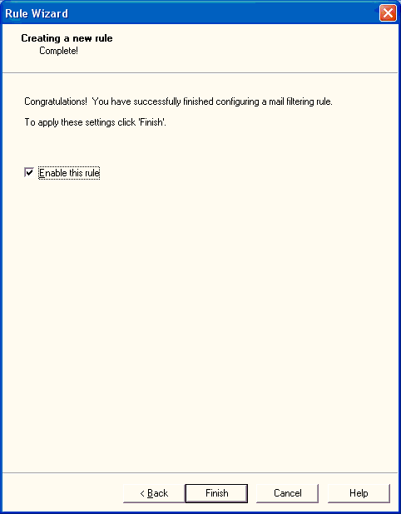
Click Finish to close the wizard and enable the new filter rule.

#$K+ Testing the Sieve Filter
Use this dialog to test your Sieve Filter rules on sample messages. Testing filter rules is important to verify the affect that they will have on your site's mail activity, and to confirm that they work as intended.
Use the Browse button to select the source of the test messages, and then click Run to execute your filtering rules against the messages in this directory.
If a message is subject to a filter rule, then this window displays the name of the message file, the filter rule that applies to it, and the action(s) taken against the message. The possible actions are Reject (message blocked), Forward (message forwarded to the given address), Copy (copy of the message is saved), Discard (message is not delivered to its recipients), and Stop (no more filter rules are applied to the message). If a message is shown with no rule or action, then that message would be delivered normally.
Refer to the section on Testing Filters for more information on using these features to test your filtering strategy.

#$K+ Kaspersky Anti-Virus Filter
This dialog provides options for the Kaspersky virus-scanning component.

Enable virus scanning on this mail server
This option controls how WorldMail scans mail for viruses. When this option is enabled, mail received by WorldMail's SMTP server will be scanned for viruses depending on the WorldMail's various virus scanning options. If disabled, virus scanning is never used for incoming messages.

Scan all messages received by SMTP
This option causes all mail received by WorldMail's SMTP server to be scanned for viruses regardless of sender or destination.

Scan all messages sent by or to enabled mailboxes/domains
This option causes mail to be scanned based on the virus scanning preferences of the sender or recipient domains on your site.

Scan result timeout
Specifies a timeout value (in milliseconds) for communications with the virus filter which executes virus scanning.

When the virus scanner is down
If the virus filter is not running or is too busy to accept new connections, this option determines WorldMail's behavior when receiving new messages. By default, if the virus filter is not available, all messages are accepted without being scanned for viruses. If you select Defer all messages, WorldMail will block all incoming messages with a temporary (4xx) error, which causes the sending SMTP server to queue the message for later delivery.

Treatment of password protected archives
Some viruses are transmitted using password protected archives which are encrypted and can not be scanned by WorldMail. WorldMail will reject these messages if you select Unsafe and accept the messages if you select Safe.

Enable automatic updates
This option specifies whether WorldMail should periodically poll for updated virus definitions. This allows WorldMail to automatically download definitions for new viruses as they are released. By default, WorldMail polls once an hour for updates to virus definition files. You can force an immediate update by clicking Update now. Your license may not support virus updates.

#$K+ Logs
KWorldMail logging options can be set using the items in the Logs folder.
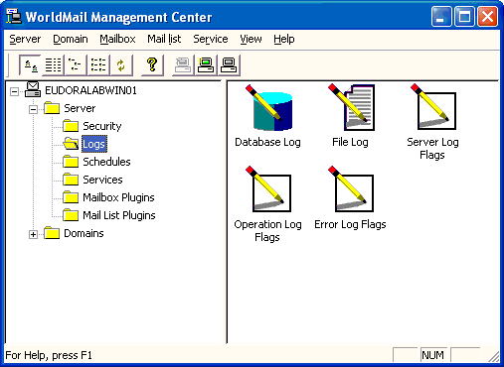
You can use these items to enable and disable logging options for different WorldMail components. The logging options change depending on the logging categories that you have selected. You can log to the Event Log K for some of the options if you are running Windows NT. You can log to the Database Log if you have enabled and configured this option.
To configure the database log or the file log, double click on the appropriate icon. To configure exactly what is logged under each of the three logging categories, double-click the appropriate log flags icon.

#$K+ Database Log K
To configure details of the log files, double-click the Database icon. You will see the following dialog.
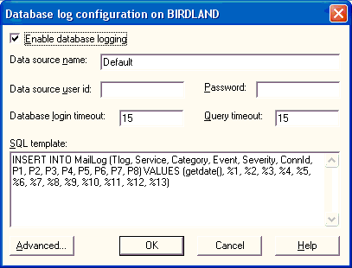

Enable database logging
Check this to turn on database logging. Database logging will not take place unless you check this, regardless of what logging options you have turned on.

Data source name
The name of the data source which points to the database log, as configured in the System DSN page of the ODBC Data Source Administrator in the Control Panel.

Data source user id
The username which WorldMail should use when connecting to the data source.

Password
The password which WorldMail should use when connecting to the data source.

Database login timeout
The time in seconds which is allowed for connecting to the database. A value of zero means an infinite timeout.

Query timeout
The time in seconds which is allowed for executing the database query. A value of zero means an infinite timeout.

SQL template
A template for the SQL command which WorldMail should use when adding information to the database. See the appendix on Database Logging for further details.

#$K+ Advanced Database Configuration K
The Advanced button brings up another dialog, which allows you to configure additional details of the database:
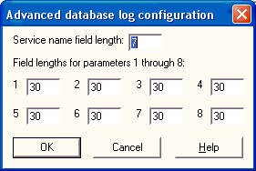
Refer to the section on Database Logging for further details.

#$K+ File Log K
KTo configure details of the log files, double-click the File Log icon. You will see the following dialog.
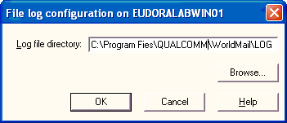

File Log Directory
Enter the full path to the directory where the log files are to be created. If the Windows Management Center is running on the same machine as the WorldMail server, you may use the Browse button to select the directory. The default value is C:\Program Files\QUALCOMM\WorldMail\LOGS.
Log files will be created in this directory, with names like TTTYYYYMMDD.LOG, where:
- TTT is one of SRV (for "server" log files), SMTPRA, SMTPDA, IMAP4A, POP3A, MAILMA, HTTPMA, LDAP3A (for "operation" log files) and ERR (for "error" log files).
- YYYY is the year.
- MM is the month (01 to 12).
- DD is the day of the month (01 to 31).
A new set of log files is created every day.
Previous versions of WorldMail used a different convention for log file names. Therefore, if you are administering a previous version of the mail server, you will see some additional fields that are not relevant to the version described by this manual. (The additional fields will appear in the blank area below the log file directory.)

#$K+ Error Log Flags K
Click on the Error Log Flags icon to set options for logging of errors:
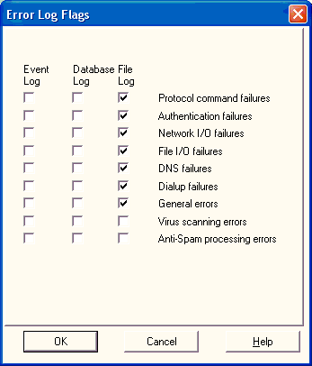

Protocol Command Failures
Select this option to record SMTP, POP3, IMAP4, LDAP3A, MAILMA and HTTPMA protocol failures. We recommend you enable this option.

Authentication Failures
Select this option to record SMTP, POP3, IMAP4, LDAP3A and MAILMA user and password authentication failures. We strongly recommend that you enable this option.

Network I/O failures
Select this option to record network communication failures. We recommend you enable this option.

File I/O failures
Select this option to record mail file access failures. We recommend you enable this option.

DNS failures
Select this option to record DNS resolution failures. We recommend you enable this option.

Dialup Failures
Select this option to log when WorldMail fails to make a dialup connection. We recommend you enable this option.

General Errors
Select this option to log general WorldMail errors. We recommend that you enable this option.

Virus Scanning Errors
Select this option to log errors related to virus scanning or virus definition updates. We recommend that you enable this option.

#$K+ Operation Log Flags K
Click on the Operation Log Flags icon to set options for logging routine operations:
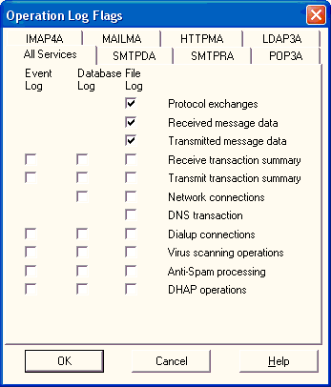

Protocol Exchanges
Select this option to record all SMTP, POP3, IMAP4, HTTPMA and MAILMA protocol exchanges that WorldMail makes. This option produces a large volume of information. This option should be used to debug problems and has an impact on performance.

Received Message Data
Select this option to record all incoming SMTP data. This option produces a huge volume of information. This logging will take a large amount of system memory and a large amount of disk space. This option should only be enabled for specific problem resolution purposes. On no account should it be turned on in everyday use.

Transmitted Message Data
Select this option to record all outgoing SMTP data. This option produces a huge volume of information. This logging will take a large amount of system memory and a large amount of disk space. This option should only be enabled for specific problem resolution purposes. On no account should it be turned on in everyday use.

Receive transaction summary
Select this option to record header information for incoming SMTP messages. This option has an impact on performance.

Transmit transaction summary
Select this option to record header information for all outgoing messages. This option has an impact on performance.

Network connections
Select this option to record all network connections made by WorldMail. This option produces a large volume of information. This option should be used to debug problems and has a significant impact on performance.

DNS Transactions
KSelect this option to record all DNS queries by WorldMail. This option produces a large volume of information. This option should be used to debug problems with DNS name resolution and has an impact on performance.

Dialup Connections
Select this option to record when WorldMail makes and breaks the dialup connection.

Virus Scanning Operations
Select this option to record successful virus scans of incoming mail.

#$K+ Server Log Flags K
Click on the Server Log Flags icon to set options for logging operations related to WorldMail services:
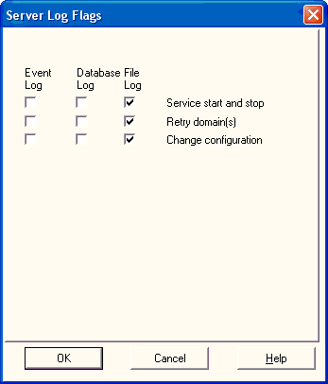

Service Start and Stop
Select this option to record when the mail services are started and stopped. We recommend you select this option.

Retry Domain(s)
Select this option to make a record when WorldMail attempts to re-send any outgoing mail. We recommend you select this option.

Change Configuration
Select this option to record when changes are made to WorldMail configuration. We recommend you select this option.

#$K+ Schedules
KUse the items in this folder to enable and configure delivery schedules and dialup connectivity.
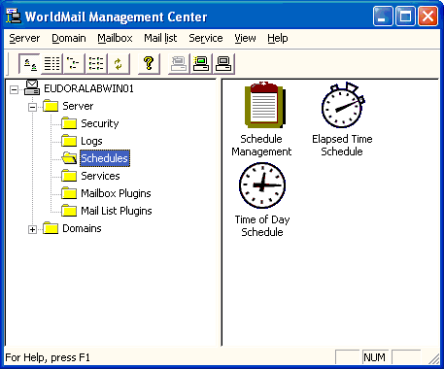
Delivery to remote domains can be schedule using two different methods. The Schedule Management form allows you to choose which method you wish to use for which domain.
The two methods are: Elapsed Time and Time of Day.

#$K+ Schedule Management K
Use the Schedule Management dialog to specify which domains will use the elapsed time schedule and which will use the time-of-day schedule. It is also used to initiate an immediate delivery attempt of messages for specified domains.
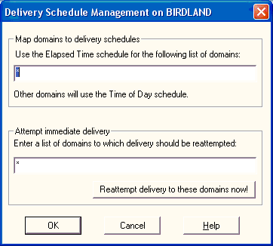

Map domains to delivery schedules
Enter a list of domain names, separated by commas. The list is processed from left to right. You may specify * as part of a domain name, representing a wildcard. You can also have an exclamation mark ! in front of a domain name, indicating that matching domains don't belong in the list.
Messages for foreign domains that match this list will be delivered according to the elapsed time schedule. By default, this field contains a single asterisk, meaning that all foreign domains use the elapsed time schedule. If you wish all foreign domains to use the time-of-day schedule instead (for instance, if you have a dialup connection to the Internet), you should enter the value !* in this field.
For example, suppose your WorldMail system is located at company HQ, and is hosting a single domain engineering.mycompany.com. It is running on the HQ Intranet that contains other mail servers, hosting domains like sales.mycompany.com. Your company's Internet connection is established only at certain times of the day. There is a branch office in another country, not connected to the company Intranet, but which has its own Internet connection and has a mail server hosting the domain italy.mycompany.com. In these circumstances, you might want to set the domain mask string to:
- !italy.mycompany.com,*mycompany.com,!*
This ensures that mail to users@italy.mycompany.com would be scheduled for delivery according to the time-of-day schedule, whereas mail to users@anywhere.else.mycompany.com would be scheduled according to the elapsed time schedule (since it is destined for servers on the local Intranet). All other foreign mail would be delivered according to the time-of-day schedule.
Note that this field has nothing to do with routing, which is always performed according to the DNS and the manual routing table. In the above example, you might wish to route mail to italy.mycompany.com and mail to domains outside the company via your ISP's mail server, and route mail to the other domains within your company in a different way. You should use the Routing dialog to achieve this.

Attempt immediate delivery
You can enter a list of domain masks (domain names, possibly containing wildcards, separated by commas) in this field. When you click the button labeled Reattempt delivery to these domains now, any messages for foreign domains which match the domain mask list will be scheduled for an immediate delivery attempt.
By default, the field contains a single asterisk. If you click the button, all messages for foreign domains will be scheduled for immediate retry.
Once you have clicked the button, the field is cleared.

#$K+ Elapsed Time Schedule K
The elapsed time delivery schedule can be configured through this dialog:
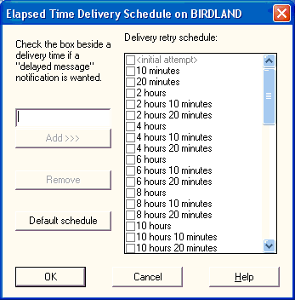
The elapsed time schedule is a list of times (measured in minutes from the time the first attempt is made) at which WorldMail will attempt to send remote messages. By default, the pattern begins: 10, 10, 100, 10, 10, 100. This means that if the first attempt fails, WorldMail will wait for ten minutes before the second attempt, and a further ten minutes before the third attempt. It will then wait 100 minutes before the fourth attempt (which will therefore be made two hours after the first attempt), and so on.
At certain points in this delivery schedule, WorldMail will return a message delayed warning to the originators of the messages for the domain in question. The Elapsed Time Schedule contains information about when such warning messages will be generated.
If delivery to a domain has been attempted without success so often that the end of the delivery schedule is reached, then messages for that domain are treated as undeliverable.
To add a delivery attempt to the Elapsed Time Delivery schedule, enter a time (in the form of a number followed by d, h or m for days, hours or minutes) and click the Add button.
To request a warning message to be generated if a particular delivery attempt fails, check the checkbox beside the delivery attempt.
To delete a delivery attempt from the schedule, select it and click the Delete button.
To revert to the default elapsed time delivery schedule, click the Default schedule button.

#$K+ Time-of-Day Schedule and Dialup Configuration K
The Time-of-Day Delivery Schedule dialog lets you configure the time-of-day delivery options and control the dialup features of WorldMail.
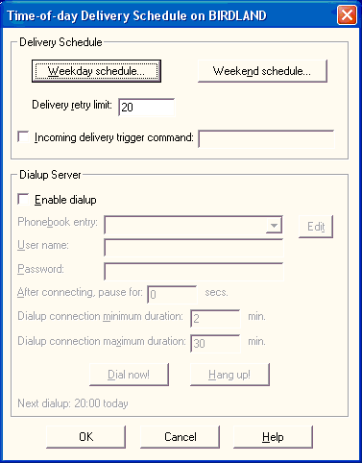

Delivery Schedule
The time-of-day schedule consists of a list of times of the day at which delivery will be attempted. A different list of times pertains on weekdays and weekends.
You can specify the maximum number of times that message delivery will be attempted before a message is treated as undeliverable.

Delivery Retry Limit
A delivery attempt for each outstanding mail domain (other than domains in the Exclude Domains field) will be made every time a dialup connection is established. If the delivery attempt is unsuccessful (for example, if the remote mail server is down or inaccessible at the scheduled dialup time), WorldMail will retain the message and retry later. However, if the number of delivery attempts exceeds a preset limit, delivery will be abandoned and a non-delivery notification will be generated. This field sets the limit for the number of attempts. The default value is 20.

Incoming Delivery trigger command
When it is time for a delivery attempt to be made, before doing anything else, WorldMail will execute the Delivery Trigger Command. This can be any command you specify, but often it will be either the MSSTART or the MSPOP command, which can be used to request your Internet Service Provider's mail server to deliver queued messages to WorldMail.
Once connected to your ISP it is often necessary to take some action to cause your ISP's mail server to start sending your mail. For instance, some ISP's let you use a finger command. Others (such as WorldMail itself) will respond to an ETRN SMTP command. If your ISP's mail server needs prompting in this way, check this box and type in the command line to execute. The command line can either invoke a program or a batch file. You must specify the full path.
If your ISP's mail server understands the ETRN command, you could use the MSSTART command to trigger delivery of queued mail for your domain:
- C:\Program Files\QUALCOMM\WorldMail\msstart -h mailserver.isp.com myco.com
This tells the mail server to start sending mail for myco.com.
Alternatively, your ISP may accumulate mail for you in a mailbox, and expect you to download it using POP. The MSPOP utility will help in this situation. MSPOP will retrieve mail from the mailbox at your ISP and will redirect it to recipients on your local system. You might type in the following trigger command line:
- C:\Program Files\QUALCOMM\WorldMail\mspop -h mailserver.isp.com -u myusername -p mypassword
Note that when calculating the duration of the dialup connection, WorldMail will not start counting until the Delivery Trigger Command (if it exists) has finished. Thus, a command that does not terminate could cause the dialup connection to stay open indefinitely.
See the section on Intermittent Connectivity for more information.
See the Appendix for the full MSPOP and MSSTART syntax.

Dialup Server
KWorldMail supports dialup connectivity to the Internet through the Microsoft Remote Access Service (RAS). This allows a computer running WorldMail to dial into an Internet Service Provider (ISP) to exchange mail on a predetermined schedule.
In order to use the WorldMail dialup support, you must install RAS on the computer running WorldMail. See the Microsoft documentation concerning RAS installation. You will need to create at least one RAS phonebook entry, containing the phone number of your ISP. Before configuring the dialup support in WorldMail, check the basic RAS setup by dialing out to your ISP using the "Dialup Networking" tool provided with RAS. If this does not work, WorldMail will not be able to dial out.
If you enable dialup, then your WorldMail server will dial the phonebook entry according to the schedule that you define. Once connected, it will send any queued outgoing mail and will initiate delivery of incoming mail using the Incoming Delivery Trigger Command.
When there is no more outgoing mail to send, and there are no incoming connections to WorldMail, the dialup connection will be closed and the phone line hung up.
The Dialup Server part of the Time of Day Schedule dialog contains the following controls:

Enable dialup
Check this box to turn on dialup support in WorldMail. Dialup support is disabled by default.

Phonebook Entry
Select an entry from the RAS phonebook that corresponds with your ISP's service. You can use the Edit button on the right to edit the phonebook entry.

User name
Your ISP will have given you a username and password to give you access to the dialup server. Type the username here. If the ISP is running a RAS server, you may be given a Microsoft domain name as well. For example, if the domain name is ISPDOM, you should add this prefix to your username, as in ISPDOM\username.

Password
Type in your ISP password here.

Pause after connecting
With some Internet Service Providers you have to wait for a short time (for example, 15 seconds) after you connect to their service before the connection becomes fully functional. Usually, this is to allow the ISP to update routing information. You can specify a time in to wait using this field.

Dialup connection time
You can specify (in minutes) the maximum time for which a dialup connection will remain open. WorldMail will close the connection after this time, even though the connection may be in use for sending and receiving mail. The default is 30 minutes. You can also specify a minimum time that the connection will remain open--WorldMail will not close the dialup connection before this time, even if it is not being used for mail. If you reduce this too far, your ISP's mail server may not have enough time to establish an SMTP connection to you. The default is 2 minutes. (Note that both these times are approximate--the actual time may be longer by up to two minutes.)
Note that when calculating the duration of the dialup connection, WorldMail will not start counting until the delivery trigger command (if there is one) has finished. Thus, a command that does not terminate could cause the dialup connection to stay open indefinitely.

Dialup Status and Controls
These fields show the status of the dialup connection. If no connection is in progress, it will show the time of the next scheduled connection, otherwise it will show Connecting, Connected or Disconnecting.
If there is no connection in progress, you can request an immediate dialup using the Dialup Now! button. In the Connected state, you may terminate the connection using the Hang up! button.
These buttons are useful for testing and debugging your dialup configuration.

#$K+ Weekday and Weekend schedules K K
To configure the weekday and weekend delivery schedules, click on the appropriate button. You will see a dialog like this:
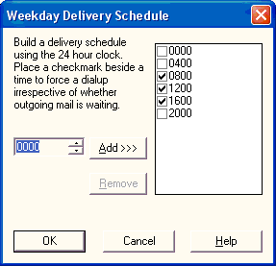
Times for delivery attempts are given using the 24-hour clock. To add a delivery time to the schedule, use the spin control to select a time, then click the Add button. To remove a time from the schedule, click on the time and then click the Remove button.
To request a dialup even when there is no outgoing mail waiting to be delivered, place a checkmark beside the corresponding time. (The checkmarks are irrelevant if dialup is not enabled.)

#$K+ Services
KIf you are administering WorldMail on your local computer, or if you are administering WorldMail from another system, you will see a Services folder in the Management Center. When you select this folder, the right-hand pane will display the installed WorldMail services:
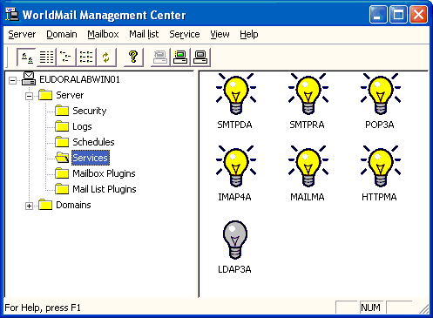
This form displays the current status of each WorldMail service. The light bulb icon shows the state of each service. To see the icons in a different format, choose one of the four leftmost buttons on the toolbar, or select the type of view you want from the View menu. To refresh the right-hand pane, choose Refresh from the View menu or click the Refresh button (the one with the two arrows).
To start a service, select it and then choose the Start option from the Service menu. Alternatively, you can use the corresponding toolbar button, or you can right-click on the icon and select Start from the popup menu. Stopping services works the same way by selecting Stop from these menus. By selecting multiple icons, you can stop and start more than one service.
Stopping the SMTP Receiver Service will prevent WorldMail from receiving mail. Stopping the SMTP Delivery Service will prevent WorldMail from sending mail. Stopping the POP3 Service will prevent users from receiving any new mail. Stopping the IMAP4 Service will prevent users from accessing their mailbox. Stopping the HTTP Management Service will prevent users from configuring their mailboxes from their Web browser. Stopping the MAILMA service will prevent users from changing their password from their e-mail client and will disable remote WorldMail Management Center access. Stopping the LDAP3A service will stop WorldMail responding to directory searches.

#$K+ Service Properties
Most of the services listen on a TCP/IP Port. You can configure this Port by selecting Service and Port from the menu. The following form will be displayed:
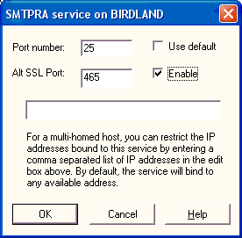

Port Number K
Enter the Port Number that the Service will listen on.

Use default
Disable this field to edit the port number for the service, or enable the field to restore the default port number.

Alt SSL Port
Enter the Port Number that the WorldMail service will listen on when communicating over SSL.

IP Address
Enter the IP address that the WorldMail service will bind its listening sockets to. Multiple IP addresses may be entered by separating them by commas (ex. 192.168.0.1, 192.168.0.2, etc.).

#$K+ Mailbox Plugins
KClick on the Mailbox Plugins folder to configure the available mailbox plugins on the target server.
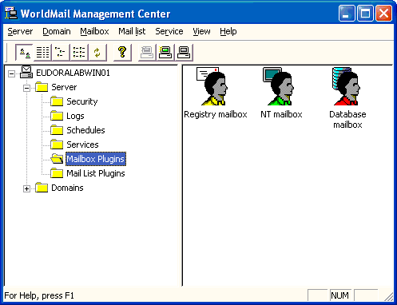
You can configure any of the Plugins by double clicking on its icon.
Each mailbox type is implemented by a Mailbox Plugin. WorldMail ships with three Mailbox Plugins: Registry, NT, and Database.

#$K+ Database Mailbox Plugin Configuration K K K
Use this form to configure the database table that you wish to use for authenticating mailboxes.
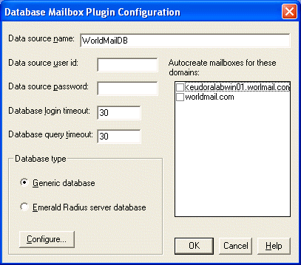

Data Source Name
Enter the name of the ODBC data source. This is configured in the System DSN page of the ODBC Data Source Administrator in the Control Panel.
The data source must be defined in the System pane of the ODBC Data Source Administrator, so that the data source is visible to the WorldMail services.

Data Source User ID
Enter the username that WorldMail should use to log into to the data source.

Data Source Password
Enter the password that WorldMail should use to log into to the data source.

Database Login Timeout
Enter the time in seconds that is allowed for connecting to the database. If you leave this blank, the default timeout of 15 seconds will be used. A value of zero means an infinite timeout.

Database Query Timeout
Enter the time in seconds that is allowed for executing the database query. If you leave this blank, the default timeout of 15 seconds will be used. A value of zero means an infinite timeout.

Database Types
The database mailbox plugin supports two kinds of databases: Generic and Emerald Radius Server.

#$K+ Generic Database Configuration
Use this form to override default configuration settings for the Database Mailbox Plugin. See the appendix on Database Plugin Examples for an example of using this feature.
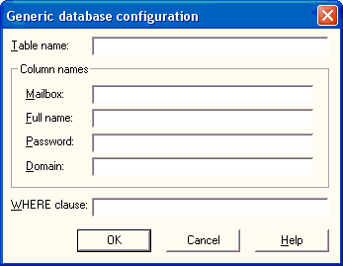
The Generic database assumes a very straightforward database schema. User information is contained in a single table, Mailboxes, with columns Mailbox, FullName, Password and Domain. You can override these defaults by filling in the fields on this form:

Table Name
Enter the name of the table or view that contains a list of your database mailboxes. The default name is Mailboxes.

Mailbox Column
Enter the name of the database column that maps to the mailbox name. Make this column the table's primary key for faster access. The default column name is Mailbox.

Full Name Column
Enter the name of the database column that contains the mailbox Full Name. The default name is FullName.

Password Column
Enter the name of the database column that contains the user's password, in plain text. The default name is Password.

Domain Column
Enter the column that contains the domain name for the user's mailbox. If this column has a null value, the default domain is assumed. If this column does not exist in the database, then WorldMail will not differentiate mailboxes in different domains when authenticating. This means that mailboxes with the same name in different domains will be authenticated with the same password.

WHERE Clause
You can further qualify the contents of the table through a filter expression which will form part of a SQL WHERE clause.

#$K+ Emerald Database Configuration K
Use this form to configure options for your Emerald database. See the appendix on Emerald Integration for an example of using this feature.
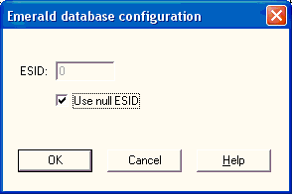
Your Emerald system administrator will need to help you configure this form.

ESID
You can create External System IDs in your Emerald Database. Use your Emerald application to create an ESID for WorldMail. You may choose to use 2, for example.

Use null ESID
If you have not created an External System ID in your Emerald database for WorldMail, enable this field.

#$K+ NT Mailbox Plugin Configuration K K K
Use this form to configure the NT Mailbox Plugin.
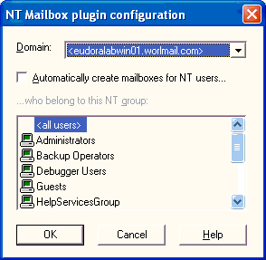
You can configure the NT Mailbox Plugin to automatically create mailboxes for members of a NT Group. This configuration can be set differently for each virtual domain.

Automatically Create NT Mailboxes
When a user tries to log on using POP or IMAP, or when a new message arrives for the mailbox, the logon attempt or delivery will normally fail if that mailbox does not exist. If you enable mailbox auto-creation for the selected NT group, then provided the user is listed in the group, the mailbox will be created automatically and the logon attempt or delivery will succeed. You can enable automatic mailbox creation for each domain individually.

NT Group
Select one of the NT Groups that you wish to use. Local Groups are listed with a computer icon. Domain Groups are listed with a server icon.

#$K+ Mail List Plugins
KClick on the Mail List Plugins folder to view the available mail list plugins on the target server.
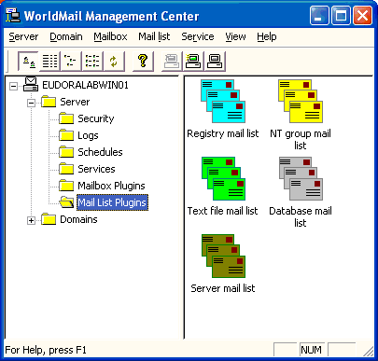
Each mail list type is implemented by a Mail List Plugin. WorldMail ships with five Mail List Plugins: Registry, NT, Text File, Database, and Server. Note that none of the Mail List Plugins have any configuration options.

#$K+ Domains
KThe Management Center contains a Domains Folder that expands to show a list of the mail domains that are managed by the Management Center. Each domain is represented by a folder, which itself contains folders for the mailboxes and mail lists belonging to that domain, and icons representing properties and options for the domain itself.

Default Domain
KThe default domain can be identified by the gray folder icon. This is the "home" domain for this server. WorldMail reads the name of the default domain from the HOST and DOMAIN fields in your TCP/IP: DNS configuration.
The default domain always exists--you cannot delete it. However, the default domain name can be changed. For example, if WorldMail was installed with the default domain mail.mycompany.com , you can change this to be mycompany.com.

Rename Default Domain
To rename the default domain, select the domain, then click on the domain name. Or, select the domain and select Rename from the right-button pop-up menu.
If you rename the default domain, it is your responsibility to ensure that the new domain name has an appropriate MX record in the DNS, so that mail addressed to user@mucompany.com gets routed to the mail server at mail.mycompany.com.
You can only rename the default domain. To rename other domains, create a new domain, move the users and mailing lists from the old domain into the new one, then delete the old domain.

New Domain
Select the Domains Folder or one of the existing virtual domain folders. Then choose the New option from the Domain menu (or click the corresponding toolbar button, or right-click on the folder and select New from the popup menu). A new domain folder will appear, and you should give it a unique name. It is your responsibility to register the domain in the DNS.

Delete Domain
To delete a domain, select the domain(s) you wish to delete, then either select Delete from the right-button pop-up menu, or click the Delete button. You cannot delete a domain if it still contains mailboxes or mail lists.

Domain Properties
To change the properties of a domain, double-click on its Domain Properties icon, or select the domain and choose Properties from the right-button pop-up menu. The resulting dialog lets you associate an IP address with the domain and control whether you want non-delivery messages from this domain to be copied to the postmaster. Note that it is not possible to associate the default domain with an IP address.

Sieve Filter
To set domain-level mail filters, double-click on the Sieve Filter icon. This displays the Sieve filter rules associated with the domain and allows you to create, modify, and delete filter rules. Domain-level filter rules are applied only to messages sent to or from mailboxes in this domain.

Kaspersky Anti-Virus Filter
To set virus scanning policies for a domain, double-click on the Kaspersky Anti-Virus Filter icon. For each domain, you can specify that all messages sent to or from the domain will be scanned for viruses, or only messages that are addressed to mailboxes that have the virus scanning option enabled.

Banner Insertion
To set custom message banners for a domain, double-click on the Banner Insertion icon. For each domain, you can specify a header and/or footer to be added to the contents of each message sent by users within that domain.

Virtual Domains
KYou can receive mail addressed to multiple domains on a single server. To do this, create a new entry for each under the Domains Folder. With virtual domains, mailboxes and mail lists can be managed on a per-domain basis, and each domain may have its own postmaster.
For example, if you add a virtual domain xyz.com, then incoming mail sent to someone@xyz.com will be delivered to mailbox someone in domain xyz.com.
Note that the DNS MX record for xyz.com must resolve to the IP address that is associated with domain xyz.com listed here. This is necessary so that other SMTP mail servers connect to the correct machine. See the DNS Overview section and the section on Multiple Domains for more information.
Each virtual domain can be (but need not be) associated with one of the IP addresses on the server. If a POP3, IMAP4 or SMTP call is received at an IP address which has a domain associated with it, then the server will assume that domain name if a mailbox name without attached domain is sent by the POP3, IMAP4 or SMTP client. If the IP address does not have a domain associated with it, then the default domain name will be assumed. (See the section on the POP3 Server for additional discussion of how the domain name may be specified when a client logs in.)

#$K+ Domain General Page K
You can configure the properties of the domain by double clicking on the Domain Properties icon. The domain properties form contains tabbed property pages. The General domain property page looks like this:
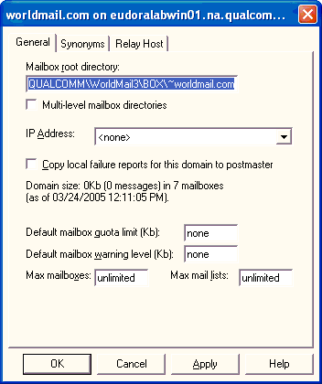

Mailbox Root Directory K
Enter the mailbox root directory that you wish to use to for the message store for your mail users. The mailbox directory root defines the location of the directories for each mailbox.
A mailbox consists of two things:
- Mailbox Properties, which are stored in the Registry. The properties are set through the Mailboxes folder in the Management Center.
- Mailbox Directory, whose location is determined by the mailbox directory root and whose name matches the associated mailbox.
The mailbox directory contains a sub-directory called inbox in which incoming mail is stored. This is referred to as the incoming mail directory for that mailbox.
Under Windows NT, it is recommended that mailbox directories are located on a NTFS partition. See the Security section for additional information.
If you wish to reset the mailbox root directory for a domain to its default value, simply leave the field blank. When you re-display the dialog, it will show the default value. The default is: C:\Program Files\QUALCOMM\WorldMail\BOX K

Multi-Level Mailbox Directories
K KUse this option to specify that mailbox directories for the domain should be multi-level.
By default, mailbox directories are located within the mailbox root directory for the domain. For example, if the mailbox directory root is C:\MAILBOX, then the mailbox directory for the mailbox fred will be C:\MAILBOX\fred. However, if an extremely large number of mailbox directories exist at the same level of the file system, mail access can become less efficient and performance can be affected. For this reason, it is advisable to use multi-level mailbox directories for domains with more than 1,000 mailboxes.
When a domain uses this option, WorldMail will use the first three letters of the mailbox name (each following an exclamation mark) to construct a three-level directory path. For example, if the mailbox directory root is C:\MAILBOX, then the multi-level mailbox directory for fred will be at C:\MAILBOX\!f\!r\!e\fred.
It's important to know that changing this option for a domain in the Windows Management Center does not convert the domain's existing mailboxes to the multi-level directory structure (or back to single level). If you enable this option for an existing domain, you must manually convert the domain's mailboxes using the MSCVTDIR K utility. For example, to convert mailbox directories in the domain example.com to multi-level, execute:
mscvtdir example.com
Refer to the Utilities Appendix for more information on MSCVTDIR.

IP Address
KUse this field to select the IP address for this virtual domain. If it is set to <none>, then the domain will share the IP address with the default domain. In this case, POP3 and IMAP4 users must log in with a fully qualified user name, such as joe@abc.com.
If you associate the virtual domain with an IP address, then the DNS record for this domain must resolve to this IP address. In addition, users must use this DNS address as their SMTP and POP3 server. In this case, POP3 and IMAP4 users can log in with their simple name, such as joe, or with their fully qualified name, such as joe@abc.com.
See the section on Multiple Domains for more information.

Copy local failure reports to postmaster
KCheck this box to copy any local delivery failure reports to the postmaster in addition to the sender. Delivery failures occur when an incoming message for the selected domain is addressed to a mailbox or mail list that does not exist.

Default Mailbox Quota Limit
K KIf quota support is licensed and enabled, the page also displays the approximate count of mailboxes, total number of messages and total message size in the domain. You can set default values for the mailbox quota limit and for the warning level. See the section on Quotas for more information.

Default Mailbox Warning Level
If quota support is licensed and enabled, use this field to set the quota warning level. This is the level of mailbox volume that will trigger a warning message to the user, alerting them that their mailbox is nearly full. See the section on Quotas for more information.

Max Mailboxes
You can use this field to limit the number of mailboxes that can be created in this domain. You may wish to use this feature if you delegate management of mailboxes for this domain to your users through the Web Management Center. Leave this field blank if you do not want a limit. If you try to set the maximum value to less than number of existing mailboxes, you will be warned but will be permitted to do so. Enter zero if you do not want to create any mailboxes in this domain. Note that your license key may override the value that you enter here, and may further limit the number of mailboxes that can be created.

Max Mail Lists
You can use this field to limit the number of mail lists that can be created in this domain. You may wish to use this feature if you delegate management of mail lists for this domain to your users through the Web Management Center. Leave this field blank if you do not want a limit. If you try to set the maximum value to less than number of existing mail lists, you will be warned, but will be permitted to do so. Enter zero if you do not want to create any mail lists in this domain. Note that your license key may override the value that you enter here, and may further limit the number of mail lists that can be created.

Mail list Root K Directory
Enter the root directory that you wish to use to for the storage of mail list messages and related information. This mail list root directory will contain sub-directories corresponding to each mail list in the domain. When using WorldMail in a clustered configuration, this root directory should be a shared file system used by each WorldMail node.

#$K+ Domain Synonyms Page K
The Synonyms page of the Domain Property dialog looks like this:
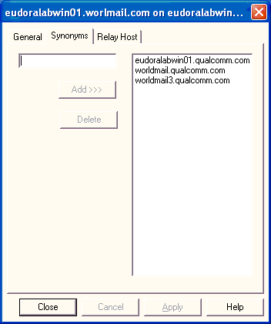
A Domain Synonym is a name that is equivalent to the virtual domain in question. If your virtual domain is xyz.com, and you create a synonym of xyzcompany.com, then mail addressed to you@xyzcompany.com will go to you@xyz.com. See the section on Multiple Domains for further information on synonyms.
To create a new synonym, type the synonym in the edit box and click Add. To delete a synonym, select it in the list box and click Delete.

#+ Relay Host Page
The Relay Host page of the Domain Property dialog looks like this:
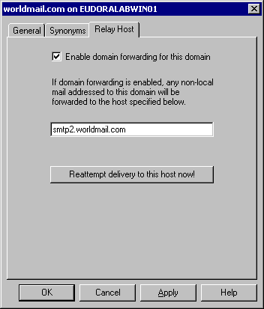
Mail servers that act as intermediaries in mail delivery are often referred to as "relays." When your system is acting as a relay, messages meant for other computers will be placed in your server's queue and delivered accordingly. WorldMail can act as an Internet gateway relaying mail to and from the Internet. Internet gateways have no local users. A relay host handles local users.
The checkbox on this dialog enables or disables domain forwarding for this domain.
All mail addressed to this domain will be automatically forwarded to the hostname specified on this page. Any valid domain name or IP address may also be entered in this field.
The "Reattempt delivery to this host now!" button will force an instant attempt to deliver any queued mail for this domain to the specified host. This button will only work when forwarding is enabled and will be disabled until the button is pressed again.

#$K+ Domain Virus Filter K
To configure domain virus scanning options, open the domain folder in the WorldMail Management Center double-click the Kaspersky Anti-Virus Filter icon. This displays the Virus Scanning Filter window:

Enable virus scanning on messages to or from this domain
This option controls the virus scanning policy for this domain. If disabled, WorldMail will not scan any messages sent to or from this domain. Otherwise, WorldMail will scan messages according to the virus scanning policy that you select here.

Scan all messages
This selection causes all messages received by WorldMail's SMTP server that are sent to or from any mailbox within this domain to be scanned. Use this option if you want all mailboxes in the domain to be protected from viruses.

Scan messages sent to/from enabled mailboxes
This selection causes messages to be scanned only if they are sent to or from mailboxes that have the virus scanning option enabled. Use this option if you want only certain mailboxes to be protected from viruses.

#$K+ Mailboxes
KSelect the Mailboxes folder within a domain to display a list of mailboxes:
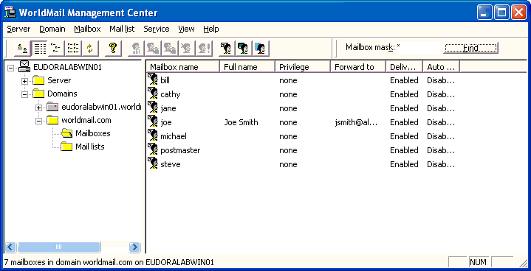
Mailboxes are slots for delivering messages for a specific user on this server. You can create three types of WorldMail mailboxes (depending on your license key): Registry mailboxes, NT mailboxes, and Database mailboxes.
If your users will access other components of your NT server, such as the file system, then you will probably want to use NT Mailboxes. This will mean that they can use the same user name and password to read their mail that they use to log into the Windows network and connect to the file system.
If your users will only use the server to send and receive mail, then you may wish to create Registry Mailboxes for them. This will limit their privileges to mail and will definitely prevent them from accessing any other part of the NT system.
If you have a database that contains a list of usernames and passwords, and you wish to integrate mail authentication with this database, then create Database Mailboxes.
You can select the type of mailbox display in the right-hand panel using one of the four leftmost buttons in the toolbar, or by using the View menu. Refresh the mailbox display using the Refresh command in the View menu, or by clicking the Refresh button (the one with the two arrows).
You can maintain the properties for a mailbox by double clicking on the mailbox icon. This will open the Mailbox General Page.

Viewing Mailboxes
KTo view mailboxes in a domain, enter a name filter in the Mailbox mask field and click Find. For example, to list all mailboxes enter the wildcard (*) character; to list only mailboxes that begin with j, enter j* in this field. After you click Find, the list of mailboxes that match the naming criteria in the current domain will be displayed.

Postmaster Mailbox
KA mailbox called postmaster is created in the default domain during installation. This mailbox is not counted for licensing purposes. If you wish the mail for the postmaster to go to a different address, you can set the forwarding address for this mailbox.
Mail addressed to postmaster@virtual.domain will be delivered to postmaster@default.domain, unless a postmaster mailbox is created in the virtual domain.

Add Registry Mailbox
You can create a new Registry Mailbox by selecting the Add Registry Mailbox button on the toolbar. This will create a new icon in the list and position the cursor next to the icon. Type the name of the new mailbox directly into the textbox.

Add NT Mailbox
You can create a new NT Mailbox by selecting the Add NT Mailbox button on the toolbar. This will display a form with a list of NT Users that do not already have a mailbox on the target server

Add Database Mailbox
You can create a new Database Mailbox by selecting the Add Database Mailbox button on the toolbar. This will display a form with a list of Database Users.

Mailbox Names
You can use any of the following characters to name a mailbox:
- Alphanumeric (a-Z)
- Period (.)
- Hyphen (-)
- Underline (_)
The following characters are illegal in a mailbox name:
- Round Bracket (())
- Square Bracket ([])
- Angle Bracket (<>)
- At Symbol (@)
- Comma (,)
- Semi-colon (;)
- Colon (:)
- Slash (\)
- Quote (")
- Space ( )
- Any Control Character

Renaming a Mailbox
KYou can rename a Registry mailbox by selecting the icon with a single click, then clicking once on the mailbox name. You cannot rename an NT Mailbox. Use the User Manager to manage local users instead.

Deleting a Mailbox
KTo delete a Mailbox, select the icon with a single click and then hit the Delete button.

#$K+ Move or Copy Mailbox K K
Use this form to move or copy a mailbox to a different domain.
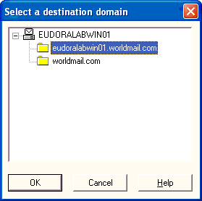
You can move the selected mailboxes to another domain. Select the destination domain and click OK.
You can choose to move the mailbox directory. The directory will be moved under the ~virtual.domain subdirectory. Note that this will not work if you are running the Management Center remotely, or if the directory is active. If the directory move fails, you can use XCOPY to manually move the files.

Move or Copy Directory
Select this option to move the associated directory.

#$K+ Add NT User K
Use this form to select Users for creating NT mailboxes.
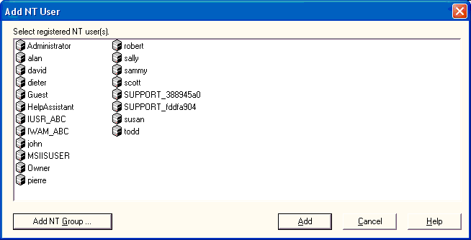
This form contains a list of NT Users that can be used to create mailboxes. Previously defined users will not appear.
Users identified by the computer icon are Local Users. This means that the account has been created in the User Manager on your WorldMail server.
Users identified by the server icon are Domain Users. This means that the account has been created on the Domain Controller to which your WorldMail server belongs.
Select one or more Windows NT user that you wish to enable for sending and receiving mail. Use the Shift and Control keys to select multiple users.
Note that it is not a good idea to select NT user names containing spaces or underlines. Although WorldMail will handle such names correctly, many mail clients and other mail software will have problems. Enclosing the name in double quotes when sending mail to it, such as "Fred Jones"@abc.com, may help, but such names are better avoided altogether.
You can create mailboxes for members of a NT Group by clicking on the Add NT Group button. You can automatically create NT mailboxes. See the section on the NT Mailbox Plugin for more information.

#$K+ Add NT Group
Use this form to select a Group for creating NT mailboxes.
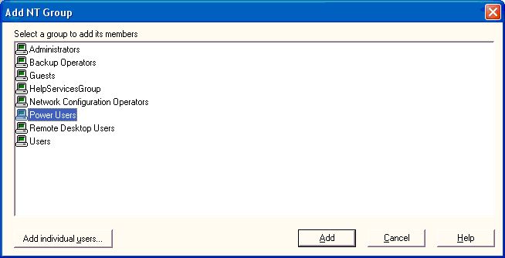
You can create mailboxes for all users in an NT Group by selecting the group and clicking on the Add button. You can automatically create NT mailboxes. See the section on the NT Mailbox Plugin for more information.
If you wish to create mailboxes for individual NT Users, select the Add Individual Users button.

#$K+ Create Database Mailboxes K
Use this form to display a list of candidate database users for creating mailboxes.
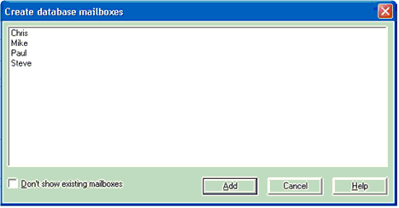
The list of mailboxes is retrieved from the database that you configured in the Database Mailbox Plugin Configuration. You can automatically create database mailboxes. See the section on configuring the Database Mailbox Plugin for more information.

Mailbox List
If your database is configured correctly, a list of users will be displayed. You can select one or more users by using the Ctrl and Shift keys. Click Add to create mailboxes for the selected users.

Don't Show Existing Mailboxes
Select this option to remove existing mailboxes from the list of users.

#$K+ Mailbox General Page K
Use this form to set the general properties for this mailbox.
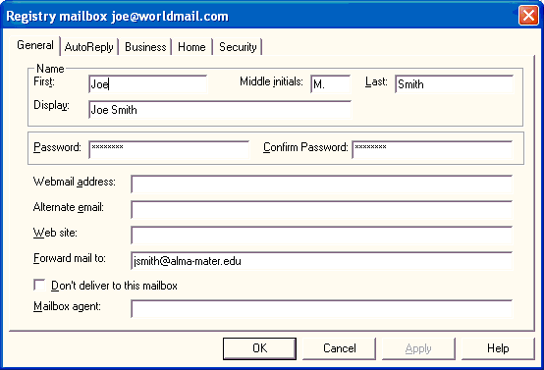

First
Enter the first name of the person who will use this mailbox.

Middle Initials
Enter the last name of the person who will use this mailbox.

Last
Enter the middle initials of the person who will use this mailbox.

Display
Enter the full name of the person who will use this mailbox. This field will be filled in automatically if this is an NT or Database mailbox.

Password
You can change the password for this mailbox by entering a new value here. You must retype the password in the confirmation field. Note that changing the password for NT Mailboxes will change the user's password in the NT User Database. Passwords are limited to 14 characters to maintain consistency with the Windows NT limit.

Confirm Password
Re-enter the new password to confirm the change. Note that passwords are limited to 14 characters to maintain consistency with the Windows NT limit.

Webmail Address
Enter an alternate e-mail address for the user. Eudora Web Client will use this address as the Reply-To: address when sending email.

Alternate Email
Enter an alternate e-mail address for the person who will use this mailbox. This address will be displayed in LDAP properties for this account. Note that this address is not used for any delivery or forwarding of email.

Web Site
Enter the web site of the person who will use this mailbox.

Forward Mail To
KEnter an Internet mail address to which messages for this user will be forwarded. Leave empty to disable forwarding. You can enter a fully qualified Internet mail address, or if the destination address is in the default WorldMail domain, you can enter just the mailbox name. You can auto-forward to multiple addresses by separating each address with a comma.

Don't Deliver to this Mailbox
Select this field to prevent any mail messages from being delivered to this mailbox. It is normally set only if the Forward To or the Auto Reply feature is being used.

Mailbox Agent
K KThis feature allows a command line to be executed when a message is delivered to the mailbox. You can specify any command that can be executed at the Windows command-line prompt, including built-in commands and batch files.
The following substitutions are performed in the command line you specify before it is executed:
Special symbols | Replaced by
%f | Full file name of the message which was received
%u | Name of the mailbox
%h | Mailbox directory
%d | Domain to which the mailbox belongs
%% | Single percent character
The message file %f will be located in the mailbox directory, but will not have a MSG extension. The command may change the contents of the message or may even delete the file. When the command completes, WorldMail will automatically rename the file (if it still exists) to have a MSG extension so that it is available for access by the POP and IMAP servers.
For more information, see the section on Mailbox Agents.

#$K+ Mailbox AutoReply Page K
KUse this form to configure the auto-reply properties for this mailbox.
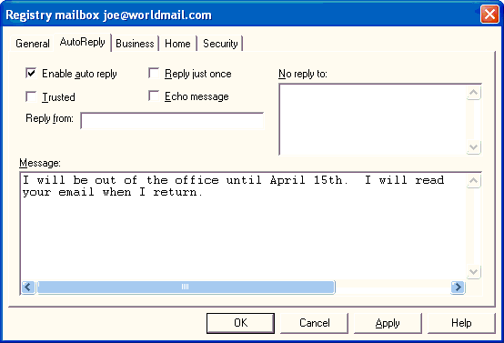

Enable Auto Reply
Select this field to enable the auto reply feature for this mailbox. Auto Reply causes WorldMail to automatically generate a reply message to the sender when an incoming e-mail arrives for this mailbox.

Reply Just Once
Select this field to ensure that no sender receives more than one auto reply WorldMail will append the email address to which it replies to the mailbox property AlreadyRepliedTo. This property is cleared when the EnableAutoReply
checkbox is reset.

Trusted
This field controls the behavior of certain directives in the message. Select this field to permit the message to include file directives that access the file system outside of the local mailbox directory.

Echo Message
Select this field to return the original message with all auto-reply messages.

Reply From
Enter an e-mail address that WorldMail will use as the From: address when creating auto-reply messages.

No Reply To
Enter list of e-mail addresses (one per line) to which auto reply messages will not be sent. Hold the Ctrl key and press Return to enter multiple lines. If a message is received which is addressed or copied to one of these addresses, then no automatic reply will be sent. You would typically include addresses of mail lists in here, since automatic replies to mail list messages are antisocial. Note that WorldMail will never send an auto reply to an address like owner-listname or like lisname-request, for the same reason.

Reply Message
Enter the text of the auto reply message. Hold the Ctrl key and press Return to enter multiple lines. You may include auto reply directives to include files and special fields in your reply message.

Auto Reply Directives
The automatic reply message for a mailbox may contain directives that are replaced by other text when the auto-reply message is actually sent. The full list of directives follows:
Directive | Replacement text
%ADDRESS | The e-mail address of the person who sent the original message
%DATE | The current date
%TIME | The current time
%INCLUDE(filename) | The contents of the filename (which must be located in the mailbox's INBOX directory, unless the mailbox is trusted)
%EXECUTE(commandline) | The output produced by executing the commandline (trusted mailboxes only)
%% | A single percent character
If you want to put a large amount of text into your message, use the %INCLUDE directive, rather than typing text into the message field. This will save space in the Registry. The operation of the %INCLUDE directive depends on the mailbox's Trusted setting. If the mailbox is trusted, then the filename should be the full path to a file that is accessible to the mail server. If the mailbox is not trusted, only files located in the mailbox's INBOX directory can be included--in this case, specify the filename as a relative path and not the full path.
The %EXECUTE directive only works for trusted mailboxes. The commandline parameter can specify any command or batch file.

#$K+ Mailbox Business Page K
Use this form to set the business address for this mailbox. The LDAP K Service returns this information in response to directory searches.
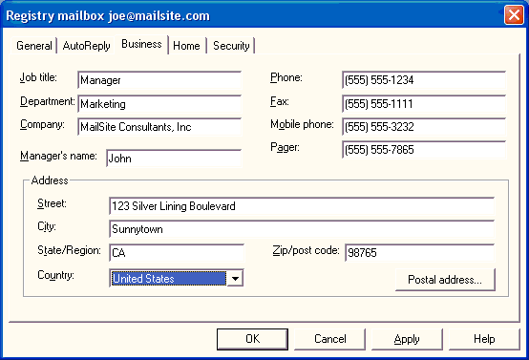

Job Title
Enter the job title of the person who will use this mailbox.

Department
Enter the department of the person who will use this mailbox.

Company
Enter the company of the person who will use this mailbox.

Manager's Name
Enter the name of the manager of the person who will use this mailbox.

Phone
Enter the business phone number of the person who will use this mailbox.

Fax
Enter the business fax number of the person who will use this mailbox.

Mobile Phone
Enter the mobile phone number of the person who will use this mailbox.

Pager
Enter the pager number of the person who will use this mailbox.

Street
Enter the business street address of the person who will use this mailbox.

City
Enter the business city address of the person who will use this mailbox.

State/Region
Enter the business state address or region of the person who will use this mailbox.

Zip/Post Code
Enter the business zip or post code address of the person who will use this mailbox.

Country
Enter the business country address of the person who will use this mailbox.

#$K+ Mailbox Postal Address
Use this form to set the postal address for this mailbox. The LDAP Service will return this information in response to directory searches.
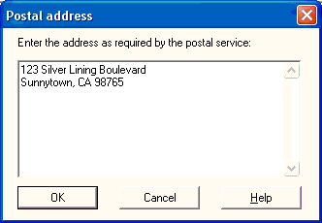
Use this form if the mailbox user's address does not conform to the standard structure of the Business or Personal page. Hold the Ctrl key and press Return to enter multiple lines.

#$K+ Mailbox Home Page K
Use this form to set the home address for this mailbox. The LDAP Service will return this information in response to directory searches.
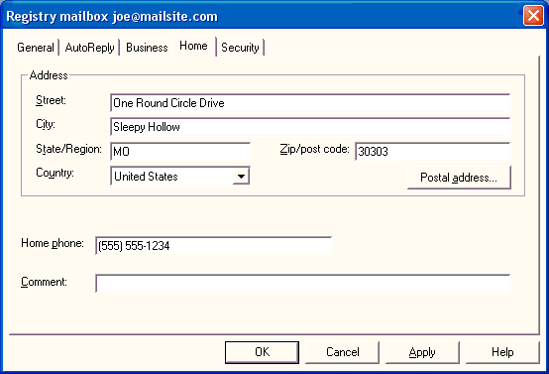

Street
Enter the home street address of the person who will use this mailbox.

City
Enter the home city address of the person who will use this mailbox.

State/Region
Enter the home state address or region of the person who will use this mailbox.

Zip/Post Code
Enter the home zip or post code address of the person who will use this mailbox.

Country
Enter the home country address of the person who will use this mailbox.

Home Phone
Enter the home phone number of the person who will use this mailbox.

Comment
Enter notes or comments for the person who will use this mailbox.

#$K+ Mailbox Security Page K
Use this form to set security parameters for the mailbox.

Privilege Level
The Privilege Level determines your administrative privilege on the server. The choices are None, Domain and Server. If set to None, the user will only be able to control his own mailbox. If set to Domain, the user can manage other mailboxes in that domain. If set to Server, the user may manage all mailboxes on that server. Refer to the section on Web Mailbox Administration for more information.

Mailbox quota
K KThis is the maximum size (in kilobytes) of the mailbox. If this is exceeded, then new messages will not be delivered to the mailbox and a non-delivery report will be generated. (Note that only MSG files are included in the size calculation.) If set to None, no quota limit will be enforced. If set to Default, the quota limit is inherited from the domain. See the Domain General Page for more information.

Warning level
This is a warning level (in kilobytes). If the size of all the messages in the mailbox exceeds this value, a message warning the user of impending danger is sent. If set to None, no warning will be sent. If set to Default, the warning level is inherited from the domain. See the Domain General Page for more information.

Services
Use these fields to define the WorldMail services that the user can access. By enabling/disabling these options, you can set a specific level of service for the user.

Enable virus scanning
Select this field to specify that all messages sent to or from this mailbox should be scanned for viruses. This option is used only when your server and domain-level virus scanning policies are configured to scan for viruses at the mailbox level.

Sieve Filter
Click this button to display the mail filtering rules associated with the mailbox. Filters rules defined at the mailbox level affect only messages sent to that mailbox. End users can create filter rules for their mailboxes through Eudora Web Client.

#$K+ Mail Lists
KSelect the Mail Lists folder to display a list of mail lists in the right-hand pane:
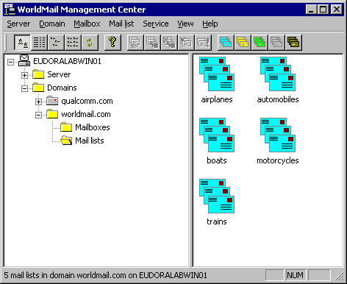
You can select the type of mail list display in the right-hand panel using one of the four leftmost buttons in the toolbar, or by using the View menu. Refresh the mail list display using the Refresh command in the View menu, or by clicking the Refresh button (the one with the two arrows).
KTo create a new list, click on the appropriate button in the toolbar. Type the name of the new list in the edit field and press Enter.

New Registry List
 | You can create a new Registry List by selecting the Add Registry List button on the toolbar.

New NT List
 | You can create a new NT List by selecting the Add NT List button on the toolbar.

New File List
 | You can create a new Text File List by selecting the Add File List button on the toolbar.

New Database List
 | You can create a new Database List by selecting the Add Database List button on the toolbar.

New Server List
 | You can create a new Server List by selecting the Add Server List button on the toolbar.

Rename a List
To rename a Mail List, select its icon with a single click and then click once on the list name. Type the new name and press Enter.

Delete a List
To delete a Mail List, select it's icon and click on the Delete button.

Configure a List
You can maintain the properties of a List by double clicking on the icon for the list. This will open the Properties form.

#$K+ Move or Copy a List K K
To move or copy a mail list to a different domain, select one or more mail list icons and then choose Move or Copy from the Mail List menu (or click the corresponding toolbar button, or select Move from the right-click popup menu). The Destination Domain dialog allows you to select a new location for the selected mail lists.
If you are running the WorldMail Management Center on the same machine as the WorldMail Engine (in other words you are not administering WorldMail remotely), and you are simply moving the mail list to another domain on the same machine, then the Management Center will give you the option of moving or copying the mail list directories as well (if they exist). However, if you are running the Management Center remotely, or if you are moving or copying the mail list to another machine, you will have to manually move the directories yourself.

#$K+ List General Page K
Use this form to configure the general list properties.
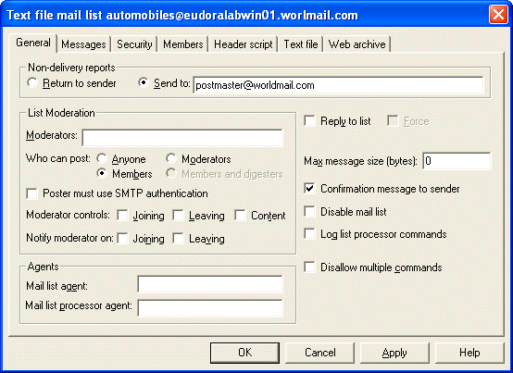

Non Delivery Reports
This specifies what action should be taken if a message to an address on the Mail List cannot be delivered. The options are:
- Return to sender with a non-delivery report (the default)
- Send to the non-delivery report to a specified e-mail address

Moderators
KEnter the Internet mail address of the moderator(s) for this list. You can specify multiple moderator addresses for a mailing list, just separate each address by commas. Each moderator must have a mailbox on your site.
If a list is not moderated, anyone can join or leave the list by sending a message with JOIN or LEAVE in its body to the -request address of the list. The moderator (s) can control who can join the list, who can leave it, and may also control posting to the list.

Who Can Post
A list can be configured to allow various people to post messages to the list. By default, only members can post, but you can select any of four posting policies:
- Anyone specifies that any email user can post a message to the list
- Members specifies that only users with addresses listed in the Members page can post.
- Moderators specifies that only the list moderators can post.
- Members and Digesters specifies that both members of the list and members of the associated digest list can post.

Poster must use SMTP authentication
This option specifies that only users with mailboxes on the local system can post to the list. When this option is enabled, senders must a login name and password via SMTP authentication to successfully post a message; if SMTP authentication is not used, or if the given name and password do not match a local mailbox, the posting will be denied.

Moderator Controls
These fields define the degree of control exercised by the list moderator.
- Joining specifies that subscription (JOIN) requests are forwarded to the moderator for approval.
- Leaving specifies that unsubscription (LEAVE) requests are forwarded to the moderator for approval.
- Content specifies that any messages to this list will be stored in a pending directory, and will only be released to the mail list when the moderator has approved them. See the section on Web List Moderation for more information about this option.

Notify Moderator
These fields define whether moderators are notified when users join or leave the list.
- Joining specifies that the moderator will be notified when new members join by e-mail.
- Leaving specifies that the moderator will be notified when of the face by e-mail.

Reply To List
Check this field to add a Reply-to: header to each list message. This is useful when recipients reply to list messages. Replies to list messages will be addressed to the list, rather than to the originator.
The exception is that if the incoming message already has a Reply-to: header, that header is left untouched and no additional Reply-to: header is added. You can force the list to overwrite an existing Reply-to: header with the Force option.

Force
If you select this option, WorldMail will discard any Reply-to: headers in an incoming message and will add the mail list's own Reply-to: header.
You can use Header Processing for more advanced editing of message headers.

Maximum Message Size
A list may be configured to reject messages greater than a certain size. Large messages sent to the list will generate a non-delivery report to the sender saying why the message was not acceptable. A value of zero (the default) means that no size limit is applied.

Mail List Agent
K KThis feature allows a command line to be executed when a new message arrives for the list or for the list-request processor. You can specify any command that can be executed at the Windows command-line prompt, including built-in commands and batch files.
The following substitutions are performed on the command line you specify before it is executed:
Special symbol | Replaced by
%f | Full file name of the message which was received
%m | Moderator address of the mailing list, or - if no moderator
%n | Name of the mailing list
%d | Domain to which the mailing list belongs
%% | Single percent character
The message file %f will be located in the mail list directory, but will not have a MSG extension. The external program may change the contents of the message or may delete the file. When the external program completes, WorldMail will automatically rename the file (if it still exists) to have a MSG extension, and will continue processing as normal.
For more information, see the section on List Agents.

Disable Mail List
This option disables the entire list. This is useful if you wish to retain the list configuration but wish to hide the list for security purposes.

Confirmation Message To Sender
Check this box to send a confirmation message to the sender. The confirmation message contains a copy of the message that was delivered to the list. If the sender is also a member of the list, she will not receive another copy by virtue of her membership.
If you do not check this option then no confirmation will be sent. If the sender is a member of the list, she will receive a copy of her message by virtue of that membership.
This option will guarantee that third party out of office auto-responders will not create mail list loops. By default, this option is checked.

Log List Processor Commands
If you select this option WorldMail will log commands that are sent to the list-request address. It will record the log information in a file called CMDLOG.TXT, located in the list-request directory. Note that this file is not cycled and WorldMail keeps appending to it. Therefore, you should remember to delete the file every so often, to ensure you don't run out of disk space.

Disallow Multiple Commands
This option is provided to help list users who may be relatively unfamiliar with list processors. Select this option to process only the first command in messages that are sent to the list-request address. This means that users do not need to disable their e-mail signature, ensuring that any accidental coincidence of signature lines with valid list processor commands is harmless.
If you enable multiple commands by turning off this option, all lines (up to the end of the message or to a STOP command) are processed.

#$K+ List Messages Page K
Use this form to configure messages for this list.
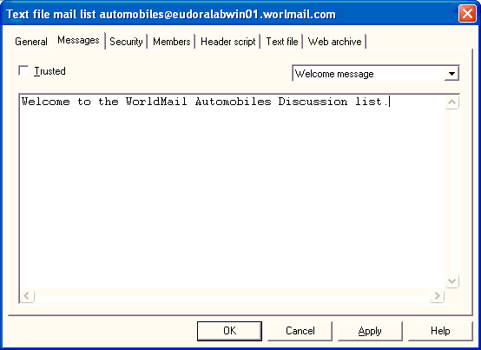
You can configure a list to send a custom Welcome message K when someone joins. Similarly, you can send a custom Goodbye message when someone leaves. Someone who sends a HELP command to the mailing list processor can also be sent a custom help message. To configure these messages, select the message category from the drop-down list. Type in a short message in the text window.

Message Category
You can create custom messages that the list processor sends in response to different commands:
- Welcome Message, which is sent when someone JOINs or SUBSCRIBEs to the list.
- Goodbye Message, which is sent when someone LEAVEs or UNSUBSCRIBEs to the list.
- Message Prolog, which is inserted at the beginning of each list message.
- Message Postscript, which is appended to the end of each list message.
- Help Message, which is sent in response to the HELP command.

List Message Text
Enter the text that you would like the list command processor to return to the sender. Use message directives for advanced message processing.
If you want to put a large amount of text into your message, use the %INCLUDE directive, rather than typing text into the configuration console directly. This is to save space in the Registry. In fact, you will find that the configuration console will only accept a relatively small amount of text; enough for a short message and a few directives.

Message Prologs and Postscripts
You can arrange for each message sent to the list to have a prolog or postscript added. This is very useful for reminding list members how to leave the list. Use the corresponding dropdown items in the Messages page in the list properties form to set this up.
You may use the same message directives as for Welcome and Goodbye messages, but the %ADDRESS directive will be replaced by the address of the mailing list, not the address of an individual recipient. Other remarks in the preceding section also apply to prologs and postscripts.
If a message to a mail list contains a MIME Content-type: header, and the content type is not text/plain, neither the prolog nor the postscript will be added. This is to avoid corrupting data such as image, movie, etc.

List Message Directives
The message that you type in can contain directives, which are replaced by other text when the message is actually sent. The full list of directives is as follows:
Directive | Replacement text
%ADDRESS | The e-mail address of the person joining or leaving the list or sending the HELP command
%DATE | The current date
%TIME | The current time
%INCLUDE(filename) | The contents of the filename
%EXECUTE(commandline) | The output produced by executing the command line (trusted mailing lists only)
%% | A single percent character
The operation of the %INCLUDE directive depends on the Trusted setting. If the list is trusted, then the filename should be the full path to a file that is accessible to the mail server. If the list is not trusted, only files located in the mailing list directory can be included--in this case, the filename should be specified as a relative path and not a full path.
The %EXECUTE directive only works for Trusted lists. The commandline parameter can specify any command or batch file.

List Message Directive Examples
Some examples may help to explain message directives. Suppose a Welcome message for a list discuss@abc.com (which is not trusted) contains the following text:
Welcome to the discuss@abc.com mailing list!
You have subscribed to the list as %ADDRESS - please remember to unsubscribe using the same address.
%INCLUDE(purpose.txt)
Thank you for joining. Enjoy the list!
When a user joins the list, she will be sent a welcome message containing the above text, with the directives replaced as described above. The file purpose.txt (which presumably contains some information about the purpose of the list) must be located on the mail server in the directory lists\~abc.com\discuss (or, if abc.com is the default domain, in directory lists\discuss).
Suppose a Goodbye message for the list discuss@abc.com (which we'll assume is trusted) contains:
Thank you for using this list.
%EXECUTE(c:\myutils\goodbye %ADDRESS)
Bye!
When a user leaves this list, she will receive a Goodbye message containing the above text, with the %EXECUTE directive replaced by the output of the program c:\myutils\goodbye. Note that the %ADDRESS is replaced by the user's e-mail address and passed to the program as a command-line argument. Only the %ADDRESS directive can be used in this way, and only with the %EXECUTE directive.
Only console programs (that is, programs which you would run from the operating system command line) can be used with the %EXECUTE directive. Batch files, interactive programs which prompt for user input, or programs that have a windowed user interface will not work.
Suppose a message containing the command HELP is sent to discuss-request@abc.com (as before, we'll assume list discuss is trusted). If the configurable help message for the list contains:
%INCLUDE(c:\special\place\abchelp.txt)
The response from the mailing list processor will be a message that includes the specified file. Note that if no help message is configured, a built-in default message will be sent as part of the normal command response (the journal message).

#$K+ List Security Page K
Use this page to configure the security settings for this list.
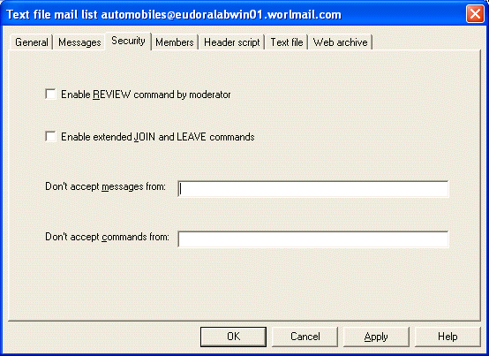

Enable REVIEW Command by Moderator
If you are the moderator of a mailing list, you may use the REVIEW K command in a message to the list-request address. The server will respond with a message containing a list of all current members.
Because list membership is potentially confidential, and because it is relatively easy to forge e-mail addresses, the REVIEW command is disabled by default.

Enable Extended JOIN and LEAVE Commands
Following the list name in the JOIN K and LEAVE K commands, you can specify a full e-mail address, in any valid RFC822 form. This extended form of the JOIN and LEAVE command is disabled by default
Here are some example extended JOIN and LEAVE commands. Note that SUBSCRIBE K and UNSUBSCRIBE K are recognized synonyms.
JOIN thelist "John Smith" jsmith@myco.co.uk
LEAVE thelist smith@domain.com (Joe Smith)
SUBSCRIBE thelist Jane Doe <janed@super-isp.net>
UNSUBSCRIBE thelist peter@my-university.edu

Don't Accept Messages From
Enter a list of addresses that you want to block from this list. Separate each address with a comma.
The syntax for these fields is:
- addressmask, addressmask, addressmask,...
where addressmask can be an e-mail address, possibly containing a wildcard asterisk (*). You can also have an exclamation mark (!) in front of an addressmask, indicating that matching addresses don't belong in the excluded list. The list is processed from left to right.

Don't Accept Commands From
Enter a list of addresses that you want to block from this list-request processor. Separate each address with a comma.
The syntax for these fields is:
- addressmask, addressmask, addressmask,...
where addressmask can be an e-mail address, possibly containing a wildcard asterisk (*). You can also have an exclamation mark (!) in front of an addressmask, indicating that matching addresses don't belong in the excluded list. The list is processed from left to right.

#$K+ List Members Page K
Use this page to manage list membership.
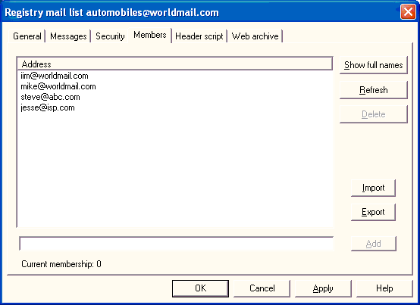
The Address field shows the e-mail addresses of all of the list members. In the case of Database mail lists, the list membership to be viewed in this list, but not changed; to modify membership of Database lists, make changes to the database table that contains the member list.

Modifying Members
You can modify the address and the full name of a list member by clicking on the entry in the list. The entry will appear in the edit field. Make your changes and click the Modify button.

Sorting Membership
You can sort the list of members either by Address or by Full Name by clicking on the corresponding column heading.

Deleting Members
Existing members can be removed using the Delete button. Use the Ctrl and Shift keys to select multiple members for deletion.

Adding Members
New members can be added by entering the mail address in the field and clicking on the Add button.

Show Full Names Button
Mail list members can have a descriptive string associated with them--typically their full name. Click on this button to display the full name of each list member.
The full name is set when a member joins the list using the JOIN command, or it can be set by typing the name and e-mail address into the Members page and clicking the Add button. Any valid SMTP e-mail address syntax is accepted.
Tip: Depending on the type of mailing list, the time taken for operations such as sorting, deleting or adding addresses may be significantly greater when full names are displayed. Keep them turned off unless you really need to see them.

Import Members
The Import button allows you to import mail list members from a text file. The button displays the Open file dialog. Locate the text file containing the Internet mail addresses of the members you wish to import into the list. Click on the OK button to import the addresses.
Each line of the text file should consist of one Internet mail address; lines can be commented by starting with #. You can also use any valid RFC822 address, for example:
"John Smith" john@abc.com
fred@abc.com
joe@efg.com
bill@hij.com
#john@xyz.com

Export Members
The Export button allows you to export mail list members to a text file. The button displays the Save As file dialog. Enter the location and name of the text file that you would like to use. Click on the OK button to export the addresses.

#$K+ List Header Script Page K
Use this form to create and edit the header script for this list.
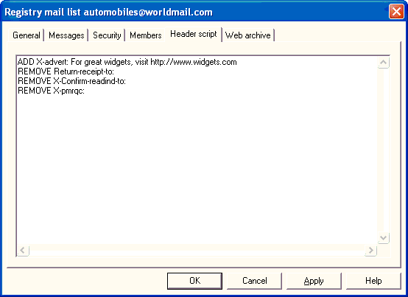
WorldMail provides a simple script language for editing the headers of messages sent to a mail list. Script commands are provided to add, rewrite and remove headers, and to test for the presence of specific headers. If you wish to perform more complex processing, you can use the Mail List Agent.
A script consists of a series of commands, one per line. The script is executed line-by-line, top to bottom. Refer to the section on List Header Processing in the Appendix for a complete description. The script commands are:
- ADD headertemplate
- REMOVE header
- REWRITE header AS headertemplate
- IFPRESENT header GOTO label
- IFABSENT header GOTO label
- IFCONTAINS header text GOTO label
- ABORT [recipient]
- :label

#$K+ List Web Archive Page K
KThe web archive property page controls the creation of an HTML archive of messages sent to the mail list. For more information about mail list archiving, see the sections on Archiving List Messages and Customizing Mail List Archiving.
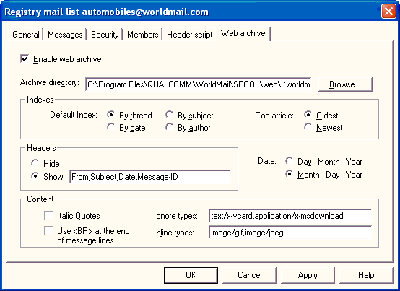

Enable web archive
Check this box to create a web-accessible archive of messages sent to the mail list.

Archive directory
Specify the name of a directory that will contain the archive. If you are running the Windows Management Center on the same machine as the mail server, you can use the Browse button to select a directory. You should select a directory which can be accessed by a web server (such as HTTPMA), so that Web users can view the archive.

Default index
Several index pages for the archive will be created. This setting controls the default page, which will be named index.html.

Top article
Controls the order of the entries in the index.

Headers
Controls whether individual message headers appear in the archive files, and which headers are shown.

Date
Controls how dates are displayed in the archive.

Italic quotes
If set, quoted messages within a message will be displayed in italics.

Use <BR>
If set, line breaks in a message will be preserved in the archive, using the HTML <BR> tag.

Ignore types
Comma-separated list of MIME types which are ignored when a message is archived.

Inline types
Comma-separated list of MIME types which are treated as inline images when a message is archived.

#$K+ List Digest Page (Digest Lists) K K
Use this form to set the list digest properties, which are available only for digest lists.
A digest list is a special form of mail list. It has the same name as its parent list, but with -digest appended.
Messages sent to the regular list address are accumulated in the list-digest directory. When the digest frequency time is reached, this list will send out a copy of the digest to each member.
You can control the digest frequency and the format of the digest messages using this form.

Digest Frequency
The digest frequency controls how long the digest accumulates messages for before it sends them out. The default is 1 day.

Digest Subject Template
You can specify the Subject: field of the messages sent out by the digest. To incorporate the date and time from when messages were accumulated, use the percent substitution variables defined below.
Variable | Replacement text
%a | Weekday name (abbreviated)
%A | Weekday name (full)
%b | Month name (abbreviated)
%B | Month name (full)
%c | "Short" date and time representation appropriate to the server's locale
%d | Day of the month as a two-digit number (01-31)
%H | Hour as a two-digit number (24-hour format: 00-23)
%I | Hour as a two-digit number (12-hour format: 00-11)
%j | Day of the year as a three-digit number (001-366)
%m | Month as a two-digit number (01-12)
%M | Minute as a two-digit number (00-59)
%p | AM/PM indicator (appropriate to server's locale) for a 12-hour clock
%S | Second as a two-digit number (00-59)
%U | Week of the year as a two-digit number (00-51), counting Sunday as the first day of the week
%w | Weekday as a single-digit number (0-6), counting Sunday as the first day of the week
%W | Week of the year as a two-digit number, with Monday as the first day of the week (00-51)
%x | "Short" date representation appropriate to server's locale
%X | Time representation appropriate to server's locale
%y | Year as a two-digit number (00-99)
%Y | Year as a four-digit number
%z, %Z | Server's time zone name or abbreviation; empty if the time zone is unknown

Include Table of Contents
Select this option to control whether the digest message will start with a table of contents.

#$K+ List Text File Page (Text File Lists) K
Use this form to configure your text file mail list.
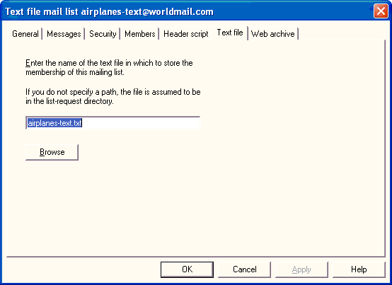
This type of mail list allows you to store membership in a text file. This is useful if you wish to maintain list membership outside of WorldMail. You still have the option of managing list membership through the Members tab in the list properties form. WorldMail will add and remove entries in the text file when JOIN and LEAVE subscription requests are received by the list-request processor.

File Name
Enter the name of the text file that stores the membership for this list. To search through the file system, select the Browse button.

#$K+ List NT Group Page (NT Lists) K
Use this form to configure your NT list.
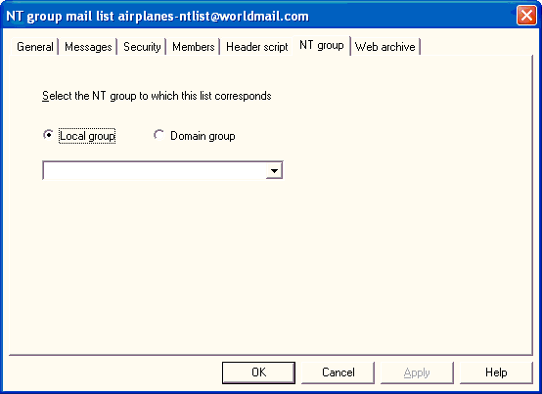
This type of mail list allows you to send a message to every member of an NT Group that has a mailbox on this server. Select the NT Group that you wish to use.

#$K+ List Database Page (Database Lists) K
Use this form to configure your database mail list. See the section on the Database Mail List Plugin for more information on using this feature.
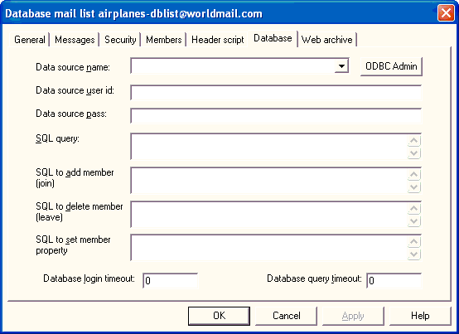
Complete the fields on this form. WorldMail will use this information to log onto your database and submit a query for list membership.

Data Source Name
Enter the name of the ODBC data source. This is configured in the System DSN page of the ODBC Data Source Administrator in the Control Panel.

Data Source User ID
Enter the username that WorldMail should use to log into to the data source.

Data Source Password
Enter the password that WorldMail should use to log into to the data source.

SQL query
The SQL statement to execute to obtain the list of e-mail addresses and full names. The SQL statement you type here must return a result set containing at least two columns, the first of which must contain an e-mail address, while the second should contain the full name of the recipient.
If you do not enter anything here, the default SQL query will be SELECT EmailAddress, FullName FROM tablename, where tablename is formed from the mailing list name by replacing any dots and hyphens by underlines.
To execute a stored procedure, use this syntax:
- {CALL ProcName(parameters)}
There must be no space between the { and the CALL.

SQL to add member (join)
The SQL statement to execute to add a member to the list. By default the statement is:
- INSERT INTO tablename (EmailAddress) VALUES (%1)
where tablename is formed from the mail list name by replacing any dots and hyphens by underlines. To avoid duplicates, it is important that the "EmailAddress" column of the database is defined to be a primary key. Parameter substitution occurs before the SQL is executed , as follows:
Marker | Type | Description
%1 | String | The email address of the new member

SQL to remove member (leave)
The SQL statement to execute to remove a member from the list. By default the statement is:
- DELETE FROM tablename WHERE EmailAddress = %1
where tablename is formed from the mail list name by replacing any dots and hyphens by underlines. Parameter substitution occurs before the SQL is executed, as follows:
Marker | Type | Description
%1 | String | The email address of the deleted member

SQL to set member property
The SQL statement to execute to set the value of a member property. By default the statement is:
- UPDATE tablename SET %2 = %3 WHERE EmailAddress = %1
where tablename is formed from the mail list name by replacing any dots and hyphens by underlines. Parameter substitution occurs before the SQL is executed, as follows:
Marker | Type | Description
%1 | String | The email address of the member
%2 | String | The name of the parameter
%3 | String | The value of the parameter

Database Login Timeout
Enter the time (in seconds) that is allowed for connecting to the database. If you leave this blank, the default timeout of 15 seconds will be used. A value of zero means an infinite timeout.

Database Query Timeout
Enter the time (in seconds) that is allowed for executing the database query. If you leave this blank, the default timeout of 15 seconds will be used. A value of zero means an infinite timeout.

#$K+ List Mailboxes Page (Server Lists) K K
Use this form to configure your server mail list.
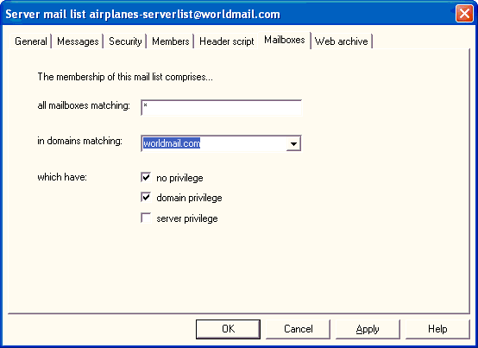
The membership of a Server mail list comprises those mailboxes on the mail server that match certain masks that you specify.

All mailboxes matching
Specify a mask string that matches all the mailbox names that the list is to contain. For instance, web* includes all mailboxes starting with web. You can specify a comma-separated list of masks (e.g. web*,post*), and you can also specify exclusions using an exclamation point (e.g. web*,!weber,post*). To include all mailboxes, specify a single asterisk.

In domains matching
Specify a mask string that matches all the (local) domain names that the selected mailboxes may be in. For instance, www.* includes all domains starting with www.. You can specify a comma-separated list of masks (e.g. www.*,mail.*), and you can also specify exclusions using an exclamation point (e.g. www.*,!www.mycompany.com,mail.*). There is a drop-down list that allows you to select a domain name. To include all domains, specify a single asterisk.

Which have
Specify the privilege level of mailboxes that are to be in the list. See the section on Mailboxes for more information about mailbox privileges.
#$K+ Web Management Center Reference
K KYou can remotely manage your WorldMail server using the Web Management Center. These remote web administration capabilities are provided by the HTTP Management Agent K and the Web Management Center. To login to the Web Management Center, connect to the following URL:
- http://host.domain.com:port
Where host.domain.com is the name of your WorldMail server, and port is the HTTP Port Number configured in the Services folder of the WorldMail Management Center. By default the port number is set to 90.
When you connect to this address the Web Management Center login page will be displayed.

#$K+ Logon Page
The Web Management Center Logon K page looks like this:
Enter the following information to log into the Web Management Center:

Mailbox
Enter the name of your mailbox (for example, joe@abc.com). If you do not provide a domain then the default domain is assumed.

Password
Enter your mailbox password.

Logon
Click on the Logon button to log into the Web Management Center. If the logon fails, an error page will be displayed describing the nature of the error, with a link back to the Logon page. If you entered a valid e-mail address and password, then a Server Page, Domain Page or Mailbox Page will be displayed, depending on your privilege level.

#$K+ Server Page
KIf you logon to the Web Management Center and have Server privilege K then you will see this page:
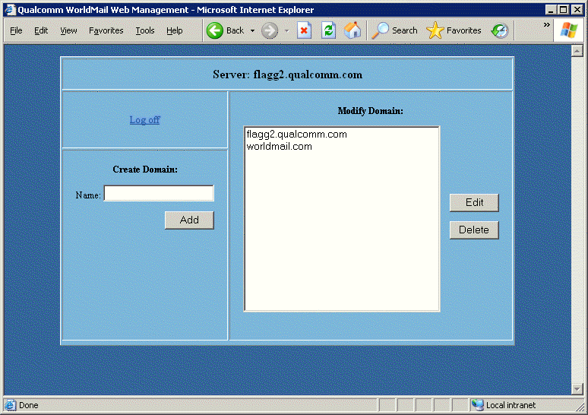
You can use this page to add and delete domains, to open the properties of each domain and to manage mailboxes and mail lists in each domain. There is also a log off link that will close the session.
To create a domain, enter a name in the Name field and click the Add button. A Report page will be displayed describing the success or failure of the operation.
To delete a domain, select the name from the Modify Domain list, and click the Delete button. A Confirm page will then be displayed describing the outcome of the operation.
To edit a domain, select a name from the Modify Domain list and click the Edit button. You will be presented with the Domain page corresponding to the name that you clicked.

#$K+ Domain General Page
KIf your privilege level is Domain or higher, then you will be presented with the Domain General page. The Domain General page looks like this:
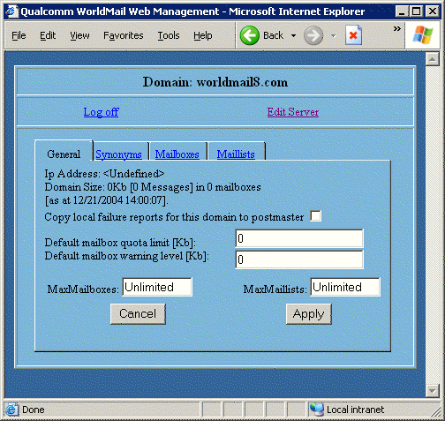
The Domain General page has four tabs: General, Synonyms, Mailboxes and Mail Lists. You can use these four domain tabs to manage the properties of these objects in the domain. The Domain General and the Domain Synonyms pages are the same as the corresponding forms in the Windows Management Center. Refer to the Windows Management Center Reference section for more information.

#$K+ Domain Mailboxes Page
KClick on the Mailboxes tab to manage mailboxes in this domain:
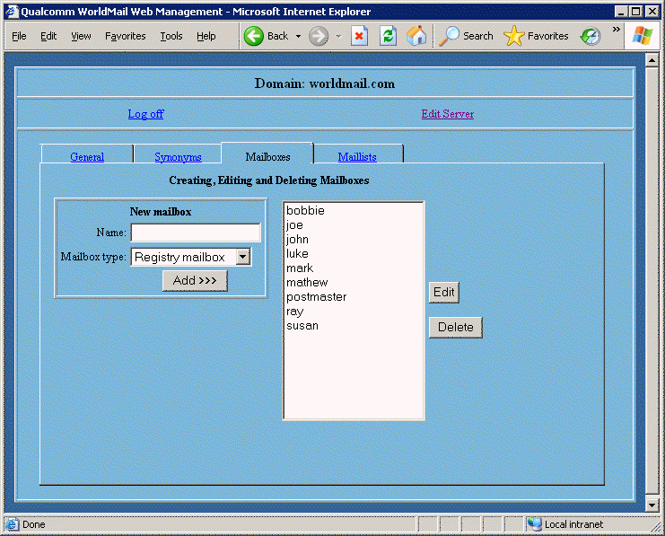
You can use this page to add, delete and modify mailboxes in this domain.
To create a mailbox, enter a name in the Name field, select the type of mailbox to create from the Mailbox type list and click the Add button. A Report Page will be displayed describing the success or failure of the operation.
To delete a Mailbox, select its name in the list and click on the Delete button. A Confirm Page will be displayed describing the operation with OK and Cancel links.
To modify a mailbox, select its name from the list and click the Edit button. After the server has authorized the operation you will be presented with the properties page for this mailbox.

#$K+ Domain Mail Lists Page
KClick on the Mail Lists tab to manage mail lists in this domain:
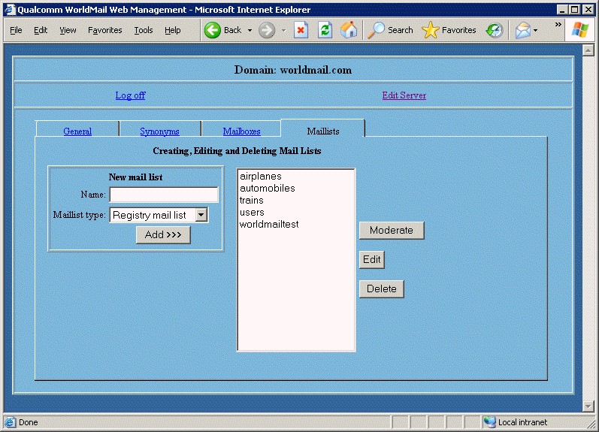
You can use this page to add, delete and modify mail lists in this domain.
To create a mail list, enter a name in the Name field, select the type of mail list to create from the Maillist type list and click the Add button. A Report Page will be displayed describing the success or failure of the operation.
To delete a Mail List, select its name in the list and click on the Delete button. A Confirm Page will be displayed describing the operation with OK and Cancel links.
To modify a mail list, select its name from the list and click the Edit button. You will be presented with the properties page for this mail list.
To moderate a mail list, select its name from the list and click the Moderate button. You will be presented with the Pending page for this mail list. Refer to the section on List Moderation for more information.

#$K+ Mailbox Properties Page
KIf your privilege K level is None then you will be presented with the Mailbox General page when you log on. You can also access the Mailbox General page from the Domain Properties page if you have Domain or Server privilege. The Mailbox General Page looks like this:
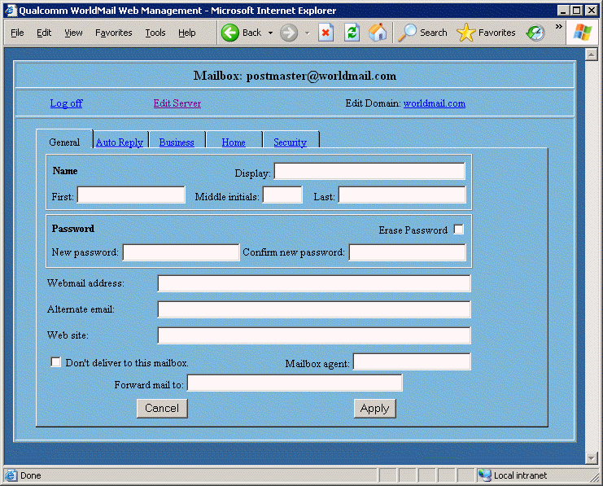
This page allows you to change the properties of an individual mailbox. It contains four tabbed pages called General, Auto Reply, Business and Home. These pages correspond to the pages in the Mailbox Properties form in the Windows Management Center program. Refer to the Windows Management Center Reference section for more information.
If you log on with privilege level None then you will see a fifth tabbed page: Mail lists. This page contains all the mail lists for which you are a moderator. This page corresponds to the Domain Mail Lists page discussed above. You can select a mail list name from the list, and click on the Edit button to get the mail list page, or on the Moderate button to get the Pending page for the list.

Privilege Level
The options available in the privilege level box will depend on your privilege:
- If you have Server privilege, then you may change any mailbox's privilege level, even that of a mailbox with Server privilege.
- If you have Domain privilege, then you may change a mailbox's privilege level to Domain or None. If the mailbox already has Server privilege then you may not change the privilege level of that mailbox.
- If you have privilege level of None then you may not change your privilege level.

Mailbox Quota and Warning Level
You can only change these settings if you have Server or Domain privilege. If you are not permitted to change these values, they will still be displayed, but cannot be changed.

Mailbox agent
You can only change the Mailbox agent if you have Server privilege. The field will not be displayed if you do not have Server privilege.

Enable Auto Reply
Check this field to enable the auto-reply message for the mailbox.

Trusted Mailboxes
This may only be changed if you have Server privilege. Otherwise it will not be displayed.

#K Changing the password
If you are logged on with Server privileges then you are permitted to change the password of any mailbox on the server. In this case, the Change Password box will have two text fields: New Password and Confirm New Password, and there will be a checkbox to erase the existing password.
If you are logged on without Server privilege then you must provide the old password in order to set a new password. To set an empty password, check the Erase Password box and leave the other password fields empty.

#$K+ Mail List Properties Page
KIf you are the moderator K of a mail list, or if you have Server or Domain privileges, then you will be able to administer these lists using this page. The Mail List General page looks like this:
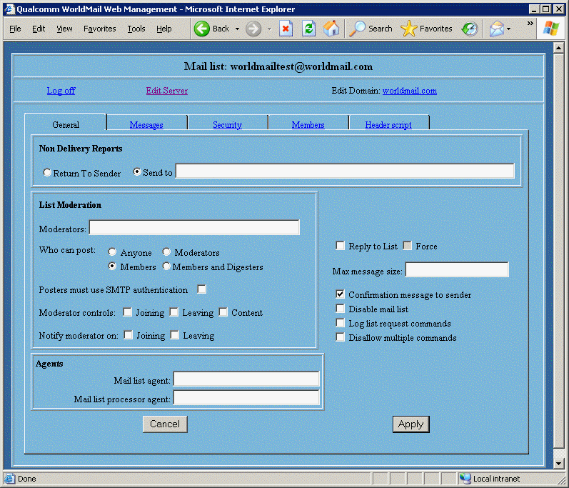
You can use this page to edit the properties of your mail list. It contains a number of tabbed pages that operate in a similar manner to the Mail List Property pages in the Windows Management Center. Refer to the Windows Management Center Reference section for more information.
The mail list General tab contains a Moderate button that takes you into the Pending Page. Here you can moderate pending messages for the mail list.

#$K+ List Moderation
KContent Moderation is a feature that allows mail list moderators to approve or reject all messages sent to a mail list. To enable this feature, select the Moderator controls content feature in the List General Page.
When a new message arrives at the server, it will be checked to see if its author may post to the list. If the author does not have posting permission (for instance, if he is not a member of the mail list and the mail list is set to disallow posting by non-members), the message will be returned to the author with an appropriate rejection message. If the author does have permission, delivery processing depends on whether content moderation is enabled for the list.
If content moderation is enabled, then the message will be placed in the pending directory for that list. If content moderation is not enabled, then the message is placed directly into the mail list directory.
For example, suppose there is a mail list called discuss in the default domain and this list has content moderation enabled. If the mail list directory is called:
- C:\Program Files\QUALCOMM\WorldMail\SPOOL\LISTS\discuss
Then the pending directory will be called:
- C:\Program Files\QUALCOMM\WorldMail\SPOOL\LISTS\discuss\pending
If the pending directory does not already exist then WorldMail will create it.
List messages will remain in the pending directory until one of the mail list moderators logs on to the List Moderation page from a web browser and reviews pending messages. Messages may be reviewed and rejected, accepted, or discarded where appropriate.
If you wish to change the appearance of the List Moderation forms, refer to section on Customizing Web Administration in the Appendix.

#$K+ Pending Page
The Pending Page looks like this:
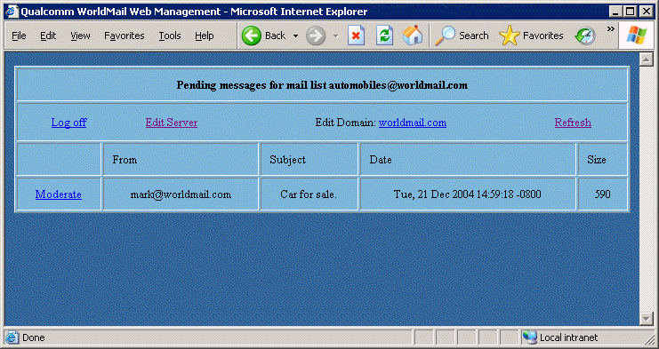
This page contains a list of all the pending messages for the mail list. Each line represents an individual message. The author, subject, date and size of the message can all be seen at a glance. Note that there will be no pending messages unless the Content Moderation option is checked in the Mail List General page.
There are three types of links on this page:
- The Refresh link will provide an updated list of pending messages.
- The Log off link will finish the moderation process for this list.
- The Moderate link beside each of the messages will display a review page for that message. This allows the moderator to accept or reject the message.

#$K+ Review Page
The review page allows you to review an individual list message:
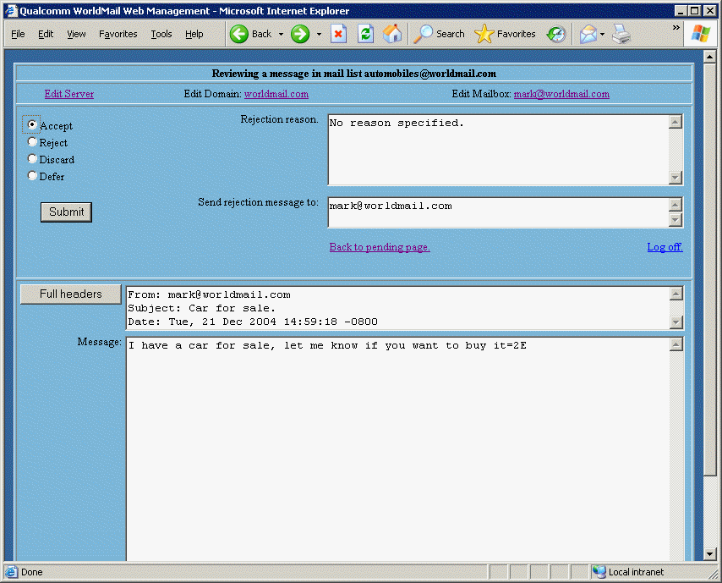
There are four actions that can be taken with a pending message. The action is taken by selecting one of the four radio buttons in the top corner.

Defer
This will do nothing with the message, leaving it in the pending directory and returning you to the pending messages page.

Discard
This will delete a message outright, removing it from the pending directory and stopping it from being sent to the mail list. No indication of its fate will be sent to the message originator. There is no way to recover a message that has been discarded.

Accept
This places the message in the list directory as a MSG file, which will result in the message being sent out to the members of the mail list.

Reject
This will stop the message from being sent to the mail list and provides the moderator with the ability to return comments and the original message to the sender. You can enter comments on why the message was rejected in the Reject Reason text area. You can enter the address to which the rejection message should be sent in the Send Rejection Message To text box.

Full Headers
If you wish to see the complete headers of the message then select the Full headers button. Once clicked, this button becomes a Partial headers button to return to the From:, Subject and Date headers. Note that this function is only available to browsers that support JavaScript. If JavaScript is not available then the full headers will be displayed.
The remaining two links on the page allow you to log off the session and return to the pending messages page. Both these options have no effect on the current message. It will stay pending until it is discarded, accepted or rejected.

#$K+ Confirm Page
The Confirm Page is displayed before any object is deleted. It looks like this:
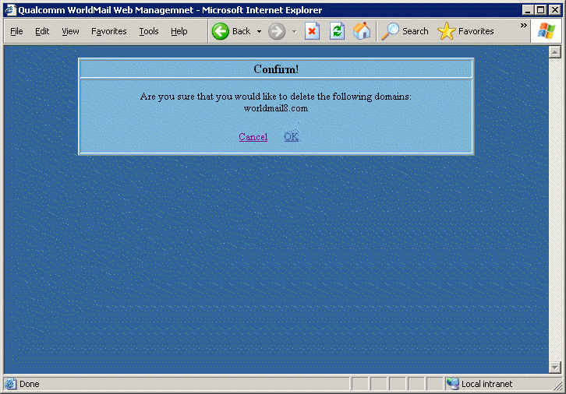
The Confirm Page describes the action that has been requested and has two links to OK or Cancel the action. Click on OK to complete the action.

#$K+ Report Page
The Report Page displays the result of an operation. It looks like this:
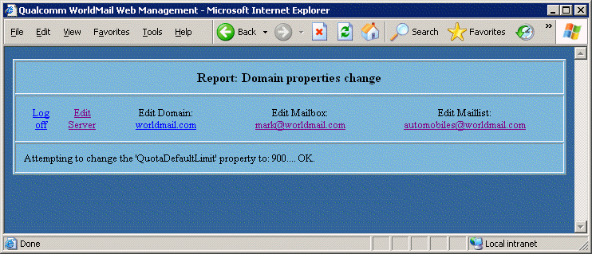
After you have performed an update operation a Report Page will describe the success or failure of each of the changes requested. The page contains at most four links to the server, domain and mailbox pages and a log off link. Your privilege level and the current state of the Web Management Center session determine which links are available.

#$K+ Logoff Page
The Logoff page looks like this:
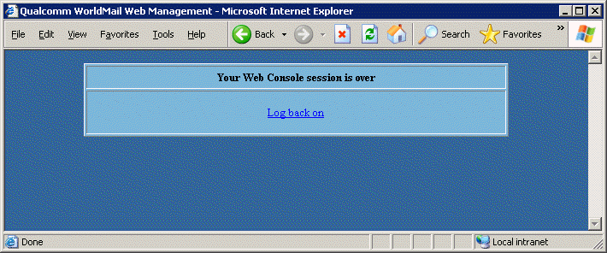
When you select the logoff link this page is displayed. It cleans up the memory on the server side of the Web Management Center application and also provides a link back to the logon page. Note that if there is no activity on a mailbox managing session for one hour then the session is terminated by the server. However, for security reasons, it is a good idea always to log off.
#$K+ Troubleshooting Procedure
KWhenever you experience problems with WorldMail we recommend that you follow this step by step procedure:
- Check TCP/IP Connectivity
Frequently the problem lies with the TCP/IP connection to the computer. See the section on TCP/IP Debugging for more information.
- Check the Server Log File or the Windows NT Event Log
Look for incidents around the date and time when the problem occurred. If the problem is associated with a specific mail message, search for the Message ID.
- Reconfigure the Logging Options using the Logging Page
Examine the on-line help to determine which logging options would provide relevant information to your problem and enable these options.
- Reproduce the problem
- Re-examine the Server Log File or the Windows NT Event Log
Look for incidents around the date and time when the problem occurred. If the problem is associated with a specific mail message, search for the Message ID in the file system and examine the file with a text editor.
- Decode the error message
Error codes fall into two categories: TCP/IP errors and Windows NT errors. Most TCP/IP errors are greater than 10000, while most Windows NT errors are less than 10000. To decode a TCP/IP error, refer to the list on the Eudora web site. To decode a Windows NT error, run this command:
- net helpmsg NNN
Where NNN is the Windows NT error code number.
- Troubleshoot the server by following the Telnet Debugging procedure

#K Debugging TCP/IP Connections
Frequently the problem lies with the TCP/IP connection to the computer. Follow this procedure to debug TCP/IP connections to the WorldMail server.

#K Problems Receiving Mail

Resolve the IP Address
Log on to a remote computer and use the command nslookup to resolve the IP address:
nslookup
Server: 192.153.156.22
> example.com
> SET TYPE=MX
query type = MX
> example.com
example.com.
0, mail.example.com.
example.com.
10, nic.scruz.net.
> SET TYPE=A
query type = A
> mail.example.com
mail.example.com.
204.147.233.1
In this case the host example.com does not have an A record (since the first query did not return any records). However example.com does have two MX records, one of which points to the host mail.example.com. A third query for the A record for mail.example.com reveals that this host has IP address 204.147.233.1.
This is the procedure that external mail servers use to resolve mail addressed to users@example.com. Substitute the name of your WorldMail server for example.com.

PING the Server
Once you have resolved the IP address for your WorldMail server, you can establish TCP/IP connectivity by pinging the host:
- C:\> ping 204.147.233.1
Pinging 204.147.233.1 with 32 bytes of data:
Reply from 204.147.233.1: bytes=32 time=10ms TTL=32
Reply from 204.147.233.1: bytes=32 time<10ms TTL=32
Reply from 204.147.233.1: bytes=32 time<10ms TTL=32

Telnet to the WorldMail Services
If all of the above steps work, then look at the section on Telnet Debugging for more information.

#K Problems Sending Mail
If WorldMail has problems sending mail to one or more remote domains, then follow the procedure above, except:
- Do it from your WorldMail server, rather than from a remote computer
- Replace example.com with the name of the problematic domain

#K Debugging with Telnet
KSometimes mail clients do not display very helpful error messages. In these situations, it can be helpful to telnet to WorldMail to check whether the problem lies with the server or the client.

POP Server
To troubleshoot the POP server from a client, execute the following command:
- telnet host.domain 110
Replace host.domain with the name or IP address of the WorldMail server. The Telnet window will open and a greeting from the server will appear. Enter the following POP commands:
- USER yourusername
- PASS yourpassword
- RETR 1
- QUIT

IMAP Server
To troubleshoot the IMAP server from a client, execute the following command:
- telnet host.domain 143
Replace host.domain with the name or IP address of the WorldMail server. The Telnet window will open and a greeting from the server will appear. Enter the following IMAP commands:
- A1 LOGIN username password
- A2 LIST "" "*"
- A3 LOGOUT

SMTP Server
To troubleshoot the SMTP server from a client, execute the following command:
- telnet host.domain 25
Replace host.domain with the name or IP address of the WorldMail server. The Telnet window will open and a greeting from the server will appear. Enter the following SMTP commands:
- HELO yourcomputername
- MAIL FROM: <yourusername>
- RCPT TO: <yourusername>
- DATA
- type the text of your message
- . (period <return> to end the data)
- QUIT
There should be a new mail message waiting for yourusername.

#K Technical Support
K KIf the above troubleshooting steps don't resolve an issue that you are encountering, check the Eudora technical support web site for more information:
http://www.eudora.com/techsupport/worldmail/
#$K+ DNS Overview
KThe Internet is a global network of computers connected using the TCP/IP protocol. Each computer has a unique numerical TCP/IP address that other computers use to communicate with it.
People find it easier to refer to computers by name. Domain Name Service (DNS) takes care of this dilemma. It's sole purpose in life is to translate (or resolve, in technical terminology) TCP/IP addresses to computer names (and vice-versa).
DNS services run on many computers on the Internet. DNS is designed so that if a computer is asked to resolve an address and does not know the answer, it will pass the request on to a higher level authority.
Your computer, as a DNS client, will submit resolution requests to DNS servers when you try to connect to Internet sites such as www.ibm.com. The primary and secondary DNS servers for your computer are entered in numerical format in the Network TCP/IP Settings.
The DNS database on the server contains a number of different mappings of names to addresses, called record types. The most common, A, is the one that most people think of as DNS. A records are the ones used for resolving WWW and FTP addresses. In general you will find one numeric address for a given host name. For example, the A record for www.ibm.com is:
- 165.87.194.133
There is a second record type is called Mail eXchange (MX) records. These records are devoted to the delivery of mail. A MX record for a particular name will have several addresses and priorities. For example, to send e-mail to DEC, you need to use the name dec.com. DEC has the following MX records, each with a different priority number:
16.1.0.22 inet-gw-2.pa.dec.com 70
16.1.0.33 inet-gw-3.pa.dec.com 90
16.1.0.23 inet-gw-2.pa.dec.com 100
These records tell mail software where to send the mail and what to do if the first machine is not available. If the mail server inet-gw-2.pa.dec.com is being rebooted, a mail server will send mail to inet-gw-3.pa.dec.com (since these are the entries with the next higher priority in the MX record).
Many destinations do not have MX records. In this case, mail software will attempt to use the A instead. Mail will be held until it is possible forward if none of these machines are available.
The following points should be noted:
- It is wise to ask your provider to act as a secondary mail server for you in case your machine becomes unavailable. For example, your disks could become full, your Internet connection could break.
- The MX records and A records for the same name could be different (thus one machine receives mail and another machine receives all other traffic).
- If MX records exist, they must be correct, otherwise your domain will not receive mail.

#$K+ License Agreement

EUDORA® WORLDMAIL SERVER VERSION 3.0

SOFTWARE LICENSE AGREEMENT (“AGREEMENT”)
QUALCOMM INCORPORATED ("QUALCOMM") IS WILLING TO LICENSE ITS EUDORA WORLDMAIL SERVER VERSION 3.0 SOFTWARE for the MICROSOFT Windows NT Platform which consists of Windows NT(tm), Windows 2000(tm), Windows XP(tm), and Windows Server 2003(tm) (THE "SOFTWARE") AND THE ACCOMPANYING DOCUMENTATION TO YOU ONLY ON THE CONDITION THAT YOU ACCEPT AND AGREE TO ALL OF THE TERMS IN THIS AGREEMENT. BY CLICKING ON THE "YES" BUTTON BELOW YOU ACKNOWLEDGE THAT YOU HAVE READ THIS AGREEMENT, UNDERSTAND IT AND AGREE TO BE BOUND BY ITS TERMS AND CONDITIONS. IF YOU DO NOT AGREE TO THESE TERMS, QUALCOMM IS UNWILLING TO AND DOES NOT LICENSE THE SOFTWARE TO YOU. IF YOU DO NOT AGREE TO THESE TERMS YOU MUST CLICK ON THE "NO" BUTTON AND DISCONTINUE THE INSTALLATION PROCESS. ANY USE OF THE SOFTWARE BY YOU IS SUBJECT TO THE TERMS AND CONDITIONS SET FORTH HEREIN.

1. LICENSE. Subject to the terms and conditions of this Agreement, QUALCOMM hereby grants you a non-transferable, nonexclusive license to install and use a single copy of the Software in machine-readable form on a single compatible computer controlled by you for use by yourself except that a reasonable number of copies of the Management Center only may be installed on other computer systems to allow remote administration of the Software by the system administrator. The Software is deemed "in use" on a computer when it is loaded into the temporary memory (i.e. RAM) or installed onto the permanent memory (e.g. hard disk or other storage medium) of that computer. If you have more than one Agreement for the Software, then at any time you may have as many copies of the Software in use as you have an Agreement for. You may copy the Software for backup purposes, provided that you reproduce all copyright and other proprietary notices that are on the original copy of the Software. A license key has been, or may be supplied to you to support your use of the Software. The license key is the confidential information of QUALCOMM and you may not disclose it to any other person or entity.

2. RESTRICTIONS. QUALCOMM and any of QUALCOMM’s applicable licensors (for the purposes of this Section 2 and Sections 4, 5 and 6, QUALCOMM and QUALCOMM’s licensor(s) shall be collectively referred to as QUALCOMM) retains all right, title, and interest in and to the Software, and any rights not expressly granted to you herein are reserved by QUALCOMM. You may not reverse engineer, disassemble, decompile, or translate the Software, or otherwise attempt to derive the source code of the Software, except to the extent (if at all) expressly permitted under any applicable law. If applicable law expressly permits such activities, any information so discovered or derived shall be deemed to be the confidential proprietary information of QUALCOMM and must be promptly disclosed by you to QUALCOMM. Any attempt to transfer any of the rights, duties or obligations hereunder is void. You may not rent, lease or loan the Software. You may not reproduce (except as expressly permitted under Section 1), distribute, publicly perform, publicly display, modify or create derivative works of or based on the Software. Additionally, you shall not use any third party software or code in conjunction with the Software nor any other software provided by QUALCOMM in such a way that: (i) creates, purports to create or has the potential to create, obligations of QUALCOMM to third parties with respect to the Software or other QUALCOMM software, including without limitation the distribution or disclosure of any source code; or (ii) grants, purports to grant, or has the potential to grant to any third party any rights to or immunities under any QUALCOMM intellectual property rights or proprietary rights, including without limitation as such rights exist in or relate to the Software. Without limiting the generality of the foregoing, you shall not combine the Software nor any other software provided by QUALCOMM with any code or software licensed under the GNU General Public License (“GPL”) or any other open source license, in any manner that could cause, or could be interpreted or asserted to cause, the Software or other QUALCOMM software (or any modifications thereto) to become subject to the terms of the GPL or such other open source license.

3. TECHNICAL SUPPORT. Limited technical support (via telephone or email response) may be available for a limited period of time if you have purchased or are using the Eudora WorldMail Server during the demo period. Information regarding availability, nature and conditions of limited technical support may be found at www.eudora.com/techsupport/options/worldmail.html.

4. NO WARRANTY. YOU EXPRESSLY ACKNOWLEDGE AND AGREE THAT THE USE OF THE SOFTWARE IS AT YOUR SOLE RISK. THE SOFTWARE (AND TECHNICAL SUPPORT, IF ANY) IS PROVIDED "AS IS" AND WITHOUT ANY WARRANTY OF ANY KIND, EXPRESS OR IMPLIED. TO THE MAXIMUM EXTENT PERMITTED UNDER APPLICABLE LAWS, QUALCOMM EXPRESSLY DISCLAIMS ALL WARRANTIES, EXPRESS OR IMPLIED, INCLUDING BUT NOT LIMITED TO IMPLIED WARRANTIES OF MERCHANTABILITY, FITNESS FOR A PARTICULAR PURPOSE, AND NONINFRINGEMENT. QUALCOMM DOES NOT WARRANT THAT THE FUNCTIONS CONTAINED IN THE SOFTWARE WILL MEET YOUR REQUIREMENTS, OR THAT THE OPERATION OF THE SOFTWARE WILL BE UNINTERRUPTED OR ERROR-FREE, OR THAT DEFECTS IN THE SOFTWARE WILL BE CORRECTED. FURTHERMORE, QUALCOMM DOES NOT WARRANT OR MAKE ANY REPRESENTATIONS REGARDING THE USE OR THE RESULTS OF THE USE OF THE SOFTWARE IN TERMS OF ITS CORRECTNESS, ACCURACY, RELIABILITY, OR OTHERWISE. NO ORAL OR WRITTEN INFORMATION OR ADVICE GIVEN BY QUALCOMM OR ITS AUTHORIZED REPRESENTATIVES SHALL CREATE A WARRANTY OR IN ANY WAY INCREASE THE SCOPE OF THIS WARRANTY. SOME JURISDICTIONS DO NOT ALLOW THE EXCLUSION OF IMPLIED WARRANTIES, SO THE ABOVE EXCLUSION MAY NOT APPLY OR MAY BE LIMITED.

5. LIMITATION OF LIABILITY. TO THE MAXIMUM EXTENT PERMITTED UNDER APPLICABLE LAWS, UNDER NO CIRCUMSTANCES, INCLUDING NEGLIGENCE, SHALL QUALCOMM, ITS AFFILIATES OR THEIR DIRECTORS, OFFICERS, EMPLOYEES OR AGENTS BE LIABLE FOR ANY INDIRECT, INCIDENTAL, SPECIAL, PUNITIVE OR CONSEQUENTIAL DAMAGES (INCLUDING BUT NOT LIMITED TO DAMAGES FOR LOSS OF BUSINESS PROFITS, BUSINESS INTERRUPTION, LOSS OF BUSINESS INFORMATION AND THE LIKE) ARISING OUT OF THE USE OR INABILITY TO USE THE SOFTWARE, EVEN IF QUALCOMM OR ITS AUTHORIZED REPRESENTATIVE HAS BEEN ADVISED OF THE POSSIBILITY OF SUCH DAMAGES. SOME JURISDICTIONS DO NOT ALLOW THE LIMITATION OR EXCLUSION OF LIABILITY FOR INCIDENTAL OR CONSEQUENTIAL DAMAGES SO THE ABOVE LIMITATION OR EXCLUSION MAY NOT APPLY. IN NO EVENT SHALL QUALCOMM'S TOTAL LIABILITY TO YOU FOR ANY AND ALL DAMAGES, LOSSES, CLAIMS AND CAUSES OF ACTIONS (WHETHER IN CONTRACT, TORT, INCLUDING NEGLIGENCE, OR OTHERWISE) EXCEED THE GREATER OF THE AMOUNT PAID BY YOU FOR THE SOFTWARE OR $10.

6. INDEMNITY. You agree to defend and indemnify QUALCOMM against all any and all claims, losses, liabilities, damages, costs and expenses, including attorney's fees, which QUALCOMM may incur as a result of or in connection with your breach of this Agreement.

7. TERM AND TERMINATION. This Agreement shall continue until terminated. You may terminate the Agreement at any time by deleting all copies of the Software and all related information. This Agreement terminates immediately and automatically, with or without notice, if you fail to comply with any provision hereof. Additionally, QUALCOMM may at any time terminate this Agreement, without cause, upon notice to you. Upon termination you must delete or destroy all copies of the Software in your possession. Sections 2, 4 through 6, 8, 9 and 11 survive termination.

8. EXPORT. The Software contains strong encryption that is subject to the laws and regulations of the US Government. Licensee agrees and certifies that neither the Software nor any other technical data received from QUALCOMM, nor the direct product thereof, will be exported, re-exported, or transferred except as authorized and as permitted by the laws and regulations of the United States Government. Prohibited exports include but are not limited to; the export, re-export, or transfer of the Software or technical data to any prohibited entities or destinations subject to the US Government's current list of restricted or embargoed countries, any parties currently listed on the US Government's Denied Parties or Specially Designated National list, and any proliferation activities prohibited by the US Government such as chemical, biological, nuclear or missile technology.

9. GOVERNMENT END USERS. If you are or are acting on behalf of an agency or instrumentality of the United States Government, the Software, as applicable, is "commercial computer software" and "commercial computer software documentation" and pursuant to FAR 12.212 or DFARS 227 7202 and their successors, as applicable, use, reproduction and disclosure of the Software is governed by the terms of this Agreement.

10. CONTRACTING PARTIES. If the Software is installed on any computer owned by a corporation or other legal entity, then this Agreement is formed by and between QUALCOMM and such entity. The individual executing this Agreement represents and warrants to QUALCOMM that they have the authority to bind such entity to the terms and conditions of this Agreement.

11. GENERAL. You agree to comply with all applicable laws, rules, and regulations in connection with your activities under this Agreement. This Agreement is governed and interpreted in accordance with the laws of the State of California without giving effect to its conflict of laws provisions. The United Nations Convention on Contracts for the International Sale of Goods is expressly disclaimed and shall not apply. Any claim arising out of or related to this Agreement must be brought exclusively in a federal or state court located in San Diego County, California and you consent to the jurisdiction of such courts. If any provision of this Agreement shall be invalid, the validity of the remaining provisions of this Agreement shall not be affected. This Agreement is the entire and exclusive agreement between QUALCOMM and you with respect to the Software and supersedes all prior agreements (whether written or oral) and other communications between QUALCOMM and you with respect to the Software.

COPYRIGHT © 2005 BY QUALCOMM INCORPORATED. ALL RIGHTS RESERVED.

QUALCOMM AND EUDORA ARE REGISTERED TRADEMARKS OF QUALCOMM INCORPORATED. ALL OTHER TRADEMARKS AND SERVICE MARKS ARE THE PROPERTY OF THEIR RESPECTIVE OWNERS.

#$K+ Appendix A - Utilities

#K MSALIAS
KThe command-line utility MSALIAS.EXE can be used to manage the alias table. The syntax is:
msalias -version
msalias -machine \\system -login user[@domain] -loginpass password …
msalias -list
msalias -addstart mapfrom mapto
msalias -addstart -file aliasfile
msalias -addend mapfrom mapto
msalias -addend -file aliasfile
msalias -delete mapfrom
msalias -deleteall [-noprompt]
msalias -reorder mapfrom beforemapfrom
One and only one of the -version, -list, -addstart, -addend, -delete, -deleteall and -reorder flags may be present. The command arguments are as follows:
-version
Display the version number of the mail server.
-machine \\system -login user[@domain] -loginpass password ...
Specifies the name of a target remote machine (preceded by a double backslash), as well as login data for a mailbox on the target server that has WorldMail server privileges. This option is used in conjunction with any of the other flags to execute the given operation on the remote system. If this is omitted, the local machine is assumed.
-list
List all the aliases, in order. The format is one alias per line, each line containing the map-from address, a single space, then the map-to address.
-addstart mapfrom mapto
Add an alias at the start of the alias table. The arguments specify the map-from address and the map-to address that will form the new alias.
-addstart -file aliasfile
Add aliases at the start of the alias table. The argument specifies the name of a text file from which the aliases will be read. The format of the file is one alias per line, each line containing the map-from address and the map-to address, separated by one or more white space characters, and/or one or more colons. Blank lines, and lines on which the first non-blank character is a #, are ignored.
-addend mapfrom mapto
Add an alias at the end of the alias table. The arguments specify the map-from address and the map-to address that will form the new alias.
-addend -file aliasfile
Add aliases at the end of the alias table. The argument specifies the name of a text file from which the aliases will be read. The format of the file is one alias per line, each line containing the map-from address and the map-to address, separated by one or more white space characters, and/or one or more colons. Blank lines, and lines on which the first non-blank character is a #, are ignored.
-delete mapfrom
Delete the alias that has the given map-from address.
-deleteall [-noprompt]
Delete all the aliases, prompting for confirmation. If the -noprompt flag is present, you will not be prompted for confirmation.
-reorder mapfrom beforemapfrom
Remove the alias that has the mapfrom map-from address from the table, and replace it immediately before the alias that has the beforemapfrom map-from address. If either alias does not exist, the command fails.

#K MSBACK
KYou can use the utility program MSBACK.EXE to save and restore your WorldMail configuration to and from a text file. You should include this command in your nightly backup script. MSBACK.EXE is a console program (i.e. it should be run at the command-line prompt). The syntax for this command is:
msback [-version]
msback [-machine \\system] [-restore [-deleteold]] filename
The command arguments are as follows:
-version
Display the version number of the mail server.
-machine \\name
Specify the name of the target WorldMail server. If this is omitted, the local machine is assumed. Note that the machine name must be preceded by a double backslash.
-restore
Read the configuration from the file and write it to the Registry. If this argument is omitted, the configuration will be read from the Registry and written to the file.
-deleteold
Delete the old configuration in the Registry before restoring the configuration from the file. If this argument is omitted, the configuration from the file will be merged with the existing configuration. This argument is only relevant if -restore is specified.
filename
The name of the file to which the configuration will be written (or from which it will be read, if -restore was specified). This argument is required.
MSBACK uses a text format to store the mail server configuration information. The format is described in BNF below. Examining a generated backup file will help make this clearer.
<configurationfile> ::= <key> [<key>]
<key> ::= <openingmarker>[<value>..][<subkey>..]<closingmarker>
<openingmarker> ::= "["<escapedkeyname>"]"
<closingmarker> ::= "[""/"<escapedkeyname>"]"
<escapedkeyname> ::= key name, control chars, %, / [ and ] chars replaced by %xx
<value> ::= <valuename> "=" <valuedata>
<valuename> ::= value name with any control chars, % and = chars replaced by %xx
<valuedata> ::= <dwordvaluedata>|<stringvaluedata>|<multistringvaluedata>
<dwordvaluedata> ::= string of decimal digits
<stringvaluedata> ::= '"'[<stringdata>]'"'
<stringdata> ::= sequence of chars with any control chars, % and " replaced by %xx
<multistringvaluedata> ::= <stringvaluedata>[<stringvaluedata>..]'"''"'
<subkey> ::= <key>
Note that an empty multistring is represented as "" "" whereas an empty string is represented as "". It is vital that the opening and closing markers and each value are on a line by themselves - i.e. no newlines within <openmarker>, <closemarker> or <value>.
You can backup the WorldMail configuration at any time. However, it is important to stop all services before restoring the configuration.

#K MSBOX
KThe utility MSBOX.EXE can be used to manage mailboxes. You can use this utility to create a batch of mailboxes or to migrate mailboxes from another mail server. The syntax is as follows:
msbox -version
msbox -machine \\system -login user[@domain] -loginpass password ...
msbox -list [domain]
msbox -list2 [domain] -security pass
msbox -create name[@domain] pluginid
msbox -delete name[@domain]
msbox -set name[@domain] property value
msbox -get name[@domain] property
msbox -pass name[@domain] [Plaintextpassword]
msbox -plugin name[@domain] pluginid
msbox -plugin @filename pluginid
msbox -createalias name[@domain] alias[@domain]
msbox -deletealias alias[@domain]
msbox -listalias name[@domain]
One and only one of the flags must be present.
-version
Display the version number of the mail server.
-machine \\system -login user[@domain] -loginpass password ...
Specifies the name of a target remote machine (preceded by a double backslash), as well as login data for a mailbox on the target server that has WorldMail server privileges. This option is used in conjunction with any of the other flags to execute the given operation on the remote system. If this is omitted, the local machine is assumed.
-list [domain]
List the mailboxes in the given domain. If the domain is omitted, the default domain is assumed.
-list2 [domain] -security pass
List the mailboxes in the given domain. If the domain is omitted, the mailboxes in the default domain are listed. The plugin ID, mailbox name, full name and password separated by tabs are listed. Because this command reveals mailbox passwords, a security pass must be supplied. The pass must be the password for the postmaster mailbox in the default domain. Note that the postmaster mailbox must exist and must have a password that does not contain spaces.
-create name[@domain] pluginid
Create a new mailbox called name in virtual domain domain, using the mailbox identified by the pluginid (see below). If the domain is omitted, the mailbox is created in the default domain.
-delete name[@domain]
Delete the mailbox name in virtual domain domain. If the domain is omitted, the mailbox is deleted from the default domain.
-set name[@domain] property value
Set the mailbox property property to value.
-get name[@domain] property
Display the value of the named mailbox property. See below for a list of property names.
-pass name[@domain] [plaintextpassword]
Set the mailbox password to plaintextpassword.
-plugin name[@domain] pluginid
-plugin @filename pluginid
Change the plugin which is responsible for the mailbox. The second form allows you to specify the name of a file containing a list of mailbox names, one per line. The pluginid indicates which plugin the mailbox should be moved to.
You can use this option to move mailboxes between Registry, NT User and Database plugins. However, note that you cannot move a mailbox (called fred, say) to use the NT User plugin or the Database plugin unless there is already an NT user with that name, or a database row with that value in the Mailbox column.
You can use the mailbox utility to convert all Registry mailboxes in a domain to Database mailboxes as follows:
- Create a text file containing all the Registry mailboxes using the command:
msbox -list my.domain.com 0 >mailboxes.txt
- Create a row in the database table for each of the mailboxes in the list. Exactly how to do this will depend on the database package you are using and on its facilities for importing data, and on the database structure you have set up.
- Use the following command to convert the Registry mailboxes to use the database plugin:
msbox -plugin @mailboxes.txt 2

PluginId
PluginId determines the type of the Mailbox. There can be up to six different types of mailboxes. Currently three are implemented. Each mailbox type has its own icon, and a PluginId reference number between 0 and 5. The implemented PluginIds are:
Number | Mailbox type | Comment
0 | Registry | Default mailbox plugin. Mailbox information stored in Registry in Registry Connector mode.
1 | NT User | Mailbox information stored in Registry and in NT user database
2 | Database | Stores mailbox name, domain and password in ODBC/ SQL database

Mailbox Properties
Each mailbox has many properties, all of which can accessed via MSBOX. These include basic mailbox properties, such as mailbox quota and auto-reply parameters, as well as directory information and Eudora Web Client webmail preferences. This table reflects the core mailbox properties, while following tables describe the directory and webmail properties.
Property name | Type | Meaning
AlreadyRepliedTo | text | List of addresses that have already received an auto reply.
CommandLine | text | Command line to execute when a message is received.
DontDeliver | integer | Don't deliver mail to this user.
EchoMessage | integer | If non-zero, include the original message in auto replies.
EnableAutoReply | integer | Automatically reply to incoming mail messages.
ForwardTo | text | Forward all messages to this address.
FullName | text | Full name of mailbox user.
LastLoginTime | integer | Date stamp of the last mailbox login action.
MailboxDirectory | text | Full path to mailbox directory. Read only.
MailboxDomain | text | The domain of the mailbox, or the empty string if the mailbox is in the default domain. Read only.
MailboxDomain2 | text | The domain of the mailbox. If the mailbox is in the default domain, the name of the default domain is returned. Read only.
MailboxName | text | The name of the mailbox. Read only.
Message | text | Text of the auto-reply message.
NoReplyTo | text | Do not auto-reply to this list of addresses.
OtherMailbox | text | Alternative e-mail address for mailbox user.
Privilege | integer | Privilege level: 0 - not privileged; 1 - domain-wide privilege; 2 - server-wide privilege.
QuotaLastChecked | integer | A number indicating the last time a quota check was run.
QuotaLimit | integer | Maximum mailbox capacity, Kb. Zero means no limit. 0xFFFFFFFF means "use the DOMAIN_QUOTADEFAULTLIMIT Domain Property". Default: 0xFFFFFFFF
QuotaLimitTime | integer | A number indicating the last time a "quota exceeded" message was sent.
QuotaMsgSize | integer | Total size in Kb of messages in the mailbox. This is a cached value and may not always be accurate.
QuotaNoMsgs | integer | Total number of messages in the mailbox. This is a cached value and may not always be accurate.
QuotaTotSize | integer | Total size of all files in the mailbox. This is a cached value and may not always be accurate.
QuotaTrigger | integer | Mailbox capacity which, if exceeded, causes a warning message to be sent to the mailbox. Zero means no warning. 0xFFFFFFFF means "use the DOMAIN_QUOTADEFAULTTRIGGER Domain Property". Default: 0xFFFFFFFF
QuotaTriggerTime | integer | A number indicating the last time a "approaching quota" message was sent.
ReplyFrom | text | Use this address as the From: field in auto-reply messages.
ReplyOnce | integer | If non-zero, don't auto-reply to addresses which have already received auto-replies.
ServiceExpress | integer | Non-zero if the user is permitted to use Eudora Web Client.
ServiceImap | integer | Non-zero if the user is permitted to use the IMAP service.
ServiceLdap | integer | Non-zero if the user is permitted to use the LDAP service.
ServiceMailma | integer | Non-zero if the user is permitted to use the MAILMA service.
ServicePop | integer | Non-zero if the user is permitted to use the POP service.
ServiceSmtp | integer | Non-zero if the user is permitted to use the SMTP service.
ServiceWconsole | integer | Non-zero if the user is permitted to use the Web Management Center.
SieveScript | text | The Sieve filtering script for the mailbox.
Trusted | integer | Non-zero if the mailbox is trusted.

Mailbox Directory Properties
Each mailbox has a set of directory properties, which are made available to users through WorldMail's LDAP server:
Property name | Type | Meaning
City | text | City (part of mailbox user's postal address).
Comment | text | Comment describing mailbox user.
Country | text | ISO two-letter Country code (part of mailbox user's postal address).
Facsimile | text | Fax phone number for mailbox user.
GivenName | text | Given name (part of mailbox user's personal name).
HomeAddress | text | Freeform postal address of mailbox user's home.
HomeCity | text | City location of mailbox user.
HomeCountry | text | Country location of mailbox user.
HomePhone | text | Telephone number of mailbox user.
HomePostCode | text | Postal code of mailbox user.
HomeState | text | State or Region of mailbox user.
HomeStreet | text | Street name of mailbox user.
Manager | text | Name of the mailbox user's manager.
MiddleInitial | text | Middle initial(s) (part of mailbox user's personal name).
Mobile | text | Telephone number of mailbox user's mobile phone.
Organization | text | Company to which the mailbox user belongs.
OrgUnit | text | Department within the company to which the mailbox user belongs.
Pager | text | Telephone number for mailbox user's pager.
PostalAddress | text | Freeform postal address of mailbox user.
PostCode | text | Postal or ZIP code (part of mailbox user's postal address).
State | text | State or region (part of mailbox user's postal address).
Street | text | Street (part of mailbox user's postal address).
Surname | text | Surname (part of mailbox user's personal name).
Telephone | text | Telephone number of mailbox user.
Title | text | Job title of the mailbox user.
URL | text | URL of mailbox user's home page.

Mailbox Webmail Properties
Each mailbox has a set of webmail properties, which define preferences for the user in Eudora Web Client:
Property name | Type | Meaning
AliasAddress | text | Alias address set in the general options
CharSet | text | Default language character set used by the mailbox
DayViewEnd | integer | Sets calendar default end date.
DayViewStart | integer | Sets calendar default start date.
DefaultCalendarView | text | Sets default calendar view mode.
DefaultPersonality | text | Selects default personality used when composing a message
DeleteConfirm | integer | Toggle delete confirm action. If set to 1, messages are sent to trash automatically.
DeleteToTrash | integer | Toggle delete to trash action. If set to 1, messages will be deleted permanently.
Display | integer | Number of messages to be displayed in the message list
DraftFolder | text | Sets the default draft folder name
ExternalEmail | text | External POP3 email address
ExternalHost | text | External POP3 email server address
ExternalIndicator | text | ID of the indicator to be used for indicating external account pop mail
ExternalLeaveMail | text | Leave messages on remote server action
ExternalPassword | text | External email user password
ExternalPort | text | External email server port, default is port 110
ExternalStorage | text | Folder name to store external mail.
ExternalTimeStamp | text | Date time stamp of external message.
ExternalUseName | text | User name of eternal email account.
NewWinExtension | text | A comma de-limited list of file extensions that cause attachments with the specified extensions to opened in a new window.
NotifySound | text | New mail notification sound.
PersonalityDisplayName | text | Personality name display.
PersonalityEmailAddress | text | Personality email address.
PersonalityHandleReply | text | Use personality when replying to messages to this address.
PersonalityName | text | Personality name
PersonalityReplyTo | text | Reply to address for personality
PersonalitySignature | text | Personality signature value
PersonalitySignatureEnable | text | Personality signature enable/disable
RefreshInterval | integer | Refresh time interval
ReplyInclude | integer | Include original message
SaveOutgoing | integer | Save outgoing message by default
SentFolder | text | Sent items folder
SortBy | text | Sort messages by name, date, or subject.
SortOrder | integer | Alphabetic sort order of messages.
SpellCheckLanguage | integer | Numeric value for available language dictionary
SpellCheckOptions | integer | Option values for spell checker
TrashFolder | text | Trash folder name
UserLanguage | text | Default user language/

#K MSCVTDIR
K KThe command-line utility MSCVTDIR.EXE can be used to convert mailbox directories from a single level to a multi-level structure (and vice versa). The multi-level directory structure allows for more efficient disk usage, and is recommended for domains that have more than 1,000 mailboxes. Note that this conversion is not executed when you enable multi-level mailboxes for a domain in the Windows Management Center; converting mailboxes can be done only by MSCVTDIR.
The syntax for MSCVTDIR is as follows:
mscvtdir [-revert] domain
The command arguments are as follows:
-revert
Specifies that mailbox directories for the given domain should be converted from multi-level to single level.
domain
Specifies the domain for which mailboxes should be converted. Note that multi-level mailbox directories must be enabled for this domain (even if reverting to old-style directories); otherwise the utility will not run.
When a mailbox directory is converted to the multi-level structure, its new location is based on the first three letters of the mailbox name. For example, the mailbox directory C:\MAILBOX\fred will be converted to C:\MAILBOX\!f\!r\!e\fred. If a mailbox name has less than three characters, an underscore character ("_") takes the place of the missing characters in the intermediate directories. For example, the mailbox directory C:\MAILBOX\f will be converted to C:\MAILBOX\!f\!_\!_\f.
After it is executed, MSCVTDIR displays the number of directories moved and the total number of mailboxes.

#K MSDOMAIN
KThe command-line utility MSDOMAIN.EXE can be used to manage virtual domains. The syntax is:
msdomain -version
msdomain -machine \\system -login user[@domain] -loginpass password …
msdomain -list
msdomain -create domain
msdomain -delete domain
msdomain -set domain property value
msdomain -get domain property
msdomain -createsynonym domain synonym
msdomain -deletesynonym [domain] synonym
msdomain -listsynonyms [domain]
One and only one of the option flags may be present (excluding the -machine flag). The command arguments are as follows:
-version
Display the version number of the mail server.
-machine \\system -login user[@domain] -loginpass password ...
Specifies the name of a target remote machine (preceded by a double backslash), as well as login data for a mailbox on the target server that has WorldMail server privileges. This option is used in conjunction with any of the other flags to execute the given operation on the remote system. If this is omitted, the local machine is assumed.
-list
List the mail domains on the server. The first domain in the list is the default domain.
-create domain
Create a new virtual domain called domain..
-delete domain
Delete the virtual domain called domain.
-set domain property value
Set the virtual domain property property to have value value.
-get domain property
Display the value of the virtual domain property property.
-createsynonym domain synonym
Create a new synonym synonym for the virtual domain domain..
-deletesynonym [domain] synonym
Delete the synonym synonym corresponding to the virtual domain domain.
-listsynonyms [domain ]
List the synonyms for the given virtual domain. If the domain name is absent, all the synonyms are listed.

Domain Properties
Each domain has multiple properties, all of which can be accessed via MSDOMAIN:
Property name | Type | Meaning
LocalFailuresToPostmaster | integer | Enable mail delivery failure notification to the postmaster.
MailInBoxDir | text | Inbox directory location.
MailListDir | text | Mail list directory location.
MaxMailboxes | integer | Maximum number of mailboxes allowed for a domain
MaxMailLists | integer | Maximum number of mailing lists allowed for a domain
MultiLevelMailboxDirs | integer | True/False value for multi-level directory structure
QuotaDefaultLimit | integer | Default mailbox quota limit for the domain.
QuotaDefaultTrigger | integer | Default quota warning trigger value.
QuotaLastChecked | integer | Time stamp the quota was checked last by the system
QuotaMsgSize | integer | Size on disk of all the messages in this domain
QuotaNoMsgs | integer | Number of messages in the message store for this domain
QuotaTotSize | integer | Total size of this domain on disk. This is bigger than the QuotaMsgSize, as it includes all the meta information like folder subscription or IMAP message flag files
WebDir | text | Holds the directory to use for web directory location such as the hypermail list archives.
MF3_DontUseDefault | integer | If this flag is not set, the domain will use the message banners of the default domain. If set, the banners specific to the domain will be used.
MF3_HeaderPlain | text | The text Header insert set for a domain
MF3_HeaderHtml | text | The HTML Header insert set for a domain
MF3_FooterPlain | text | The text Footer insert set for a domain
MF3_FooterHtml | text | The HTML Footer insert set for a domain
SieveScript | text | The Sieve filtering script associated with the domain.

#K MSIMPORTEXPORT
KThis utility exports and imports all the Servers configuration information to and from an XML file.
The syntax is as follows:
Msimportexport -[im|ex]port filename
-delete
-server [-property old1[:new1][,old2[:new2]]..]
-domains [-property old1[:new1][,old2[:new2]]..]
-mailboxes [-plugin old1[:new1][,old2[:new2]]..]
[-property old1[:new1][,old2[:new2]]..]
-maillists [-plugin old1[:new1][,old2[:new2]]..]
[-property old1[:new1][,old2[:new2]]..]
The command arguments are as follows:
-import
This indicates that you want to import the xml file into WorldMail.
-export
This indicates that you want to export the xml file into WorldMail.
Filename.xml
This is the name for the file that you wish to export or import with the extension of .xml
-delete
This is the only argument that can be used on its own. This will delete all settings from the WorldMail server.
-server [-property old1[:new1][,old2[:new2]..]
This argument restores the Server properties from the xml file. With the option -property the information in the XML file can be overridden. To use this use on or more option in the below Server Objects with -property 0:1.
-domains [-property old1[:new1][,old2[:new2]..]
This argument restores the Domains properties from the xml file. With the option -property the information in the XML file can be overridden. To use this use on or more option in the below Domain Properties with -property 0:1.
-mailboxes [-plugin old1[:new1][,old2[:new2]..] [-property old1[:new1][,old2[:new2]..]
This argument restores the Mailboxes properties from the xml file. This option needs to be used in conjunction with -domains.
MSImportExport's default -plugin value is 0 which is Registry. Below in the Plugin Objects below explain each option.
With the option -property the information in the XML file can be overridden. To use this use on or more option in the below Mailboxes Objects with -property 0:1.
-maillists [-plugin old1[:new1][,old2[:new2]..] [-property old1[:new1][,old2[:new2]..]
This argument restores the Mailboxes properties from the xml file. This option needs to be used in conjunction with -domains and -mailboxes.
MSImportExport's default -plugin value is 0 which is Registry. Below in the Plugin Objects below explain each option.
With the option -property the information in the XML file can be overridden. To use this use on or more option in the below Mailboxes Objects with -property 0:1.

PluginId
PluginId determines the type of the Mailbox. There can be up to six different types of mailboxes. Currently three are implemented. Each mailbox type has its own icon, and a PluginId reference number between 0 and 5. The implemented PluginIds are:
Number | Mailbox type | Comment
0 | Registry | Default mailbox plugin. Mailbox information stored in Registry in Registry Connector mode.
1 | NT User | Mailbox information stored in Registry and in NT user database
2 | Database | Stores mailbox name, domain and password in ODBC/ SQL database

Server Properties
Each server has multiple properties. These properties are identified in this table:
Property name | Type | Meaning
AcceptForRelayFrom | String | Comma-separated list of host name or IP address masks controlling which hosts can use the mail server for relaying mail to other domains.
AcceptForRelayTo | String | Comma-separated list of mail domain name masks controlling which other domains the mail server will relay to.
AcceptUnknownSmtpHosts | Integer | If non-zero, mail will be accepted from hosts with IP addresses which cannot be found in the DNS.
AlternateResentHeaders | Integer | Controls whether resent messages (i.e., messages which are autoforwarded from a mailbox) have the standard Resent-* headers or the alternate set of X-Resent-* headers.
ArchiveDir
DefaultDomainName | String | The name of the default domain.
DeliveryTriggerCommand | String | Command line which is executed when the dialup connection is established.
DeliveryTriggerEnabled | Integer | Non-zero if the delivery triggers command is enabled.
DialupEnabled | Integer | Non-zero to enable dialup support.
DialupInitialWait | Integer | Time in seconds which will elapse after connection succeeds, before any delivery attempts are made.
DialupPassword | String | Encrypted password for the dialup server.
DialupTimeMax | Integer | Maximum duration in seconds of dialup connection.
DialupTimeMin | Integer | Minimum duration in seconds of dialup connection.
DialupUserName | String | User name for the dialup server.
LookupIncomingCalls | Integer | If non-zero, SMTPDA will look up the IP address of an incoming SMTP call in the DNS. The call will be rejected if the address is not found.
MailInBoxDir | String | The directory of the mail inbox
MaxSmtpRecipients | Integer | Maximum number of SMTP RCPT TO commands which will be accepted for a given message, or 0 if no limit.
NoDialupDomainMask | String | List of domains which use the elapsed time schedule.
NoRblForFriends | Integer | If true (non-zero), friendly sites from will not be looked up in the black list servers.
NoThirdParyRelay | Integer | If non-zero, RCPT TO commands which specify non-local addresses will be rejected, unless the preceding MAIL FROM command did specify a local address.
NoUnauthenticatedEtrn | Integer | This property controls the behavior of the SMTP "ETRN" command There are six possible values, as follows. 0 means ETRN is unconditionally allowed. 1 means it is allowed only if the connection is authenticated. 2 means allowed only if the host is "friendly". 3 means allowed if the connection is authenticated or the host is "friendly". 4 means allowed if the connection is authenticated or the host is "friendly". 5 means ETRN is not allowed.
NoUnauthenticatedRelay | Integer | If non-zero, RCPT TO commands which specify non-local addresses will be rejected, irrespective of other constraints, unless the call has been authenticated. Definition extended at verion 4.2.5 to permit three values; 1 implies the definition as above; 2 relaxes that constraint for mail received from hosts listed in the property ACCEPTFORRELAYFROM.
QuotaCopyPostmaster | Integer | This is non-zero if the postmaster is to be copied on quota warning messages.
QuotaFailPermanent | Integer | If true (non zero), mail for over-quota mailboxes Will be rejected with a permanent (552) reply code.
QuotaMinWarningMsgGap | Integer | This is the minimum period (in days) which is allowed to elapse between quota warning messages being generated.
QuotasEnabled | Integer | Enable the use of quotas.
RblDomain | String | The domain name which is appended to the host's IP address in order to do a lookup in the RBL.
RblEnabled | Integer | If non-zero, the RBL service will be looked up to see whether a remote host is a known spam originator.
RegistryFormatVersion | Integer | This is used to prevent a down-level configuration console from configuring an up-level mail server installation, and to enable an up-level configuration console to adapt to configure a down\level mail server installation.
RejectAllMailFrom | String | Comma-separated list of host name or IP address masks controlling which hosts can use the MAIL and VRFY SMTP commands.
RejectAllMailFromAddresses | String | This contains a comma-separated list of email address masks. If an incoming MAIL FROM command has a return address which matches one of these address masks, the command (and thus the message) will be rejected.
RetrySchedule | String | A string representing the retry schedule. The string consists of a number of comma-separated "tries". Each try consists of an interval in minutes, followed by a colon and the letter T (if a "delayed" message is to be sent on this try) or the letter F (otherwise). Note that this string is generated automatically by the configuration console based on the values of RetryInterval1, WarnAfterDays and FailAfterDays. The default value is thus based on the default values of those variables.
VrfyMode | Integer | If non-zero, then a VRFY SMTP command will elicit more information about whether name@domain.com is a mailbox or a mail list (or is unknown).
WConsoleCheckWebDirOnly | Integer | If non-zero, WConsole will search for template files only in the default web directory for a given domain. Otherwise the mailbox directories will be searched first.
WeekdaySchedule | String | Time-of-day delivery schedule for weekdays. Format: comma-separated list of times in HHMM format, each optionally followed by "u" to indicate unconditional dialup.
WeekendSchedule | String | Time-of-day delivery schedule for weekdays. Same format asWeekdaySchedule.

Domain Properties
Each domain has multiple properties. These properties are identified in this table:
Property name | Type | Meaning
LocalFailuresToPostmaster | integer | Enable mail delivery failure notification to the postmaster.
MailInBoxDir | Text | Inbox directory location.
MailListDir | Text | Mail list directory location.
MaxMailboxes | integer | Maximum number of mailboxes allowed for a domain
MaxMailLists | integer | Maximum number of mailing lists allowed for a domain
MultiLevelMailboxDirs | integer | True/False value for multi-level directory structure
QuotaDefaultLimit | integer | Default mailbox quota limit for the domain.
QuotaDefaultTrigger | integer | Default quota warning trigger value.
QuotaLastChecked | integer | Time stamp the quota was checked last by the system
QuotaMsgSize | integer | Size on disk of all the messages in this domain
QuotaNoMsgs | integer | Number of messages in the message store for this domain
QuotaTotSize | integer | Total size of this domain on disk. This is bigger than the QuotaMsgSize, as it includes all the meta information like folder subscription or IMAP message flag files
WebDir | Text | Holds the directory to use for web directory location such as the hypermail list archives.
MF3_DontUseDefault | Integer | If this flag is not set, the domain will use the message banners of the default domain. If set, the banners specific to the domain will be used.
MF3_HeaderPlain | Text | The text Header insert set for a domain
MF3_HeaderHtml | Text | The HTML Header insert set for a domain
MF3_FooterPlain | Text | The text Footer insert set for a domain
MF3_FooterHtml | Text | The HTML Footer insert set for a domain
SieveScript | Text | The Sieve filtering script associated with the domain.

Mailbox Properties
Each mailbox has many properties. These include basic mailbox properties, such as mailbox quota and auto-reply parameters, as well as directory information and Eudora Web Client webmail preferences. This table reflects the core mailbox properties, while following tables describe the directory and webmail properties.
Property name | Type | Meaning
AlreadyRepliedTo | text | List of addresses that have already received an auto reply.
CommandLine | text | Command line to execute when a message is received.
DontDeliver | integer | Don't deliver mail to this user.
EchoMessage | integer | If non-zero, include the original message in auto replies.
EnableAutoReply | integer | Automatically reply to incoming mail messages.
ForwardTo | text | Forward all messages to this address.
FullName | text | Full name of mailbox user.
LastLoginTime | integer | Date stamp of the last mailbox login action.
MailboxDirectory | text | Full path to mailbox directory. Read only.
MailboxDomain | text | The domain of the mailbox, or the empty string if the mailbox is in the default domain. Read only.
MailboxDomain2 | text | The domain of the mailbox. If the mailbox is in the default domain, the name of the default domain is returned. Read only.
MailboxName | text | The name of the mailbox. Read only.
Message | text | Text of the auto-reply message.
NoReplyTo | text | Do not auto-reply to this list of addresses.
OtherMailbox | text | Alternative e-mail address for mailbox user.
Privilege | integer | Privilege level: 0 - not privileged; 1 - domain-wide privilege; 2 - server-wide privilege.
QuotaLastChecked | integer | A number indicating the last time a quota check was run.
QuotaLimit | integer | Maximum mailbox capacity, Kb. Zero means no limit. 0xFFFFFFFF means "use the DOMAIN_QUOTADEFAULTLIMIT Domain Property". Default: 0xFFFFFFFF
QuotaLimitTime | integer | A number indicating the last time a "quota exceeded" message was sent.
QuotaMsgSize | integer | Total size in Kb of messages in the mailbox. This is a cached value and may not always be accurate.
QuotaNoMsgs | integer | Total number of messages in the mailbox. This is a cached value and may not always be accurate.
QuotaTotSize | integer | Total size of all files in the mailbox. This is a cached value and may not always be accurate.
QuotaTrigger | integer | Mailbox capacity which, if exceeded, causes a warning message to be sent to the mailbox. Zero means no warning. 0xFFFFFFFF means "use the DOMAIN_QUOTADEFAULTTRIGGER Domain Property". Default: 0xFFFFFFFF
QuotaTriggerTime | integer | A number indicating the last time a "approaching quota" message was sent.
ReplyFrom | text | Use this address as the From: field in auto-reply messages.
ReplyOnce | integer | If non-zero, don't auto-reply to addresses which have already received auto-replies.
ServiceExpress | integer | Non-zero if the user is permitted to use Eudora Web Client.
ServiceImap | integer | Non-zero if the user is permitted to use the IMAP service.
ServiceLdap | integer | Non-zero if the user is permitted to use the LDAP service.
ServiceMailma | integer | Non-zero if the user is permitted to use the MAILMA service.
ServicePop | integer | Non-zero if the user is permitted to use the POP service.
ServiceSmtp | integer | Non-zero if the user is permitted to use the SMTP service.
ServiceWconsole | integer | Non-zero if the user is permitted to use the Web Management Center.
SieveScript | text | The Sieve filtering script for the mailbox.
Trusted | integer | Non-zero if the mailbox is trusted.

Mailbox Directory Properties
Each mailbox has a set of directory properties, which are made available to users through WorldMail's LDAP server:
Property name | Type | Meaning
City | text | City (part of mailbox user's postal address).
Comment | text | Comment describing mailbox user.
Country | text | ISO two-letter Country code (part of mailbox user's postal address).
Facsimile | text | Fax phone number for mailbox user.
GivenName | text | Given name (part of mailbox user's personal name).
HomeAddress | text | Freeform postal address of mailbox user's home.
HomeCity | text | City location of mailbox user.
HomeCountry | text | Country location of mailbox user.
HomePhone | text | Telephone number of mailbox user.
HomePostCode | text | Postal code of mailbox user.
HomeState | text | State or Region of mailbox user.
HomeStreet | text | Street name of mailbox user.
Manager | text | Name of the mailbox user's manager.
MiddleInitial | text | Middle initial(s) (part of mailbox user's personal name).
Mobile | text | Telephone number of mailbox user's mobile phone.
Organization | text | Company to which the mailbox user belongs.
OrgUnit | text | Department within the company to which the mailbox user belongs.
Pager | text | Telephone number for mailbox user's pager.
PostalAddress | text | Freeform postal address of mailbox user.
PostCode | text | Postal or ZIP code (part of mailbox user's postal address).
State | text | State or region (part of mailbox user's postal address).
Street | text | Street (part of mailbox user's postal address).
Surname | text | Surname (part of mailbox user's personal name).
Telephone | text | Telephone number of mailbox user.
Title | text | Job title of the mailbox user.
URL | text | URL of mailbox user's home page.

Mailbox Webmail Properties
Each mailbox has a set of webmail properties, which define preferences for the user in Eudora Web Client:
Property name | Type | Meaning
AliasAddress | Text | Alias address set in the general options
CharSet | Text | Default language character set used by the mailbox
DayViewEnd | integer | Sets calendar default end date.
DayViewStart | integer | Sets calendar default start date.
DefaultCalendarView | Text | Sets default calendar view mode.
DefaultPersonality | Text | Selects default personality used when composing a message
DeleteConfirm | integer | Toggle delete confirm action. If set to 1, messages are sent to trash automatically.
DeleteToTrash | integer | Toggle delete to trash action. If set to 1, messages will be deleted permanently.
Display | integer | Number of messages to be displayed in the message list
DraftFolder | Text | Sets the default draft folder name
ExternalEmail | Text | External POP3 email address
ExternalHost | Text | External POP3 email server address
ExternalIndicator | Text | ID of the indicator to be used for indicating external account pop mail
ExternalLeaveMail | Text | Leave messages on remote server action
ExternalPassword | Text | External email user password
ExternalPort | Text | External email server port, default is port 110
ExternalStorage | Text | Folder name to store external mail.
ExternalTimeStamp | Text | Date time stamp of external message.
ExternalUseName | Text | User name of eternal email account.
NewWinExtension | Text | A comma de-limited list of file extensions that cause attachments with the specified extensions to opened in a new window.
NotifySound | Text | New mail notification sound.
PersonalityDisplayName | Text | Personality name display.
PersonalityEmailAddress | Text | Personality email address.
PersonalityHandleReply | Text | Use personality when replying to messages to this address.
PersonalityName | Text | Personality name
PersonalityReplyTo | Text | Reply to address for personality
PersonalitySignature | Text | Personality signature value
PersonalitySignatureEnable | Text | Personality signature enable/disable
RefreshInterval | integer | Refresh time interval
ReplyInclude | integer | Include original message
SaveOutgoing | integer | Save outgoing message by default
SentFolder | Text | Sent items folder
SortBy | Text | Sort messages by name, date, or subject.
SortOrder | integer | Alphabetic sort order of messages.
SpellCheckLanguage | integer | Numeric value for available language dictionary
SpellCheckOptions | integer | Option values for spell checker
TrashFolder | Text | Trash folder name
UserLanguage | Text | Default user language/

Mail List Properties
Each mail list has multiple properties. These properties are identified in this table:
Property name | Type | Meaning
BounceAction | integer | A value of 1 indicates that non-delivery reports resulting from messages to this list should go to the original sender. Any other value indicates that the non-delivery reports should go to the BouncesTo address.
BouncesTo | text | Address to send non-delivery reports for list messages.
CommandLine | text | Command to be executed when messages are received by the list.
ConfirmToSender | integer | If set to 1, the sender of a message to the mail list will receive a confirmation message containing a copy of the message which went to the list. If the sender is also a member of the list, she will not receive another copy by virtue of her membership. If set to zero, no confirmation will be sent, and if the sender is a member of the list, she will receive a copy of her message by virtue of that membership. Default: 1.
DigestContents | integer | Non-zero if digest messages sent to list members should be preceded by a table of contents.
DigestFrequency | text | Frequency of digest messages, in the format nu, where n is a number and u is one of H (hours) or D (days).
DigestMessageNo | integer | Running counter of the number of messages digested so far.
DigestSubject | text | Template to be used for Subject: header in digest messages.
Disable | integer | If non-zero, new messages to the list or the list-request address will be rejected.
EnableExtendedCommands | integer | Non-zero if the extended format of the JOIN and LEAVE commands are allowed.
EnableReview | integer | Non-zero if the REVIEW command from the moderator will be accepted.
GoodbyeMessageDirectives | text | Text and directives for goodbye message.
GoodbyeMessageSubject | text | Subject for goodbye message. Default: "Goodbye".
HeaderScript | text | Header processing script for the list.
HelpMessageDirectives | text | Text and directives for help message.
HelpMessageSubject | text | Subject for help message. Default: "Help information".
HypermailEnabled | text | If set, then an archive will be kept for a mail list.
HypermailDir | text | Directory where the archive for a list will be written to
HypermailMailCommand | text | Creates links in the archives to mail addresses. The default is: mailto:$TO?subject=$SUBJECT, where $TO is replaced by an email address and $SUBJECT by the subject
HypermailOtherArchivesURL | text | Other archives URL
HypermailAboutArchivesURL | text | URL to page describing archive
HypermailHeaders | text | Set to show headers in the articles
HypermailInlineTypes | text | Which image mime types should be inlined for display.
HypermailIgnoreTypes | text | A list of MIME attachments that are quietly ignored.
HypermailDefaultIndex | text | Either author, date, subject or thread listing
HypermailReverseIndex | integer | Set to put the most recent message at the top of the indexes
HypermailHideHeaders | text | Set to hide headers in the articles
HypermailShowBr | integer | Set for <BR> after each line of the message
HypermailItalicQuotes | integer | Set for quoted lines to be in italics.
HypermailThrdLevels | integer | The number of thread level indents
HypermailEuroDate | integer | Define as 1 to use European date format "DD MM YYYY", default is 0 to use American date form
IgnoreCommandsFrom | text | Comma-separated list of address masks controlling who can submit commands to the list processor.
IgnoreMessagesFrom | text | Comma-separated list of address masks controlling who can submit mail to the list.
ListDir | text | The name of the directory that stores list messages. Read-only.
ListDomain | text | The domain of the mail list, or the empty string if the mail list is a member of the default domain. Read-only.
ListDomain2 | text | The domain of the mail list. If the mail list is a member of the default domain, returns the default domain name. Read-only.
ListName | text | The name of the mail list. Read-only.
LocalLanguageJournal | integer | Non-zero if journal files for this list should record command output in your local language as well as in English. Not implemented in all builds.
LogRequestCommands | integer | Non-zero if commands to the list processor should be logged.
MaxMessageSize | integer | Maximum size of message which may be sent to the list (bytes).
MaxRecipients | integer | If non-zero, specifies the maximum number of recipients which will appear in an RCP file generated from this mail list. Multiple messages are created if the list contains more than this number of recipients. If zero, only one message, addressed to all the recipients, is created. Default: 0.
Members\Group | text | (NT lists only)
Members\GroupType | text | (NT lists only)
Members_MailboxMask | text | (Server lists only)
Members_DomainMask | text | (Server lists only)
Members_PrivilegeMask | integer | (Server lists only)
Members_File | text | (Text lists only)
Members_LoginTimeout | integer | (Database lists only)
Members_QueryTimeout | integer | (Database lists only)
Members_DataSourceName | text | (Database lists only)
Members_DataSourceUser | text | (Database lists only)
Members_DataSourcePass | text | (Database lists only)
Members_SqlStatement | text | (Database lists only)
Members_SqlJoin | text | (Database lists only)
Members_SqlLeave | text | (Database lists only)
Members_SqlSetMemberProperty | text | (Database lists only)
MessageFooterDirectives | text | Text and directives for end of message body.
MessageHeaderDirectives | text | Text and directives for top of message body.
Moderator | text | Comma-separated list of e-mail addresses of the list moderator(s).
ModeratorControlContent | integer | Non-zero if all list messages must be approved by the list moderator.
ModeratorControlJoin | integer | Non-zero if JOIN requests must be approved by the list moderator.
ModeratorControlLeave | integer | Non-zero if LEAVE requests must be approved by the list moderator.
NoMultipleCommands | integer | Non-zero if multiple commands in one mail message to the list processor are disallowed.
NotifyOnMemberLeave | integer | If non-zero, the list moderator will be informed (by e-mail) of a successful LEAVE request.
NotifyOnNewMember | integer | If non-zero, the list moderator will be informed (by e-mail) of a successful JOIN request.
ReplyToList | integer | Controls insertion of Reply-to: header. 0 - don't insert. 1 - insert if not present. 2 - insert, or replace if present.
RequestCommandLine | text | Command to be executed when messages are received by the list processor.
RequestDir | text | The name of the directory in which messages to the -request address are stored. Read-only.
SecureSubmission | integer | Non-zero if the SMTP authentication is required for submission.
Trusted | integer | Non-zero if this list is "trusted".
UserJoinAllowed | integer | Non-zero if a JOIN command to the list processor is supported for this list. Read-only.
UserLeaveAllowed | integer | Non-zero if a LEAVE command to the list processor is supported for this list. Read-only.
WelcomeMessageDirectives | text | Text and directives for welcome message.
WelcomeMessageSubject | text | Subject for welcome message. Default: "Welcome".
WhoCanSend | integer | Who can send messages to the list. 1 - members only. 2 - anyone. 3 - moderators only. 4- members and digest list members only.

#K MSLDIF
KThe command-line utility MSLDIF.EXE can be used to export information about WorldMail mailboxes in LDAP Data Interchange Format (LDIF). (LDAP stands for Lightweight Directory Access Protocol - an LDAP server supplies Directory services to its clients.)
There are a number of RFCs and Internet Drafts dealing with LDAP - principally RFCs 2251 to 2256. LDIF is defined in an Internet Draft draft-good-ldap-ldif-01.txt. This utility creates entries in the inetOrgPerson object class defined in draft-smith-ldap-inetorgperson-01.txt.
The syntax is as follows:
msldif [-s system] [-f outputfile]
[-l locality] [-st state] [-ou orgunit] [-o org]
[-c country] [domain [domain [...]]]
The command arguments are as follows:
-s system
Specify the name of a remote machine from which mailbox information is to be exported. If this is omitted, the local machine is assumed.
-f outputfile
Specify the name of a file to receive the exported data. If this is omitted, the standard output is assumed, and the output information may thus be piped to another process.
-l locality
-st state
-ou orgunit
-o org
-c country
Each entry in an LDIF file starts with a Distinguished Name (DN) which locates the entry relative to other objects in the Directory. The DN may contain any of the above attributes. Exactly which attributes you need to specify, and what values you should give them, depend on the structure of your Directory. If none of these attributes are specified, the conversion utility will use the mail domain name to construct a default DN for each entry.
[domain [domain [...]]]
You may (optionally) specify one or more domains for which you wish to export mailbox information. If no domains are specified, mailbox information for all the domains on the mail server will be exported.

#K MSLIST
KThe command-line utility MSLIST.EXE can be used to manage mail lists. The syntax is:
mslist -version
mslist -machine \\system -login user[@domain] -loginpass password ...
mslist -list [domain]
mslist -create name[@domain] pluginid
mslist -delete name[@domain]
mslist -set name[@domain] property value
mslist -get name[@domain] property
mslist -members name[@domain]
mslist -add name[@domain] newmember
mslist -remove name[@domain] member
One and only one of the -version, -list, -create, -delete, -set, -get, -members, -add and -remove flags may be present. The command arguments are as follows:
-version
Display the version number of the mail server.
-machine \\system -login user[@domain] -loginpass password ...
Specifies the name of a target remote machine (preceded by a double backslash), as well as login data for a mailbox on the target server that has WorldMail server privileges. This option is used in conjunction with any of the other flags to execute the given operation on the remote system. If this is omitted, the local machine is assumed.
-list [domain]
List the mail lists in the given domain. If the domain is omitted, the mail lists in the default domain are listed.
-create name[@domain] pluginid
Create a new mail list called name in virtual domain domain, using the mail list plugin identified by the pluginid. If the domain is omitted, the mail list is created in the default domain.
-delete name[@domain]
Delete the mail list name in virtual domain domain. If the domain is omitted, the mail list is deleted from the default domain.
-set name[@domain] property value
Set the mail list property property to have value value.
-get name[@domain] property
Display the value of the mail list property property.
-add name[@domain] newmember
Add the newmember address to the mail list.
-remove name[@domain] member
Remove the member address from the mail list.
-members name[@domain]
List all the members of the mail list.

Mail List Properties
Each mail list has multiple properties. These properties are identified in this table:
Property name | Type | Meaning
BounceAction | integer | A value of 1 indicates that non-delivery reports resulting from messages to this list should go to the original sender. Any other value indicates that the non-delivery reports should go to the BouncesTo address.
BouncesTo | text | Address to send non-delivery reports for list messages.
CommandLine | text | Command to be executed when messages are received by the list.
ConfirmToSender | integer | If set to 1, the sender of a message to the mail list will receive a confirmation message containing a copy of the message which went to the list. If the sender is also a member of the list, she will not receive another copy by virtue of her membership. If set to zero, no confirmation will be sent, and if the sender is a member of the list, she will receive a copy of her message by virtue of that membership. Default: 1.
DigestContents | integer | Non-zero if digest messages sent to list members should be preceded by a table of contents.
DigestFrequency | text | Frequency of digest messages, in the format nu, where n is a number and u is one of H (hours) or D (days).
DigestMessageNo | integer | Running counter of the number of messages digested so far.
DigestSubject | text | Template to be used for Subject: header in digest messages.
Disable | integer | If non-zero, new messages to the list or the list-request address will be rejected.
EnableExtendedCommands | integer | Non-zero if the extended format of the JOIN and LEAVE commands are allowed.
EnableReview | integer | Non-zero if the REVIEW command from the moderator will be accepted.
GoodbyeMessageDirectives | text | Text and directives for goodbye message.
GoodbyeMessageSubject | text | Subject for goodbye message. Default: "Goodbye".
HeaderScript | text | Header processing script for the list.
HelpMessageDirectives | text | Text and directives for help message.
HelpMessageSubject | text | Subject for help message. Default: "Help information".
HypermailEnabled | text | If set, then an archive will be kept for a mail list.
HypermailDir | text | Directory where the archive for a list will be written to
HypermailMailCommand | text | Creates links in the archives to mail addresses. The default is: mailto:$TO?subject=$SUBJECT, where $TO is replaced by an email address and $SUBJECT by the subject
HypermailOtherArchivesURL | text | Other archives URL
HypermailAboutArchivesURL | text | URL to page describing archive
HypermailHeaders | text | Set to show headers in the articles
HypermailInlineTypes | text | Which image mime types should be inlined for display.
HypermailIgnoreTypes | text | A list of MIME attachments that are quietly ignored.
HypermailDefaultIndex | text | Either author, date, subject or thread listing
HypermailReverseIndex | integer | Set to put the most recent message at the top of the indexes
HypermailHideHeaders | text | Set to hide headers in the articles
HypermailShowBr | integer | Set for <BR> after each line of the message
HypermailItalicQuotes | integer | Set for quoted lines to be in italics.
HypermailThrdLevels | integer | The number of thread level indents
HypermailEuroDate | integer | Define as 1 to use European date format "DD MM YYYY", default is 0 to use American date form
IgnoreCommandsFrom | text | Comma-separated list of address masks controlling who can submit commands to the list processor.
IgnoreMessagesFrom | text | Comma-separated list of address masks controlling who can submit mail to the list.
ListDir | text | The name of the directory that stores list messages. Read-only.
ListDomain | text | The domain of the mail list, or the empty string if the mail list is a member of the default domain. Read-only.
ListDomain2 | text | The domain of the mail list. If the mail list is a member of the default domain, returns the default domain name. Read-only.
ListName | text | The name of the mail list. Read-only.
LocalLanguageJournal | integer | Non-zero if journal files for this list should record command output in your local language as well as in English. Not implemented in all builds.
LogRequestCommands | integer | Non-zero if commands to the list processor should be logged.
MaxMessageSize | integer | Maximum size of message which may be sent to the list (bytes).
MaxRecipients | integer | If non-zero, specifies the maximum number of recipients which will appear in an RCP file generated from this mail list. Multiple messages are created if the list contains more than this number of recipients. If zero, only one message, addressed to all the recipients, is created. Default: 0.
Members\Group | text | (NT lists only)
Members\GroupType | text | (NT lists only)
Members_MailboxMask | text | (Server lists only)
Members_DomainMask | text | (Server lists only)
Members_PrivilegeMask | integer | (Server lists only)
Members_File | text | (Text lists only)
Members_LoginTimeout | integer | (Database lists only)
Members_QueryTimeout | integer | (Database lists only)
Members_DataSourceName | text | (Database lists only)
Members_DataSourceUser | text | (Database lists only)
Members_DataSourcePass | text | (Database lists only)
Members_SqlStatement | text | (Database lists only)
Members_SqlJoin | text | (Database lists only)
Members_SqlLeave | text | (Database lists only)
Members_SqlSetMemberProperty | text | (Database lists only)
MessageFooterDirectives | text | Text and directives for end of message body.
MessageHeaderDirectives | text | Text and directives for top of message body.
Moderator | text | Comma-separated list of e-mail addresses of the list moderator(s).
ModeratorControlContent | integer | Non-zero if all list messages must be approved by the list moderator.
ModeratorControlJoin | integer | Non-zero if JOIN requests must be approved by the list moderator.
ModeratorControlLeave | integer | Non-zero if LEAVE requests must be approved by the list moderator.
NoMultipleCommands | integer | Non-zero if multiple commands in one mail message to the list processor are disallowed.
NotifyOnMemberLeave | integer | If non-zero, the list moderator will be informed (by e-mail) of a successful LEAVE request.
NotifyOnNewMember | integer | If non-zero, the list moderator will be informed (by e-mail) of a successful JOIN request.
ReplyToList | integer | Controls insertion of Reply-to: header. 0 - don't insert. 1 - insert if not present. 2 - insert, or replace if present.
RequestCommandLine | text | Command to be executed when messages are received by the list processor.
RequestDir | text | The name of the directory in which messages to the -request address are stored. Read-only.
SecureSubmission | integer | Non-zero if the SMTP authentication is required for submission.
Trusted | integer | Non-zero if this list is "trusted".
UserJoinAllowed | integer | Non-zero if a JOIN command to the list processor is supported for this list. Read-only.
UserLeaveAllowed | integer | Non-zero if a LEAVE command to the list processor is supported for this list. Read-only.
WelcomeMessageDirectives | text | Text and directives for welcome message.
WelcomeMessageSubject | text | Subject for welcome message. Default: "Welcome".
WhoCanSend | integer | Who can send messages to the list. 1 - members only. 2 - anyone. 3 - moderators only. 4- members and digest list members only.

#K MSPOP
KThe MSPOP.EXE utility downloads e-mail messages from a mailbox on a remote POP3 server. It examines the To: CC: and Bcc: fields on the downloaded message to determine which local mailboxes (or mail lists) to send them to. If MSPOP.EXE cannot determine where a message should go, it will forward it to the postmaster.
mspop -h hostname -u username -p password
[-f address] [-e address] [-r] [-v] [-s size1] [+s size2]
Where the arguments are:
-h hostname
The IP address or host name of the POP server. This argument is required.
-u username
The username of the account on the POP server which is to be downloaded. This argument is required.
-p password
The password of the account on the POP server which is to be downloaded. This argument is required.
-f address
If this flag is specified, then all downloaded messages will be force delivered to this address.
-e address
If this flag is specified, then all downloaded mail for which MSPOP cannot determine a local recipient address will be sent to this address.
-r
If this flag is specified, then the messages will be retained, not deleted from the POP server.
-v
If this flag is specified, then the version number will be displayed.
-s size1
If this flag is specified then only messages smaller than size1 bytes will be downloaded.

+s size2
If this flag is specified then only messages bigger than size2 bytes will be downloaded. The +s option may be used in conjunction with -s to select a range of sizes, in which case only messages whose sizes lie within the range will be downloaded.
To debug the operation of MSPOP, turn on logging for Protocol Exchanges and Received Message Data. MSPOP will make logging entries to the Log File.

#K MSPURGE
KThe MSPURGE.EXE utility deletes unused mailboxes. This tool can be used to automatically remove mailboxes from your site that have not been used for some time.
mspurge -version
mspurge -machine \\system -user user[@domain] -pass password ...
mspurge [-domain domain]
[-plugin pluginid]
[-age age]
[-unusedmailboxes]
[-deletemessages]
[-commit]
[-silent]
[-noquestions]
[-deleteForwards]
[-deleteAutoReplies]
[-exclude mailboxNameList]
Where the arguments are:
-version
Display the version number of the mail server.
-machine \\system -user user[@domain] -pass password ...
Specifies the name of a target remote machine (preceded by a double backslash), as well as login data for a mailbox on the target server that has WorldMail server privileges. This option is used in conjunction with any of the other flags to execute the given operation on the remote system. If this is omitted, the local machine is assumed.
-domain domain
The domain of the unused mailboxes to purge. If omitted, the default domain is assumed.
-plugin pluginid
The type of mailboxes (specified by plugin ID) to purge. If omitted, all mailbox types are included.
-age age
The age (in days) that a mailbox must be unused for it to be purged. If omitted, one year (365 days) is the assumed value.
-unusedmailboxes
This flag specifies that mailboxes that have never been used (as opposed to mailboxes not used for a certain number of days) should be purged. If omitted, mailboxes that have never been used will not be purged.
-deletemessages
This flag specifies that the mailbox directories and messages of purged mailboxes should be deleted from the file system. If omitted, mailbox directories and messages are retained for mailboxes purged from WorldMail.
-commit
This flag specifies that mailboxes selected for purging should be deleted. If omitted, MSPURGE displays a list of mailbox that would be purged by the given operation but does not purge any mailboxes.
-silent
This flag specifies that MSPURGE should not display a list of mailboxes to be purged.
-noquestions
This flag specifies that MSPURGE should not display confirmation prompts when executing.
-deleteForewards
This flag specifies that mailboxes configured to use mail forwarding should be included among the mailboxes deleted by MSPURGE. By default, these mailboxes are excluded from MSPURGE operations because they typically represent mailboxes that are not accessed via POP/IMAP but which are actively used.
-deleteAutoReplies
This flag specifies that mailboxes configured to use an automatic reply should be included among the mailboxes deleted by MSPURGE. By default, these mailboxes are excluded from MSPURGE operations because they typically represent mailboxes that have are not accessed via POP/IMAP but which are actively used.
-exclude mailboxNameList
This will exclude a list of mail boxes.

#K MSQUOTA
KThis utility resets the quota information of a given domain, mailbox or all mailboxes.
The syntax is as follows:
msquota - [-machine name] [-user user [-pass [pass]] default is this machine
[-domain domain] * => alldomains, default domain if absent
[-mailbox mailbox] recalculate for single mailbox in domain supplied in -
domain argument
[-silent] work silently
[-version] display version no only
[-help] show this help text
The command arguments are as follows:
-machine name
When using remotely you will nee to specify the name of the server that is running WorldMail.
-user user[-pass [pass]
When connecting remotely you need to logon to that server this will enable you to logon to the WorldMail Server Remotly.
-domain
This option will reset the quota information for all mailboxes in a domain.
-mailbox
This will reset the quota information on a particular mailbox
-silent
This option when enabled will not echo out the mailboxes and domains that have been reset.
-version
This displays the version of this utility
-help
This displays the command line options that are available.

#K MSRETRY
KThe command-line utility program MSRETRY.EXE instructs the WorldMail mail server to reattempt delivery to a given domain or domains. The syntax for this command is:
msretry -version
msretry [-machine \\system -login user[@domain] -loginpass password]
domainmask domainmask ..
Where the arguments are as follows:
-machine \\system -login user[@domain] -loginpass password ...
Specifies the name of a target remote machine (preceded by a double backslash), as well as login data for a mailbox on the target server that has WorldMail server privileges. If this is omitted, the local machine is assumed. If you specify the -machine option, the mail server may not recognize your request for up to two minutes
domainmask
Specify one or more fully-qualified name(s) of the domain(s) to which delivery should be re-attempted. The domain mask may contain the asterisk character as a wildcard. Specifying a single asterisk causes all domains to be retried.

#K MSSEND
KThe command-line program MSSEND.EXE sends a text file to a specified address. The syntax for this command is:
mssend -s server -f from -i file -t to -u "subject" -v
Where the arguments are:
-s server
The host name of the destination SMTP server.
-f from
The e-mail address of the sender.
-i file
The text file to send.
-t to
The e-mail address of the recipient.
-u "subject"
The subject for the mail message, enclosed in "double quotes".
-v
Displays the version of MSSEND.

#K MSSENDMESSAGES
KA utility program for sending .MSG files through SMTPRA. The return path for the message is taken from the Sender or the From headers, and the recipients are taken from the To, Cc, and Bcc headers.
mssendmessages [DontStartSMTPRA] -DirectoryName <DirectoryName>
DontStartSMTPRA
If specified, then the program will make no attempt to start SMTPRA on the local machine.
-DirecrotyName
All the .MSG files in this directory will be processed.

#K MSSTART
KThe command-line program MSSTART.EXE connects to a remote mail server and uses the ETRN K command to initiate delivery of queued mail. The SMTP receiver service at the target mail server must support the ETRN command. The WorldMail SMTP Receiver service supports this command.
The syntax for this command is:
msstart [-h hostname] [-u username [-p password]] domain [domain ...]
Where the arguments are:
-h hostname
The IP address or fully-qualified domain name of the mail server. If omitted, the machine on which the command is executed is assumed to be the mail server.
-u username
The IP address or fully-qualified domain name of the mail server. If omitted, the machine on which the command is executed is assumed to be the mail server.
-p password
The IP address or fully-qualified domain name of the mail server. If omitted, the machine on which the command is executed is assumed to be the mail server.
domain
A domain name or machine name for which mail is to be downloaded. Multiple names can be specified. If a name is preceded by the wildcard * character (e.g. *myco.com), then all matching domains will be started (which might in this case include mail.myco.com and myco.com).

#K MSCONV
KThe utility MSCONV.EXE is used to convert mailbox directories (and messages0 from third-party mail servers to WorldMail. The syntax for this command is:
msconv [-h?vtqd] -s source [-u username] -m type directory
Where the arguments are as follows:
-h,?
Displays usage information.
-v
Displays version number.
-t
Displays trace information.
-q
Runs MSCONV in "quiet" mode, which suppresses output.
-d
Specifies that WorldMail create multi-level mailbox directories.
-s source
Specifies the source mailbox directory. If omitted, the current directory is assumed.
-u username
User name of the mailbox to convert. If this option is omitted, all mailboxes will be converted.
-m type
Defines the source mailbox type. The available mailbox types are:
Post.Office
SendMail
SLMail
NTMail
IMail
IMS
directory
Defines the destination WorldMail mailbox directory.

#K MSCONVUSER
KThe utility MSCONVUSER.EXE is used to convert user information from third-party mail servers to WorldMail.
To use MSCONVUSER, first install WorldMail on the same machine as the third-party mail server, but do not start any WorldMail services. Start the third-party server's LDAP server (which MSCONVUSER uses to obtain user information), and then execute MSCONVUSER.
The syntax for this command is:
msconvuser [-h?vtq] -s src_domain -m mbox_type WorldMail_domain
Where the arguments are as follows:
-h,?
Displays usage information.
-v
Displays version number.
-t
Displays trace information.
-p
WorldMail plugin ID for created users (default 0=Registry)
-q
Runs MSCONVUSER in "quiet" mode, which suppresses output.
-s domain
Specifies the domain of the user accounts to be converted.
-m type
Defines the source mailbox type. The available mailbox types are:

IMail
WorldMail_domain
The destination WorldMail domain for the user information.

#K MSCONVUSER2
KThe utility MSCONVUSER2.EXE is used to convert user information from third-party mail servers to WorldMail.
To use MSCONVUSER2, first install WorldMail on the same machine as the third-party mail server (but do not start any WorldMail services) and then execute MSCONVUSER2.
The syntax for this command is:
msconvuser2 -[h?vtq] -m type [-o xmlfile] [-i indent]
[-p plugin] [-d domain] --
Where the arguments are as follows:
-h,?
Displays usage information.
-v
Displays version number.
-t
Displays trace information.
-q
Runs MSCONVUSER2 in "quiet" mode, which suppresses output.
-m type
Defines the source user type. The available mailbox types are:

Post.Office
-o xmlfile
Defines the name of the output file (stdout by default):
-i indent
Indent factor to use when writing XML output (default is 0).
-p plugin
The WorldMail mailbox type of the converted mailboxes. The default is 0 (Registry mailboxes).
-d domain
The destination WorldMail domain for the user information.
#$K+ Appendix B - Customizing Web Administration
K KYou can customize the appearance of the Web Management Center using template files. This is useful for:
- Translating the pages into a different language
- Removing some of the fields to restrict what users can change
- Personalizing the pages with information and logos which are specific to your site

#K Home Page
The default home page for the HTTP Management Agent service is called index.htm. This page automatically redirects the user's browser to the Web Management Center login page. The WorldMail SETUP program installs this file in a folder called web\default under the Mail Spool Directory. For example:
- C:\Program Files\QUALCOMM\WorldMail\spool\web\default\index.htm
The SETUP program also installs a copy in the folder templates under the WorldMail Program Directory.
You can create a different home page for each of your virtual domains by copying the index.htm template into a folder that corresponds to the domain name under the Mail Spool Directory. For example:
- C:\Program Files\QUALCOMM\WorldMail\spool\web\abc.com\index.htm
The HTTP Management Agent will read the index.htm file in this folder when a user connects to the IP address of a virtual domain. Note that this affects only virtual domains that have been assigned to an IP address - if a virtual domain shares the same IP address as the default domain, then the Web Management Center pages for that virtual domain are the same as the default domain.

#K Sample Template Files
WorldMail ships with the following sample template files for each of the Web Management Center pages:
Template File Name | Web Management Center Page
confirm.htm | Update confirmation page
domain.htm | Tabbed domain property pages
error.htm | Error page
login.htm | Login page
logoff.htm | Logoff page
mailbox.htm | Tabbed mailbox property pages
maillist.htm | Tabbed mail list property pages
pending.htm | Mail list pending message page
report.htm | Update report page
review.htm | Mail list pending message review page
server.htm | Server properties page
These template files are written using standard HTML containing special tags. The Web Management Center reads the template file and converts the special tags into useful information. Locate the sample template files under your WorldMail program directory, for example:
- C:\Program Files\QUALCOMM\WorldMail\templates

Installing the Template Files
To install the template files, copy the samples to the Mailbox Root Directory. You can determine the Mailbox Root Directory for the default domain by running the Windows Management Center and opening the Domain Properties for the Default Domain. For example:
- copy c:\Program Files\QUALCOMM\WorldMail\templates\*.* c:\Program Files\QUALCOMM\WorldMail\box\*.*
You can install separate template files for each WorldMail virtual domain. If the template files do not exist for a virtual domain, then the Web Management Center will use the template files in the default domain. For example, if you have a virtual domain vdom.com:
- copy c:\Program Files\QUALCOMM\WorldMail\templates\*.* c:\Program Files\QUALCOMM\WorldMail\box\~vdom.com\*.*

Editing the Template Files
After you have installed the sample template files you can use a text editor or Microsoft FrontPage to edit them.
Note that other HTML editors may corrupt the format of the template files and consequently are not supported.
The template files are written in standard HTML and contain special template tags. The template tags take the following format:
- <%WConsole:PropertyName%>.
The Web Management Center recognizes the WConsole template tag, reads the PropertyName and replaces the tag with the appropriate data before sending the web page to the browser. Each Template page has a different set of PropertyNames as described in the following sections. Note that alphabetic case is significant, and no spaces are allowed.

#K Login.htm
The login page template must consist of a form with two inputs called Email and Password. The tag:
- <%WConsole:FormURL%>
Should be inserted in the form's ACTION attribute and the method POST should be used.

#K Server.htm
The server page template will typically contain three sections, for adding, editing and deleting domains.
Each of the three sections should be a form containing three inputs, and should be sent to:
- <%WConsole:DomainFunctionFormURL%>
The three inputs should be as follows:
UniqueId | The UniqueID is a special tag that the Web Management Center requires to authenticate the user. This tag must be included, but the full control, including the input HTML tags, can be obtained by the HiddenFields property.
Domains | This will be interpreted as a comma separated list of domains. Multiple domains may be created or deleted, but only one domain may be edited at a time.
Function | This should take the value Create, Edit or Delete depending on the desired operation of the form.
The names of the domains on the server can be obtained by enclosing some HTML between the following two tags:
- <%WConsole:DomainListBegin%>
- <%WConsole:DomainListEnd%>
The Web Management Center will repeat all of the HTML between these two tags, once for each of the domains. Properties that may occur between the DomainListBegin and DomainListEnd properties are as follows:
DomainListName | Displays the name of the current domain
DomainListEditURL | Provides a URL that will edit the current domain
DomainListDeleteURL | Provides a URL that will delete the current domain
Other properties that can be placed anywhere in the document are:
Server | Displays the name of the mail server
LogOffLink | Provides a link to neatly finish off a session
NumberDomains | Provide the number of domains on the server

#K Domain.htm
The domain page template will typically contain nine sections. Editing the domain's properties, adding or deleting synonym domains, adding, editing and deleting mailboxes, and adding, editing and deleting mail lists.
Each of the nine sections should consist of a form containing at least the inputs UniqueId and Domain. The UniqueId is a special tag that the Web Management Center requires to authenticate the user, and Domain is the name of the displayed domain. Both of these tags must be included, but the full controls, including the input HTML tags, can be obtained using the tag:
- <%WConsole:HiddenFields%>
The form for editing the domain's properties may contain between two and eight fields and should be sent to:
- <%WConsole:EditPropertiesFormURL%>
If any of these inputs are not included, then the domain's property will remain unchanged.
The inputs should be as follows:
UniqueId, Domain and Tab | These are provided by the property HiddenFields as described above. Tab is a special value that can be used to create a tabbed book effect. Details of how to do this can be found in the Advanced Templates section.
LocalFailuresToPostmaster | This describes whether or not local failure messages are sent to the postmaster. It must be either empty or take the value 'on' and is therefore best suited to a checkbox input. The tag LocalFailuresToPostmaster will be either CHECKED or empty, depending on whether this property is currently set or clear.
QuotaDefaultLimit | This defines the default maximum mailbox size. It should either take the value Default or -1, or a non-negative integer. The current value of this property is available from the QuotaDefaultLimit tag.
QuotaDefaultTrigger | This defines the default quota trigger size. It should either take the value Default or -1, or a non-negative integer. The current value of this property is available from the QuotaDefaultTrigger tag.
MaxMailboxes | This defines the maximum number of mailboxes that the domain can hold, but can only be changed if you have Server privileges. An input in available by using the MaxMailboxesInput tag, that will either be hidden and only display the value of the maximum mailboxes, or will be a text input, depending on the user privileges.
MaxMaillists | This defines the maximum number of mail lists that the domain can host. It also may only be changed if you have server privileges, so much in the same way as for MaxMailboxes, MaxMaillists has a MaxMaillistsInput tag.
The forms for creating and deleting synonym domains should both contain six inputs, and be sent to the following tag:
- <%WConsole:SynonymFunctionFormURL%>
The inputs should be as follows:
UniqueId, Domain and Tab | These are provided by the property HiddenFields as described above. Tab is a special value that can be used to create a tabbed book effect. Details of how to do this can be found in the Advanced Templates section.
Function | This should take the value Add or Delete depending on the desired operation of the form.
NewSynonyms | This will be interpreted as a comma separated list of synonym domains to create. If the Function input has value Delete this value will be ignored.
CurrentSynonyms | This will be interpreted as a comma separated list of synonym domains to delete. If the Function input has value Add this value will be ignored.
The names of the existing synonyms for this domain can be obtained by enclosing some HTML between the following two tags:
- <%WConsole:SynonymListBegin%>
- <%WConsole:SynonymListEnd%>
The Web Management Center will repeat all of the HTML between these two tags, once for each of the synonyms. Properties that may occur between the SynonymListBegin and SynonymListEnd properties are as follows:
SynonymListName | Displays the name of the current synonym
SynonymListDeleteURL | Provides a URL that will delete the current synonym.
The form for adding, deleting and editing mailboxes should contain six inputs and should be sent to:
- <%WConsole:MailboxFunctionFormURL%>
The six inputs should be as follows:
UniqueId, Domain and Tab | These are provided by the property HiddenFields as described above. Tab is a special value that can be used to create a tabbed book effect. Details of how to do this can be found in the Advanced Templates section.
Mailboxes | A comma separated list of mailboxes to create, edit or delete. Only one mailbox may be edited at a time.
Function | This should be either Add, Delete or Edit. If the function is Edit, then only one Mailbox should be specified in the Mailboxes input.
MailboxTypeDescription | This describes the type of mailbox to create. If a select input is created with this name and the tag MailboxTypeOptions, inside, then the value will be valid.
The names of the mailboxes in the domain can be obtained by enclosing some HTML between the following two tags:
- <%WConsole:MailboxListBegin%>
- <%WConsole:MailboxListEnd%>
The Web Management Center will repeat all of the HTML between these two tags, once for each of the mailboxes. Properties that may occur between the MailboxListBegin and MailboxListEnd properties are as follows:
MailboxListName | Displays the name of the current mailbox
MailboxListEditURL | Provides a URL that will edit the current mailbox
MailboxListDeleteURL | Provides a URL that will delete the current mailbox
The form for adding, deleting and editing mail lists should contain six inputs and should be sent to:
- <%WConsole:MaillistFunctionFormURL%>
The six inputs should be as follows:
UniqueId, Domain and Tab | These are provided by the property HiddenFields as described above. Tab is a special value that can be used to create a tabbed book effect. Details of how to do this can be found in the Advanced Templates section.
Maillists | A comma separated list of mail lists to create, edit, moderate or delete. Only one mail list may be edited or moderated at a time.
Function | This should be either Add, Delete, Edit, or Moderate. If the function is Edit or Moderate, then only one mail list should be specified in the Mail lists input.
MaillistTypeDescription | This describes the type of mail list to create. If a select input is created with this name and the tag MaillistTypeOptions, inside, then the value will be valid.
The names of the mail lists in the domain can be obtained by enclosing some HTML between the following two tags:
- <%WConsole:MaillistListBegin%>
- <%WConsole:MaillistListEnd%>
The Web Management Center will repeat all of the HTML between these two tags, once for each of the mail lists. Properties that may occur between the MaillistListBegin and MaillistListEnd properties are as follows:
MaillistListName | Displays the name of the current mail list
MaillistListEditURL | Provides a URL that will edit the current mail list
MaillistListDeleteURL | Provides a URL that will delete the current mail list
MaillistListModerateURL | Provides a URL that will moderate the current mail list
Other tags that can be placed anywhere in the document are:
Domain | The name of the current domain
UserPrivilege | The privilege level of the current user. Either None, Domain or Server
LogOffLink | Provides a link to neatly finish off a session
EditServerLink | Provides a link to edit the server. If the user does not have Server privilege, then this link will be an empty string.
IpAddress | The IP address of the current domain
QuotaNoMsgs | The number of messages in the domain
QuotaTotSize | The total size in Kb of the domain
QuotaLastChecked | The last time that the size of the domain was checked
NumberMailboxes | The number of mailboxes in the domain

#K Mailbox.htm
The mailbox page template will typically contain two sections: editing the mailbox's properties, and editing and moderating mail lists. Each section should consist of a form containing at least the inputs UniqueId and MailboxAddress. The UniqueId is a special tag that the Web Management Center requires to authenticate the user, and MailboxAddress is the name of the current mailbox. Both of these tags must be included, but the full controls, including the input HTML tags, can be obtained using the tag:
- <%WConsole:HiddenFields%>
The form for editing the mailbox's properties may contain between two and 42 inputs, and should be sent to:
- <%WConsole:FormURL%>
If any of these inputs are not included, then the mailbox's property will remain unchanged. The inputs should be as follows:
UniqueId, MailboxAddress, and Tab | These are provided by HiddenFields and must be included. The Web Management Center will be unable to authorize the operation without them. Tab is used to create a tabbed notebook effect. More details on how to do this can be found in the Advanced Templates section.
Privilege | The privilege level of the user. This may be Server, Domain or None. A list of options that the user may select between this mailbox may be obtained from the property PrivilegeOptions.
QuotaLimit | The quota limit for this mailbox. The user requires Server privilege in order to change this property. The full control, input tags and all, may be obtained from the QuotaLimitInput property.
QuotaTrigger | The quota trigger for this mailbox. The user requires Server privilege in order to change this property. The full control input tags and all, may be obtained from the QuotaTriggerInput property.
PasswordAuthType | To change the password you must either have Server privilege, or supply the old password. This takes either the value Server or OldPassword to reflect which type of authorization is to be used. The property PasswordAuthorizationInput will provide a hidden input with the appropriate value according to the users privilege level. It also provides a PasswordOld input which is either hidden if the user has Server privilege, or visible if not.
PasswordOld | The old password. This is ignored if the PasswordAuthType property equals Server.
Password and PasswordConfirm | These two values must be equal and their value will be the new password. In order to change the password, the property Password must be included somewhere in the template file. It does not actually provide any text, but tells the server that we wish to be able to change the password.
PasswordEmpty | If no password is desired this should be set to on. It is therefore best suited to a checkbox input.
DontDeliver | If the server is not to deliver to this mailbox then this should be set to 'on'. It is therefore best suited to a checkbox input. The current value may be obtained by the property DontDeliver. It will either be empty or return CHECKED.
ForwardTo | The address to forward mail to. It's default property is available from the ForwardTo tag.
CMDLine | The mailbox agent command template. The current value may be obtained from the property CommandLine.
EnableAutoReply | If the server should automatically reply to mail sent to this mailbox, this should be set to on. It is therefore best suited to a checkbox input. The current value may be obtained by the property EnableAutoReply. It will either be empty or return CHECKED.
Trusted | Describes if this mailbox is trusted. The user requires Server privilege in order to change this property. The full control, input tags and all, may be obtained from the TrustedInput property. If the user does not have server privileges, this will return no visible text.
ReplyOnce | If the server should only reply once to messages, this should be set to 'on'. It is therefore best suited to a checkbox input. The current value may be obtained by the property ReplyOnce. It will either be empty or return CHECKED.
EchoMessage | If the original message should be included in the reply, this should be set to 'on'. It is therefore best suited to a checkbox input. The current value may be obtained by the property EchoMessage. It will either be empty or return CHECKED.
NoReplyTo | Address that the server should not reply to. The current value may be obtained from the property NoReplyTo.
ReplyFrom | Who the server's automatic message should be from. The current value may be obtained from the property ReplyFrom.
Message | The message the server will reply with. The current value may be obtained from the property Message.
Title | The title of the owner of the mailbox. The current value is available from the Title tag.
GivenName | The first name of owner of the mailbox. The current value is available from the GivenName tag.
MiddleInitial | The middle two initials of the mailbox. There can be only two middle initials, and the current value is available from the MiddleInitial tag.
Surname | The surname of the owner of the mailbox. The current value is available from the Surname tag.
FullName | The full name of the owner of the mailbox. The current value is available through the FullName tag.
Organization | The organization that the owner of the mailbox belongs to. The current value is available through the Organization tag.
OrgUnit | The department or unit within the organization to which the user belongs. The default is available through the OrgUnit tag.
Manager | The manager of the owner of the mailbox. The default is available through the Manager tag.
Street | These correspond to the work address of the mailbox's owner. The current value of these properties is available from tags equal to their names.
City
State
Country | The country should be a country code of two letters. A list of acceptable country codes can be obtained by using the CountryOptions tag within a select input. The current value will be highlighted if this tag is used.
PostCode | The current value is available through the PostCode tag.
PostalAddress | The current value is available through the PostalAddress tag.
Telephone | The current value of these properties is available from tags equal to their names.
Mobile
Pager
Facsimile
Comment
HomeAddress
HomePhone
OtherMailbox
URL
The form for editing and moderating mail lists, should contain six inputs and should be sent to:
<%WConsole:MaillistFormURL%>
The six inputs should be as follows:
UniqueId, MailboxAddress and Tab | These are provided by HiddenFields and must be included. The Web Management Center will be unable to authorize the operation without them. Tab is used to create a tabbed notebook effect. More details on how to do this can be found in the Advanced Templates section.
Maillists | The mail lists to edit or moderate
Function | This should be either Editor Moderate
The names of the mail lists that this mailbox is allowed to moderate can be obtained by enclosing some HTML between the following two tags:
- <%WConsole:MaillistBegin%>
- <%WConsole:MaillistEnd%>
The Web Management Center will repeat all the HTML between these two tags, once for each of the mailboxes. Properties that may occur between the MaillistListBegin and MaillistListEnd properties are as follows:
MaillistListName | Displays the name of the current mail list
MaillistListEditURL | Provides a URL that will edit the current mailbox
MaillistListModerateURL | Provides a URL that will open a moderate session for the current mail list
Other tags that can appear anywhere in the template file are:
UserPrivilege | The privilege level of the user. Either Server, Domain or None
MailboxAddress | The address of the current mailbox
LogOffLink | Provides a link to neatly finish off a session
EditServerLink | Provides a link to edit the server. If the user does not have Server privilege, then this link will be an empty string.
EditDomainLink | Provides a link to edit the domain. If the user has no privileges, then this link will be an empty string.
QuotaNoMsgs | The number of messages in the mailbox
QuotaTotSize | The total size of the mailbox
QuotaLastChecked | The time that the total size was last calculated

#K Maillist.htm
The mail list page template will typically contain two sections: editing the mail list's properties, and adding and removing mail list members.
Both sections should consist of a form containing at least the inputs UniqueId and MaillistAddress. The UniqueId is a special tag that the Web Management Center requires to authenticate the user, and MaillistAddress is the name of the current mail list. Both of these tags must be included, but the full controls, including the input HTML tags, can be obtained using the tag:
- <%WConsole:HiddenFields%>
Another special tag is <%WConsole:IsDigest%>. This is a Boolean (having the value 0=false, 1=true) set true if the mail list name ends with the character sequence -digest. This is used within maillist.htm to determine whether or not the digest tab should be displayed.
The form for editing the mail list's properties may contain between two and thirty two inputs, and should be sent to:
- <%WConsole:EditPropertiesFormURL%>
If any of these inputs are not included, then the mail list's property will remain unchanged.
The inputs should be as follows:
UniqueId, MaillistAddress and Tab | These are provided by HiddenFields and must be included. The Web Management Center will be unable to authorize the operation without them. Tab is used to create a tabbed notebook effect. More details on how to do this can be found in the Advanced Templates section.
BounceAction | This defines whether non-delivery reports should be returned to the sender, or sent to an address. This property should either be ReturnTo or SendTo. As this property is either or, it is best suited to a radio button input. The ReturnTo=SendTo, and ReturnTo=ReturnTo tag will return CHECKED for the current setting, and nothing for the other.
BouncesTo | The address that non-delivery messages should be sent to. If BounceAction is set to SendTo, then this property must not be empty.
Moderator | A comma separated list of E-mail addresses corresponding to the moderators for this mail list.
WhoCanSend | Defines who is allowed to send messages to this list. This property should be either Anyone, Moderators, Members or MembersAndDigesters. As this property must be one of the above, it is best suited to a radio button input. The WhoCanSend=Anyone, WhoCanSend=Moderators, WhoCanSend=Members and WhoCanSend=MembersAndDigesters tags will return CHECKED for only the value of the current setting, and nothing for the remaining tags.
ModeratorControlJoin | If the moderator should control who joins this list, then this property should be set to on. It is therefore best suited to a checkbox input. The current value may be obtained by the property ModeratorControlJoin. It will either be empty or return CHECKED.
ModeratorControlLeave | If the moderator should control who leaves this list, then this property should be set to on. It is therefore best suited to a checkbox input. The current value may be obtained by the property ModeratorControlLeave. It will either be empty or return CHECKED.
ModeratorControlContent | If the moderator should control the content of the messages posted to this list, then this property should be set to on. It is therefore best suited to a checkbox input. The current value may be obtained by the property ModeratorControlContent. It will either be empty or return CHECKED.
NotifyOnNewMember | If the moderator should be notified when a new member joins the list, then this property should be set to on. It is therefore best suited to a checkbox input. The current value may be obtained by the property NotifyOnNewMember. It will either be empty or return CHECKED.
NotifyOnMemberLeave | If the moderator should be notified when a member leaves the list, then this property should be set to on. It is therefore best suited to a checkbox input. The current value may be obtained by the property NotifyOnMemberLeave. It will either be empty or return CHECKED.
CommandLine | Command to be executed when messages are received by the list. The current value is available through the CommandLine tag.
RequestCommandLine | Command to be executed when messages are received by the list processor. The current value is available through the RequestCommandLine tag.
ReplyToList | If a reply to header is not present in a submitted message, and reply to list header should be inserted, this property should be set to on. It is therefore best suited to a checkbox input. The current value may be obtained by the property ReplyToList. It will either be empty, or return CHECKED.
ForceReplyTo | If a reply to list header should always be inserted, overwriting any existing header, then this property should be set to on. It is therefore best suited to a checkbox input. The current value may be obtained by the property ForceReplyTo. It will either be empty, or return CHECKED.
MaxMessageSize | The maximum message size for this list in Kb. This should be an integer, and its current setting can be obtained from the MaxMessageSize tag.
Disable | If this list is disabled, then this property should be set to on. It is therefore best suited to a checkbox input. The current value may be obtained by the property Disable. It will either be empty, or return CHECKED.
LogRequestCommands | If request commands should be logged, then this property should be set to on. It is therefore best suited to a checkbox input. The current value may be obtained by the property LogRequestCommands. It will either be empty, or return CHECKED.
NoMultipleCommands | If multiple commands are not allowed, then this property should be set to on. It is therefore best suited to a checkbox input. The current value may be obtained by the property NoMultipleCommands. It will either be empty, or return CHECKED.
Trusted | If this mail list is trusted, then this property should be set to on. You may only change this input if you have server privileges. The complete valid input, including the describing text is available through the TrustedInput tag.
WelcomeMessageDirectives | The welcome message for this list that is send out when a new member joins the list. The current message can be obtained from the WelcomeMessageDirectives tag.
GoodbyeMessageDirectives | The goodbye message for this list that is send out when a member leaves the list. The current message can be obtained from the GoodbyeMessageDirectives tag.
HelpMessageDirectives | The help message for this list that is send out when a member sends a help message to the list. The current message can be obtained from the HelpMessageDirectives tag.
MessageHeaderDirectives | The header message that appears on all messages sent from this list. The current message can be obtained from the MessageHeaderDirectives tag.
MessageFooterDirectives | The footer message that appears on all messages sent from this list. The current message can be obtained from the MessageFooterDirectives tag.
EnableReview | If the REVIEW command is to be allowed by moderators, then this property should be set to on. It is therefore best suited to a checkbox input. The current value may be obtained by the property EnableReview. It will either be empty, or return CHECKED.
EnableExtendedCommands | If the extended JOIN and LEAVE commands are to be enabled, then this property should be set to on. It is therefore best suited to a checkbox input. The current value may be obtained by the property EnableExtendedCommands. It will either be empty, or return CHECKED.
IgnoreMessagesFrom | A comma separated list of addresses that messages are ignored from. The current list is available by the IgnoreMessagesFrom tag.
IgnoreCommandsFrom | A comma separated list of addresses that commands are ignored from. The current list is available by the IgnoreCommandsFrom tag.
HeaderScript | The header processing script for the list. The current list is available by the HeaderScript tag.
DigestFrequency | An indication of the frequency at which the digest should be compiled. This is rendered as a string comprising a decimal number followed by the qualifying letter H or D denoting hours or days. The special tag DigestFrequencyOption produces a list of html <OPTION>s for use within a <SELECTION> with the current value selected.
DigestSubject | A string template used to generate the subject for the digest message.
DigestContents | An indication that a table of contents should be included in the digest. Returns either empty or CHECKED.
The form for adding and removing mail list members, should contain six inputs and should be sent to:
- <%WConsole:MembersFormURL%>
The six inputs should be as follows:
UniqueId, MaillistAddress and Tab | These are provided by HiddenFields and must be included. The Web Management Center will be unable to authorize the operation without them. Tab is used to create a tabbed notebook effect. More details on how to do this can be found in the Advanced Templates section.
Function | This should be either Add or Delete.
CurrentMembers | The members to delete from the list.
NewMembers | The members to add to the list.
The names of the members of the mail list can be obtained by enclosing some HTML between the following two tags:
- <%WConsole:MembersStart%>
- <%WConsole:MembersEnd%>
The Web Management Center will repeat all of the HTML between these two tags, once for each of the members. Properties that may occur between the MembersStart and MembersEnd properties are as follows:
MemberAddress | Displays the address of the current member of the list
Other tags that can appear anywhere in the template file are:
UserPrivilege | The privilege level of the user. Either Server, Domain or None
MaillistAddress | The address of the current mail list
LogOffLink | Provides a link to neatly finish off a session
EditServerLink | Provides a link to edit the server. If the user does not have Server privilege, then this link will be an empty string.
EditDomainLink | Provides a link to edit the domain. If the user has no privileges, then this link will be an empty string.
EditMailboxLink | Provides a link to edit the mailbox that the user is currently authorized to open

#K Pending.htm
The pending page template will typically consists of some HTML enclosed between the following two tags:
- <%WConsole:Pending_Begin%>
- <%WConsole:Pending_End%>
The Web Management Center will repeat all the html between these two tags, once for each of the messages in the pending directory. Tags which may occur between the Pending_Begin and Pending_End tags are as follows:
Pending_From | Displays who the message is from
Pending_Subject | The subject of the message
Pending_Date | The date which the message was sent to the list
Pending_Size | The size of the message in bytes
Pending_FileName | The name of the message file on the server
Pending_ReviewURL | The URL of the review page for the message
Other tags that can be placed anywhere in the document are
UserPrivilege | The privilege level of the user. Either Server, Domain or None
MailListName | The name of the mail list under moderation
ModeraterEmailAddress | The E-mail address of the current moderator as supplied in the login page
NumberOfMessages | The number of messages in the pending directory
LogOffURL | Provide a link to neatly finish a moderation session
LogOffLink | Creates a logoff link
ReStartURL | Has the effect of re-loading the pending page providing the user with the most uptodate information on the messages in the pending directory.
ReStartLink | Creates a link to refresh the pending page
EditServerLink | Provides a link to edit the server. If the user does not have Server privilege, then this link will be an empty string.
EditDomainLink | Provides a link to edit the domain. If the user has no privileges, then this link will be an empty string.
EditMailboxLink | Provides a link to edit the mailbox that the user is currently authorized to open

#K Review.htm
The review page template will typically contain one form with six inputs, and should be sent to:
- <%WConsole:FormURL%>
The inputs should be as follows:
UniqueID, MaillistAddress and FileName | These can be obtained from the special HiddenFields tag. They provide important information that the Web Management Center requires to authenticate the user and must be included.
Accept | This should take values of Accept, Reject, Discard or Defer. As there are only fixed values that it can take, it is best suited to radio boxes. If this field is not included, then the value is defaulted to Defer.
RejectReason | This is the text that will be added to the top of a rejection message. It is best suited to a text area input, but if the field is not included then the default of No reason specified will be used.
RejectTo | This is a comma separated list of addresses to which the rejection message will be sent. It is best suited to a text input box where a useful default address can be obtained from the RejectToAddress property. See below for more details. If this field is not included then no rejection message will be generated and the message will be silently discarded.
The <%WConsole:RejectToAddress%> tag will provide you with an expected reject to address. This is the Reply-to: header of the message. If the Reply-to: header consists only of the address of the list, or is not present at all, then the From: header will be used to generate the reject to address.
Also on this page, there should be a section for displaying the message itself. The properties that can be used to display information about the message itself are as follows:
From | The author of the message as found in the From: header of the message
Subject | The subject of the message
Date | The date the message was sent
HeaderText | The full headers in text format. The newline character is given by the start of a new line, so this tag is suitable for use between <PRE></PRE> tags.
HeaderHTML | The full headers of the message in HTML format. The newline character is given by &#13;&#10;, so this is suitable for Textareas or text input fields of a form.
BodyText | The text of the actual message itself
Other tags that are available for use in review.htm are as follows:
UserPrivilege | The privilege level of the user. Either Server, Domain or None
FileName | The name of the message file
MailListName | The name of the mail list being moderated
LogOffURL | A link to the log off page
ReStartURL | A link to the pending messages page
EditServerLink | Provides a link to edit the server. If the user does not have Server privilege, then this link will be an empty string.
EditDomainLink | Provides a link to edit the domain. If the user has no privileges, then this link will be an empty string.
EditMailboxLink | Provides a link to edit the mailbox that the user is currently authorized to open

#K Report.htm
There are no special features on the report page template. Valid tags are as follows:
UserPrivilege | The privilege level of the user. Either Server, Domain or None
LogOffLink | Provides a link to neatly finish off a session
EditServerLink | Provides a link to edit the server. If the user does not have Server privilege, then this link will be an empty string.
EditDomainLink | Provides a link to edit the domain. If the user has no privileges, then this link will be an empty string.
EditMailboxLink | Provides a link to edit the mailbox that the user is currently authorized to open. If there is no mailbox then this tag will return an empty string.
EditMaillistLink | Provides a link to edit the mail list that the user is currently authorized to open. If there is no mail list then this tag will return an empty string.
Function | The purpose of the report
ReportLog | A log describing the success or failure of the operation that has just been performed

#K Confirm.htm
This page should contain a textual message and two links. The tags are as follows.
Action | The action that has to be confirmed
OKURL | The link to proceed
CancelURL | The link to cancel and go back to the page that produced this page

#K Error.htm
The error page template will be used every time an error occurs. Possible tags are as follows:
ErrorMessage | A comment describing the error
ReturnTo | A comment describing where the ReturnURL points
ReturnURL | A URL pointing to a suitable point where moderation can continue

#K Logoff.htm
The only extra tag available in the logoff page template is:
- <%WConsole:LoginURL%>
It provides the facility to have a link back to the login page such that a new session may be started.

#K Advanced Templates
There are a few other tags that can be used in templates to create more advanced effects (like a tabbed notebook effect), and to display certain sections of HTML only under certain circumstances.

#K Tabbed Note Book Effects
The domain, mailbox and mail list templates may be used to produce several different HTML pages. As the user clicks links on the page, Web Management Center produces different HTML pages, from the same template, depending on which link the user clicked.
This feature is used in the default templates to create a tabbed notebook of HTML pages, with a different set of properties or forms on each page. However, a different set of pages (e.g. using navigation buttons to achieve a wizard-style interface) could be implemented relatively easily using this feature.
The three tags that make this all possible are as follows:
TabPageURL | This tag provides an incomplete URL that is used to navigate between the different pages. You should append immediately after it, the name of the tabbed page. Once clicked, the page will be redisplayed but showing the details of the specified tab.
TabPageStart | This tag is used to mark sections of HTML as belonging to different tabs of the page. It should be appended with the name of the tab, which must be identical to the name given after the TabPageURL navigation link. Any HTML between this tag and it's corresponding TabPageEnd tag will be ignored unless the name of the current tab, matches the name of the section tabs.
TabPageEnd | This marks the end of the tabbed page section
Tab | This returns the name of the current tab
When the page is first loaded, it will assume the Default tab, so in you should name the section that you wish the user to see first, Default. One other special tab name is All. If the All tab is selected, then every section will be included. Look at the sample templates for more detail.

#K Conditional statements
There are three further tags that are available on every template page, which provide a means of displaying sections of HTML only under certain circumstances. One way in which this could be used is to only allow a user to change a property if they have a certain privilege level. The three tags are as follows:
if_ | Following the if_ tag there should be name=value pair that represents the condition. The name should be the name of a tag applicable to the current page, and value is a string value that the property will be tested against. If the condition evaluates to false, then the section from here until the matching endif tag will be ignored.
ifnot_ | This works in the same way as the if_ tag, but here if the condition evaluates to true, then the section from here to the matching endif tag will be ignored.
Endif | This marks the end of a conditional section. Each if_ and ifnot_ must have a corresponding endif.
#$K+ Appendix C - Customizing Eudora Web Client
K KThe Eudora Web Client web-based mail client can be extensively customized for your site. This is useful for:
- Personalizing the pages with information and logos which are specific to your site
- Inserting banner advertisements into the interface pages
- Translating the user interface into a different language

#K Eudora Web Client Files
Eudora Web Client files are installed in a folder named express in the WorldMail home directory. For example:
- C:\Program Files\QUALCOMM\WorldMail\express
When customizing Eudora Web Client, you should first make a copy of the express directory and its contents, and make changes only to this new directory. Included in this folder is a web directory, which contains the following files:
File Name | Eudora Web Client Console Page
addressbook.asp | Address book page
attachdelete.asp | Page used for removing attachments from a new message
attachupload.asp | Page used to upload attachments for new messages
calendar.asp | Calendar page
default.asp | Front page used to log in to the client
envelope.xsl | Converts headers for display
envelopesort.xsl | Sorts message headers
express.asp | Configuration file for frames in the interface
expresscfg.asp | Eudora Web Client configuration file
extshoot.asp | Troubleshooting utility
global.asa | Global event script
imap4.asp | Page that displays folders and message lists
imap4proclib.asp | Eudora Web Client procedure libraries
initialize.asp | Performs user authentication
localcfg.asp | Configuration file for language-specific options
loginerror.asp | Page shown after a failed login
mscomproclib.asp | Eudora Web Client procedure libraries
note.asp | Notes page
options.asp | Options page
pop3proclib.asp | Eudora Web Client procedure libraries
proclib.asp | Eudora Web Client procedure libraries
side.asp | Menu page displayed in left frame
smtp.asp | Message compose page
stylecfg.asp | Configuration file that defines style sheet options
task.asp | Tasks page
top.asp | Banner page displayed in the top frame
languages/*.asp | Pages that define the text used for each language in the interface.
images/*.gif | Images used in the interface, including icons and buttons

#K HTML Files
Most Eudora Web Client files contain encrypted information that cannot be altered. However, several of these files include primarily HTML content and can be modified to customize them for your site. These files are:
default.asp
express.asp
loginerror.asp
side.asp
stylecfg.asp
top.asp
When customizing Eudora Web Client for your site, you will be working with these files to change the look and feel of the user interface.

#K Configuration Parameters
Among the Eudora Web Client files is expresscfg.asp , a configuration file that defines a variety of user interface characteristics. This file contains a series of parameter names and associated values. When customizing Eudora Web Client, edit this file to set the appropriate values for your site.
The following sections describe the parameters contained in expresscfg.asp, which is also commented to assist you while editing it.
Property | Description | Default
strApplicationName | Name of the webmail application, which is displayed in page titles and other locations | Eudora Web Client
tblHeadColor | Background color of table headings | #47b22e
tblSubHead1Color | Background color of table sub-headings, used in the Calendar page | #8037A3
tblHeadTxtColor | Color of text in table headings | #ffffff
tblSubHead1TxtColor | Color of text in table sub-headings, used in the Calendar page | #ffffff
tblBodyColor1 | Background color of table entries | #eaeaea
tblBodyColor2 | Background color of alternate table entries | #eaeaea
tblBodyTxtColor | Color of text in tables | #000000
strToDayHighlight | Color used to highlight current day in Calendar | #5cde60
strInMonthDayBG | Background color for days in current month in Calendar | #eaeaea
strOutMonthDayBG | Background color for days in next/previous month in Calendar | #c4c4c4
strDayViewGridBorder | Color of the border shown in the Calendar's day view | #ccccccc
strDayViewGridBG | Background color of the table shown in the Calendar's day view | #ffffff
strDayViewGridBusy | Background color of events in the Calendar's day view | #eaeaea
BodyColor | Body background color | #ffffff
LinkColor | Color of text links | #663399
BodyBGImage | Background image (leave blank for no background image) | (blank)
cntBodyColor | Background color of the body text area | #ffffff
cntWidth | Width of the body text area | 650
cntBorder | Width of the border around body text area | 0
MsgButtonColor | Color of the buttons in the message view screen (used only when image buttons are disabled) | #663399
MsgButtonTxtColor | Color of the text on the buttons in the message view screen (used only when image buttons are disabled) | #ffffff
strDefaultDomain | Login domain (leave blank to allow login for all domains) | (blank)
strHost | Hostname of the IMAP server | localhost
intIMAP4Port | Port of the IMAP server (typically 143) | 143
strOutHost | Hostname of the SMTP server | localhost
intSMTPPort | Port of the SMTP server (typically 25) | 25
bolAuthSMTP | Flag to enable/disable SMTP authentication | True
strLogPath | Path to the WorldMail log directory (leave blank to disable logging) | (blank)
intAttachLimit | Message attachment limit | 5
bolChangePass | Flag to allow/prevent users to change their password | True
bolChangeForward | Flag to allow/prevent users to set mail forwarding | True
bolUseAutoRespond | Flag to allow/prevent users to set auto-reply features | True
bolMultiplePersonality | Flag to allow/prevent users to create multiple return addresses (personalities) | True
bolExternalMail | Flag to allow/prevent users to access remote external POP3 mailboxes | True
strDefaultLanguage | The default language selected in the login page | English
bolChangeLanguage | Flag to allow/prevent users from selecting alternate languages | True
aryAvailLanguageName | List of available Eudora Web Client languages | (List of languages)
aryAvailLanguageCode | Two-character codes corresponding to the available languages | (List of language codes)
bolChangeRegion | Flag to allow/prevent users from changing regional settings | True
intSessionLength | Number of minutes of inactivity that causes a session to time out | 20
strLogOutRedirect | Page displayed when the user logs out | default.asp
strDefaultTrash | Folder to which deleted messages are moved | Deleted Items
bolDefaultDeleteToTrash | Default value for option to move deleted messages to the trash folder | True
bolChangeTrash | Flag to allow/prevent users to change the folder for deleted mail | True
strDefaultSent | Folder in which copies of sent messages are stored | Sent Items
bolDefaultSaveOutgoing | Default value for option to save copies of sent messages to the Sent Items folder | False
bolChangeSent | Flag to allow/prevent users to change the folder for sent mail | True
strDefaultDraft | Folder in which draft messages are stored | Drafts
bolChangeDraft | Flag to allow/prevent users to change the folder for draft messages | True
strSendMsgFooter | Footer text to append to the message body of each sent message | (blank)
strCustomHeaderName | Name of a custom header inserted in each sent message | (blank)
strCustomHeaderValue | Value of a custom header | (blank)
bolIncludeBusiness | Flag to enable/disable business-related fields for address book entries | True
strTempDir | Directory in which temporary message data is stored | (Installation directory)

#K Language Settings
In addition to the global configuration options defined in expresscfg.asp, Eudora Web Client includes settings that are specific to the language selected by the user. These include the buttons and user interface text displayed in the Eudora Web Client interface.
The configuration file localcgf.asp defines language-specific options for all available languages. For each of the languages supported by Eudora Web Client, this file contains the following settings:
strCPAlias | Defines the character set used for the given language. In general, this value should not be modified.
bolUseImageButtons | Flag to use image buttons in the interface. If set to false, Eudora Web Client uses standard HTML buttons throughout the interface.

Within the Eudora Web Client directory, a Language directory contains an ASP file for each supported language that defines the user interface text used for that language in the Eudora Web Client interface. To change the text shown in the Eudora Web Client interface, simply edit these files to include your own content.
Language files are commented to indicate the interface text being defined. For example, in english.asp, which defines the English user interface, the following block of options define the menu labels shown in the left margin of Eudora Web Client:
'Side Navigation Bar
lngNavInbox = "Inbox"
lngNavCompose = "Compose"
lngNavAddressBook = "Address Book"
lngNavFolders = "Folders"
lngNavOptions = "Options"
lngNavLogOff = "Log Off"
To change the labels shown in the Eudora Web Client menu simply enter new values for these options. Be sure to enclose each value in "double quotes".

#K Graphics
The Eudora Web Client pages include a variety of graphics, including button images, message icons, and WorldMail logos. All of these graphics are stored in the images directory (and its language-specific subdirectories), and can be replaced with your own graphics to customize the pages for your site.
When adding your own graphics, you must use the same file names for your image files. These images need not be the same size as the default Eudora Web Client images, and will be displayed at their correct height and width.

#K Frame Layout
Eudora Web Client interface pages use a three-frame layout: the top frame includes the product logo, a left frame contains menu selections, and a center frame displays content. You can change this layout by modifying the frame layout settings in express.asp, which defines the size of the frames, their locations, and other values.
For example, to change the height of the top frame to 75 pixels, change the value of the rows attribute in the first frameset tag from 100 to 75:
<frameset rows="75,*" frameborder="0" border="0" framespacing="0">

#K Inserting Banner Ads
A common customization is the insertion of banner advertisements in the Eudora Web Client interface pages. To insert banner ads at the top of each Eudora Web Client page, execute the following steps:
- In framecfg.asp, eliminate the top frame by removing the first frameset tag and the frame tag for ExpressTop.
- Create an HTML page that contains your banner ads (for example, banner.html).
- Add an include directive in the Eudora Web Client pages addressbook.asp, imap.asp, options.asp, and smtp.asp that inserts your banner page code. For example:
<!--#include file="banner.html"-->

#K Adding Virtual Directory to IIS
To allow users to access your customized pages, you must add your Eudora Web Client directory as a virtual directory in an IIS web site. This is done automatically during Eudora Web Client installation. However, if you want to manually add the virtual directory to IIS, execute the following steps:
- In the IIS K Management Console, create a new virtual directory in the Default Web Site (or another existing site).
- In the New Virtual Directory Wizard, select your new Eudora Web Client directory as the source directory.
- Click the right mouse button on the new virtual directory in the Management Console and select Properties.
- Once these changes have been made, go to your new Eudora Web Client directory and customize the files as needed.

#K Virtual Domains
You can add multiple instances of Eudora Web Client to your site that each use different configuration options and graphics. This means that you can host Eudora Web Client branded for virtual domains on your site. To create multiple instances of Eudora Web Client, create another copy of the Eudora Web Client directory, and follow the above procedures for customizing options and adding the virtual directory to IIS.
#$K+ Appendix D - Customizing Mail List Archiving
K KMessages sent to a mail list can be archived in HTML format so that they can be viewed with a web browser. Use the Web Archive mail list property page to enable this feature.
The format of the web archive is controlled not only by the settings on the property page, but also by Archive Template files. Template files may be useful if:
- You want to display the archive pages in a different language.
- You want to personalize the pages with information, logos, and such that are specific to the mail list or to your site.

#K Archive Template Files
WorldMail ships with the following template files for the List Archive pages:
Template File Name | List Archive Page
article.htm | Message page
index.htm | Index of mail list postings
These template files are written using standard HTML containing special tags. WorldMail reads the template file and converts the special tags into useful information. Locate the sample template files under your WorldMail program directory, for example:
- C:\Program Files\QUALCOMM\WorldMail\templates\archive

Installing the Template Files
The list archive templates must be located in the mail list root directory of the default domain. For example:

C:\Program Files\QUALCOMM\WorldMail\SPOOL\lists
If you wish the archive to have a different appearance depending on which domain the mail list belongs to, you can place templates in the mail list root directory for the domain in question. For example:

C:\Program Files\QUALCOMM\WorldMail\SPOOL\lists\~domain.com
If you wish the archive for one mail list to have a different appearance from the other mail lists in the same domain, then template files may be placed in the list directory for that list. For example:

C:\Program Files\QUALCOMM\WorldMail\SPOOL\lists\~domain.com\Listname

Editing the Template Files
After you have installed the sample template files you can use a text editor or Microsoft FrontPage to edit them. Note that other HTML editors may corrupt the format of the template files and consequently are not supported.
The template files are written in standard HTML and contain special template tags. The archive template tags take the following format:
- <%Hypermail:PropertyName%>.
The WorldMail archiving facility recognizes the Hypermail template tag, reads the PropertyName and replaces the tag with the appropriate data before sending the web page to the browser. Each Template page has a different set of PropertyNames as described in the following sections. Note that alphabetic case is significant, and no spaces are allowed.

Index.htm
Each of the four index pages (by thread, by date, by subject and by author) is generated from the same index template. The available properties on this page are as follows:
ArchiveAddress | The e-mail address of the archive
GenerationDate | The generation date of this archive including hours, minutes, seconds, days, months, years and time-zone.
IndexSummary | Three links of HTML describing the number of messages in the archive, the date of the first article, and the date of the last article in the archive.
IndexSummaryTable | A summary of the archive containing the same information given by the IndexSummary property, but in table format.
IndexName | The name of the index page, either 'By Thread', 'By Date', 'By Subject' or 'By Author'.
IndexTableTop | The navigation table without a link to the current index, and including a link to the IndexTableBottom table.
IndexTableBottom | The navigation table without a link to the current index, and including a link to the top of the page, where we expect to find the IndexTableTop table.
IndexLinksTop | A list of index links in [a|b|c] format, excluding a link to the current index.
IndexLinksBottom | A list of index links in [a|b|c] format, excluding a link to the current index.
Index | The entries of the index. Each is surrounded by <LI>,</LI> tags and it is therefore suitable to surround this tag with <UL>,</UL>.

Article.htm
The available properties on this page are as follows:
ArchiveAddress | The e-mail address of the archive
GenerationDate | The generation date of this archive including hours, minutes, seconds, days, months, years and time-zone.
IndexSummary | Three links of HTML describing the number of messages in the archive, the date of the first article, and the date of the last article in the archive.
IndexSummaryTable | A summary of the archive containing the same information given by the IndexSummary property, but in table format.
IndexTableArticle | The navigation table with links to all the index pages at the point where they reference this article, and a link to send a reply to the archived message.
IndexLinksArticle | Links to all the index pages at the point where they reference this article.
AuthorLink | The author's name, E-mail address and the date the article was sent.
Email | The E-mail address of the author.
SubjectMeta | A meta tag describing the content of the message for use in the <HEAD> section of the document..
AuthorMeta | A meta tag defining the author of the message for use in the <HEAD> section of the document.
Subject | The subject of the current message.
MessageId | The id of the current message.
MessageLinks | A list of navigation links including 'next', 'previous' and 'next in thread' links. Each link is surrounded by <LI></LI> tags.
MessageReplyLinks | A list of links that are likely to be replies to this message. Each link is surrounded by <LI></LI> tags.
EmailBody | The content of the message, starting with the headers, then the body, then the attachments if any.

#$K+ Appendix E - List Header Processing

#K KHeader Processing Script Syntax

Syntax: ADD headertemplate

Example: ADD X-advert: For great widgets, visit www.widgets.com
Adds the given header text to the end of the headers on the message. Any pre-existing headers of the same type are left unaltered. In the header template, the following combinations have effect: %% is replaced by a single %; %d is replaced by the current date and time.

Syntax: REMOVE header

Example: REMOVE Return-receipt-to:
Removes all headers of the given type from the message. Case is not significant when matching header names. The terminating colon is required.

Syntax: REWRITE header AS headertemplate

Example: REWRITE X-Sender: AS X-OriginalSender: %v
Replaces the first occurrence of the header with the header template. In the header template, the following combinations have effect: %% is replaced by a single %; %v is replaced by the original value of the header; %d is replaced by the current date and time.

Syntax: IFPRESENT header GOTO label

Example: IFPRESENT Cc: GOTO ccpresent
If the header is present in the message, continue processing the script commands from the label. If the mailing list is not "trusted" (see above), only "forward" gotos are possible, to eliminate the possibility of an infinite loop.

Syntax: IFABSENT header GOTO label

Example: IFABSENT Cc: GOTO ccabsent
If the header is not present in the message, continue processing the script commands from the label. If the mailing list is not "trusted", only "forward" gotos are possible, to eliminate the possibility of an infinite loop.

Syntax: IFCONTAINS header text GOTO label

Example: IFCONTAINS Subject: xyz GOTO alabel
If the header is present in the message, and the value of the header contains (as a substring) text, continue processing the script commands from the label. (Note that the text may not contain white space.) If the mail list is not "trusted" (see above), only "forward" gotos are possible, to eliminate the possibility of an infinite loop.

Syntax: ABORT [recipient]

Example: ABORT postmaster@mydomain.com
The message is not sent to the mailing list. If the optional argument recipient is present, the message is forwarded to that address.

Syntax: :label

Example: :ccpresent
A colon introduces a label, which can be the target of an IF... GOTO command, as previously described. Label names may not contain space - everything after the space is ignored.
Note that after the mailing list header script has been executed, the mailing list processor will do its own, built-in header processing. It will rewrite any Sender: headers as Original-sender: and add its own Sender: field. (This is to help prevent mailing list loops - your mailing list script should never remove any Original-sender: or Sender: headers, otherwise disastrous mailing loops can result.) If the Reply to list feature is enabled, the mailing list processor will add a Reply-to: field if there isn't one already present.
You should be aware that there are certain headers that can cause Message Delivered acknowledgement messages to be sent. It is a good idea to remove these headers using a script. As a minimum, therefore, your script should contain:
REMOVE Return-receipt-to:
REMOVE X-Confirm-reading-to:
REMOVE X-pmrqc:
#$K+ Appendix F - Database Plugin Examples
This section contains examples of configuring the Database Mailbox Plugin and Database Mail List Plugin.

#K Database Mailbox Plugin Example
Here is a step-by-step example of how to use the Database Mailbox Plugin in Generic mode with a Microsoft Access database.

Install Microsoft Access

Install the Microsoft Access ODBC driver

Create a default data source
- Go to the control panel and start the ODBC Data Source Administrator
- Select the System DSN page
- Click the Add button
- Select the Microsoft Access driver and click Finish
- Type Default as the data source name
- Optionally, enter a description of the data source
- Click Create to create a new database
- Enter a name for the new database file (of type .MDB) and click OK. You will be told that the database has been created correctly
- Click OK to finish creating the data source
- Click OK once more to dismiss the ODBC Data Source Administrator

Create a table in the new database for your mailboxes
- Start Microsoft Access
- Open the database you created in the preceding step
- In the database window, select the Tables tab and click the New button
- Select Design View and click OK
- In the Field Name column of the design view, enter the following fields:
- Mailbox
- FullName
- Password
- Domain
All should be of type Text
- Select the row containing the Mailbox field and then choose Primary Key from the Edit menu
- Close the design view window. When prompted to save the changes to the table, say Yes and call the table Mailboxes

Enter information into the table
- If the table worksheet is not already displayed, double-click on the corresponding icon under the Tables tab to open it
- Enter (say) ten users, each with a unique mailbox name
- Under the Mailbox column, enter a unique mailbox name. Only use the characters alphanumeric, period, hyphen and underscore
- Under the FullName column, enter the corresponding user's name
- Under the Password column, enter a password for this user
- Leave the Domain field blank unless you have defined some virtual domains in WorldMail; in that case you may wish to specify virtual domain names for each user, but still leave a few blank
- Repeat until you have got several users (say ten) in the table
- Close the table worksheet
- Close the database and quit Access

Configure the database mailbox plugin
- Start the Management Center and open the Plugins Folder
- Double click on the Database Mailbox Plugin icon
- Leave the fields in the configuration dialog blank, and verify that the Generic database type is selected
- Click the Configure button to edit the configuration information for the Generic database type
- Where the dialog asks for Domain column name, enter Domain. Leave the other fields blank
- Click OK to save the Generic Database configuration
- Click OK to dismiss the database plugin configuration dialog

Add mailboxes from the database to WorldMail
- In the Mailboxes folder, ensure that the default domain is selected. Right-click in the display area and select New database mailbox from the popup menu
- You will see a list containing the users you entered into the database with blank domain entries. Select one or more of those users and click Add. New mailboxes will be created in the default domain for those users
- Double-click on one of the new mailboxes to display its properties. Observe that the full name matches what is in the database
- Send mail to one of the new mailboxes, and verify that it is delivered and can be retrieved using POP or IMAP. Note that the password to use is the one specified in the database

#K Database Mail List Plugin Example
This is a step-by-step example of how to set up a simple database list with Microsoft Access:

Install Microsoft Access

Install the Microsoft Access ODBC driver

Create a data source for the default domain
- Go to the control panel and start the ODBC Data Source Administrator.
- Select the System DSN page
- Click the Add button
- Select the Microsoft Access driver and click Finish
- Type Default as the data source name
- Optionally, enter a description of the data source
- Click Create to create a new database
- Enter a name for the new database file (of type .MDB) and click OK. You will be told that the database has been created correctly
- Click OK to finish creating the data source
- Click OK once more to dismiss the ODBC Data Source Administrator

Create a table in the new database for your mailing list
- Start Microsoft Access
- Open the database you created in the preceding step
- In the database window, select the Tables tab and click the New button
- Select Table Wizard and click OK
- Select the Mailing List sample table
- Select the EmailAddress sample field and click the > button to add it to the fields in your new table
- Select the LastName sample field and click the > button to add it to the fields in your new table
- Select the LastName field in your new table and click Rename Field
- Rename the field to FullName and click OK
- Click Next to go on to the next stage in the Table Wizard procedure
- Enter a name for the table. This will be the same as the mailing list name, so choose a name that starts with a letter and contains only letters and digits
- Click Next to go on to the next stage in the Table Wizard procedure
- Click Finish to complete the table creation

Enter information into the table
- If the table worksheet is not already displayed, double-click on the corresponding icon under the Tables tab to open it
- Under the EmailAddress column, enter an e-mail address
- Under the FullName column, enter the corresponding name
- Repeat until you have got several addresses in the table
- Close the table worksheet
- Close the database and quit Access

Create a mailing list in WorldMail
- Start the WorldMail Management Center and select your default domain
- Open the Mail Lists folder
- Right-click in the mail list pane
- Select New Database Mail List from the popup menu
- Give the new mailing list a name - it must be the same name as the table you created earlier
- Double-click the mailing list icon to display the mailing list properties. Do NOT enter anything on the Configuration page!
- Select the Members page
- If you are running the Management Center locally, you should see the addresses and names you entered into the table earlier

Test the mailing list
- Send a mail message to the new mailing list. Everyone whose address is in the database table should receive a copy of the message
#$K+ Appendix G - Database Logging
KYou can configure WorldMail to log operational information to any ODBC database. This section explains how to configure WorldMail to do this.
There are three steps:
- Setting up the database
- Configuring WorldMail
- Retrieving the logged information
We will discuss each of these in turn.

#K Setting up the database
You need a database that supports ODBC, such as Microsoft SQL Server (for busy sites) or Microsoft Access (less busy sites). You will probably wish to create a new database for WorldMail, although you can use an existing database if you want. If your database package supports authentication you may also wish to create a database login ID and password for WorldMail to use.
Your first task with the new database will be to set up an ODBC data source. Be sure to create the data source in the System page of the ODBC Data Source Administrator.
Your next task will be to create a database table in which the log information will be stored. The default WorldMail configuration assumes that the table is called MailLog, but you may change this if you wish. The table should have one column for each of the fields that you wish WorldMail to record - the default configuration specifies fourteen columns. The default column names, their types and default widths, and their purpose are shown below:
Column name | Type | Substitution Number | Purpose
Tlog | Datetime | None | Time at which the log entry was made.
Service | Char(7) | %1 | Name of service making the log entry.
Category | Smallint or tinyint | %2 | 0 = error log; 1 = operation log; 2 = server log.
Event | Smallint | %3 | Identifies the type of entry.
Severity | Smallint or tinyint | %4 | 0 = success; 1 = information; 2 = warning; 3 = error
ConnId | Int | %5 | Unique number for every connection (per service), for tying together log entries relating to the same connection.
P1 | Char(30) | %6 | Text parameter, the use of which depends on the particular Event.
P2 | Char(30) | %7 | As above.
P3 | Char(30) | %8 | As above.
P4 | Char(30) | %9 | As above.
P5 | Char(30) | %10 | As above.
P6 | Char(30) | %11 | As above.
P7 | Char(30) | %12 | As above.
P8 | Char(30) | %13 | As above.
Here is a SQL script to create an appropriate default database structure. Note that some databases do not support tinyint - you can use smallint instead.
CREATE TABLE MailLog (
Tlog datetime,
Service char(7),
Category tinyint,
Event smallint,
Severity tinyint,
ConnId int,
P1 char(30) NULL,
P2 char(30) NULL,
P3 char(30) NULL,
P4 char(30) NULL,
P5 char(30) NULL,
P6 char(30) NULL,
P7 char(30) NULL,
P8 char(30) NULL)
Note that the parameters P1 through P8 must be capable of having NULL values.

Example (Part 1): Microsoft Access
This example shows how to set up WorldMail and Microsoft Access to log details of each incoming and outgoing message. First, set up Microsoft Access and ODBC. (The example is continued later in this chapter.)
- Ensure you have installed WorldMail, Microsoft Access, and Microsoft's ODBC drivers, including the Microsoft Access ODBC driver

Create a new database
- Start Microsoft Access
- When prompted which database to use, select Create new blank database
- Name the new database WORLDMAIL.MDB and specify a suitable location for it
- When the database property sheet is displayed, select the Tables tab and click the New button to create a new table
- Select Design View and click OK to start defining the table
- Create the following fields in the table. Be sure to set the field sizes correctly. (Read the help information provided with Access if you are unsure how to do this.)

Field | Type | Field Size | Comments
Tlog | Date/time |  | Set the Default Value to be Date()+Time()
Service | Text | 7
Event | Number | Integer
MsgId | Text | 11 | This width ensures that only the most useful portion of the message ID is stored.
HostAddress | Text | 15
HostName | Text | 80
Frm | Text | 100 | We can't use the name "From" because it is a SQL reserved word.
To | Text | 255 | This is the largest size we can make a column in Access.
Size | Text | 12
- Close the Design View window. When prompted, name the table MailLog. You do not need to give the table a primary key
- Close Microsoft Access

Create a Data Source
- Go to the control panel and start the ODBC Data Source Administrator.
- Select the System DSN page
- Click the Add button
- Select the Microsoft Access driver and click Finish
- Type WORLDMAILSRC as the data source name.
- Optionally, enter a description of the data source.
- Click Select to select the database file. Specify the file WORLDMAIL.MDB that you created in the preceding step
- Click OK to finish creating the data source
- Click OK once more to dismiss the ODBC Data Source Administrator.
You have now set up the database and ODBC data source ready for WorldMail. This example is continued below

#K Configuring WorldMail
The next step is to configure WorldMail so that it logs information to your new database. Read the chapter that discusses logging carefully, and in the Database Log Configuration dialog, fill in the data source name, the user ID and password if required.
Unless you have adopted the default database table structure outlined above, you will also need to modify the VALUES clause in the SQL template.
You should replace MailLog in the default template with the name of your table. You should also replace the column names in the default template with your own column names.
If you have decided to use fewer than fourteen columns in your table, you will need to modify the VALUES clause in the SQL template. When adding a row to the table, WorldMail replaces every occurrence of %1 in the SQL template with the name of the server, %2 with the category value, and so on through %13. (See above for a complete list of the substitution parameters.) The default SQL template records all thirteen parameters; however, you can omit parameters from the SQL template if you do not wish to log the corresponding information.
Note that the first column in the default SQL template (Tlog) gets its value from the getdate() built-in SQL function. It has no corresponding substitution parameter.
If your table uses widths for the text columns (the Service and Px columns or their equivalents in your table) which differ from the default widths, you will need to tell WorldMail about the new widths. Click the Advanced button, and enter the new widths into the resulting Advanced dialog. This ensures that WorldMail truncates the text values if necessary (because storing a long string in a column too small for it causes a SQL error).
Finally, select the options you wish to log to the database in each of the Server, operation and Error categories. Dismiss the configuration console. The services will now start logging information to the database.
If you have problems with database logging, turn on file logging of General Errors. The error log file should indicate the nature of the problem.

Example (Part 2): Microsoft Access
This continues the example begun in the preceding subsection. In this part, we configure WorldMail to use the database we created earlier.
- In the WorldMail Windows Management Center, open the Logs Folder and double click on the Database Log icon to bring up the Database Log Configuration Page
- In the dialog, enter WORLDMAILSRC as the data source name. Leave the User ID, Password and Login Timeouts unchanged.
- In the SQL Template field, enter the following string:
INSERT INTO MailLog (Service, Event, MsgId, HostAddress, HostName, Frm, To, Size) VALUES (%1, %3, %6, %8, %9, %10, %11, %12)
- Click the Advanced button and enter the following field lengths:
Service: 7
1: 11 2: 30 3: 15 4: 80
5: 100 6: 255 7: 12 8: 30
- Click OK twice to dismiss the dialogs.
- In the Operation section of the logging page, select the Received Message Summary and Transmitted Message Summary options under the Database column. Turn off all other options under that column (in the Error and Server categories as well).
- Click OK to dismiss the dialog.
You should now find that WorldMail is logging information about received and transmitted messages to the Access database.

#K Retrieving the logged information
WorldMail does not come with any tools for examining the data in the log database. Your database package will have its own tools for running database queries. However, this section gives some brief guidance about appropriate SQL queries that you can use with the default database.
To interpret the log information, it is important to appreciate the significance of the Event column. This indicates what the log entry is about, and allows you to interpret the parameters Px correctly. Appendix N Event ID's lists all of Event Ids with explanations.
To obtain a list of all outgoing SMTP connections, use the SQL query:
SELECT * FROM MailLog
WHERE Service='SMTPDA'
AND Event=261
Another important value is the ConnId column. Rows that have the same Service and ConnId values relate to the same TCP/IP connection. Thus, to look at all log records relating to connection number 5432 to the POP server, you could use the query:
SELECT * FROM MailLog
WHERE Service='POP3A'
AND ConnId=5432

#$K+ Appendix H - Emerald Integration
KThe Emerald software contains a Radius server for validating access to the network. The Radius server uses a Microsoft SQL Server database containing user information. If you select the Emerald Radius Server Database option in the database mailbox plugin, the plugin will use the Emerald database for mailbox authentication.
The database mailbox plugin does not contain detailed knowledge of the Emerald database schema. All access to the database is performed by calling stored procedures. Two stored procedures are used: VerifyMailUser and ListMailUsers. These are shipped as part of the Emerald release 2.5 and RadiusNT release 2.5. If you do not have them, you should approach IEA-Software (supplier of the Emerald and RadiusNT packages) to obtain them.
You can further qualify the contents of the table through a filter expression which will form part of a SQL WHERE clause.

#K Emerald Database Example
To configure WorldMail to work with Emerald, you will need to work with the person who manages the Emerald database. Review the following configuration procedure with that person. You may need to alter the procedure slightly depending on your particular setup.

Install the Microsoft SQL Server ODBC driver

Install Emerald
(It may be installed on a different machine)

Create a data source for Emerald
- On the machine running WorldMail, go to the control panel and start the ODBC Data Source Administrator
- Select the System DSN page
- Click the Add button
- Select the Microsoft SQL Server driver and click Finish
- Type EmeraldDataSource (or some other suitable name) as the data source name
- Optionally, enter a description of the data source
- In the Server field, enter the name of the machine on which SQL Server is running
- Click Options to display additional configuration choices
- Enter the name of the Emerald database. The SQL Server administrator will be able to tell you this
- Click OK to create a new data source
- Click OK once more to dismiss the ODBC Data Source Administrator

Configure SQL Server to work with WorldMail
(The SQL Server administrator should perform this step)
- Create a new database login called MailServer (or some other suitable name) and give it a password
- Ensure the new login has adequate permissions. WorldMail needs to read all the tables in the database, but does not need to update them
- Ensure you have the stored procedures VerifyMailUser and ListMailUsers, and that the login you just set up has permission to execute them
- Create a new External System in Emerald called WorldMail (or some other suitable name), and note the External System ID (ESID) which it is allocated
- Set the External System ID for the accounts that you want to use with WorldMail

Configure the database mailbox plugin
- On the machine running WorldMail, start the WorldMail configuration Management Center and select the Plugins folder
- Double click on the Database Mailbox Plugin icon
- Enter the Data Source Name, the Data Source Login and the Data Source Password from above
- Select the Emerald Database type, and click the Configure button to edit the configuration information for the database
- Enter the ESID value for WorldMail from above
- Click OK to save the Emerald database configuration
- Click OK to dismiss the database plugin configuration dialog

Add mailboxes from the database to WorldMail
- In the Mailboxes page, ensure that the default domain is selected. Right-click in the display area and select New Database Mailbox from the popup menu
- You will see a list containing the Emerald users who have blank domain entries. Select one or more of those users and click Add. New mailboxes will be created in the default domain for those users
- Double-click on one of the new mailboxes to display its properties. Observe that the full name matches the database
- Send mail to one of the new mailboxes, and verify that it is delivered and can be retrieved using POP or IMAP. Note that the login password is the one specified in the database

#$K+ Appendix I - Service Command Line Syntax
The POP3A, SMTPDA, SMTPRA, IMAP4A, HTTPMA, MAILMA and LDAP3A programs may be executed from the command line. The POP3A syntax is described below. The syntax for the other programs is the same.

Syntax
POP3A [-remove | -install] [-version][-ipaddress] [-status]
[-start] [-stop] [-pause] [-resume] [-silent]

Parameters
-control <number> Service control switched, please see numbers below
130 Generate dump file safely
131 Crash Deliberately
132 Generate dump file without entering critical section
-install Add the POP3 service to the services database
-version Report the version number of POP3 service
-ipaddress Report the IP addresses on which POP3 service listens
-status This reports the current status of the
POP3 service - i.e. whether or not it is running
-start This starts the POP3 service
-stop This stops the POP3 service
-pause This pauses the POP3 service if it is running
-resume This starts the POP3 service if it is paused
-remove Remove the POP3 service from the services
database. This will also delete the POP3
server-specific configuration information
from the Registry
-silent Do not display a result dialog form

Notes
-silent is the only parameter that can be combined with another parameter.
#$K+ Appendix J - IMAP4 ACLs
KThis section describes issues relating to IMAP folders and to Access Control Lists (ACLs).

#K IMAP Folders
Each IMAP mailbox has to store information about each message in the mailbox (or folder). The IMAP server keeps such information in four files:
File | Purpose
folder.imp | holds the per message information such as its flags and the name of the file holding the actual message.
subscrib.imp.user | is used to record if the user has subscribed to the folder.
keyword.imp | holds the set of user definable keywords associated with the folder. Up to 63 separate keywords can be associated with each folder.
acl.imp | holds the access control list for the folder.
An IMAP mailbox/folder is in effect a directory that holds all the information about the mailbox. Normally the messages are held in the same directory as the *.imp files but in some circumstances the messages will actually be held in a separate directory. (A collection of news messages for example would be held in one directory and which would be accessed by all users although an individual user's view of such a message collection would be held in a separate per user directory).
The default IMAP inbox corresponds to the user\inbox directory. Any personal folders created by the user are mapped as sub directories of the inbox directory. The association of folders and directories is shown (by example) in the table below
IMAP folder | Directory
Inbox | user/inbox
Development | user/inbox/development
Development/internet | user/inbox/development/internet
Development/wan | user/inbox/development/wan
expenses | user/inbox/expenses
By default, users will have access only to their own folders, but they can make some or all of their folders accessible to other users by creating access control lists for the folder. The access control list allows the user to specify which users are to have access to the folder and the type of access they are allowed.
To access these shared folders a user would specify the name of a folder as:

#shared/username/foldername
The #shared tag tells the server that the folder is not the user's own folder and that the next component of the mailbox name is the name of the user who owns the folder.
All the accessible folders of another user can be found by using an IMAP LIST command with a mailbox name such as #shared/username/*, and all the accessible folders can be obtained by a LIST command with a mailbox name of #shared/*.

#K ACL files
The access rights for a folder are held in the file ACL.IMP, located in that folder. Each such access control list (ACL) file contains a sequence of ASCII text records in the format:
name access-right access-right access-right
Where spaces are used to separate the components. Any records starting with a semicolon are ignored and treated as comment lines. The name must be the name of an individual user (with her own mailbox). The name anybody specifies the access rights available to all users. To determine the rights for a user, the access control file is scanned from top to bottom and the specified user accumulates rights - unless the access right is none in which case the user will have no access rights. (In a future version the name can be the name of a mailing list and every user in the list will have the specified access rights).
The access-right can be one of the following:
Access | Description
None | no access allowed
lookup | to allow the folder name to be reported by LIST/LSUB.
read | to allow a user to select or examine a folder and search or copy from the folder.
write | to allow the user to update the flags in a folder and delete messages
insert | to allow the user to append or copy into the folder
create | to allow the user to create sub-folders
post | to allow the user to send mail (not enforced)
rename* | to allow the user to rename the folder
administer | to allow the user to update the access rights
full | gives the user all possible rights
delete* | to allow the user to delete the folder
The access rights marked with * are extensions to the access rights that are standardized in the IMAP ACL extension.
The IMAP server supports stronger authentication mechanisms, through the AUTHENTICATE command. This command is generic - it takes a parameter that identified the actual authentication mechanism that the mail client wishes to use.
#$K+ Appendix K - SMTP Protocol
KProper use of some of WorldMail's security features requires an elementary understanding of the SMTP protocol. An SMTP client program makes a TCP connection to an SMTP server program (in this case, to WorldMail). The SMTP client then issues an SMTP command, often followed by parameters; on receiving the command, the SMTP server performs some action and returns a response indicating success, temporary failure, or permanent failure of the action. The client and server continue to exchange commands and responses in order to transfer mail messages from the client to the server. When the client has no more mail to send, it will terminate the connection.
A typical exchange is shown below. Lines starting C: are sent by the client; lines starting S: are sent by the server. (Of course, the C: and S: are not actually part of the protocol!)
(Client establishes TCP connection)
S: 220 myserver.mycompany.com ESMTP receiver ready | Initial greeting from SMTP server
C: EHLO theclient.somewhere.com | This command identifies the client to the server and requests a list of server capabilities. Sometimes the (older) HELO command is used instead.
S: 250- myserver.mycompany.com  S: 250-SIZE 0  S: 250-ETRN  S: 250 8BITMIME | The server responds with its identification and a list of the protocol extensions it supports.
C: MAIL FROM: <mailbox@somedomain.com> SIZE=1234 | The client initiates a message transfer with the MAIL FROM command. The address folloging the command is called the "return path" - it indicates where any non-delivery reports for this message should be sent. In this example, the client indicates the size of the message to the server.
S: 250 mailbox@somedomain.com OK | The server confirms that it is happy to accept mail from this address.
C: RCPT TO: <user1@mycompany.com> | The client specifies a recipient for the message.
S: 250 user1@mycompany.com OK | The server confirms that it is happy to deliver the message to that recipient.
C: RCPT TO: <user2@otherdomain.com> | The client specifies another recipient for the message.
S: 551 We do not relay mail to otherdomain.com. | The server rejects the recipient, giving its reason. Note that "success responses start with a '2' whereas (permanent) "failure" responses start with a '5'.
C: DATA | The client indicates it is ready to send the message itself.
S: 354 Please send message data | The server is ready to accept the data.
C: (message data) | The client sends the message data, terminated by a single dot on a line by itself.
S: 250 message received | The server confirms it has received the message, and accepts responsibility for transferring it to the acknowledged recipients.
C: QUIT | The client is finished transferring messages.
S: 221 Bye | Server responds to the QUIT command.
(Client closes connection)
Other SMTP commands not illustrated above include: VRFY (verifies an address); ETRN (requests that the mail server initiates delivery to a specified domain); and AUTH (provides secure authentication of the client).
If you'd like to know more about the SMTP protocol, consult RFC 821 and RFC 1123 (available from http://www.ietf.org/).
#$K+ Appendix L - Event ID's
HEX | ID | Description
0x0001 | 1 | %1 service terminating.
0x0002 | 2 | %1 service pausing.
0x0003 | 3 | %1 service resuming.
0x0000 | 0 | Windows Sockets call %1 failed with error %2.
0x0100 | 256 | The %1 service is starting.
0x0101 | 257 | The %1 service is stopping.
0x0102 | 258 | The %1 service has loaded new configuration information.
0x0103 | 259 | >>> %1
0x0104 | 260 | <<< %1
0x0105 | 261 | Outgoing SMTP call established to %1 at %2.
0x0106 | 262 | Outgoing SMTP call to %1 completed at %2.
0x0107 | 263 | Outgoing POP call established to %1 at %2.
0x0108 | 264 | Outgoing POP call to %1 completed at %2.
0x0109 | 265 | Incoming SMTP call from %1 at %2.
0x010A | 266 | Incoming SMTP call from %1 completed at %2.
0x010B | 267 | Incoming SMTP call from %1 aborted at %2.
0x010C | 268 | Incoming POP call from %1 at %2.
0x010D | 269 | Incoming POP call from %1 completed at %2.
0x010E | 270 | Incoming POP call from %1 aborted at %2.
0x010F | 271 | Incoming management call from %1 at %2.
0x0110 | 272 | Incoming management call from %1 completed at %2.
0x0111 | 273 | Incoming management call from %1 aborted at %2.
0x0112 | 274 | Incoming IMAP call from %1 at %2.
0x0113 | 275 | Incoming IMAP call from %1 completed at %2.
0x0114 | 276 | Incoming IMAP call from %1 aborted at %2.
0x0115 | 277 | Incoming HTTP call from %1 to %3 at %2.
0x0116 | 278 | Incoming HTTP call from %1 completed at %2.
0x0117 | 279 | Incoming HTTP call from %1 aborted at %2.
0x0118 | 280 | Incoming LDAP call from %1 accepted at %2.
0x0119 | 281 | Incoming LDAP call from %1 completed at %2.
0x011A | 282 | Incoming LDAP call from %1 aborted at %2.
0x011B | 283 | Incoming SMTP call from %1 closed by client at %2.
0x011C | 284 | Incoming POP call from %1 closed by client at %2.
0x011D | 285 | Incoming POP call from %1 closed due to timeout at %2.
0x011E | 286 | Incoming SMTP call from %1 closed due to timeout at %2.
0x011F | 287 | MailFilter2 function "%1" succeeded with data : %2
0x0120 | 288 | MsHimalaya function "%1" succeeded with data : %2
0x0121 | 289 | The %1 service is suspending; %2
0x0122 | 290 | The %1 service is resuming.
0x0200 | 512 | SMTP command failed when talking to %3: <<< %1 >>> %2
0x0201 | 513 | SMTP command failed when talking to %3: >>> %1 <<< %2
0x0202 | 514 | POP command failed when talking to %3: <<< %1 >>> %2
0x0203 | 515 | POP command failed when talking to %3: >>> %1 <<< %2
0x0204 | 516 | IMAP command failed when talking to %3: >>> %1 <<< %2
0x0205 | 517 | Authentication failed for mailbox %1 in domain %2 with error %3
0x0206 | 518 | Authentication failed for mailbox %1 in domain %2 with error %3 client IP address %4
0x0300 | 768 | Function "%1" failed with error: %2
0x0301 | 769 | C run-time library function "%1" failed.
0x0302 | 770 | The service could not determine the IP address of this computer. Please check that TCP/IP is correctly installed and configured.
0x0303 | 771 | InitThisService() failed with error %1 at checkpoint %2.
0x0304 | 772 | The authentication DLL %1 could not be loaded: error %2.
0x0305 | 773 | Unable to access the %1 entry point in the authentication DLL %2.
0x0306 | 774 | The authentication DLL %2 refused to support the server reason code = %1.
0x0307 | 775 | Memory allocation error (%1) detected at line %2 in module %3.
0x0308 | 776 | This component is not licensed for use.
0x0309 | 777 | This software is not licensed for this operating system.
0x030A | 778 | The license for this software has expired. Please contact your supplier.
0x030B | 779 | The license key for this software is missing or invalid. Please contact your supplier for a valid license key.
0x030C | 780 | The license key for this software failed validation (reason unspecified).
0x030D | 781 | The license key for this software is in an unrecognised format.
0x030E | 782 | The license key for this software is not in a recognised format.
0x030F | 783 | There are more than the licensed maximum number of mailboxes.
0x0310 | 784 | There are more than the licensed maximum number of mail lists.
0x0311 | 785 | Network I/O error %2 encountered when sending command to %1.
0x0312 | 786 | Network I/O error %2 encountered when sending command response to %1.
0x0313 | 787 | Network I/O error %2 encountered when awaiting command from %1.
0x0314 | 788 | Network I/O error %2 encountered when awaiting response from %1.
0x0315 | 789 | Network I/O error %2 encountered when transmitting file to %1.
0x0316 | 790 | File I/O error %2 encountered when reading message data from %1.
0x0317 | 791 | File I/O error %2 encountered when writing message data to %1.
0x0318 | 792 | Network I/O error %2 encountered when sending message data to %1.
0x0319 | 793 | Network I/O error %2 encountered when reading message data from %1.
0x031A | 794 | Message %1 is dead: %2
0x031B | 795 | When recording an event in the logging database execution of a SQL statement failed. SQL statement: %1 Error code: %2 Explanation: %3 Error source: %4
0x031C | 796 | Could not connect to the logging database. Data source: %1 Error code: %2 Explanation: %3 Error source: %4
0x031D | 797 | The license key is for a different version of the product.
0x031E | 798 | Could not create directory %1. The Win32 error code was %2.
0x031F | 799 | Could not initialise domain manager. The Win32 error code was %1.
0x0320 | 800 | Could not initialise mailbox manager. The Win32 error code was %1.
0x0321 | 801 | Could not initialise mail list manager. The Win32 error code was %1.
0x0322 | 802 | Could not determine DNS server address.
0x0323 | 803 | Error %2 encountered when reading recipient file %1.
0x0324 | 804 | Error %3 encountered in function %4 when attempting to open mailbox %1 in domain %2.
0x0325 | 805 | The outgoing SMTP connection to %1 was unexpectedly closed by the remote host while the following command was in progress: %2
0x0326 | 806 | Could not add message %1 to mail list archive: %2
0x0327 | 807 | GetMailboxClusterNode failed on mailbox %1 in domain %2 with error: %3
0x0328 | 808 | SetMailboxClusterNode failed on mailbox %1 in domain %2 with error: %3
0x0329 | 809 | GetClusterNodeInfo failed for host name%1' with error: %2
0x032A | 810 | The licensed mailbox limit has been exceeded. The service is terminating.
0x032B | 811 | The connection is in an invalid state (code %1).
0x032C | 812 | Network I/O error %2 in state %3 encountered on connections with %1.
0x032D | 813 | Could not open message %1 - error %2.
0x032E | 814 | Could not open folder %1 for mailbox %2 - error %3.
0x032F | 815 | Could not add message to folder %1 for mailbox %2 - error %3.
0x0330 | 816 | Could not start asynchronous file copy from %1 to %2. The error code was %3.
0x0331 | 817 | Could not initialise mail folder manager. The Win32 error code was %1.
0x0332 | 818 | MailFilter1 function "%1" failed with error: %2
0x0333 | 819 | MailFilter2 function "%1" failed with error: %2
0x0334 | 820 | MailFilter3 function "%1" failed with error: %2
0x0335 | 821 | MsHimalaya function "%1" failed with error : %2
0x0336 | 822 | This mail server is not licensed for clustering and another mail server was detected using the same configuration database. The service is terminating.
0x0337 | 823 | Failed to send a message to "%1" from "%2" while %5 The message was to have subject "%3" and content: %4
0x0338 | 824 | SQLConnector database exception Error code: %1 Explanation: %2
0x0339 | 825 | SQLConnector database connection counters Connection count: %1 Exception count: %2 Transaction count: %3 Average duration: %4
0x1100 | 4352 | The %1 service will retry outstanding domains matching "%2".
0x1101 | 4353 | Message %1 sent at %2 to %3 (%4). Size: %7 bytes Return-path: %5 Recipients: %6
0x1102 | 4354 | Looking up %1 with DNS request ID %2
0x1103 | 4355 | Send the DNS request to %1
0x1104 | 4356 | Response received from %1
0x1105 | 4357 | DNS response code (RCODE) %1 for DNS request ID %2.
0x1106 | 4358 | The response contains %1.
0x1107 | 4359 | AN Record: Name %1 2%
0x1108 | 4360 | MX Record: Preference %1 Name %2.
0x1109 | 4361 | AR Record: Name %1 2%
0x110A | 4362 | A Record: IP Number %1.
0x110B | 4363 | Response truncated. Sending DNS query to %1 using TCP.
0x110C | 4364 | NS Record: Name %1 2%
0x110D | 4365 | NS Record: Name server %1.
0x110E | 4366 | Dialup connection to %1 successfully established at %2.
0x110F | 4367 | Dialup connection to %1 successfully hung up at %2.
0x1200 | 4608 | Mailbox agent failed when executing on %1: error %2.
0x1201 | 4609 | Could not copy %1 to %2: error %3.
0x1202 | 4610 | Could not build mailbox agent command line with %1 and %2 The error code was %3.
0x1203 | 4611 | Could not execute mailbox agent command line %1. The error code was %2.
0x1204 | 4612 | Could not autoforward message %1 on behalf of %2@%3. The error code was %4.
0x1205 | 4613 | Could not create autoreply message to %1 on behalf of %2. The error code was %3.
0x1300 | 4864 | %1 could not be loaded. Dialup is disabled.
0x1301 | 4865 | Cannot create or write to file %1 for message from %2.
0x1302 | 4866 | Query ID mismatch in DNS response. Sent %1 received %2.
0x1303 | 4867 | Truncated DNS response for domain %1.
0x1304 | 4868 | The incoming message %1 from %2 cannot be found.
0x1305 | 4869 | The gateway %1 is invalid or does not exist.
0x1306 | 4870 | Autoreply to message %1 failed.
0x1307 | 4871 | The route %1 is invalid or does not exist. It will be ignored.
0x1308 | 4872 | The message %1 in directory %2 is invalid.
0x1309 | 4873 | The SMTP Delivery Service could not delete file %1 due to system error %2. Please delete the file manually.
0x130A | 4874 | The message file %1 for message %2 could not be opened.
0x130B | 4875 | The incoming message file %1 from %2 cannot be found.
0x130C | 4876 | Cannot create or write to file %1 for message from %2.
0x130D | 4877 | Autoreply to message %1 failed.
0x130E | 4878 | The incoming message file %1 from %2 is invalid.
0x130F | 4879 | No response from any DNS server when searching for %1.
0x1310 | 4880 | Truncated DNS response for domain %1.
0x1311 | 4881 | Query ID mismatch in DNS response. Sent %1 received %2.
0x1312 | 4882 | DNS response code (RCODE) indicates an error %1.
0x1313 | 4883 | Failed to parse the DNS response.
0x1314 | 4884 | Reached the maximum recursion limit. Failed to look up %1.
0x1315 | 4885 | Could not dial out to %1. %2
0x1316 | 4886 | Could not hang up connection to %1. %2
0x1317 | 4887 | Status error during hang up of connection to %1. %2
0x1318 | 4888 | Error executing dialup delivery trigger command %1
0x1319 | 4889 | Error on dialup connection: %1
0x131A | 4890 | Dialup connection terminated unexpectedly.
0x131B | 4891 | Unexpected state of dialup connection: %1
0x131C | 4892 | Cannot lock "%1": error code %2.
0x131D | 4893 | Cannot move "%1" to "%2": error code %3.
0x131E | 4894 | Cannot start writing to %1: error %2.
0x131F | 4895 | Cannot start reading from %1: error %2.
0x1320 | 4896 | The recipient file %1 contains multiple message IDs.
0x1321 | 4897 | Unexpected block size returned when reading recipient file %1.
0x1322 | 4898 | Cannot create or write to file %1 for message from %2. The error code was %3.
0x2100 | 8448 | Message %1 received at %2 from %8 (%4 [%3]). Size: %7 bytes Return-path: %5 Recipients: %6
0x2101 | 8449 | Address %1 resolves to %2.
0x2102 | 8450 | The address %1 (%2) was found in the Realtime Black List.
0x2300 | 8960 | Asynchronous DNS completion with WinSock error %2 on unknown task handle %1.
0x2301 | 8961 | DNS reverse lookup of %1 fails with error %2.
0x2302 | 8962 | AsyncDnsAccessOpen failed in %1.
0x2303 | 8963 | RBL lookup not performed - the RblDomain name is empty.
0x2304 | 8964 | DNS lookup of %1 not performed. The AsyncDnsGetHostByName error code was %2.
0x2305 | 8965 | DNS lookup of %1 not performed. The AsyncDnsGetHostByAddress error code was %2.
0x2306 | 8966 | Could not rename %1 to %2 The error code was %3.
0x2307 | 8967 | Could not lock directory %1 The error code was %2.
0x2308 | 8968 | Could not build command line with %1 and %2 The error code was %3.
0x2309 | 8969 | Could not execute command line %1 The error was: %2.
0x230A | 8970 | Could not create new thread for %1. The error code was %2.
0x3300 | 13056 | File I/O error %2 encountered when creating/opening a file in CMD %1.
0x3301 | 13057 | File I/O error %2 encountered when reading from file in CMD %1.
0x3302 | 13058 | File I/O error %2 encountered when writing to file in CMD %1.
0x3303 | 13059 | File I/O error %2 encountered when setting file pointer in CMD %1.
0x3304 | 13060 | File I/O error %2 encountered in GetFileSize in CMD %1.
0x3305 | 13061 | The mailbox for %1 in %2 is in use.
0x3306 | 13062 | Cannot determine mailbox directory for %1 in %2.
0x4100 | 16640 | >>> %2 %3 %4
0x4101 | 16641 | <<< %2
0x4102 | 16642 | IMAP4 log record switched due to size of log at %1.
0x4103 | 16643 | IMAP4 log record reopened for connection from %1 and user %2 at %3.
0x4104 | 16644 | ... %2
0x4105 | 16645 | Fetch command duration: %1 seconds
0x4300 | 17152 | IMAP4 Change Password command too long: >>> %1
0x4301 | 17153 | The UID of message %1 in folder %2 for mailbox %3 changed unexpectedly from %4 to %5 at location %6.
0x5300 | 21248 | The directory %1 could not be created.
0x5301 | 21249 | Needs %1.dll version %2 found version %3.
0x6300 | 25344 | Cannot change current directory to "%1".
0x6301 | 25345 | Error opening log file "%1" - logging temporarily disabled.
0x6302 | 25346 | Error writing to log file "%1" - logging temporarily disabled.
0x6303 | 25347 | Network I/O error %2 encountered when reading HTTP request from %1.
0x6304 | 25348 | Network I/O error %2 encountered when sending HTTP response to %1.
0x6305 | 25349 | HTTP command failed when talking to %1: >>> %2 <<< HTTP/1.0 %3 %4

#$K+ Appendix M - Glossary
Agent: An agent is a program that is executed by WorldMail whenever a message arrives to the system, to a mailbox, to a mail list, or to a mail list processing address. Agents allow you to extend WorldMail's functionality by adding sophisticated message-handling abilities, such as checking e-mail for virus attachments or archiving messages.
Alias: An alias is a delivery rule that causes messages received for a particular e-mail address to be redirected to another e-mail address. maps one e-mail address to another. mapping of one e-email
Auto-reply: An auto-reply is a message that is automatically sent in response to mail received by a mailbox. Auto-reply messages are typically used to distribute frequently requested information, or to alert senders that you'll be away from your e-mail for a few days and won't be able to immediately respond.
Cluster: A cluster is a group of computers that act as a unified system. WorldMail's clustering allows multiple server machines (knows as nodes) to host mailboxes for a single domain.
DNS: Domain Name Service (DNS) is a name lookup service that translates familiar internet names (such as ibm.com) into numeric TCP/IP addresses (such as 129.34.139.30) that computers understand.
Digest: A digest is a collection of messages sent to a mail list that is distributed as a single e-mail. Digests are convenient because they allow users to receive one large message instead of having their mailbox cluttered with dozens of messages.
ESMTP: ESMTP stands for Extended SMTP. ESMTP defines a number of extensions to the SMTP protocol as defined in RFC1854, RFC1869 and RFC1870.
Event Log: The Windows NT Event Log records operating system errors, events and incidents. You can use the Event Viewer to review the entries in the event log. The Event Viewer can open event logs on remote computers.
HOSTS: The HOSTS table is used to maintain a local list of TCP/IP names and addresses. On your Windows NT machine the HOSTS table can be found in: %WINDIR%\SYSTEM32\DRIVERS\ETC\HOSTS. On your Windows 95 machine the HOSTS table can be found in: %WINDIR%. The file is in ASCII format and can be edited using NOTEPAD. Any changes will take effect immediately.
HTML: HTML stands for Hyper Text Markup Language. HTML is the language of the World Wide Web. HTML is often used to present entry forms for users to enter and update information from their Web browser.
HTTP: HTTP stands for Hyper Text Transfer Protocol. This is the communication language of the World Wide Web. All Web clients and Web servers communicate using this protocol.
IMAP: IMAP stands for Internet Mail Access Protocol. IMAP is an Internet standard that advances the capability of POP. IMAP provides all of the functionality found in POP. In addition it provides access to a comprehensive message and folder store on the server. WorldMail has implemented this standard in the IMAP4 Service.
Internet Mail Address: The standard format for an Internet Mail Address is user@host.domain, where user is the user account on the host that the mail message will be delivered to, host is the name of the mail host and domain is the name of the internet domain. This address standard is defined in RFC822. See the DNS Overview for more information on Internet domain naming.
Internet: The Internet is the global network of computers that communicate using the standard TCP/IP protocol. All mail on the Internet is delivered using the standard SMTP protocol.
LAN: Abbreviation for Local Area Network. This is the computer network internal to your organization.
Loop: A mail loop is an error condition that occurs when a message is repeatedly routed through the same mail systems. Loops typically result from errors in DNS setup.
Mailbox: An electronic mailbox is an individual e-mail account that typically corresponds to a person who uses it to send and receive mail.
Mail list: A mail list is a special e-mail account that forwards all received messages to the members of the list.
MIME: MIME stands for Multipurpose Internet Mail Extensions. MIME is an Internet standard defined in RFC1521. MIME defines the format for embedding multimedia object types, such as picture files, in standard SMTP mail messages.
Moderator: A moderator is a user who is responsible for managing a mail list. Moderators can define the parameters associated with the list, set the mail list's membership, and control the content of messages posted to the list.
Ping: Ping is a command line utility used to verify and diagnose TCP/IP operations. You can use Ping to verify network connectivity to another computer by entering: ping hostname on the command line. Ping will attempt to resolve the hostname to a TCP/IP address by connecting to the DNS server specified in the Control Panel: Network: TCP/IP configuration.
Postmaster: A postmaster is the e-mail administrator for an Internet site. Postmasters typically create and delete mailboxes, grant access privileges to other users, and generally run the e-mail system. E-mail administrators can typically be contacted at postmaster@domain.com.
POP: POP stands for Post Office Protocol. POP is an Internet standard defined in RFC1725. POP defines the language that computers use when transferring incoming mail messages from a mail server to a mail client over a TCP/IP network. WorldMail has implemented this standard in the POP3A Service.
RAS: Remote Access Service (RAS) provides network connectivity for an NT machine over the serial (modem) port. The capability of this connection nearly matches the capability of a direct network connection using an Ethernet board, for example. The main difference is that some event needs to make and break the RAS connection; whereas an Ethernet connection is always available.
Registry: The Registry contains all of the information related to the hardware and software configuration of your computer. The mail server makes several entries in the Registry to record information about the mail services, the mail configuration and the mail users. The Registry entries are created and maintained through the Installation Wizard and the Management Center program. Do not make any direct changes to the registry unless instructed to do so by technical support.
RFC: Request For Comment (RFC) is the term for the standards setting process used by the Internet Engineering Task Force (IETF). Each Internet standard has a unique RFC number. For example, the Simple Mail Transfer Protocol (SMTP) standard is described in RFC821. A complete list of RFCs can be found at http://www.rfc-editor.org.
SMTP: SMTP stands for Simple Mail Transfer Protocol. SMTP is an Internet standard defined in RFC821. SMTP is an application level network protocol that runs on top of TCP/IP. It defines the language that computers use when transferring mail messages between machines over a network. The mail server has implemented this standard in the SMTPRA Service.
Sniffer: A sniffer is a program that captures data exchanged on the Internet. Sniffers can be used to capture sensitive information, such as mailbox passwords transmitted by e-mail clients.
Spam: Spam is the name commonly used to describe unsolicited commercial e-mail.
TCP/IP: TCP/IP is the acronym given to the suite of networking protocols that define the communication language between computers. The protocols originated in the UNIX world and have been ported to the Personal Computer, Minicomputer and Mainframe worlds. TCP/IP stands for Transmission Control Protocol / Internet Protocol. Each computer on a TCP/IP network has a name and address. The full name is similar to host.company.com where company.com is the domain name. The address is similar to 123.45.67.89. HOSTS tables or DNS servers provide the name to address conversions.

# TableofContents
$ Table of Contents
+ mailsite:0000
K Table of Contents
# Acknowledgments
$ Acknowledgments
K Acknowledgments
+ mailsite:0000
# Introduction
$ Introduction
K Introduction
+ mailsite:0000
# MailSitePackagingOptions
$ WorldMail Packaging Options
K WorldMail Packaging Options
+ mailsite:0000
# MailSiteComponents
$ WorldMail Components
K WorldMail Components
+ mailsite:0000
K Components
K Engine
K Management Centers,Windows
K Windows Management Center
K Management Centers,Web
K Web Management Center
K Eudora Web Client
K Eudora Connect
# KeyMailSiteFeatures
$ Key WorldMail Features
K Key WorldMail Features
+ mailsite:0000
K Features
K Auto-reply
K APOP
K AUTH
K AUTHORIZE
K SPA
K Virtual domains
K Domains,Virtual
K Agents
# WhatsNewinVersion61
$ What's New in Version 6.1
K What's New in Version 6.1
+ mailsite:0000
# Installation
$ Installation
K Installation
+ mailsite:0000
K Installation
# Requirements
K Requirements
K Requirements
K Eudora Web Client,Requirements
# InstallationContents
K Installation Contents
K Management Center
# MailSiteEngine
K WorldMail Engine
K WorldMail Engine
# MailSiteConsole
K WorldMail Management Center
K Management Center
# MailSiteExpress
K Eudora Web Client
K Eudora Web Client
# MailSitePocket
K Eudora Connect
K Eudora Connect
# MailSiteCommandLineUtilities
K WorldMail Command-Line Utilities
# MailSystemConversionUtilities
K Mail System Conversion Utilities
# InstallingMailSiteSELEandSP
$ Installing WorldMail SE, LE, and SP
K Installing WorldMail
+ mailsite:0000
# ModifyingMailSite
$ Modifying WorldMail
K Modifying WorldMail
+ mailsite:0000
K Uninstalling
# ReparingMailSite
$ Repairing WorldMail
K Repairing WorldMail
+ mailsite:0000
K Uninstalling
# UpgradingMailSite
$ Upgrading WorldMail
K Upgrading WorldMail
+ mailsite:0000
# UnInstallingMailSite
$ UnInstalling WorldMail
K UnInstalling WorldMail
+ mailsite:0000
K Uninstalling
# SilentInstallations
$ Silent Installations
K Silent Installations
+ mailsite:0000
# QuickStart
$ Quick Start
K Quick Start
+ mailsite:0000
# VerifyyourDefaultDomain
K 1. Verify your Default Domain
K Default domain
K Domains,Default
# CheckyourDNSSetup
K Check your DNS Setup
K DNS
# StarttheMailSiteServices
K Start the WorldMail Services
# CheckClientConnectivity
K Check Client Connectivity
# ConfigureyourMailClient
K Configure your Mail Client
# SendaTestMessage
K Send a Test Message
# CheckforNewMail
K Check for New Mail
# Mailboxes
$ Mailboxes
K Mailboxes
+ mailsite:0000
K Mailboxes
K Mailbox directories
# MailboxTypes
K Mailbox Types
K Mailboxes,Types
# AddingMailboxes
K Adding Mailboxes
K Mailboxes,Creating
# PostmasterMailboxes
K Postmaster Mailboxes
K Postmaster
K Mailboxes,Postmaster
# CatchallMailboxes
K Catchall Mailboxes
K Catchall
K Mailboxes,Catchall
# ConvertingMailboxes
K Converting Mailboxes
K Mailboxes,Converting
# AutomaticMailHandling
K Automatic Mail Handling
# AutomaticReplyFacility
K Automatic Reply Facility
K Auto-reply
# AutomaticForwarding
K Automatic Forwarding
K Forwarding
K Mailboxes,Forwarding
# MailboxQuotas
K Mailbox Quotas
K Quotas
# WebMailboxAdministration
K Web Mailbox Administration
K Web Management Center
K Management Centers,Web
# MailLists
$ Mail Lists
K Mail Lists
+ mailsite:0000
K Mail lists
# MailListTypes
K Mail List Types
K Mail lists,Types
K Registry Lists
K Mail lists,Registry
K NT Lists
K Mail lists,NT
K Text File Lists
K Mail lists,Text File
K Database Lists
K Mail lists,Database
K Server Lists
K Mail lists,Server
# HowMailListsWork
K How Mail Lists Work
# MailListTasks
K Mail List Tasks
# CreatingaMailList
K Creating a Mail List
K Mail lists,Creating
# JoiningaMailList
K Joining a Mail List
K Mail lists,Joining
# LeavingaMailList
K Leaving a Mail List
K Mail lists,Leaving
# RemovingaMailList
K Removing a Mail List
# CreatingaDigestList
K Creating a Digest List
K Digest mail lists
K Mail lists,Digest
# MailListProcessorCommands
K Mail List Processor Commands
K List Processors
K Mail lists,Processors
K HELP
K JOIN
K LEAVE
K STOP
K SUBSCRIBE
K UNSUBSCRIBE
K REVIEW
# ListProcessorExamples
K List Processor Examples
# ListAgent
K List Agent
K Agents,Mail list
K List Agent
K Mail lists,Agent
# MailListDirectories
K Mail List Directories
K Directories,Mail list
K Mail lists,Directories
# MailListContentModeration
K Mail List Content Moderation
K Moderators
K Mail lists,Moderator
# ArchivingListMessages
K Archiving List Messages
K Archiving,Mail lists
K Mail lists,Archiving
# Domains
$ Domains
K Domains
+ mailsite:0000
K Domains
# SelectingtheDomainType
K Selecting the Domain Type
K Domains,Types
# SynonymDomains
K Synonym Domains
K Domains,Synonyms
K Synonym domains
# VirtualDomainswithSeparateIPAddresses
K Virtual Domains with Separate IP Addresses
K Domains,Virtual
K Virtual domains
# VirtualDomainswithSharedIPAddresses
K Virtual Domains with a Shared IP Address
K Domains,Virtual
K Virtual domains
# SettingtheDefaultDomainName
K Setting the Default Domain Name
K Default domain
K Domains,Default
# CreatingtheDNSEntries
K Creating the DNS Entries
K DNS
# AddingtheVirtualDomains
K Adding the Virtual Domains
# AddingtheMailboxes
K Adding the Mailboxes
# ForwardingDomains
$ Forwarding Domains
K Forwarding Domains
+ mailsite:0000
# TestingtheConfiguration
K Testing the Configuration
# Aliases
$ Aliases
K Aliases
+ mailsite:0000
K Aliases
# Settingupanalias
K Setting up an alias
# Deletinganalias
K Deleting an alias
# Wildcardaliases
K Wildcard aliases
K Aliases,Wildcard
# Maptableorder
K Map table order
# ImportingandExporting
K Importing and Exporting
# AliasesversusSynonymDomains
K Aliases versus Synonym Domains
K Synonym domains
K Domains,Synonyms
# DeliveryPrecedence
$ Delivery Precedence
K Delivery Precedence
+ mailsite:0000
K Aliases
K Catchall
K Mailboxes,Catchall
# IntermittentConnectivity
$ Intermittent Connectivity
K Intermittent Connectivity
+ mailsite:0000
# CentralHubwithDialupSatelliteServers
K Central Hub with Dialup Satellite Servers
K Dialup connectivity
K ETRN
K MSSTART
# DialupSatelliteServer
K Dialup Satellite Server
K MSPOP
# MailDeliverySchedules
K Mail Delivery Schedules
K Schedules
K Delivery Schedule Management
K Elapsed Time Schedule
K Time of Day Schedule
# DialupSupport
K Dialup Support
# Backup
$ Backup
K Backup
+ mailsite:0000
# PerformingaComprehensiveBackup
K Performing a Comprehensive Backup
K Backup
# RegistryConfiguration
K Registry Configuration
# SpooledMailMessages
K Spooled Mail Messages
K Directories,Spool
# MailboxDirectories
K Mailbox Directories
K Mailbox directories
K Directories,Mailboxes
# DirectoryStoreDatabase
K Directory Store Database
# TransferringMailSitetoanothercomputer
K Transferring WorldMail to another computer
K MSBACK
# Security
$ Security
K Security
+ mailsite:0000
K Security
# MessageStoreSecurity
K Message Store Security
# PasswordSecurity
K Password Security
# SMTPSecurity
K SMTP Security
K SMTP Security
# BasicSecuritySettings
K Basic Security Settings
# EnablefullVRFYsupport
K Enable full VRFY support
K VRFY
# AuthenticatedETRN
K Authenticated ETRN
K ETRN
# MaximumMessageSize
K Maximum message size
K Maximum message size
# AntiDenialofServicePolicies
K Anti-Denial of Service Policies
# AntiSpamPolicies
K Anti-Spam Policies
K Spam
K Blacklist
# AntiRelayPolicies
K Anti-Relay Policies
K Relay
# SMTPAuthentication
K SMTP Authentication
K SMTP authentication
# DHAPSettings
K Directory Harvest Attack Prevention (DHAP) Settings
# AdvancedSMTPSecurity
K Advanced SMTP Security
# Usingthemasklists
K Using the mask lists
# SpamPolicies
K Spam Policies
# Procedurewhenreceivingmail
K Procedure when receiving mail
# SecurityExamples
K Security Examples
# SecurityForMailLists
K Security for Mail Lists
# TransportLayerSecurity
K Transport Layer Security (TLS/SSL)
# MailFilters
$ Mail Filters
K Mail Filters
+ mailsite:0000
K Mail Filters
# FilterLevels
K Filter Levels
# UsingFilters
K Using Filters
# NameAndDescription
K Name and Description
K Rule Wizard
# AddingFilterCriteria
K Adding Filter Criteria
# SetAFilterAction
K Set a Filter Action
# TestingFilters
K Testing Filters
# MessageQuarantine
K Message Quarantine
# AdvancedFilterOptions
$ Advanced Filter Options
K Advanced Filter Options
+ mailsite:0000
# ScriptEditing
K Script Editing
# RegularExpressions
K Regular Expressions
# VirusScanning
$ Virus Scanning
K Virus Scanning
+ mailsite:0000
K Virus scanning
# KasperskyAntiVirus
K Kaspersky Anti Virus
# VirusScanningPolicies
K Virus Scanning Policies
# ServerVirusScanning
$ Server Virus Scanning
K Server Virus Scanning
+ mailsite:0000
# DomainVirusScanning
K Domain Virus Scanning
# MailboxVirusScanning
K Mailbox Virus Scanning
# hSpamScanning
$ Spam Scanning
K Spam Scanning
+ mailsite:0000
# SpamScanningPolicy
$ Spam Scanning Policy
K Spam Scanning Policy
+ mailsite:0000
# eServerSpamScanning
$ Server Spam Scanning
K Server Spam Scanning
+ mailsite:0000
# fDomainSpamScanning
$ Domain Spam Scanning
K Domain Spam Scanning
+ mailsite:0000
# gMailboxSpamScanning
$ Mailbox Spam Scanning
K Mailbox Spam Scanning
+ mailsite:0000
# SpamScoreLogging
K Spam Score Logging
# Agents
$ Agents
K Agents
+ mailsite:0000
K Agents
# ServerAgent
K Server Agent
K Server Agent
# MailboxAgents
K Mailbox Agents
K Mailboxes,Agent
K Mailbox Agents
# MailboxAgentExample
K Mailbox Agent Example
# ListAgents
K List Agents
K Mail lists,Agent
K List Agent
# ListAgentExample
K List Agent Example
# ListProcessorAgents
K List Processor Agents
K List Processor Agent
# ArchiveAgent
K Archive Agent
K Archiving,Messages
K Archive Agent
# Databases
$ Databases
K Databases
+ mailsite:0000
K Databases
# SettingUpDatabaseAccess
K Setting Up Database Access
# DatabaseMailboxPlugin
K Database Mailbox Plugin
K Plugins,Database mailbox
K Database Mailbox plugin
# EmeraldDatabase
K Emerald Database
K Emerald
# GenericDatabase
K Generic Database
# DatabaseMailListPlugin
K Database Mail List Plugin
K Plugins,Database mail list
K Database Mail List plugin
# Monitoring
$ Monitoring
K Monitoring
+ mailsite:0000
K Monitoring
# Logging
K Logging
K Logging
# PerformanceMonitor
K Performance Monitor
K Performance Monitor
# POP3AObject
K POP3A Object
K POP3A
# IMAP4AObject
K IMAP4A Object
K IMAP4A
# SMTPDAObject
K SMTPDA Object
K SMTPDA
# SMTPRAObject
K SMTPRA Object
K SMTPRA
# SpamTestResultsObject
K Spamtest Result Object
K SMTPRA
# LDAP3AObject
K LDAP3A Object
K LDAP3A
# HTTPMAObject
K HTTPMA Object
K HTTPMA
# MAILMAObject
K MAILMA Object
K MAILMA
# DiskMaintenance
K Disk Maintenance
K Disk maintenance
K Fragmentation
# MonitoringSpamTraffic
$ Monitoring Spam Traffic
K Monitoring Spam Traffic
+ mailsite:0000
# MailSiteEngineChapter
$ WorldMail Engine
K WorldMail Engine
+ mailsite:0000
K Engine
# SMTPReceiverService
K SMTP Receiver Service
K SMTPRA
# SMTPDeliveryService
K SMTP Delivery Service
K SMTPDA
# POP3Server
K POP3 Server
K POP3A
# IMAP4Server
K IMAP4 Server
K IMAP4A
# LDAP3AServer
K LDAP3 Server
K LDAP3A
# HTTPManagementServer
K HTTP Management Server
K HTTPMA
# MAILMAServer
K MAILMA Server
K MAILMA
# WorkingDirectories
K Working Directories
# MailboxDirectory
K Mailbox Directory
K Mailbox directories
K Directories,Mailboxes
# MailSpoolDirectory
K Mail Spool Directory
K Mail Spool directory
K Directories,Spool
K Directories,incoming
K Directories,holding
K Directories,domains
K Directories,dead
K Directories,lists
# WindowsConsoleReference
$ Windows Management Center Reference
K Windows Management Center Reference
+ mailsite:0000
K Management Centers,Windows
K Windows Management Center
# MailSiteSystems
$ WorldMail Systems
K WorldMail Systems
+ mailsite:0000
# RegisteringaNewServer
$ Registering a New Server
K Registering a New Server
+ mailsite:0000
K Servers,Registering
# DeregisteringaServer
K De-registering a Server
K Servers,De-registering
# EditingaServer
K Editing a Server
# DisconnectingfromaServer
K Disconnecting from a Server
# ServerFolder
$ Server
K Server
+ mailsite:0000
# LicensePage
$ License
K License
+ mailsite:0000
K License
# DirectoriesPage
$ Directories
K Directories
+ mailsite:0000
K Spool directory
K Directories,Spool
# AliasesPage
$ Aliases
K Aliases
+ mailsite:0000
K Aliases
# RoutesPage
$ Routes
K Routes
+ mailsite:0000
K Routes
# RouteDefinition
$ Route Definition
K Route Definition
+ mailsite:0000
# QuotasPage
$ Quotas
K Quotas
+ mailsite:0000
K Quotas
# AgentsPage
$ Agents
K Agents
+ mailsite:0000
K Agents
K Server Agent
K Directories,Archive
K Archive Agent
# ConfigurationConnector
$ Configuration Connector
K Configuration Connector
+ mailsite:0000
# BannerInsertion
$ Banner Insertion
K Banner Insertion
+ mailsite:0000
# SecurityFolder
$ Security
K Security
+ mailsite:0000
K Spam
# GeneralPropertyPage
$ General Security Settings
K General Security Settings
+ mailsite:0000
K SMTP Security
K VRFY
K ETRN
K Header rewriting
K Resent headers
# AntiSpamPropertyPage
$ Anti-Spam Security Properties
K Anti-Spam Security Properties
+ mailsite:0000
K DNS
K Authenticated SMTP
K Authenticated SMTP
# RejectAllIncomingMailFromTheseAddresses
$ Reject All Incoming Mail From These Addresses
K Reject All Incoming Mail From These Addresses
+ mailsite:0000
# RejectAllIncomingMailFromTheseHosts
$ Reject All Incoming Mail From These Hosts
K Reject All Incoming Mail From These Hosts
+ mailsite:0000
# AcceptMailForRelayToTheseDomains
$ Accept Mail For Relay To These Domains
K Accept Mail For Relay To These Domains
+ mailsite:0000
# AcceptMailForRelayFromTheseHosts
$ Accept Mail For Relay From These Hosts
K Accept Mail For Relay From These Hosts
+ mailsite:0000
# SecurityMasks
$ Security Masks
K Security Masks
+ mailsite:0000
# DhapPropertyPage
$ DHAP Security Properties
K DHAP Security Properties
+ mailsite:0000
# TlsPropertyPage
$ TLS Security Properties
K TLS Security Properties
+ mailsite:0000
# AntiRelayWizard
$ Anti-Relay Wizard
K Anti-Relay Wizard
+ mailsite:0000
K Anti-Relay Wizard
# AntiSpamWizard
$ Anti-Spam Wizard
K Anti-Spam Wizard
+ mailsite:0000
K Anti-Spam Wizard
# AntiDoSWizard
$ Anti-DoS Wizard
K Anti-DoS Wizard
+ mailsite:0000
K Anti-DoS Wizard
# SieveFilterRules
$ Sieve Filter Rules
K Sieve Filter Rules
+ mailsite:0000
# Description
$ Description
K Description
+ mailsite:0000
K Rule Wizard
# Condition
$ Condition
K Condition
+ mailsite:0000
# CreatingANewCriterion
$ Creating a New Criterion
K Creating a New Criterion
+ mailsite:0000
# AdvancedClauseCriterion
$ Advanced Clause Criterion
K Advanced Clause Criterion
+ mailsite:0000
# TestingARegularExpression
$ Testing a Regular Expression
K Testing a Regular Expression
+ mailsite:0000
# Action
$ Action
K Action
+ mailsite:0000
# Complete
$ Complete
K Complete
+ mailsite:0000
# TestingTheSieveFilter
$ Testing the Sieve Filter
K Testing the Sieve Filter
+ mailsite:0000
# KasperskyVirusFilter
$ Kaspersky Virus Filter
K Kaspersky Virus Filter
+ mailsite:0000
# LogFolder
$ Logs Folder
K Logs Folder
+ mailsite:0000
K Logging
K Event Log
# DatabaseLogPage
$ Database Log Page
K Database Log Page
+ mailsite:0000
K Database Log Configuration
# AdvancedDatabaseConfiguration
$ Advanced Database Configuration
K Advanced Database Configuration
+ mailsite:0000
K Advanced Database Log Configuration
# FileLogPage
$ File Log Page
K File Log Page
+ mailsite:0000
K File Log Configuration
K Directories,Logs
# ErrorLogFlags
$ Error Log Flags
K Error Log Flags
+ mailsite:0000
K Error Log Flags
# OperationLogFlags
$ Operation Log Flags
K Operation Log Flags
+ mailsite:0000
K Operation Log Flags
K DNS
# ServerLogFlags
$ Server Log Flags
K Server Log Flags
+ mailsite:0000
K Server Log Flags
# SchedulesFolder
$ Schedules Folder
K Schedules Folder
+ mailsite:0000
K Schedules
# ScheduleManagement
$ Schedule Management
K Schedule Management
+ mailsite:0000
K Schedule Management
# ElapsedTimeSchedule
$ Elapsed Time Schedule
K Elapsed Time Schedule
+ mailsite:0000
K Elapsed Time Schedule
# TimeofDaySchedule
$ Time-of-Day Schedule and Dialup Configuration
K Time-of-Day Schedule and Dialup Configuration
+ mailsite:0000
K Time of Day Schedule
K Dialup connectivity
# WeekdayandWeekendSchedule
$ Weekday and Weekend schedules
K Weekday and Weekend schedules
+ mailsite:0000
K Weekday Delivery Schedule
K Weekend Delivery Schedule
# ServicesFolder
$ Services Folder
K Services Folder
+ mailsite:0000
K Services
# ServiceProperties
$ Service Properties
K Service Properties
+ mailsite:0000
K Port number
# MailboxPluginsFolder
$ Mailbox Plugins
K Mailbox Plugins
+ mailsite:0000
K Mailbox Plugins
# DatabaseMailboxPluginConfiguration
$ Database Mailbox Plugin Configuration
K Database Mailbox Plugin Configuration
+ mailsite:0000
K Database Mailbox plugin
K Plugins,Database mailbox
K Mailboxes,Database
# GenericDatabaseConfiguration
$ Generic Database Configuration
K Generic Database Configuration
+ mailsite:0000
# EmeraldDatabaseConfiguration
$ Emerald Database Configuration
K Emerald Database Configuration
+ mailsite:0000
K Emerald
# NTMailboxPluginConfiguration
$ NT Mailbox Plugin Configuration
K NT Mailbox Plugin Configuration
+ mailsite:0000
K NT Mailbox plugin
K Plugins,NT mailbox
K Mailboxes,NT
# MailListPluginsFolder
$ Mail List Plugins
K Mail List Plugins
+ mailsite:0000
K Mail List Plugins
# DomainsFolder
$ Domains Folder
K Domains Folder
+ mailsite:0000
K Domains
K Domains,Default
K Domains,Virtual
# DomainGeneralPage
$ Domain General Page
K Domain General Page
+ mailsite:0000
K Domains,Properties
K Directories,Mailbox root
K Directories,BOX
K Mailboxes,Directories
K Directories,Mailboxes
K MSCVTDIR
K IP address
K Postmaster
K Mailboxes,Quotas
K Quotas
K Directories,Mailbox root
# DomainSynonymsPage
$ Domain Synonyms Page
K Domain Synonyms Page
+ mailsite:0000
K Domains,Synonyms
# RelayHostPage
+ mailsite:0000
# DomainVirusFilter
$ Domain Virus Filter
K Domain Virus Filter
+ mailsite:0000
K Domains,Virus filter
# MailboxesFolder
$ Mailboxes Folder
K Mailboxes Folder
+ mailsite:0000
K Mailboxes
K Postmaster
K Postmaster
K Mailboxes,Renaming
K Mailboxes,Deleting
# MoveMailbox
$ Move or Copy Mailbox
K Move or Copy Mailbox
+ mailsite:0000
K Mailboxes,Moving
K Mailboxes,Copying
# AddNTUser
$ Add NT User
K Add NT User
+ mailsite:0000
K Mailboxes,NT
# AddNTGroup
$ Add NT Group
K Add NT Group
+ mailsite:0000
# CreateDatabaseMailboxes
$ Create Database Mailboxes
K Create Database Mailboxes
+ mailsite:0000
K Mailboxes,Database
# MailboxGeneralPage
$ Mailbox General Page
K Mailbox General Page
+ mailsite:0000
K Mailboxes,General page
K Forwarding
K Agents,Mailboxes
K Mailboxes,Agent
# MailboxAutoReplyPage
$ Mailbox AutoReply Page
K Mailbox AutoReply Page
+ mailsite:0000
K Mailboxes,AutoReply page
K Auto-reply
# MailboxBusinessPage
$ Mailbox Business Page
K Mailbox Business Page
+ mailsite:0000
K Mailboxes,Business page
K LDAP
# MailboxPostalAddressPage
$ Mailbox Postal Address Page
K Mailbox Postal Address Page
+ mailsite:0000
# MailboxHomePage
$ Mailbox Home Page
K Mailbox Home Page
+ mailsite:0000
K Mailboxes,Home page
# MailboxSecurityPage
$ Mailbox Security Page
K Mailbox Security Page
+ mailsite:0000
K Mailboxes,Home page
K Quotas
K Mailboxes,Quotas
# MailListsFolder
$ Mail Lists Folder
K Mail Lists Folder
+ mailsite:0000
K Mail lists
K Mail lists,Creating
# MoveList
$ Move or Copy a List
K Move or Copy a List
+ mailsite:0000
K Mail lists,Moving
K Mail lists,Copying
# ListGeneralPage
$ List General Page
K List General Page
+ mailsite:0000
K Mail lists,General page
K Moderators
K Agents
K Mail lists,Agent
# ListMessagesPage
$ List Messages Page
K List Messages Page
+ mailsite:0000
K Mail lists,Messages page
K Mail lists,Welcome message
# ListSecurityPage
$ List Security Page
K List Security Page
+ mailsite:0000
K Mail lists,Security page
K REVIEW
K JOIN
K LEAVE
K SUBSCRIBE
K UNSUBSCRIBE
# ListMembersPage
$ List Members Page
K List Members Page
+ mailsite:0000
K Mail lists,Members page
# ListHeaderScriptPage
$ List Header Script Page
K List Header Script Page
+ mailsite:0000
K Mail lists,Header script page
# ListWebArchivePage
$ List Web Archive Page
K List Web Archive Page
+ mailsite:0000
K Mail lists,Web archive page
K Archiving,Mail lists
# ListDigestPage
$ List Digest Page (Digest Lists)
K List Digest Page (Digest Lists)
+ mailsite:0000
K Mail lists,Digest page
K Digest mail lists
# ListTextFilePage
$ List Text File Page (Text File Lists)
K List Text File Page (Text File Lists)
+ mailsite:0000
K Mail lists,Text file page
# ListNTGroupPage
$ List NT Group Page (NT Lists)
K List NT Group Page (NT Lists)
+ mailsite:0000
K Mail lists,NT Group page
# ListDatabasePage
$ List Database Page (Database Lists)
K List Database Page (Database Lists)
+ mailsite:0000
K Mail lists,Database page
# ListMailboxesPage
$ List Mailboxes Page (Server Lists)
K List Mailboxes Page (Server Lists)
+ mailsite:0000
K Mail lists,Mailboxes page
K Mail lists,Server
# WebConsoleReference
$ Web Management Center Reference
K Web Management Center Reference
+ mailsite:0000
K Web Management Center
K Management Centers,Web
K HTTPMA
# WebLogonPage
$ Logon Page
K Logon Page
+ mailsite:0000
K Web Management Center,Logon page
# WebServerPage
$ Server Page
K Server Page
+ mailsite:0000
K Web Management Center,Server page
K Privileges
# WebDomainGeneralPage
$ Domain General Page
K Domain General Page
+ mailsite:0000
K Web Management Center,Domain General page
# WebDomainMailboxesPage
$ Domain Mailboxes Page
K Domain Mailboxes Page
+ mailsite:0000
K Web Management Center,Mailboxes page
# WebDomainListsPage
$ Domain Mail Lists Page
K Domain Mail Lists Page
+ mailsite:0000
K Web Management Center,Mail Lists page
# WebMailboxPropertiesPage
$ Mailbox Properties Page
K Mailbox Properties Page
+ mailsite:0000
K Web Management Center,Mailbox Properties page
K Privileges
# Changingthepassword
K Changing the password
# WebMailListPropertiesPage
$ Mail List Properties Page
K Mail List Properties Page
+ mailsite:0000
K Web Management Center,Mail List Properties page
K Moderators
# WebListModeration
$ List Moderation
K List Moderation
+ mailsite:0000
K Web Management Center,List Moderation
# WebPendingPage
$ Pending Page
K Pending Page
+ mailsite:0000
# WebReviewPage
$ Review Page
K Review Page
+ mailsite:0000
# WebConfirmPage
$ Confirm Page
K Confirm Page
+ mailsite:0000
# WebReportPage
$ Report Page
K Report Page
+ mailsite:0000
# WebLogOffPage
$ Logoff Page
K Logoff Page
+ mailsite:0000
# TroubleshootingProcedure
$ Troubleshooting Procedure
K Troubleshooting Procedure
+ mailsite:0000
K Troubleshooting
# DebuggingTCPIPConnections
K Debugging TCP/IP Connections
# ProblemsReceivingMail
K Problems Receiving Mail
# ProblemsSendingMail
K Problems Sending Mail
# DebuggingwithTelnet
K Debugging with Telnet
K telnet
# TechnicalSupport
K Technical Support
K Technical Support
K Support
# DNSOverview
$ DNS Overview
K DNS Overview
+ mailsite:0000
K DNS
# LicenseAgreement
$ License Agreement
K License Agreement
+ mailsite:0000
# Utilities
$ Utilities
K Utilities
+ mailsite:0000
# MSALIAS
K MSALIAS
K MSALIAS
# MSBACK
K MSBACK
K MSBACK
# MSBOX
K MSBOX
K MSBOX
# MSCVTDIR
K MSCVTDIR
K Directories,Mailboxes
K MSCVTDIR
# MSDOMAIN
K MSDOMAIN
K MSDOMAIN
# MSIMPORTEXPORT
K MSIMPORTEXPORT
K MSIMPORTEXPORT
# MSLDIF
K MSLDIF
K MSLDIF
# MSLIST
K MSLIST
K MSLIST
# MSPOP
K MSPOP
K MSPOP
# MSPURGE
K MSPURGE
K MSPURGE
# MSQUOTA
K MSQUOTA
K MSQUOTA
# MSRETRY
K MSRETRY
K MSRETRY
# MSSEND
K MSSEND
K MSSEND
# MSSENDMESSAGES
K MSSENDMESSAGES
K MSSENDMESSAGES
# MSSTART
K MSSTART
K MSSTART
K ETRN
# MSCONV
K MSCONV
K MSCONV
# MSCONVUSER
K MSCONVUSER
K MSCONVUSER
# MSCONVUSER2
K MSCONVUSER2
K MSCONVUSER2
# CustomizingWebAdministration
$ Customizing Web Administration
K Customizing Web Administration
+ mailsite:0000
K Customization,Web Management Center
K Web Management Center,Customization
# HomePage
K Home Page
# SampleTemplateFiles
K Sample Template Files
# Loginhtm
K Login.htm
# Serverhtm
K Server.htm
# Domainhtm
K Domain.htm
# Mailboxhtm
K Mailbox.htm
# Maillisthtm
K Maillist.htm
# Pendinghtm
K Pending.htm
# Reviewhtm
K Review.htm
# Reporthtm
K Report.htm
# Confirmhtm
K Confirm.htm
# Errorhtm
K Error.htm
# LogOffhtm
K Logoff.htm
# AdvancedTemplates
K Advanced Templates
# TabbedNoteBookEffects
K Tabbed Note Book Effects
# Conditionalstatements
K Conditional statements
# CustomizingMailSiteExpress
$ Customizing Eudora Web Client
K Customizing Eudora Web Client
+ mailsite:0000
K Customization,Eudora Web Client
K Eudora Web Client,Customization
# MailSiteExpressFiles
K Eudora Web Client Files
# HTMLFiles
K HTML Files
# ConfigurationParameters
K Configuration Parameters
# LanguageSettings
K Language Settings
# Graphics
K Graphics
# FrameLayout
K Frame Layout
# InsertingBannerAds
K Inserting Banner Ads
# AddingVirtualDirectorytoIIS
K Adding Virtual Directory to IIS
K IIS
# VirtualDomains
K Virtual Domains
# CustomizingMailListArchiving
$ Customizing Mail List Archiving
K Customizing Mail List Archiving
+ mailsite:0000
K Customization,Mail list archiving
K Mail lists,Archiving
# TemplateFiles
K Template Files
# ListHeaderProcessing
$ List Header Processing
K List Header Processing
+ mailsite:0000
# HeaderProcessingScriptSyntax
K Header Processing Script Syntax
K Mail lists,Header processing
# DatabasePluginExamples
$ Database Plugin Examples
K Database Plugin Examples
+ mailsite:0000
# DatabaseMailboxPluginExample
K Database Mailbox Plugin
# DatabaseMailListExample
K Database Mail List Plugin
# DatabaseLogging
$ Database Logging
K Database Logging
+ mailsite:0000
K Logging
# Settingupthedatabase
K Setting up the database
# ConfiguringMailSite
K Configuring WorldMail
# Retrievingtheloggedinformation
K Retrieving the logged information
# EmeraldIntegration
$ Emerald Integration
K Emerald Integration
+ mailsite:0000
K Emerald
# EmeraldDatabaseExample
K Emerald Database Example
# ServiceCommandLineSyntax
$ Service Command Line Syntax
K Service Command Line Syntax
+ mailsite:0000
# IMAP4ACLs
$ IMAP4 ACLs
K IMAP4 ACLs
+ mailsite:0000
K IMAP ACLs
# IMAPFolders
K IMAP Folders
# ACLfiles
K ACL files
# SMTPProtocol
$ SMTP Protocol
K SMTP Protocol
+ mailsite:0000
K SMTP
# EventID
$ Appendix L - Event ID's
K Appendix L - Event ID's
+ mailsite:0000
# Glossary
$ Glossary
K Glossary
+ mailsite:0000

