**UNIVERSITY OF MORATUWA, SRI LANKA**

**Faculty of Engineering**

**Department of Electronic and Telecommunication Engineering**

**Semester 4 (Intake 2020)**



**BM2102 - Analysis of Physiological Systems**

Assignment 2 - Analysis of Cardiac Physiology

Marasinghe M.M.H.N.B.

200381U

Table of Contents

Normal Sinus Rhythm 3

Aortic Valve Stenosis 9

# Normal Sinus Rhythm

Simulation

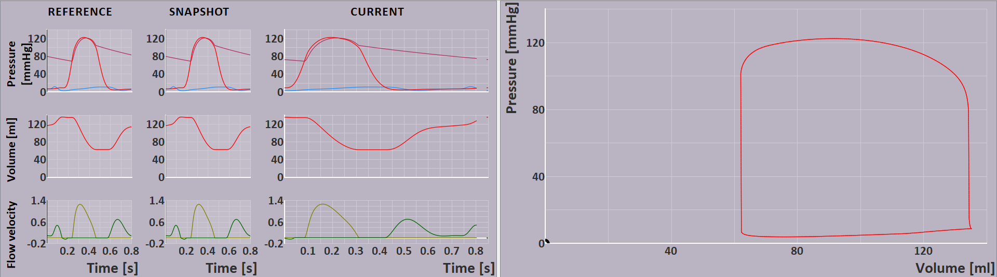

1. Aortic valve opening and closing

Aortic valve opening

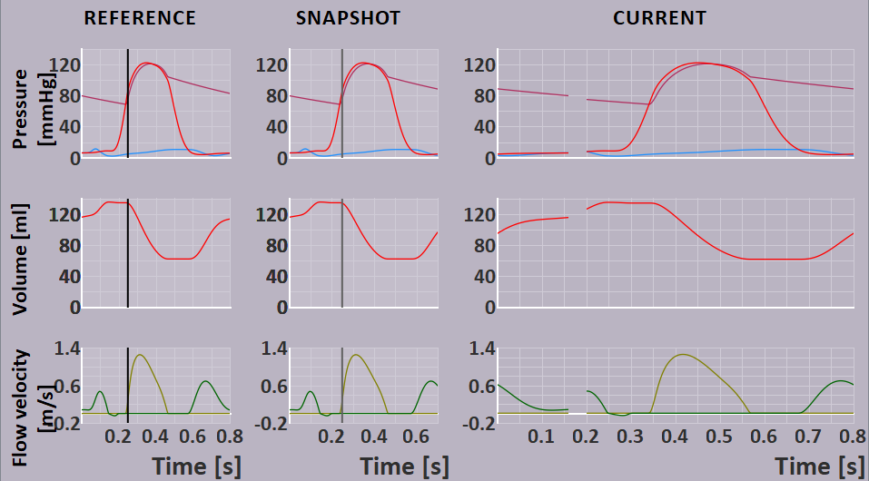

Aortic valve closing

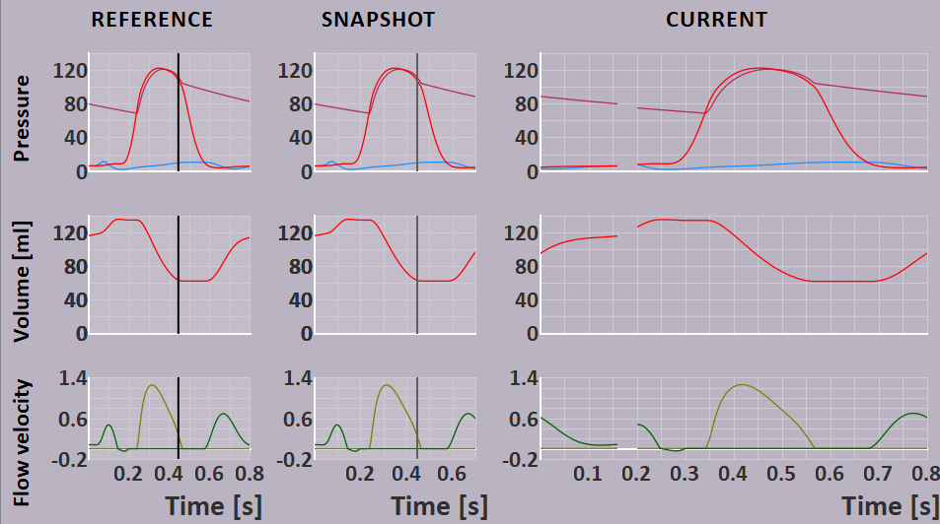

1. Mitral valve opening and closing.

Mitral valve opening

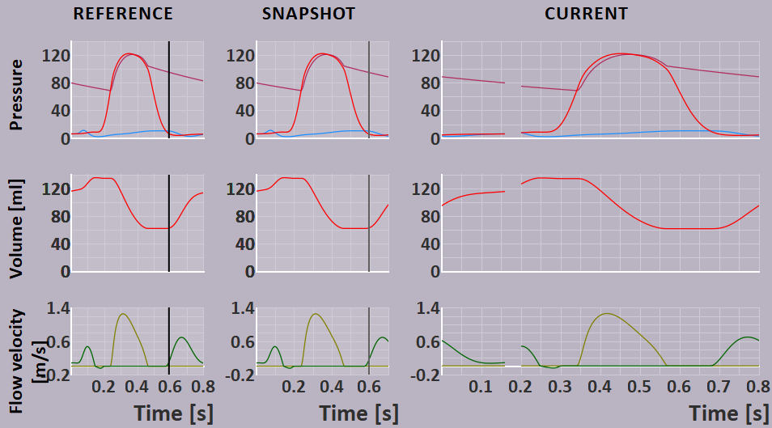

Mitral valve closing

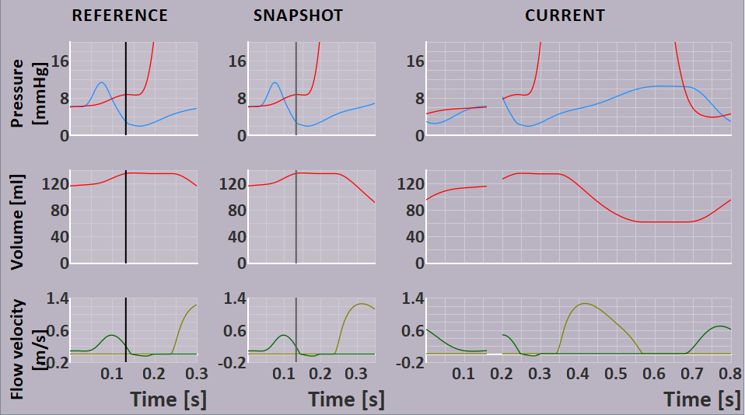

1. points of the pressure-volume relation correspond to the closing and opening of the aortic and mitral valves.
2. aortic opening

1. aortic closing

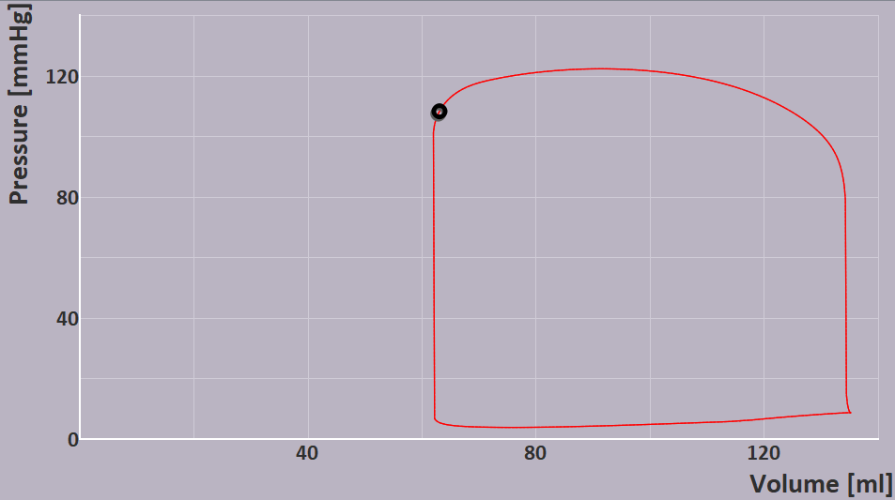

1. mitral opening

1. mitral closing

1. identifying phases

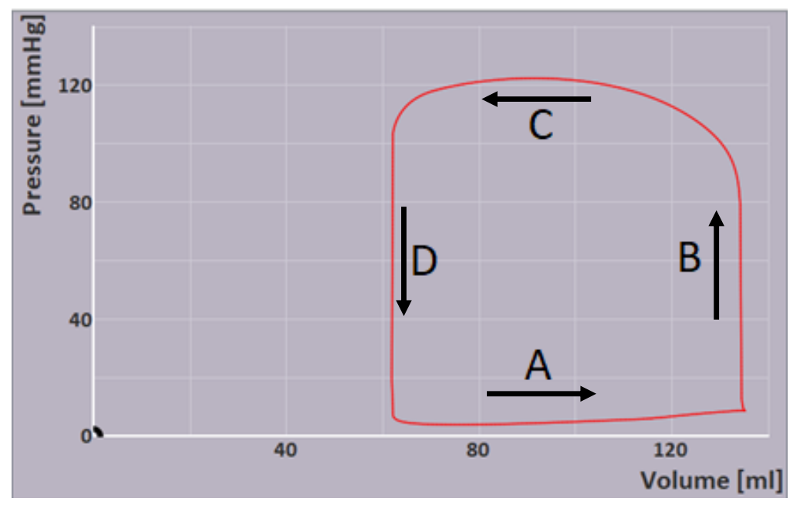

A – filling

B – isovolumic contraction

C – ejection

D – isovolumic relaxation

1. flow velocity pattern in aortic valve and mitral valve

flow velocity pattern in aortic valve – only one hump can be observed. This is because over the ejection phase pressure inside the left ventricle is higher than or closely equal to pressure in aorta. Therefore, blood flow increases as aortic valve opens and comes to a peak and then decreases when pressure difference between aorta and left ventricle is decreasing. Hence only one hump can be observed.

Pressure variation of aorta and left ventricle during ejection phase

Flow velocity pattern in mitral valve - two humps can be observed. Initially, blood flows passively from the atrium to the ventricle due to the pressure gradient, causing the first hump on the flow velocity diagram. However, the flow velocity decreases briefly as the ventricular pressure builds up upon filling the ventricle. Subsequently, the atria contract, actively pushing more blood into the ventricle. This additional blood flow increases the flow velocity again, producing the second hump on the flow velocity diagram.

Pressure variation of left atria and left ventricle during ejection phase

1. fast increase and slow increase of atrial pressure

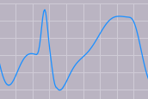

slow increase

fast increase

**Fast increase** – during atrial systole, due to contraction of atrial walls blood pressure inside the atria increases. P wave of ECG waveform corresponds to this increase.

**Slow increase** – during ventricular systole (atrial diastole overlaps with this), due to extra blood pumped into atria slowly increases pressure inside the atria.

1. E- wave and A- wave

A wave

e

E wave

e

1. E wave peak = 0.69

A wave peak = 0.465

E/A ratio = 1.484

1. Estimate the relative amount of left ventricular filling.

amount of left ventricular filling that is due to passive filling = 116mL-62.1 mL = 53.9 mL

amount of left ventricular filling that is due to active filling = 135mL -116 mL = 19 mL

1. To convert Vvalve into Qvalve we need to know the Opening Cross Sectional Area of the valve.

# Aortic Valve Stenosis

1. Explain terms preload and afterload.

**Preload** refers to the initial stretching of the heart's ventricular muscle fibers just before contraction and is determined by the volume of blood present in the ventricles at the end of diastole (the filling phase of the cardiac cycle).

**Afterload** is the resistance that the heart must overcome during ventricular contraction to eject blood into the arteries and is determined by the pressure in the arteries that the heart must push against to pump blood during systole.

1. Simulation of Aortic Stenosis 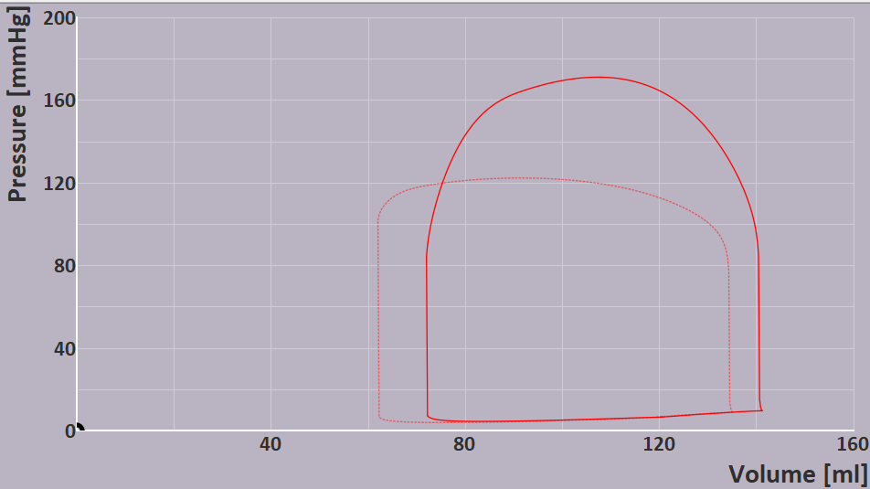

When we gradually increase the percentage of stenosis from 0% to 80%, we can observe that pressure during ejection phase increases. This is due to the reduced area of valve which results in a higher afterload. Hence during systole left ventricle muscles have to contract to increase pressure inside the left ventricle to a higher value than normal to maintain the blood flow close to normal value.

Maximal left ventricular pressure is around 170 mmHg (171 mmHg)

1. what aortic valve stenosis does to the preload of the left ventricle and the afterload of the left ventricle. And what happens to the cardiac output as a result of this change.

**Preload of the Left Ventricle**

In aortic valve stenosis, the narrowing of the aortic valve impedes the forward flow of blood from the left ventricle into the aorta. Therefore, there is an incomplete ejection of blood from the left ventricle, causing blood to back up into the left atrium and further into the pulmonary veins. This leads to an increase in the left ventricular end-diastolic volume (We can clearly observe this in simulated graph.) resulting in an elevated preload.

**Afterload of the Left Ventricle**

Afterload refers to the resistance the left ventricle must overcome during systole to eject blood into the aorta and the rest of the body. In aortic valve stenosis, the narrowing of the aortic valve increases the afterload on the left ventricle. The ventricle must generate higher pressure to push blood through the narrowed valve and into the aorta. This increased afterload places greater stress on the left ventricular muscle during contraction.

**Cardiac Output**

In aortic valve stenosis, the narrowed valve reduces the amount of blood that can be effectively pumped out of the left ventricle during each contraction. The increased afterload and impaired ejection of blood result in a decrease in stroke volume. To compensate for this, the heart may try to increase its rate (heart rate) to maintain an adequate cardiac output. However, as stenosis worsens, the heart's compensatory mechanisms may become inadequate, leading to a decrease in cardiac output.

1. aortic blood pressure at the moment of maximal left ventricular pressure and the pressure drop across the stenotic aortic valve at that same moment.

Maximal left ventricular pressure = 171 mmHg

Aortic blood pressure at the same moment = 105 mmHg

Pressure drop across the stenotic aortic valve = 66 mmHg

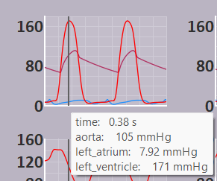

1. maximal blood flow velocity at aortic valve = 4.14 m/s

calculated pressure drop = 4x(4.14)2 = 68.56 mmHg

pressured drop observed in the simulation is 66 mmHg which is very close to the calculated value obtained by approximated equation.

1. Duration of ejection = 0.51-0.25 = 0.26 s
2. Without stenosis = 21.33 squares

With 80% of stenosis = 24.66 squares

Percentage increase = (24.66-21.33)/21.33 x 100% = 15%

1. How will the myocardial tissue of the left ventricle adapt to be able to generate the chronically increased pump work? What is the effect of this adaptation on afterload?

In response to increased pump work caused by 80% aortic stenosis, the left ventricle adapts by thickening its muscle fibers (left ventricular hypertrophy). This helps generate higher pressure (leading to increases afterload) to overcome the narrowed aortic valve and maintain sufficient blood flow.

Also thickening of muscle fibers would reduce the volume of the left ventricle. This would lead to reduced stroke volume and to maintain the blood flow heart rate would have to increase.

However, prolonged stenosis can lead to weakening of cardiac muscles over time leading to a risk of heart failure.