Lab 05

GKH Fonseka

27522

Question 03

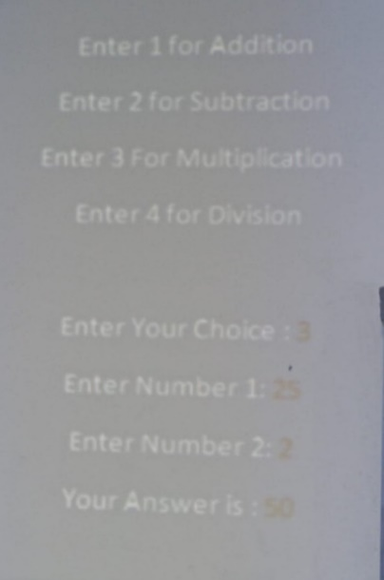

1.Create the above mentioned console application and display it to the user. If user need to do an Addition user need to insert 1 as the choice. For subtraction it should be 2 etc.

Your program should contain a separate class call “CalculateValues” and inside the class you should add *four methods* which perform *four arithmetic operations*. All the methods should take two parameters which are user inserted numbers.

And at the end of the method return the answer out of the method.

In main class if user want to do an addition call only the addition method in separate class.

If user want to do a subtraction call only the subtraction method in separate class. ETC.

And display the final answer as shown in the figure 01.

using System;

using System.Collections.Generic;

using System.Linq;

using System.Text;

using System.Threading.Tasks;

namespace LS05

{

internal class Program

{

static void Main(string[] args)

{

Console.WriteLine("Choose an operation:");

Console.WriteLine("1. Addition");

Console.WriteLine("2. Subtraction");

Console.WriteLine("3. Multiplication");

Console.WriteLine("4. Division");

Console.Write("Enter your choice: ");

int choice = int.Parse(Console.ReadLine());

Console.Write("Enter the first number: ");

double num1 = double.Parse(Console.ReadLine());

Console.Write("Enter the second number: ");

double num2 = double.Parse(Console.ReadLine());

switch (choice)

{

case 1:

Console.WriteLine("Result: " + CalculateValues.Addition(num1, num2));

break;

case 2:

Console.WriteLine("Result: " + CalculateValues.Subtraction(num1, num2));

break;

case 3:

Console.WriteLine("Result: " + CalculateValues.Multiplication(num1, num2));

break;

case 4:

Console.WriteLine("Result: " + CalculateValues.Division(num1, num2));

break;

default:

Console.WriteLine("Invalid choice!");

break;

}

Console.ReadLine();

}

}

public static class CalculateValues

{

public static double Addition(double num1, double num2)

{

return num1 + num2;

}

public static double Subtraction(double num1, double num2)

{

return num1 - num2;

}

public static double Multiplication(double num1, double num2)

{

return num1 * num2;

}

public static double Division(double num1, double num2)

{

if (num2 == 0)

{

throw new DivideByZeroException();

}

return num1 / num2;

}

}

}

Question 04

2.Add a separate class file to Console application program and create a method call *private void sayHello().*

Inside the method display hello world.

In main class create object and try to access the sayHello() method by using the class object.

Can you access the method? Explain why?

public class Greetings

{

private void sayHello()

{

Console.WriteLine("Hello, World!");

}

}

class Program

{

static void Main(string[] args)

{

Greetings greetings = new Greetings();

greetings.sayHello();

}

}

Question 05

Declare a Single dimensional array with 10 elements. Input the values to the array and find the followings,

* Minimum value.
* Maximum value.
* Average value.
* Reverse order of values.

Hint – use a method which in separate class. And call the method from main the method**.**

using System;

using System.Collections.Generic;

using System.Linq;

using System.Text;

using System.Threading.Tasks;

namespace LS05

{

internal class Program

{

static void Main(string[] args)

{

int[] arr = new int[10];

Console.WriteLine("Enter 10 integers to populate the array:");

for (int i = 0; i < arr.Length; i++)

{

arr[i] = int.Parse(Console.ReadLine());

}

ArrayStats stats = new ArrayStats(arr);

Console.WriteLine("Minimum value: {0}", stats.GetMinValue());

Console.WriteLine("Maximum value: {0}", stats.GetMaxValue());

Console.WriteLine("Average value: {0}", stats.GetAverageValue());

Console.WriteLine("Array in reverse order:");

foreach (int num in stats.GetReversedArray())

{

Console.Write("{0} ", num);

}

Console.ReadLine();

}

}

public class ArrayStats

{

private int[] arr;

public ArrayStats(int[] arr)

{

this.arr = arr;

}

public int GetMinValue()

{

int min = arr[0];

for (int i = 1; i < arr.Length; i++)

{

if (arr[i] < min)

{

min = arr[i];

}

}

return min;

}

public int GetMaxValue()

{

int max = arr[0];

for (int i = 1; i < arr.Length; i++)

{

if (arr[i] > max)

{

max = arr[i];

}

}

return max;

}

public double GetAverageValue()

{

double sum = 0;

foreach (int num in arr)

{

sum += num;

}

return sum / arr.Length;

}

public int[] GetReversedArray()

{

int[] reversedArr = new int[arr.Length];

for (int i = 0; i < arr.Length; i++)

{

reversedArr[arr.Length - 1 - i] = arr[i];

}

return reversedArr;

}

}

}