**While Loop in R with Example**

A loop is a statement that keeps running until a condition is satisfied. The syntax for a while loop is the following:

while (condition) {

Exp

}

[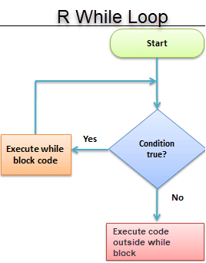](https://www.guru99.com/images/r_programming/032818_1244_WhileLoopin1.png)

**Note**: Remember to write a closing condition at some point otherwise the loop will go on indefinitely.

**Example 1:**

Let's go through a very simple example to understand the concept of while loop. You will create a loop and after each run add 1 to the stored variable. You need to close the loop, therefore we explicitely tells R to stop looping when the variable reached 10.

**Note**: If you want to see current loop value, you need to wrap the variable inside the function print().

#Create a variable with value 1

begin <- 1

#Create the loop

while (begin <= 10){

#See which we are

cat('This is loop number',begin)

#add 1 to the variable begin after each loop

begin <- begin+1

print(begin)

}

**Output:**

## This is loop number 1[1] 2

## This is loop number 2[1] 3

## This is loop number 3[1] 4

## This is loop number 4[1] 5

## This is loop number 5[1] 6

## This is loop number 6[1] 7

## This is loop number 7[1] 8

## This is loop number 8[1] 9

## This is loop number 9[1] 10

## This is loop number 10[1] 11

**Example 2:**

You bought a stock at price of 50 dollars. If the price goes below 45, we want to short it. Otherwise, we keep it in our portfolio. The price can fluctuate between -10 to +10 around 50 after each loop. You can write the code as follow:

set.seed(123)

# Set variable stock and price

stock <- 50

price <- 50

# Loop variable counts the number of loops

loop <- 1

# Set the while statement

while (price > 45){

# Create a random price between 40 and 60

price <- stock + sample(-10:10, 1)

# Count the number of loop

loop = loop +1

# Print the number of loop

print(loop)

}

**Output:**

## [1] 2

## [1] 3

## [1] 4

## [1] 5

## [1] 6

## [1] 7

cat('it took',loop,'loop before we short the price. The lowest price is',price)

**Output:**

## it took 7 loop before we short the price.The lowest price is 40