Lab Task #1 Mobile Application Development

Login Screen

Submitted By:

Sagar Chhabriya

Submitted to:

Mr. Shahzaib Hassan

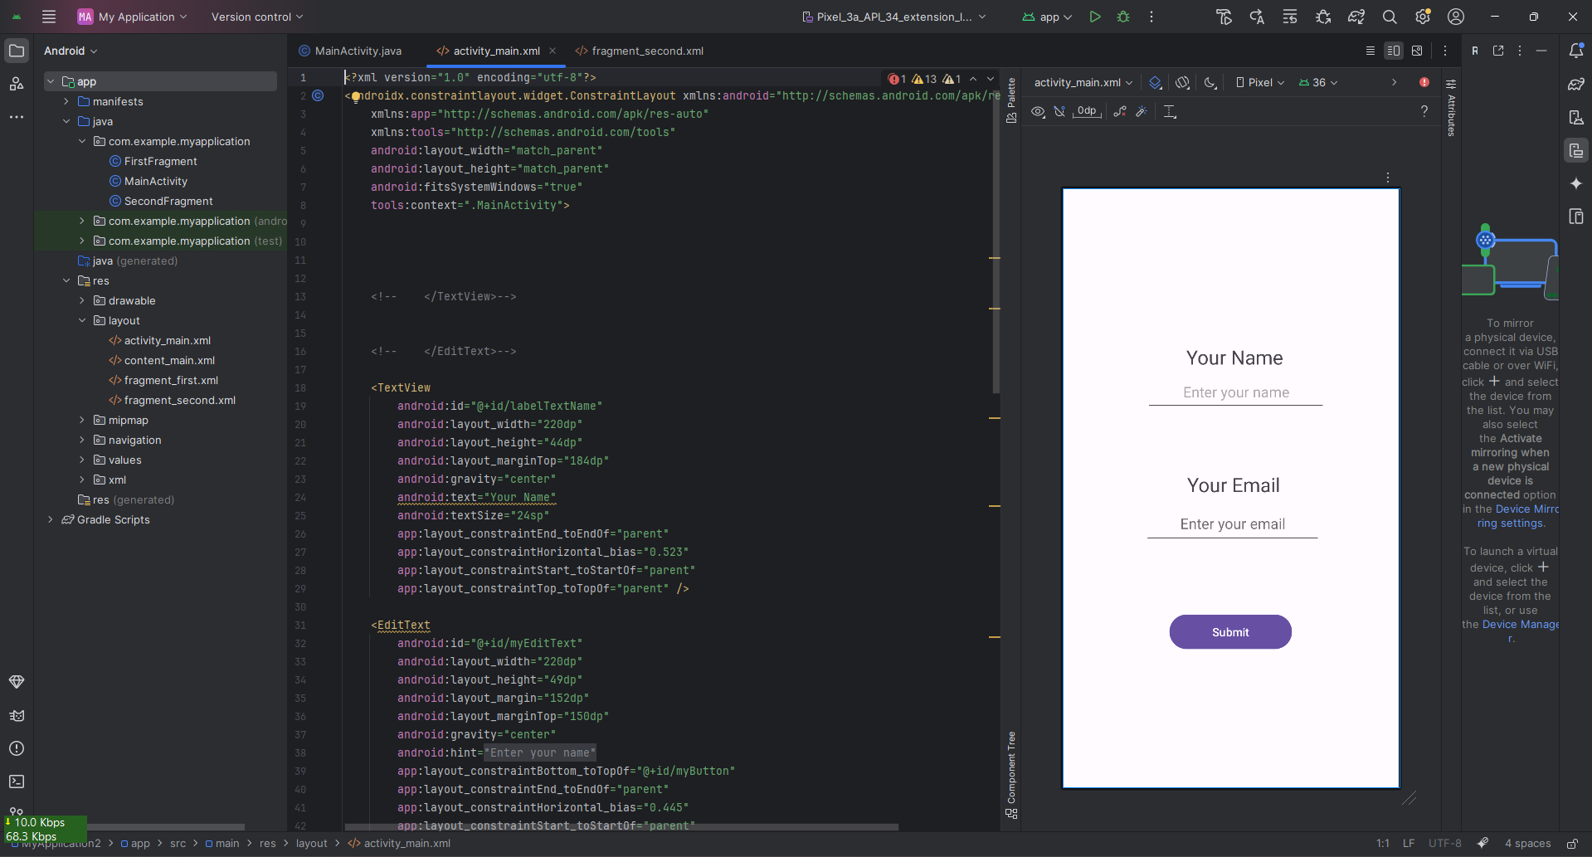

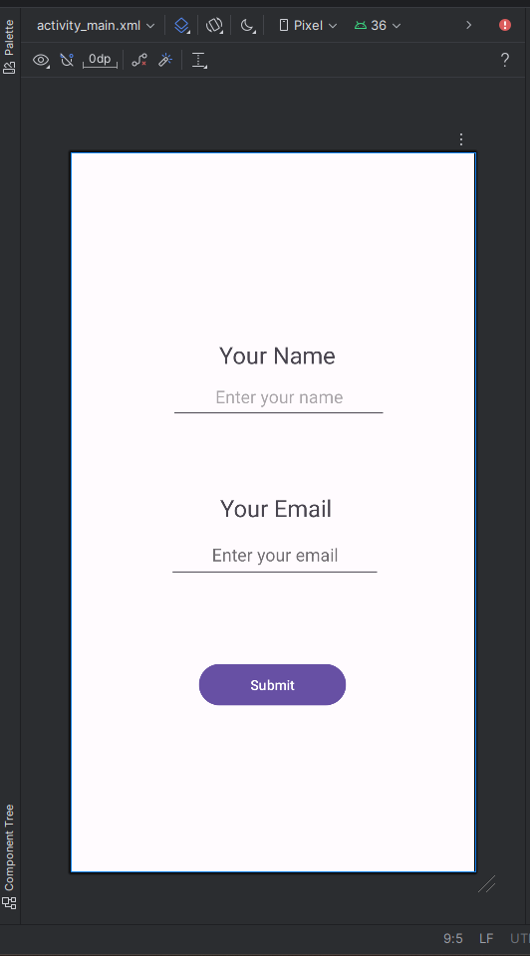

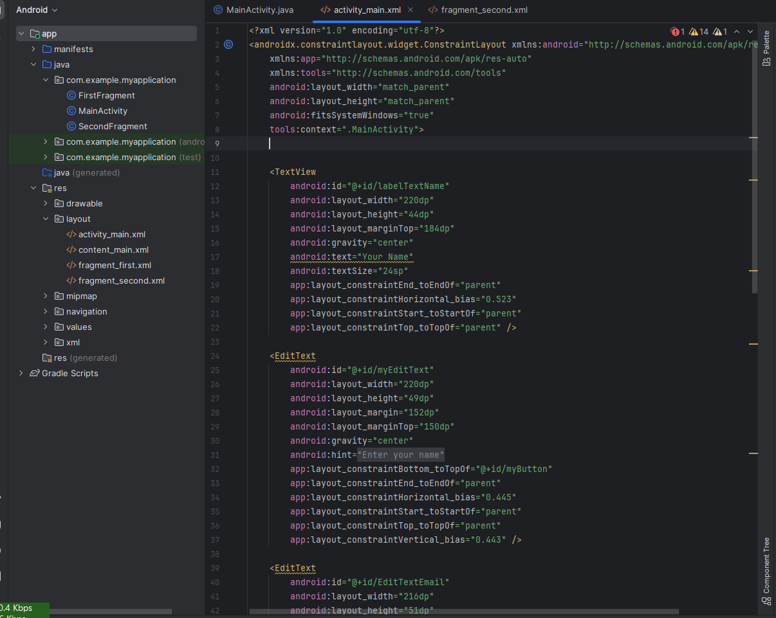Code Screenshots

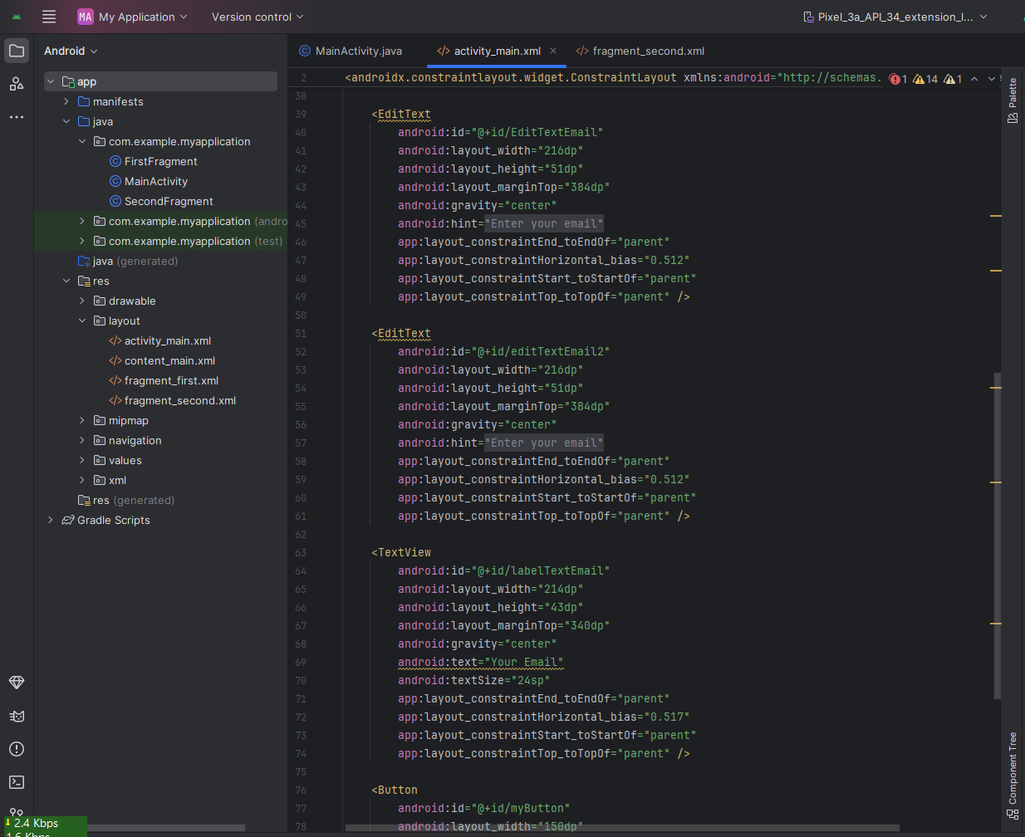

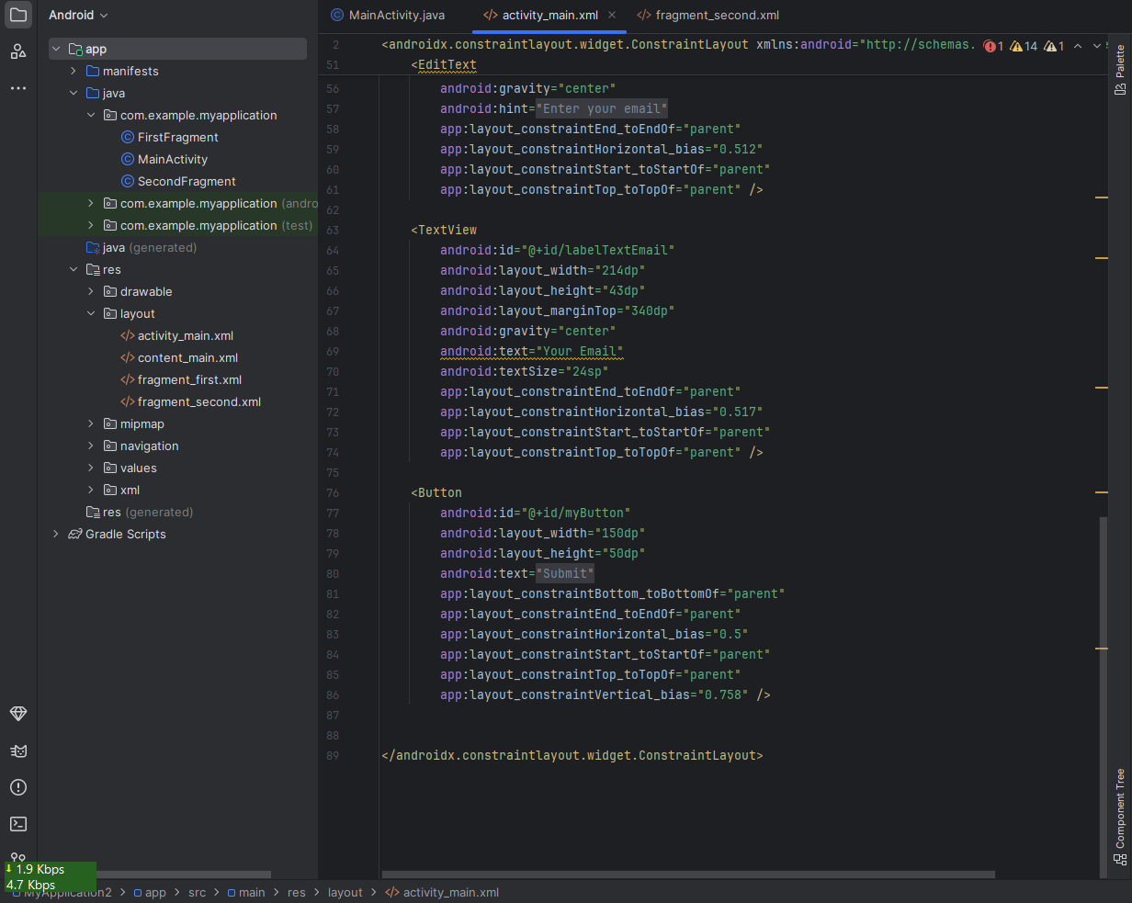

*End of Task*