LEARNING HTML
HTML Introduction
HTML is the standard markup language for creating Web pages.
What is HTML?
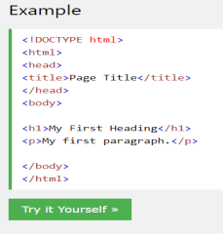
• HTML stands for Hyper Text Markup
Language
• HTML is the standard markup language
for creating Web pages
• HTML describes the structure of a Web
page
• HTML consists of a series of elements
• HTML elements tell the browser how to
display the content
• HTML elements label pieces of content
such as "this is a heading", "this is a
paragraph", "this is a link", etc.
Example Explained
• The <!DOCTYPE html> declaration defines that this document is an HTML5 document • The <html> element is the root element of an HTML page
• The <head> element contains meta information about the HTML page • The <title> element specifies a title for the HTML page (which is shown in the browser's title bar or in the page's tab)
• The <body> element defines the document's body, and is a container for all the visible contents, such as headings, paragraphs, images, hyperlinks, tables, lists, etc. • The <h1> element defines a large heading
• The <p> element defines a paragraph
What is an HTML Element?
An HTML element is defined by a start tag, some content, and an end tag: <tagname>Content goes here...</tagname>
The HTML element is everything from the start tag to the end tag:
<h1>My First Heading</h1>
<p>My first paragraph.</p>
Start tag Element content End tag <h1> My First Heading </h1> <p> My first paragraph. </p> <br> none none

Note: Some HTML elements have no content (like the <br> element). These elements are called empty elements. Empty elements do not have an end tag!
Web Browsers
The purpose of a web browser (Chrome, Edge, Firefox, Safari) is to read HTML documents and display them correctly. A browser does not display the HTML tags, but uses them to determine how to display the document:
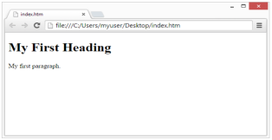
HTML Page Structure
Below is a visualization of an HTML page structure:
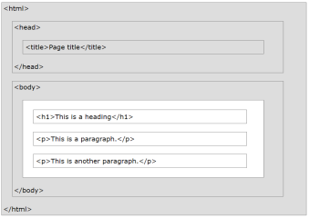
Note: Only the content inside the <body> section (the white area above) will be displayed in a browser.
HTML History
Since the early days of the World Wide Web, there have been many versions of HTML:
Year Version
1989 Tim Berners-Lee invented www
1991 Tim Berners-Lee invented HTML
1993 Dave Raggett drafted HTML+
1995 HTML Working Group defined HTML 2.0
1997 W3C Recommendation: HTML 3.2
1999 W3C Recommendation: HTML 4.01
2000 W3C Recommendation: XHTML 1.0
2008 WHATWG HTML5 First Public Draft
2012 WHATWG HTML5 Living Standard
2014 W3C Recommendation: HTML5
2016 W3C Candidate Recommendation: HTML 5.1
2017 W3C Recommendation: HTML5.1 2nd Edition
2017 W3C Recommendation: HTML5.2

This tutorial follows the latest HTML5 standard.
3 | P a g e C S 1 1 1 – I n t r o d u c t i o n t o C o m p u t i n g
HTML Editors
A simple text editor is all you need to learn HTML.
Learn HTML Using Notepad or TextEdit
Web pages can be created and modified by using professional HTML editors. However, for learning HTML we recommend a simple text editor like Notepad (PC) or TextEdit (Mac). We believe in that using a simple text editor is a good way to learn HTML. Follow the steps below to create your first web page with Notepad or TextEdit.
Step 1: Open Notepad (PC)
• Windows 8 or later:
• Open the Start Screen (the window symbol at the bottom left on your screen). Type Notepad.
• Windows 7 or earlier:
• Open Start > Programs > Accessories > Notepad
Step 1: Open TextEdit (Mac)
• Open Finder > Applications > TextEdit
• Also change some preferences to get the application to save files
correctly. In Preferences > Format > choose "Plain Text"
• Then under "Open and Save", check the box that says "Display HTML files as HTML code instead of formatted text".
• Then open a new document to place the code.
Step 2: Write Some HTML
Write or copy the following HTML code into Notepad:
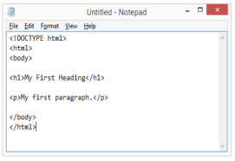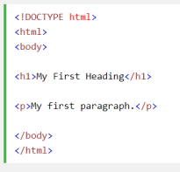
Step 3: Save the HTML Page
Save the file on your computer. Select File > Save as in the Notepad menu. Name the file "index.htm" and set the encoding to UTF-8 (which is the preferred encoding for HTML files).
4 | P a g e C S 1 1 1 – I n t r o d u c t i o n t o C o m p u t i n g
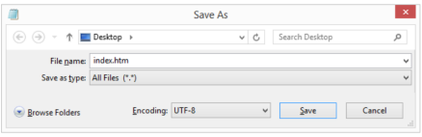Tip: You can use either .htm or .html as file extension. There is no difference, it is up to you.
Step 4: View the HTML Page in Your Browser
Open the saved HTML file in your favorite browser (double click on the file, or right-click - and choose "Open with"). The result will look much like this:
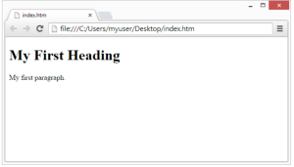
W3Schools Online Editor - "Try it Yourself"
With our free online editor, you can edit the HTML code and view the result in your browser. It is the perfect tool when you want to test code fast. It also has color coding and the ability to save and share code with others:
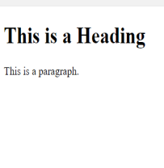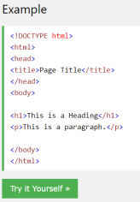
Result
Click on the "Try it Yourself" button to see how it works.
HTML Basic Examples
In this chapter we will show some basic HTML examples. Don't worry if we use tags you have not learned about yet.
HTML Documents
All HTML documents must start with a document type declaration: <!DOCTYPE html>. The HTML document itself begins with <html> and ends with </html>. The visible part of the HTML document is between <body> and </body>.
The <!DOCTYPE> Declaration
The <!DOCTYPE> declaration represents the document type, and helps browsers to display web pages correctly. It must only appear once, at the top of the page (before any HTML tags). The <!DOCTYPE> declaration is not case sensitive. The <!DOCTYPE> declaration for HTML5 is: 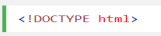
HTML Headings
HTML headings are defined with the <h1> to <h6> tags.
<h1> defines the most important heading. <h6> defines the least important heading: 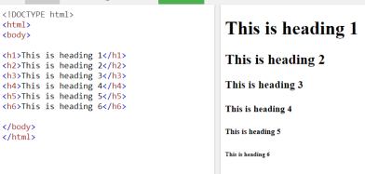
HTML Paragraphs
HTML paragraphs are defined with the <p> tag:
HTML Links
HTML links are defined with the <a> tag:
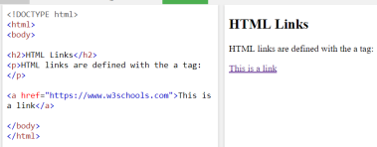The link's destination is specified in the href attribute. Attributes are used to provide additional information about HTML elements.
HTML Images
HTML images are defined with the <img> tag. The source file (src), alternative text (alt), width, and height are provided as attributes:
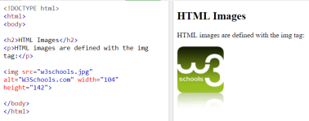How to View HTML Source?
Have you ever seen a Web page and wondered "Hey! How did they do that?" View HTML Source Code:
Right-click in an HTML page and select "View Page Source" (in Chrome) or "View Source" (in Edge), or similar in other browsers. This will open a window containing the HTML source code of the page.
Inspect an HTML Element:
Right-click on an element (or a blank area), and choose "Inspect" or "Inspect Element" to see what elements are made up of (you will see both the HTML and the CSS). You can also edit the HTML or CSS on-the-fly in the Elements or Styles panel that opens.
HTML Elements
An HTML element is defined by a start tag, some content, and an end tag. <tagname>Content goes here...</tagname>
The HTML element is everything from the start tag to the end tag:
<h1>My First Heading</h1>
<p>My first paragraph.</p>
7 | P a g e C S 1 1 1 – I n t r o d u c t i o n t o C o m p u t i n g
Start tag Element content End tag <h1> My First Heading </h1> <p> My first paragraph. </p> <br> none none

Note: Some HTML elements have no content (like the <br> element). These elements are called empty elements. Empty elements do not have an end tag!
Nested HTML Elements
HTML elements can be nested (this means that elements can contain other elements). All HTML documents consist of nested HTML elements.
The following example contains four HTML elements (<html>, <body>, <h1> and <p>):
Example Explained
The <html> element is the root element and it defines the whole HTML document. It has a start tag <html> and an end tag </html>. Then, inside the <html> element there is a <body> element:
The <body> element defines the document's body. It has a start tag <body> and an end tag </body>. Then, inside the <body> element there are two other elements: <h1> and <p>:
The <h1> element defines a heading. It has a start tag <h1> and an end tag </h1>:
The <p> element defines a paragraph. It has a start tag <p> and an end tag </p>:
Never Skip the End Tag
Some HTML elements will display correctly, even if you forget the end tag:
However, never rely on this! Unexpected results and errors may occur if you forget the end tag!
Empty HTML Elements
HTML elements with no content are called empty elements. The <br> tag defines a line break, and is an empty element without a closing tag:
HTML is Not Case Sensitive
HTML tags are not case sensitive: <P> means the same as <p>. The HTML standard does not require lowercase tags, but W3C recommends lowercase in HTML, and demands lowercase for stricter document types like XHTML.
HTML Tag Reference
W3Schools' tag reference contains additional information about these tags and their attributes.
Tag Description
<html> Defines the root of an HTML document
<body> Defines the document's body
<h1> to <h6> Defines HTML headings

HTML Attributes
HTML attributes provide additional information about HTML elements.
• All HTML elements can have attributes
• Attributes provide additional information about elements
• Attributes are always specified in the start tag
• Attributes usually come in name/value pairs like: name="value"
The href Attribute
The <a> tag defines a hyperlink. The href attribute specifies the URL of the page the link goes to:
The src Attribute
The <img> tag is used to embed an image in an HTML page. The src attribute specifies the path to the image to be displayed:
There are two ways to specify the URL in the src attribute:
1. Absolute URL - Links to an external image that is hosted on another website. Example: src="https://www.w3schools.com/images/img_girl.jpg".
Notes: External images might be under copyright. If you do not get permission to use it, you may be in violation of copyright laws. In addition, you cannot control external images; it can suddenly be removed or changed.
2. Relative URL - Links to an image that is hosted within the website. Here, the URL does not include the domain name. If the URL begins without a slash, it will be relative to the current page. Example: src="img_girl.jpg". If the URL begins with a slash, it will be relative to the domain. Example: src="/images/img_girl.jpg".
Tip: It is almost always best to use relative URLs. They will not break if you change domain.
The width and height Attributes
The <img> tag should also contain the width and height attributes, which specifies the width and height of the image (in pixels):
The alt Attribute
The required alt attribute for the <img> tag specifies an alternate text for an image, if the image for some reason cannot be displayed. This can be due to slow connection, or an error in the src attribute, or if the user uses a screen reader.
Example
Example
See what happens if we try to display an image that does not exist:
The style Attribute
The style attribute is used to add styles to an element, such as color, font, size, and more.
The lang Attribute
You should always include the lang attribute inside the <html> tag, to declare the language of the Web page. This is meant to assist search engines and browsers. The following example specifies English as the language:
Country codes can also be added to the language code in the lang attribute. So, the first two characters define the language of the HTML page, and the last two characters define the country. The following example specifies English as the language and United States as the country:
The title Attribute
The title attribute defines some extra information about an element.
The value of the title attribute will be displayed as a tooltip when you mouse over the element:
We Suggest: Always Use Lowercase Attributes
The HTML standard does not require lowercase attribute names. The title attribute (and all other attributes) can be written with uppercase or lowercase like title or TITLE. However, W3C recommends lowercase attributes in HTML, and demands lowercase attributes for stricter document types like XHTML.
We Suggest: Always Quote Attribute Values
The HTML standard does not require quotes around attribute values. However, W3C recommends quotes in HTML, and demands quotes for stricter document types like XHTML.
Good:
Bad:
Sometimes you have to use quotes. This example will not display the title attribute correctly,
because it contains a space:
Single or Double Quotes?
Double quotes around attribute values are the most common in HTML, but single quotes can also be used. In some situations, when the attribute value itself contains double quotes, it is necessary to use single quotes:
Or vice versa:
HTML Headings
HTML headings are titles or subtitles that you want to display on a webpage. HTML headings are defined with the <h1> to <h6> tags. <h1> defines the most important heading. <h6> defines the least important heading.
HTML Tag Reference
Tag Description
<html> Defines the root of an HTML document
<body> Defines the document's body
<h1> to <h6> Defines HTML headings

HTML Paragraphs
A paragraph always starts on a new line and is usually a block of text. The HTML <p> element defines a paragraph. A paragraph always starts on a new line, and browsers automatically add some white space (a margin) before and after a paragraph.
HTML Display
You cannot be sure how HTML will be displayed. Large or small screens, and resized windows will create different results. With HTML, you cannot change the display by adding extra spaces or extra lines in your HTML code. The browser will automatically remove any extra spaces and lines when the page is displayed:
HTML Horizontal Rules
The <hr> tag defines a thematic break in an HTML page, and is most often displayed as a horizontal rule. The <hr> element is used to separate content (or define a change) in an HTML page:
The <hr> tag is an empty tag, which means that it has no end tag.
HTML Line Breaks
The HTML <br> element defines a line break. Use <br> if you want a line break (a new line) without starting a new paragraph:
The <br> tag is an empty tag, which means that it has no end tag.
The Poem Problem
This poem will display on a single line:
Solution - The HTML <pre> Element
The HTML <pre> element defines preformatted text. The text inside a <pre> element is displayed in a fixed-width font (usually Courier), and it preserves both spaces and line breaks:
HTML Tag Reference
Tag Description
<p> Defines a paragraph
<hr> Defines a thematic change in the content
<br> Inserts a single line break
<pre> Defines pre-formatted text

HTML Styles
The HTML style attribute is used to add styles to an element, such as color, font, size, and more.
The HTML Style Attribute
Setting the style of an HTML element, can be done with the style attribute. The HTML style attribute has the following syntax:
Background Color
The CSS background-color property defines the background color for an HTML element. Example
Set the background color for a page to powderblue:
Example
Set background color for two different elements:
Text Color
The CSS color property defines the text color for an HTML element:
Example
Fonts
The CSS font-family property defines the font to be used for an HTML element:
Text Size
The CSS font-size property defines the text size for an HTML element:
Text Alignment
The CSS text-align property defines the horizontal text alignment for an HTML element:

