**MP2**

Group Members: Huiyi Zou, Zelin Han

In MP1, we designed a movie database, but we just assumed it did not have the same movie title.

Therefore, we improve our design. Here is the new version:

We have these entities and relationships:

* Movie: title, year, length, genre
* Star: sname, gender, birthday, nationality
* Director: dname, gender, birthday, nationality
* Studio: mname, location
* Score: title, year, score
* StarIn: title, year, sname
* DirectedBy: title, year, dname
* MadeBy: title, year, mname

-The Movie has attributes title(KEY), year(KEY), length and genre, where the ‘title’ and ‘year’ could not be NULL.

-The Star has attributes sname(KEY), gender, birthday and nationality, where the ‘sname’ could not be NULL.

-The Director has attributes dname(KEY), gender, birthday and nationality, where the ‘dname’ could not be NULL.

-The Studio has attributes mname(KEY) and location, where the ‘mname’ could not be NULL.

-Each movie has exactly one score of movie rating and exactly one director, but could has many stars and be made by many studios. Each star could play a role in many movies. Movies can be directed by same director or made by same studio.

-The gender could only be ‘F’ or ‘M’.

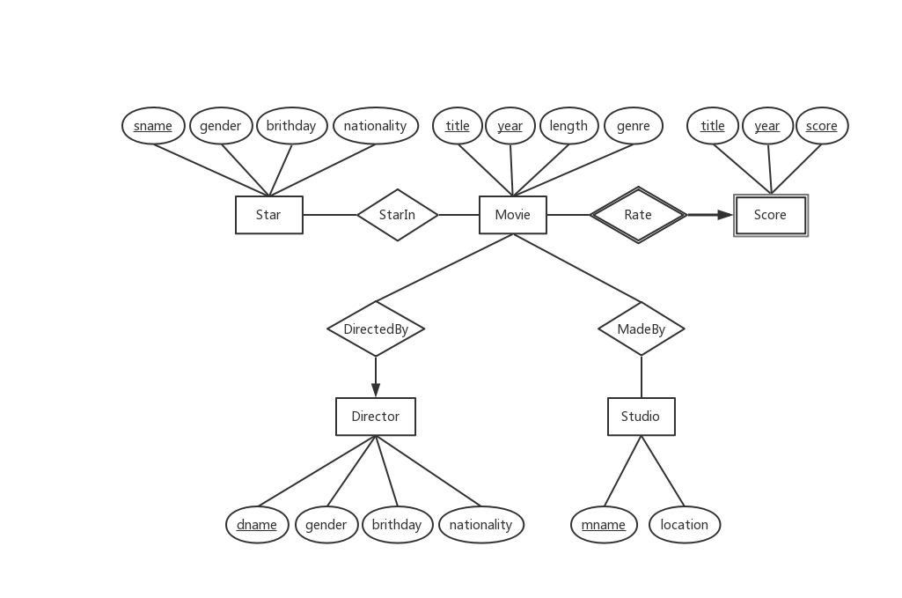**E/R Diagram:**

**From E/R to Relations:**

Movie (title, year, length, genre)

Star (sname, gender, birthday, nationality)

Director (dname, gender, birthday, nationality)

Studio (mname, location)

Score (titleFK-Movie, yearFK-Movie, score)

StarIn (titleFK-Movie, yearFK-Movie, snameFK-Star)

DirectedBy (titleFK-Movie, yearFK-Movie, dnameFK-Director)

MadeBy (titleFK-Movie, yearFK-Movie, mnameFK-Studio)

Our design does not allow anomalies. There are three main anomalies that may happen:

* Insert Anomalies: certain attributes cannot be inserted into the database without the presence of other attributes.
* Delete Anomalies: certain attributes are lost because of the deletion of other attributes.
* Update Anomalies: one or more instances of duplicated data is updated, but not all.

For each table:

* In the relation Movie, it has non-trivial functional dependencies:

title, year → length, genre, where {title, year} is the key (superkey)

title, year, length → genre, where {title, year, length} is a superkey

title, year, genre → length, where {title, year, genre} is a superkey

Since the title and year are the primary key, if we know the value of title and year, we can get the length and genre. Thus, we can say that the length and genre are the functionally depended on title and year. When we insert a movie by using title and year, it does not make sense if we don’t insert its length and genre; since every movie has length and genre. When we delete a movie, some information will be lost by deletion of title and year. But we don’t care about the length and genre, if we delete the movie. When update a movie, it will not influence other movies; since it is impossible that two movie have the same title and year. Therefore, there is no anomalies in this table.

* In the relation Star, it has non-trivial functional dependencies:

sname → gender birthday nationality, where sname is the key (superkey)

sname gender → birthday nationality, where {sname, gender} is a superkey

sname birthday → gender nationality, where {sname, birthday} is a superkey

sname nationality → gender birthday, where {sname, nationality} is a superkey

sname gender birthday → nationality, where {sname, gender, birthday} is a superkey

sname gender nationality → birthday, where {sname, gender, nationality} is a superkey

sname birthday nationality → gender, where {sname, birthday, nationality} is a superkey

In the similar way, gender, birthday and nationality are functionally depended on the star name. For insert anomalies, every star has gender birthday nationality. Thus it doesn’t make sense if we only insert the sname. For delete anomalies, we only care about whether the star exist or not. If we delete the sname, the gender and other information are no longer important. For update anomalies, it’s unlikely that two star have the same name. So every star is independent and it will not affect other stars information. Therefor, this table has no serious anomalies.

* In the relation Director, it has non-trivial functional dependencies:

dname → gender birthday nationality, where dname is the key (superkey)

dname gender → birthday nationality, where {dname, gender} is a superkey

dname birthday → gender nationality, where {dname, birthday} is a superkey

dname nationality → gender birthday, where {dname, nationality} is a superkey

dname gender birthday → nationality, where {dname, gender, birthday} is a superkey

dname gender nationality → birthday, where {dname, gender, nationality} is a superkey

dname birthday nationality → gender, where {dname, birthday, nationality} is a superkey

This table, is the same at the star table. The only difference is they store two kind of people, but it doesn’t influence the anomalies. Thus, this table also has no serious anomalies.

* In the relation Studio, it has non-trivial functional dependencies:

mname → location, where mname is the key (superkey)

This table has only two attributes and mname is primary key. For insert and delete anomalies, any studio has a location and we don’t care about the location when we delete the mname. For update anomalies, it’s almost impossible that two studio have the same name. So when we update a studio, it will not affect others. Hence, this table has no anomalies.

* In the relation Score, it has non-trivial functional dependencies:

In this table, every attributes are primary key. For insert and delete anomalies, every movie has a score and when we delete a movie the score is no more important; on the other hand, when we delete the score, there is no need for movie; since this table is about score. For update anomalies, it’s almost impossible that two movie have the same title and year. So when we update a movie, it will not influence others. Thus, this table has no anomalies.

Therefore, the relations Movie, Star, Director, Studio and Score are in BCNF, which means no bad FDs.

In addition, for relations StarIn, DiectedBy, MadeBy, each of them has no functional dependency, since all of their attributes form the primary key for each relation.

**SQL Schema:**

CREATE TABLE Movie (

title CHAR(100) NOT NULL,

year INT NOT NULL,

length INT,

genre CHAR(30),

PRIMARY KEY (title,year)

);

CREATE TABLE Score (

title CHAR(100) NOT NULL,

year INT NOT NULL,

score FLOAT NOT NULL,

PRIMARY KEY (title, year, score),

FOREIGN KEY ('title','year') REFERENCES Movie('title','year') ON DELETE CASCADE ON UPDATE CASCADE

);

CREATE TABLE Star (

sname CHAR(30) NOT NULL PRIMARY KEY,

gender CHAR(1) CHECK (gender IN ('F', 'M')),

birthday DATE,

nationality CHAR(20)

);

CREATE TABLE StarIn (

title CHAR(100) NOT NULL,

year INT NOT NULL,

sname CHAR(30) NOT NULL,

PRIMARY KEY (title, year, sname),

FOREIGN KEY ('title','year') REFERENCES Movie('title','year') ON DELETE CASCADE ON UPDATE CASCADE,

FOREIGN KEY (sname) REFERENCES Star(sname) ON DELETE CASCADE ON UPDATE CASCADE

);

CREATE TABLE Director (

dname CHAR(30) NOT NULL PRIMARY KEY,

gender CHAR(1) CHECK (gender IN ('F', 'M')),

birthday DATE,

nationality CHAR(20)

);

CREATE TABLE DirectedBy (

title CHAR(100) NOT NULL,

year INT NOT NULL,

dname CHAR(30) NOT NULL,

PRIMARY KEY (title, year, dname),

FOREIGN KEY ('title','year') REFERENCES Movie('title','year') ON DELETE CASCADE ON UPDATE CASCADE,

FOREIGN KEY (dname) REFERENCES Director(dname) ON DELETE CASCADE ON UPDATE CASCADE

);

CREATE TABLE Studio (

mname CHAR(30) NOT NULL PRIMARY KEY,

location CHAR(200)

);

CREATE TABLE MadeBy (

title CHAR(100) NOT NULL,

year INT NOT NULL,

mname CHAR(30) NOT NULL,

PRIMARY KEY (title, year, mname),

FOREIGN KEY ('title','year') REFERENCES Movie('title','year') ON DELETE CASCADE ON UPDATE CASCADE,

FOREIGN KEY (mname) REFERENCES Studio(mname) ON DELETE CASCADE ON UPDATE CASCADE

);

**Populate Table:**

INSERT INTO Movie

VALUES ('The Prestige', 2006, 130, 'thriller'),

('The Conjuring', 2013, 112, 'horror'),

('Insidious', 2010, 102, 'horror'),

('The Shining', 1980, 144, 'horror'),

('Les Misérables', 2012, 158,'musical drama'),

('Interstellar', 2014, 169, 'sci-fi'),

('The Notebook', 2004, 124, 'drama'),

('Doctor Strange', 2016, 115,'sci-fi'),

('Ready Player One', 2018, 140,'sci-fi'),

('Silent Hill', 2006, 125, 'horror'),

('Les Misérables', 1998, 134, 'drama');

INSERT INTO Star

VALUES ('Hugh Jackman', 'M', '1968-10-12', 'Australian'),

('Christian Bale', 'M', '1974-01-30', 'American'),

('Vera Farmiga', 'F', '1973-08-06', 'American'),

('Shelley Duvall', 'F', '1949-07-07', 'American'),

('Anne Hathaway', 'F', '1982-11-12', 'American'),

('Jessica Chastain', 'F', '1977-03-24', 'American'),

('Radha Mitchell', 'F', '1973-11-12', 'Australian'),

('Rachel McAdams', 'F', '1978-11-17', 'Canadian'),

('Patrick Wilson', 'M', '1973-07-03', 'American'),

('Jack Nicholson', 'M', '1937-04-22', 'American'),

('Matthew McConaughey', 'M', '1969-11-04', 'American'),

('Tye Sheridan', 'M', '1996-11-11', 'American'),

('Russell Crowe', 'M', '1964-04-07', 'Australian'),

('Ryan Gosling', 'M', '1980-11-12', 'Canadian'),

('Benedict Cumberbatch', 'M', '1976-07-19', 'English'),

('Liam Neeson', 'M', '1952-06-07', 'American'),

('Geoffrey Rush', 'M', '1951-07-06', 'Australian');

INSERT INTO Director

VALUES ('Christopher Nolan', 'M', '1970-07-30', 'English'),

('Stanley Kubrick', 'M', '1928-07-26', 'American'),

('Nick Cassavetes', 'M', '1959-05-21', 'American'),

('Scott Derrickson', 'M', '1966-07-16', 'American'),

('Steven Spielberg', 'M', '1946-12-18', 'American'),

('David Lynch', 'M', '1946-01-20', 'American'),

('Martin Scorsese', 'M', '1942-11-17', 'American'),

('Tom Hopper', 'M', '1977-02-26', 'Australian'),

('James Wan', 'M', '1972-10-05', 'Australian'),

('Christophe Gans', 'M', '1960-03-11', 'French'),

('Bille August', 'M', '1948-11-09', 'Dane');

INSERT INTO Studio

VALUES ('Working Title Films', 'England'),

('Syncopy', 'England'),

('Hawk Films', 'England'),

('Warner Bros.', 'U.S.'),

('Blumhouse Productions', 'U.S.'),

('Legendary Pictures', 'U.S.'),

('Gran Via', 'U.S.'),

('Marvel Studios', 'U.S.'),

('Amblin Partners', 'U.S.'),

('Konami', 'Japan'),

('Mandalay Entertainment', 'U.S.');

INSERT INTO Score

VALUES ('The Prestige', 2006, 8.5),

('The Conjuring', 2013, 7.5),

('Insidious', 2010, 6.9),

('The Shining', 1980, 8.4),

('Les Misérables', 2012, 7.6),

('Interstellar', 2014, 8.6),

('The Notebook', 2004, 7.9),

('Doctor Strange', 2016, 7.5),

('Ready Player One', 2018, 7.5),

('Silent Hill', 2006, 6.6),

('Les Misérables', 1998, 7.4);

INSERT INTO DirectedBy

VALUES ('The Prestige', 2006, 'Christopher Nolan'),

('The Conjuring', 2013, 'James Wan'),

('Insidious', 2010, 'James Wan'),

('The Shining', 1980, 'Stanley Kubrick'),

('Les Misérables', 2012, 'Tom Hopper'),

('Interstellar', 2014, 'Christopher Nolan'),

('The Notebook', 2004,'Nick Cassavetes'),

('Doctor Strange', 2016, 'Scott Derrickson'),

('Ready Player One', 2018, 'Steven Spielberg'),

('Silent Hill', 2006, 'Christophe Gans'),

('Les Misérables', 1998, 'Bille August');

INSERT INTO MadeBy

VALUES ('The Prestige', 2006, 'Warner Bros.'),

('The Prestige', 2006, 'Syncopy'),

('The Conjuring', 2013,'Warner Bros.'),

('Insidious', 2010, 'Blumhouse Productions'),

('The Shining',1980, 'Hawk Films'),

('Les Misérables', 2012, 'Working Title Films'),

('Interstellar', 2014, 'Syncopy'),

('Interstellar', 2014, 'Legendary Pictures'),

('The Notebook', 2004, 'Gran Via'),

('Doctor Strange', 2016, 'Marvel Studios'),

('Ready Player One', 2018, 'Warner Bros.'),

('Ready Player One', 2018, 'Amblin Partners'),

('Silent Hill', 2006, 'Konami'),

('Les Misérables', 1998, 'Mandalay Entertainment');

INSERT INTO StarIn

VALUES ('The Prestige', 2006, 'Hugh Jackman'),

('The Prestige', 2006, 'Christian Bale'),

('The Conjuring', 2013, 'Vera Farmiga'),

('The Conjuring', 2013, 'Patrick Wilson'),

('Insidious', 2010, 'Patrick Wilson'),

('The Shining',1980, 'Jack Nicholson'),

('The Shining',1980, 'Shelley Duvall'),

('Les Misérables', 2012, 'Hugh Jackman'),

('Les Misérables', 2012, 'Russell Crowe'),

('Les Misérables', 2012, 'Anne Hathaway'),

('Interstellar', 2014, 'Matthew McConaughey'),

('Interstellar', 2014, 'Jessica Chastain'),

('Interstellar', 2014, 'Anne Hathaway'),

('The Notebook', 2004, 'Ryan Gosling'),

('The Notebook', 2004, 'Rachel McAdams'),

('Doctor Strange', 2016, 'Benedict Cumberbatch'),

('Doctor Strange', 2016, 'Rachel McAdams'),

('Ready Player One',2018, 'Tye Sheridan'),

('Silent Hill', 2006, 'Radha Mitchell'),

('Les Misérables', 1998, 'Liam Neeson'),

('Les Misérables', 1998, 'Geoffrey Rush');

**Result:**

Movie

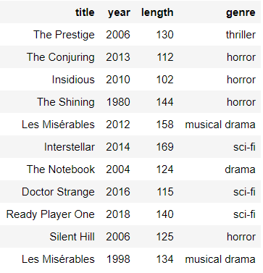

Star

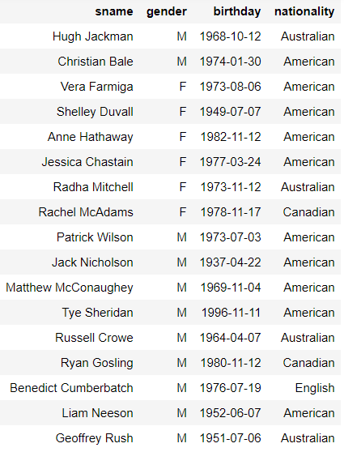

Director

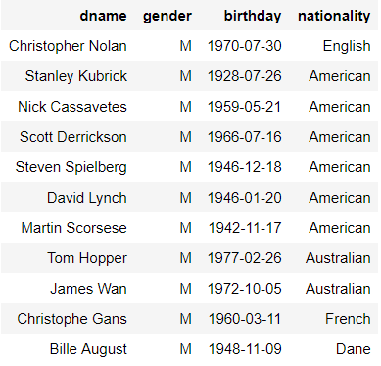

Studio

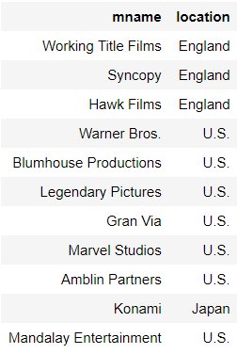

StarIn

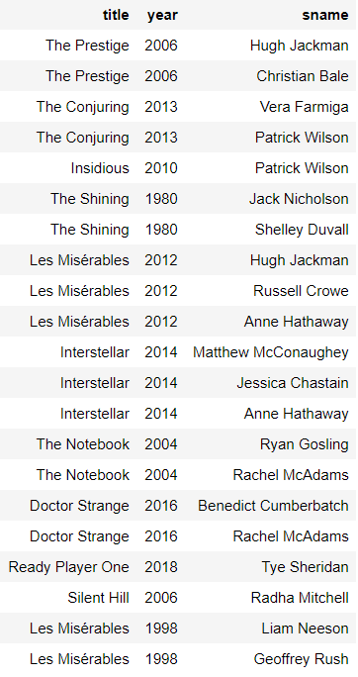

DirectedBy

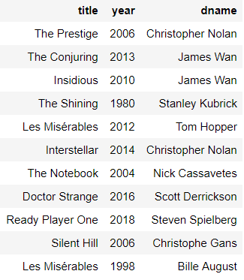

MadeBy

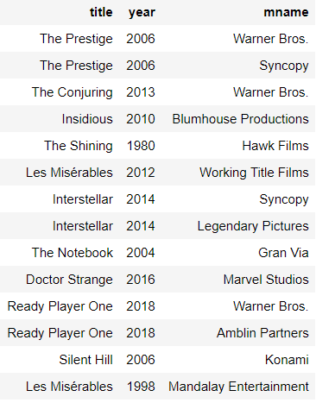

Score

