CHAPTER 1
INTRODUCTION

1.1 INTRODUCTION
Healthy lifestyle is an important topic for everyone because it contains many fundamental parts of human life. A healthy lifestyle leaves you fit, energetic and at reduced risk for disease, based on the choices you make about your daily habits.
Living healthy is about maintaining a healthy lifestyle and introducing habits that will improve your health.
Healthy is essential for everyone. Among many healthy are physical health and mental health. As the saying goes, if you are healthy, you must live and eat healthy eating well, being physically active, and taking care of your mind as much as possible is the best way to support your health.
1.2 OBJECTIVES
The aim of the project is to raise awareness about the importance of having a healthy lifestyle and along with that the ways of how we can live in a healthy way.
- List the guidelines for a healthy lifestyle.
- Describe the health benefits of physical activity.
- Identify healthy and unhealthy foods.
- Understanding the importance of a healthy lifestyle among the participants.
1.3 BENEFITS
If you are in good health, you will be happy and active, and you will do everything as you please. You can create as much as you can.
- Good health will make you happy
- Prevents disease
- Saves money
- Lengthens lifespan
- Increased happiness
CHAPTER 2
REQUIREMENTS

2.1 NON-FUNCTIONAL REQUIREMENTS
  - BROWSER TESTING AND SUPPORT FOR GOOGLE CHROME
  - MICROSOFT EDGE
  - FIREFOX
2.2 HARDWARD REQUIREMETNS
- PC OF LAPTOP (ACER, DELL, HP)
- PRINTER
- USE
- WIRELESS ROUTERS
2.3 FRONT END
- HTML
- CSS
CHAPTER 3
IMPLEMENTATION

3.1 Home Page
There are five sections on our home page:
- Home
- About
- Contact
- Review
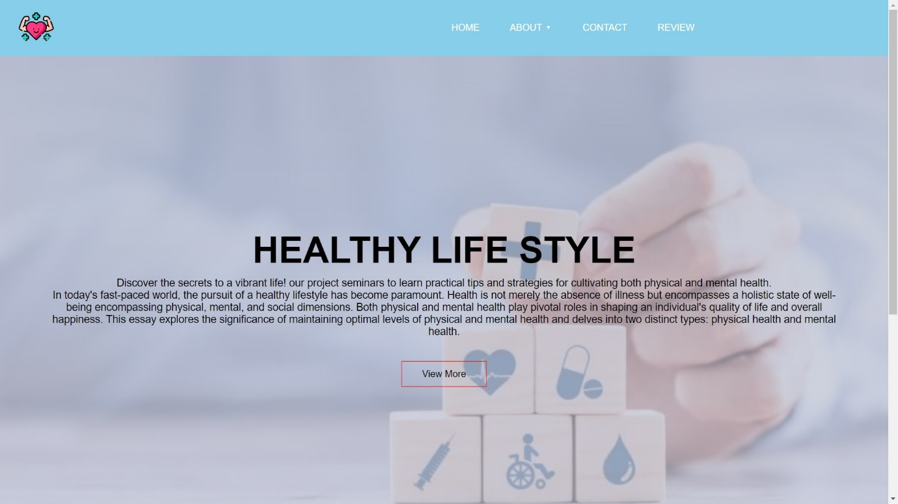
When you click the ‘View More’ button, it will take you to the Home page.

Fig:3.1 Home Page

3.2 About Page

If you click “ABOUT” that will shows you two menu “Physical Healthy” and “Mental Health”. And then you can click what you want to know and click.

Fig:3.2 About Page
3.2.1 Physical Health
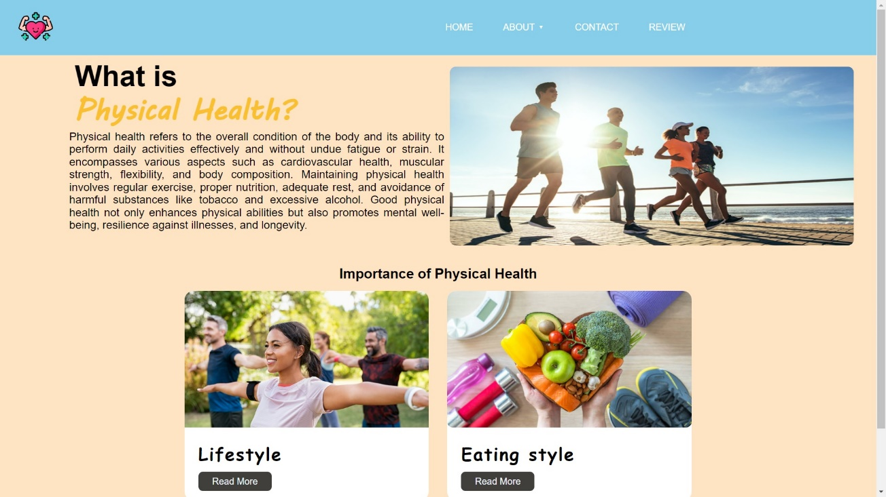
This page explained about physical health and there are two facts for physical health.

Fig: 3.3 About Page for Physical Health
3.2.1.1 Life Style
This page will help and support your body. And you can read about healthy habit as shown in figure.
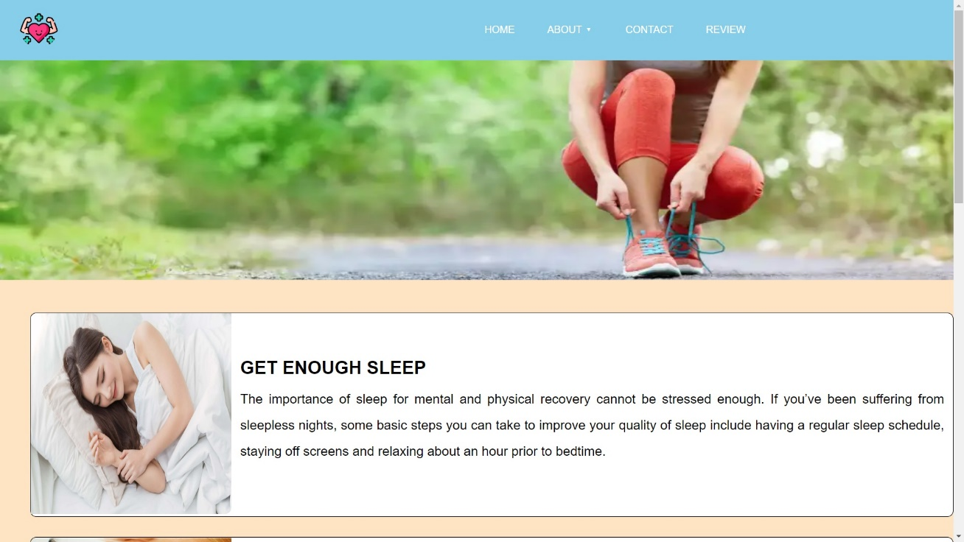
Fig:3.4 Life Style for Physical Health

3.2.1.2 Eating Style
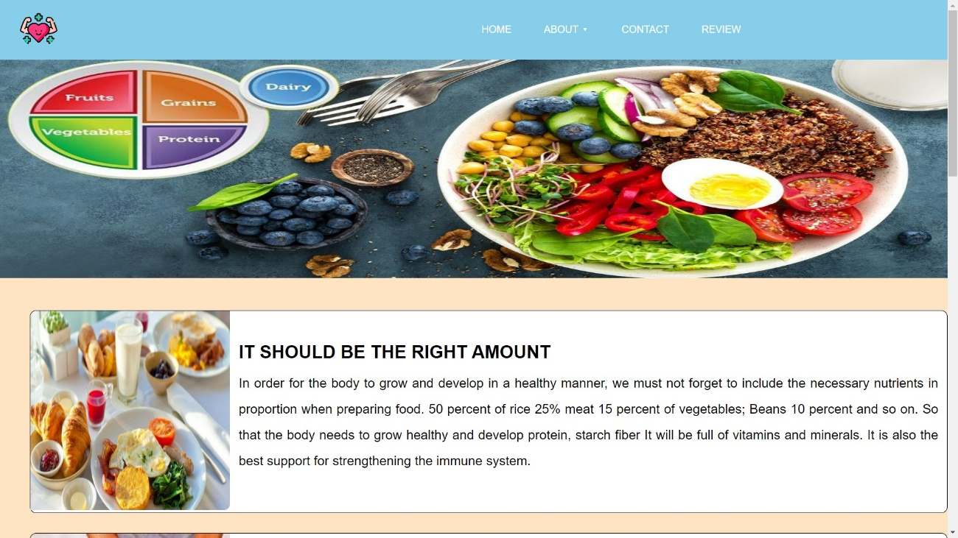
We will show in that page what you should eat to be healthy, as shown in figure,
Fig:3.5 Eating Style for Physical Health
3.2.2 Mental Health
This page will help you from stress and trauma, so you can read about psychological and social facts.
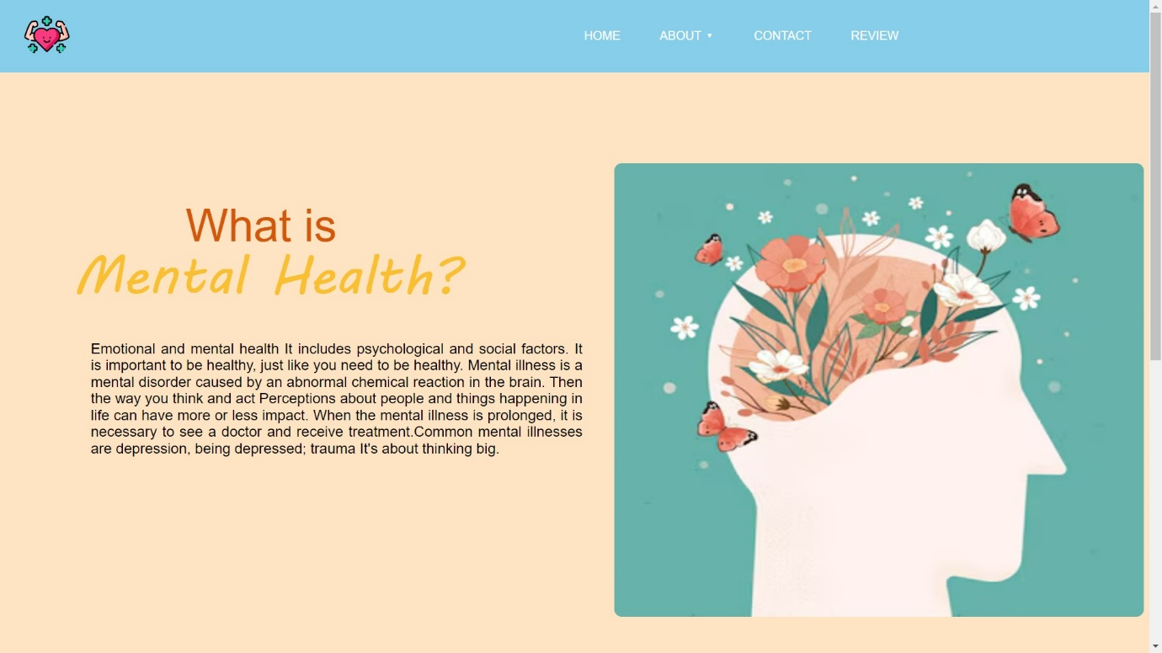
Fig:3.6 About page for Mental Health

3.2.2.1 Characteristics of Mental Health
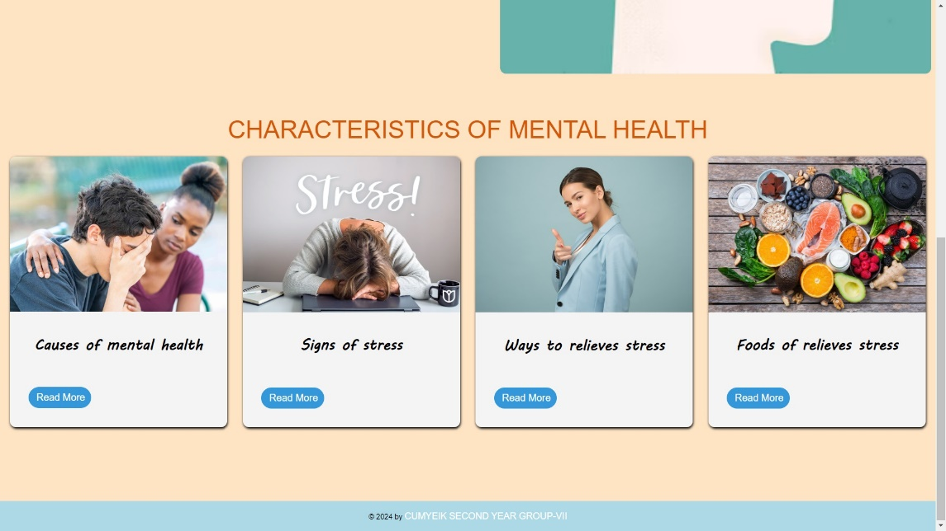
You can select and read about mental health types that below four boxes.

Fig:3.7 Characteristics for Mental Health
3.3 Contact Page
We have described the exact address and phone number where you can be contacted.
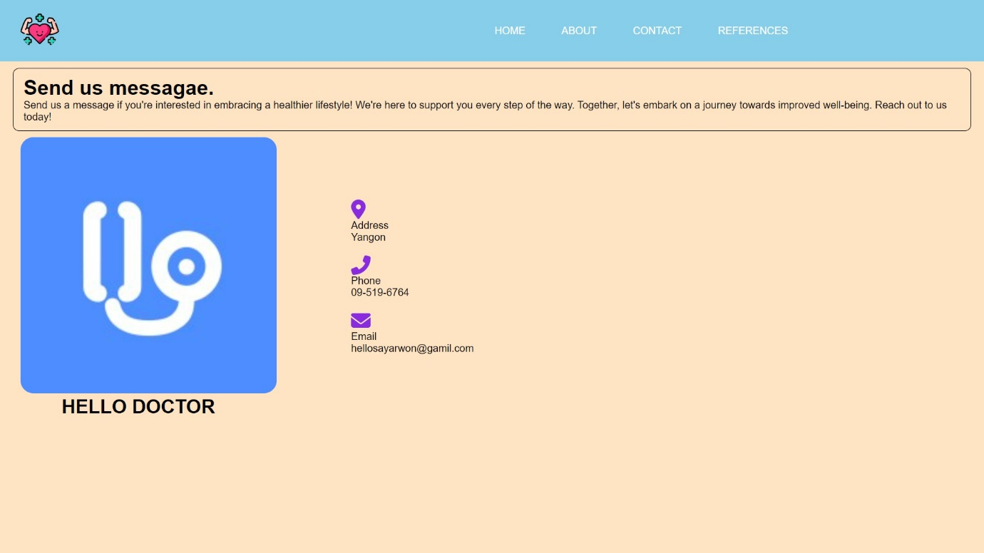
Fig:3.8 Contact Page
3.4 Review Page
In this you can see that customer who visited to our website.
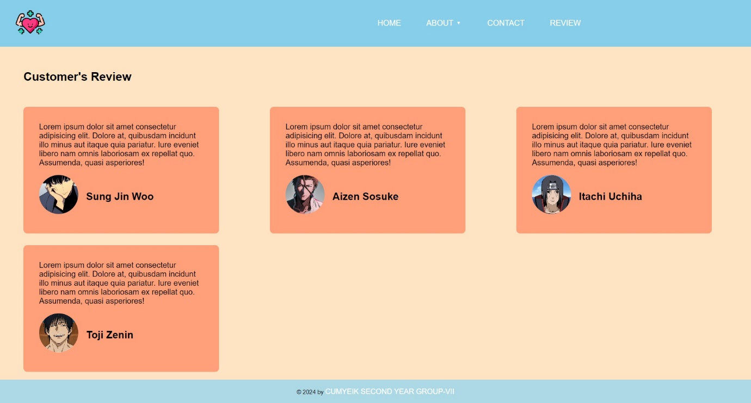
Fig:3.9 Review Page

CHAPTER 4
CONCLUSION

In conclusion, achieving and maintaining good health is a lifelong journey that requires conscious choices and daily commitment. By focusing on a balanced diet, regular exercise, sufficient sleep, stress management, and avoiding harmful habits, you can significantly improve your well-being. Additionally, staying proactive with preventive healthcare and nurturing your mental health and social connections are equally essential. Remember that good health is a precious gift, and it's up to you to protect and nurture it throughout your life. Your choices today will shape your health for years to come, so make them count.
CHAPTER 5
REFERENCES

- Web-Development-and-Design-Foundations-With-Html5-6th-Edition-Felke-Morris-Solutions-Manual
- http://www.w3c.org
- http://www.webprofessionals.org
- https://www.geeksforgeeks.org
- https://www.w3schools.com
- https://hellosayarwon.com

