DEPARTMENT OF ADVANCED SCIENCE AND TECHNOLOGY
UNIVERSITY OF COMPUTER STUDIES, MYEIK
2023-2024 ACADEMIC YEAR
CST-2155: Skills & Knowledge I: Web platform-based Development (HTML+CSS)
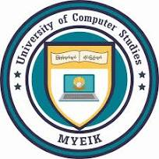
HEALTHY LIFE STYLE

Submitted By
KPTMYK-001298 Mg Min Han Set Naing
KPTMYK-001273 Mg Bhone Pyae Thu
KPTMYK-001285 Ma May Thiri Paing
KPTMYK-001337 Ma Nadi Htwe
KPTMYK-001275 Ma Moe Myint Myat Tun
KPTMYK-001288 Ma Pan Cherry Myo

Group (VII)
Second Year (B.C.Sc/B.C.Tech)
March, 2024

