Department of Information Science
2025-2026 Academic Year
Fourth Year, Second Semester
Object Oriented Design and Development
(CS-4223)
Assignment I
Answers

Date:

Answer the Question. (ကျောင်းသားတစ်ဦးလျှင် မေးခွန်း ၁ပုဒ်စီ)
အဖြေသည် မေးထားသည့်Title နှင့် Concept မိလျှင် အမှတ်ပေးပါသည်။
- What is the critical ability of an Object Oriented System? (5 Marks)
A critical ability of Object Oriented development is to skillfully assign responsibilities to software objects. It is one activity that must be performed either while drawing a UML diagram or programming and it strongly influences the robustness, maintainability, and reusability of software components.
- Define a Domain Model. (5 Marks)
Object-oriented analysis is concerned with creating a description of the domain from the perspective of objects. There is an identification of the concepts, attributes, and associations that are
considered noteworthy.
The result can be expressed in a domain model that shows the noteworthy domain concepts or objects. For example, a partial domain model is shown in Figure 1.2.
It can be noted that a domain model is not a description of software objects; it is a visualization
of the concepts or mental models of a real-world domain and it is also called a conceptual object
model.
- What is the UML? (5 Marks)
The Unified Modeling Language (UML) is a visual language for specifying, constructing and
documenting the artifacts of systems. The word visual in the definition is a key point - the UML is the de facto standard diagramming notation for drawing or presenting pictures (with some text) related to software primarily OO software.
- What are the three ways to apply UML? (5 Marks)
UML as sketch Informal and incomplete diagrams (often hand sketched on whiteboards) created to explore difficult parts of the problem or solution space, exploiting the power of visual languages. UML as blueprint Relatively detailed design diagrams used either for reverse engineering to visualize and better understanding existing code in UML diagrams, or for code generation (forward engineering). If reverse engineering, a UML tool reads the source or binaries and generates (typically) UML package, class, and sequence diagrams. These "blueprints" can help the reader understand the bigpicture elements, structure, and collaborations. Before programming, some detailed diagrams can provide guidance for code generation (e.g., in Java), either manually or automatically with a tool. It's common that the diagrams are used for some code, and other code is filled in by a developer while coding (perhaps also applying UML sketching).
- UML as programming language - Complete executable specification of a software system in UML.
(5 Marks)
Executable code will be automatically generated, but is not normally seen or modified by developers; one works only in the UML "programming language." This use of UML requires a practical way to diagram all behavior or logic (probably using interaction or state diagrams), and is still under development in terms of theory, tool robustness and usability. Agile modeling emphasizes UML as sketch; this is a common way to apply the UML, often with a high return on the investment of time (which is typically short).
- What are the three perspectives to apply UML? (5 Marks)
Three Perspectives to Apply UML Conceptual perspective the diagrams are interpreted as describing things in a situation of the real world or domain of interest. Specification (software) perspective the diagrams (using the same notation as in the conceptual perspective) describe software abstractions or components with specifications and interfaces, but no commitment to a particular implementation (for example, not specifically a class in C# or Java). Implementation (software) perspective the diagrams describe software implementations in a particular technology (such as Java).
- Define a) Conceptual Class,b) Software Class,c) Implementation Class. (5 Marks)
Conceptual class - real-world concept or thing. A conceptual or essential perspective. The UP Domain Model contains conceptual classes.
Software class - a class representing a specification or implementation perspective of a software component, regardless of the process or method.
Implementation class - a class implemented in a specific OO language such as Java.
- What is the Unified Process (UP)? (5 Marks)
A software development process describes an approach to building, deploying, and possibly
maintaining software. The Unified Process has emerged as a popular iterative software development process for building object-oriented systems. In particular, the Rational Unified Process or RUP, a detailed refinement of the Unified Process, has been widely adopted.
The UP is very flexible and open, and encourages including skillful practices from other iterative
methods, such as from Extreme Programming (XP), Scrum, and so forth. For example, XP's test-
driven development, refactoring and continuous integration practices can fit within a UP project. So can Scrum's common project room ("war room") and daily Scrum meeting practice.
The UP combines commonly accepted best practices, such as an iterative lifecycle and risk-driven
development, into a cohesive and well-documented process description.
- What is the importance of the Unified Process (UP)? (5 Marks)
      - The UP is an iterative process. Iterative development influences how to introduce OOA/D , and to understand how it is best practiced.
      - UP practices provide an example structure for how to do and thus how to explain OOA/D.
      - The UP is flexible, and can be applied in a lightweight and agile approach that includes practices from other agile methods (such as XP or Scrum).
- What are the benefits of iterative development? (5 Marks)
Benefits include:
less project failure, better productivity, and lower defect rates; shown by research into iterative and evolutionary methods early rather than late mitigation of high risks (technical, requirements, objectives, usability, and so forth) early visible progress early feedback, user engagement, and adaptation, leading to a refined system that more closely meets the real needs of the stakeholders managed complexity; the team is not overwhelmed by "analysis paralysis" or very long and complex steps the learning within an iteration can be methodically used to improve the development process itself, iteration by iteration.
- What are the different UP Phases? (5 Marks)
An UP Project organizes work and iterations across four major phases:
      - Inception – approximate Vision, Business case, S cope, vague estimates
      - Elaboration – Refined BVision, iterative implementation of the core architecture, resolution of high risks, identification of most requirements and scope, more realistic estimates
3) Construction – Iterative implementation of the remaining lower risk and easier elements, and
preparation for deployment
4) Transition – beta tests, deployment
- What is Inception? (5 Marks)
Envision the product scope, vision, and business case.
Do the stakeholders have basic agreement on the vision of the project, and is it worth investing in serious investigations?
The purpose of inception stage is not to define all the requirements. The Up is not the waterfall and the first phase inception is not the time to do all requirements or create believable estimates or plans. That happens during elaboration. The intent of inception is to establish some initial common vision for the objectives of the project, determine if it is feasible, and decide if its is worth some serious investigation in elaboration. It can be brief.
- Define Requirements. (5 Marks)
Requirements are capabilities and conditions to which the system – and more broadly, the project
must conform.
The UP promotes a set of best practices, one of which is to manage requirements. In the context of changing and and unclear stakeholder’s wishes – Managing requirements means – a systematic approach to finding, documenting, organizing, and tracking the changing requirements of a system.
A prime challenge of requirements analysis is to find, communicate, and remember (To write down) what is really needed, in a form that clearly speaks to the client and development team members.
- What are the types and categories of requirements? (5 Marks)
In the UP, requirements are categorized according to the FURPS+ model [Grady92], a useful
mnemonic with the following meaning:
➢ Functional - features, capabilities, security. 
➢ Usability - human factors, help, documentation.
  Reliability - frequency of failure, recoverability, predictability.
  Performance - response times, throughput, accuracy, availability, resource usage.
  Supportability - adaptability, maintainability, internationalization, configurability.
  The "+" in FURPS+ indicates ancillary and sub-factors, such as:
➢ Implementation resource limitations, languages and tools, hardware, ...
  Interface constraints imposed by interfacing with external systems.
  Operations system management in its operational setting.
➢ Packaging for example, a physical box.
➢ Legal licensing and so forth.
It is helpful to use FURPS+ categories (or some categorization scheme) as a checklist for requirements coverage, to reduce the risk of not considering some important facet of the system.
Some of these requirements are collectively called the quality attributes, quality requirements, or
the "- ilities" of a system. These include usability, reliability, performance, and supportability. In
common usage, requirements are categorized as functional (behavioral) or non-functional (everything else); some dislike this broad generalization [BCK98], but it is very widely used.
- What are the key requirement artifacts? (5 Marks)
The Key requirements artifacts are:
Use-Case Model - A set of typical scenarios of using a system. There are primarily for
Functional (behavioral) requirements.
Supplementary Specification - Basically, everything not in the use cases. This artifact is
primarily for all non-functional requirements, such as performance or licensing. It is also the place to record functional features not expressed (or expressible) as use cases; for example, a report generation.
Glossary- In its simplest form, the Glossary defines noteworthy terms. It also encompasses the concept of the data dictionary, which records requirements related to data, such as validation rules, acceptable values, and so forth. The Glossary can detail any element: an attribute of an object, a parameter of an operation call, a report layout, and so forth.
Vision - Summarizes high-level requirements that are elaborated in the Use-Case Model and
Supplementary Specification, and summarizes the business case for the project. A short
executive overview document for quickly learning the project's big ideas.
Business Rules - Business rules (also called Domain Rules) typically describe requirements or policies that transcend one software project they are required in the domain or business, and many applications may need to conform to them. An excellent example is government tax laws. Domain rule details may be recorded in the Supplementary Specification, but because they are usually more enduring and applicable than for one software project, placing them in a central Business Rules artifact (shared by all analysts of the company) makes for better reuse of the sanalysis effort.

- Consider the use case “Register New Member” is described in the following table to Sequence diagram.

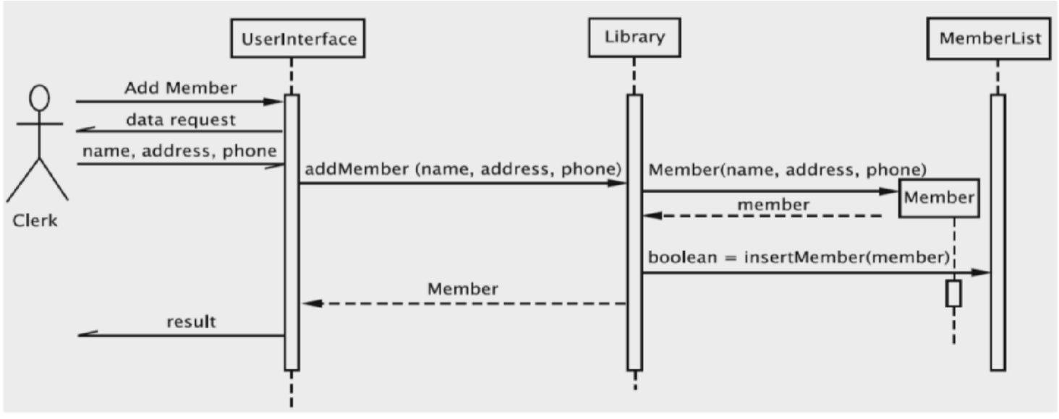
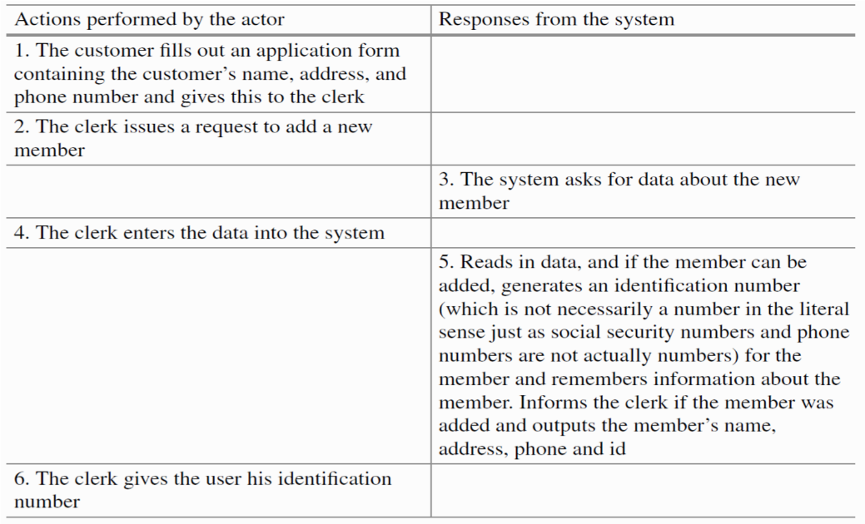
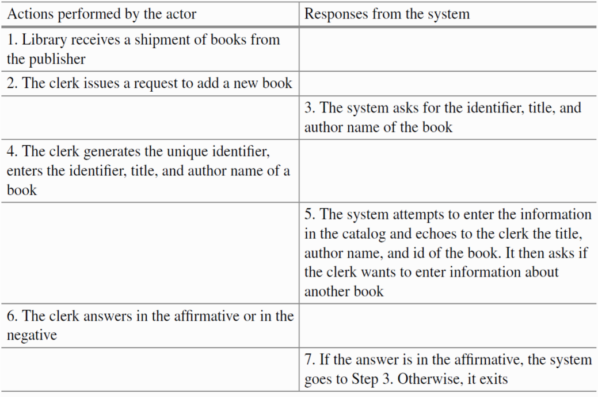
- Consider the use case “Adding New Books” is described in the following table to Sequence diagram.
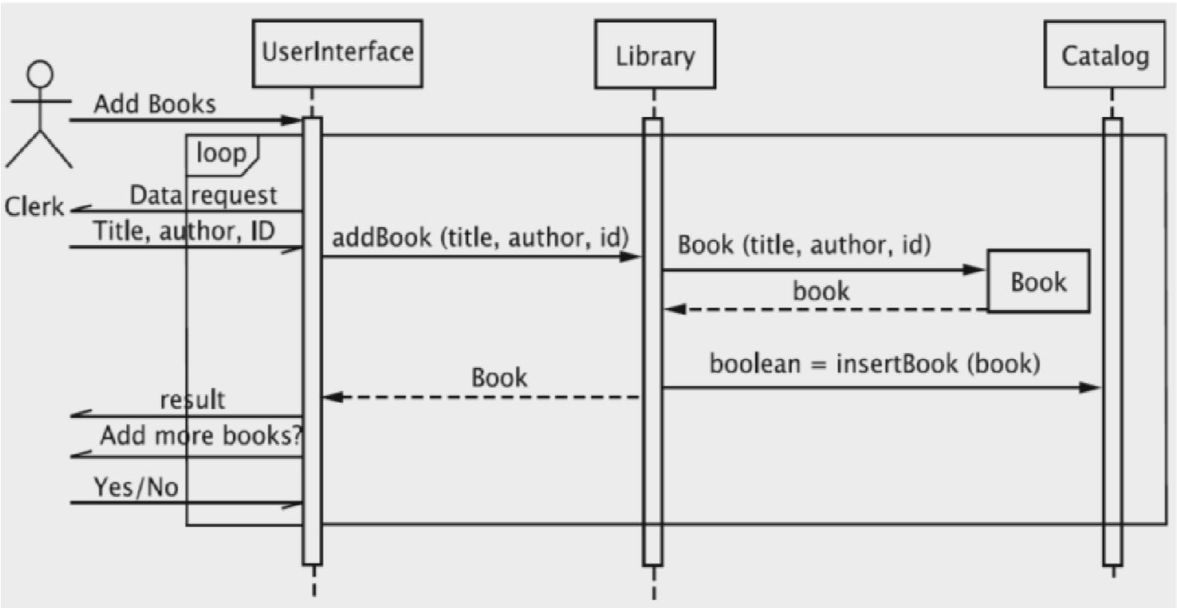

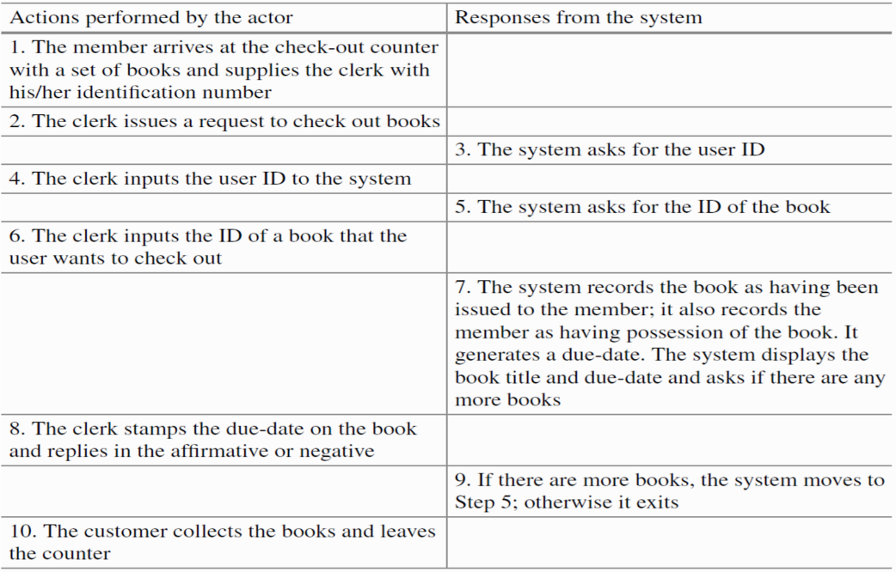
- Consider the use case “Book Checkout” is described in the following table to Sequence diagram.

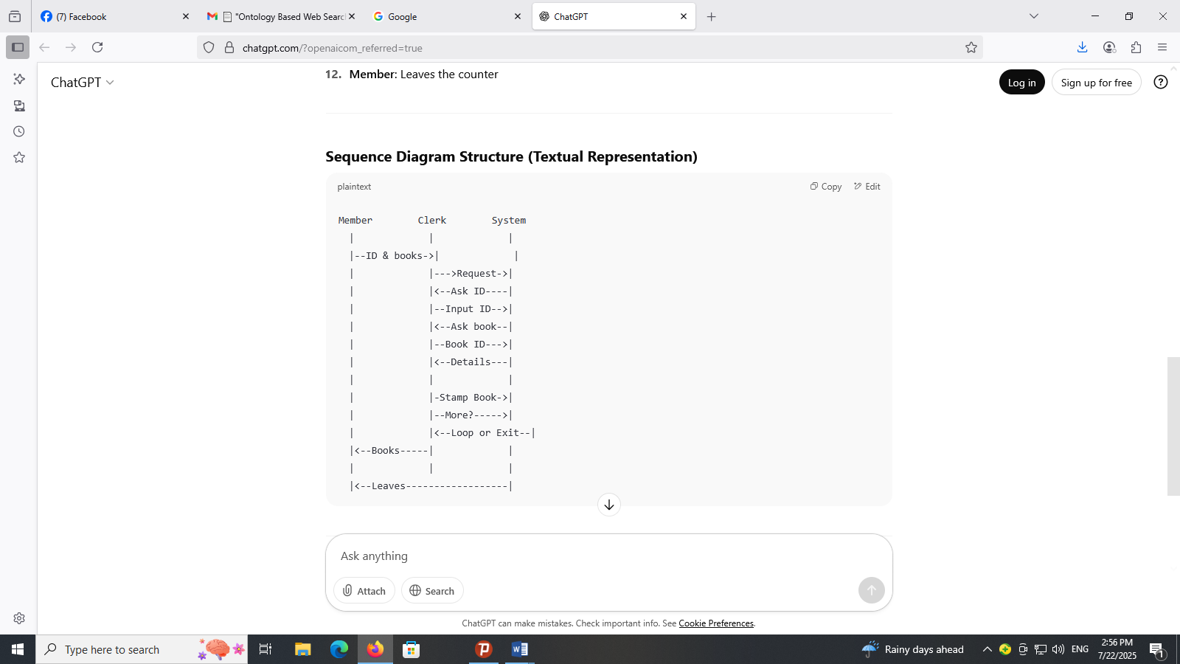

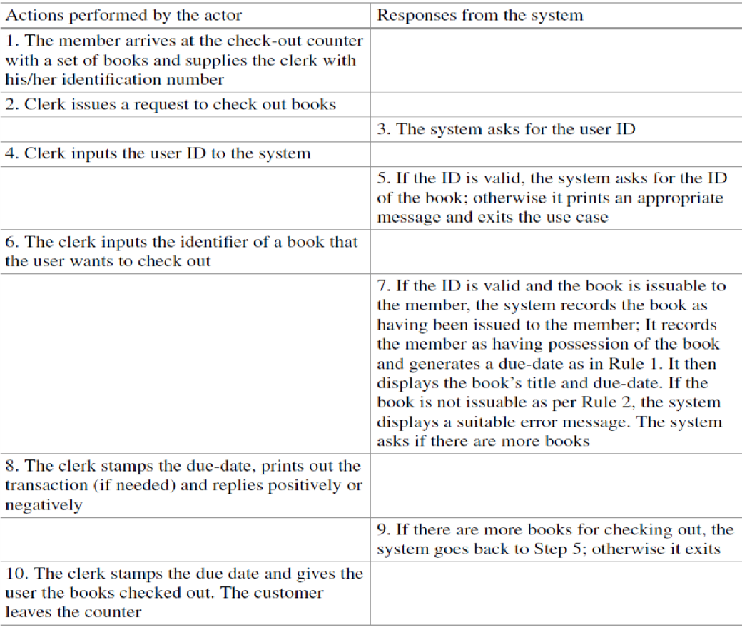
- Consider the use case “Book Checkout” is described in the following table to Sequence diagram.

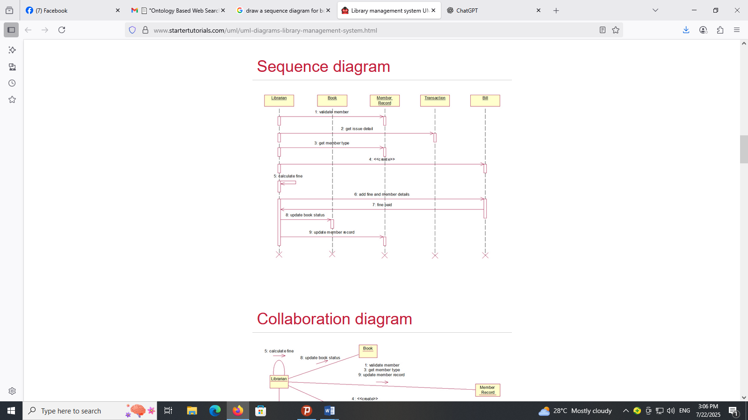
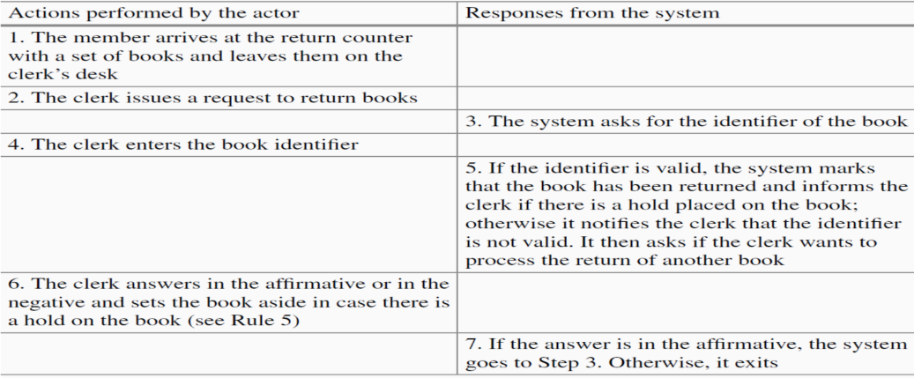
- Consider the use case “Return Book” is described in the following table to Sequence diagram.
