Hanshi Zuo

Jacob Zawacki

1.

1. Arithmetic Intensity of a kernel:

$$q=\frac{f}{m}$$

Floating point operations: 6 total (2 add, 4 multiply)

Memory operations: 2 (8 byte) loads, 1 (8 byte) write

$$q=\frac{6}{2*8+8}=\frac{6}{24}=\frac{1}{4}$$

1. Roofline Model:

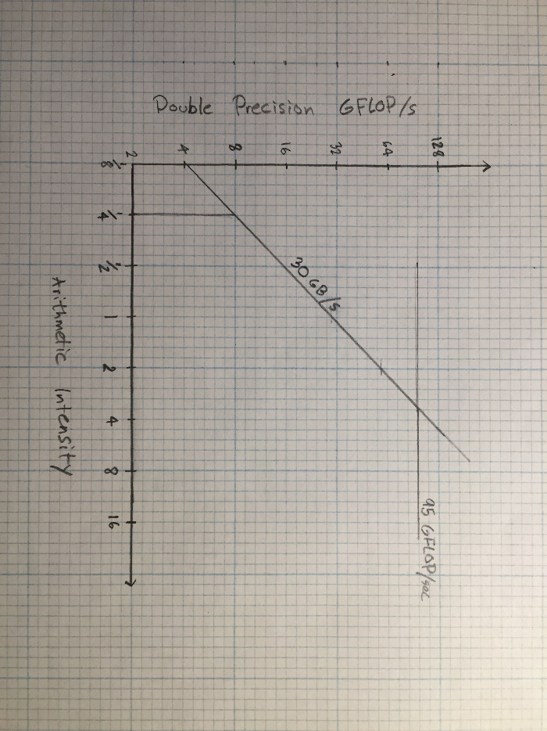

The expected performance of the kernel is about 7.5 GFLOP/s.

This performance is memory-bound.